***CSE321 Lab Assignment 04***

Name: Mehnaz Ara Fazal

ID: 20301295

Section: 01

Email: [mehnaz.ara.fazal@g.bracu.ac.bd](mailto:mehnaz.ara.fazal@g.bracu.ac.bd)

**Task-1 SJF Preemptive Scheduling**

**#include <stdio.h>**

**int main(){**

**//WT = TA - BT**

**//TA = CT - AT**

**int n = 0;**

**printf("Number of Process\n");**

**scanf("%d",&n);**

**int noOfFinishedProcess = 0;**

**int bt[n];**

**int wt[n];**

**int ta[n];**

**int arr_t[n];**

**int ct[n];**

**int remaining_bt[n];**

**int time_counter = 0;**

**float awt = 0;**

**float ata = 0;**

**printf("Provide all arrival time, one by one\n");**

**for(int b = 0;b<n;b++){**

**scanf("%d",&arr_t[b]);**

**}**

**printf("Provide all burst time, one by one\n");**

**for(int k = 0;k<n;k++){**

**scanf("%d",&bt[k]);**

**remaining_bt[k] = bt[k];**

**}**

**int total_time = 0; //sum of all burst times**

**for (int z = 0;z<n;z++){**

**total_time += bt[z];**

**}**

**int gantt_chart[total_time];**

**int *ptr = &gantt_chart[0];**

**while (noOfFinishedProcess != n){**

**int counter = 0;**

**for (int s = 0;s<n;s++){**

**if (arr_t[s] <= time_counter && remaining_bt[s] != 0){**

**counter += 1;**

**}**

**}**

**int temp_arr[counter]; //burst comparison array**

**int arr_index = 0;**

**for (int m =0;m<n;m++){**

**if(arr_t[m] <= time_counter && remaining_bt[m] != 0){**

**temp_arr[arr_index] = m;**

**arr_index += 1;**

**}**

**}**

**int min_index = -1;**

**if(counter > 1){**

**min_index = temp_arr[0];**

**for(int w = 1;w<counter;w++){**

**if(remaining_bt[temp_arr[w]] < remaining_bt[min_index]){**

**min_index = temp_arr[w];**

**}**

**}**

**}**

**else if(counter == 1){**

**min_index = temp_arr[0];**

**}**

**if (min_index != -1){**

**remaining_bt[min_index] -= 1;**

**time_counter += 1;**

**\*ptr = min_index + 1;**

**ptr ++;**

**}**

**if(remaining_bt[min_index] == 0){**

**ct[min_index] = time_counter;**

**noOfFinishedProcess ++;**

**}**

**}**

**for (int r = 0;r<n;r++){**

**ta[r] = ct[r] - arr_t[r];**

**wt[r] = ta[r] - bt[r];**

**}**

**printf("Gantt Chart:\t");**

**for(int v = 0;v<total_time;v++){**

**if (v != 0){**

**if (gantt_chart[v] != gantt_chart[v-1]){**

**printf("P%d\t",gantt_chart[v]);**

**}**

**}**

**else if (v == 0){**

**printf("P%d\t", gantt_chart[v]);**

**}**

**}**

**printf("\n");**

**printf("Proc\tAT\tBT\tCT\tWT\tTAT\n");**

**for(int p = 0;p<n;p++){**

**printf("P%d\t%d\t%d\t%d\t%d\t%d\n",p+1,arr_t[p],bt[p],ct[p],wt[p],ta[p]);**

**}**

**for(int a = 0;a<n;a++){**

**awt += wt[a];**

**ata += ta[a];**

**}**

**awt = awt/n;**

**ata = ata/n;**

**printf("Average waiting time: %f\n",awt);**

**printf("Average turnaround time: %f\n",ata);**

**return 0;**

**}  
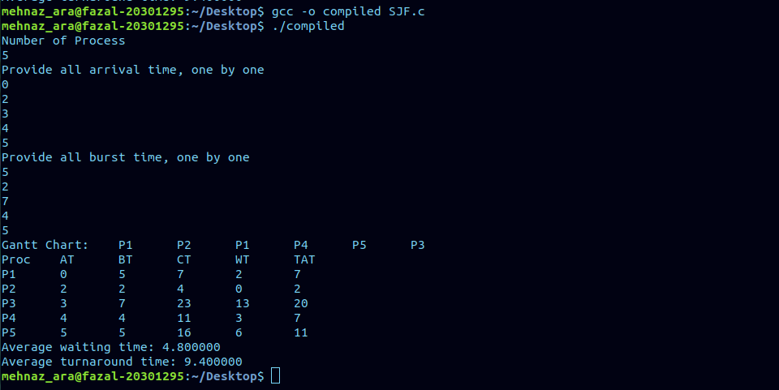**

**Task-2 Round Robin Scheduling**

**#include <stdio.h>**

**int main(){**

**//WT = TA - BT**

**//TA = CT - AT**

**//Since arrival time not given in the question, assuming all arrival times to be 0ms and hence (Turn Around Time = Completion Time)**

**int n;**

**printf("Number of Process\n");**

**scanf("%d",&n);**

**int noOfFinishedProcess = 0;**

**int bt[n];**

**int wt[n];**

**int ta[n];**

**int remaining_bt[n];**

**int time_quantum = 0;**

**int time_counter = 0;**

**int time_counter1[n];**

**float awt = 0;**

**float ata = 0;**

**int gantt_chart[n*5];**

**int *ptr = &gantt_chart[0];**

**for (int l = 0;l<(n*5);l++){**

**gantt_chart[l] = 0;**

**}**

**printf("Provide time quantum value\n");**

**scanf("%d",&time_quantum);**

**printf("Provide all burst time, one by one\n");**

**for(int k=0;k<n;k++){**

**scanf("%d",&bt[k]);**

**remaining_bt[k] = bt[k];**

**}**

**while(noOfFinishedProcess != n){**

**for (int i = 0;i<n;i++){**

**if (remaining_bt[i] != 0){**

**if (remaining_bt[i] > time_quantum){**

**\*ptr = (i+1);**

**ptr ++;**

**remaining_bt[i] = remaining_bt[i] - time_quantum;**

**time_counter += time_quantum;**

**}**

**else if (remaining_bt[i] < time_quantum){**

**\*ptr = (i+1);**

**ptr ++;**

**time_counter += remaining_bt[i];**

**noOfFinishedProcess += 1;**

**time_counter1[i] = time_counter;**

**remaining_bt[i] = 0;**

**ta[i] = time_counter1[i];**

**}**

**else if (remaining_bt[i] == time_quantum){**

**\*ptr = (i+1);**

**ptr ++;**

**time_counter += time_quantum;**

**noOfFinishedProcess += 1;**

**time_counter1[i] = time_counter;**

**remaining_bt[i] = 0;**

**ta[i] = time_counter1[i];**

**}**

**}**

**}**

**}**

**for (int j = 0;j<n;j++){**

**wt[j] = ta[j] - bt[j];**

**}**

**printf("Gantt Chart:\t");**

**int temp = 0;**

**while(gantt_chart[temp] != 0){**

**printf("P%d\t",gantt_chart[temp]);**

**temp ++;**

**}**

**printf("\n");**

**printf("Proc\tAT\tBT\tCT\tWT\tTAT\n");**

**for(int m = 0;m<n;m++){**

**printf("P%d\t%d\t%d\t%d\t%d\t%d\n",m+1,0,bt[m],time_counter1[m],wt[m],ta[m]);**

**}**

**for (int p = 0;p<n;p++){**

**awt += wt[p];**

**ata += ta[p];**

**}**

**awt = awt/n;**

**ata = ata/n;**

**printf("Average waiting time: %f\n",awt);**

**printf("Average turnaround time: %f\n",ata);**

**return 0;**

**}**

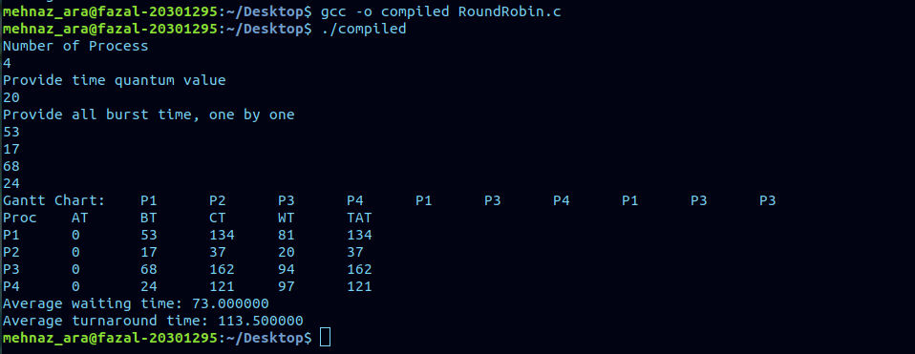

**Task-3 Priority Scheduling  
#include <stdio.h>**

**int main(){**

**//WT = TA - BT**

**//TA = CT - AT**

**int n = 0;**

**printf("Number of Process\n");**

**scanf("%d",&n);**

**int noOfFinishedProcess = 0;**

**int bt[n];**

**int wt[n];**

**int ta[n];**

**int arr_t[n];**

**int ct[n];**

**int priority[n];**

**int remaining_bt[n];**

**int time_counter = 0;**

**float awt = 0;**

**float ata = 0;**

**printf("Provide all arrival time, one by one\n");**

**for(int b = 0;b<n;b++){**

**scanf("%d",&arr_t[b]);**

**}**

**printf("Provide all burst time, one by one\n");**

**for(int k = 0;k<n;k++){**

**scanf("%d",&bt[k]);**

**remaining_bt[k] = bt[k];**

**}**

**printf("Provide all priorities, one by one\n");**

**for(int u = 0;u<n;u++){**

**scanf("%d",&priority[u]);**

**}**

**int total_time = 0; //sum of all burst times**

**for (int z = 0;z<n;z++){**

**total_time += bt[z];**

**}**

**int gantt_chart[total_time];**

**int *ptr = &gantt_chart[0];**

**while (noOfFinishedProcess != n){**

**int counter = 0;**

**for (int s = 0;s<n;s++){**

**if (arr_t[s] <= time_counter && remaining_bt[s] != 0){**

**counter += 1;**

**}**

**}**

**int temp_arr[counter]; //burst comparison array**

**int arr_index = 0;**

**for (int m =0;m<n;m++){**

**if(arr_t[m] <= time_counter && remaining_bt[m] != 0){**

**temp_arr[arr_index] = m;**

**arr_index += 1;**

**}**

**}**

**int min_index = -1;**

**if(counter > 1){**

**min_index = temp_arr[0];**

**for(int w = 1;w<counter;w++){**

**if(priority[temp_arr[w]] < priority[min_index]){**

**min_index = temp_arr[w];**

**}**

**}**

**}**

**else if(counter == 1){**

**min_index = temp_arr[0];**

**}**

**if (min_index != -1){**

**remaining_bt[min_index] -= 1;**

**time_counter += 1;**

**\*ptr = min_index + 1;**

**ptr ++;**

**}**

**if(remaining_bt[min_index] == 0){**

**ct[min_index] = time_counter;**

**noOfFinishedProcess ++;**

**}**

**}**

**for (int r = 0;r<n;r++){**

**ta[r] = ct[r] - arr_t[r];**

**wt[r] = ta[r] - bt[r];**

**}**

**printf("Gantt Chart:\t");**

**for(int v = 0;v<total_time;v++){**

**if (v != 0){**

**if (gantt_chart[v] != gantt_chart[v-1]){**

**printf("P%d\t",gantt_chart[v]);**

**}**

**}**

**else if (v == 0){**

**printf("P%d\t", gantt_chart[v]);**

**}**

**}**

**printf("\n");**

**printf("Proc\tAT\tBT\tCT\tWT\tTAT\n");**

**for(int p = 0;p<n;p++){**

**printf("P%d\t%d\t%d\t%d\t%d\t%d\n",p+1,arr_t[p],bt[p],ct[p],wt[p],ta[p]);**

**}**

**for(int a = 0;a<n;a++){**

**awt += wt[a];**

**ata += ta[a];**

**}**

**awt = awt/n;**

**ata = ata/n;**

**printf("Average waiting time: %f\n",awt);**

**printf("Average turnaround time: %f\n",ata);**

**return 0;**

**}**

