Parallel Programming Assignment 2 (MPI)

Team Members
Sandeep N Menon : 14CO140
Matthew George : 14CO225

Q1
Given below is the output
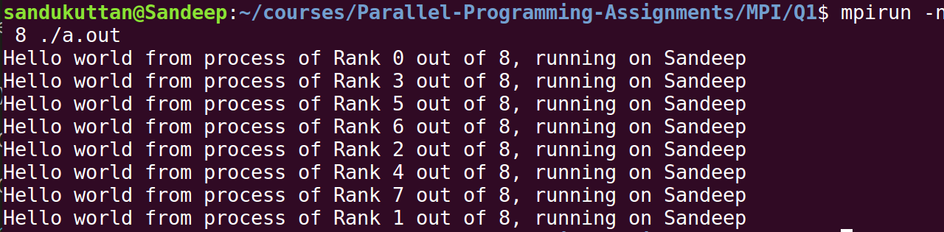
Number of threads is 8. Hence “Hello World !” is printed 4 times.

Q2
Given below is the output
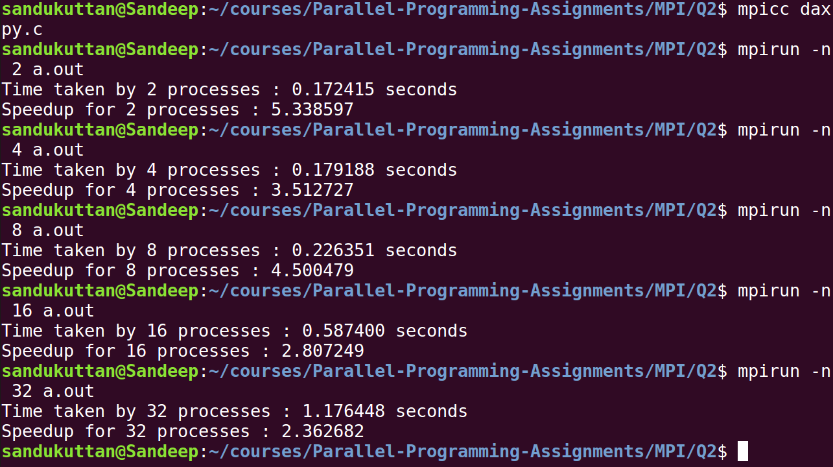
Speedup is shown in the output.
Q3

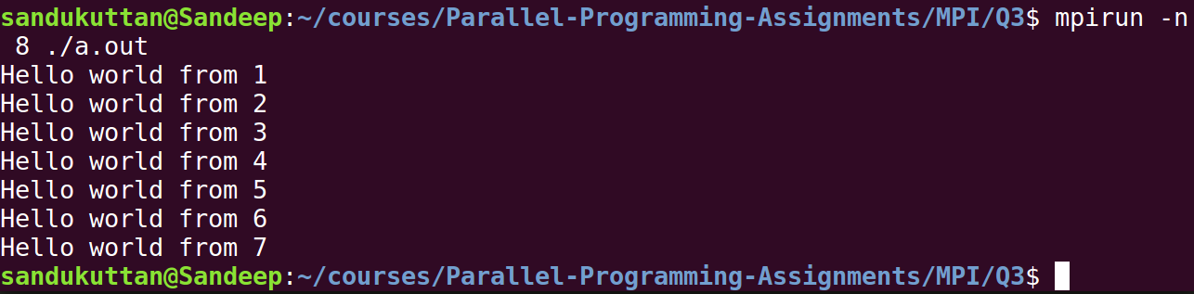
“Hello world” message is sent to master process from the other 7 processes.

Q4
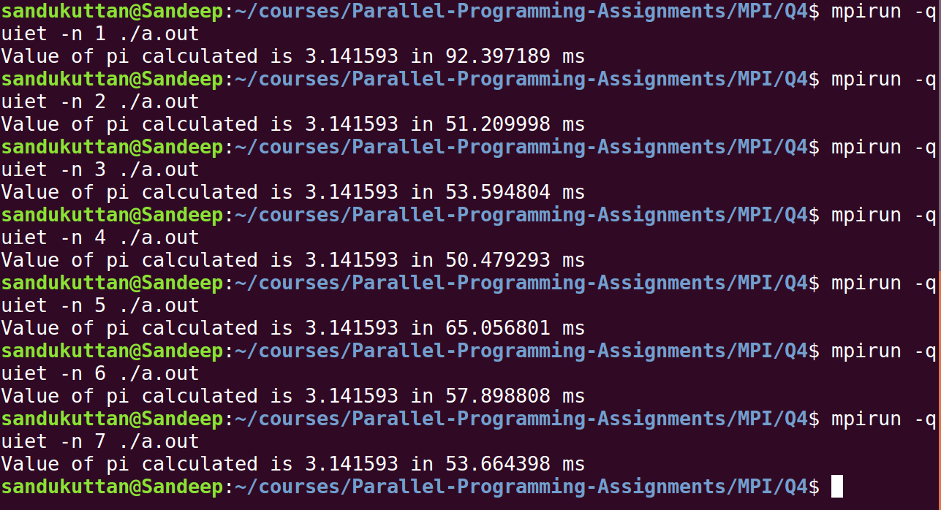
Value of pi is calculated. The time taken by different number of processes is shown in the output.

Q5

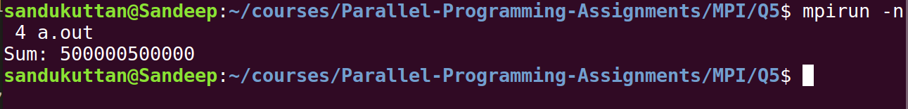

Sum of N = 1000000, is shown in the output.

Q6
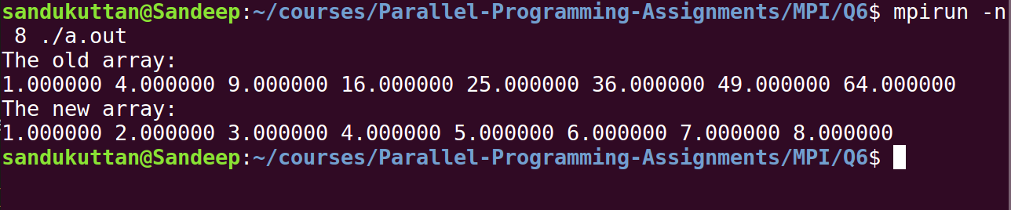
The square root of the old array is calculated by scattering its elements into different processes, calculating square root there and gathering it back at the master process.

Q7

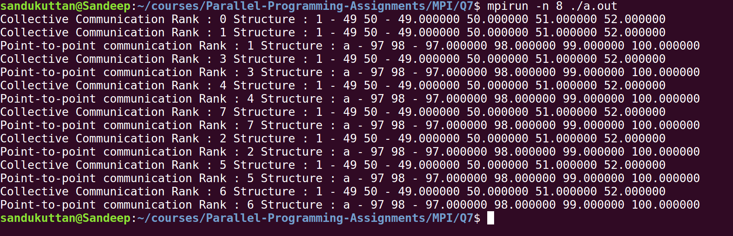

The following code snippet is used to fill the structure
struct dd get_filled_struct(char key)
{
struct dd temp;
temp.c = key;
for(int i=0;i<4;++i)
{
if(i<2)
{
temp.iA[i] = key + i;
}
temp.fA[i] = key + i;
}
return temp;
}

The derived datatype was created and broadcasted by the master process, whose output is shown prefixed with Collective Communication.
Also, the master process invidually send the datatype to the other process, whose output is prefixed by Point-to-point communication.

Q8

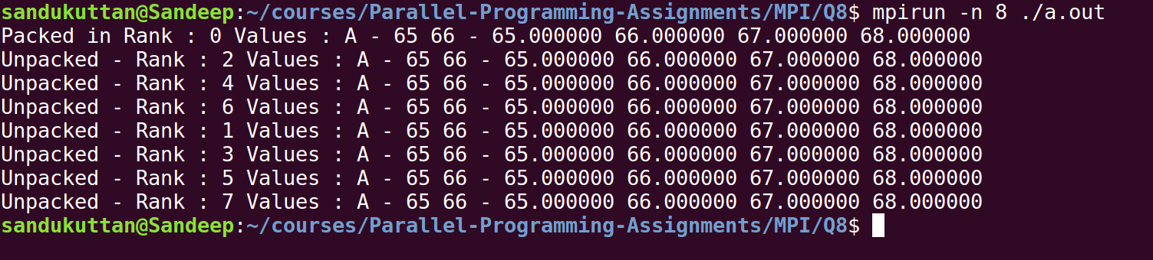
The same problem statement in Q7, is done using the Pack and Unpack functions in MPI.

Q9

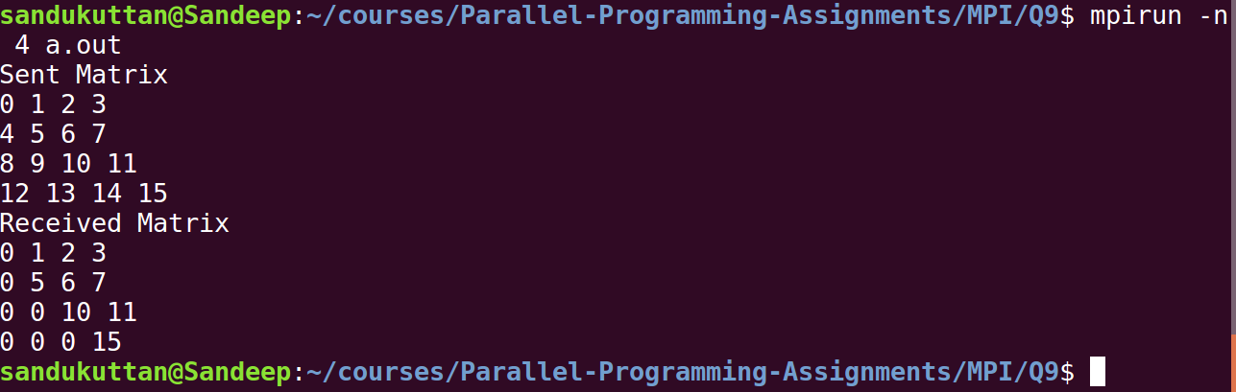
An indexed derived datatype which taken only the upper triangle of a matrix is declared. The above shown matrix is send my the master process using this derived datatype to process 1.
The matrix received by process 1 is an upper triangular matrix as shown in the output.

Q10

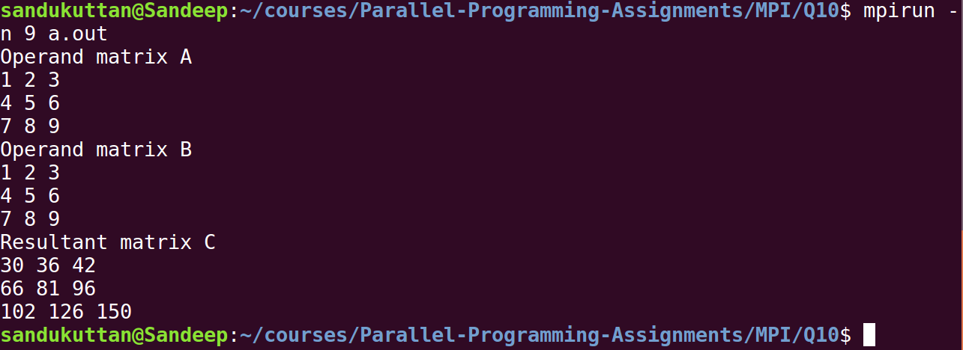

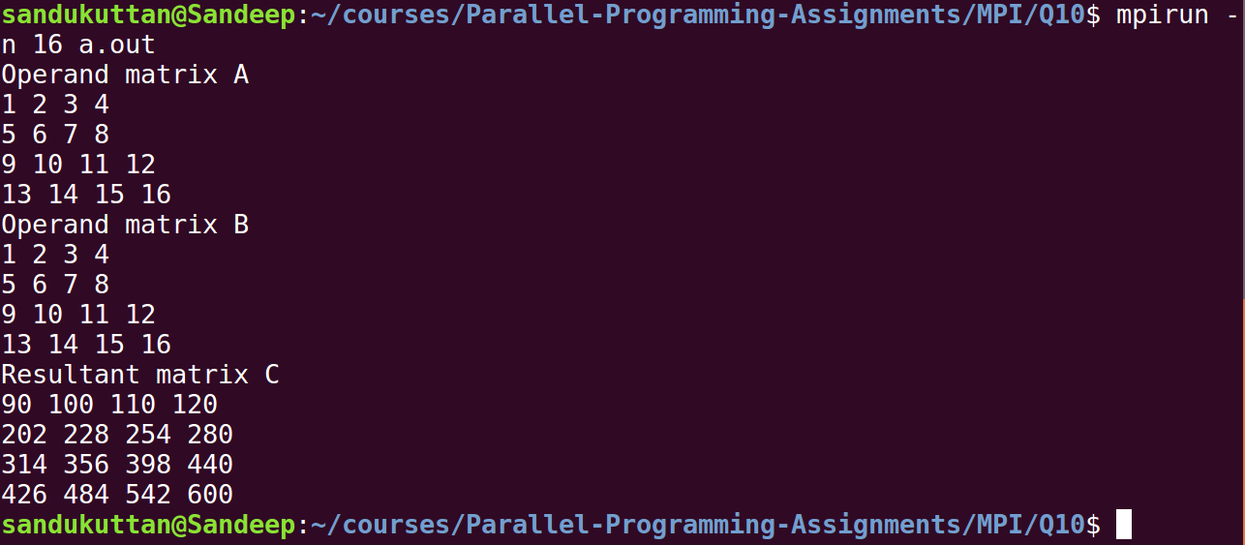
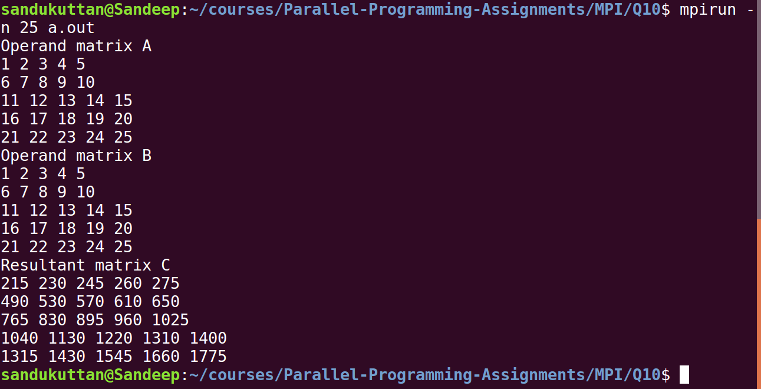
The cannon’s algorithm was implemented. The output is shown for 3x3, 4x4 and 5x5 matrices respectively.
The matrices are filled using the following code snippet
for(int i = 0; i < N; ++i)
for(int j = 0; j < N; ++j)
arr[i][j] = i*N + j;

To change the dimension of the matrix do the following
1. #define N 4 : Change this macro in line 3 of the code
2. while running run : mpirun -n 25 a.out, where 25 is for a 5x5 matrix.

