Parallel Programming Assignment 1

Team Members
Sandeep N Menon : 14CO140
Matthew George : 14CO225

Q1
Given below is the output
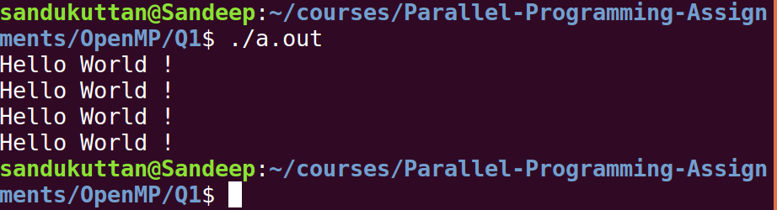
Default number of threads is 4. Hence “Hello World !” is printed 4 times.

Q2
Given below is the output
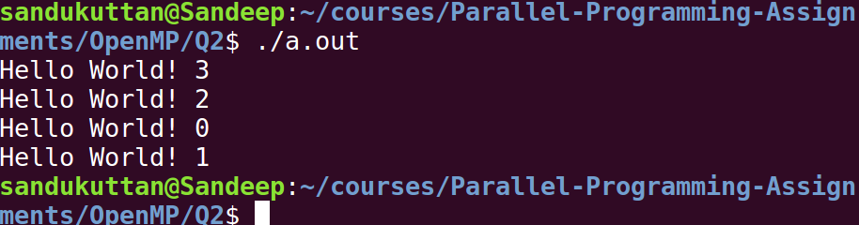
Default number of threads is 4. Hence thread ID ranges from 0 to 3.

Q3
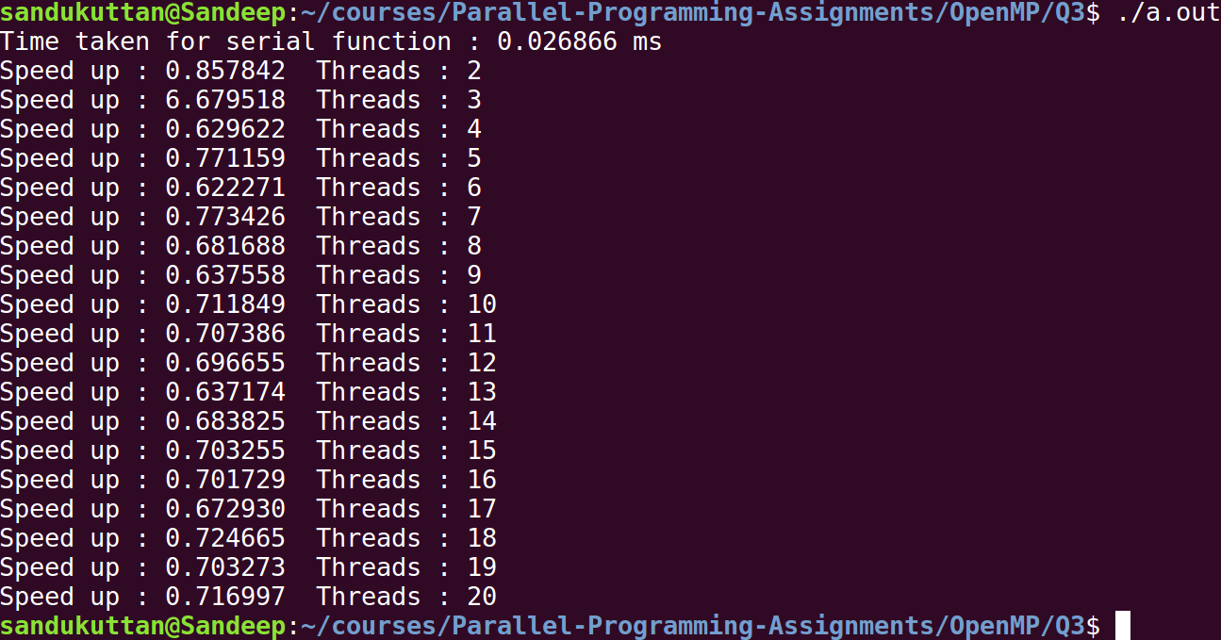
Maximum speedup is obtained when number of threads is 4.
When number of threads is increased further, runtime increases since the number threads are greater than the number of cores in the system. Hence time is consumed in scheduling the excess threads by operating system among the cores.

Q4
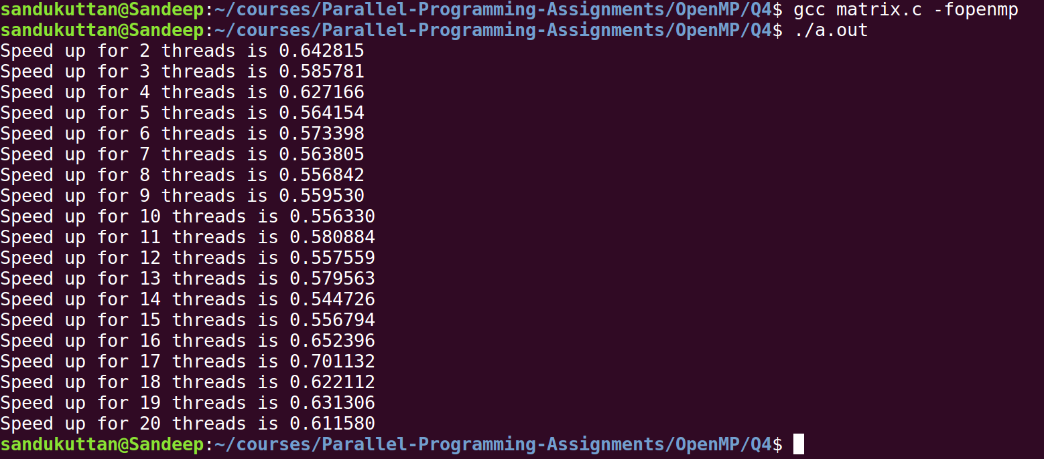
Matrix multiplication done using parallel calculations speeds up the process as seen in the output.
The void check_eq_matrix() function checks if the output of the serial and parallel codes are equal. Only if they are equal the speedup is shown. Since speedup is shown for threads from 2 to 20, the parallel calculation gas given the right output.

The matrix multiplication algorithm 3 loops nested with a complexity of O(n^3). We fork the master thread at each level of loop to obtain the best speedup.
The inner most loop sums up the product of corresponding row and column. This is done using the reduction operation provided my OpenMP.

Q5
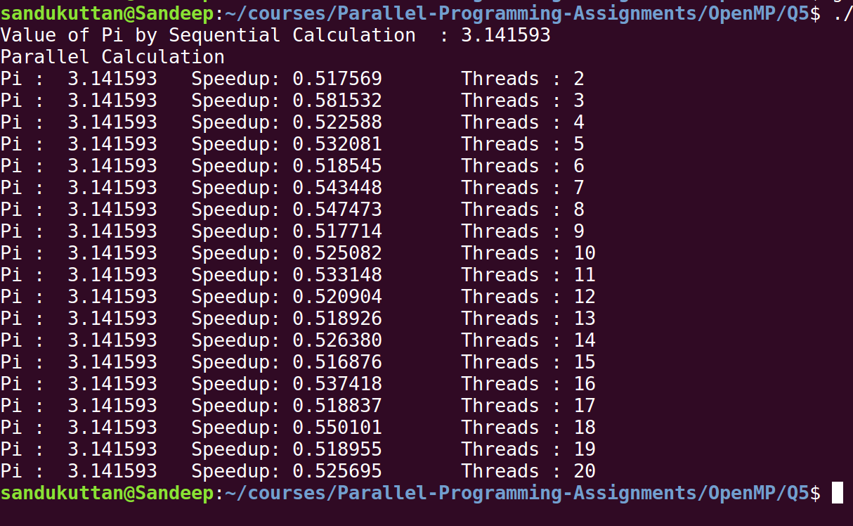
Shared variables are
1. sum : which stores the area under the curve

Private variables are
1. ID : thread ID
2. increment : loop increment to split the loop iteration among the threads
3. t_sum : to calculate sum for each thread

Since every thread spawned calculates its own sum, the total sum has to be summed up. This sum variable is shared but cannot be simultaneously updated my multiple threads. Hence its updation is given inside a “critical” construct which ensures that only one thread updates its value at a time.

Q6
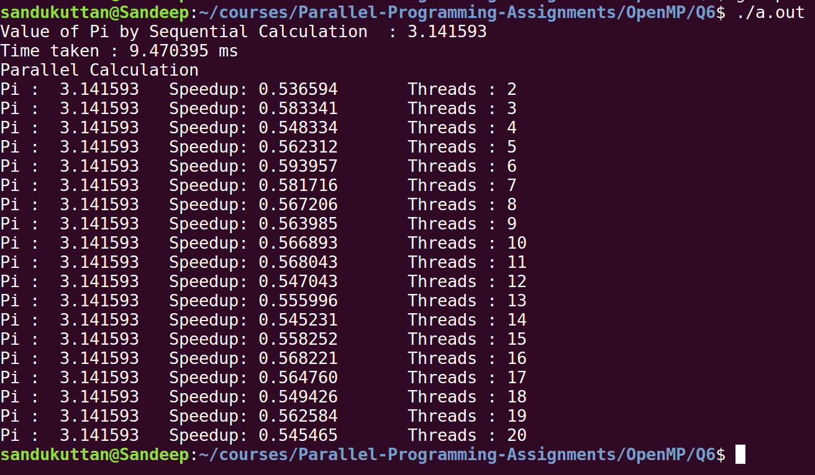
The reduction clause is used to sum the area under the curve. Every thread creates its own local copy of the sum and then reduction is done using the operator specified in reduction (op : list) .

Q7
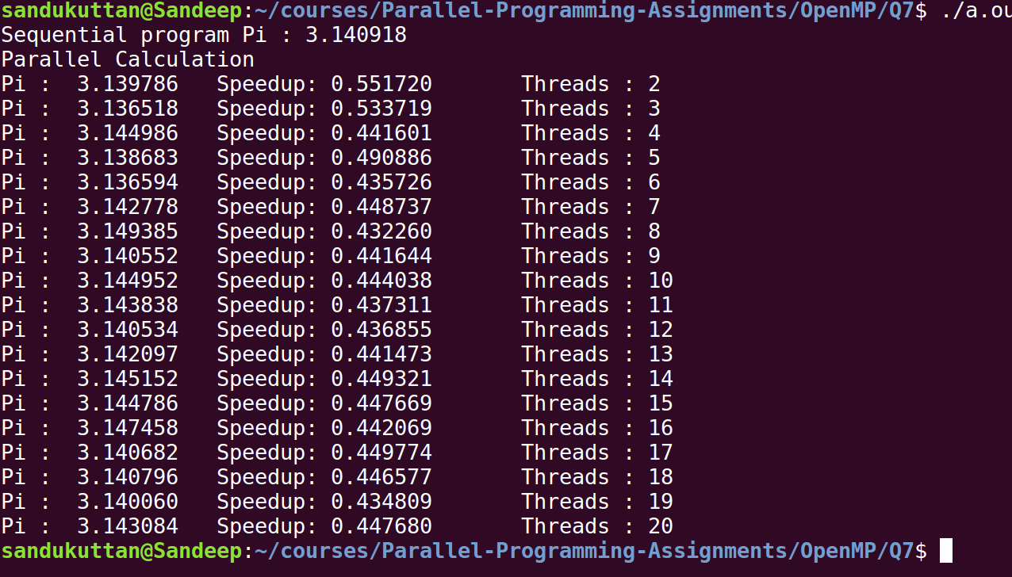
Random numbers are generator using the Linear Congruential Generator defined by

X(n+1) = (a*X(n) + c) mod m

Bonus part
1. Random number generator was made threadsafe using the “#pragma omp threadprivate(seed)” construct in OpenMP. This allows each thread to have its own private seed.

2. The random number generator was made numerically correct, ie with non-overlapping sequences of pseudo-random numbers by using the leap frog algorithm.
This can be done for linear congruential generators, and involves replacing the multiplier a and the additive constant c by new values a^N and c(a^N – 1)/(a-1), where N is the number of threads.

Q8
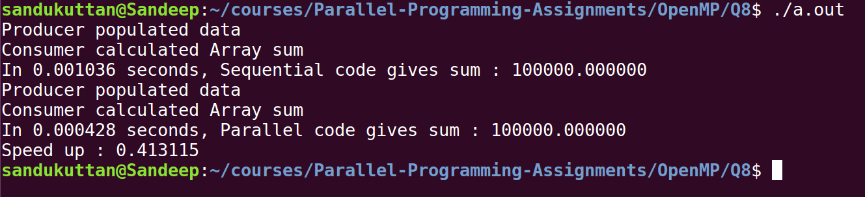
Two threads, one for producer and one for consumer was created. The sections clause was used to reserve each section for one thread.
The consumer knows the producer has completed execution by getting notified by a global flag.

