**LAB # 3**

**Q#1. Write a program in C++ that can calculate the factorial of a number by passing the address of that number to a function, using pointers.**

**INPUT:**

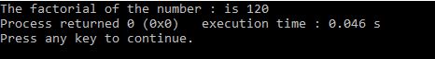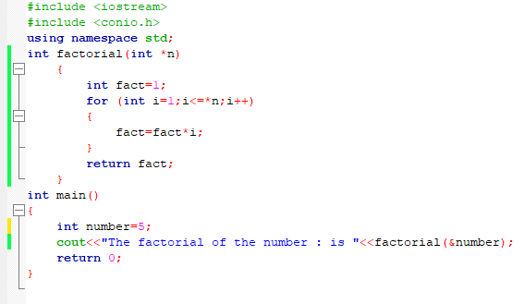

**OUTPUT:**

**Q#2. Write down a C++ program that will declare and initialize two arrays and would generate the sum of these two arrays by using pointers**.

**INPUT:**

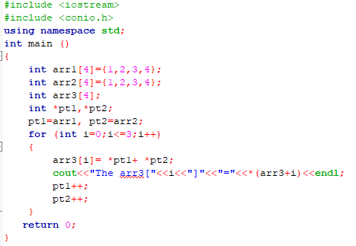

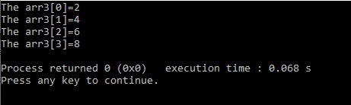**OUTPUT:**

**Q#3. Write down a C++ program, that will Calculate the area of a Circle by using Constant Data member PI=3.14, and by using Constant Pointer.**

**INPUT:**

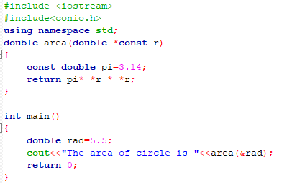

**OUTPUT:**

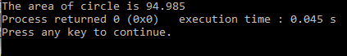

**Q#4. Write down a C++ program that would generate some table 2*1=2,2*10=20by using pointers.**

**INPUT:**

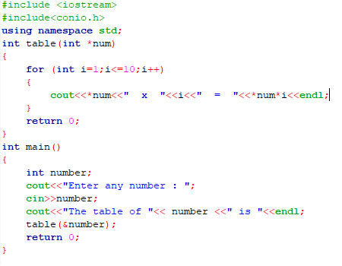

**OUTPUT:**

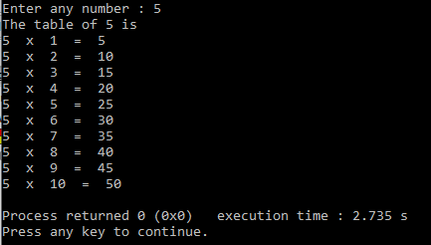

**Q#5. Write down a C++ program that would design a simple Calculator, by using Pointers.**

**INPUT:**

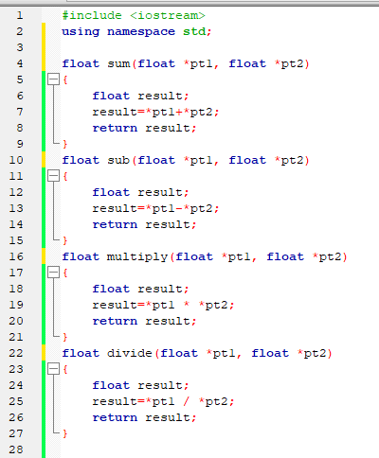

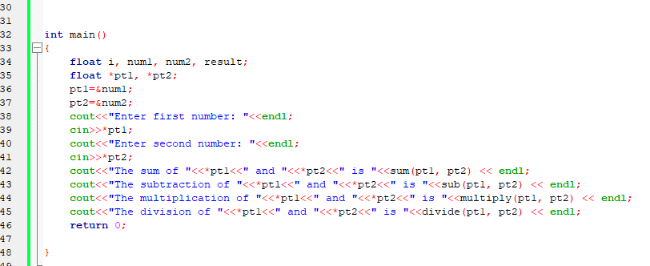

**OUTPUT:**

