**LAB # 5**

**Lab Exercise:**

## You are already familiar with the Rectangle and DormRoom object types and have also written class descriptions for the two classes. Write down C++ class declarations for both the class.

**INPUT:**

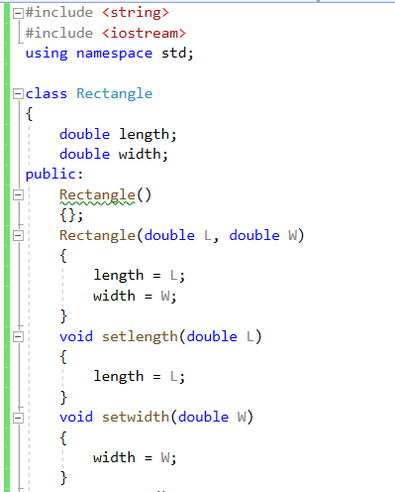

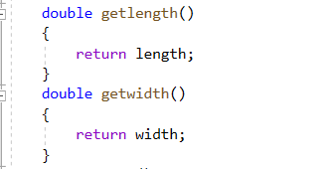

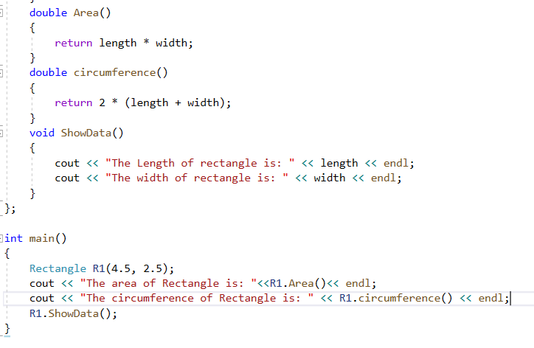

**OUTPUT:**

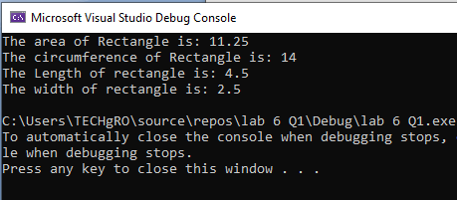

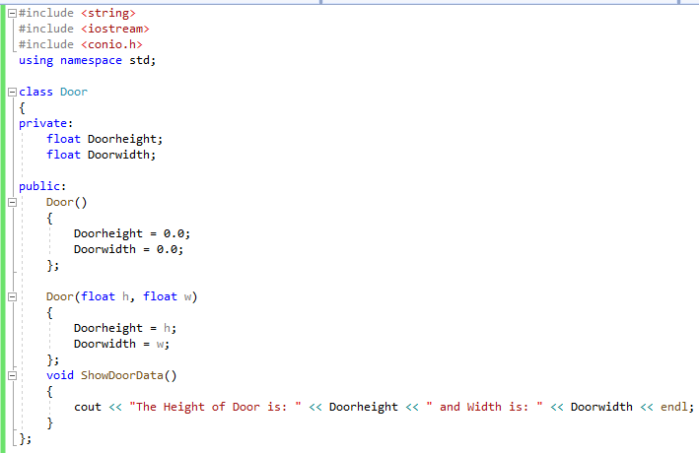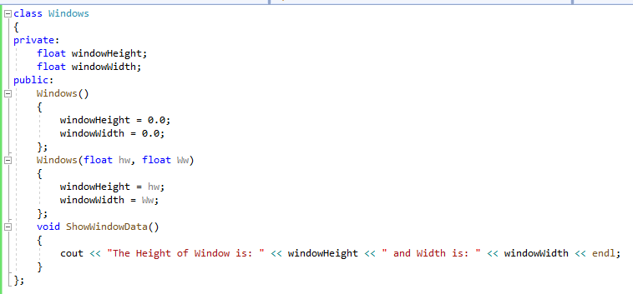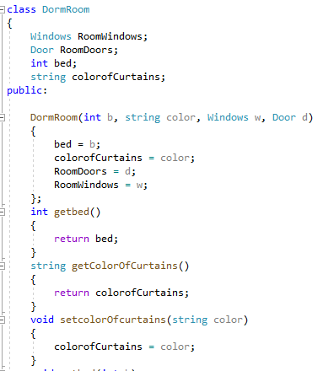

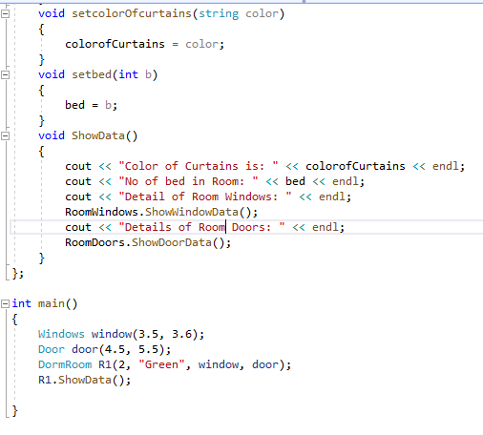



**OUTPUT:**

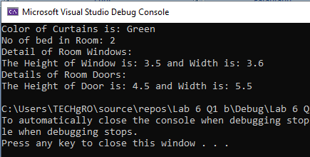

## A company called Restaurant Products, Inc. wants to produce small machines for use by waiters in a restaurant. Each machine is initialized with the name of the restaurant and the local sales tax rate. When a customer has finished eating, the waiter enters the cost of the meal and has the machine output a bill in the following form:

Bill

Meal cost xx.xx

Tax xx.xx

Tip xx.xx

Total cost xx.xx

The bill automatically adds a 15% tip to the cost. After this the waiter enters the amount paid by the customer and outputs a receipt that includes the following information in the following form:

Receipt

Total cost xx.xx

Payment xx.xx

Change xx.xx

Thank you for dining at <restaurant name>.

To produce the software for this machine write down the class description and declaration for the MealBill class.

**INPUT:**

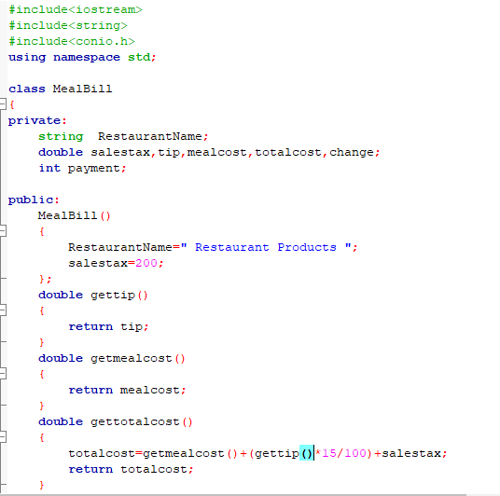

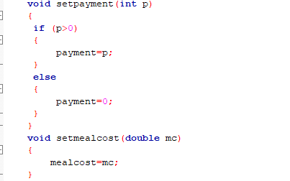

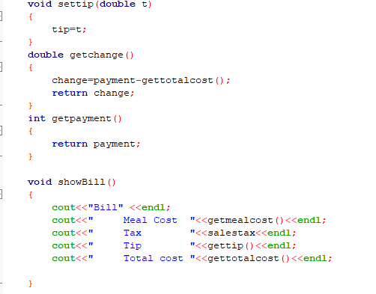

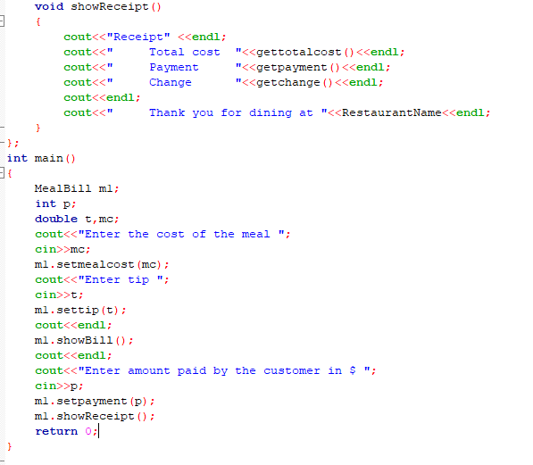

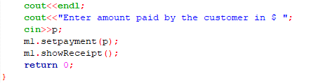

**OUTPUT:**

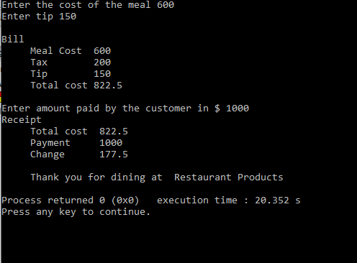

## Write a program for The University Summit Restaurant, which allows a student Ahmed Ali to charge the cost of a meal to his student account. Records are stored in the student account object ahmedAli that has a current balance of Rs.2000.00. The Summit Restaurant implements billing by creating a MealBill object, which is set to charge 6% sales tax.

The program first prompts for the cost of the meal and then computes and prints the bill. It then makes a charge to the student’s account and prints the receipt. In the end the program prints the current status of Ahmed’s account.

**INPUT:**

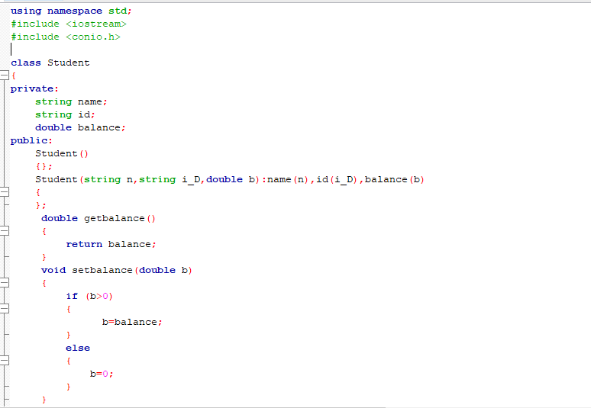



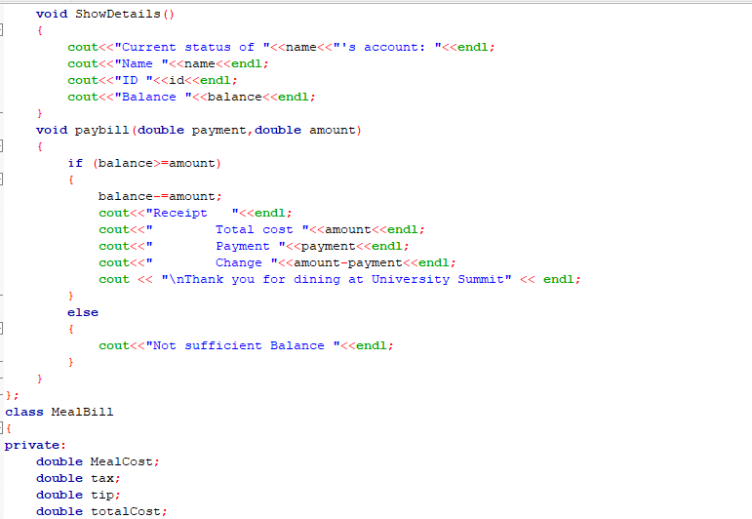



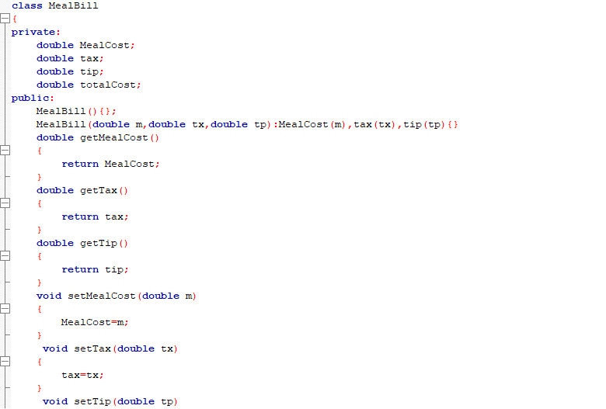

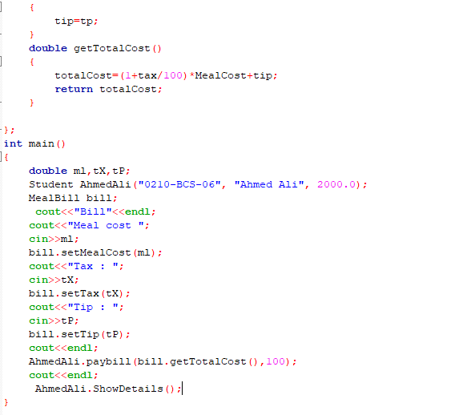



**OUTPUT:**

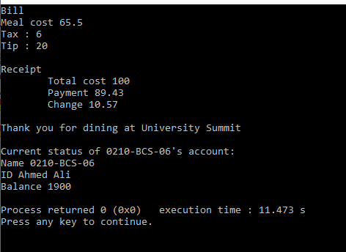

## A student’s grade record is maintained by the registrar in the Academic Dept. The record includes the studentID along with the total number of credits attempted and the total grade points earned by the student. The grades points are determined by the scale A(4), B(3), C(2), D(1), and F(0).

E.g. 4-credit course with grade B: grade points = 4 * 3 = 12

A student’s grade record is initialized with his/her ID, number of credits and the grade points earned. The number of credits and grade points default to 0 (GPA 0.0), for anew student. The student record is used for the purpose of

1. determining the GPA – the total credits and the grade points are used to compute the GPA.
2. to write the grade point information in the following format:

### Student: 0210-BCS-01 Units: 100 GradePts: 345 GPA: 3.45

Each semester the registrar updates the student records with grades from recently completed courses. For instance, assume student “0210-BCS-01” completed a semester in which he/she earned 16 credits and 58 grade points. So, credits and gradePts are now increased to 116 and 403, respectively.

Write down the description and declaration for the GradeRecord class.

**INPUT:**

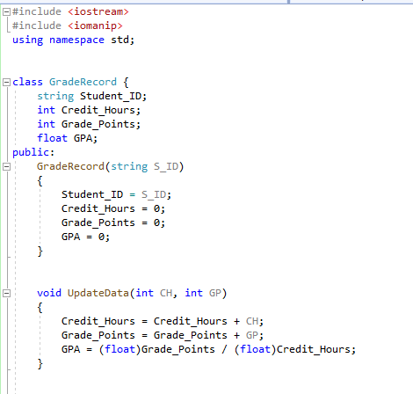

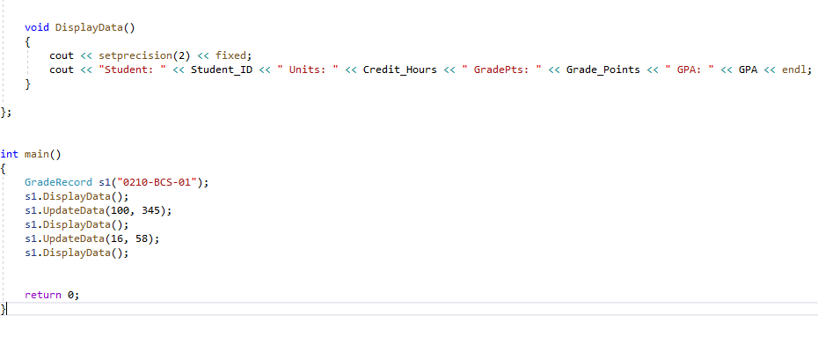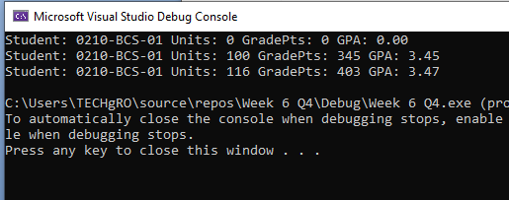

## Write a program that creates a student grade record for a new student. To indicate that student is new print the students initial grade point average. The program then prompts for the grade points and credits that the student has earned in the first semester and updates his/her grade record. The student’s record at the end of the semester is then output to the screen.

**INPUT:**

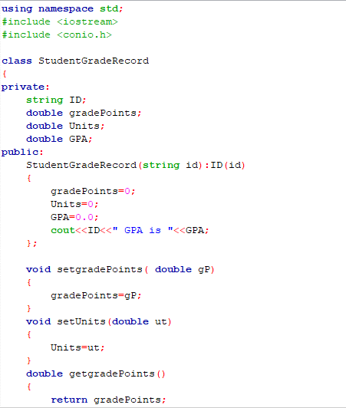



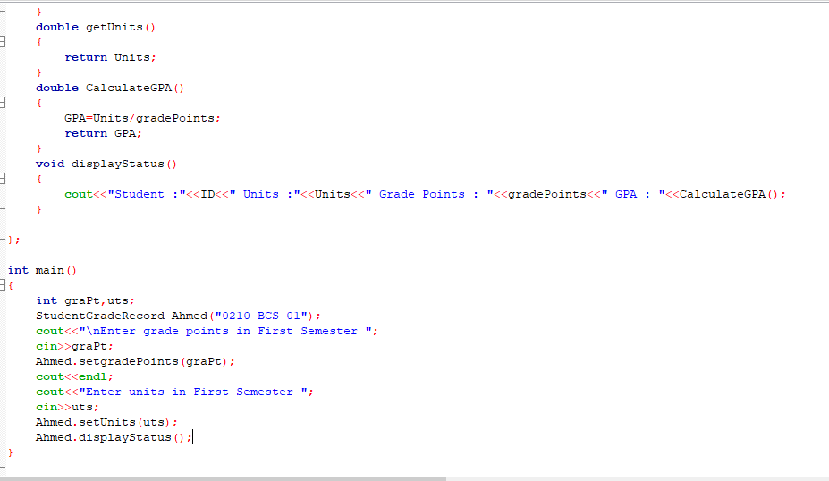

**OUTPUT:**

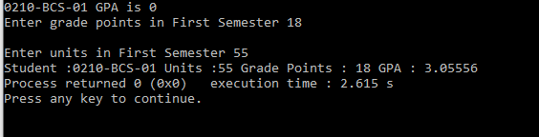

**Q#6.**

Create a Base Class Person having attributes( name,age,gender) with behavior of showdata(displaying all the members) and override same method in derived classes. Derive student Class and from student class derive graduate student with appropriate data members and behavior.

**INPUT:**

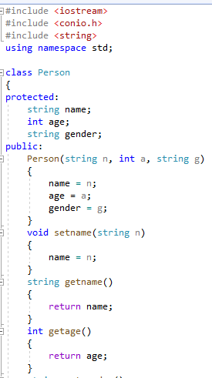

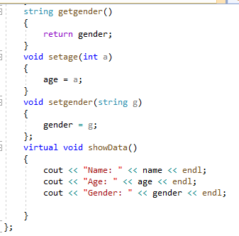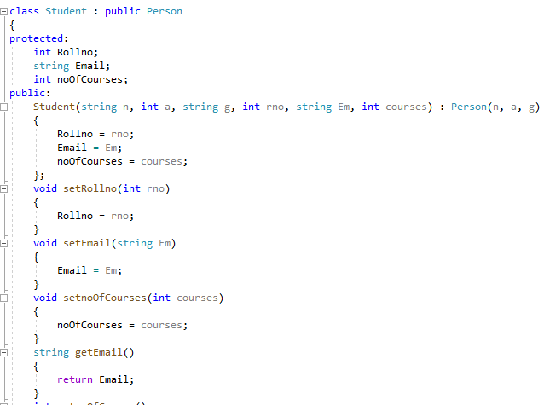

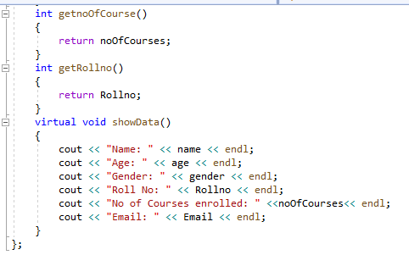

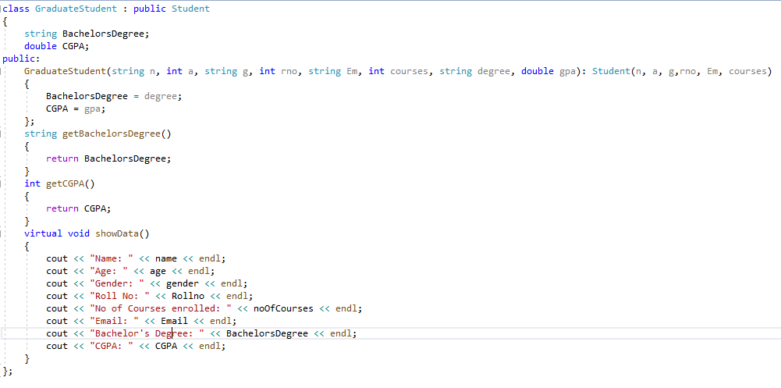

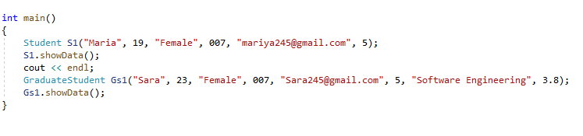

**OUTPUT:**

