**LAB # 7**

**Q1**

Create a Point Class consisting of two members x and y. Override Tostring() method and inherit Circle class from the Point Class that should include one data member radius and calculate area and circumference of a circle.

**INPUT:**

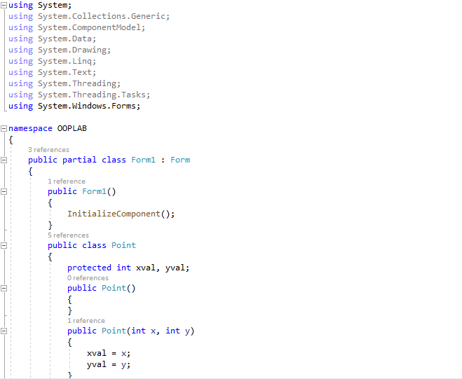

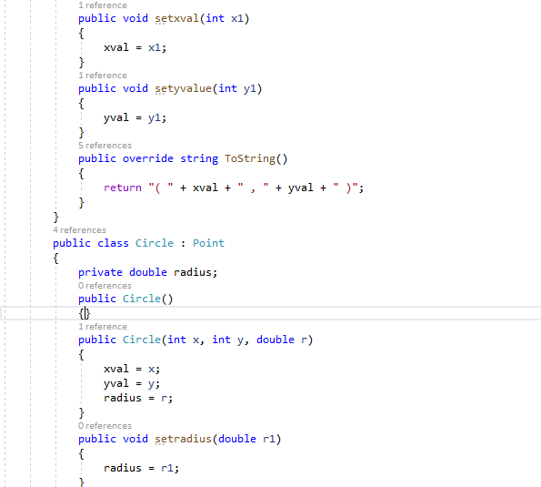

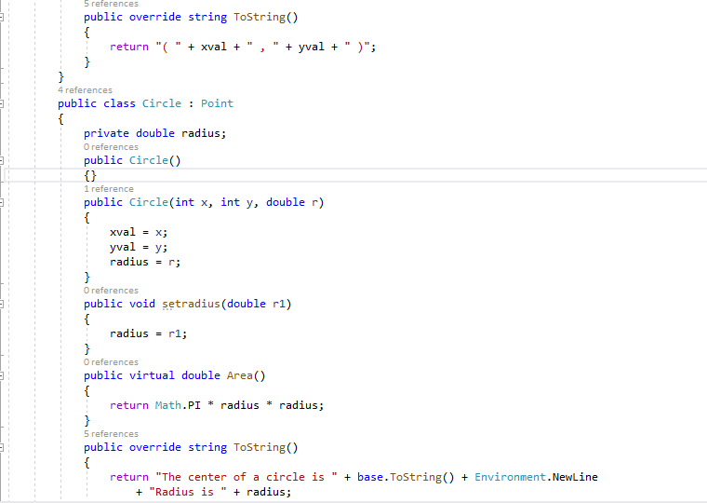

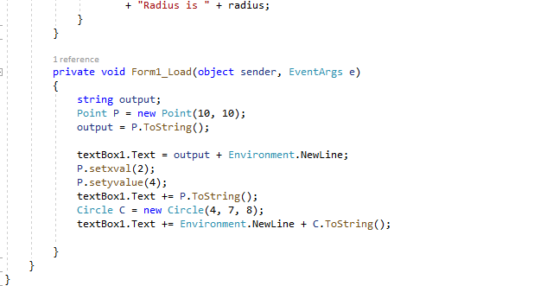

**OUTPUT:**

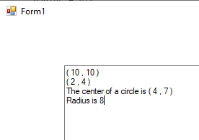

**Q4**

Create a Calculator class that offers four methods. Add, subtract, multiply and Divide. Consisting of two private members of type double to take input from the user. Create object of a class and start using the calculator class.

**INPUT:**

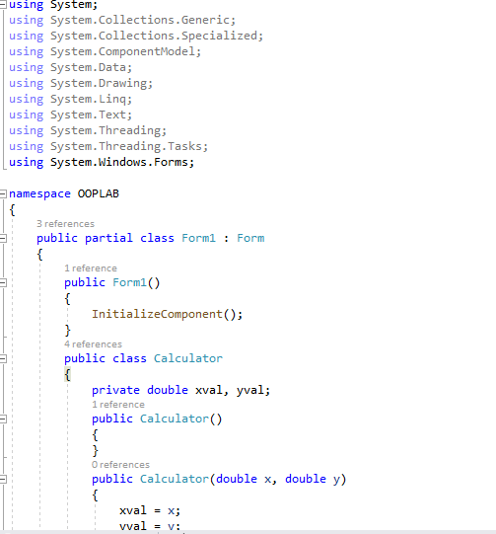

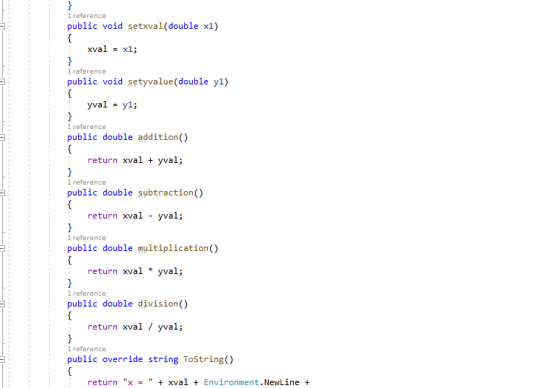

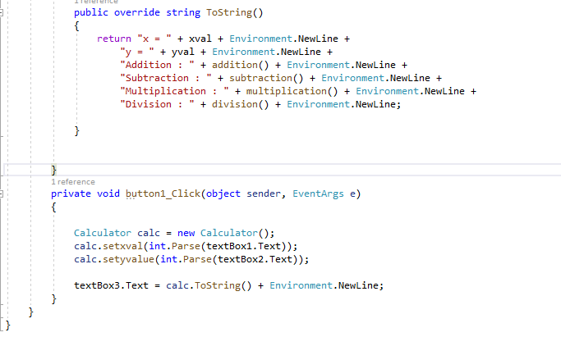

**OUTPUT:**

