**LAB # 8**

**OBJECTIVES**

To learn about use of different controls like buttons, text boxes, combo box and timer controls in C# applications and how to apply graphics and Mouse events.

**TASK – 1**

Create a simple C# that will place one combo box filled with the names of different shapes by using item property of combo box and application should be able to draw the selected shape of combo box control by creating graphic ,pen and solid brush objects.

**INPUT:**

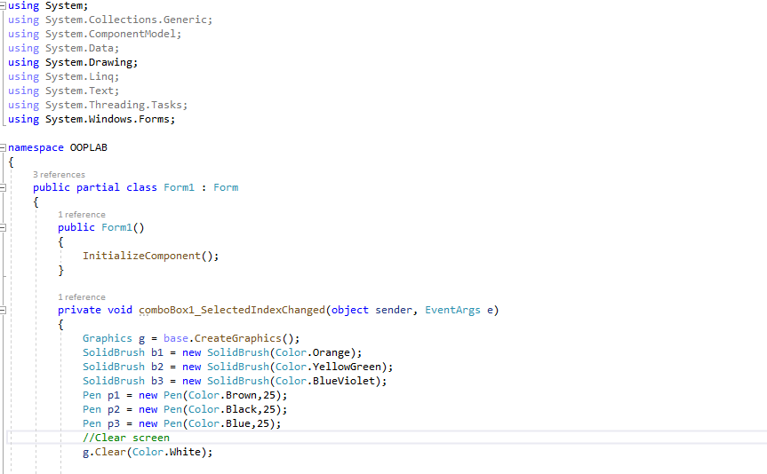

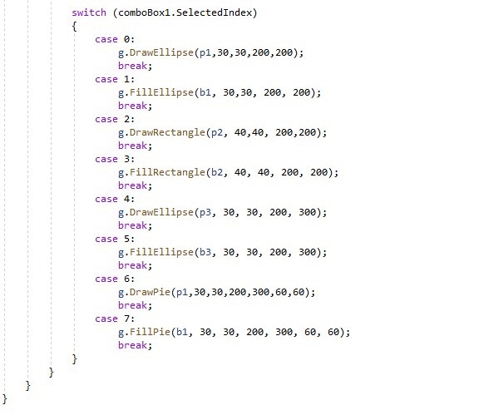

**OUTPUT:**

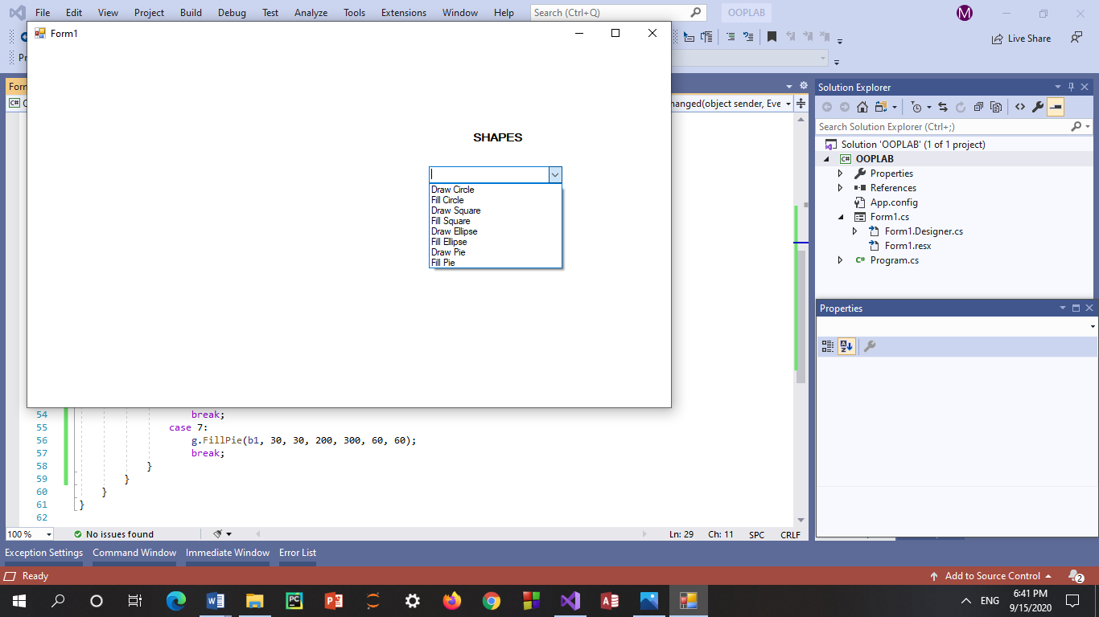

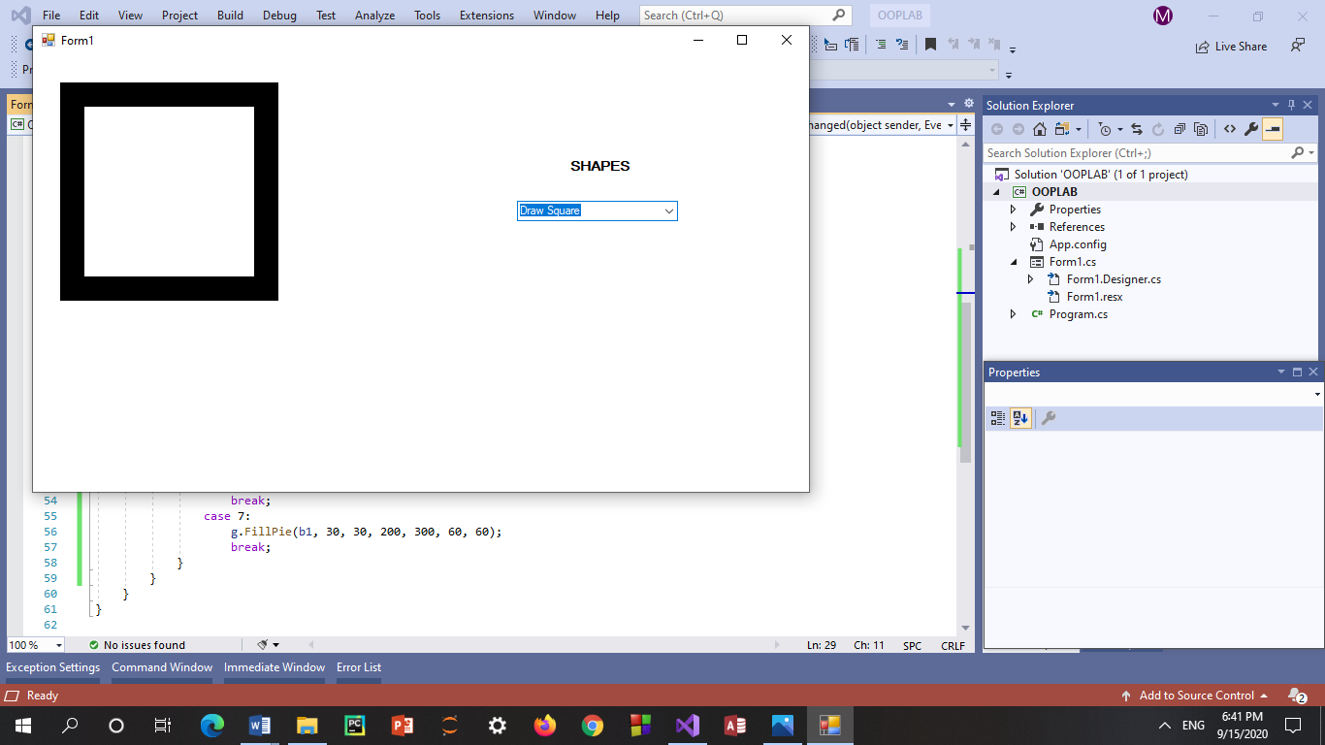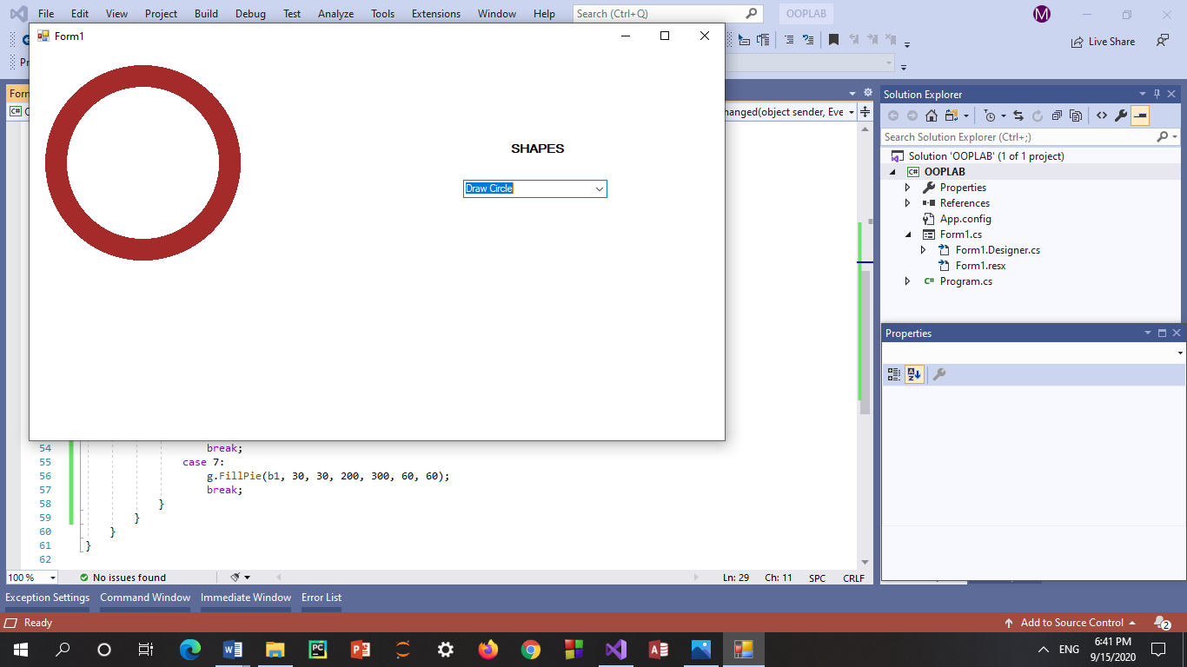

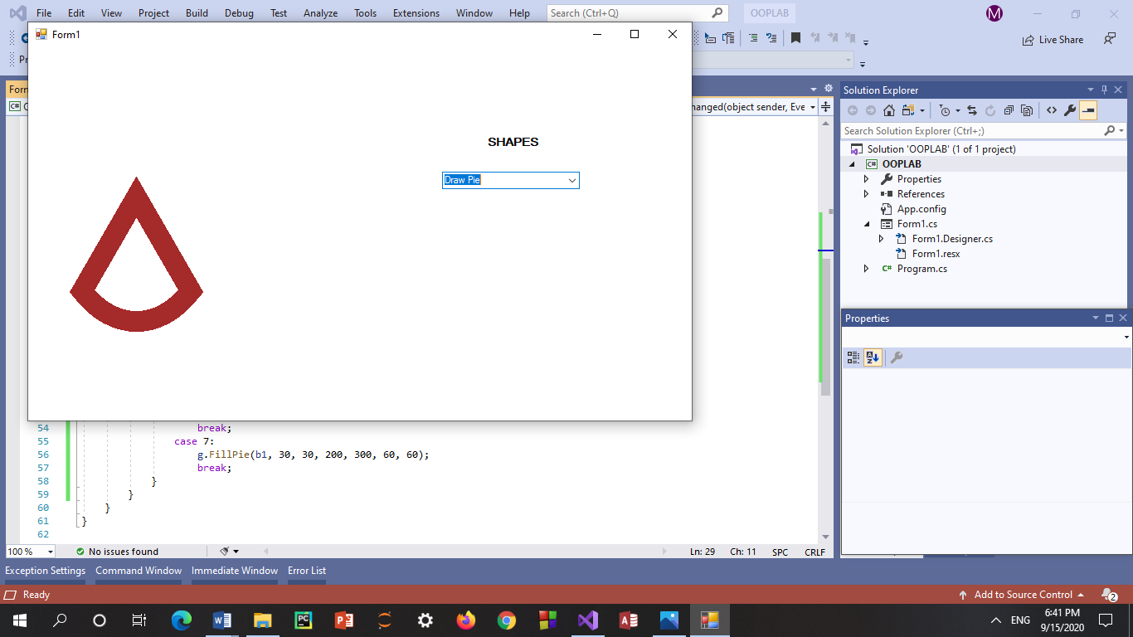

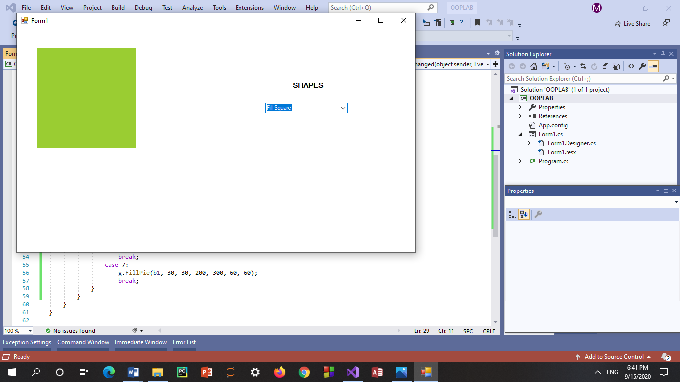

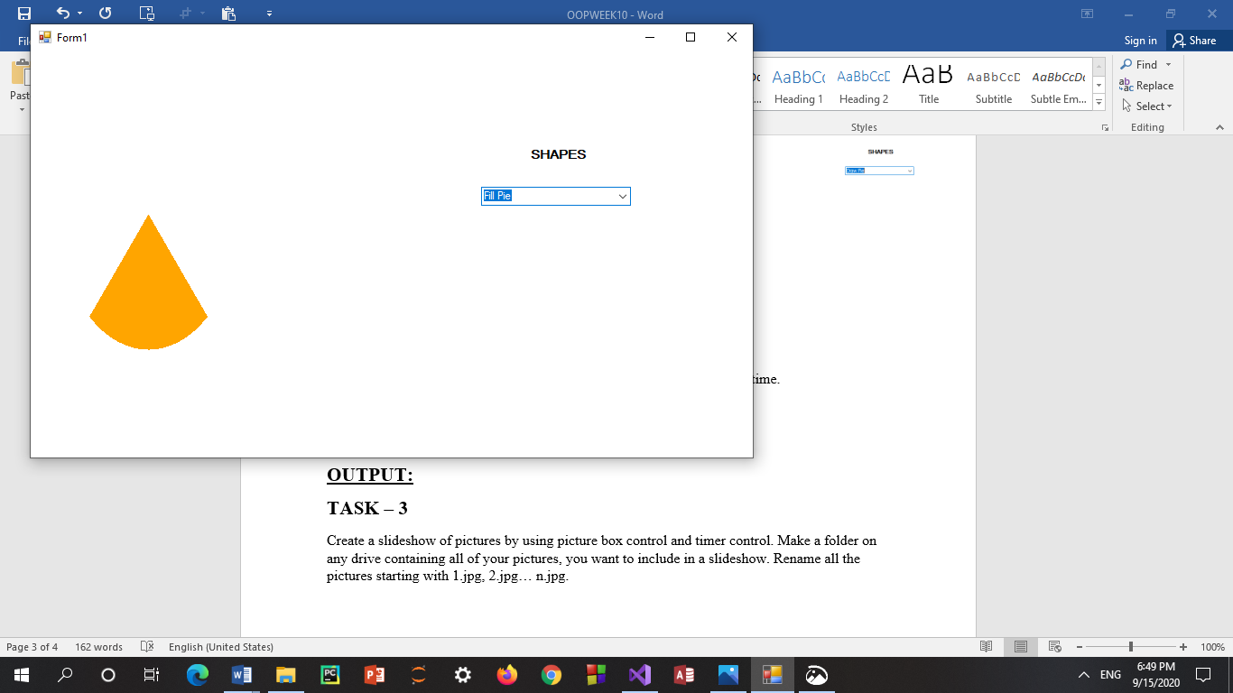

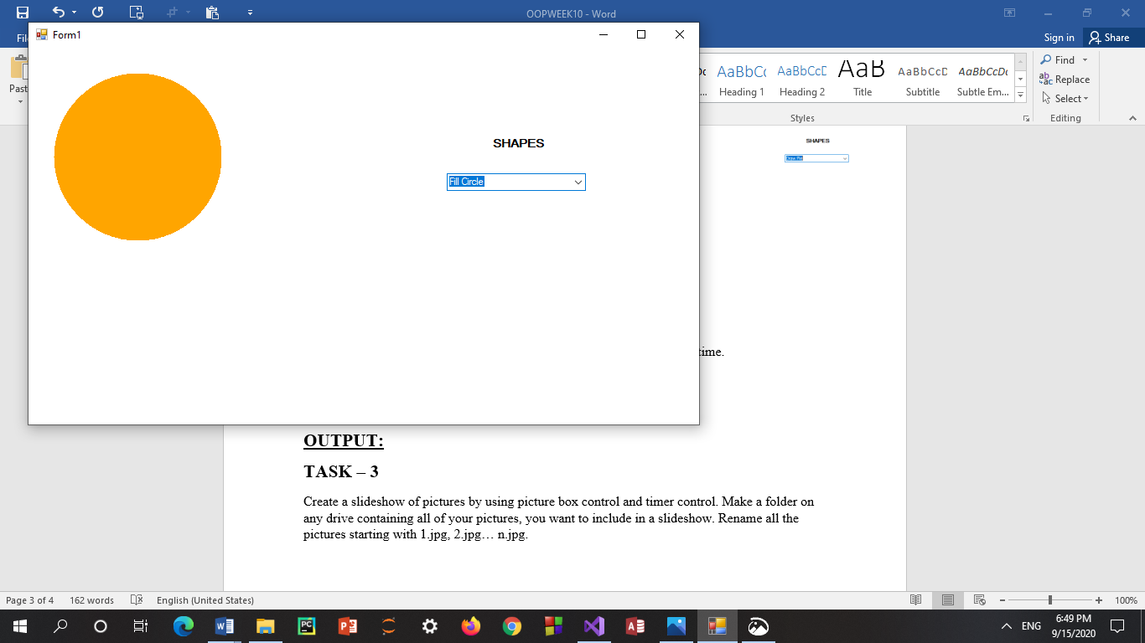

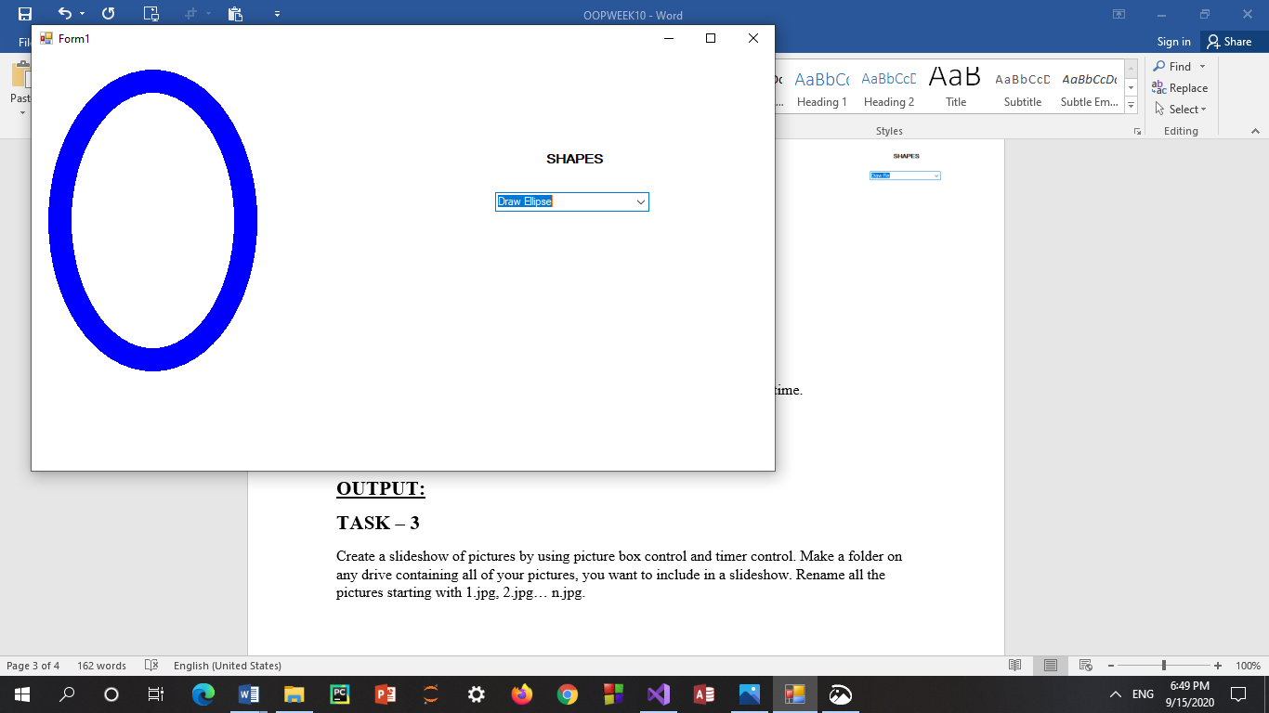

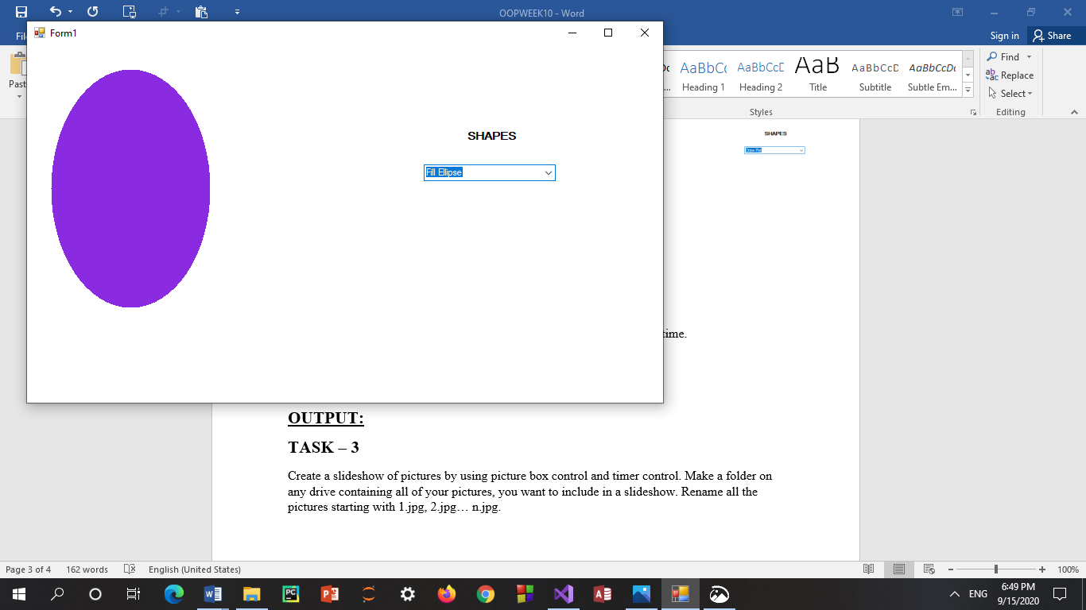

**TASK – 2**

Create an array of Buttons that would display buttons dynamically at run time.

**INPUT:**

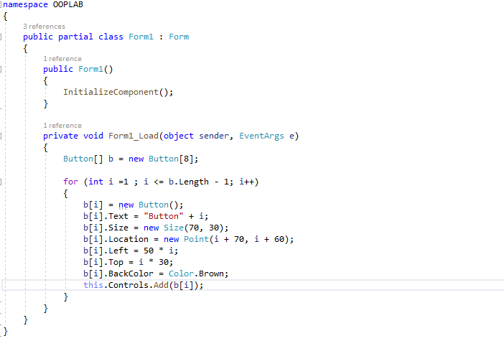

**OUTPUT:**

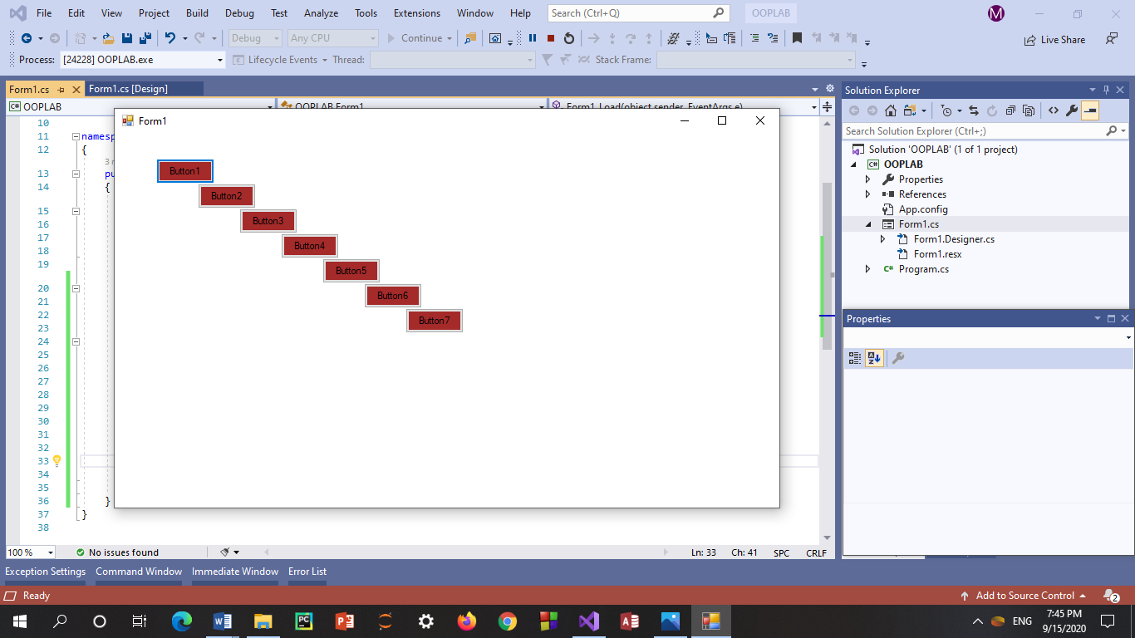

**TASK – 3**

Create a slideshow of pictures by using picture box control and timer control. Make a folder on any drive containing all of your pictures, you want to include in a slideshow. Rename all the pictures starting with 1.jpg, 2.jpg… n.jpg.

**INPUT:**

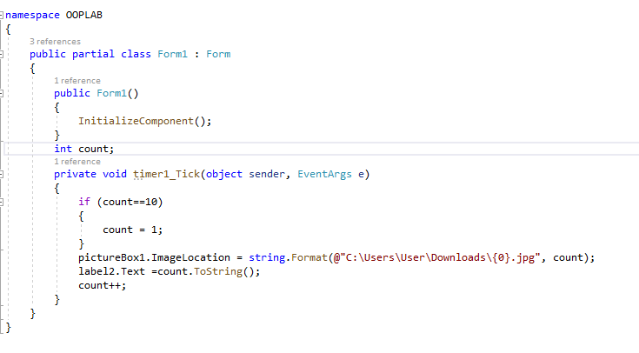

**OUTPUT:**

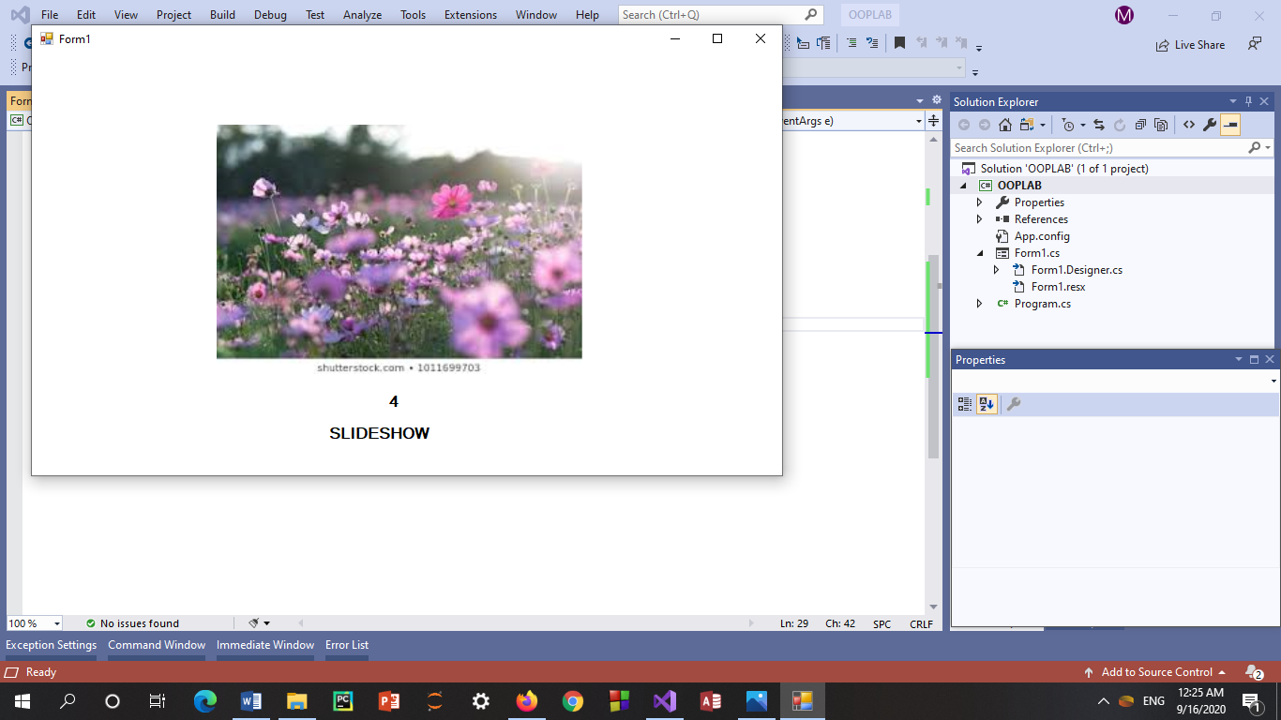

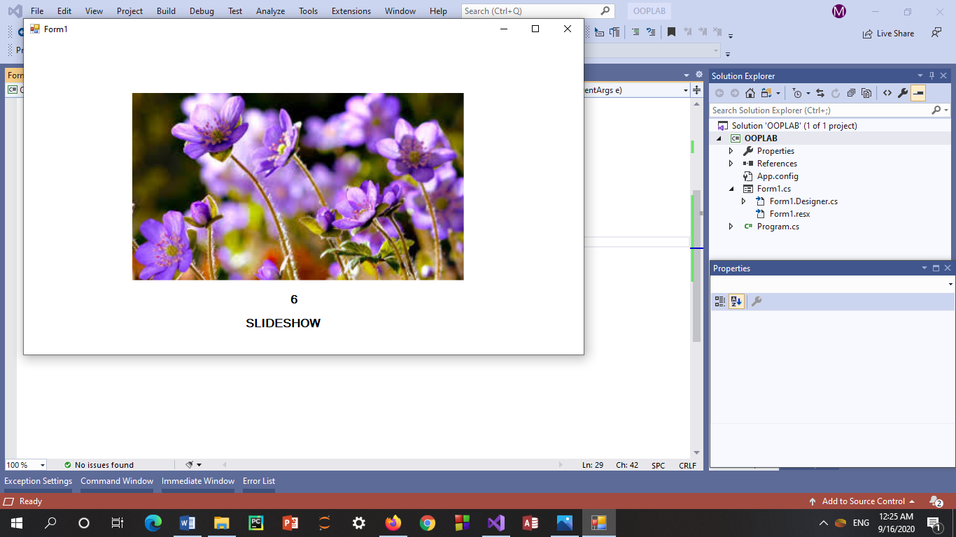

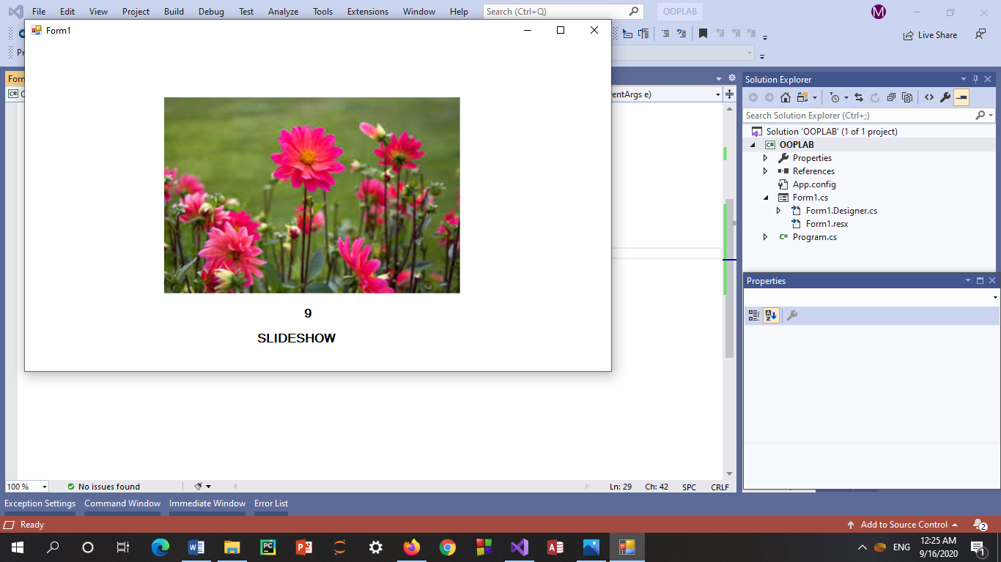

**TASK – 4**

Using Mouse up, down and Mouse move events. Create an application that can draw freehand drawing.

**INPUT:**

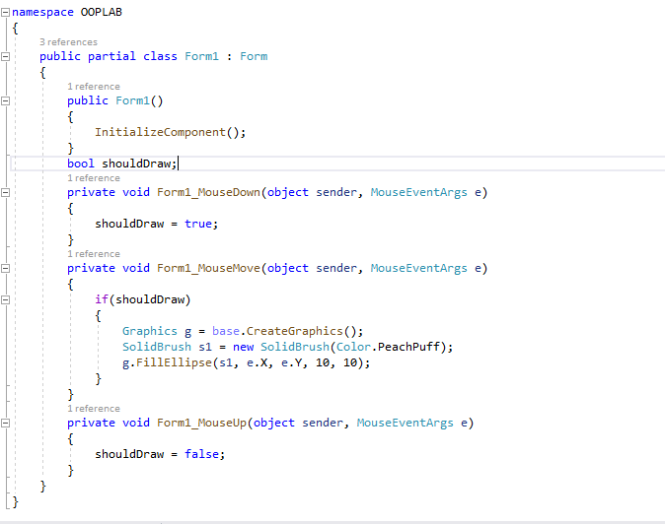

**OUTPUT:**

