**LAB # 9**

Q1: Create a teacher and student management system in C#. This simple application how to create database connectivity in C # application.

**Form #1**

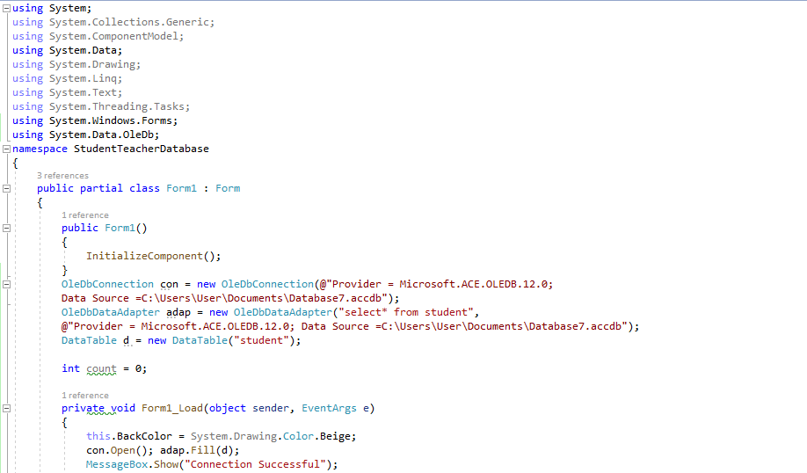

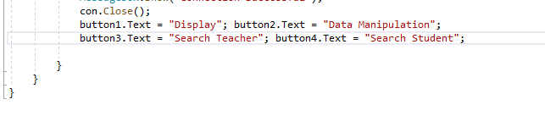

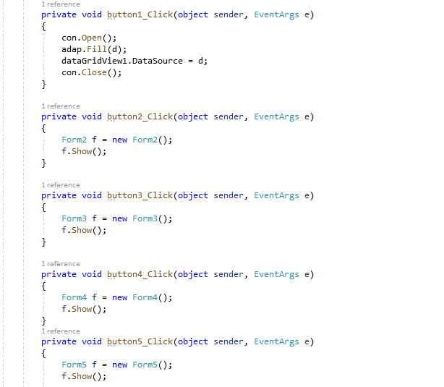

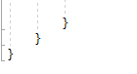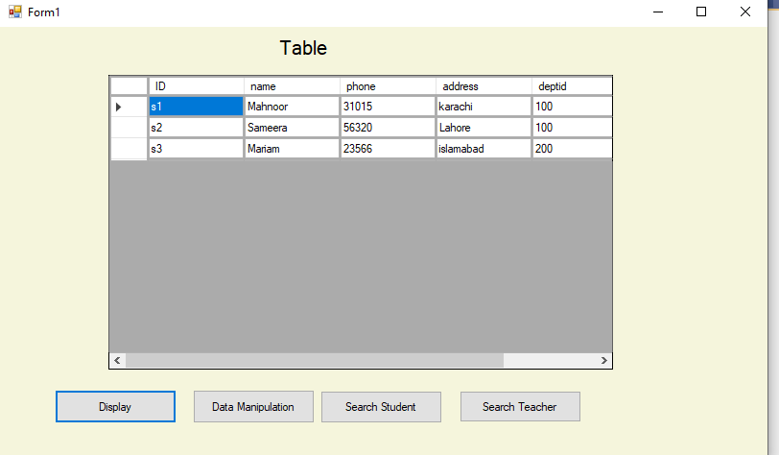

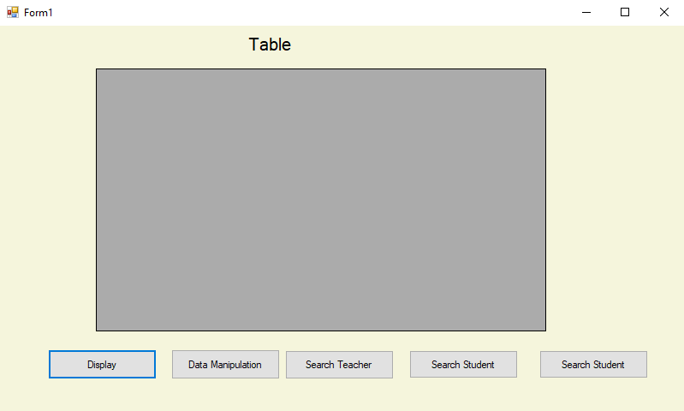

**FORM#2**

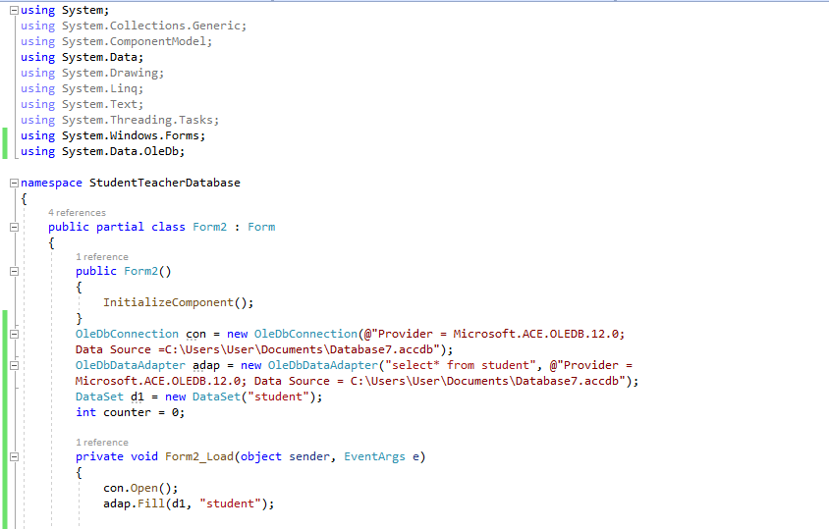

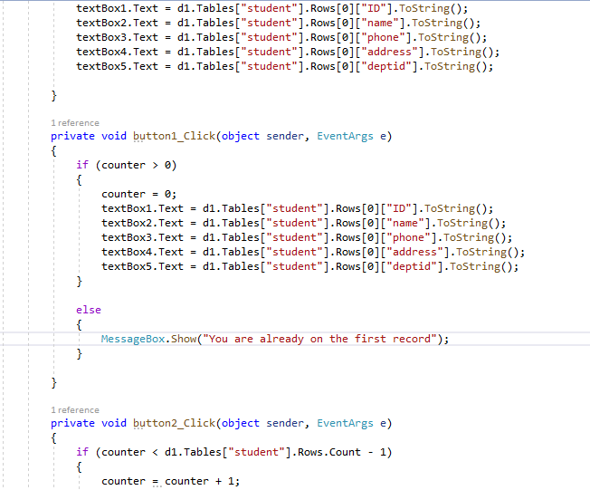

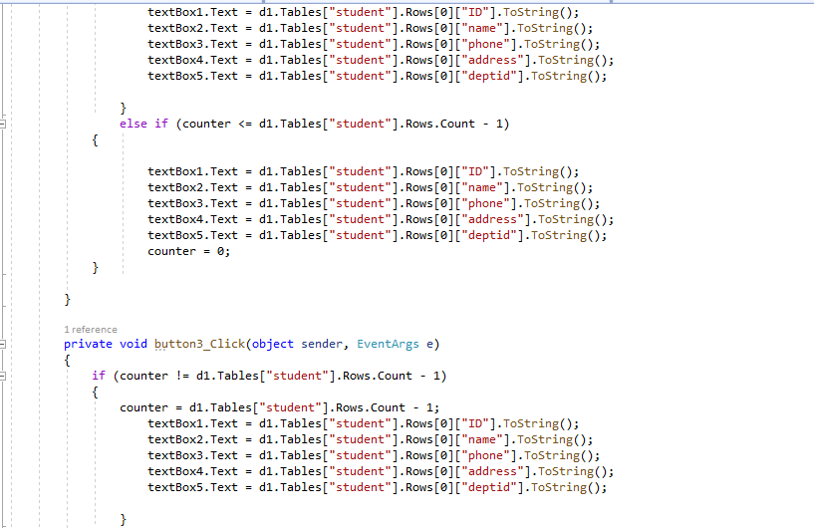



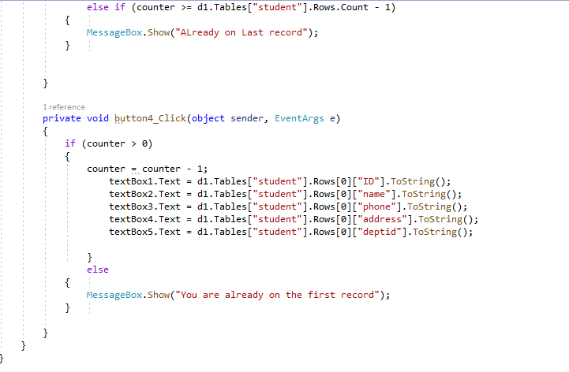

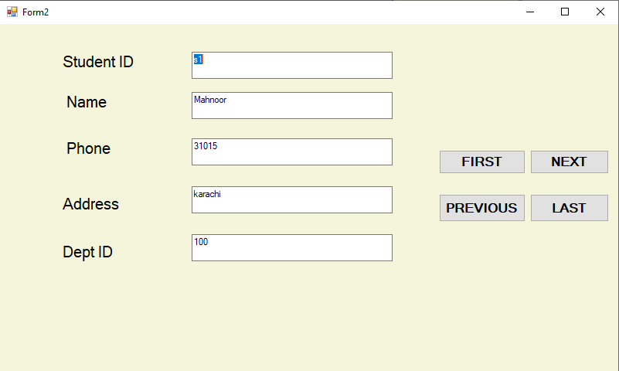

**FORM#3**

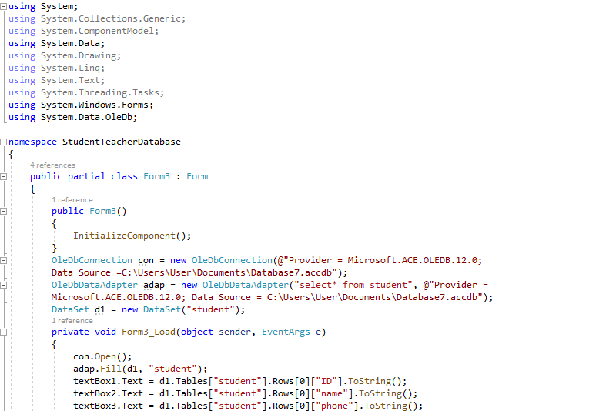

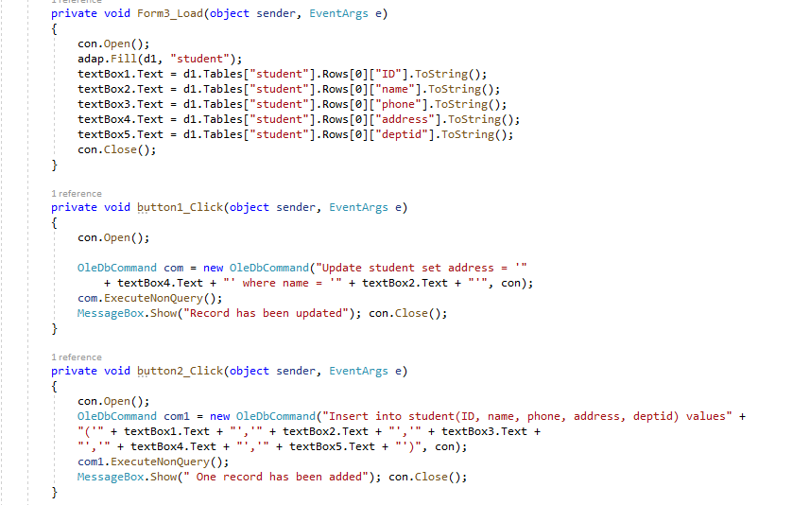

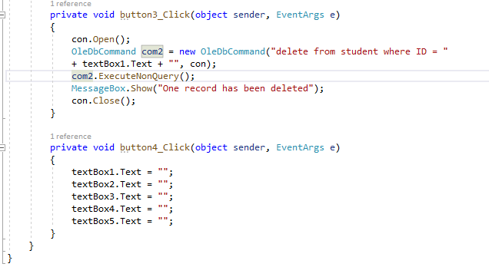

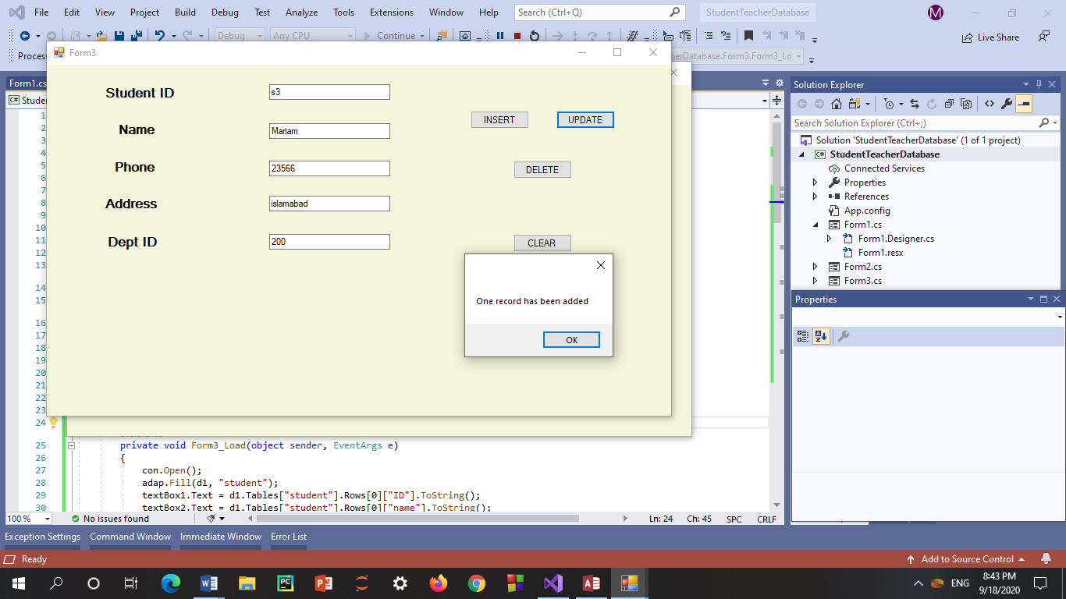

**Form#4**

using System;

using System.Collections.Generic;

using System.ComponentModel;

using System.Data;

using System.Drawing;

using System.Linq;

using System.Text;

using System.Threading.Tasks;

using System.Windows.Forms;

using System.Data.OleDb;

namespace StudentTeacherDatabase

{

public partial class Form4 : Form

{

public Form4()

{

InitializeComponent();

}

OleDbConnection con = new OleDbConnection(@"Provider = Microsoft.ACE.OLEDB.12.0;

Data Source =C:\Users\User\Documents\Database7.accdb");

OleDbDataAdapter adap = new OleDbDataAdapter("select* from student", @"Provider =

Microsoft.ACE.OLEDB.12.0; Data Source = C:\Users\User\Documents\Database7.accdb");

DataSet d1 = new DataSet("student");

private void Form4_Load(object sender, EventArgs e)

{

con.Open();

comboBox1.DropDownStyle = ComboBoxStyle.DropDownList;

OleDbCommand com = new OleDbCommand("select name from student", con);

OleDbDataReader d1 = com.ExecuteReader(); while (d1.Read())

{

string b = d1["name"].ToString(); comboBox1.Items.Add(b);

}

}

private void button1_Click(object sender, EventArgs e)

{

string b = comboBox1.Items[comboBox1.SelectedIndex].ToString();

OleDbDataAdapter adap = new OleDbDataAdapter("select student.name,Courses.coursename from Courses inner join student on Courses.cid = student.cid where name = '" + b + "'", con);

DataTable d2 = new DataTable("Courses");

adap.Fill(d2);

dataGrid1.DataSource = d2;

}

private void button2_Click(object sender, EventArgs e)

{

dataGrid1.DataSource = null;

}

}

}

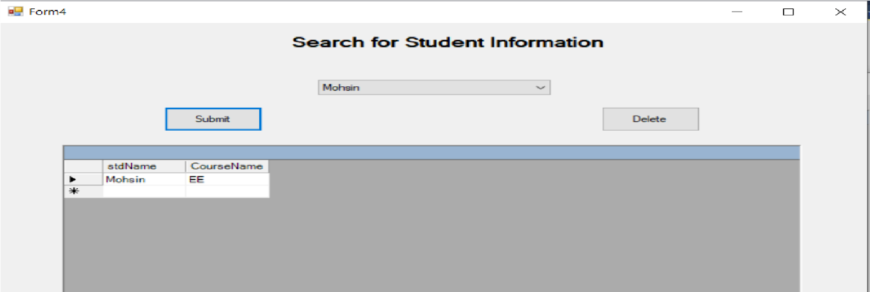

**Form#5**

using System;

using System.Collections.Generic;

using System.ComponentModel;

using System.Data;

using System.Drawing;

using System.Linq;

using System.Text;

using System.Threading.Tasks;

using System.Windows.Forms;

using System.Data.OleDb;

namespace StudentTeacherDatabase

{

public partial class Form5 : Form

{

public Form5()

{

InitializeComponent();

}

OleDbConnection con = new OleDbConnection(@"Provider = Microsoft.ACE.OLEDB.12.0;

Data Source =C:\Users\User\Documents\Database7.accdb");

OleDbDataAdapter adap = new OleDbDataAdapter("select* from student", @"Provider =

Microsoft.ACE.OLEDB.12.0; Data Source = C:\Users\User\Documents\Database7.accdb");

DataSet d1 = new DataSet("student");

private void Form5_Load(object sender, EventArgs e)

{

con.Open();

comboBox1.DropDownStyle = ComboBoxStyle.DropDownList;

OleDbCommand com = new OleDbCommand("select ename from emp", con);

OleDbDataReader d1 = com.ExecuteReader(); while (d1.Read())

{

string b = d1["ename"].ToString(); comboBox1.Items.Add(b);

}

}

private void comboBox1_SelectedIndexChanged(object sender, EventArgs e)

{

string c = comboBox1.Items[comboBox1.SelectedIndex].ToString();

OleDbDataAdapter adap = new OleDbDataAdapter("select

emp.ename, Courses.CourseName from Courses inner join emp on Courses.empno = emp.empno where ename = '" + c + "'", con);

DataTable d2 = new DataTable("Courses"); adap.Fill(d2);

dataGrid1.DataSource = d2;

}

private void button1_Click(object sender, EventArgs e)

{

this.Hide();

}

}

}

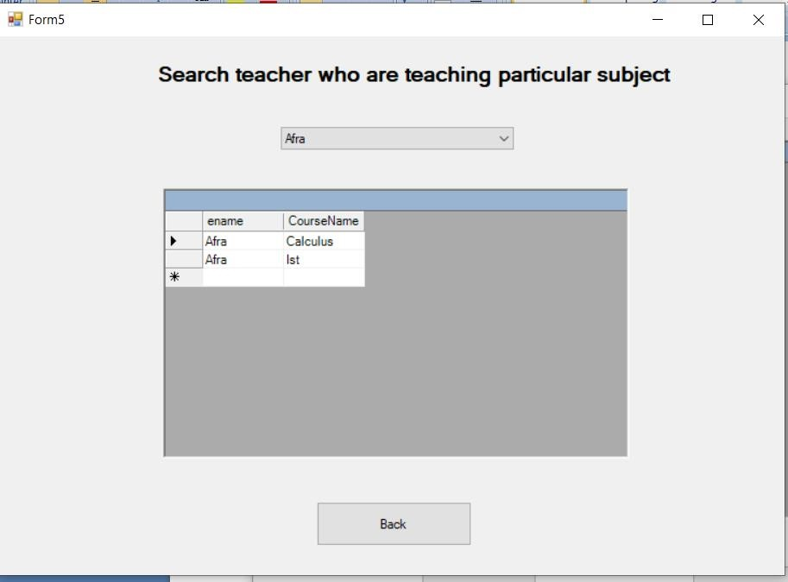

**RELATIONSHIPS:**

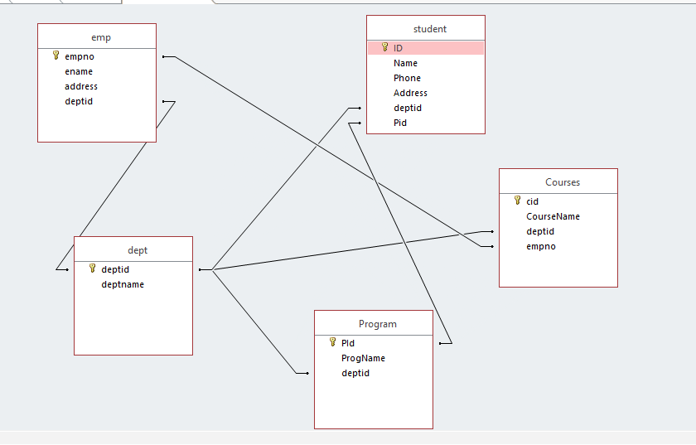

Q2: This database application demonstrates the use of ADO.Net classes usingAccess Database.

Steps:

1. For this example we have created MS-ACCESS database named Csharp1.mdb. The table structure for the bank table used in this example is show below: The properties of the fields are as follows a- AccountNo - Number - Long Integer b-Name - string c- BranchCode - int d-AccountType - int e- ATMReq - int f-Balance - Number – Decimal
2. Create a new Windows Application project. From toolbox’s Data tab, select OleDbDataAdapter component and configure it to establish connection with your database.
3. Design your GUI.
4. In this application, we will be working with individual data bound controls.
5. Select first Textbox control on your form.
6. Open DataBinding section on control’s Properties window, locate the Text item, and expand its list of possible settings. Select the one you want to display in your control.

**INPUT:**

using System;

using System.Collections.Generic;

using System.ComponentModel;

using System.Data;

using System.Drawing;

using System.Linq;

using System.Text;

using System.Threading.Tasks;

using System.Windows.Forms;

using System.Data.OleDb;

namespace StudentTeacherDatabase

{

public partial class Form1 : Form

{

public Form1()

{

InitializeComponent();

}

OleDbConnection con = new OleDbConnection(@"Provider = Microsoft.ACE.OLEDB.12.0; Data Source = D:\Csharp12.mdb");

OleDbDataAdapter adap = new OleDbDataAdapter("select* from bank", @"Provider =

Microsoft.ACE.OLEDB.12.0; Data Source = D:\Csharp12.mdb");

DataSet d1 = new DataSet("bank");

int counter = 0;

private void Form1_Load(object sender, EventArgs e)

{

this.BackColor = System.Drawing.Color.LawnGreen; string[] a = { "29039", "20492", "20549", "20954", "20482" };

comboBox1.Items.AddRange(a); con.Open();

adap.Fill(d1, "bank");

if (d1.Tables["bank"].Rows[0]["AccountType"].ToString() == "saving")

{

radioButton2.Checked = true;

}

else

{

radioButton1.Checked = true;

}

textBox1.Text = d1.Tables["bank"].Rows[counter]["AccountNo"].ToString();

textBox2.Text = d1.Tables["bank"].Rows[counter]["Name"].ToString();

textBox3.Text = d1.Tables["bank"].Rows[counter]["Balance"].ToString();

comboBox1.Text = d1.Tables["bank"].Rows[counter]["BranchCode"].ToString();

con.Close();

}

private void button6_Click(object sender, EventArgs e)

{

textBox1.Text = ""; textBox3.Text = "";

comboBox1.Text = ""; textBox2.Text = "";

radioButton1.Checked = false;

radioButton2.Checked = false;

checkBox1.Checked = false;

}

private void button5_Click(object sender, EventArgs e)

{

Application.Exit();

}

private void button1_Click(object sender, EventArgs e)

{

if (counter < d1.Tables["bank"].Rows.Count - 1)

{

counter = counter + 1;

textBox1.Text = d1.Tables["bank"].Rows[counter]["AccountNo"].ToString();

textBox2.Text = d1.Tables["bank"].Rows[counter]["Name"].ToString();

textBox3.Text = d1.Tables["bank"].Rows[counter]["Balance"].ToString();

comboBox1.Text = d1.Tables["bank"].Rows[counter]["BranchCode"].ToString();

if (d1.Tables["bank"].Rows[counter]["AccountType"].ToString() == "Saving")

{

radioButton2.Checked = true;

}

else

{

radioButton1.Checked = true;

}

if (d1.Tables["bank"].Rows[counter]["ATMreq"].ToString() == "True")

{

checkBox1.Checked = true;

}

else

{

checkBox1.Checked = false;

}

}

else

{

MessageBox.Show("You are already on last record");

}

}

private void button2_Click(object sender, EventArgs e)

{

if (counter > 0)

{

counter = counter - 1;

textBox1.Text = d1.Tables["bank"].Rows[counter]["AccountNo"].ToString();

textBox2.Text = d1.Tables["bank"].Rows[counter]["Name"].ToString();

textBox3.Text = d1.Tables["bank"].Rows[counter]["Balance"].ToString();

comboBox1.Text = d1.Tables["bank"].Rows[counter]["BranchCode"].ToString();

if (d1.Tables["bank"].Rows[counter]["AccountType"].ToString() == "Saving")

{

radioButton2.Checked = true;

}

else

{

radioButton1.Checked = true;

}

if (d1.Tables["bank"].Rows[counter]["ATMreq"].ToString() == "True")

{

checkBox1.Checked = true;

}

else

{

checkBox1.Checked = false;

}

}

else if (counter == 0)

{

MessageBox.Show("You are already on the first record");

}

}

private void button4_Click(object sender, EventArgs e)

{

con.Open();

OleDbCommand com = new OleDbCommand("Update bank set Balance='" + textBox3.Text + "' where AccountNo='" + textBox1.Text + "'", con);

int i = com.ExecuteNonQuery(); if (i > 0)

{

MessageBox.Show(" One record has been updated");

}

else

{

MessageBox.Show(" Could not update");

}

con.Close();

}

string AccountType = string.Empty;

private void button3_Click(object sender, EventArgs e)

{

con.Open();

OleDbCommand com1 = new OleDbCommand("Insert into bank(AccountNo,Name, BranchCode, Balance, ATMreq, AccountType) values('" + textBox1.Text + "', '" + textBox2.Text + "', '" + comboBox1.Text + "', '" + textBox3.Text + "', '"+checkBox1.Checked+"', @AccountType)", con);

com1.Parameters.AddWithValue("@AccountType", AccountType); int i = com1.ExecuteNonQuery(); if (i > 0)

{

MessageBox.Show(" One record has been added");

}

else

{

MessageBox.Show(" Could not update");

}

con.Close();

}

private void radioButton1_CheckedChanged(object sender, EventArgs e)

{

AccountType = "Current";

}

private void radioButton2_CheckedChanged(object sender, EventArgs e)

{

AccountType = "Saving";

}

}

}

**OUTPUT:**

