INDUSTRIAL PROJECT REPORT
ON
Intent Classification
A report submitted in partial fulfilment of the requirement for the award of
The degree of
BACHELOR OF TECHNOLOGY
In
COMPUTER SCIENCE AND ENGINEERING


Submitted By:-
Name :Deepak Mehra
ROLL NO. : 170102102
Batch : 2017-2021

Department of Information Technology
DIT UNIVERSITY, DEHRADUN
(State Private University through State Legislature Act No. 10 of 2013 of Uttarakhand and approved by UGC)
Mussoorie Diversion Road, Dehradun, Uttarakhand - 248009, India.
2019

DECLARATION

I hereby certify that the work, which is being presented in the project report, entitled Intent Classification, in partial fulfilment of the requirement for the award of the Degree of Bachelor of Technology and submitted to the institution is an authentic record of my/It’s own work carried out during the period 27th May 2019 to 19th July 2019 under the supervision of Mrs. Anjali Thakur.

Date: 19th July 2019

ACKNOWLEDGEMENT

The internship opportunity I had with Genpact, was a great chance for learning and professional development. Therefore, I consider myself as a very lucky individual as I was provided with an opportunity to be a part of it. I am also grateful for having a chance to meet so many wonderful people and professionals who led me through this internship period.
Bearing in mind, I am using this opportunity to express my deepest gratitude and special thanks to my Supervisor Ms. Anjali Thakur who in spite of being extraordinarily busy with her duties, took time out to hear, guide and keep me on the correct path and allowing me to carry out my project at this esteemed organization and extending during the training.
I express my deepest thanks to Ms. Subha Singh, my Project Manager for taking part in useful decision & giving necessary advices and guidance. I choose this moment to acknowledge her contribution gratefully.
It is my radiant sentiment to place on record my best regards, deepest sense of gratitude to Ms. Riva Singh, Manager Human Resources, for her guidance since day one. Her immense contribution in providing the necessary valuables was a boon for me.
I perceive this opportunity as a big milestone in my career development. I will strive to use gained skills and knowledge in the best possible way, and I will continue to work on their improvement in order to attain desired career objectives. Hope to continue cooperation with all of you in the future.
Sincerely,
Deepak Mehra
Date: 19th May 2019
ABSTRACT
This Report presents the brief description of my Summer Project done by me at Genpact with the Machine Learning team of the corporation.
The project is entitled as Intent Classification which is an important component of Natural Language Understanding.
This project comprises of various modules from Data Preprocessing to building machine learning models for training and testing data in order to obtain the required result.
Over all this project was an immense source of learning for me and I really enjoyed doing this project.


TABLE OF CONTENT
CHAPTER PAGE
Chapter 1 -- Organization Overview 1
1.1. Introduction 1
1.2. Services provided by company 3
Chapter 2 –Introduction to Project 4
Chapter 3 – Modules of the Project 7
Chapter 4- Implementation Details 29
Chapter 5 – Screen Shots 33
Chapter 6 – Conclusion 39
Chapter 7 – Future scope 40
Bibliography 42
Abbreviations 43

LIST OF FIGURES
FIGURE NAME PAGE
F1. Human Natural Language Understanding 2
F2. Data Engineering Pipeline 8
F3. Document Frequency Diagram 16
F4 .Output Encoding 17
F5. K-means Clustering 19
F6. Topic Modelling 21
F7.LDA matrix 22
F8. LDA matrix 23
F9. LDA Architecture 24
F10.Formal Definition of LDA 24
F11.RAW Dataset 34
F12. Processed Data 34
F13.Tf-IDF top values and score 34
F14.Count Vectorizer Top Values and Score 35
F15. Clusters Before Running the Model 35
F16.Elbow Graph 35
F17.Clusters After running K-means model 36
F18.LDA visualization 36
F19.Pie Chart of Categories 37
F20. Bar Graph of Categories 37
F21.Comarision of Various Models 38
F22.Accuracy of various models 38
F23.Confusion Matrix 39
F24.Classification Report 39

Chapter 1
Organization Overview
Introduction
Genpact (NYSE: G) is an American professional services firm headquartered in New York City, New York.
Genpact began in 1997 as a unit within General Electric. Its charter was to provide business process services to GE's businesses. During the eight years that followed, Genpact began to manage a wide range of processes across GE's financial services and manufacturing businesses.
In January 2005, the company became independent and began to serve clients outside of GE. The company name, Genpact, is designed to convey the business impact it generates for its clients. In August 2007, Genpact was listed on the NYSE under the symbol 'G'. Since then the company has grown from 32,000 employees and revenue of US$823 million, to 77,000+ employees and revenues of US$2.57 billion (2016).
In 2009, Genpact launched a joint venture with an Indian company NDTV to offer outsourcing services for the media industry. It was fully funded by Keyur Patel of Fuse.
Bain Capital became the firm's largest shareholder in October 2012.
In February 2019, Genpact contractors in Hyderabad who were assigned content moderation tasks for Facebook reportedly experienced psychological trauma while evaluating videos depicting suicide, torture, terrorism, and pornography.

Products

In June 2017, Genpact announced Genpact Cora, an artificial intelligence (AI)-based platform for enterprises. The platform has an application program interface (API) design and open architecture that includes Genpact’s own intellectual property as well as other providers. Genpact Cora's claimed benefits include deciphering large chunks of data, seamless customer service, faster financial reporting, and increasing speed to market.

Genpact completed the acquisition of Endeavour Software Technologies, an enterprise mobility software company, based out of Austin TX, in April 2016.

Acquisition

In August 2017, Genpact acquired TandemSeven, a Boston-headquartered company.

Genpact then acquired OnSource in September 2017. OnSource, headquartered in Braintree, Mass., is a provider of an Inspection-as-a-Service (IaaS) product for property and casualty (P&C) insurance carriers and their customers. OnSource uses technologies such as real-time browser-based communication, self-service applications, and drones to put consumers in control of their insurance claims.

On 18 July 2018, Genpact signed an agreement to acquire Barkawi Management Consultants, a leading supply chain management firm with operations in the U.S. and Europe that is part of the Barkawi Group.

Management

On 17 June 2011, NV “Tiger” Tyagarajan became the president and chief executive officer (CEO) of Genpact and was appointed to the Board of Directors. He had served as chief operating officer of Genpact. He succeeded Pramod Bhasin, who stepped down as CEO and member of the board and became non-executive vice chairman of the company.

Tyagarajan had been CEO of Genpact from 1999 to 2002, when he led the business through a critical growth phase as a subsidiary of GE. When Genpact became an independent company, he rejoined Genpact from GE Capital U.S. as executive vice president of sales and business development from 2005 to 2009. Thereafter, he took on the role of Genpact’s chief operating officer.

Services Provided By Company
Genpact provides a plethora services catering to all facets of a business. Ranging from Procurement and Supply Chain Solutions to Risk and Compliance, Genpact has professionals dedicated to providing the very best services in their respective domains. Mentioned below are a few umbrella services that are provided by the company.
- Analytics
- Automation
- Customer Experience
- Industrial Internet of Things
- Order Management
- Source to Pay
- Supply Chain Management
- Anti-Corruption Monitor
- Fraud and Disputes
- Regulatory Affairs
- Third Party Risk Manager
- Commercial Lending and Leasing
- Collections
- Mortgage Services
- Onboarding and Activation
- Property and Casualty Claims Management
- Property and Casualty Underwriting
- Wealth Management
- Trade Promotions Management
- Accounts Payable
- Enterprise Performance Management
- F&A Multi-Tower Consulting
- Invoice to Cash

CHAPTER 2
Introduction To Project
Natural Language Understanding
NLU is an artificial intelligence language that uses computer software to recognize text or speech sentences.
The NLU provides a direct human-computer interaction. The NLU allows human languages to be understood statically by the computer without the use of if / else. The purpose of the NLU system is to interpret a text.

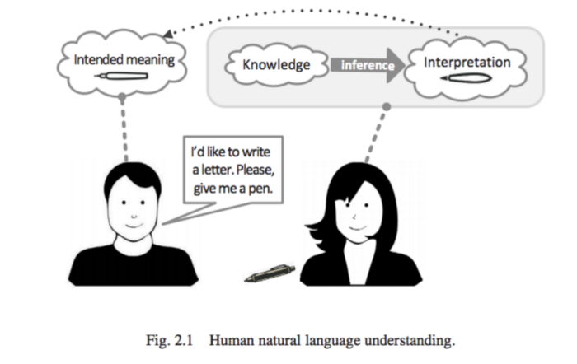
F1
The Natural Language Understanding (NLU) covers one of AI’s complex challenges. NLU is used by speech agents, including Alexa, Siri, and Google Assistant. The NLU can digest the spoken text such as “What is the weather forecast for tomorrow?” And then one day later, it can understand the forecast weather at that location as a request.
NLU usage areas can be listed as follows.
- In social media interactions
- During the course of product recommendation
- In creating profiles of content
- In financial estimates

The problems that NLU systems deal with can be listed as follows:
- Ambiguities on the subject: The data may not be mathematically meaningful since it is textual data.
- Not complete data: Since the content of the textual content depends on the exact nature of the data, it also poses difficulties in modeling.
- The data is ambiguous: Due to the fact that textual data is not numerical, it is difficult to make meaning from texts precisely.

The important systems from the NLU service provider.
- IBM Watson Conversation
- API.ai API
- Microsoft LUIS
- Amazon Lex
- Recast.ai API
- wit.ai API
- SNIPS API

Intent Classification
There are a lot of applications that require text classification or we can say intent classification. Nowadays, everything is required to be categorized like contents; products are often tagged by category.
However, the vast majority of text classification articles and tutorials on the internet are binary text classification such as email spam filtering (spam vs. ham), sentiment analysis (positive vs. negative). Our real-world problem is much more complicated than that. This Project deals with multiple categorical Classes and hence will provide you a walk through, through the Classification of the text into multiple categories.
Intent classification is an important component of Natural Language Understanding (NLU) systems in any Chabot platform.
The best way to understand it by taking an example:
So as I said it is an important component of Chabot platform and as we all know that chat bots are more like assistant for us in our daily lives. So say you have an assistant and you tell him/her to ‘book you a cab’. Now here your assistant knows how to respond for that query of yours because he/she has brain that trained for this. But how will you train your Chabot to respond for a particular query. So in case of chat bots, to make them respond according to the users query we uses “intent classification” and the categories in which a Chabot respond these are known as “intents”.
So say you asked for booking a cab then it will respond under that category and if you asked for booking a flight then it will respond under that category and so on.

CHAPTER 3
Modules of the Project
- Data Preparation
  - Stemming and Lemmatization
- Encoding
  - Input Encoding/ Text Representation
  - Output Encoding
- Unsupervised Machine Learning
  - K-means Clustering
- Topic Modeling
  - Latent Dirichlet Allocation
- Train and Validation Set
- Defining Model
- Conclusion
Data Preparation
Data preparation is the process of cleaning and transforming raw data prior to processing and analysis. It is an important step prior to processing and often involves reformatting data, making corrections to data and the combining of data sets to enrich data.
Data preparation is often a lengthy undertaking for data professionals or business users, but it is essential as a prerequisite to put data in context in order to turn it into insights and eliminate bias resulting from poor data quality.

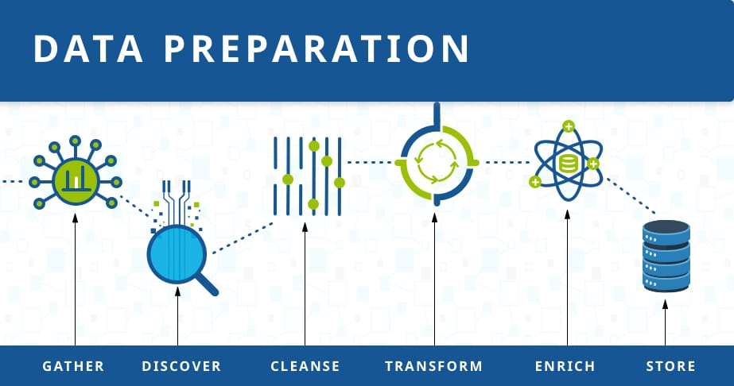
F2

Gather Data

The data preparation process begins with finding the right data. This can come from an existing data catalog or can be added ad-hoc.In our case Data was the HTML body of Emails provided by the company.

2. Discover and Assess Data
After collecting the data, it is important to discover each dataset. This step is about getting to know the data and understanding what has to be done before the data becomes useful in a particular context.
3. Cleanse and Validate Data
Cleaning up the data is traditionally the most time consuming part of the data preparation process, but it’s crucial for removing faulty data and filling in gaps. Important tasks here include:
- Removing extraneous data and outliers.
- Filling in missing values.
- Conforming data to a standardized pattern.
- Masking private or sensitive data entries.
Once data has been cleansed, it must be validated by testing for errors in the data preparation process up to this point. Often times, an error in the system will become apparent during this step and will need to be resolved before moving forward.

4. Transform and enrich data
Transforming data is the process of updating the format or value entries in order to reach a well-defined outcome, or to make the data more easily understood by a wider audience. Enriching data refers to adding and connecting data with other related information to provide deeper insights.

5. Store data
Once prepared, the data can be stored or channeled into a third party application—such as a business intelligence tool—clearing the way for processing and analysis to take place.
Stemming and Lemmatization
For grammatical reasons, documents are going to use different forms of a word, such as organize, organizes, and organizing. Additionally, there are families of derivationally related words with similar meanings, such as democracy, democratic, and democratization. In many situations, it seems as if it would be useful for a search for one of these words to return documents that contain another word in the set.
The goal of both stemming and lemmatization is to reduce inflectional forms and sometimes derivationally related forms of a word to a common base form. For instance:
am, are, is be
car, cars, car's, cars' car
The result of this mapping of text will be something like:
the boy's cars are different colours the boy car be differ colour
However, the two words differ in their flavour.
Stemming usually refers to a crude heuristic process that chops off the ends of words in the hope of achieving this goal correctly most of the time, and often includes the removal of derivational affixes.
Lemmatization usually refers to doing things properly with the use of a vocabulary and morphological analysis of words, normally aiming to remove inflectional endings only and to return the base or dictionary form of a word, which is known as the lemma. If confronted with the token saw, stemming might return just s, whereas lemmatization would attempt to return either see or saw depending on whether the use of the token was as a verb or a noun. The two may also differ in that stemming most commonly collapses derivationally related words, whereas lemmatization commonly only collapses the different inflectional forms of a lemma. Linguistic processing for stemming or lemmatization is often done by an additional plug-in component to the indexing process, and a number of such components exist, both commercial and open-source.
The most common algorithm for stemming English, and one that has repeatedly been shown to be empirically very effective, is Porter's algorithm (Porter, 1980). The entire algorithm is too long and intricate to present here, but we will indicate its general nature. Porter's algorithm consists of 5 phases of word reductions, applied sequentially. Within each phase there are various conventions to select rules, such as selecting the rule from each rule group that applies to the longest suffix. In the first phase, this convention is used with the following rule group:
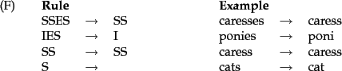

Many of the later rules use a concept of the measure of a word, which loosely checks the number of syllables to see whether a word is long enough that it is reasonable to regard the matching portion of a rule as a suffix rather than as part of the stem of a word. For example, the rule:
(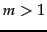) EMENT
would map replacement to replac, but not cement to c.

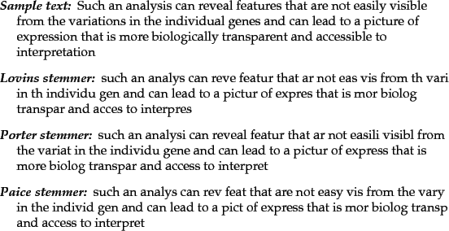
Above figure presents an informal comparison of the different behaviours of these stemmers. Stemmers use language-specific rules, but they require less knowledge than a lemmatizer, which needs a complete vocabulary and morphological analysis to correctly lemmatize words. Particular domains may also require special stemming rules. However, the exact stemmed form does not matter, only the equivalence classes it forms.
Rather than using a stemmer, you can use a lemmatizer, a tool from Natural Language Processing which does full morphological analysis to accurately identify the lemma for each word. Doing full morphological analysis produces at most very modest benefits for retrieval. It is hard to say more, because either form of normalization tends not to improve English information retrieval performance in aggregate - at least not by very much. While it helps a lot for some queries, it equally hurts performance a lot for others. Stemming increases recall while harming precision.

Encoding
Text Representation
Recalling that, in order to represent our text, every row of the dataset will be a single document of the corpus. The columns (features) will be different depending of which feature creation method we choose:
- Word Count Vectors
With this method, every column is a term from the corpus, and every cell represents the frequency count of each term in each document.
- TF–IDF Vectors
TF-IDF is a score that represents the relative importance of a term in the document and the entire corpus. TF stands for Term Frequency, and IDF stands for Inverse Document Frequency:

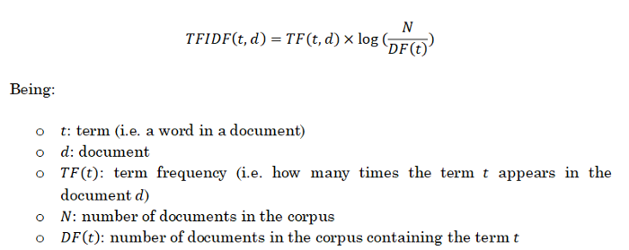
The TF-IDF value increases proportionally to the number of times a word appears in the document and is offset by the number of documents in the corpus that contain the word, which helps to adjust for the fact that some words appear more frequently in general.
It also takes into account the fact that some documents may be larger than others by normalizing the TF term (expressing instead relative term frequencies).
These two methods (Word Count Vectors and TF-IDF Vectors) are often named Bag of Words methods, since the order of the words in a sentence is ignored. The following methods are more advanced as they somehow preserve the order of the words and their lexical considerations.
- Word Embeddings
The position of a word within the vector space is learned from text and is based on the words that surround the word when it is used. Word embeddings can be used with pre-trained models applying transfer learning.
- Text based or NLP based features
We can manually create any feature that we think may be of importance when discerning between categories (i.e. word density, number of characters or words, etc…).
We can also use NLP based features using Part of Speech models, which can tell us, for example, if a word is a noun or a verb, and then use the frequency distribution of the PoS tags.
- Topic Models
Methods such as Latent Dirichlet Allocation try to represent every topic by a probabilistic distribution over words, in what is known as topic modeling.
We have chosen TF-IDF vectors to represent the documents in our corpus. This election is motivated by the following points:
- TF-IDF is a simple model that yields great results in this particular domain, as we will see later.
- TF-IDF features creation is a fast process, which will lead us to shorter waiting time for the user when using the web application.
- We can tune the feature creation process to avoid issues like overfitting.
When creating the features with this method, we can choose some parameters:
- N-gram range: we are able to consider unigrams, bigrams, trigrams…
- Maximum/Minimum Document Frequency: when building the vocabulary, we can ignore terms that have a document frequency strictly higher/lower than the given threshold.
- Maximum features: we can choose the top N features ordered by term frequency across the corpus.
We have chosen the following parameters:

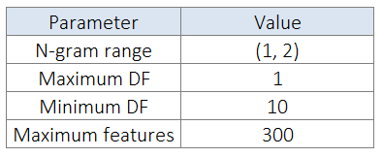
F3
We expect that bigrams help to improve our model performance by taking into consideration words that tend to appear together in the documents. We have chosen a value of Minimum DF equal to 10 to get rid of extremely rare words that don’t appear in more than 10 documents, and a Maximum DF equal to 100% to not ignore any other words. The election of 300 as maximum number of features has been made because we want to avoid possible over fitting, often arising from a large number of features compared to the number of training observations.
As we will see in the next sections, these values lead us to really high accuracy values, so we will stick to them. However, these parameters could be tuned in order to train better models.
There is one important consideration that needs to be mentioned. Recall that the calculation of TF-IDF scores needs the presence of a corpus of documents to compute the Inverse Document Frequency term. For this reason, if we wanted to predict a single news article at a time (for example once the model is deployed), we would need to define that corpus.
This corpus is the set of training documents. Consequently, when obtaining TF-IDF features from a new article, only the features that existed in the training corpus will be created for this new article.
It is straight to conclude that the more similar the training corpus is to the news that we are going to be scraping when the model is deployed, the more accuracy we will presumably get.
Output Encoding
Machine learning models require numeric features and labels to provide a prediction. For this reason we must create a dictionary to map each label to a numerical ID. We have created this mapping scheme:

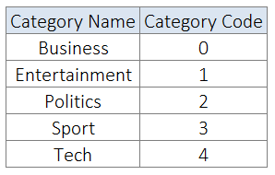
F4

Clustering
K-means Clustering
K-means clustering is a type of unsupervised learning, which is used when you have unlabeled data (i.e., data without defined categories or groups). The goal of this algorithm is to find groups in the data, with the number of groups represented by the variable K. The algorithm works iteratively to assign each data point to one of K groups based on the features that are provided. Data points are clustered based on feature similarity. The results of the K-means clustering algorithm are:
- The centroids of the K clusters, which can be used to label new data
- Labels for the training data (each data point is assigned to a single cluster)
Rather than defining groups before looking at the data, clustering allows you to find and analyze the groups that have formed organically. The "Choosing K" section below describes how the number of groups can be determined.
Each centroid of a cluster is a collection of feature values which define the resulting groups. Examining the centroid feature weights can be used to qualitatively interpret what kind of group each cluster represents.
Algorithm
The Κ-means clustering algorithm uses iterative refinement to produce a final result. The algorithm inputs are the number of clusters Κ and the data set. The data set is a collection of features for each data point. The algorithms starts with initial estimates for the Κ centroids, which can either be randomly generated or randomly selected from the data set. The algorithm then iterates between two steps:
Assignment step: Assign each observation to the cluster whose mean has the least squared Euclidean distance, this is intuitively the "nearest" mean.
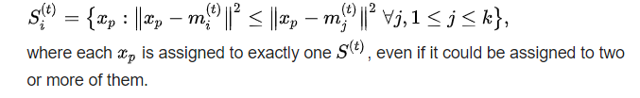

Update step: Calculate the new means (centroids) of the observations in the new clusters.
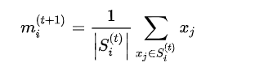
The algorithm iterates between steps one and two until a stopping criteria is met (i.e., no data points change clusters, the sum of the distances is minimized, or some maximum number of iterations is reached).
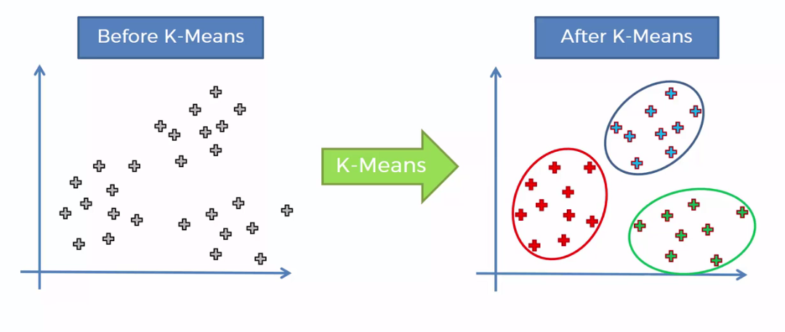
F5

This algorithm is guaranteed to converge to a result. The result may be a local optimum (i.e. not necessarily the best possible outcome), meaning that assessing more than one run of the algorithm with randomized starting centroids may give a better outcome.
Topic Modelling
In machine learning and natural language processing, a topic model is a type of statistical model for discovering the abstract "topics" that occur in a collection of documents. Topic modelling is a frequently used text-mining tool for discovery of hidden semantic structures in a text body. Intuitively, given that a document is about a particular topic, one would expect particular words to appear in the document more or less frequently: "dog" and "bone" will appear more often in documents about dogs, "cat" and "meow" will appear in documents about cats, and "the" and "is" will appear equally in both. A document typically concerns multiple topics in different proportions; thus, in a document that is 10% about cats and 90% about dogs, there would probably be about 9 times more dog words than cat words. The "topics" produced by topic modelling techniques are clusters of similar words. A topic model captures this intuition in a mathematical framework, which allows examining a set of documents and discovering, based on the statistics of the words in each, what the topics might be and what each document's balance of topics is.
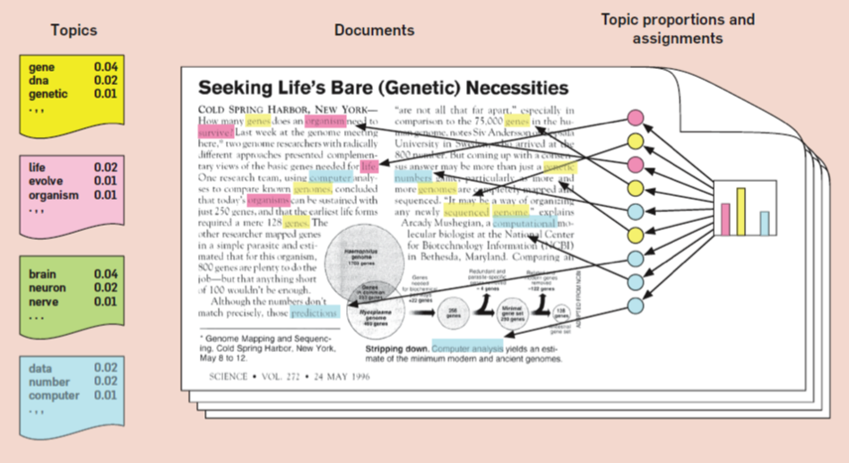
F6
Latent Dirichlet Allocation for Topic Modelling
Latent Dirichlet Allocation is the most popular topic modeling technique and in this article, we will discuss the same.
LDA assumes documents are produced from a mixture of topics. Those topics then generate words based on their probability distribution. Given a dataset of documents, LDA backtracks and tries to figure out what topics would create those documents in the first place.
LDA is a matrix factorization technique. In vector space, any corpus (collection of documents) can be represented as a document-term matrix. The following matrix shows a corpus of N documents D1, D2, D3 … Dn and vocabulary size of M words W1, W2 .. Wn. The value of i, j cell gives the frequency count of word Wj in Document Di.
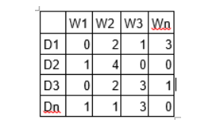
F7
LDA converts this Document-Term Matrix into two lower dimensional matrices – M1 and M2.
M1 is a document-topics matrix and M2 is a topic – terms matrix with dimensions (N, K) and (K, M) respectively, where N is the number of documents, K is the number of topics and M is the vocabulary size.
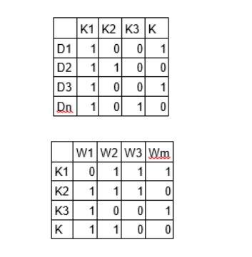
F8
Notice that these two matrices already provide topic word and document topic distributions, however, these distributions needs to be improved, which is the main aim of LDA. LDA makes use of sampling techniques in order to improve these matrices.
It iterates through each word “w” for each document “d” and tries to adjust the current topic – word assignment with a new assignment. A new topic “k” is assigned to word “w” with a probability P which is a product of two probabilities p1 and p2.
For every topic, two probabilities p1 and p2 are calculated. P1 – p (topic t / document d) = the proportion of words in document d that are currently assigned to topic t. P2 – p (word w / topic t) = the proportion of assignments to topic t over all documents that come from this word w.
The current topic – word assignment is updated with a new topic with the probability, product of p1 and p2. In this step, the model assumes that all the existing word – topic assignments except the current word are correct. This is essentially the probability that topic t generated word w, so it makes sense to adjust the current word’s topic with new probability.
After a number of iterations, a steady state is achieved where the document topic and topic term distributions are fairly good. This is the convergence point of LDA.
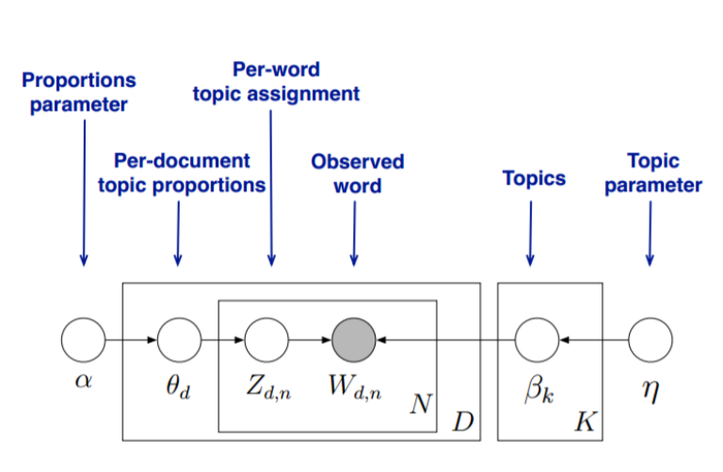
F9

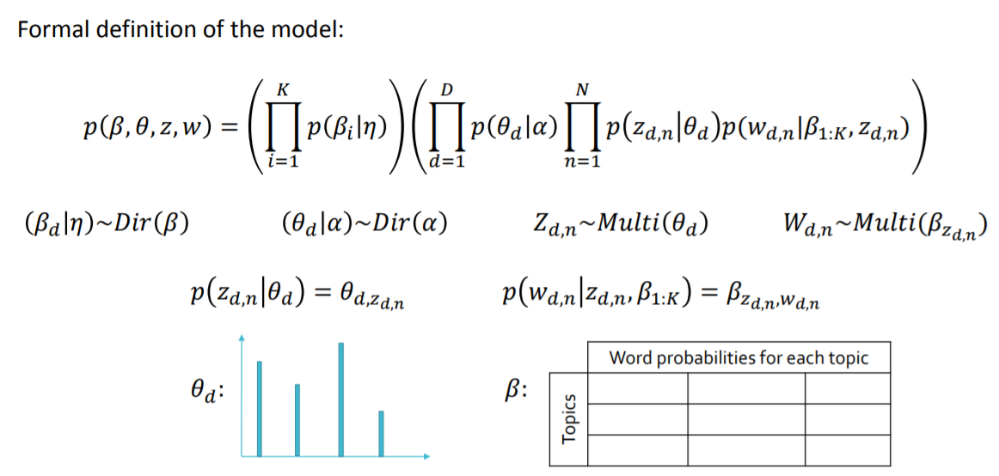
F10
Parameters of LDA
Alpha and Beta Hyper parameters – alpha represents document-topic density and Beta represents topic-word density. Higher the value of alpha, documents are composed of more topics and lower the value of alpha, documents contain fewer topics. On the other hand, higher the beta, topics are composed of a large number of words in the corpus, and with the lower value of beta, they are composed of few words.
Number of Topics – Number of topics to be extracted from the corpus. Researchers have developed approaches to obtain an optimal number of topics by using Kullback Leibler Divergence Score. I will not discuss this in detail, as it is too mathematical. For understanding, one can refer to this original paper on the use of KL divergence.
Number of Topic Terms – Number of terms composed in a single topic. It is generally decided according to the requirement. If the problem statement talks about extracting themes or concepts, it is recommended to choose a higher number, if problem statement talks about extracting features or terms, a low number is recommended.
Number of Iterations / passes – Maximum number of iterations allowed to LDA algorithm for convergence.

Training and Validation
In machine learning, a common task is the study and construction of algorithms that can learn from and make predictions on data. Such algorithms work by making data-driven predictions or decisions, through building a mathematical model from input data.
The data used to build the final model usually comes from multiple datasets. In particular, three data sets are commonly used in different stages of the creation of the model.
The model is initially fit on a training dataset, that is a set of examples used to fit the parameters (e.g. weights of connections between neurons in artificial neural networks) of the model. The model (e.g. a neural net or a naive Bayes classifier) is trained on the training dataset using a supervised learning method (e.g. gradient descent or stochastic gradient descent). In practice, the training dataset often consist of pairs of an input vector (or scalar) and the corresponding output vector (or scalar), which is commonly denoted as the target (or label). The current model is run with the training dataset and produces a result, which is then compared with the target, for each input vector in the training dataset. Based on the result of the comparison and the specific learning algorithm being used, the parameters of the model are adjusted. The model fitting can include both variable selection and parameter estimation.
Successively, the fitted model is used to predict the responses for the observations in a second dataset called the validation dataset. The validation dataset provides an unbiased evaluation of a model fit on the training dataset while tuning the model's hyper parameters (e.g. the number of hidden units in a neural network). Validation datasets can be used for regularization by early stopping: stop training when the error on the validation dataset increases, as this is a sign of over fitting to the training dataset. This simple procedure is complicated in practice by the fact that the validation dataset's error may fluctuate during training, producing multiple local minima. This complication has led to the creation of many ad-hoc rules for deciding when over fitting has truly begun.
Finally, the test dataset is a dataset used to provide an unbiased evaluation of a final model fit on the training dataset. If the data in the test dataset has never been used in training (for example in cross-validation), the test dataset is also called a holdout dataset.

k-Fold Cross Validation
Cross-validation is a resampling procedure used to evaluate machine learning models on a limited data sample.
The procedure has a single parameter called k that refers to the number of groups that a given data sample is to be split into. As such, the procedure is often called k-fold cross-validation. When a specific value for k is chosen, it may be used in place of k in the reference to the model, such as k=10 becoming 10-fold cross-validation.
Cross-validation is primarily used in applied machine learning to estimate the skill of a machine learning model on unseen data. That is, to use a limited sample in order to estimate how the model is expected to perform in general when used to make predictions on data not used during the training of the model.
It is a popular method because it is simple to understand and because it generally results in a less biased or less optimistic estimate of the model skill than other methods, such as a simple train/test split.
The general procedure is as follows:
- Shuffle the dataset randomly.
- Split the dataset into k groups
- For each unique group:
  - Take the group as a hold out or test data set
  - Take the remaining groups as a training data set
  - Fit a model on the training set and evaluate it on the test set
  - Retain the evaluation score and discard the model

Summarize the skill of the model using the sample of model evaluation scores
Importantly, each observation in the data sample is assigned to an individual group and stays in that group for the duration of the procedure. This means that each sample is given the opportunity to be used in the hold out set 1 time and used to train the model k-1 times.
Model Definition
Since our motive was to categorize the emails into 3 categories hence we used classification algorithms. The main Algorithm used in this project are:
- Logistic Regression
Logistic regression is a machine learning algorithm for classification. In this algorithm, the probabilities describing the possible outcomes of a single trial are modeled using a logistic function.
Advantages: Logistic regression is designed for this purpose (classification), and is most useful for understanding the influence of several independent variables on a single outcome variable.
Disadvantages: Works only when the predicted variable is binary, assumes all predictors are independent of each other, and assumes data is free of missing values.

- Support Vector Machines.
Support vector machine is a representation of the training data as points in space separated into categories by a clear gap that is as wide as possible. New examples are then mapped into that same space and predicted to belong to a category based on which side of the gap they fall.
Advantages: Effective in high dimensional spaces and uses a subset of training points in the decision function so it is also memory efficient.
Disadvantages: The algorithm does not directly provide probability estimates, these are calculated using an expensive five-fold cross-validation.
- Naïve Bayes Classifier.
Naive Bayes algorithm based on Bayes’ theorem with the assumption of independence between every pair of features. Naive Bayes classifiers work well in many real-world situations such as document classification and spam filtering.
Advantages: This algorithm requires a small amount of training data to estimate the necessary parameters. Naive Bayes classifiers are extremely fast compared to more sophisticated methods.
Disadvantages: Naive Bayes is is known to be a bad estimator.

- Random Forest Classifier.
Random forest classifier is a meta-estimator that fits a number of decision trees on various sub-samples of datasets and uses average to improve the predictive accuracy of the model and controls over-fitting. The sub-sample size is always the same as the original input sample size but the samples are drawn with replacement.
Advantages: Reduction in over-fitting and random forest classifier is more accurate than decision trees in most cases.
Disadvantages: Slow real time prediction, difficult to implement, and complex algorithm.

Chapter 4
Implementation Details
Data
The data used for this project was textual Data of invoice emails of a Spanish company called Kone ,which had 1 lakh emails that were to be classified into three categories namely status ,escalation and others.
However for prototype building and to get the insight of data only 8744 emails were chosen for the case.

Data Engineering
In order to retrieve most relevant information out of the data, the dataset was to be cleaned, for what Basic Pre-processing steps were followed and in order to sort out the relevant stuffs from the emails more than 20 Regex patterns were used to drop the words that had no correlation in category formation. Irrelevant columns were dropped out to make Dataset more precise and concise.
Text Preparation
After Data Engineering the emails were to converted in machine understandable code for which stemming and lemmatization was performed, and then using CountVectorizer and Tf-Idf the occurrence of word in One VS One was One VS all the document was tested.
K- means Clustering
Since we had to categorize the data we into different categories for behavioral analysis and out of curiosity we decided to check, the variance of Data and in how many categories could it be distributed upon.
In order to find out the suitable number of K in this process we made an elbow graph.After running the model successfully for k=6, we received the following output.
Topic Modeling Using LDA for Analyzing the Clusters.
In order to analyze the clusters Topic Modeling was performed using one of the most famous method called Latent Dirichlet Allocation and as a result top 20 topics were gained.However this information was not enough to categorize the data into 3 categorize ,hence an alternate method of manual labeling was choose and a New Data Frame was made that had 1000 manually labeled emails which were then used to label the next 500 emails and the process was continued. The process was performed till the considerable amount of data for training was not gathered.
Train and Validation Set
We need to set apart a test set in order to prove the quality of our models when predicting unseen data. We have chosen a random split with 85% of the observations composing the training test and 15% of the observations composing the test set. We will perform the hyper parameter tuning process with cross validation in the training data, fit the final model to it and then evaluate it with totally unseen data so as to obtain an evaluation metric as less biased as possible.
Defining Model
We have tested several machine learning models to figure out which one may fit better to the data and properly capture the relationships across the points and their labels. We have only used classic machine learning models instead of deep learning models because of the insufficient amount of data we have, which would probably lead to over fit models that don’t generalize well on unseen data.
We have tried the following models:
- Random Forest
- Support Vector Machine
- Multinomial Naïve Bayes
- Multinomial Logistic Regression
Each one of them has multiple hyper parameters that also need to be tuned. We have followed the following methodology when defining the best set of hyper parameters for each model:
Firstly, we have decided which hyper parameters we want to tune for each model, taking into account the ones that may have more influence in the model behavior, and considering that a high number of parameters would require a lot of computational time.
Then, we have defined a grid of possible values and performed a Randomized Search using 3-Fold Cross Validation (with 50 iterations). Finally, once we get the model with the best hyper parameters, we have performed a Grid Search using 3-Fold Cross Validation centered in those values in order to exhaustively search in the hyper parameter space for the best performing combination.
We have followed this methodology because with the randomized search we can cover a much wider range of values for each hyper parameter without incurring in really high execution time. Once we narrow down the range for each one, we know where to concentrate our search and explicitly specify every combination of settings to try.
The reason behind choosing 𝐾 = 3 as the number of folds and 50 iterations in the randomized search comes from the trade-off between shorter execution time or testing a high number of combinations. When choosing the best model in the process, we have chosen the accuracy as the evaluation metric.

Best Model Selection
Below we show a summary of the different models and their evaluation metrics.We choose the SVM classifier above the remaining models because it has highest accuracy. Applying Grid Search further increases the score upto 97% of Accuracy. The confusion matrix and the classification report of the SVM model are the following:

Chapter 5
Screen Shots
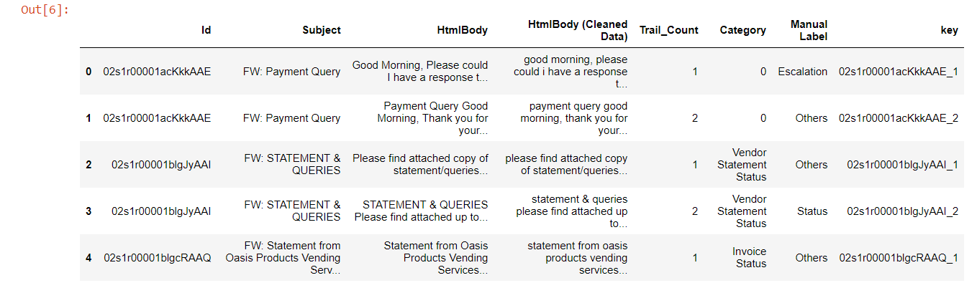
F11
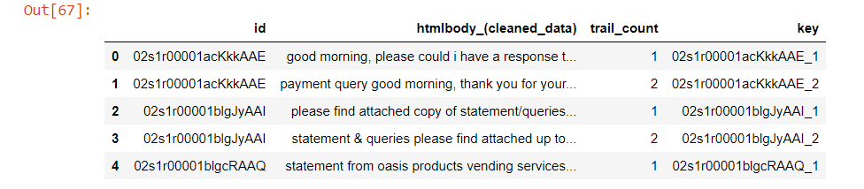
F12
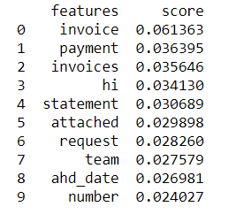
F13
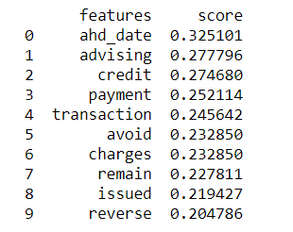
F14
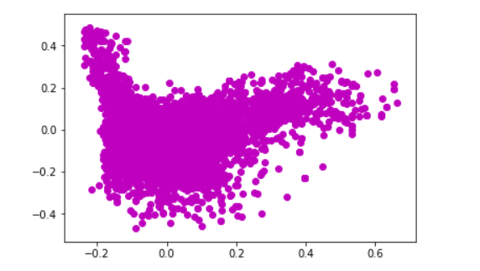
F15
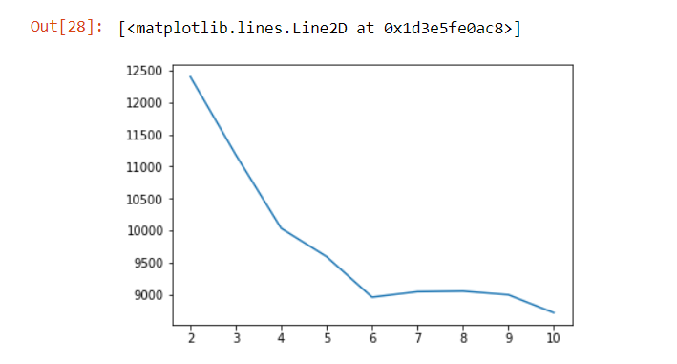
F16
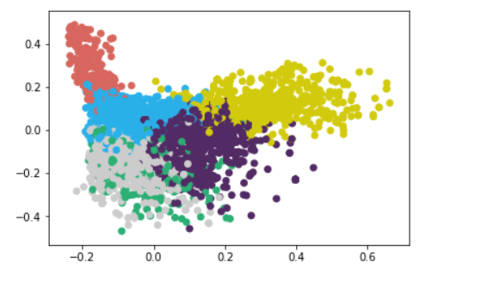
F17
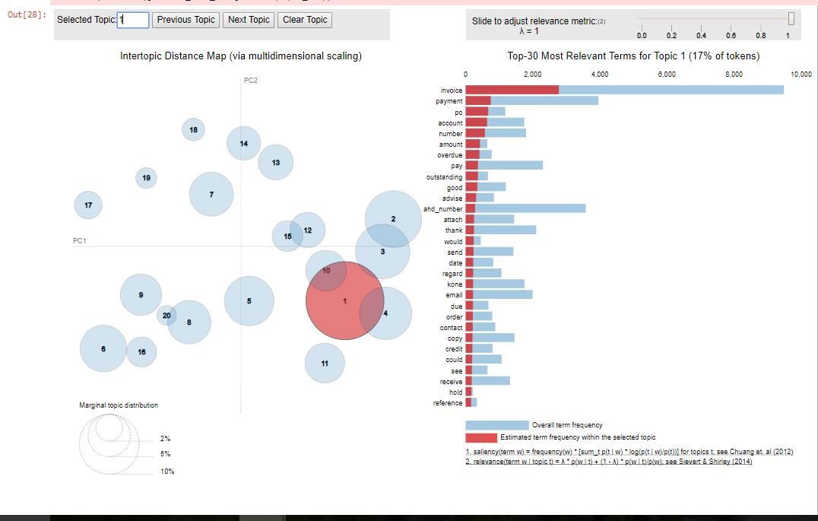
F18
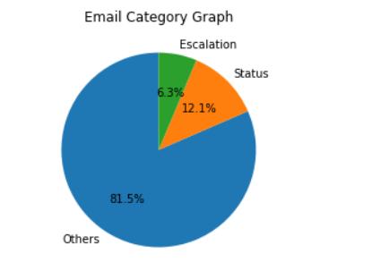
F19
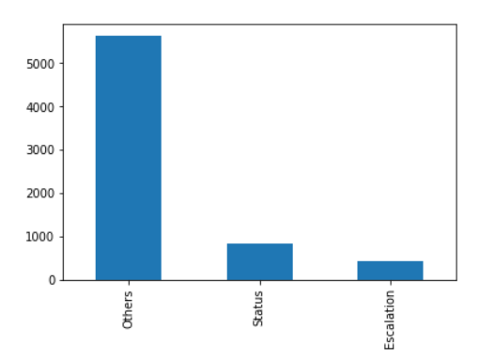
F20
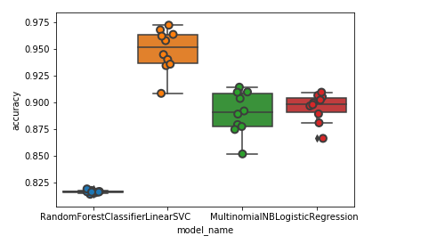
F21
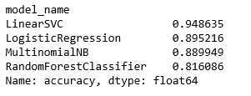
F22
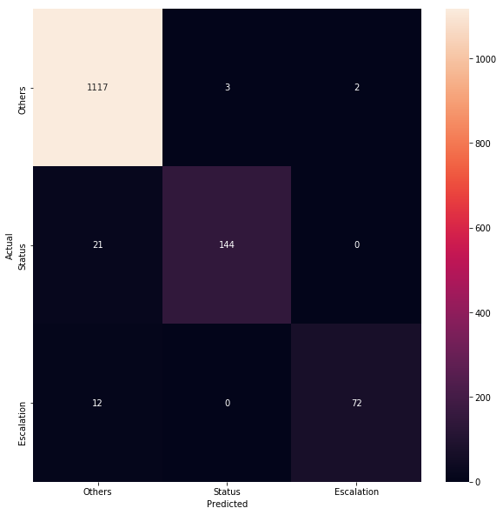
F23
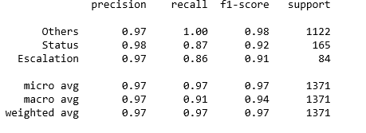
F24

Chapter 6
Conclusion
K-means clustering may be good for clustering the data, however it does not guarantee convergence of model.
Topic modeling is a nice way of retrieving the information from unsupervised formed clusters.
Among all the Classification Models for Textual data the best algorithm that outshines is SVM.
Support Vector Machine is the classification algorithm that outshines all the other algorithms and gives an accuracy of 94 % on testing Data.
On performing Grid Search for model optimization the accuracy increases up to 97%.

Chapter 7
Future Scope
Intent Classification is a powerful state of the art technique that can be used in future for making machine understand better human intention and intervention. It sets the foundation of the modern Chat Bot Development and provides an effective way of understanding complicated human language.Provided effective hardware and advanced Deep Learning highly efficient and effective deployment can be done in the field that could indeed prove themselves as boon in the tech firms.

Smarter search
The future of NLP is also for smarter search—something we’ve been talking about here at Expert System for a long time. Applied to search, the same capabilities that allow a Chabot to understand a customer’s request can enable “search like you talk” functionality (much like you could query Siri) rather than focusing on keywords or topics. Recently, Google announced that it has added NLP capabilities to Google Drive to allow users to search for documents and content using conversational language.

Intelligence from unstructured information
An understanding of human language is especially powerful when applied to extract information and reveal meaning and sentiment in large amounts of text content (aka unstructured information), especially the types of content that must be manually examined by people. Analysis that accurately understands the subtleties of language—the choice of words, the tone used—can provide useful knowledge and insight of information, especially in the carefully worded language of annual reports, call transcripts and other investor-sensitive communications, as well as legal and compliance documents.

Supporting invisible UI
Human communication—both conversation and text—are part of most every interaction we have with machines. Amazon’s Echo is just one example of the move toward a future that puts humans more directly in contact with technology. The concept of an invisible or zero user interfaces will rely on direct interaction between user and machine, whether through voice, text or a combination of the two. NLP that leverages a greater contextual understanding of human language, in other words, as it gets better at understating us—what we say no matter how we say it, and what we are doing—will be essential for any invisible or zero UI application.

Bibliography
- https://www.genpact.com/
- https://scikit-learn.org/stable/model_selection.html
- https://www.kaggle.com/raymishra/intent-classification-for-email-data
- https://chatbotslife.com/know-your-intent-sota-results-in-intent-classification-8e1ca47f364c
- https://blog.rasa.com/rasa-nlu-in-depth-part-1-intent-classification/
- https://blog.vsoftconsulting.com/blog/intent-classification-and-its-significance-in-chatbot-development
- https://paperswithcode.com/task/intent-classification

Abbreviations

1) GE: General Electric’s.
2) NYSE: New York Stock Exchange
3) US: United State
4) AI: Artificial Intelligence
5) API: Application Program Interface
6) Iaas: Infrastructure as a Service
7) NLU: Natural Language Understanding
8) Tf-IDF: Term frequency–Inverse Document Frequency.
9) POS: Part of Speech
10) LDA: Latent Dirichlet Allocation
11) SVM: Support Vector Machine

