03-analysis

Lucky Mehra

9/18/2020

## Loading required package: pacman

## Study count by different categories

Study count by **Principal Investigator**.

## Parsed with column specification:  
## cols(  
## .default = col_character(),  
## year = col_double(),  
## marketable_loss = col_double(),  
## total_loss = col_double(),  
## yield_wf_num_1 = col_double(),  
## yield_wf_jumbo = col_double(),  
## yield_wf_canner = col_double(),  
## yield_weedy_num_1 = col_double(),  
## yield_weedy_jumbo = col_double(),  
## yield_weedy_canner = col_double(),  
## comment2 = col_logical(),  
## yield_wf_marketable = col_double(),  
## yield_wf_total = col_double(),  
## yield_weedy_marketable = col_double(),  
## yield_weedy_total = col_double()  
## )

## See spec(...) for full column specifications.

|  |  |
| --- | --- |
| pi | n |
| meyers | 53 |
| jennings | 37 |
| culpepper | 5 |
| vangessel | 4 |
| cohoon | 2 |
| cutulle | 1 |
| miller | 1 |

Study count by **sweetpotato variety**.

|  |  |
| --- | --- |
| variety | n |
| covington | 47 |
| beauregard | 45 |
| averre | 2 |
| evengaline | 2 |
| orleans | 2 |
| beauregard and covington | 1 |
| beauregard and orleans | 1 |
| hernandez | 1 |
| murasaki | 1 |
| NA | 1 |

Study count by **soil type**.

|  |  |
| --- | --- |
| soil_type | n |
| loamy_sand | 40 |
| silt_loam | 40 |
| sandy_loam | 22 |
| NA | 1 |

Study count by **primary weed type**.

|  |  |
| --- | --- |
| primary_weed | n |
| Palmer amaranth | 56 |
| Yellow nutsedge | 11 |
| Broadleaf signalgrass | 9 |
| Readroot pigweed | 6 |
| Redroot pigweed | 6 |
| Crabgrass | 3 |
| Goosegrass | 3 |
| Palmer | 2 |
| Palmer / C. ragweed | 2 |
| Carpetweed | 1 |
| Common barnyard grass | 1 |
| Common lambsquarters | 1 |
| Slender pigweed | 1 |
| NA | 1 |

Study count by **irrigation type**.

|  |  |
| --- | --- |
| irrigation_type | n |
| irri_overhead | 57 |
| non_irrigated | 45 |
| NA | 1 |

Study count by **location**.

|  |  |
| --- | --- |
| location | n |
| Clinton_NC | 47 |
| Pontotoc_MS | 34 |
| TyTy_GA | 5 |
| Faison_NC | 4 |
| Georgetown_DE | 4 |
| Houlka_MS | 3 |
| Houston_MS | 2 |
| PAINTER_VA | 2 |
| Blackville_SC | 1 |
| Chase_LA | 1 |

## Figures

Distribution of marketable yield loss across 103 studies.

Average marketable loss by **year**.

## `summarise()` ungrouping output (override with `.groups` argument)

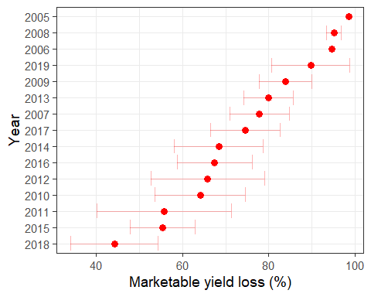

Average marketable loss by **location**.

## `summarise()` ungrouping output (override with `.groups` argument)

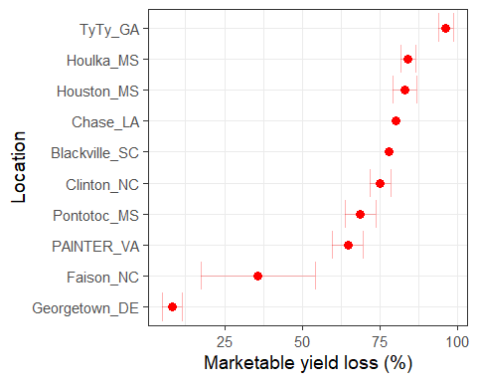

Average marketable loss by **variety**.

## `summarise()` ungrouping output (override with `.groups` argument)

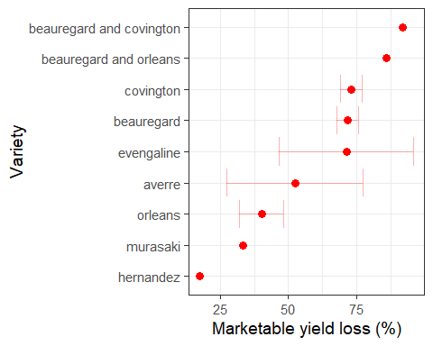

Average marketable loss by **primary weed**.

## `summarise()` ungrouping output (override with `.groups` argument)

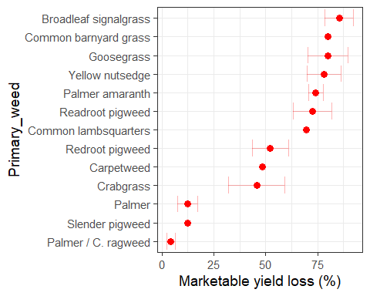

Average marketable loss by **soil type**.

## `summarise()` ungrouping output (override with `.groups` argument)

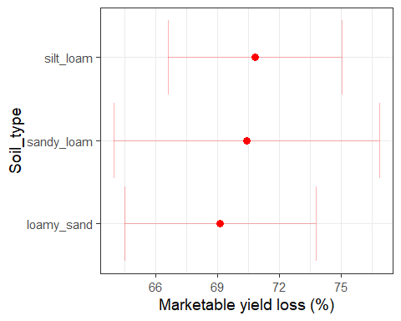

Average marketable loss by **irrigation type**.

## `summarise()` ungrouping output (override with `.groups` argument)

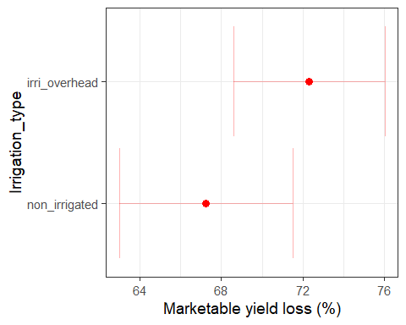

Create a table to report average marketable yield loss by state.

## `summarise()` ungrouping output (override with `.groups` argument)

state

marketable_loss

number_of_studies

North Carolina

71.98863

51

Mississippi

70.60329

39

Other States

60.08924

12

Louisiana

80.07080

1

Mege above table with sweetpotato production and area harvested data from USDA NASS.

## Parsed with column specification:  
## cols(  
## YEAR = col_double(),  
## LOCATION = col_character(),  
## `STATE ANSI` = col_double(),  
## `ASD CODE` = col_logical(),  
## `COUNTY ANSI` = col_logical(),  
## `REFERENCE PERIOD` = col_character(),  
## COMMODITY = col_character(),  
## `AREA HARVESTED in ACRES` = col_number(),  
## `AREA PLANTED in ACRES` = col_number(),  
## `PRODUCTION in $` = col_number(),  
## `PRODUCTION in CWT` = col_number(),  
## `YIELD in CWT / ACRE` = col_double(),  
## `PRICE RECEIVED in $ / CWT` = col_double()  
## )  
## Parsed with column specification:  
## cols(  
## YEAR = col_double(),  
## LOCATION = col_character(),  
## `STATE ANSI` = col_double(),  
## `ASD CODE` = col_logical(),  
## `COUNTY ANSI` = col_logical(),  
## `REFERENCE PERIOD` = col_character(),  
## COMMODITY = col_character(),  
## `AREA HARVESTED in ACRES` = col_number(),  
## `AREA PLANTED in ACRES` = col_number(),  
## `PRODUCTION in $` = col_number(),  
## `PRODUCTION in CWT` = col_number(),  
## `YIELD in CWT / ACRE` = col_double(),  
## `PRICE RECEIVED in $ / CWT` = col_double()  
## )  
## Parsed with column specification:  
## cols(  
## YEAR = col_double(),  
## LOCATION = col_character(),  
## `STATE ANSI` = col_double(),  
## `ASD CODE` = col_logical(),  
## `COUNTY ANSI` = col_logical(),  
## `REFERENCE PERIOD` = col_character(),  
## COMMODITY = col_character(),  
## `AREA HARVESTED in ACRES` = col_number(),  
## `AREA PLANTED in ACRES` = col_number(),  
## `PRODUCTION in $` = col_number(),  
## `PRODUCTION in CWT` = col_number(),  
## `YIELD in CWT / ACRE` = col_double(),  
## `PRICE RECEIVED in $ / CWT` = col_double()  
## )

## Parsed with column specification:  
## cols(  
## YEAR = col_double(),  
## LOCATION = col_character(),  
## `STATE ANSI` = col_logical(),  
## `ASD CODE` = col_logical(),  
## `COUNTY ANSI` = col_logical(),  
## `REFERENCE PERIOD` = col_character(),  
## COMMODITY = col_character(),  
## `AREA HARVESTED in ACRES` = col_number(),  
## `AREA PLANTED in ACRES` = col_number(),  
## `PRODUCTION in $` = col_number(),  
## `PRODUCTION in CWT` = col_number(),  
## `YIELD in CWT / ACRE` = col_double(),  
## `PRICE RECEIVED in $ / CWT` = col_double()  
## )

## value for "which" not specified, defaulting to c("rows", "cols")

## Joining, by = "state"

State

Marketable loss (%)

Loss in $s

Loss in cwt1

Number of studies

Harvested (acres)

Production in $s

Production in CWT

Yield (cwt/acre)

Louisiana

80.1

35231150

1761558

1

8300

44000000

2200000

265

Mississippi

70.6

57824096

3212450

39

26000

81900000

4550000

175

North Carolina

72.0

188294912

7911551

51

78500

261562000

10990000

140

Other States

60.1

40133603

1400680

12

10300

66790000

2331000

226

1

One cwt = 100 lbs