**ONLINE ELECTRONICS**

**SHOP**

**MANAGEMENT SYSTEM**

COURSE: CSE311 (Database Management System)

GROUP: 11

GROUP MEMBERS: Mehrab Karim Opee (2031321642)

Md. Khairul Alam Munna

(2022484642)

Online Electronics Shop Management System provides the customers to purchase their desired electronic products, be it televisions, refrigerators, smartphones, smart watches, etc. at reasonable prices. It also provides the owner an opportunity to keep in track with inventories and stocks and also the net income of the shop. By doing this project, lots of customers could buy their desired electronic products without going outside regularly during the COVID-19 pandemic while also giving the electronic shop owners an advantage to continue their businesses during the pandemic. Through the system, customers can buy electronic products as well as check the specifications of these products. They also have the option of payment system. In addition, they also have the chance to give review about the products they purchase in the review section. For owners, they can sell products and add the details of those products to inform the customers about their desired products while also checking how much of the products are in stock. They can also check the net income acquired from these products through the system.

**ONLINE**

**ELECTRONICS SHOP**

**MANAGEMENT**

**SYSTEM**

Project: REQUIREMENT ANALYSIS &

FEATURE DESCRIPTION

In recent times, there has been an infectious trend of online shopping and lots of people are dwelling on it especially during the COVID-19 pandemic. Even the shopping of electronic items has gone online as well.

Our final product will be a website where the electronic shop owner can sell electronic items and the customers could purchase those items, keeping the trend and competition of online electronic shopping in mind.

Firstly, the shop owner monitors and maintains the whole shop system. S/he would enlist the electronic products on the website with specifications and prices. S/he can also check the net income acquired from the sale of these products.

Customers can access the website and check their desired electronic products with specifications. Then they can decide to purchase those products with the option of payment method. They also have the opportunity to review those products in the review section.

**Project: ONLINE ELECTRONICS SHOP MANAGEMENT SYSTEM**

|  |  |  |
| --- | --- | --- |
|  | Home: (Customers) | |
|  | | This page acts as a dashboard for the customers. It contains several options like- mobile phones, TVs, headphones, laptops, smart watches, air conditioners, microwave ovens and review. If a customer clicks on that, then s/he will be redirected to that page. |
|  | | **Mobile phones:** |
|  | | This enlists all the mobile phones of several different brands with the option of specifications in it. By clicking on it, s/he will be redirected to that page. |
|  | | **TVs:** |
|  | | This enlists all the TVs of several different brands with the option of specifications in it. By clicking on it, s/he will be redirected to that page. |
|  | | **Laptops:** |
|  | | This enlists all the laptops of several different brands with the option of specifications in it. By clicking on it, s/he will be redirected to that page. |
|  | | **Air Conditioners:** |
|  | | This enlists all the air conditioners of several different brands with the option of specifications in it. By clicking on it, s/he will be redirected to that page. |
|  | | **Microwave Ovens:** |
|  | | This enlists all the microwave ovens of several different brands with the option of specifications in it. By clicking on it, s/he will be redirected to that page. |
|  | | **Smart Watches:** |
|  | | This enlists all the smart watches of several different brands with the option of specifications in it. By clicking on it, s/he will be redirected to that page. |
|  | | **Headphones:** |
|  | | This enlists all the headphones of several different brands with the option of specifications in it. By clicking on it, s/he will be redirected to that page. |
|  | | **Review:** |
|  | | This redirects to a page where customers can review their products or about the shop in a dedicated drop-box section. |

|  |  |  |
| --- | --- | --- |
|  | Home: (Owners) | |
|  | | This page acts as a dashboard for the shop owners. It contains several options like- products and account balance. If a shop owner clicks on that, then s/he will be redirected to that page. |
|  | | **Products:** |
|  | | This redirects to the page where a shop owner can check his/her stocks and can add or remove products accordingly.  **Add:**  By clicking add, it would be redirected to the next page. It would ask the owners to add name, type, specifications and price. |
|  | | **Account Balance:** |
|  | | This redirects to the page where the owners can check the balance after selling the electronic products. |

**SITEMAP OF THE ONLINE ELECTRONICS SHOP MANAGEMENT SYSTEM**

Home (Customers):

Review

Headphones

Smart Watches

Air Conditioners

Laptops

TVs

Mobile Phones

|  |  |
| --- | --- |
|  |  |
|  |  |
|  |  |
|  |  |
|  |  |
|  |  |
|  |  |
|  |  |
|  |  |
|  |  |
|  |  |
|  |  |

Home

Home (Owners):

Add

Account Balance

Products

Home

**GANTT CHART FOR ONLINE ELECTRONICS SHOP MANAGEMENT SYSTEM:**

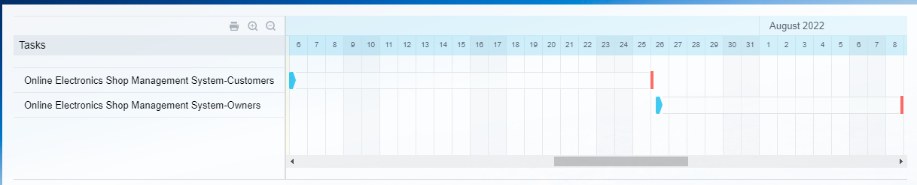

**LINK TO GITHUB REPOSITORY PART:**

https://github.com/mehrabopee/cse311-group11