WEEK 02 TECHNICAL REPORT
YCB-Video Dataset Understanding II — BOP Subset
Intern | Mehrana Rezaei
Group | Group 1 — Basic ML Knowledge
Main Quest | Neural Networks and Deep Learning
Side Quest | YCB-Video — Dataset Understanding II
Week 2 focuses on turning the Week 1 dataset inspection into a reusable loading and exploration pipeline. The executed notebook loads the YCB-V BOP'19 test subset programmatically, links RGB/depth/annotations for any frame, builds frame- and instance-level tables, visualizes masks and boxes, computes dataset statistics, and checks simple data-quality issues. No model was trained in Week 2.

1. Objective
The practical objective of Week 2 was to load and inspect YCB-Video more systematically than in Week 1. Instead of manually opening a few files, I built a reusable frame loader and dataset explorer that connects each frame to its RGB image, depth map, camera information, object annotations, full masks, visible masks, and visible bounding boxes. I also created dataset-level tables and calculated basic statistics so that later classification work can be based on measured properties of the data rather than assumptions.
The implementation continued to use the lightweight YCB-V BOP'19 test subset. This kept the work reproducible and avoided downloading the full original YCB-Video dataset. No training loop or neural-network model was implemented this week.

2. Main Quest Progress and Relevant Concepts
This week I focused on understanding the basic workflow of neural networks. I learned how data moves forward through the network, how each layer transforms the input using weights, biases, and activation functions, and why nonlinear activations such as ReLU are important for learning complex patterns.
I also learned how vectorization makes neural-network computations more efficient by processing multiple examples together instead of using loops. During training, forward propagation produces predictions, backpropagation calculates how each parameter contributed to the error, and gradient descent updates the weights and biases to improve the model.
I also studied random initialization and why it is necessary to prevent different neurons from learning the same features. Finally, I learned how these ideas extend from shallow networks to deep neural networks with multiple hidden layers, and the difference between learned parameters and manually chosen hyperparameters.

2.1 Connection to later neural-network work
A neural-network training pipeline requires consistent inputs, labels, and a clear understanding of data distribution. The Week 2 loader provides synchronized RGB/depth data and object annotations for individual frames, while frame_df and instance_df provide compact indexes that can later be filtered into selected classes and train/validation/test subsets. The class-count and visibility analysis also identifies issues such as imbalance and heavy occlusion that can affect optimization and generalization in later weeks.

3. YCB-Video Background
YCB-Video is an RGB-D object dataset designed for object recognition and 6D pose-estimation research in cluttered scenes. For this internship task, I continued to use the BOP representation of YCB-V. In the BOP format, each scene contains synchronized RGB and depth images together with JSON annotation files and per-instance mask images. The Week 2 BOP'19 subset contains 12 test scenes and all 21 YCB object classes represented in the inspected data.

3.1 Key data types used in Week 2
- RGB: the color image for a frame, loaded as a NumPy array.
- Depth: the raw depth image plus the per-frame depth_scale used to obtain scaled depth values.
- scene_camera.json: per-frame camera information, including camera intrinsics and depth scaling.
- scene_gt.json: object IDs and pose annotations for each frame.
- scene_gt_info.json: visible bounding boxes and visibility fraction for each object instance.
- mask/: full object masks for annotated instances.
- mask_visib/: only the currently visible part of each annotated object.

4. Method
I reused the same BOP subset from Week 1 when available. The notebook first checks whether datasets/ycbv/test already exists; if not, it downloads and extracts the official BOP base archive and the approximately 660 MB YCB-V BOP'19 test archive. I then built a loader that accepts a scene ID and image ID and returns all synchronized data for that frame.
- Verified the BOP test directory and enumerated the scene folders.
- Created load_frame(scene_id, image_id) to load RGB, raw/scaled depth, camera data, object annotations, and masks.
- Created frame_df with one row per frame and instance_df with one row per annotated object instance.
- Visualized a representative frame as RGB + depth, visible bounding boxes, and visible masks.
- Calculated scene, frame, object-instance, class-distribution, visibility, and bounding-box statistics.
- Checked for missing depth files, missing masks, missing visible masks, and invalid visible bounding boxes.
- Saved reusable CSV indexes and a JSON summary for later reporting/experiments.

5. Implementation
The implementation was organized in week02_ycb_dataset_explorer.ipynb. The notebook is short and code-focused: each section has only a small Markdown explanation followed by executable cells. Its main addition over Week 1 is a reusable data-loading and indexing layer rather than one-off inspection code.
Stage | Implementation | Week 2 purpose
Dataset reuse | Check datasets/ycbv/test; download only if missing | Avoid unnecessary re-download and keep the same dataset basis as Week 1
Frame loader | load_frame(scene_id, image_id) | Return synchronized RGB, depth, camera, objects, boxes, and masks
Frame index | frame_df | One row per image with scene/image ID and object count
Instance index | instance_df | One row per object instance with class, visibility, and bbox statistics
Explorer | Matplotlib views for RGB/depth/boxes/masks | Inspect different frames by changing one sample index
Statistics | Pandas describe/groupby + plots | Measure class distribution, visibility, box size, and objects per frame
Quality checks | Path existence + bbox validity checks | Identify missing or structurally invalid annotations
Outputs | CSV tables + week02_summary.json | Create reproducible inputs for the weekly report and later experiments

6. Results
The following values come directly from the executed notebook run.
Result | Observed value
Scenes found | 12
Frames indexed | 900
Object instances | 4,125
Unique object classes | 21
Mean objects per frame | 4.5833
Objects per frame range | 3 to 6
Mean visibility | 0.8966
Median visibility | 0.9902
Minimum visibility | 0.0754
Instances with visibility < 25% | 23
Mean visible bbox area | 26,829.73 px²
Visible bbox area range | 2,726 to 106,190 px²
Missing depth files | 0
Missing full masks | 0
Missing visible masks | 0
Invalid visible boxes | 0
Selected sample | Scene 000048, image 000001
Selected RGB shape | 480 × 640 × 3
Selected depth shape | 480 × 640
Objects in selected frame | 5
Selected object IDs | [1, 6, 14, 19, 20]

6.1 Representative visualizations
The figures below are embedded outputs from the executed notebook, not recreated with different data.
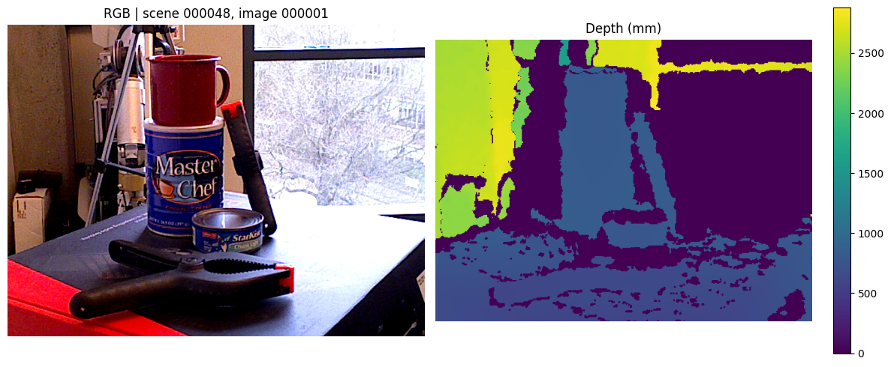
Figure 1. Representative RGB frame and its scaled depth representation (scene 000048, image 000001).
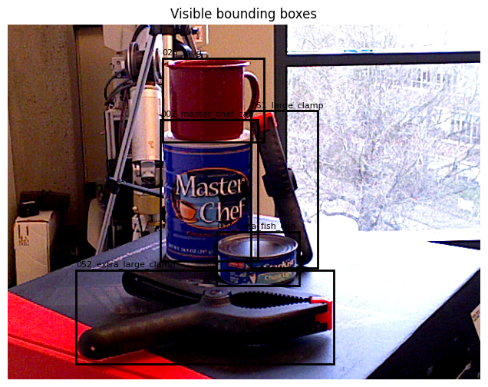
Figure 2. Visible ground-truth bounding boxes and class labels for the selected frame.
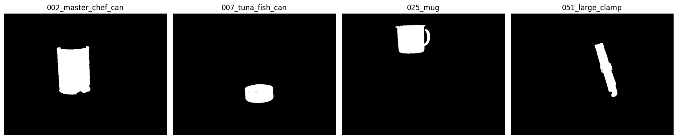
Figure 3. Visible masks for four object instances in the selected frame.
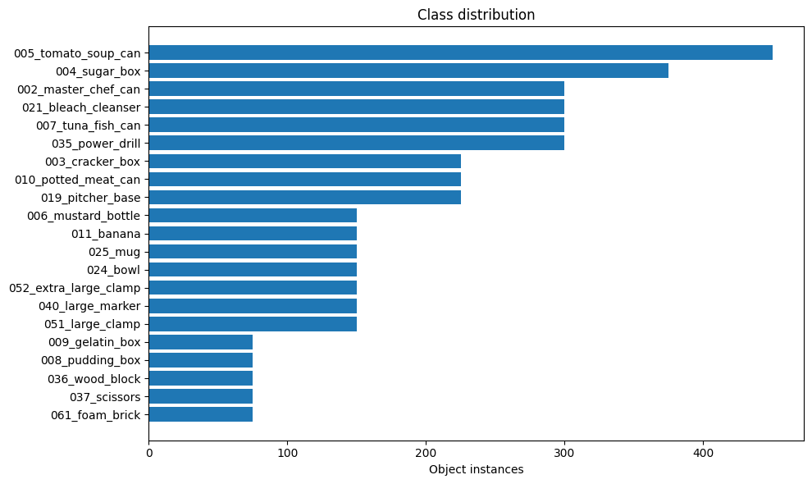
Figure 4. Object-instance class distribution across the inspected BOP'19 subset.
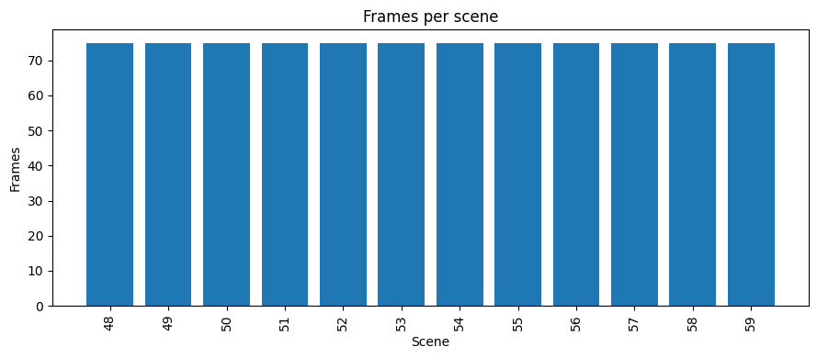
Figure 5. Frames per scene; each of the 12 inspected scenes contributes 75 frames.

6.2 Observations
The inspected subset is structurally clean for the checks implemented in Week 2. All 900 indexed frames had matching depth files, all 4,125 object instances had both full and visible masks, and no visible bounding box had a non-positive width or height. Each of the 12 scenes contributed 75 frames, so the scene-level sampling in this subset is uniform.
The object-level data is not equally distributed across classes. The most frequent class, 005_tomato_soup_can, appears 450 times, while several classes appear only 75 times. This creates a 6:1 difference between the largest and smallest class counts. The visibility statistics are generally strong — the median visibility is about 0.99 — but 23 instances have visibility below 25%, so severe occlusion is still present. The lowest-visibility examples in the notebook are dominated by 005_tomato_soup_can in scene 50.
The selected sample also illustrates why masks and boxes provide different information. Bounding boxes localize each object using a rectangle and can overlap heavily in a cluttered scene, while visible masks preserve the actual visible pixel shape of each object. This distinction will matter when the project later moves from classification to detection and segmentation.

7. Failure Analysis and Questions Discovered
Week 2 did not include model failures, but the dataset analysis revealed several engineering issues that should be considered before training. The structural checks found no missing depth/mask files and no invalid visible boxes, so the main concerns are not corrupted files but data difficulty and dataset design choices.
- Occlusion: 23 instances have visibility below 25%, with a minimum observed visibility of about 7.5%. These samples may be difficult for a simple cropped-object classifier.
- Class imbalance: instance counts range from 75 to 450. A future training subset should avoid letting frequent classes dominate the objective.
- Box/mask choice: visible bounding boxes are easy to crop but may contain background or neighboring objects, while masks isolate visible object pixels more precisely.
- Explorer readability: several bounding-box labels overlap in cluttered frames; the data is valid, but the visualization itself could be improved for dense scenes.
- Dataset split design: this notebook intentionally used the BOP'19 test subset for understanding/exploration. Week 3 training should define an appropriate selected-class dataset and explicit train/validation/test split before fitting a model.

7.1 Questions discovered
- Should severely occluded instances be retained, filtered by a visibility threshold, or used only for robustness evaluation?
- Should the Week 3 selected-class subset be balanced by sampling the same number of instances per class?
- For classification crops, should the pipeline use bbox_visib directly or apply the visible mask to reduce background/clutter?
- Should the BOP'19 test subset remain exploration/evaluation-only while model training uses an appropriate training source to avoid contaminating a held-out benchmark?

8. Conclusion and Next Step
By the end of Week 2, I moved from basic file-by-file inspection to a reusable programmatic YCB-V loading pipeline. I can now select a scene and frame and retrieve the synchronized RGB image, depth data, camera information, object annotations, bounding boxes, full masks, and visible masks through one loader. I also created frame-level and object-instance-level tables that make dataset statistics and filtering straightforward.
The executed analysis indexed 12 scenes, 900 frames, 4,125 object instances, and all 21 YCB classes. The basic structural checks found no missing depth/mask files and no invalid visible boxes, but the statistics exposed class imbalance and a small set of heavily occluded objects. These findings should guide the next stage rather than being ignored. In Week 3, the next step is Object Classification I: select a manageable class subset, define clean train/validation/test splits, prepare classifier inputs, and train a baseline model while keeping the data decisions reproducible.

