

**e-Yantra Robotics Competition - 2016**

**Implementation Analysis – Explorer Bot**

**eYRC-EB#4665**

|  |  |
| --- | --- |
| **Team leader name** | **NIKHIL MEHRA** |
| **College** | **DRONACHARYA COLLEGE OF ENGINEERING** |
| **Email** | [**Mehranikhil204@gmail.com**](mailto:Mehranikhil204@gmail.com) |
| **Date** | **05/02/2017** |

**Preparing the Arena** **(5)**

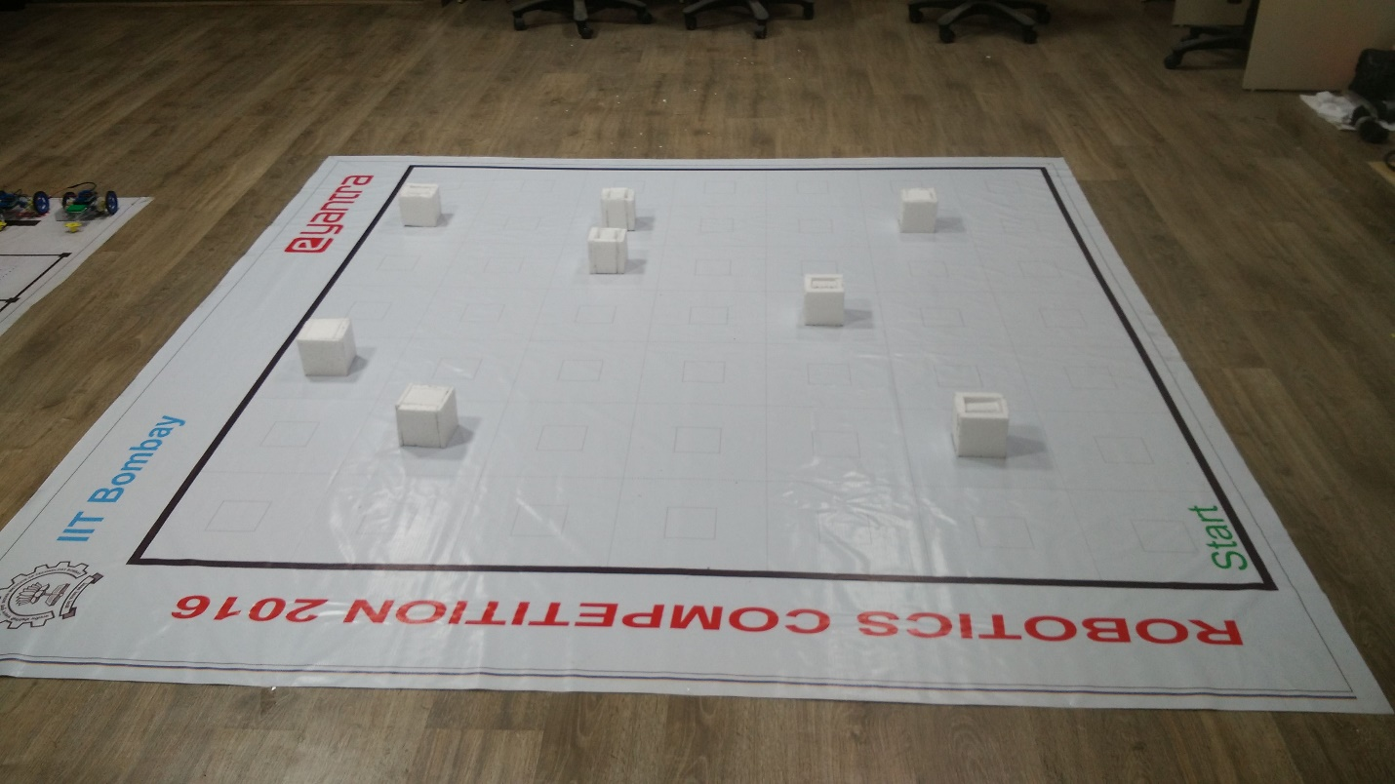

**Design Analysis**

**Q1. Teams have to make a mechanism for placing the camera to detect the markers.**

1. **Choose an option to position the mechanism on the robot and why? (5)**
2. **Front 2. Back 3. Right/Left**

**Answer: ___Front___**

The mechanism is positioned at the front of the robot on a base disk. When the robot is standing facing towards the Marker then the camera's vision is about 10.5 cm vertically when the distance between the marker and the camera placed is about 15 cm then it encloses the marker very well within its vision thus enabling the marker to be read properly. The robot has to take a turn at most of 90 degrees when the mechanism is placed at the front. In other cases, when the mechanism is placed at back then robot may have to travel in backward, else it may have to take turns at most of 180 degrees if the mechanism is placed either right or left of the robot. Also, this mechanism of viewing and walking of the robot is the most natural way of walking and observing things as the humans do.

1. **Explain the design of the mechanism and how it is mounted on the robot. (10)**

The camera is disassembled keeping only the camera lens, LEDs, circuit board and the front outer cover of the camera. The camera front outer cover along with the lens, LEDs and circuitry is mounted on the base disk using a rigid camera holding 3D printed structure which is made up of PLA (Polylactic Acid) material. A center screw is used which holds both the camera-holding structure and the caster support to the base disk. The structure has a rectangular base with a thickness of 2 mm and a rectangular hollow shape carved out at its center to place the camera in it. The rectangular base has the following dimensions: 4.5 cm x 2 cm.

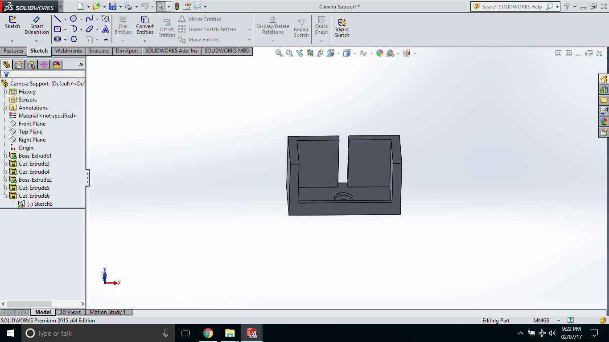

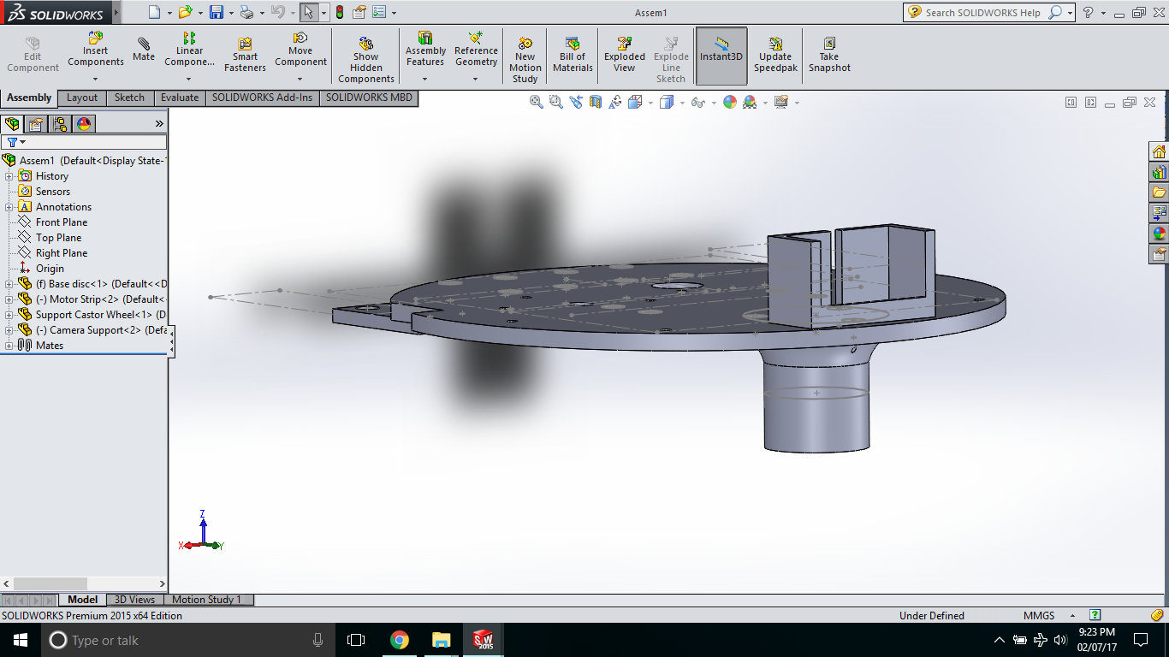

1. **To design the mechanism for Camera to detect marker, what challenge/s do you expect to face and how you will overcome them? (5)**

1. It is possible that the camera may not detect the marker due to several factors such as the view is incomplete (marker is visible partially), or the orientation of the robot is not right, or the navigation is such that the camera is not able to capture the marker.

Sol. The camera calibration is done to take the complete view or detect the marker and the interested coordinate positions where the camera on the bot can detect the respective ArUco markers from the data provided (i.e. coordinates of Sites Of Interests and the axes towards which ArUCo markers are facing ) are calculated.

2. There is a possibility of oscillation error in the robot.

Sol. The destination coordinates will be given in such a way that this mechanism solves the above challenge as the camera is placed at the front of the robot, therefore, making it go in a forward direction always to detect the marker thus eliminating the oscillation error. As in order to remove the oscillation error a robot must stop in the direction of its movement.

3. The marker is placed at height of 5 cm above the ground. And the ground clearance of our robot is 5.1 cm which gives the disadvantage to view the marker.

Sol. This will be solved by disassembling the camera into a smaller size and thus bringing down the height of the camera lens and marker into the vision of the camera.

**Q2. Explain the package/s used for marker detection and algorithm to classify correct object after detection. (5)**

**1. usb_cam package –** This package is used to run the camera which is connected to Raspberry pi.

**2.** **viewpoint_estimation package -**  This package is used to decode and identify the ArUco Markers.

**3. SOI Identification Script –** This script identifies various different types of objects according to the various different code of ArUco markers.

**Marker Detection Algorithm**

Step 1: Start

Step 2: [Initialisation] Node rospy.init_node('NODE1')

Step 3: Subscribe Data from topic Estimated Marker

rospy.Subscriber('/Estimated_marker',Marker,Print_result,queue_size=1)

Step 4: Set rate of rospy as 1mg/

Step 5: [Initialisation] function: Print_result() with an argument ‘temp’

Step 6: [Initialisation] List of ID Markers: marker_list

Step 7: [Initialisation] Dictionary of Marker description: marker_dic

Step 8: [Initialisation and Assigning] new variable: Result:=temp

Step 9: [Comparing the list 'marker_list' with variable 'Result']

             if Result == marker_list[i]

                    print marker description from marker_dic[Result]

             else

                   print that no record found of this marker

Step 10: Repeat above until rospy is shutdown

Step 11: Exit

**Algorithm Analysis**

**Q-1 Draw a flowchart illustrating the major nodes and topics that are used for theme implementation. How are ROS nodes in Arduino and Raspberry Pi connected with base Station? (20)**

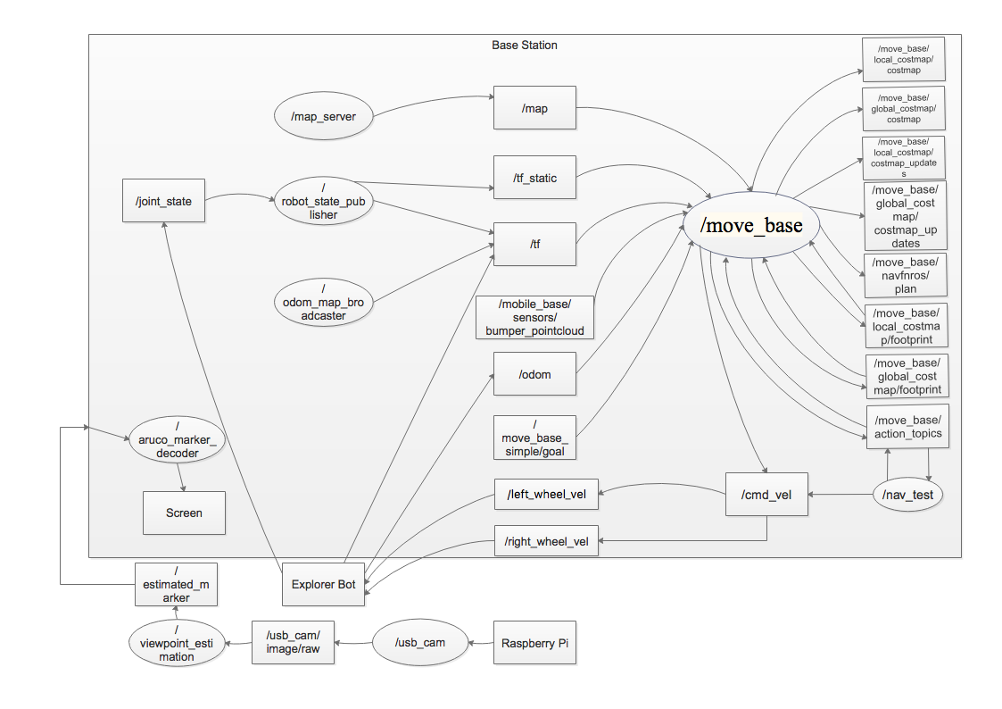

**Q-2 Explain the implementation of following task in theme:**

**a. Path Planning**

**b. Motor speed control**

**c. Visualization of robot in Rviz**

**d. Localization of robot in Rviz (10)**

**Path Planning:**  In order to navigate Explorer bot and successfully identify all the SOI in the arena path planning is necessary towards the completion of the theme. Relevant coordinates/positions from which the camera on Explorer bot can capture and identify the respective ArUco markers from the given data (i.e. coordinates of SOI and the axes towards which ArUco markers are facing) are found out. Using all the relevant coordinates and Navigation stack which uses Dijkstra's algorithm path planning will be done.

**Motor Speed Control:**  After path planning during navigation there can be a lot of different turns at different angles and orientations. A variable velocity is necessary so as to undertake all the different turns in the arena accurately. We can control the change in speed of the motor accurately using proportional–integral–derivative controller (PID) which is a control loop feedback mechanism. A PID controller continuously calculates an error value e(t) as the difference between the desired set point and a measured process variable and applies a correction based on proportional, integral, and derivative terms (sometimes denoted P, I, and D respectively) and giving our robot a correct path.

**Visualization of robot in Rviz:** In order to visualize robot in Rviz a robot model is required. In our theme, we have prepared a URDF model of the robot. A visualization is a great tool which graphically helps us to visualize the robot in the virtual environment (theme map). It also helps us to visualize sensor data like in our case we can add a camera on the robot and can see what the camera captures virtually.

**Localization of robot in Rviz:** Localization of robot in Rviz will be done with the help of Navigation stack package in ROS. Desired destination goals which we want our robot to achieve will be sent.

**Theme Implementation**

**With the end of Task 3 you must have finished the construction of the explorer bot. Now, study the rule book and try to implement the solution for the theme. Final task of the competition is to submit the video and code for the theme implementation. Submission date for video and code will be notified in future.**

**Start early and be ready for video submission. Stay tuned for further instruction.**