# Installation

**Required Software:**

Android Studio

Visual Studio Code

Mongo DB Compass

Database Name: (Self-Checkout3)

**To run the Web Application**

1. First Download the files and unzip the files .
2. Make an account in mongodb atlas and get the link to connect mongo db compass

Then go to the mongodb compass and paste the link with your user password which added on mongodb atlas account database

Once you add the password and connected to the database ,make a database called self-checkout and add a table called Users

Then after add Data by choosing JSON or CSV files.You can find the database folder and import the Self-Checkout2.Users files to the Users

After that copy the correct link to the database and follow the instructions

1. Open the Self-Checkout_Web_Admin_Panel-mai folder by using the VS code.
2. Open the Terminal and find the Backend path and follow the steps

cd Backend 🡪 npm install 🡪npm start

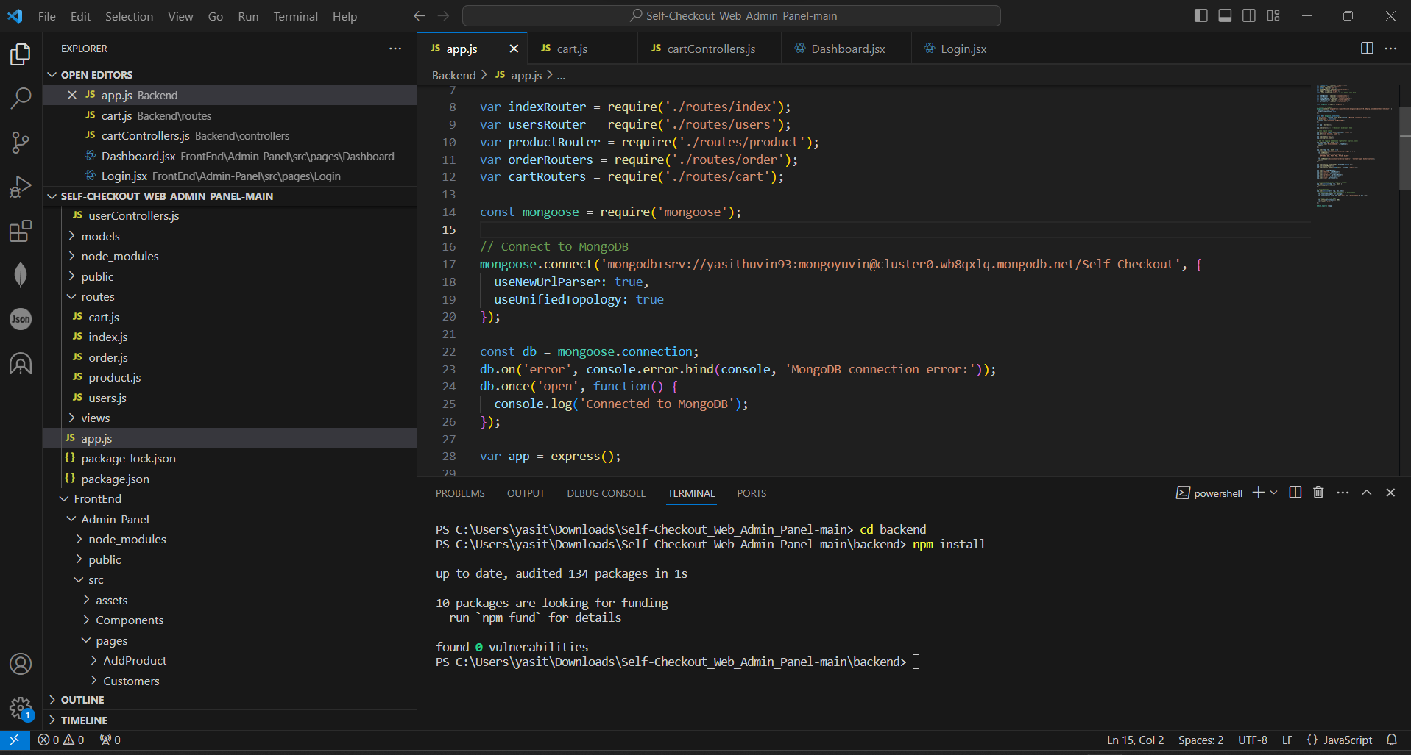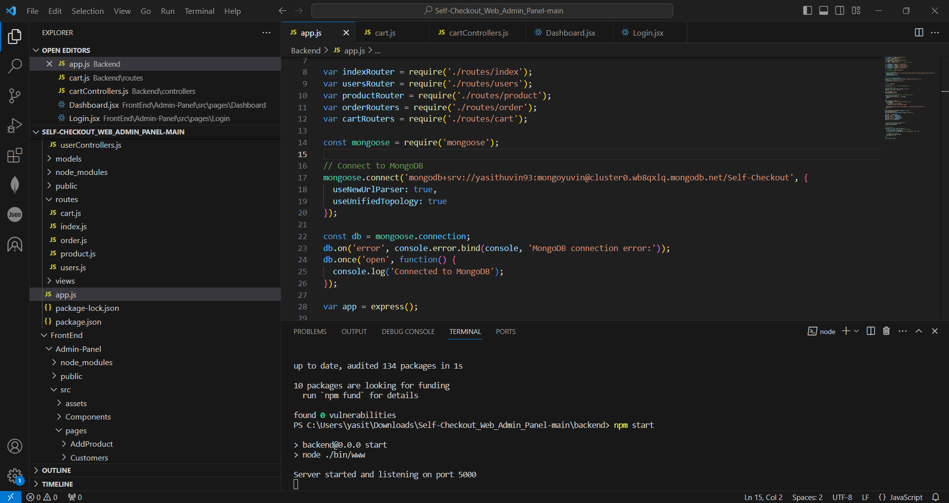

1. Then open another Terminal and follow the steps,

Cd Frontend 🡪cd admin-panel 🡪npm install 🡪npm start

1. Then after you will get a link for the Admin panel web.

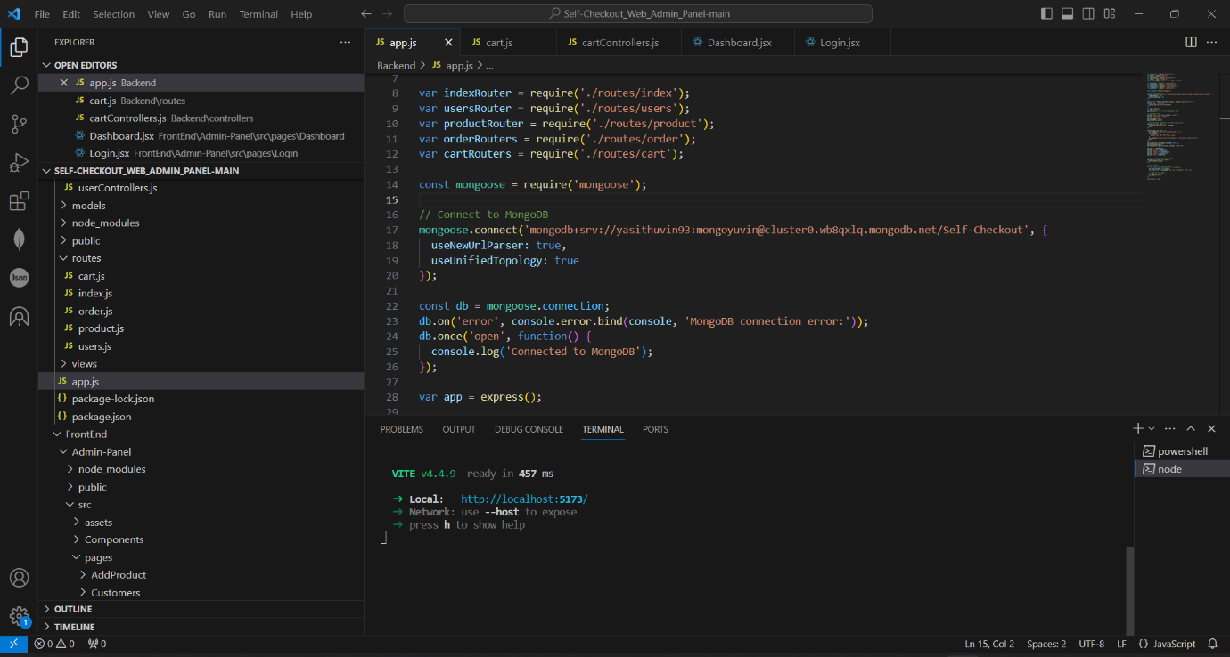

Once you run the web application ,database tables will create and update automatically

**To run the Mobile application with the database connection**

Follow the steps

1. Once run the web application go back to the VS code and open another new terminal and type the given command exactly .

**ngrok http 5000**

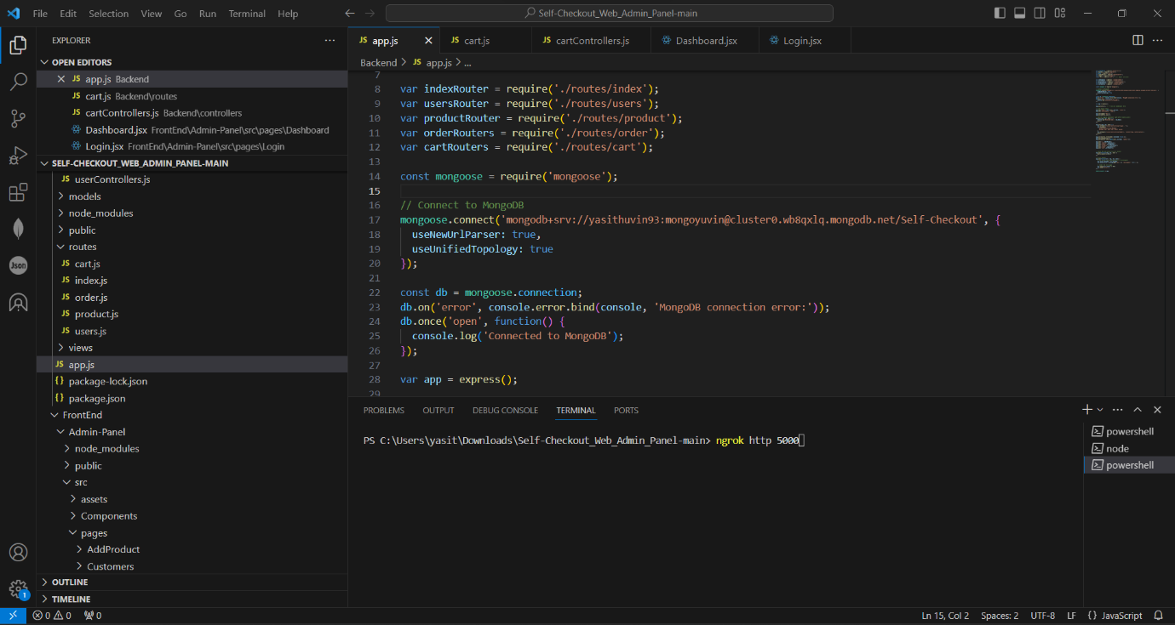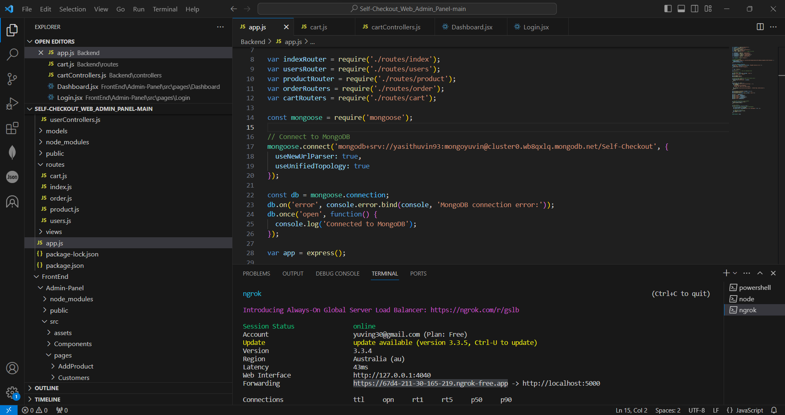

1. Then after you will get a link for the database connection .
2. Open the Self-Checkout-main folder by using Android Studio
3. Copy that link and paste it in the Constants.java file code

Then after you can Run the mobile application

Thank you.