One Video and the Time-Reversal Test
Mehran Piran
17 October 2026

Abstract
The first medical video-localisation pilot showed that a frozen vision-language model could recognise the general context of a blood-draw procedure but could not reliably distinguish an action from its opposite. This second study investigated whether that failure was specific to one recording or a structural limitation of frame-based image-text representations. A curated corpus of 21 needle-procedure clips from 11 independent filming shoots was assembled, containing 460 frames sampled at one frame per second. A controlled time-reversal experiment was then used: each video was compared with the same video played backward, so both versions contained exactly the same frames and differed only in temporal order. This test showed that any method that independently scores frames and then combines them using an order-symmetric operation is mathematically unable to distinguish the forward and reversed videos. Numerical testing confirmed this result across all 21 clips, with the largest forward-reverse score difference only 1.19 × 10⁻⁷, corresponding to numerical precision. Several simple order-sensitive alternatives were then evaluated, including endpoint displacement, a shared direction-of-progress classifier, zero-shot caption-direction testing, and frame-to-frame projection measures at four frames per second. None performed significantly above chance. The frame-to-frame movements in the embedding space were also almost perpendicular to the text direction separating an action from its reverse, suggesting that useful direction information was not accessible through these simple linear read-outs. The study therefore extends the first pilot by showing that the failure to understand action direction is not simply an accident of one video. Instead, it is a structural limitation of approaches based on independent image embeddings. Reliable recognition of fine-grained action direction is likely to require models that explicitly represent change over time, such as optical-flow methods or video encoders trained to model motion.

Figures
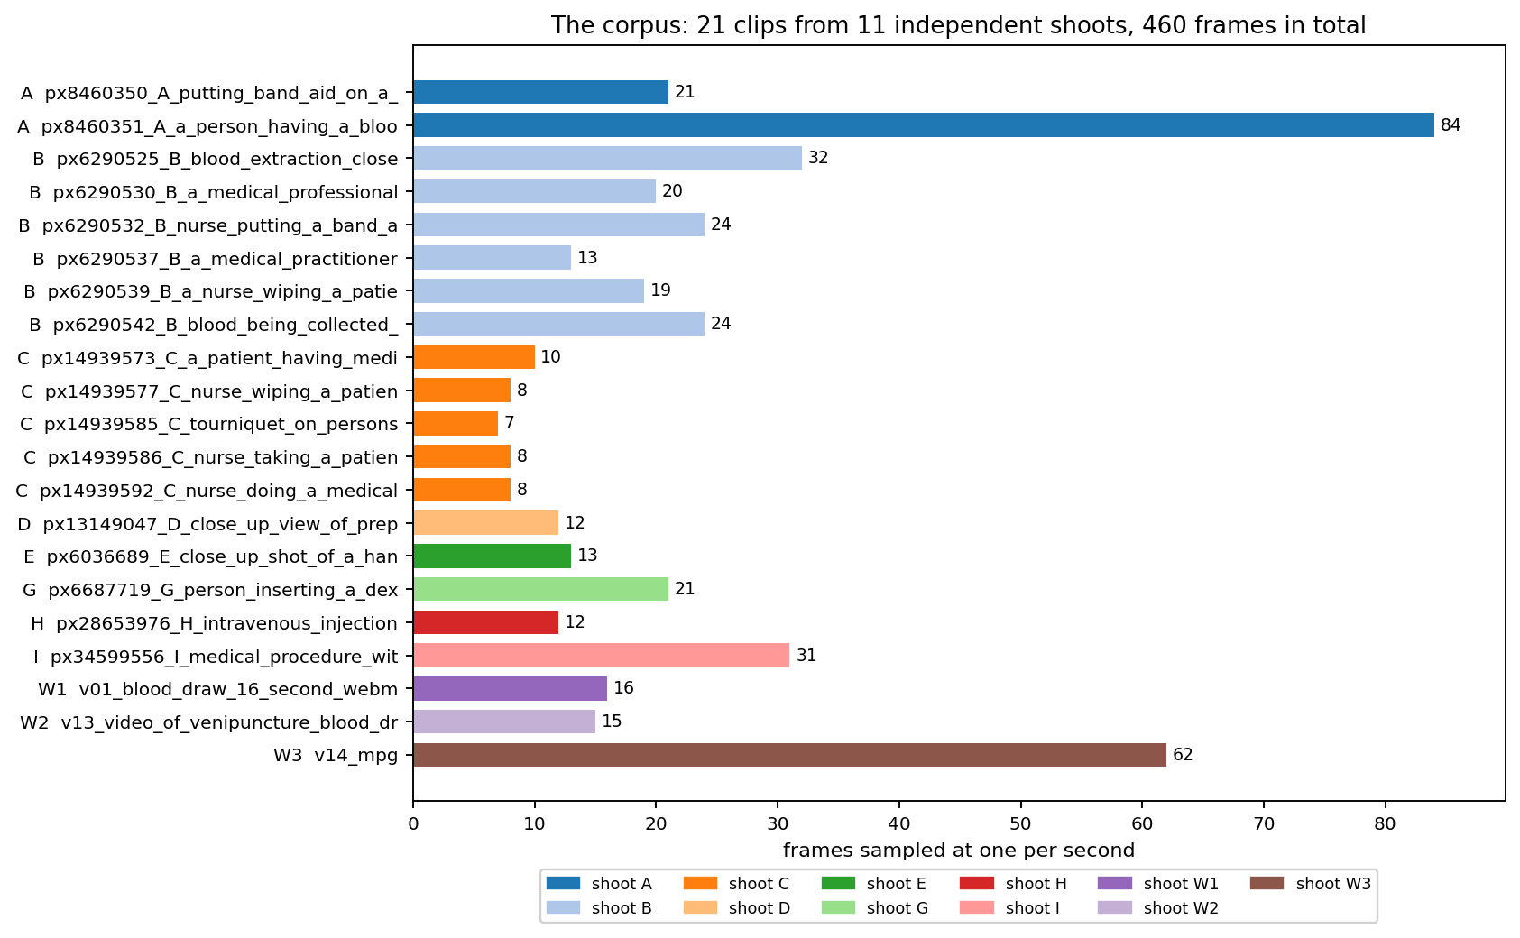
Figure 1. The corpus used in this study: 21 clips from 11 independent filming shoots.
This figure shows what the corpus contains. Each bar is one clip, and the length of the bar is the number of frames taken from that clip at one frame per second. The colour gives the shoot the clip came from, and the letter at the start of each label repeats that shoot. The 21 clips together hold 460 frames. The shoots are very uneven, because shoot B supplied six clips while several shoots supplied only one. Clips from the same shoot share a room, a patient and a camera, so they are not independent of each other. This is the reason every later test in this study holds out a whole shoot rather than a single clip.
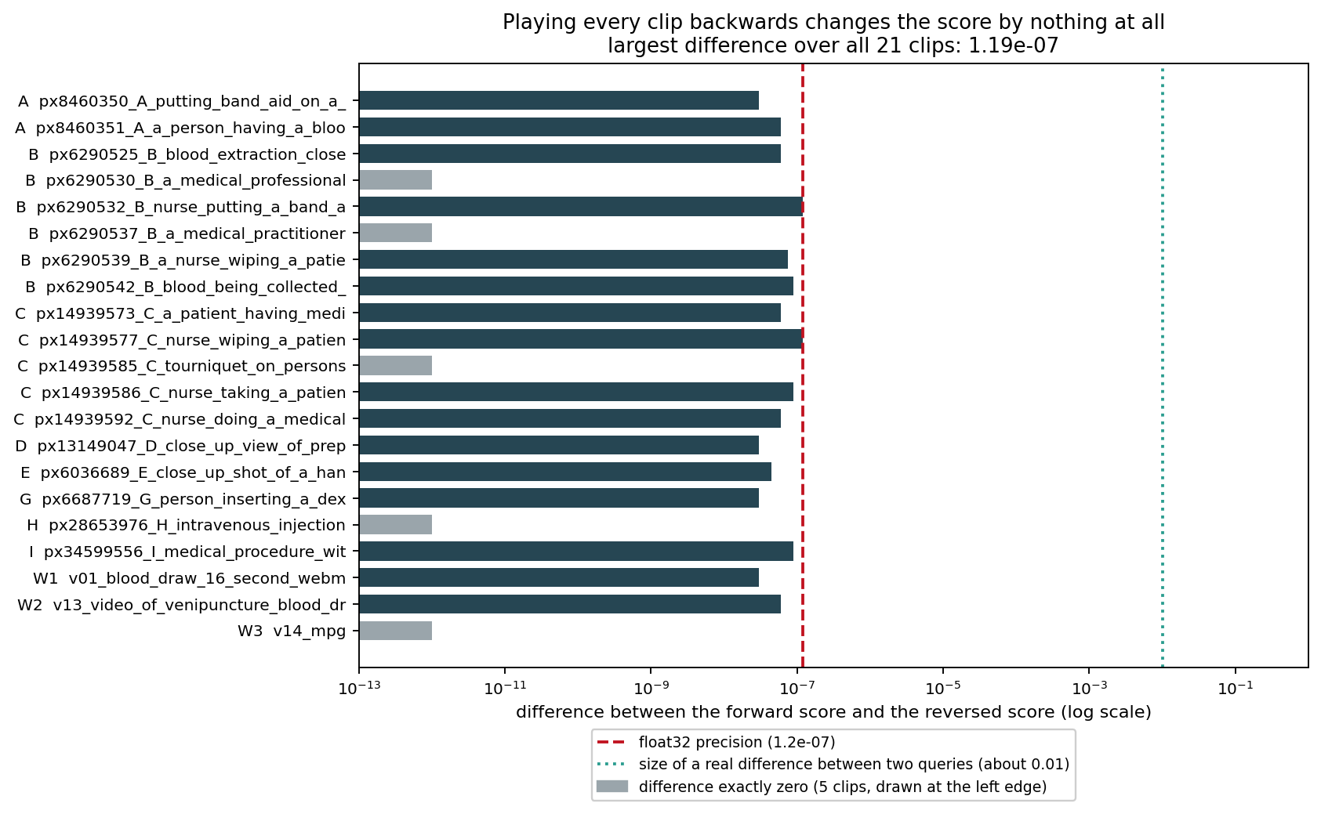
Figure 2. The difference between the score of the forward clip and the score of the same clip played backward, for all 21 clips.
This figure shows the central result. Each bar is one clip, and its length is the difference between the score the pipeline gives to the forward clip and the score it gives to the same clip played backward. The scale is logarithmic, so each step to the right is ten times larger. The red dashed line marks the precision of the numbers the computer uses, and the green dotted line marks the size of a difference that would matter, which is about 0.01. Every bar lies far to the left of the green line, and five clips show a difference of exactly zero. The largest difference found anywhere is 1.19 × 10⁻⁷, which is the size of a rounding error and not a real difference. Reversing a clip turns every action into its opposite, so this figure shows that the pipeline cannot tell an action from its opposite at all. This is not a weakness that more data would fix, because the frames of the reversed clip are the same frames in a different order, and the method never looks at the order.
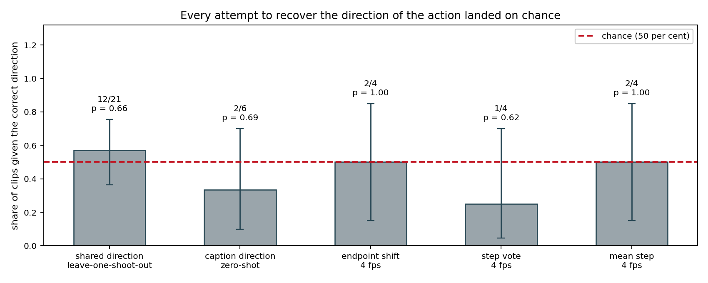
Figure 3. Five order-sensitive tests, each measured against chance.
This figure shows what happened when the pipeline was changed so that the order of the frames does matter. Each bar is one test, and its height is the share of clips given the correct direction. The red dashed line at 0.5 is chance, because each clip can be forward or backward and a coin would be right half of the time. The thin black lines are 95 per cent confidence intervals, and the text above each bar gives the raw count and the probability of seeing that result by luck alone. Every bar sits at or near the chance line, and every p value is large, which means no test did better than guessing. The confidence intervals are wide because the corpus is small, so this figure shows an absence of evidence for these simple methods rather than proof that no method can ever work.
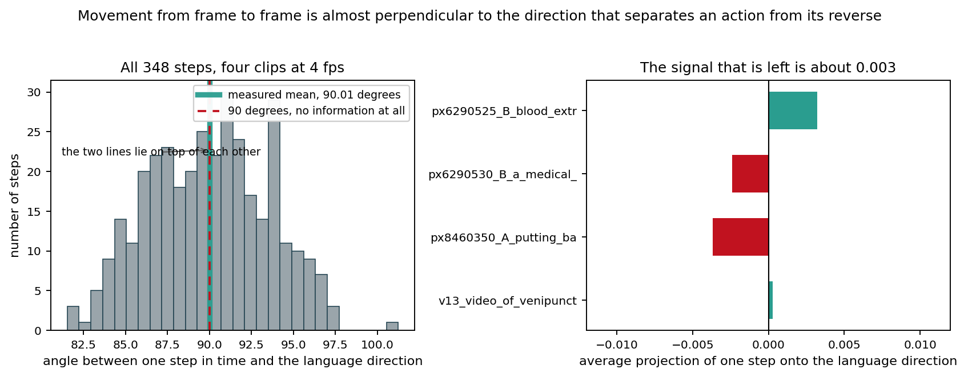
Figure 4. Why the simple repairs failed: movement between frames is almost at a right angle to the direction in which language separates an action from its reverse.
This figure explains the previous one. For each pair of neighbouring frames the study measured the direction the clip moves in the embedding space, and compared it with the direction that separates the two opposite captions. The left panel is a histogram of the angle between those two directions for every step in four clips sampled at four frames per second. An angle of 90 degrees, marked by the red dashed line, means the movement carries no information about which caption is correct. The measured angles sit on top of that line: the mean over all 348 steps is 90.01 degrees, and the four clips give 89.82, 90.14, 90.21 and 89.98 degrees. The right panel gives the average projection for each clip, and the values are about 0.003, which is very close to zero and changes sign from clip to clip. In plain words, the clip does move through the embedding space as time passes, but it moves sideways with respect to the question being asked, so no simple linear read-out can recover the direction of the action.

