One Video and the Time-Reversal Test
Mehran Piran
13 October 2026

Abstract
This pilot study investigated whether pretrained vision-language models can locate fine-grained actions inside a continuous medical procedure video using only natural-language descriptions. An 84-second blood-draw video was sampled at one frame per second and manually annotated for six real actions. Four hard negative queries and three easy negative queries were also included to test whether the system could reject actions that did not occur. Five frozen model configurations were compared, including CLIP ViT-B/32, CLIP ViT-L/14, two alternative image-preprocessing versions of ViT-L/14, and BioMedCLIP ViT-B/16. Three increasingly complete systems were evaluated: frame-by-frame similarity scoring, temporal smoothing across neighbouring seconds, and an abstention mechanism that allowed the model to return no answer when confidence was low. The strongest model was CLIP ViT-L/14 with temporal smoothing, which increased mean temporal IoU from 0.079 to 0.265. The larger visual encoder performed much better than the smaller one, and temporal smoothing gave a large improvement only when the original visual signal was already useful. BioMedCLIP outperformed a general CLIP model of similar size but remained below the larger ViT-L/14 model. Abstention rejected all easy negative queries and one of four hard negatives without reducing localisation accuracy for the best model. The most important finding was that CLIP could identify the general medical context but could not reliably distinguish an action from its opposite. The queries describing needle insertion and needle removal produced almost identical score curves, with a correlation of 0.969 and the same peak time. These results suggest that frame-based vision-language models can provide useful localisation signals, but fine-grained medical video understanding requires information about motion and action direction that cannot be obtained from isolated frames alone.

Results
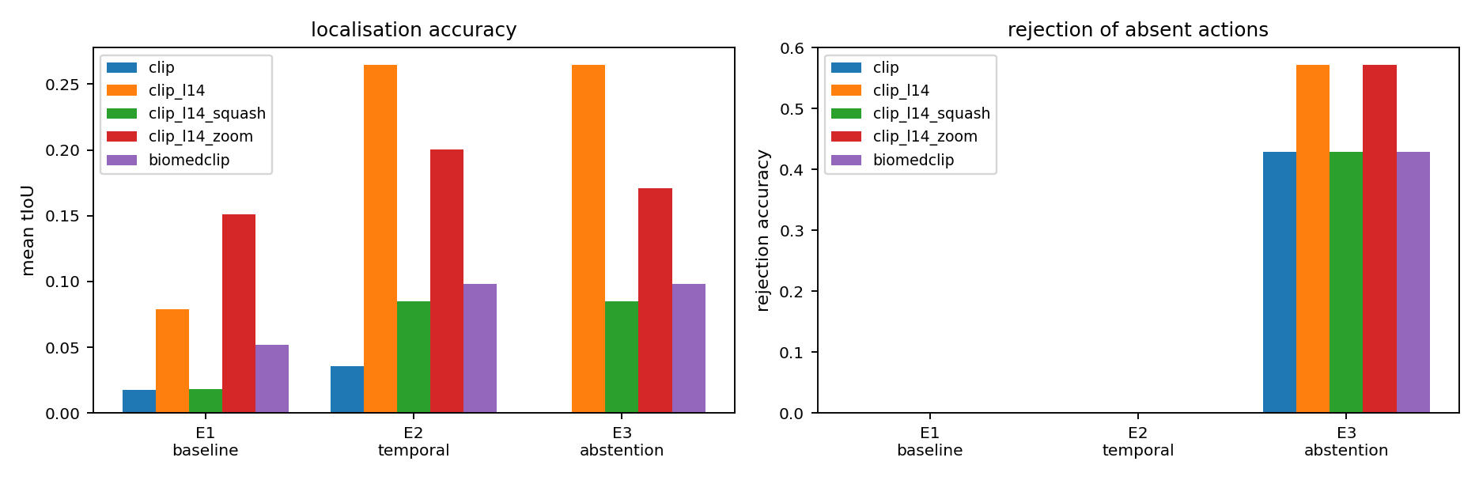
Figure 1. Localisation accuracy and rejection ability for all five frozen settings.
This figure supports the first two highlighted results. The left panel gives the mean temporal IoU for the three systems, and the right panel gives the share of absent actions that were refused. Each colour is one frozen setting. In the left panel the bars for CLIP ViT-L/14 are far taller than the bars for CLIP ViT-B/32, which is the effect of the larger visual encoder. Every setting also rises from E1 to E2, which is the effect of temporal smoothing, and for ViT-L/14 this is the step that raises the score from 0.079 to 0.265. BioMedCLIP sits above CLIP ViT-B/32 but clearly below ViT-L/14, which is the comparison stated in the abstract. The bars in the right panel are zero for E1 and E2 because only E3 is allowed to refuse an answer.
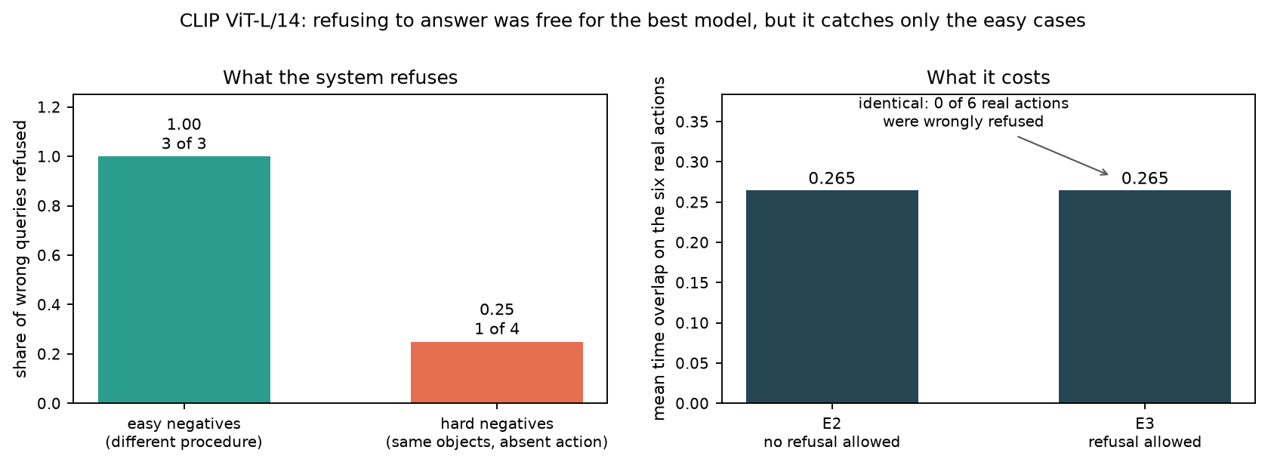
Figure 2. What the abstention rule catches, and what it costs, for CLIP ViT-L/14.
This figure supports the highlighted result about abstention. The left panel splits the absent actions into the two kinds used in this study. All three easy negatives, which describe a different procedure, were correctly refused. Only one of the four hard negatives was refused, and those four reuse the same objects as a real action, so they are the cases that matter. The right panel shows the price paid for this ability. The mean temporal IoU is 0.265 both before and after the rule is switched on, and no real action was wrongly refused, so for this model the ability to say nothing was obtained at no cost in accuracy.
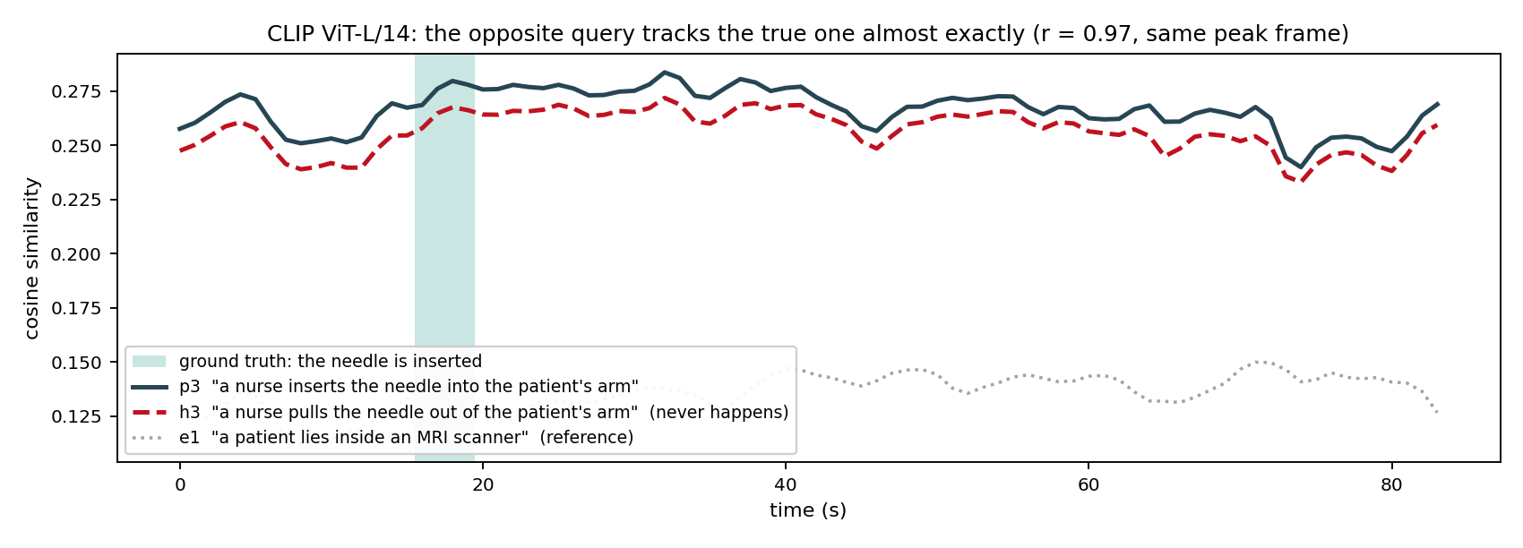
Figure 3. A true action, its opposite, and an unrelated action, scored over time by CLIP ViT-L/14.
This figure supports the most important highlighted result. Time in seconds runs along the bottom and the smoothed similarity score runs up the side. The green band marks the seconds when the needle is really inserted. The solid dark line is the query describing needle insertion and the red dashed line is the query describing needle removal, which never happens anywhere in this video. The two lines rise and fall together, agree with a correlation of 0.969, and reach their highest value at the same second. The grey dotted line is an unrelated query about an MRI scanner, and it stays far below and moves on its own. Together the three lines show that the model recognises the medical context very well while remaining unable to tell the direction of the action.
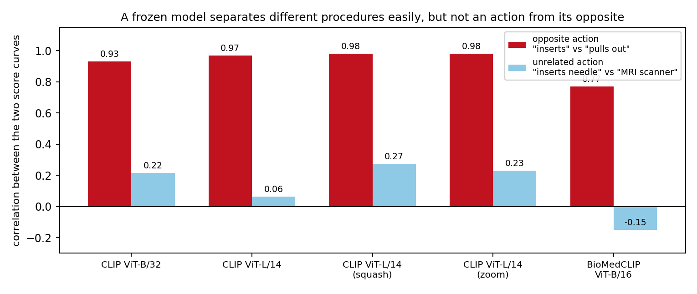
Figure 4. Agreement with the opposite action compared with agreement with an unrelated action, for all five settings.
This figure shows that the previous result is not a property of one model. For each setting the dark red bar is the correlation between the insertion query and the removal query, and the light blue bar is the correlation between the insertion query and the unrelated MRI query. The dark red bars stay high everywhere, between 0.77 and 0.98, while the light blue bars stay low, between minus 0.15 and 0.27. A larger encoder does not close this gap and in fact widens it. Only BioMedCLIP, on the right, lowers the dark red bar at all, and it is also the weakest model at localisation, so this observation is a lead for future work rather than a solution.
The four figures below show the same thing for four of the frozen settings, so that the numbers in the abstract can be checked query by query. Each figure has one panel for each of the six real actions. Time in seconds runs along the bottom of every panel and the smoothed similarity score runs up the side. The dark line is the score curve of that query. The green band is the true time of the action and the orange band is the time the system predicted. The number printed in the top right corner of a panel is the time overlap for that action, where 1 would be a perfect answer and 0 means the two bands do not touch at all. A good result looks like an orange band sitting on top of a green band.
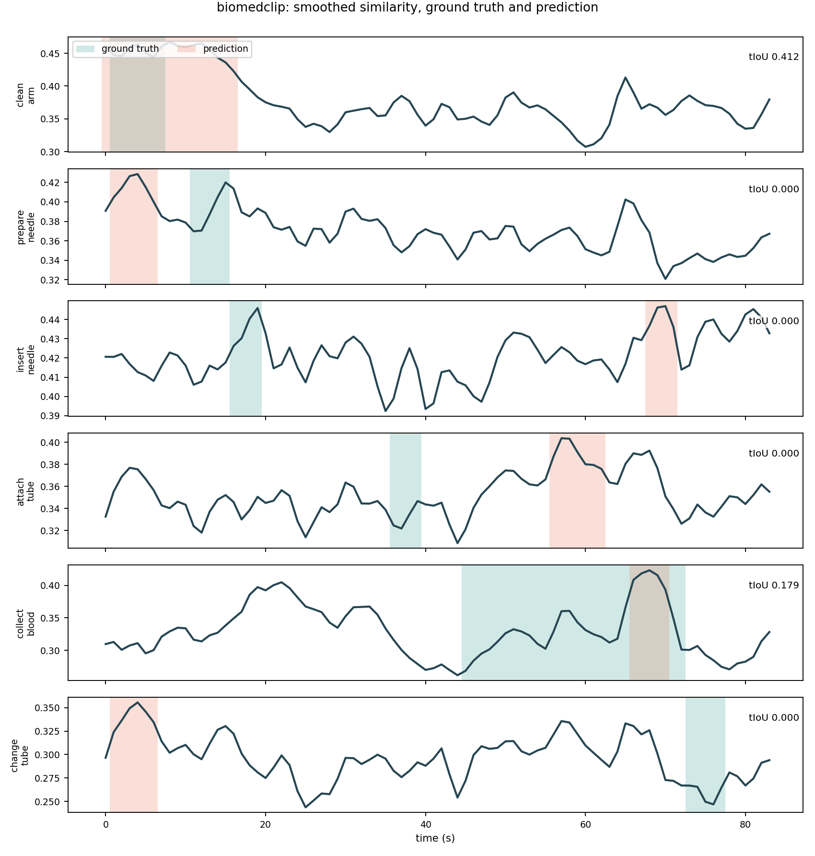
Figure 5. Score curves for the six real actions, BioMedCLIP ViT-B/16.
BioMedCLIP reaches a mean overlap of 0.098. Only two of the six actions are found at all. Cleaning the arm scores 0.412, but the predicted band runs from 0 to 16 seconds while the action lasts from 1 to 7 seconds, so the model has found the right region and not the right boundaries. Collecting the blood scores 0.179. The other four actions score zero, and the way they fail is the interesting part. Inserting the needle, attaching the tube and collecting the blood all peak between 57 and 70 seconds, which is the long stretch where the tube is filling, while preparing the needle and changing the tube both peak at 4 seconds. Six different sentences are therefore being answered with only two places in the video. The model has learned from figures printed in scientific papers, and those are a poor match for a video recorded in a clinic.
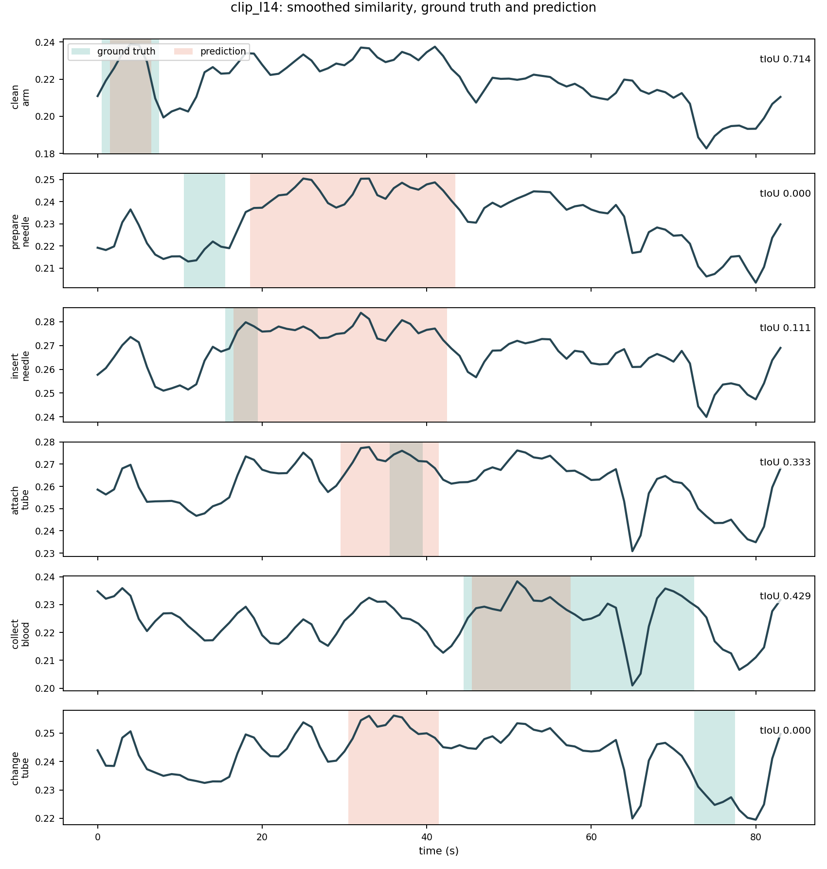
Figure 6. Score curves for the six real actions, CLIP ViT-L/14. This is the best system in the study.
This is the setting that reaches a mean overlap of 0.265. Cleaning the arm is found well at 0.714, and the first panel shows a clean single peak inside the green band. Collecting the blood scores 0.429 and attaching the tube scores 0.333, but in both cases the orange band is much shorter than the green one, so the model finds the moment and underestimates how long the action lasts. Two actions score zero. Preparing the needle happens from 11 to 15 seconds and the system answers 19 to 43 seconds. Changing the tube happens from 73 to 77 seconds and the system answers 31 to 41 seconds, which is not even close. Three of the six curves peak between 32 and 36 seconds, in the middle of the video where the hands work close to the arm and every frame looks much like the one before it. The model matches the objects named in the sentence and has little sense of when the action happens.
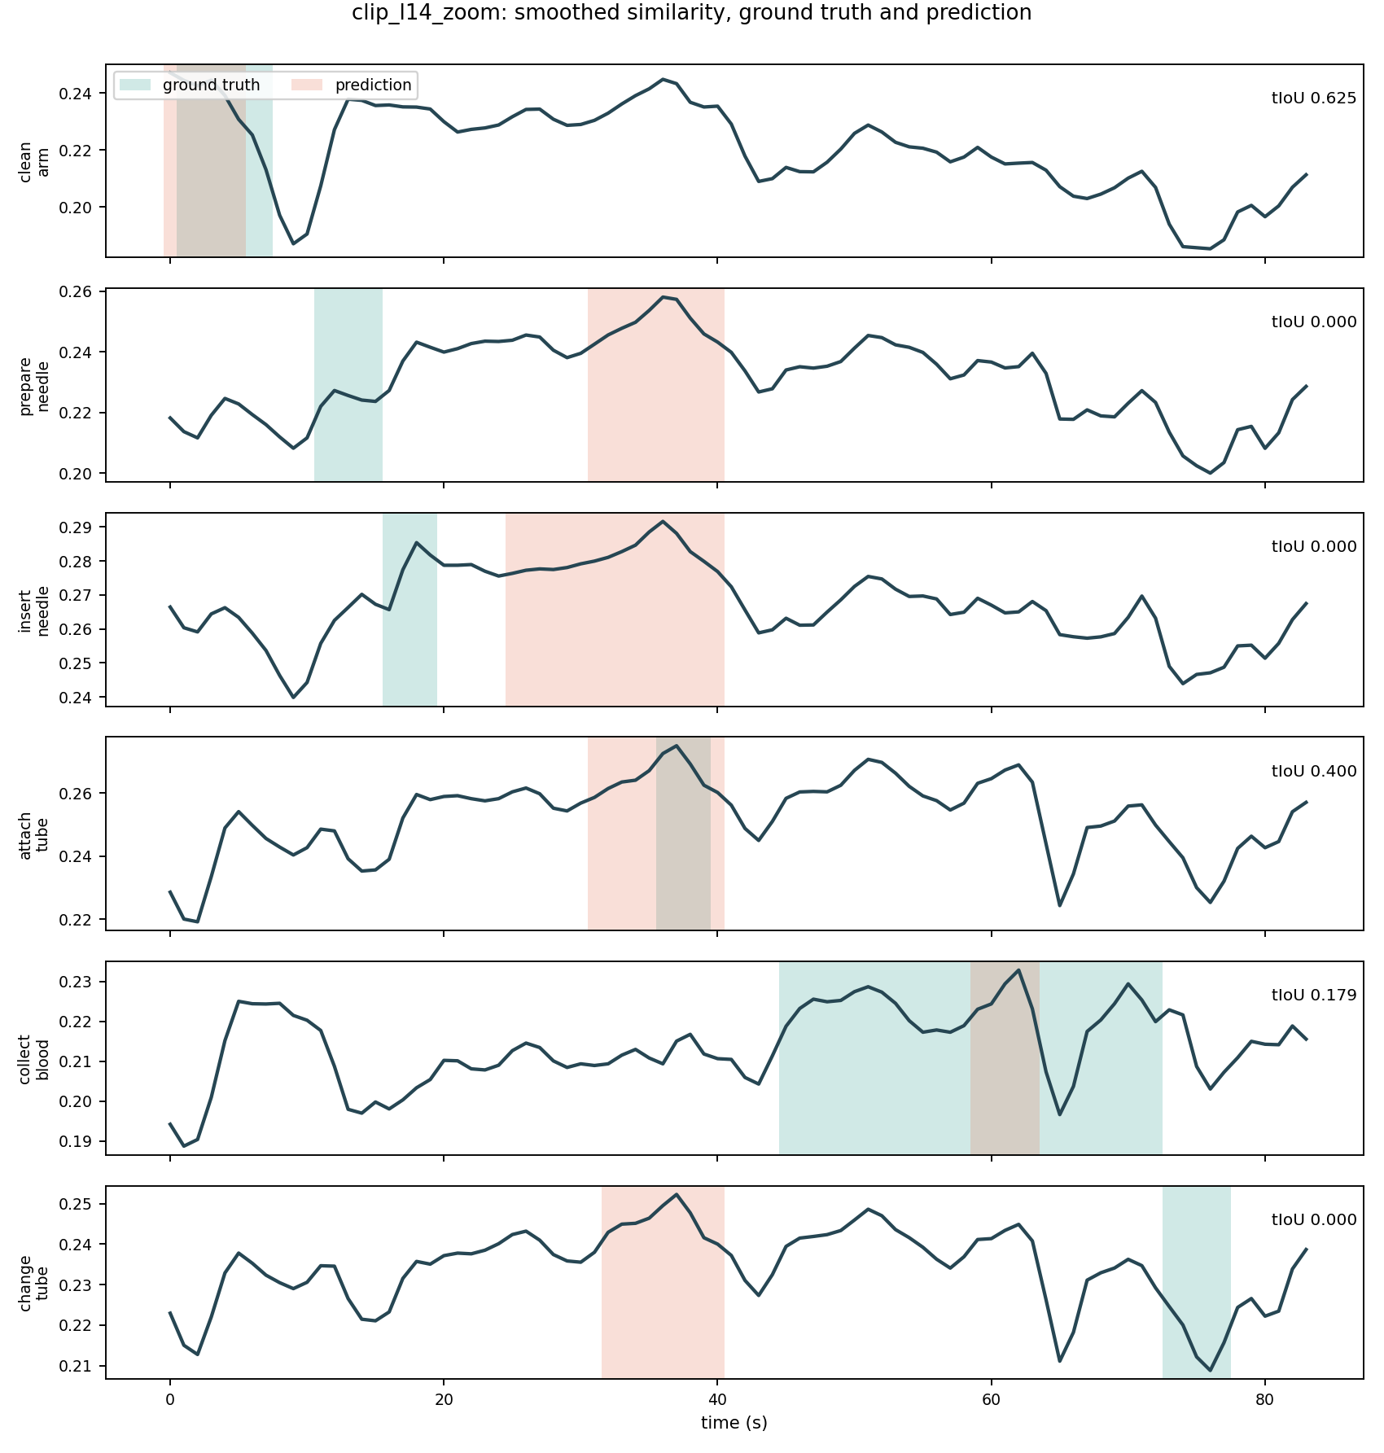
Figure 7. Score curves for the six real actions, CLIP ViT-L/14 with a tight crop around the procedure.
This setting crops a fixed box around the place where the procedure happens, instead of letting the standard pipeline cut a square from the centre of the frame and throw away the left and right thirds. Cropping helped before smoothing, where it almost doubled the score, but after smoothing it reaches 0.201 and so finishes below the standard pipeline at 0.265. The figure shows why. Attaching the tube is the best result of any setting in the study at 0.400, and cleaning the arm still scores 0.625, so the crop does help when the action is in the cropped box. Against that, preparing the needle, inserting the needle and changing the tube now all peak within one second of each other, at 36 or 37 seconds. Removing the background removed information that was keeping those three queries apart.
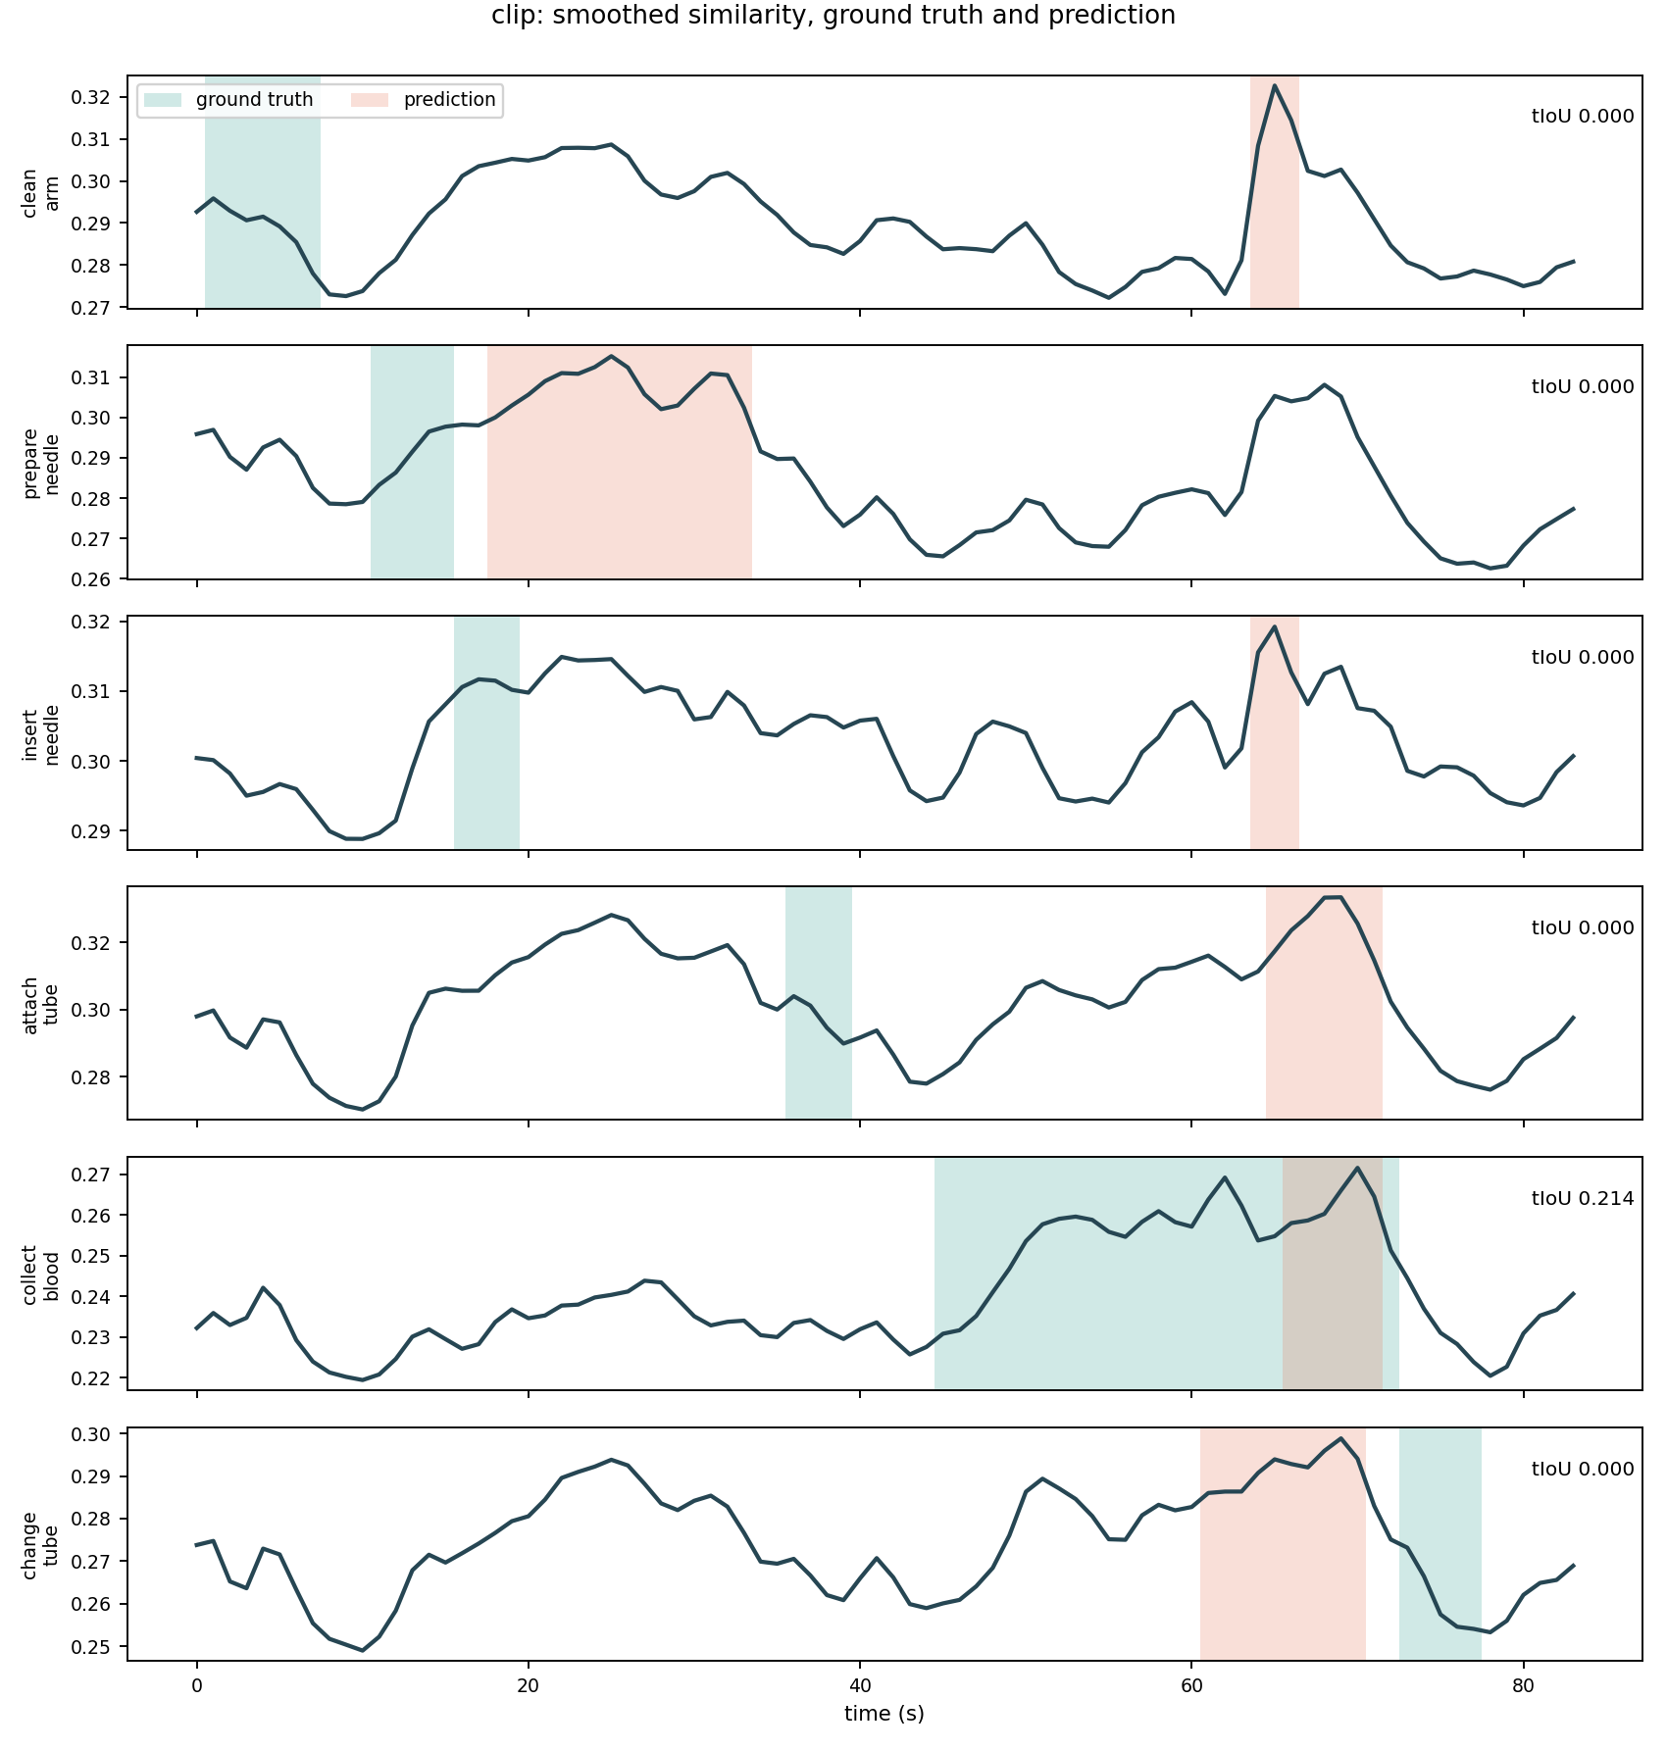
Figure 8. Score curves for the six real actions, CLIP ViT-B/32. This is the weakest setting.
This is the small model, with a mean overlap of 0.036, and the figure shows a failure that is different in kind from the others. Four of the six curves peak between 65 and 70 seconds, and a fifth peaks at 69 seconds, so almost every query is answered with the same late part of the video no matter what the sentence says. The curves are nearly copies of each other. What the model is responding to is the frame rather than the query, which means its output carries almost no information about the sentence that was asked. Only collecting the blood gets a non-zero overlap, at 0.214, and that happens by luck, because the true action is long and happens to cover the region the model always picks. Comparing this figure with Figure 6 is the clearest way to see why the size of the visual encoder mattered more than anything else that was tested.

