UNIT/01: URBAN AND RURAL LIFE
WRITING
IN THIS unIT YOU WILL
LEARN HOW TO
• identify the main features of a line graph
• achieve a high score for Task Achievement
• describe and compare using adjectives and adverbs.
Lead-in
01 Using the verb to grow and the adverb rapidly, complete the sentences to describe the information in the graphs. Focus on the correct verb. tense in each case, bearing in mind the time phrases you are given and the dates in the graph.  1 Since five years ago, {i}sales have grown rapidly{/i} to 90,000.  2 Between {blk}1980 and 1990 sales grew rapidly{/blk} to 90,000.  3 From 2020 to 2030 {blk}sales will / are predicted to / are expected to grow rapidly{/blk} to 90,000.  4 By the year 2000, {blk}sales had grown rapidly{/blk} to 90,000  5 By the year 2020, {blk}sales will have grown rapidly{/blk} to 90,000. | 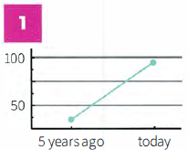

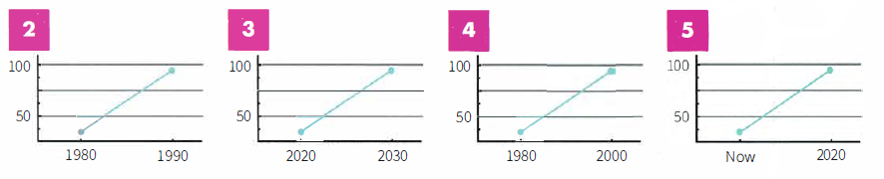
02 | With a partner, make correct sentences using a verb from column 1, an adverb from column 2 and a time phrase.
Example:
Student A: increase, slowly, by the year 2000
Student B: By the year 2000, it had increased slowly to 90%.
Verb | Adverb | Time phrase
Increase  decrease  fall  rise  climb  drop | dramatically  slowly  sharply  consistently  gradually  steadily | by the year 2000  from 1995 to 2000  for the next ten years  between 2010 and now  by the year 2030  since 2016

