Assignment 1 Report

DD2424

Mehrdad Darraji

1. **Gradient Implementation and Test**

Using the formulas from lecture, I was able to successfully compute the gradient for model W and b.

* Let $\{\left(x_{1}, y_{1}\right),…, \left(x_{n_{b}}, y_{n_{b}}\right)\}$ be the data n the mini-batch $D^{(t)}$
* Gather all $x_{i}$ and $y_{i}$ from the batch into the matrix

$X_{batch}= \left(\begin{matrix}↑ & & ↑ \\ x_{1} & … & x_{n_{b}} \\ ↓ & & ↓\end{matrix}\right)$, $Y_{batch}= \left(\begin{matrix}↑ & & ↑ \\ y_{1} & … & y_{n_{b}} \\ ↓ & & ↓\end{matrix}\right)$

* Complete the forward pass
$$P_{batch}=SoftMax(WX{}_{batch}+b1_{n_{b}}^{T})$$

* Complete the backward pass
$$G_{batch}= -\left(Y_{batch}- P_{batch}\right)$$

$$\frac{∂L}{∂W}= \frac{1}{n_{b}}G_{batch}X_{batch}^{T} , \frac{∂L}{∂b}= \frac{1}{n_{b}}G_{batch}1_{n_{b}}^{}$$

* Add he gradient for the regularization term

$$\frac{∂J}{∂W}= \frac{∂L}{∂W} +2λW , \frac{∂J}{∂b}= \frac{∂L}{∂b}$$

I computed the relative error between the numerically computed gradient value $g_{n}$ and an analytically computed gradient value $g_{a}$ with an eps value of 0.0001

$$\frac{|g_{a}-g_{n}|}{max⁡(eps, \left|g_{a}\right|+|g_{n}|)}$$

The result seemed to be very well as the error between my gradient function and the ComputeGradsNumSlow was a very small. Below are different tests I ran and results:

|  |  |  |  |  |  |  |
| --- | --- | --- | --- | --- | --- | --- |
| Batch Size | 50 | 50 | 50 | 200 | 200 | 200 |
| Lambda | 0 | 0.1 | 1 | 0 | 0.1 | 1 |
| W error | 1.54e-8 | 3.68e-7 | 1.99e-7 | 1.32e-8 | 5.44e-7 | 1.20e-6 |
| b error | 7.33e-10 | 7.33e-10 | 7.33e-10 | 6.70e-10 | 6.70e-10 | 6.70e-10 |

1. **Experiments**

Through four experiments, we analyze the results of the loss functions and accuracies of the train and validation datasets, then afterwards have a visualization of the weight matrix. Finally, we see the accuracy level achieved by each experiment on the test dataset.

*Note:* in the plots, the blue line represents the training set, the red line represents the validation set, the x-axis represents the epochs, and the y-axis represents the loss or the accuracy.

* 1. **Experiment a: lambda = 0, n_epochs = 40, n_batch = 100, eta = .1**

The plots shown below have lines that are very jagged with high variance and a lot of noise in the weights– this is due to having a high learning rate and no regularization.

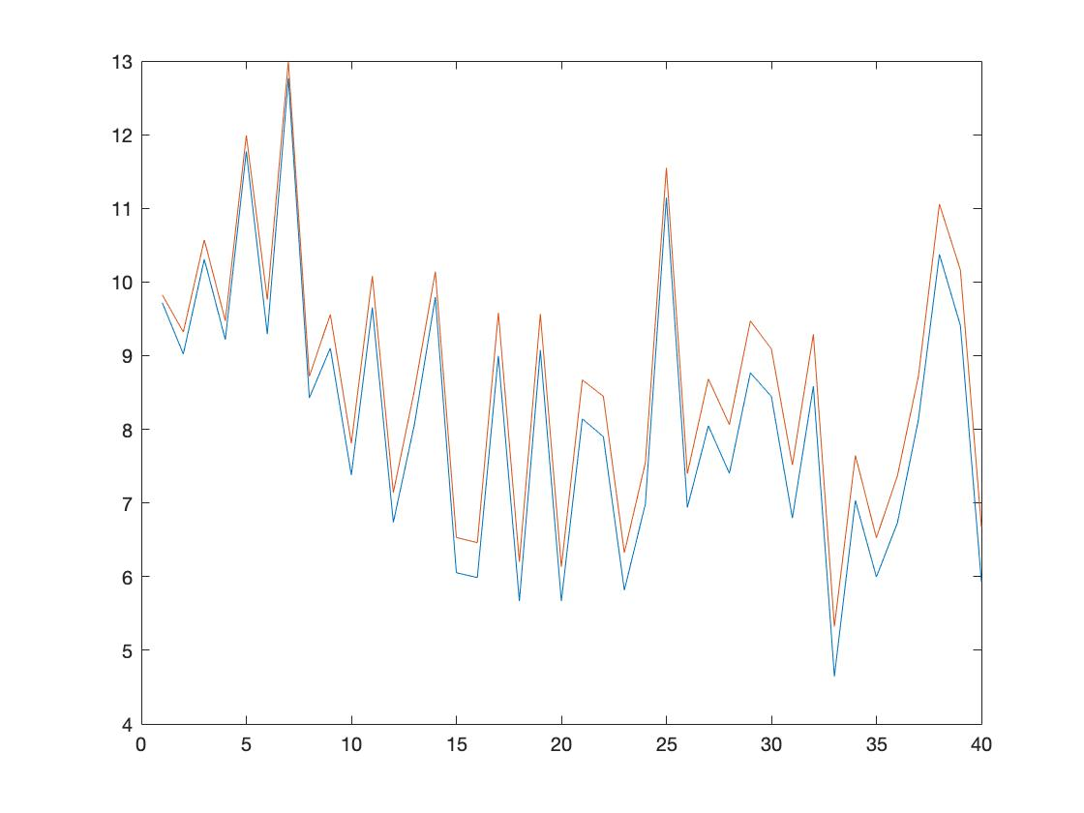

Figure 1: Plot showing loss curves for Experiment a.

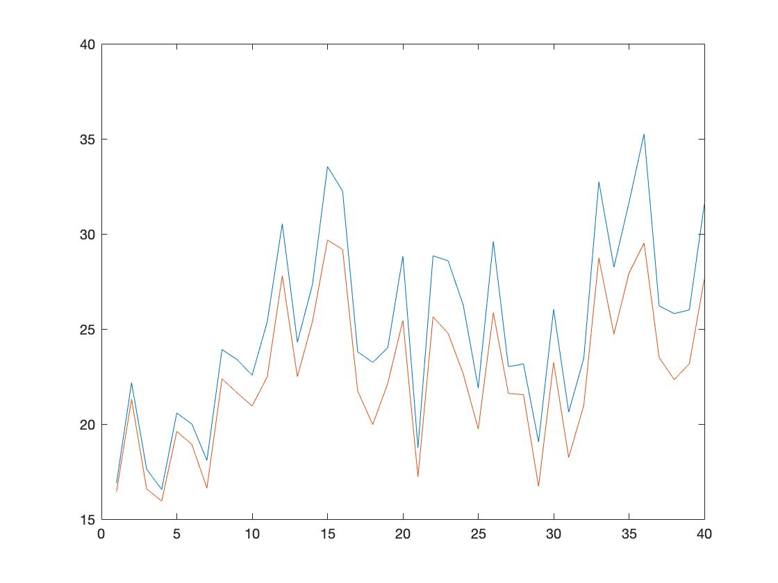

Figure 2: Plot showing the accuracy for Experiment a.

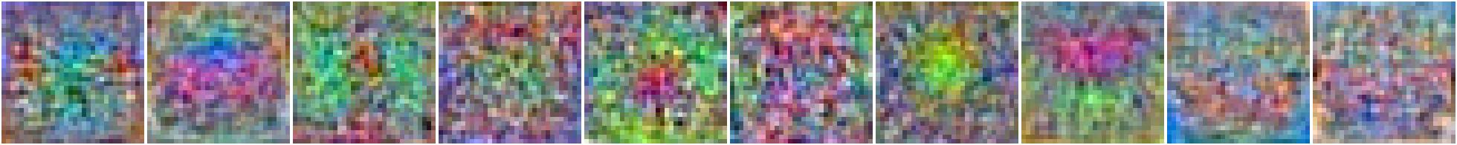

Figure 3: Visualization of the learned W matrix for Experiment a.

* 1. **Experiment b: lambda = 0, n_epochs = 40, n_batch = 100, eta = .01**

This experiment resulted differently than the last experiment. It has a lower learning rate – this smoothed out the curves in the plots and had a more stable weight matrix. This was an improvement from the last experiment, but the images are still a bit noisy.

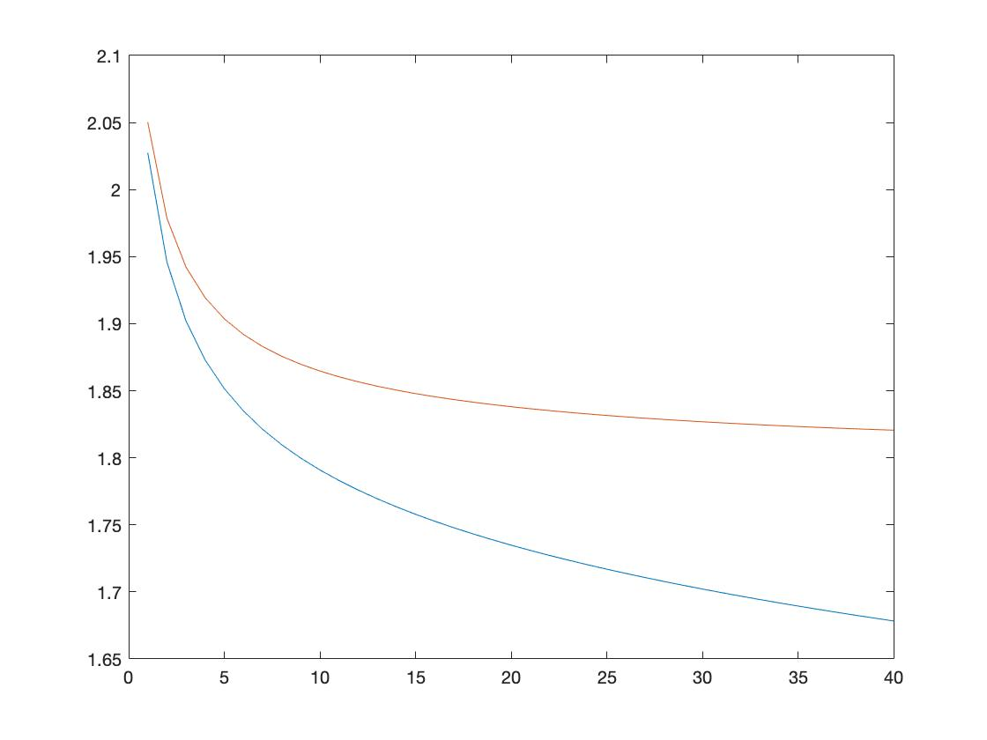

Figure 4: Plot showing loss curves for Experiment b.

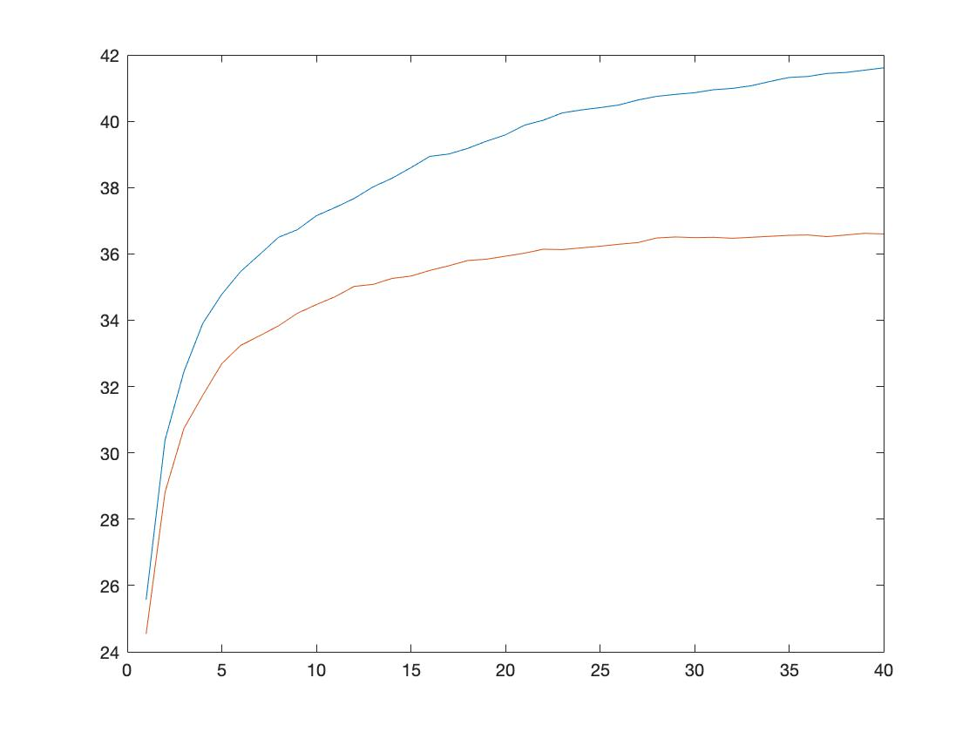

Figure 5: Plot showing the accuracy for Experiment b.

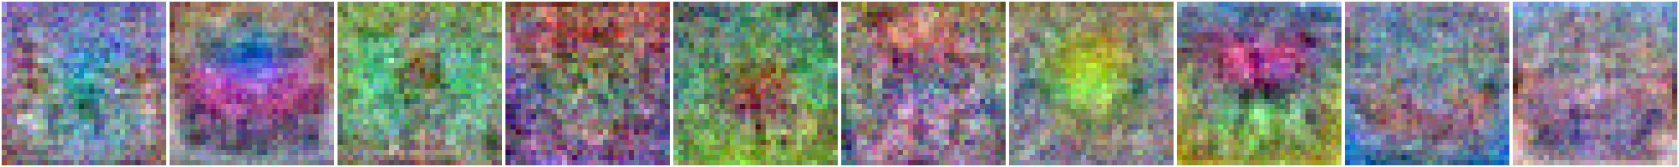

Figure 6: Visualization of the learned W matrix for Experiment b.

* 1. **Experiment c: lambda = .1, n_epochs = 40, n_batch = 100, eta = .01**

In this experiment, we decided to increase the regularization term – this resulted in a smoother weight matrix visualization and the performance became more stable than before. Another change is in the plots, where it takes less epochs for the curves to become stable.

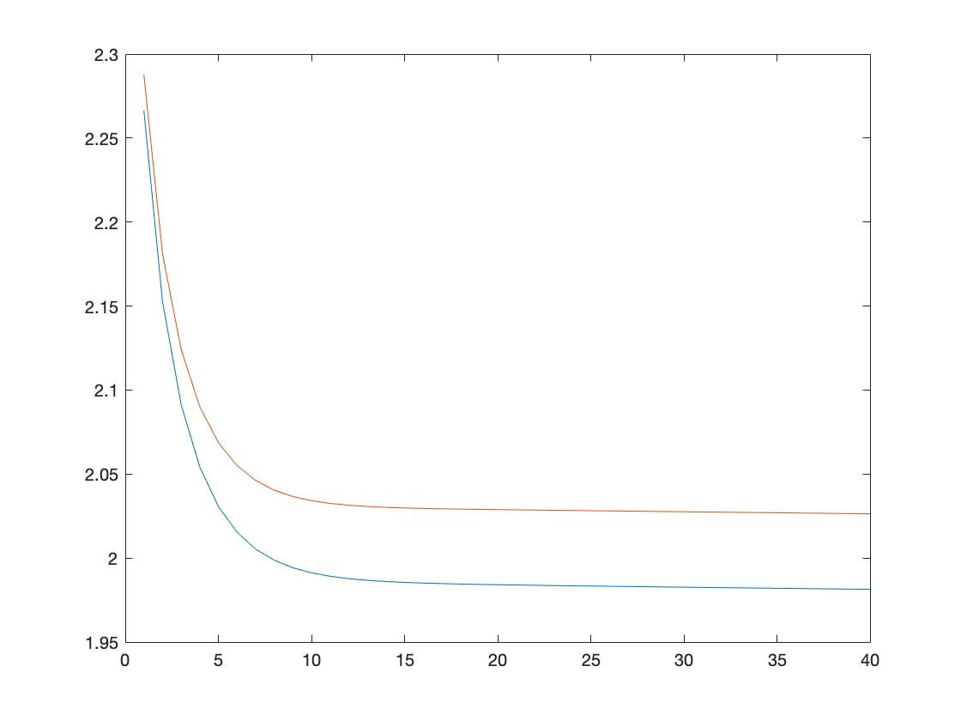

Figure 7: Plot showing loss curves for Experiment c.

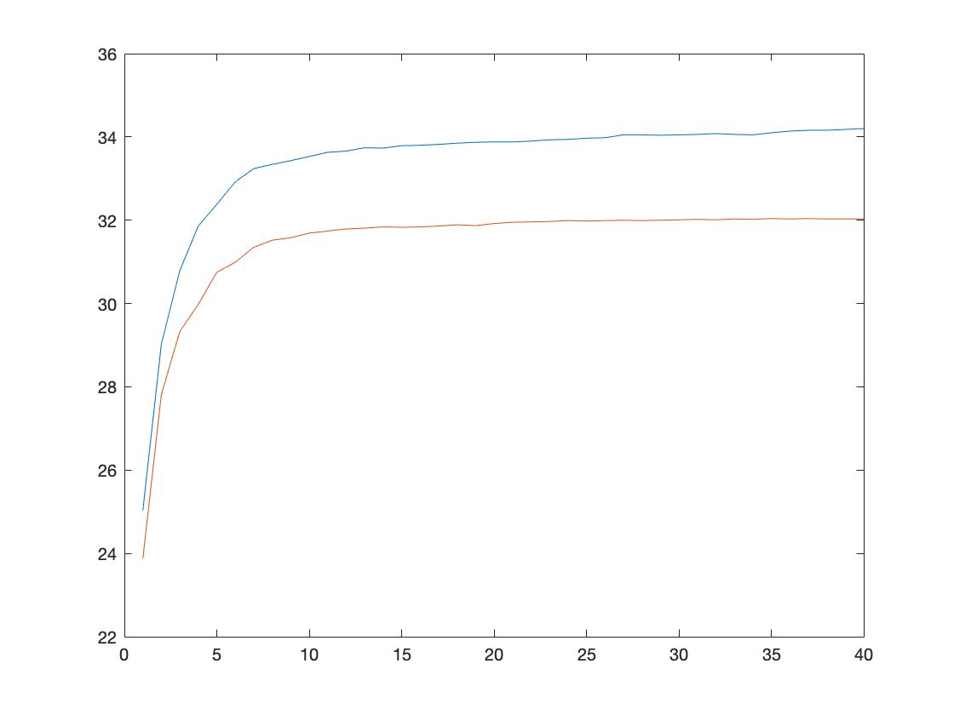

Figure 8: Plot showing the accuracy for Experiment c.

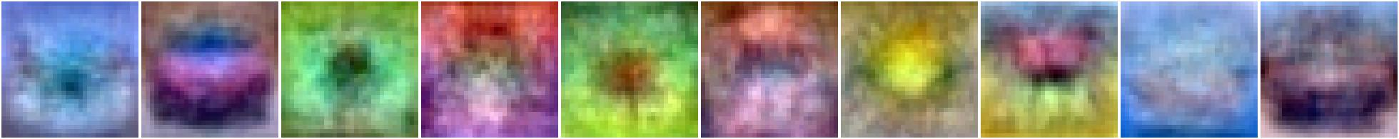

Figure 9: Visualization of the learned W matrix for Experiment c.

* 1. **Experiment d: lambda = 1, n_epochs = 40, n_batch = 100, eta = .01**

In the last experiment, we increased the regularization even more; however, it was too high and resulted in low performance. The loss and accuracy plots suddenly make a turn instead of smoothly stabilizing.

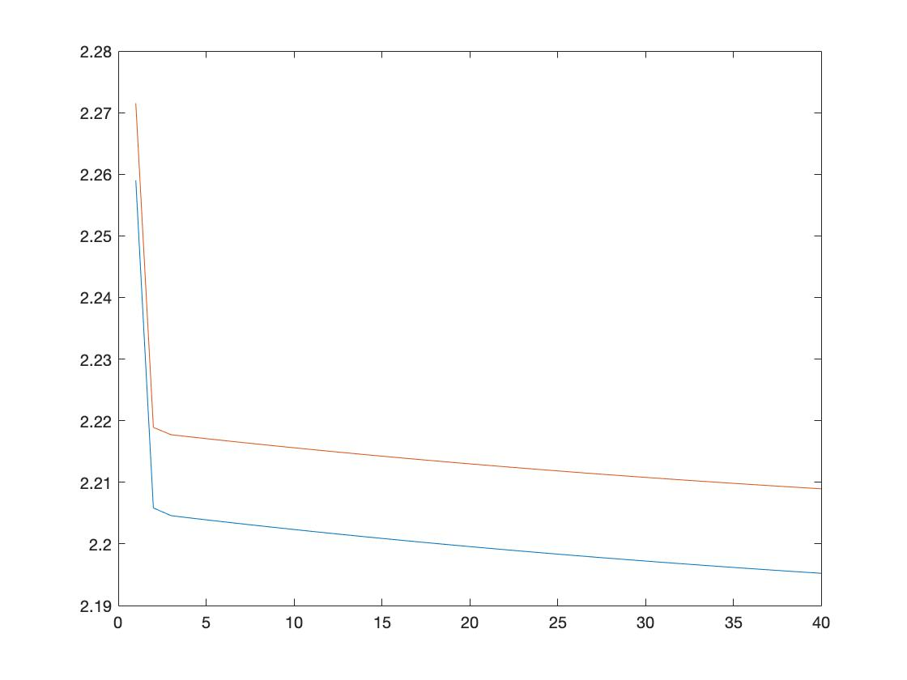

Figure 10: Plot showing loss curves for Experiment d.

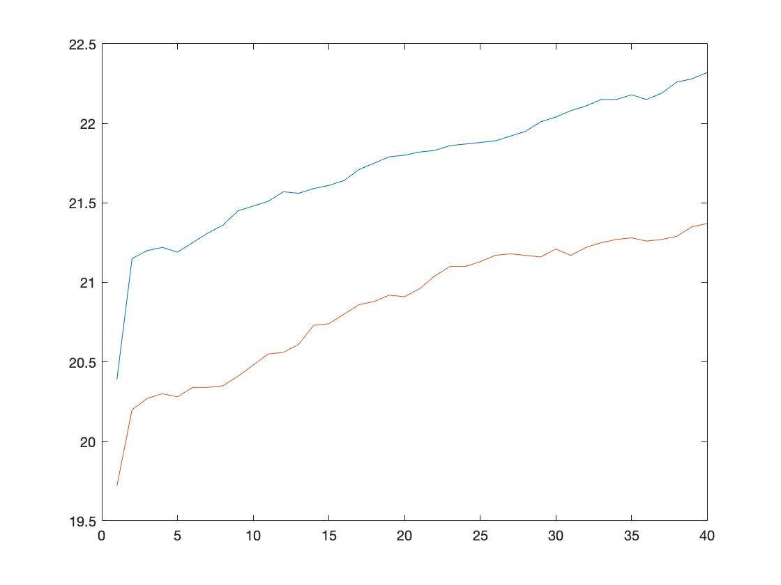

Figure 11: Plot showing the accuracy for Experiment d.



Figure 12: Visualization of the learned W matrix for Experiment d.

After each experiment, I get the final test accuracy that my network achieves after each of the training runs. Below are the results:

|  |  |
| --- | --- |
| **Experiments** | **Accuracies** |
| a | 27.58% |
| b | 36.65% |
| c | 33.37% |
| d | 21.92% |