**Linear Algebra**

When formalizing intuitive concepts, a common approach is to construct a set of objects (symbols) and a set of rules to manipulate these objects. This is known as an algebra.

Linear algebra is the study of vectors and certain algebra rules to manipulate vectors. The vectors are called “geometric vectors”, which are usually denoted by a small arrow above the letter, e.g., $\vec{x}$ and $\vec{y}$.

1. **Geometric Vectors:**

geometric vectors are instances of the vector concepts introduced previously. Interpreting vectors as geometric vectors enables us to use our intuitions about direction and magnitude to reason about mathematical operations:

+ = Addition Two Geometric Vectors

λ $\vec{x}$, λ ∈ R Multiplication by a Scalar

1. **Polynomial Vectors:**

Polynomials are (rather unusual) instances of vectors. Note that polynomials are very different from geometric vectors. While geometric vectors are concrete “drawings”, polynomials are abstract concepts. However, they are both vectors in the sense previously de-scribed.

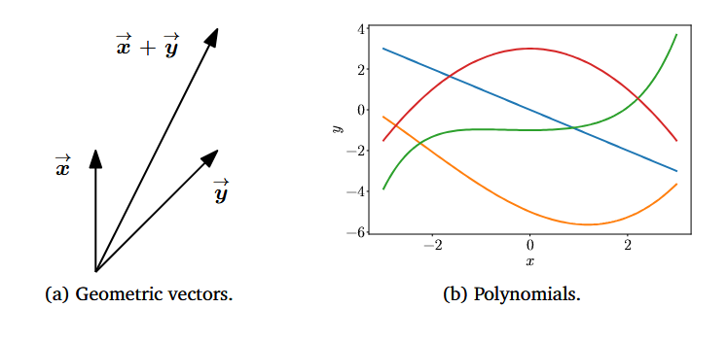

1. **Audio signals are Vectors**:

Audio signals are represented as a series of numbers. We can add audio signals together, and their sum is a new audio signal. If we scale an audio signal, we also obtain an audio signal. Therefore, audio signals are a type of vector, too.

1. **Elements of Rn** (tuples of n real numbers) are **Vectors**. Rn is more abstract than polynomial.

a + b = c ∈ Rn

λa ∈ Rn

Linear algebra focuses on the similarities between these Vector Concepts. We can add them together and multiply them by Scalars. We will largely focus on vectors in Rn since most algorithms in linear algebra are formulated in Rn. We often consider data to be represented as vectors in Rn. We will focus on finite dimensional vector spaces, in which case there is a 1:1 correspondence between any kind of vector and Rn. When it is convenient, we will use intuitions about geometric vectors and consider array-based algorithms. One major idea in mathematics is the idea of “closure”. This is the question: What is the set of all things that can result from my proposed operations? In the case of vectors: What is the set of vectors that can result by starting with a small set of vectors, and adding them to each other and scaling them? This results in a vector space. The concept of a vector space and its properties underlie much of machine learning. The concepts introduced in this chapter are summarized in the below Figure.

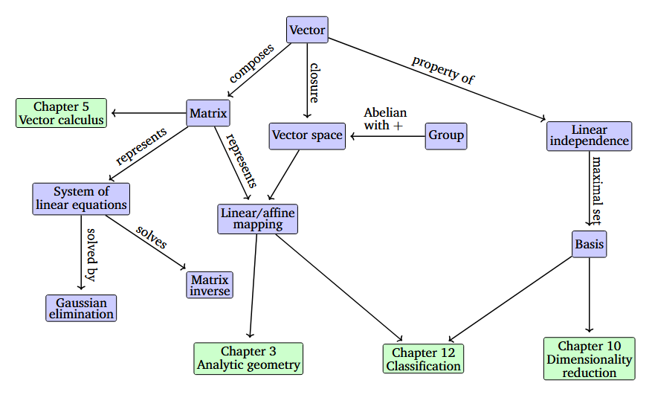

**Systems of Linear Equations**

Matrices are commonly used in machine learning and data science to represent data and its transformations. In this week, you will learn how matrices naturally arise from systems of equations and how certain matrix properties can be thought in terms of operations on system of equations.

**Learning Objectives**

* Form and graphically interpret 2x2 and 3x3 systems of linear equations
* Determine the number of solutions to a 2x2 and 3x3 system of linear equations
* Distinguish between singular and non-singular systems of equations
* Determine the singularity of 2x2 and 3x3 system of equations by calculating the determinant

**Lesson 1: Systems of Linear equations: two variables**

* Machine learning motivation
* Systems of sentences
* Systems of equations
* Systems of equations as lines
* A geometric notion of singularity
* Singular vs nonsingular matrices
* Linear dependence and independence
* The determinant