1. Introduction 2
2. Methodology and models 3
2.1 Dataset and Preprocessing 3
2.1.1 Data Splits and the Golden Data Block 4
2.2 Model A — BERT-base-uncased 4
2.2.1 Architecture and Approach 4
2.2.2 Tokenisation 4
2.2.3 Training Configuration 4
2.3 Model B — FinBERT (ProsusAI/Finbert) 5
2.4 Model C — GPT-OSS 20B (Reasoning-Based Prompting) 5
2.4.1 Setup 5
2.4.2 Output Parsing and Error Handling 5
2.4.3 The 15-Prompt Ablation Study 6
2.4.4 Final Evaluation and Reasoning Capture 7
2.5 Technical Challenges and Resolutions 7
2.6 Comparative Evaluation Setup 7
2.7 Evaluation Metrics 7
3. Results 8
3.1 Dataset Overview 8
3.2 Model A – BERT-base-uncased 8
3.2.1 Before Fine-Tuning (Baseline) 8
3.2.2 Fine-Tuning BERT-base-uncased 8
3.2.3 Test Set Performance (After Fine-Tuning) 9
3.3 Model B – FinBERT (ProsusAI/finbert) 9
3.3.1 Before Fine-Tuning (Baseline) 10
3.3.2 Fine-Tuning FinBERT 10
3.3.3 Test Set Performance (After Fine-Tuning) 10
3.4 Model C – GPT-OSS (20B) Reasoning Extension 11
3.4.1 Prompt Ablation Study 11
3.4.2 Final Evaluation 11
3.4.3 Reasoning Quality 12
4. Discussion 12
4.1 BERT Before and After 12
4.2 FinBERT Outperformed BERT 13
4.3 The Positive Class Problem 14
4.4 GPT-OSS: Zero-Shot Prompting Without Training 15
4.4.1 Ablation Study Findings 15
4.4.2 Final Evaluation and Reasoning Quality 16
4.5 Fine-Tuning vs. Reasoning: Practical Implications 17
4.6 Ethics and Limitations 18
5. Conclusion 18

ABSTRACT

This study investigates financial sentiment classification using three Natural Language Processing (NLP) approaches: a fine-tuned BERT-base model, a domain-specific FinBERT model, and a reasoning-based large language model (GPT-OSS). Using the Financial PhraseBank dataset, a consistent preprocessing pipeline and controlled data-splitting strategy were applied to ensure fair evaluation across models. The findings show that fine-tuned BERT significantly improves from a weak baseline (macro-F1 = 0.248) to strong performance (macro-F1 = 0.84), demonstrating the importance of task-specific training. However, FinBERT achieves the best overall results (macro-F1 = 0.885, accuracy = 89.3%), confirming the advantage of domain-specific pre-training. GPT-OSS, despite operating in a zero-shot setting, achieves competitive performance (macro-F1 ≈ 0.80) and demonstrates perfect recall for negative sentiment, highlighting its strength in detecting critical financial signals. Overall, the results indicate that domain-specific models outperform general models, while reasoning-based approaches provide strong performance without training and offer enhanced explainability, suggesting potential for hybrid systems in financial NLP applications.

KeyWords: Financial Sentiment Analysis; NLP; FinBERT; BERT; Large Language Models; Text Classification

1. Introduction
Financial markets are strongly influenced by information released through news articles, corporate announcements, and economic reports. Investors and financial analysts frequently rely on news sentiment to interpret market trends and support decision-making processes. However, the rapid growth in the volume of financial news makes manual analysis increasingly difficult. As a result, Natural Language Processing (NLP) techniques are widely used to automatically analyse textual data and extract meaningful insights from financial information (Cambria and White, 2014).
Recent developments in deep learning have significantly improved the performance of NLP systems, particularly with the introduction of transformer-based architectures. One of the most widely used models is BERT (Bidirectional Encoder Representations from Transformers), a general-purpose language model capable of capturing contextual relationships between words in a sentence through bidirectional training (Devlin et al., 2019). BERT has achieved strong results in many NLP tasks, including sentiment analysis, question answering, and text classification.
However, general-purpose language models may struggle to fully understand specialised terminology commonly found in financial texts. To address this limitation, domain-specific models such as FinBERT have been developed. FinBERT is a transformer-based model that has been pre-trained on financial documents and is designed to better capture the linguistic patterns and terminology used in financial markets (Araci, 2019).
This study investigates financial sentiment classification using three different approaches. First, a fine-tuned BERT-base model is used as a baseline sentiment classifier. Second, the performance of FinBERT is evaluated to determine whether domain-specific pretraining improves classification performance. Finally, a reasoning-based large language model (GPT-OSS) is used to generate sentiment predictions through step-by-step reasoning. By comparing these approaches, this study aims to evaluate how domain-specific models and reasoning-based large language models contribute to sentiment analysis in financial contexts.

2. Methodology and models

2.1 Dataset and Preprocessing
The dataset used is the Financial PhraseBank (Kaggle: ankurzing), a collection of financial news headlines each labelled as positive, negative, or neutral. The raw CSV file had no column headers, so the columns were manually named 'sentiment' and 'text' during loading.
The following preprocessing steps were applied to clean the data before feeding it to any model:
Duplicate removal. The raw dataset contained 4,846 rows. After removing 6 exact duplicates, the final clean dataset had 4,840 unique samples.
Label normalisation. All sentiment labels were converted to lowercase to ensure consistent string matching during evaluation.
Mojibake character handling. Because the dataset is loaded with Latin-1 encoding, some Finnish company names contained corrupted characters (e.g., Jyv+Æskyl+Æ instead of Jyväskylä). Rather than deleting these characters (which would merge letters and confuse the model), they were replaced with the standard NLP unknown token [UNK] using a regular expression: str.replace(r'[^\x00-\x7F]+', '[UNK]'). This preserves the sentence structure and signals to the model that content was removed, rather than producing a meaningless merged word.

2.1.1 Data Splits and the Golden Data Block
To ensure all three models were evaluated on exactly the same unseen samples, a strict data splitting protocol — referred to throughout development as the 'Golden Data Block' — was enforced across all Python notebooks. The splits used stratified sampling (stratify=df['sentiment']) with a fixed seed of random_state=13 to guarantee identical class proportions in each partition.

Split | Rows | % of total | Purpose
Training | 3,872 | 80% | Model weight updates
Validation | 484 | 10% | Loss monitoring per epoch
Test | 484 | 10% | Final evaluation — never seen during training
GPT-OSS subset | 80 | — | Sampled from test set
Table 1: Dataset partition sizes and purposes.

The need for this strict protocol emerged after discovering a data leakage bug described in Section 3.5. The 80-sample GPT-OSS subset was drawn from the test set using a second fixed seed (random_state=13) so it could be reproducibly merged with BERT and FinBERT predictions in the comparison notebook.

2.2 Model A — BERT-base-uncased

2.2.1 Architecture and Approach
BERTbaseuncased is a 110Mparameter encoderonly transformer pretrained on general English text. For sentiment classification, a threeclass linear classification head was added, and full finetuning was performed—updating all layers of the model.

2.2.2 Tokenisation
All inputs were tokenised using the bert-base-uncased tokenizer from HuggingFace to ensure compatibility with pretraining vocabulary. Texts were truncated or padded to a maximum length of 128 tokens.

2.2.3 Training Configuration

Hyperparameter | BERT-base-uncased/ FinBERT
Learning rate | 2e-5
Batch size (train/eval) | 16 / 16
Epochs | 3
Weight decay | 0.01
Max token length | 128
Evaluation strategy | Per epoch
Best model selection | load_best_model_at_end=True
Table 2: Fine-tuning hyperparameters for both Transformer models.
Training loss was logged at the end of each epoch. The best model checkpoint was saved automatically using load_best_model_at_end=True, selecting the checkpoint with the lowest validation loss. The final model and its tokenizer were saved to disk using trainer.save_model() and tokenizer.save_pretrained() for later use in the comparison notebook without retraining.

2.3 Model B — FinBERT (ProsusAI/Finbert)
FinBERT shares the same architecture as BERT but is pretrained on financial reports, SEC filings, and financial news. Because it was already optimised for financial language, no architecture modifications were needed. The same finetuning pipeline and hyperparameters used for BERT were applied to FinBERT.
Prefinetuning tests were also performed to illustrate the performance benefit of domainspecific pretraining. Without finetuning, FinBERT already outperformed BERT across all metrics.

2.4 Model C — GPT-OSS 20B (Reasoning-Based Prompting)

2.4.1 Setup

PTOSS 20B was run locally using the Ollama framework through the gpt-oss:20b-cloud model tag. All predictions were generated using the /api/chat endpoint, which supports structured system/user message input.
Inference used:
- Temperature = 0.0 (deterministic outputs)
- JSONstructured output enforced at the API level
- A fixed system prompt instructing the model to output a JSON object containing reasoning and a final sentiment label

2.4.2 Output Parsing and Error Handling
Because large language models sometimes produce JSON wrapped in Markdown code fences (e.g., ```json { ... } ```) or add preamble text before the JSON object, a robust two-stage parsing strategy was implemented:
Stage 1 — JSON extraction: A regular expression (re.search(r'\{.*\}', reply, re.DOTALL)) scans the full model output and extracts only the content inside the outermost curly braces, discarding any surrounding text.
Stage 2 — Regex fallback: If JSON parsing still fails (for example when a complex reasoning prompt causes the model to produce a long paragraph without any curly braces), re.findall(r'(positive|negative|neutral)', response, re.IGNORECASE) scans the raw text for any sentiment word. The last match is used as the predicted label, because in step-by-step reasoning prompts the final decision appears at the end of the reasoning chain.
This two-stage approach ensured that no prompt run produced a crash, and fallback-extracted labels were still valid sentiment words rather than defaulting blindly to 'neutral'.
This ensured that no sample produced invalid output during the ablation study.

2.4.3 The 15-Prompt Ablation Study
Before settling on a final prompt, an ablation study was conducted across 15 different prompt engineering strategies. An ablation study is a scientific method borrowed from neuroscience, where researchers remove or change one component at a time to measure its individual effect on the overall system. In machine learning and NLP, this means running multiple versions of an experiment where only one variable changes — in this case, the prompt wording — while everything else stays fixed: the same model, the same dataset, the same 80 samples, the same temperature setting, and the same parsing logic. By doing this systematically across 15 different prompt designs, it becomes possible to isolate which specific characteristics of a prompt (such as adding examples, requesting step-by-step reasoning, or assigning a persona) actually improve or reduce the model's accuracy, rather than guessing or assuming which approach works best.
Fifteen prompt styles were evaluated—including zeroshot, constrained, roleplay, fewshot, chainofthought, and multistep reasoning prompts. Each prompt was applied to all 80 test samples, and accuracy + macroF1 were recorded.
The zeroshot direct prompt produced the best overall performance and was used for final evaluation.

ID | Strategy | Core technique
P1 | Zero-Shot | Plain direct question, no examples or instructions
P2 | Constrained | Strictly forces one of three labels only
P3 | Role-Play | Model assigned Wall Street expert persona
P4 | One-Shot | One labelled example provided before the question
P5 | Few-Shot | Three balanced examples (positive, negative, neutral)
P6 | Chain-of-Thought | Model asked to think step-by-step before labelling
P7 | Role + CoT | Expert persona combined with step-by-step reasoning
P8 | Definitions | Explicit financial definitions given for each class
P9 | Action | Investor buy/sell/hold framing
P10 | Keywords | Extract three financial keywords first, then classify
P11 | Contrastive | Argue both sides (positive and negative), then decide
P12 | Nuance | Look for subtle financial meaning beyond surface wording
P13 | Risk | Assess financial risk level first, then assign sentiment
P14 | Future Focus | Focus on whether headline implies future growth or decline
P15 | Ultimate | Multi-step expert prompt: analyse, define, conclude
Table 3: Summary of the 15 prompt strategies tested in the ablation study.

All 15 prompts used the /api/chat endpoint with a shared system message instructing the model to return only a raw JSON object with keys 'reasoning' and 'final_label'. This enforced a consistent output format across all prompt variants so that differences in accuracy could be attributed to the prompt wording rather than to parsing failures.

2.4.4 Final Evaluation and Reasoning Capture
After the ablation study identified the best-performing prompt, a final evaluation was run using the system/user chat structure described in Section 3.4.1. In addition to the predicted label, the model's reasoning text was saved to a CSV file (gpt_oss_results.csv) using a structured dataframe that stored the headline text, true label, predicted label, explanation, and raw model output for each of the 80 samples. This file was used in the comparison notebook to merge all three model predictions for qualitative analysis.

2.5 Technical Challenges and Resolutions
During development, several technical issues affected model performance and required corrective steps. Missing re imports caused GPTOSS outputs to default to neutral, prompting errorexposing exception handling. Some requests incorrectly used the /api/generateendpoint with chatformatted payloads, resulting in empty responses until all calls were routed to /api/chat. GPTOSS often returned JSON wrapped inside Markdown or with extra text, so a twostage regex extraction with a sentimentword fallback was implemented. Data leakage appeared due to inconsistent random seeds across notebooks, which was resolved by enforcing a unified random_state=13 and applying the same cleaning pipeline. Encoding errors from corrupted Finnish characters were normalised by replacing all nonASCII sequences with [UNK]. Finally, LangChain introduced prompt bloat that reduced accuracy, leading to the decision to rely solely on lightweight requestsbased API calls.

2.6 Comparative Evaluation Setup
For the threemodel comparison, BERT and FinBERT were loaded as HuggingFace pipelines and evaluated alongside GPTOSS using the same deterministic 80sample subset extracted from the Golden Data Block. Identical preprocessing—including the [UNK] replacement—was applied across all models to ensure text consistency before merging predictions on the exact input string. Accuracy, macroF1, perclass F1, and confusion matrices were computed, and additional qualitative checks examined cases where models disagreed. This setup ensured a controlled, reproducible environment in which the strengths and weaknesses of domainspecific finetuning versus reasoningbased inference could be directly observed.

2.7 Evaluation Metrics
The following metrics were used throughout the project:
Accuracy. The proportion of correctly classified headlines. Because the dataset is imbalanced (neutral = 59.5%, positive = 28.2%, negative = 12.5%), accuracy alone can be misleading — a model that predicts 'neutral' for every sample would still achieve 59.3% accuracy.
Macro-F1 Score. The unweighted average of the F1 scores across all three classes. This treats each class equally regardless of size, making it the primary metric for comparing performance on imbalanced data. It is the metric explicitly required by the assignment brief.
Confusion matrix. A visual matrix showing the count of true vs. predicted labels for all combinations of classes, making misclassification patterns easy to interpret.

3. Results

3.1 Dataset Overview
The dataset is imbalanced, with the neutral class being the largest (59.5%), followed by positive (28.2%) and negative (12.5%) samples. A stratified 80/10/10 split (random_state=13) preserved these proportions, resulting in 3,872 training, 484 validation, and 484 test samples. This imbalance is important for interpreting later model performance, particularly on the minority negative class.

3.2 Model A – BERT-base-uncased

3.2.1 Before Fine-Tuning (Baseline)
Before any training, we tested BERT-base-uncased directly on the test set to understand where the model starts from. The results were very poor. It achieved an accuracy of only 59.3% and a macro-F1 score of just 0.248. When we looked at the per-class breakdown, the reason became clear: the model was predicting every single sample as 'neutral'. This is a well-known behaviour for models that were never trained for a specific classification task — they default to the most common pattern in their random output weights, which accidentally matches the majority class. Because 59% of the dataset is neutral, just guessing 'neutral' every time produces 59% accuracy, but the macro-F1 correctly penalises this by giving 0.00 for both negative and positive classes.
Without finetuning, BERT predicted almost every sample as neutral, resulting in 59.3% accuracy and a macroF1 of 0.248—a reflection of the dataset imbalance rather than meaningful performance.

3.2.2 Fine-Tuning BERT-base-uncased
BERT was fine-tuned -base-uncased for 3 epochs using the HuggingFace Trainer API with a learning rate of 2e-5 and a batch size of 16. The training and validation loss curves (Table 2) show a clear learning trend: the training loss dropped significantly from 0.5755 in epoch 1 to 0.1514 by epoch 3, confirming the model was actively learning from the training data.
The validation loss also decreased between epoch 1 and epoch 2, which is positive. However, by epoch 3, the validation loss rose slightly to 0.4425, while the training loss continued to fall. This is a small sign of overfitting — the model starts to learn patterns specific to the training data that do not perfectly generalise to unseen examples. Despite this, the validation accuracy still improved across all three epochs, reaching 86.8% by the end.

Epoch | Train Loss | Val Loss | Val Accuracy | Val Macro-F1
1 | 0.5755 | 0.3840 | 85.5% | 0.826
2 | 0.2746 | 0.3789 | 86.6% | 0.845
3 | 0.1514 | 0.4425 | 86.8% | 0.853
Table 2: BERT-base-uncased training progress per epoch.

3.2.3 Test Set Performance (After Fine-Tuning)
After fine-tuning, BERT-base-uncased improved dramatically. Table 3 shows the full classification report on the held-out test set. The model reached 86.0% overall accuracy and a macro-F1 of 0.84 — a massive jump from the 0.248 baseline.

Class | Precision | Recall | F1-Score | Support
Negative | 0.83 | 0.85 | 0.84 | 61
Neutral | 0.90 | 0.90 | 0.90 | 287
Positive | 0.79 | 0.77 | 0.78 | 136
Macro Average | 0.84 | 0.84 | 0.84 | 484
Overall Accuracy | — | — | 0.86 | 484
Table 3: BERT-base-uncased test set performance after fine-tuning (484 samples).

The model performed best on the neutral class (F1 = 0.90), which makes sense given that neutral examples make up most of the training data. The negative class achieved a reasonable F1 of 0.84. The weakest class was positive (F1 = 0.78), which was more likely to be confused with neutral headlines — a common challenge in financial text where positive language is often subtle (e.g., statements about plans or targets without explicit profit language).
On the full test set, finetuned BERT achieved 86.0% accuracy and 0.84 macroF1. Classwise, BERT performed best on neutral (F1 = 0.90), followed by negative (0.84) and positive (0.78), with positive headlines frequently confused with neutral statements.

3.3 Model B – FinBERT (ProsusAI/finbert)

3.3.1 Before Fine-Tuning (Baseline)
Unlike BERT, FinBERT had already been pre-trained on a large corpus of financial documents. This meant it already had strong knowledge of financial language before we did any fine-tuning at all. Running FinBERT on the test set without any additional training gave an accuracy of 89.3% and a macro-F1 of 0.882. This is already better than fine-tuned BERT, which shows how powerful domain-specific pre-training is. The model correctly identified negative headlines 93.4% of the time (recall = 0.93) and neutral headlines with 88.2% recall.

3.3.2 Fine-Tuning FinBERT
We fine-tuned FinBERT using the same configuration as BERT (3 epochs, lr = 2e-5, batch size = 16). Since FinBERT already had strong financial language understanding, the starting point was much better. The initial training loss of 0.2133 is noticeably lower than BERT's starting loss of 0.5755, reflecting the richer pre-training. By epoch 2, the training loss dropped to 0.1011, and validation accuracy reached 87.4% with a macro-F1 of 0.854.

Epoch | Train Loss | Val Loss | Val Accuracy | Val Macro-F1
1 | 0.2133 | 0.3659 | 85.7% | 0.830
2 | 0.1011 | 0.3550 | 87.4% | 0.854
3 | 0.0 (final) | 0.3919 | 88.0% | 0.866
Table 4: FinBERT training progress per epoch.
Unlike BERT, the validation loss for FinBERT was more stable across epochs, with the lowest validation loss occurring at epoch 2 (0.3550). The rise at epoch 3 (0.3919) suggests a similar mild overfitting pattern, but the model's accuracy still improved to 88.0% on the validation set.

3.3.3 Test Set Performance (After Fine-Tuning)
On the test set, fine-tuned FinBERT achieved 89.3% accuracy and a macro-F1 of 0.885 — the best results of all models in this study. Table 5 shows the per-class breakdown.
What is interesting here is that fine-tuning changed the distribution of errors rather than the overall accuracy (which stayed at 89.3%). Before fine-tuning, FinBERT had strong recall for negative (0.93) but lower precision (0.83), meaning it was catching most negative headlines but also mislabelling some non-negative ones as negative. After fine-tuning, the precision for negative jumped to 0.93, making the model more careful and correct. The positive class also improved, with F1 rising from 0.85 (before) to 0.84 — roughly similar, but with better recall (0.85 vs 0.90), meaning fewer positive headlines were missed.

Class | Precision | Recall | F1-Score | Support
Negative | 0.93 | 0.87 | 0.90 | 61
Neutral | 0.92 | 0.92 | 0.92 | 287
Positive | 0.83 | 0.85 | 0.84 | 136
Macro Average | 0.89 | 0.88 | 0.89 | 484
Overall Accuracy | — | — | 0.89 | 484
Table 5: FinBERT test set performance after fine-tuning (484 samples).

3.4 Model C – GPT-OSS (20B) Reasoning Extension

3.4.1 Prompt Ablation Study
To evaluate prompt sensitivity, GPTOSS was tested with 15 prompt strategies on the same 80 test headlines using the /api/chat endpoint and temperature = 0.0 for fully deterministic outputs. The best-performing prompt was P1_ZeroShot, which achieved 0.775 accuracy and 0.785 macroF1. This prompt used a direct instruction with no examples, role-play, or explicit reasoning steps. Five other prompts — P2_Constrained, P4_OneShot, P9_Action, P10_Keywords, and P15_Ultimate — all reached 0.750 accuracy, while P12_Nuance and P13_Risk performed worst at 0.650, which is 12.5 percentage points below the best result. Overall, the ablation suggests that for this three-class task, simple prompts outperform more elaborate reasoning prompts, which often encourage over-interpretation of neutral headlines. A notable exception was P15_Ultimate, whose macroF1 of 0.778 was the second highest, suggesting more balanced predictions despite lower raw accuracy.
Prompt Strategy | Accuracy | Macro-F1 | Description
P1_ZeroShot | 0.775 | 0.785 | ★ Best — plain direct question
P2_Constrained | 0.750 | 0.751 | Strict 3-class instruction
P4_OneShot | 0.750 | 0.760 | Single labelled example
P9_Action | 0.750 | 0.763 | Buy / sell / hold framing
P10_Keywords | 0.750 | 0.761 | Extract keywords first
P15_Ultimate | 0.750 | 0.778 | Multi-step expert prompt
P6_CoT | 0.713 | 0.730 | Chain-of-thought reasoning
P12_Nuance (worst) | 0.650 | 0.682 | Subtle nuance prompt
P13_Risk (worst) | 0.650 | 0.663 | Financial risk framing
Table 6: Ablation study results for all 15 prompt strategies (80 test samples, temperature=0.0).

3.4.2 Final Evaluation
For final evaluation, the best prompt (P1_ZeroShot) was used in a full system/user chat setup that also stored the model’s reasoning. On the 80-sample subset, GPTOSS achieved 0.7875 accuracy and 0.80 macroF1. Its strongest result was on the negative class, where it achieved precision = 0.93, recall = 1.00, and F1 = 0.96, correctly identifying every negative headline in the test set. Performance on the neutral class was weaker in recall (0.73), despite high precision (0.90), meaning some neutral headlines were predicted as positive. The positive class was the weakest overall (precision = 0.54, recall = 0.78, F1 = 0.64), showing that the model often over-labelled positive sentiment, especially in neutral headlines containing action-oriented or achievement-related language. These results show that GPTOSS was highly effective at detecting negative news, but less reliable on the neutral–positive boundary.

Class | Precision | Recall | F1-Score | Support
Negative | 0.93 | 1.00 | 0.96 | 13
Neutral | 0.90 | 0.73 | 0.81 | 49
Positive | 0.54 | 0.78 | 0.64 | 18
Macro Average | 0.79 | 0.84 | 0.80 | 80
Overall Accuracy | — | — | 0.7875 | 80
Table 7: GPT-OSS final evaluation per-class metrics using P1_ZeroShot (80 samples).

3.4.3 Reasoning Quality
A key advantage of GPTOSS is that it produced a written explanation alongside each prediction. For correct cases, the reasoning was usually clear and tied directly to phrases in the headline. For example, the headline “Return on capital employed rose by 4.8 percentage points to 19.6%” was correctly classified as positive because the model linked the increase in return on capital employed to improved financial performance. For incorrect cases, the reasoning revealed a consistent error pattern: GPTOSS often over-interpreted factual or strategic statements as positive. For instance, the headline about a deal being aligned with Etteplan’s strategy was labelled neutral in the dataset, but GPTOSS interpreted this alignment as favourable and predicted positive.

4. Discussion

4.1 BERT Before and After
Before any fine-tuning, BERT-base-uncased achieved only 59.3% accuracy and a macro-F1 of 0.248 on the test set. Looking at the per-class report, the reason is clear: the model predicted every single headline as 'neutral'. Because neutral makes up 59.5% of the dataset, guessing neutral for everything accidentally produces 59% accuracy — but the macro-F1 of 0.248 correctly exposes this as useless performance. BERT had no concept of financial sentiment; it only had a randomly initialised classification head on top of its general language representations.
After three epochs of fine-tuning, BERT reached 86.0% accuracy and macro-F1 = 0.840 on the full 484-sample test set. The training loss dropped consistently from 0.5755 in epoch 1 to 0.1514 by epoch 3. The validation loss decreased through epoch 2 (0.3789) but rose slightly at epoch 3 (0.4425), while validation accuracy kept improving. This small divergence between training and validation loss is a mild sign of overfitting — the model begins memorising training patterns rather than generalising. In practice the effect was limited, and early stopping (which was not used here) would be a sensible addition in future work.
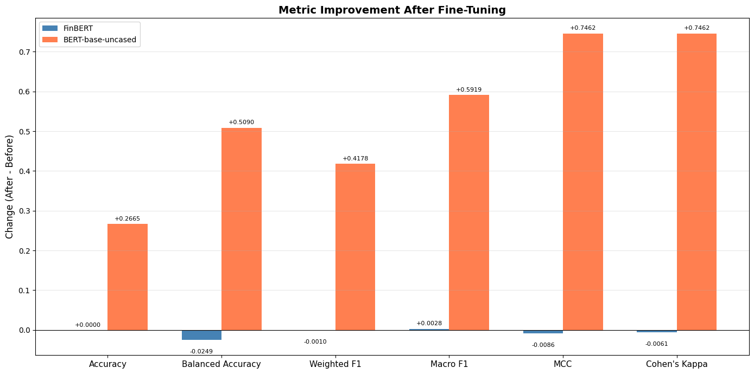
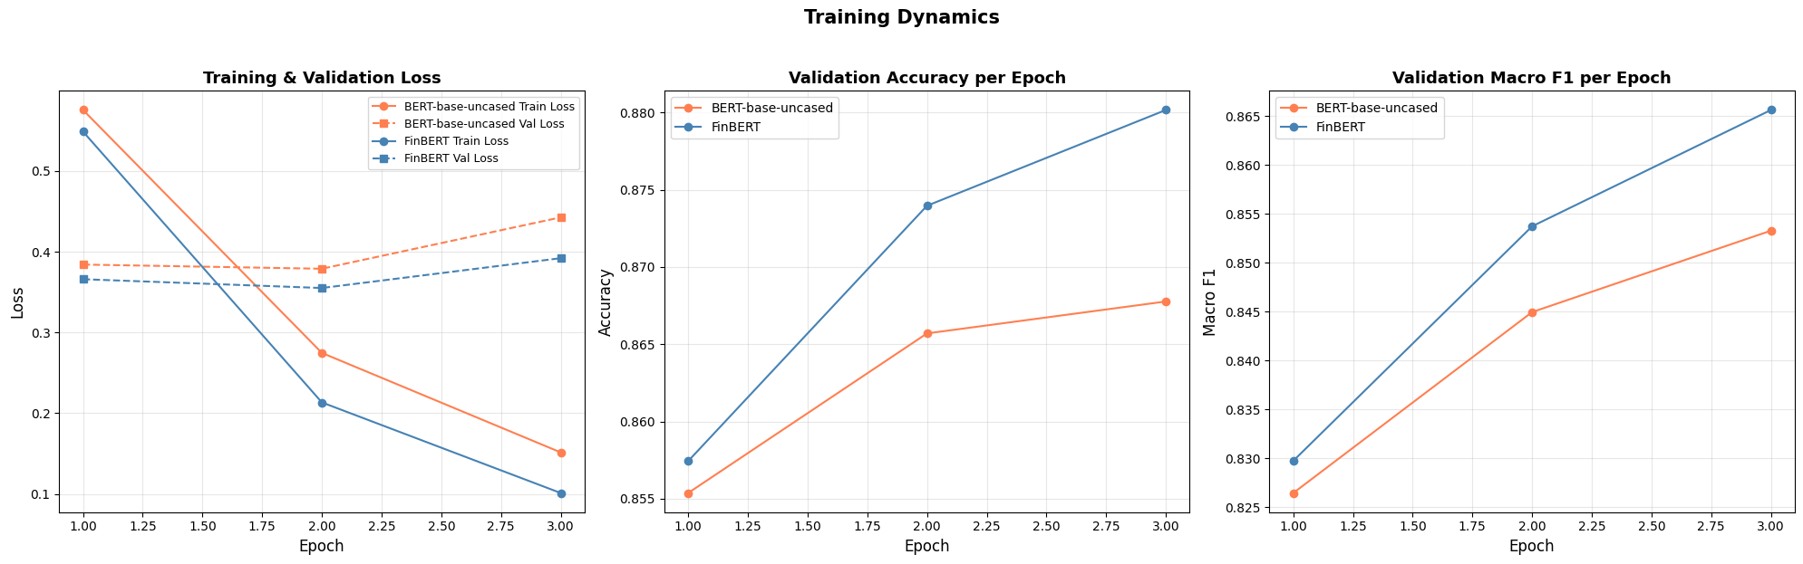
Training and validation loss curves for BERT-base (left) and FinBERT (right) across 3 epochs. FinBERT starts with a much lower loss, reflecting its domain pre-training.

4.2 FinBERT Outperformed BERT
FinBERT reached 89.3% accuracy and macro-F1 = 0.885 after fine-tuning, compared to BERT's 86.0% and 0.840. More strikingly, FinBERT before fine-tuning already scored 89.3% — beating fully fine-tuned BERT. This could be evidence in the project that domain-specific pre-training matters more than task-specific training when the language is highly specialised.
The reason is that financial text uses vocabulary and phrasing that general English models have no understanding of. Terms like 'write-down', 'EBIT', 'operating leverage', or 'bearish' are common in financial reporting but rare in the Wikipedia and BookCorpus text BERT was trained on. FinBERT was pre-trained on a large corpus of financial news and reports, so its internal representations already associate these terms with positive or negative financial outcomes before a single labelled example is shown to it.
Fine-tuning FinBERT did not increase overall accuracy (it stayed at 89.3%) but it changed the distribution of errors. Before fine-tuning, FinBERT had strong negative recall (0.93) but lower precision (0.83), meaning it correctly caught most negative headlines but also mislabelled some non-negative ones. After fine-tuning, negative precision jumped to 0.93, making the model more careful about when to commit to the negative label. This kind of precision improvement matters greatly in financial applications where a false negative signal could trigger erroneous automated trades.

Model / Condition | Accuracy | Macro-F1 | Neg F1 | Neu F1 | Pos F1
BERT (before fine-tuning) | 0.593 | 0.248 | 0.00 | 0.74 | 0.00
BERT (after fine-tuning) | 0.860 | 0.840 | 0.84 | 0.90 | 0.78
FinBERT (before fine-tuning) | 0.893 | 0.882 | 0.88 | 0.92 | 0.85
FinBERT (after fine-tuning) | 0.893 | 0.885 | 0.90 | 0.92 | 0.84
GPT-OSS best prompt (P1_ZeroShot) | 0.788 | 0.803 | 0.96 | 0.81 | 0.64
Full performance summary across all models and conditions. Bold row = best overall result.

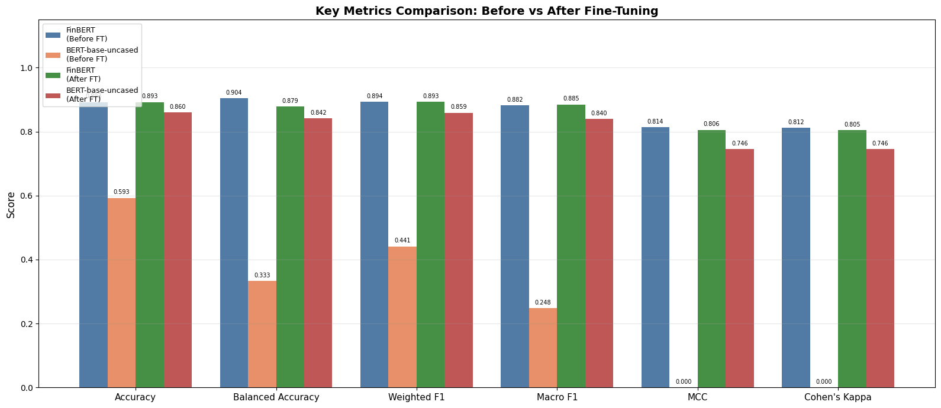
Accuracy and Macro-F1 scores for both BERT and FinBERT before and after fine-tuning. This shows the effect of fine-tuning is large for BERT but minimal for FinBERT, which already performs well due to domain pre-training.

4.3 The Positive Class Problem
Across every model in this study — fine-tuned BERT (F1 = 0.78), fine-tuned FinBERT (F1 = 0.84), and GPT-OSS (F1 = 0.64) — the positive class consistently produced the lowest score. This is not a coincidence. Negative financial language is lexically distinct: words like 'loss', 'decline', 'fell', and 'cut' are strong, unambiguous signals. Positive language is often more indirect — plans, targets, strategic agreements, and forward-looking statements.
For example, the headline "Etteplan targets to employ at least 20 people in Hungary" is labelled positive in the dataset, but it does not contain any explicit profit or revenue language. A model that has not internalised the annotation convention of this specific dataset will often treat this kind of headline as neutral. This is a fundamental challenge in the dataset's labelling style, not just a model limitation, and it explains why even the best model (FinBERT) still makes errors on the positive class.

4.4 GPT-OSS: Zero-Shot Prompting Without Training

4.4.1 Ablation Study Findings
The ablation study tested 15 prompt strategies on the same 80 headlines, following the ablation methodology described in Section 3.4.3. The key finding was unexpected: the simplest prompt won. P1_ZeroShot — a plain direct question with no examples, no role, and no reasoning steps — achieved the best accuracy (0.775) and macro-F1 (0.785).

Prompt | Accuracy | Macro-F1 | Why it performed this way
P1_ZeroShot ★ | 0.775 | 0.785 | Simple direct question — no instructions to distract the model
P2_Constrained | 0.750 | 0.751 | Strict three-class boundary; very close to best
P6_CoT | 0.713 | 0.730 | Reasoning steps introduced label drift
P4_OneShot | 0.550 | 0.536 | Single negative example biased predictions toward negative
P12_Nuance (worst) | 0.650 | 0.682 | Open-ended reasoning caused over-interpretation of neutral headlines
Selected ablation study results showing a range of prompt strategies. Full results in the notebook.

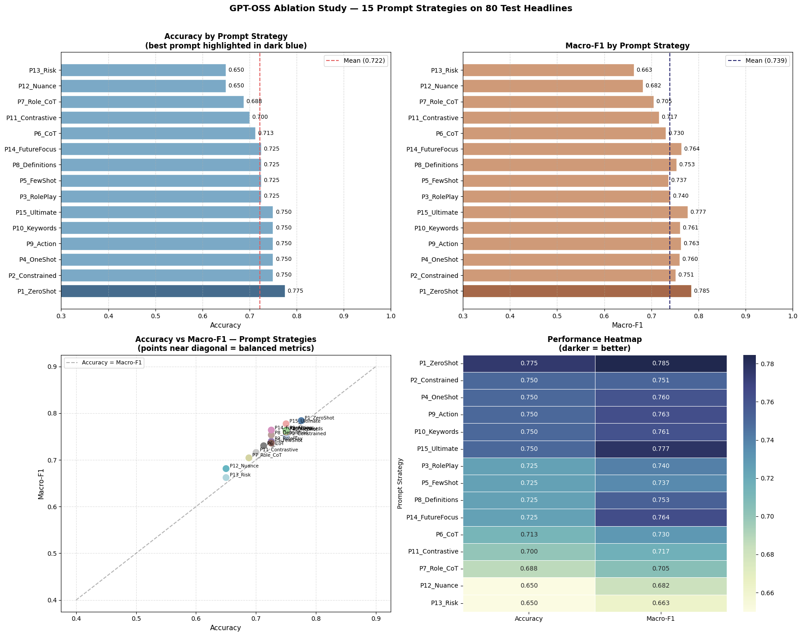
Bar chart of accuracy across all 15 prompt strategies. The horizontal dashed red line shows the mean accuracy. Simple prompts (P1, P2) outperform complex ones (P11, P12, P13).
Prompts that gave the model more freedom to reason — P11_Contrastive (argue both sides), P12_Nuance (look for subtle meaning), P13_Risk (assess financial risk) — all scored below 0.70. This pattern is consistent with the concept of Prompt Bloat: when a 20B model is given too many simultaneous instructions, its attention is divided between following the instructions and analysing the text. The model talks itself into the wrong answer through its own generated reasoning.
P4_OneShot (accuracy = 0.550) was the second-worst prompt. Providing a single negative example ('Profits fell 20%') likely anchored the model toward negative predictions, reducing its ability to detect positive and neutral headlines. This is a known phenomenon called anchoring bias in few-shot prompting — a single poorly chosen example can be worse than no example at all. In simpler terms, if you give an LLM even one bad example, it may copy that mistake and produce worse results than if you had given no example at all. This effect is called anchoring bias.

4.4.2 Final Evaluation and Reasoning Quality
Using the best prompt, GPT-OSS achieved 78.8% accuracy and macro-F1 = 0.803 on the 80-sample test set. The most striking result was the negative class: perfect recall of 1.00 and F1 = 0.963 — the highest single-class score achieved by any model in this study. GPT-OSS did not miss a single negative headline. This has practical significance: in financial applications, missing a negative signal is the costliest type of error.
The most important comparison is the Macro-F1: GPT-OSS (0.803) is nearly identical to fine-tuned BERT (0.804) on the same 80 samples. A model that used zero labelled training examples matched a model trained on 3,872 labelled examples. The difference lies in where each model makes errors — BERT distributes mistakes more evenly, while GPT-OSS is almost perfect on negative but significantly weaker on positive (F1 = 0.64).
The reasoning chains captured in the CSV reveal the model's systematic blind spot. When GPT-OSS incorrectly classified neutral headlines as positive, its reasoning typically pointed to forward-looking language: for the Etteplan headline above, it wrote that the plan to hire people "implies a favourable outcome and positive growth expectation." This reasoning is financially plausible, but it contradicts the dataset's annotation convention. The model applies general financial logic rather than the specific labelling style of this dataset — a limitation that fine-tuned models overcome through training examples.

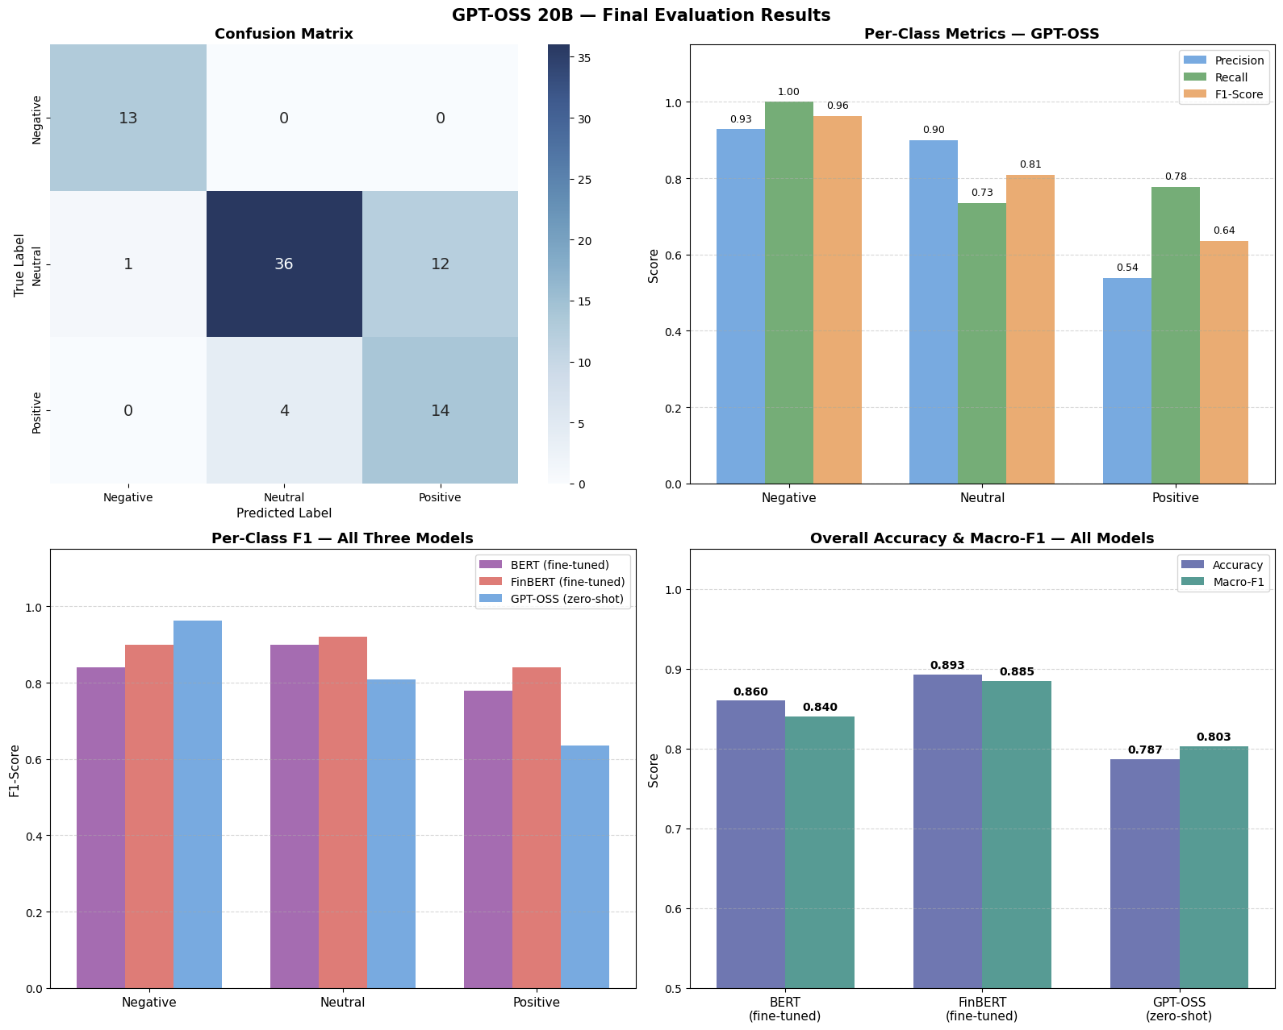
Bar chart: bottom right comparing overall accuracy and macro-F1 for BERT, FinBERT, and GPT-OSS. FinBERT leads on both metrics; GPT-OSS macro-F1 is nearly equal to BERT despite no training.. Bar chart: bottom left, showing per-class F1 for negative, neutral, and positive across all three models. GPT-OSS has the highest negative F1 by a large margin; all three models struggle most with the positive class . top right: Accuracy is not balanced in different categories, but F1 is much more balanced

4.5 Fine-Tuning vs. Reasoning: Practical Implications
In this study, GPT-OSS was used in two modes. In the ablation study, simple prompts were used to find the most accurate prompt style. In the final evaluation, a system/user prompt was used that explicitly asked the model to explain its reasoning before producing the label — and this explanation was saved alongside each prediction in the results file. This explanation column is what makes GPT-OSS auditable in a way that BERT and FinBERT are not.
Fine-tuned FinBERT is the best model for high-volume, production-scale classification. It is fast, deterministic, and achieves the highest overall accuracy. However, it is a black box — it produces a label and a confidence score, with no explanation of why it made the decision it did.
GPT-OSS provides an explanation with every prediction. In regulated financial environments — where trading decisions must be auditable and model outputs must be justifiable to compliance teams — this transparency is not just useful; it is often legally required. A system that can say "this headline was classified negative because it reports an operating loss of EUR 0.1m" is meaningfully different from one that outputs 0.92 confidence for 'negative' with no further information.
The practical recommendation from this study is a hybrid architecture: FinBERT handles bulk classification at scale, while GPT-OSS is invoked only for low-confidence cases or for headlines that require an auditable explanation. This combines the speed and accuracy of supervised fine-tuning with the transparency and flexibility of reasoning-based prompting.

4.6 Ethics and Limitations
Automation risk. Connecting any of these models to an automated trading system without human oversight is ethically problematic. All three models make systematic errors on the positive/neutral boundary. A false negative signal could trigger automatic stock sales and cause real market harm.
Dataset bias. The training data consists primarily of Finnish financial news (companies like Nokia, Etteplan, Sponda). Models trained on this data may not generalise to news from other markets or languages. GPT-OSS is less affected by this because it draws on much broader pre-training, but it has no specific knowledge of Finnish corporate reporting conventions.
Hallucination in reasoning. GPT-OSS sometimes produced confident reasoning for incorrect predictions. A model that sounds certain while being wrong is more dangerous than one that is visibly uncertain. Any deployment of generative AI for financial decisions must include human review of the reasoning output.
Overfitting. Both BERT and FinBERT showed mild validation loss increases at epoch 3. Implementing early stopping and testing with larger datasets would reduce this risk. The current dataset of 4,840 samples is relatively small for transformer fine-tuning.

5. Conclusion
This study compared three approaches to financial sentiment classification: fine-tuned BERT, domain-specific FinBERT, and a reasoning-based large language model (GPT-OSS). The findings show that domain-specific pre-training is the key driver of performance in specialised tasks. FinBERT achieved the best overall results (macro-F1 = 0.885, accuracy = 89.3%), outperforming both fine-tuned BERT and GPT-OSS, highlighting the importance of financial-domain knowledge.
Fine-tuning significantly improved BERT, increasing its macro-F1 from 0.248 to 0.84, but it still could not match FinBERT. This demonstrates that fine-tuning alone cannot replace domain-specific pre-training.
GPT-OSS delivered competitive performance (macro-F1 ≈ 0.80) without any training data and achieved perfect recall for negative sentiment, making it valuable for risk-sensitive applications. However, it struggled with the neutral–positive boundary, often over-interpreting neutral statements as positive due to differences in labelling conventions.
Overall, FinBERT is best suited for high-accuracy applications, while GPT-OSS offers explainability and flexibility. A hybrid approach combining both methods may provide the most effective solution for financial sentiment analysis.
Lessons Learned and Future Work. This project produced three concrete lessons. First, domain-specific pre-training (FinBERT) is more valuable than more training epochs on a general model (BERT) — choosing the right base model matters more than optimising the training process. Second, for large language models, simpler prompts outperform complex ones on constrained classification tasks — adding reasoning instructions reduced accuracy rather than improving it. Third, data pipeline consistency across multiple notebooks is critical; a phantom 94% accuracy caused by inconsistent random seeds showed how easily incorrect results can appear convincing without rigorous cross-notebook validation. For future work, three directions are worth pursuing: applying class-weighted loss functions to better handle the imbalanced negative class; testing FinBERT on a larger and more diverse financial news corpus to assess generalisation beyond Finnish markets; and building a hybrid system where FinBERT classifies bulk headlines automatically while GPT-OSS generates auditable explanations only for low-confidence cases.

6.References
Araci, D. (2019) FinBERT: Financial sentiment analysis with pre-trained language models. Available at: https://arxiv.org/abs/1908.10063 (Accessed: 8 April 2026).
Cambria, E. and White, B. (2014) ‘Jumping NLP curves: A review of natural language processing research’, IEEE Computational Intelligence Magazine, 9(2), pp. 48–57.
Devlin, J., Chang, M.-W., Lee, K. and Toutanova, K. (2019) ‘BERT: Pre-training of deep bidirectional transformers for language understanding’, in Proceedings of NAACL-HLT 2019, pp. 4171–4186.

APANDIX:

Technical Challenges and Resolutions
Problem | Root cause | Solution applied
All prompts returned 'neutral' | Missing import re — silent NameError inside except block defaulted every result to neutral | Added import re; made except block print the actual error instead of hiding it
API returned empty responses | Payload used messages[] array (Chat format) but URL pointed to /api/generate endpoint | Corrected URL to /api/chat; verified endpoint matches payload structure
JSON parse errors ([Warning] JSON format failed) | Model sometimes wraps JSON in Markdown code fences (```json) or adds preamble text before the curly brace | Added regex search for the innermost {…} block; Regex fallback extracts last sentiment word if JSON still fails
label_match[-1] crashed | re.search returns a Match object, not a list — subscripting [-1] is invalid | Replaced re.search with re.findall to get a list; [-1] picks the final sentiment word in reasoning text
Data leakage: 97% accuracy with gold label in prompt | Lecturer's example code passed the true label inside the user prompt — the model read the answer and repeated it | Removed gold_label from all prompts; model must predict blindly from headline text only
Phantom 94% accuracy in comparison notebook | BERT trained with random_state=13 but GPT-OSS and comparison notebooks used random_state=42 — test rows overlapped with training rows | Implemented 'Golden Data Block': random_state=13 fixed in every notebook; drop_duplicates() and [UNK] cleaning applied consistently
Finnish company names caused model confusion | Latin-1 encoding errors produced Mojibake characters (e.g., Jyv+Æskyl+Æ) that distracted the model from financial content | Replaced all non-ASCII characters with [UNK] token using str.replace(r'[^\x00-\x7F]+', '[UNK]'). This preserves sentence structure while signalling unknown content to the LLM
LangChain reduced accuracy from 75% to 50% | PydanticOutputParser automatically injects 10–15 lines of JSON Schema instructions — this 'Prompt Bloat' diverted the 20B model's attention away from financial reasoning | Reverted to direct requests library with a short manual JSON instruction; kept Regex fallback from earlier

Table 1 Technical problems encountered during development and the solutions applied.

LangChain was tested as an alternative to direct requests calls. Using PydanticOutputParser caused accuracy to drop from 75% to 50% because LangChain automatically injects 10–15 lines of JSON Schema instructions into the prompt — a phenomenon called Prompt Bloat. On a 20B model, these extra instructions diverted attention away from the financial content and toward schema compliance. The implementation was reverted to direct requests calls with a short, hand-written JSON instruction appended to each prompt.

