AI-POWERED DISASTER
INTELLIGENCE PLATFORM
Flood-Focused MVP for Pakistan
Project Documentation
Predict • Detect • Assess • Prioritize

Project Type: AI/ML + GIS Disaster Intelligence MVP
Initial Hazard: Flooding
Primary Region: Pakistan
Prototype Interface: Streamlit

1. Executive Summary
The AI-Powered Disaster Intelligence Platform is a proposed decision-support system for Pakistan that begins with flood risk. Its purpose is to combine machine learning, weather and river information, satellite/geospatial data, and an interactive dashboard to help users move from raw data to understandable risk information. The long-term concept covers four stages: prediction, detection, impact assessment, and response prioritization.
The current initial demo is intentionally smaller. It uses synthetic training data and a Random Forest classifier inside a Streamlit dashboard. Users select a district and enter rainfall, temperature, humidity, and river level. The model returns a demonstration flood probability and classifies the result as Low, Medium, or High risk. It is a proof of concept, not an operational flood-warning system.

2. Problem Statement
Pakistan faces recurring flood risk and severe consequences when major events occur. The 2022 floods affected about 33 million people; a joint post-disaster assessment estimated US$14.9 billion in damages and US$15.2 billion in economic losses. This scale of impact creates a need for timely, location-aware information that can support preparedness, impact assessment, and resource allocation.
Pakistan already operates official forecasting and early-warning capabilities through institutions such as the Pakistan Meteorological Department's Flood Forecasting Division and NDMA. Therefore, this project is positioned as a complementary intelligence and decision-support layer rather than a replacement for official warning systems.

3. Project Objectives
- Build an understandable AI/ML prototype for flood-risk analysis.
- Convert environmental inputs into a simple flood-risk probability and risk category.
- Provide a visual dashboard that non-technical users can understand.
- Create a foundation for future GIS mapping, satellite flood detection, and exposure analysis.
- Support future organizational use cases such as reporting, monitoring, and response prioritization.
- Design the architecture so additional hazards can be added later.

4. Target Users
User Group | Potential Use
Government / disaster authorities | Risk visualization, situational awareness, planning and reporting
NGOs / humanitarian teams | Identify potentially affected areas and support response planning
Infrastructure operators | Monitor exposure of roads, facilities and other assets
Businesses | Monitor location and supply-chain exposure
Researchers / universities | Experiment with flood prediction, GIS and disaster datasets

5. Core Features
Feature | Description | MVP Status
Flood risk prediction | Estimate flood probability from environmental variables. | Initial demo
Risk classification | Convert probability into Low, Medium or High risk. | Initial demo
District selection | Allow the user to choose a location in the dashboard. | Initial demo
Interactive dashboard | Display inputs, probability, risk and guidance. | Initial demo
GIS risk map | Show risk geographically at district/local level. | Next phase
Satellite flood detection | Detect inundated areas from earth-observation imagery. | Future
Impact / exposure assessment | Estimate potentially exposed people, roads and buildings. | Future
Alerts and reports | Generate warnings and downloadable summaries. | Future
Multi-hazard support | Extend to landslides, GLOFs, wildfire, urban flooding, etc. | Long term

6. Technology Stack
Technology | Role
Python | Primary language for data processing, machine learning and backend logic
Pandas | Tabular data preparation and manipulation
NumPy | Numerical operations and synthetic demo data
Scikit-learn | Random Forest model, train/test split and evaluation
Streamlit | Simple web dashboard for the initial demonstration
GeoPandas / Rasterio | Planned geospatial and raster processing
OpenCV / PyTorch | Potential image and satellite-analysis components
FastAPI | Potential API layer for a production application
PostgreSQL + PostGIS | Potential database for spatial and disaster records
Leaflet / JavaScript | Potential interactive mapping frontend

7. Initial Demo Architecture
Synthetic Data → Train/Test Split → Random Forest → Streamlit Inputs → Probability → Risk Level → Guidance
The demo keeps the architecture intentionally simple so the full ML pipeline can be explained during a presentation. A future version should replace synthetic data with validated Pakistan-specific datasets and separate model training from live inference.

8. Machine Learning Workflow

8.1 Demo Data
The prototype creates 500 synthetic records. Each record contains rainfall, temperature, humidity, and river level. A rule is used to generate the demonstration target: flood = 1 when rainfall is above 200 mm, humidity is above 65%, and river level is above 6 m. Because the labels are generated from a known rule, this dataset is only for demonstrating code flow.

8.2 Features and Target
Type | Variables
Input features (X) | Rainfall, temperature, humidity, river level
Target (y) | Flood: 0 = No Flood, 1 = Flood

8.3 Training and Testing
The data is split into 80% training data and 20% testing data. The Random Forest classifier learns from the training portion. The test portion is used to calculate a demonstration accuracy score on records the model did not use for fitting.

8.4 Prediction
When the user clicks Analyze Flood Risk, the four selected environmental values are passed to the trained model. predict_proba() returns the estimated probability for the flood class. The application multiplies that probability by 100 to display a percentage.

8.5 Risk Thresholds
Flood Probability | Displayed Risk
Below 30% | LOW
30% to below 70% | MEDIUM
70% or above | HIGH

These thresholds are demonstration choices. Operational thresholds would need to be calibrated using real observations, hazard definitions, model validation, and requirements from relevant disaster-management experts.

9. Demo Walkthrough
Step | What Happens
1. Select District | Choose a demonstration district such as Lahore, Rawalpindi, Multan, Dadu, Sukkur or Peshawar.
2. Enter Conditions | Adjust rainfall, temperature, humidity and river level using sliders.
3. Analyze | Click Analyze Flood Risk.
4. Review Probability | The model displays an estimated demonstration flood probability.
5. Review Risk | The probability is converted into Low, Medium or High risk.
6. Read Guidance | The interface shows a simple monitoring/prioritization message.

Figure 1. Initial demo model flow
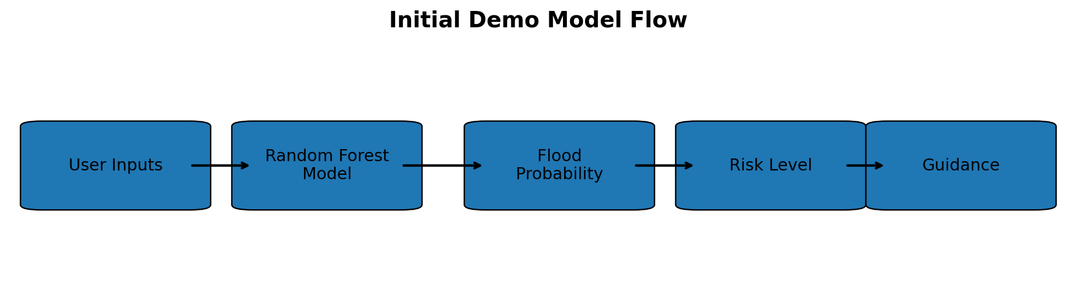
Figure 2. Example Streamlit dashboard mockup
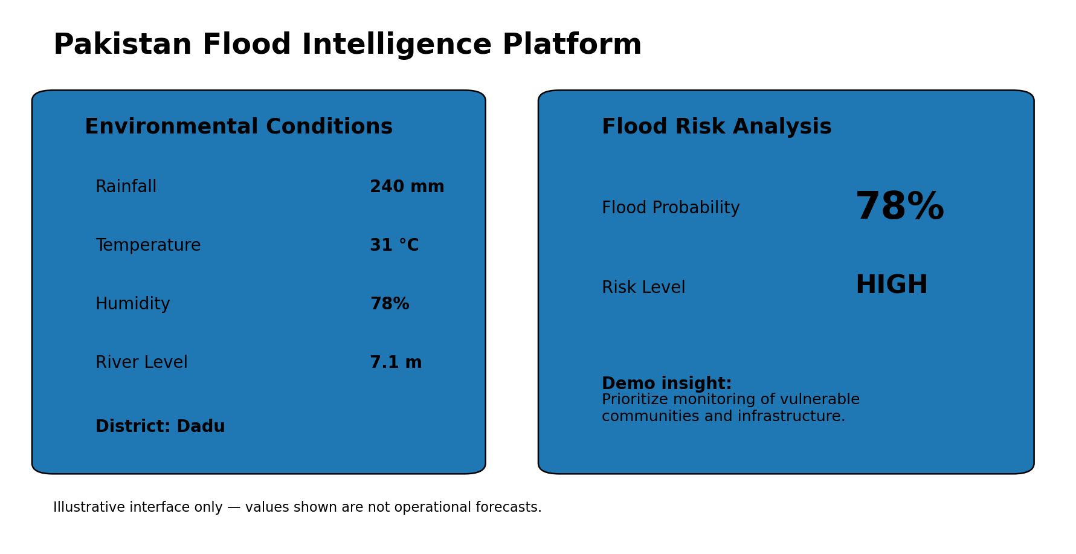
The dashboard image is a presentation mockup of the initial demo. The displayed 78% value is illustrative, not a real flood forecast.

10. Expected Demo Insights
- The audience can see a complete ML pipeline from input data to prediction.
- Higher-risk combinations of rainfall, humidity and river level should generally produce higher flood probabilities because of how the synthetic target was created.
- The dashboard demonstrates how a technical model can be translated into a simple decision-support interface.
- The accuracy displayed by the prototype is not evidence of real-world forecasting performance.
- The strongest next improvement is replacing synthetic records with real historical observations and adding geographic visualization.

11. Proposed Production Architecture
Weather + River + Satellite + Historical + GIS Data
↓
Data Processing
↓
ML / Computer Vision Models
↓
Geospatial Risk & Exposure Analysis
↓
Dashboard / API
↓
Alerts • Maps • Reports • Response Priorities

12. Data Strategy
No single dataset is expected to cover the entire system. A practical implementation would combine weather and rainfall records, river observations, historical flood extents, satellite imagery, administrative boundaries, population layers, road networks and building/infrastructure data.
- Phase 1: structured flood-risk dataset for supervised ML.
- Phase 2: Pakistan administrative boundaries and GIS layers.
- Phase 3: satellite imagery for flood-extent detection.
- Phase 4: population and infrastructure layers for exposure estimation.
- Phase 5: operational or near-real-time data feeds, subject to access and validation.

13. Datasets and Data Sources
The MVP should begin with open Pakistan-specific flood and geospatial datasets. Different datasets serve different parts of the system; they are not all required for the first demo.
Pakistan Monsoon Flood Extent 2022–2025 (Zenodo) — District- and tehsil-level flood extent, flooded-area percentages and spatial clustering. Useful for historical GIS analysis. Open dataset/source
High-Resolution 30 m Flood Susceptibility Maps of Pakistan (Zenodo) — National-scale flood susceptibility rasters. Useful for risk-map and GIS layers. Open dataset/source
Flood Conditioning Raster Layers for Pakistan (Zenodo) — Predictor raster layers used for flood susceptibility modelling. Useful for future ML/geospatial modelling. Open dataset/source
FSM-PK Project Repository — Open-source code, notebooks and links for Pakistan flood susceptibility mapping. Open dataset/source
UNOSAT Pakistan Flood Products — Satellite-detected flood extents with downloadable GIS products for real flood events. Open dataset/source
xBD-S12 Disaster Damage Dataset — Satellite imagery and damage-assessment resources for the later building-damage component; not Pakistan-specific. Open dataset/source
Recommended MVP order: start with the Pakistan flood extent CSV/GeoPackage and susceptibility data; add UNOSAT satellite products when the GIS stage is working; use xBD-S12 only when building damage assessment becomes part of the prototype.

14. MVP Business Model
At MVP stage, the goal is validation rather than maximizing revenue. The most realistic early model is to keep the public/demo version free, charge small organizations for limited pilots, and test low monthly subscriptions only after the dashboard provides repeatable value.
Offering | Illustrative Starting Price | Example Customer
Free Demo | PKR 0 | University demo / early feedback
MVP Pilot | PKR 25,000–75,000 one-time | Small NGO / local organization / pilot partner
Starter MVP | PKR 15,000 per month | Single-area dashboard with basic reports
Pro MVP | PKR 35,000 per month | More areas, alerts and enhanced reporting
Custom MVP | PKR 75,000–150,000 per project | Small custom dashboard / data integration

These are deliberately modest MVP pricing hypotheses for Pakistan. They are not established market prices. The team should validate willingness to pay through interviews and pilots before raising prices or pursuing larger institutional contracts.

15. Illustrative MVP Year-1 Revenue Scenario
Revenue Source | Assumption | Illustrative Revenue
MVP pilots | 2 × PKR 50,000 | PKR 100,000
Starter MVP customers | 3 × PKR 15,000 × 6 months | PKR 270,000
Pro MVP customer | 1 × PKR 35,000 × 6 months | PKR 210,000
Small custom project | 1 × PKR 100,000 | PKR 100,000
Illustrative total |  | PKR 680,000

This scenario represents a small first-year MVP rather than a scaled startup. PKR 680,000 is an illustrative revenue target based on only a few pilots and early customers; actual revenue could be lower or zero while the product is being validated.

16. Limitations and Responsible Use
- The initial model uses synthetic data; it must not be used for real emergency decisions.
- Model probability is not the same as an official flood warning.
- The district dropdown does not currently change the underlying model or load district-specific observations.
- The synthetic label rule makes the demo accuracy easier than a real forecasting problem.
- Real deployment requires high-quality historical and current data, geographic validation, model calibration and continuous monitoring.
- Impact estimates should be described as potential exposure unless damage has been independently verified.
- Official warnings from relevant authorities should remain the authoritative source for emergency action.

17. Development Roadmap
Phase | Goal | Deliverable
1 - Prototype | Demonstrate ML workflow | Synthetic-data Streamlit demo
2 - Real data | Train on historical Pakistan-relevant data | Validated baseline model
3 - GIS | Add geographic visualization | District risk map
4 - Satellite | Detect flood extent | Inundation layer
5 - Exposure | Overlay people, roads and buildings | Impact/exposure dashboard
6 - Pilot | Test with one organization/region | User feedback + case study
7 - Scale | Add APIs, alerts and more hazards | Multi-hazard intelligence platform

18. Future Enhancements
- Real-time weather and river data ingestion.
- Satellite change detection and flood segmentation.
- District- and tehsil-level models.
- Population and infrastructure exposure estimates.
- Automated PDF/CSV situation reports.
- Role-based dashboards for different organizations.
- SMS/email/app alerts where appropriate.
- Explainable AI to show which variables drive risk.
- Multi-hazard modules for GLOFs, landslides, wildfire and urban flooding.

19. Conclusion
The project demonstrates how AI/ML can be combined with geospatial information to turn disaster data into clearer operational insights. The first demo is intentionally educational and limited, but it establishes the end-to-end workflow needed for a more realistic system. The recommended path is to validate the flood-risk component with real data first, then add mapping, satellite analysis, exposure estimation, and organizational pilots before expanding into a multi-hazard platform.

20. References
- World Bank. Pakistan: Flood Damages and Economic Losses Over USD 30 billion and Reconstruction Needs Over USD 16 billion - New Assessment. 28 October 2022.
- Flood Forecasting Division, Pakistan Meteorological Department. Flood Early Warning System.
- National Disaster Management Authority (Pakistan). Technical Early Warning.
- World Bank. Pakistan Country Climate and Development Report / disaster resilience materials.

Dataset references:
- Pakistan Monsoon Flood Extent Dataset 2022–2025: https://zenodo.org/records/20100773
- High-Resolution Flood Susceptibility Mapping Data of Pakistan: https://zenodo.org/records/18513602
- Flood Conditioning Raster Layers for Pakistan: https://zenodo.org/records/20200726
- FSM-PK open-source repository: https://github.com/waleedgeo/FSM-PK
- UNOSAT Pakistan flood extent product: https://unosat.org/products/4197
- xBD-S12 disaster damage dataset: https://github.com/prs-eth/xbd-s12

