**Digital Skills Final   
Project Report**



Computer Science Department

Fall 2020

GCS – 150 – Final Project

Mehreen Junaid S20106424

Joud Kaki S20106234

Layan Jaman S20106590

Reyoof Almuhanna S12906090

**Outline:**

* Main function
* Read function
* Write function
* Remove word function
* Reverse function
* Sort function
* Add new line function
* Replace word function
* Add word function
* Remove occurrences

**Functions:**

A group of statements within a program that perform a particular task.

**Why do we use functions?**

* Simpler code
* Ability to examine each function individually
* Easier Teamwork Facilitation
* Multiple team members have the ability to write different functions

1. **Main Function**:

When an operating system starts running a program, programming languages have a special function that is run immediately. This function is generally called main() and must be called to make the program work.

*Code:*

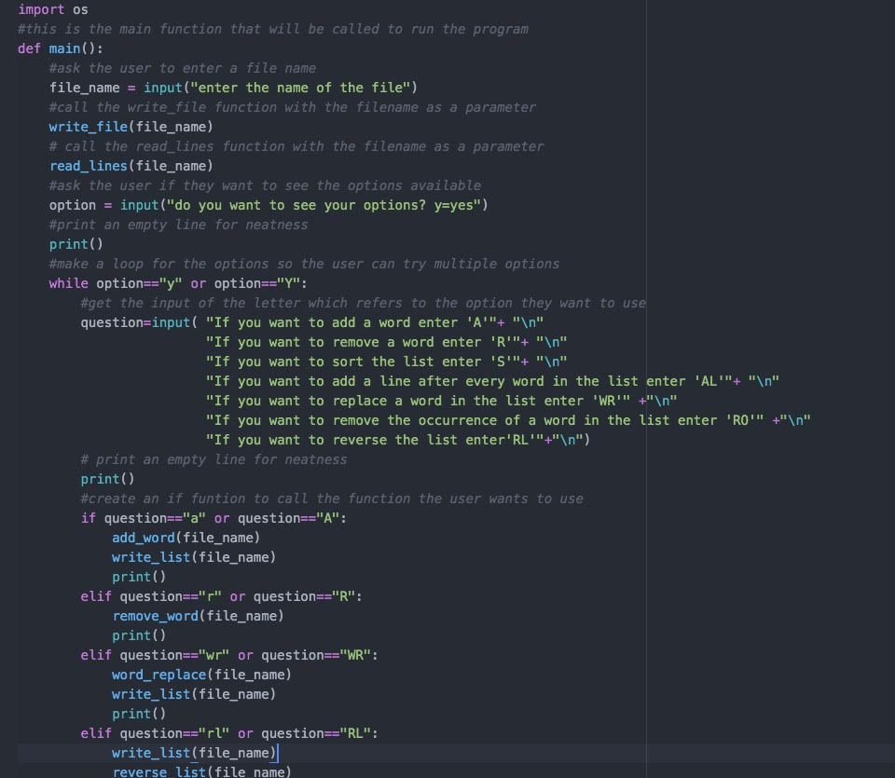

1. **Sort list ascending:**

*Code:*

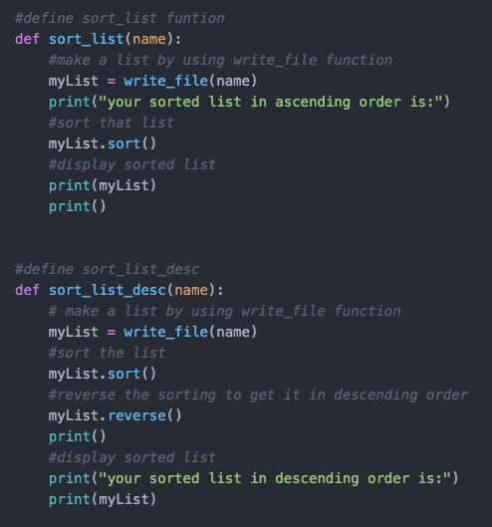

*Run:*

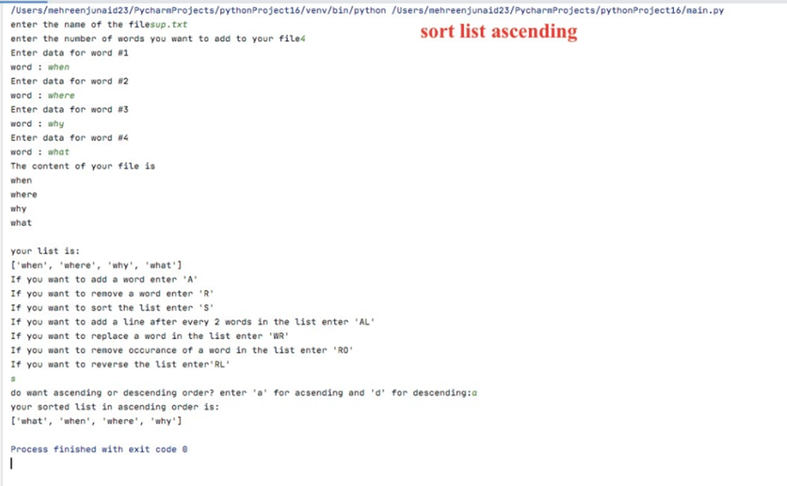

1. **Sort list descending**

*Code:*



*Run:*

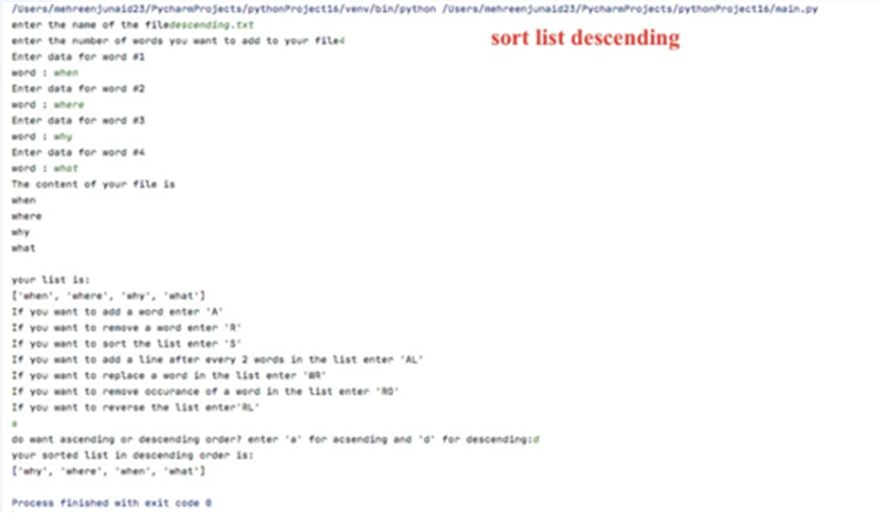

1. **Reverse list**

*Code:*

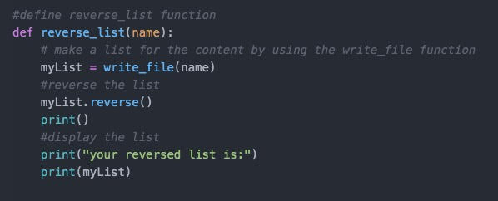

*Run:*

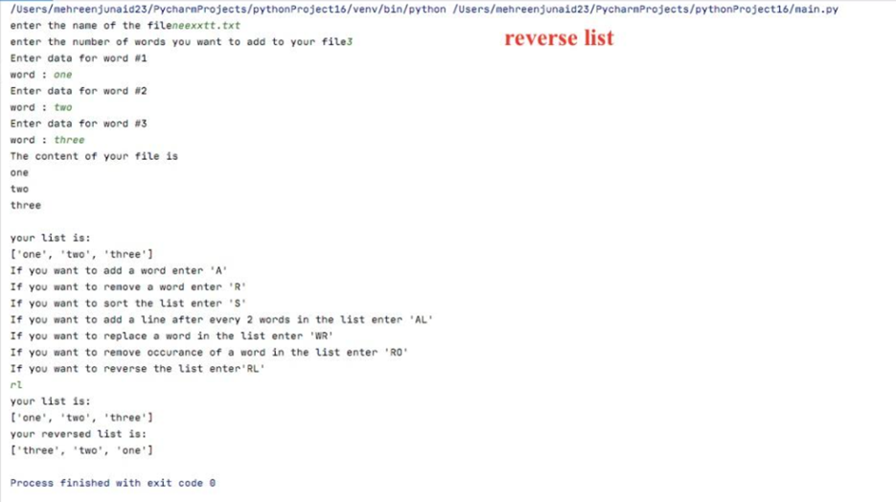

1. **Remove word**

*Code:*

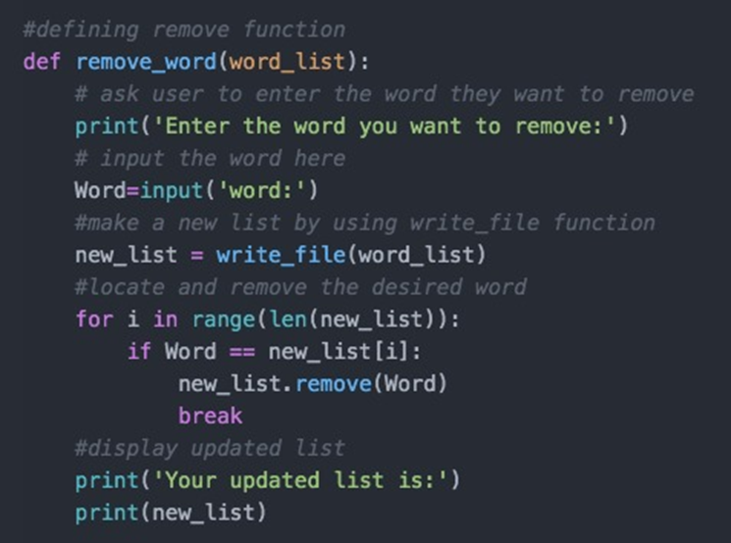

*Run:*

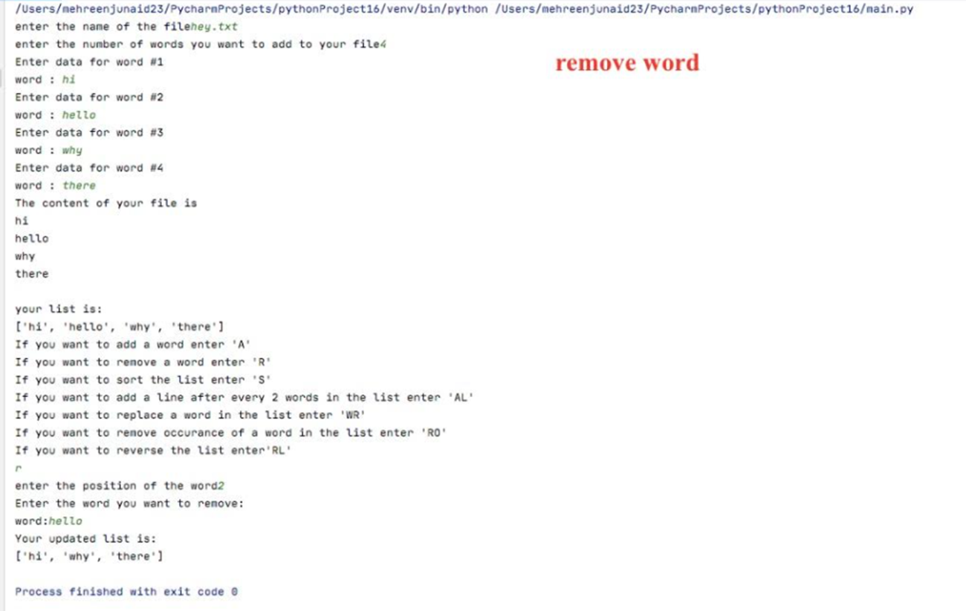

1. **Remove occurrence**

*Code:*

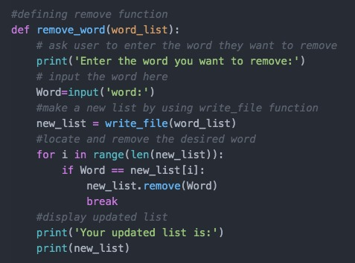

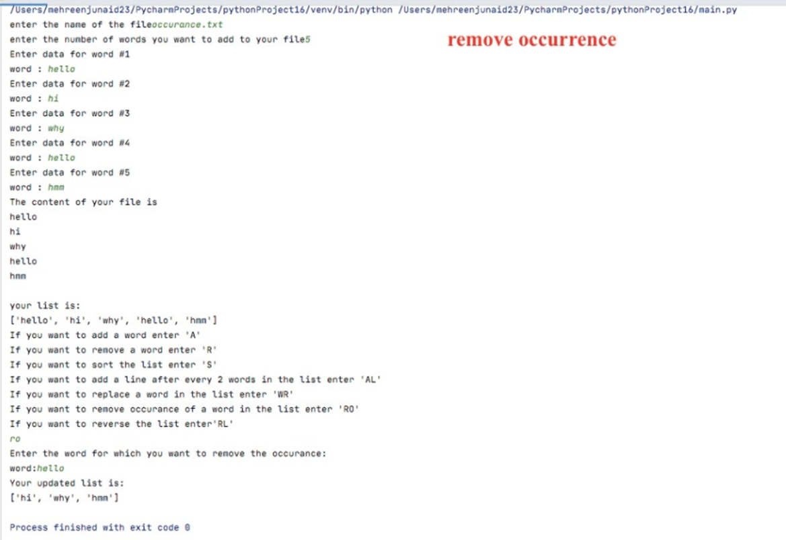*Run:*

1. **Replace word**

*Code:*

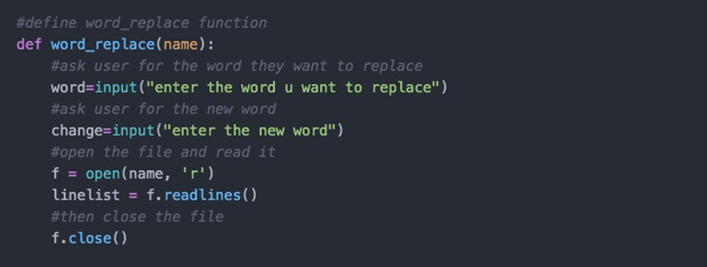

*Run:*

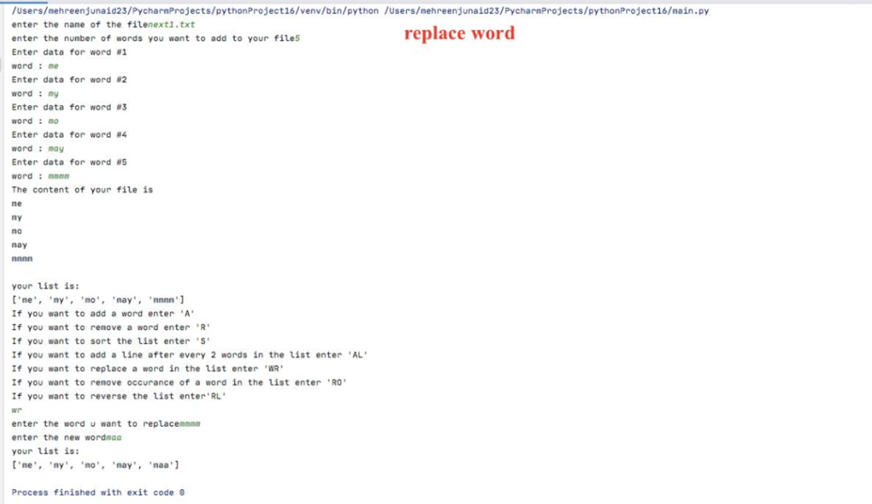

**Complications we faced during the code:**

* Finding the problem and fixing it
* searching for the right arguments to use
* making all the function work when put together
* Communication due to the COVID-19 pandemic outbreak my group members and I had to communicate online, for this reason it was harder than if we simply met and had the code done in a few hours.

**Learning Outcome:**

My team and I benefited a lot from this project because it arranged steps for us to solve it, and the idea of ​​the topic became clear. We faced some issues initially while organizing our thoughts, but we helped each other understand the project.

We faced many unreasonable errors, but after using google and asking other groupmates for help, we got our code done correctly.

We learned the importance of functions while working as a group and how it made the work easier. Also, we learned how to relate and connect all the functions to run the program and make it work.

**Code Improvements:**

Reducing the repetition of opening and checking a file.

**Task Distribution:**

