**Exercises**

1. Write an expression that checks whether an integer is **odd or even**.

using System;

namespace detyra1

{

class Program

{

static void Main(string[] args)

{

Console.WriteLine("shkruani nje numer:");

int number = Convert.ToInt32(Console.ReadLine());

bool even = number % 2 == 0;

Console.WriteLine("{0}", even);

}

}

}

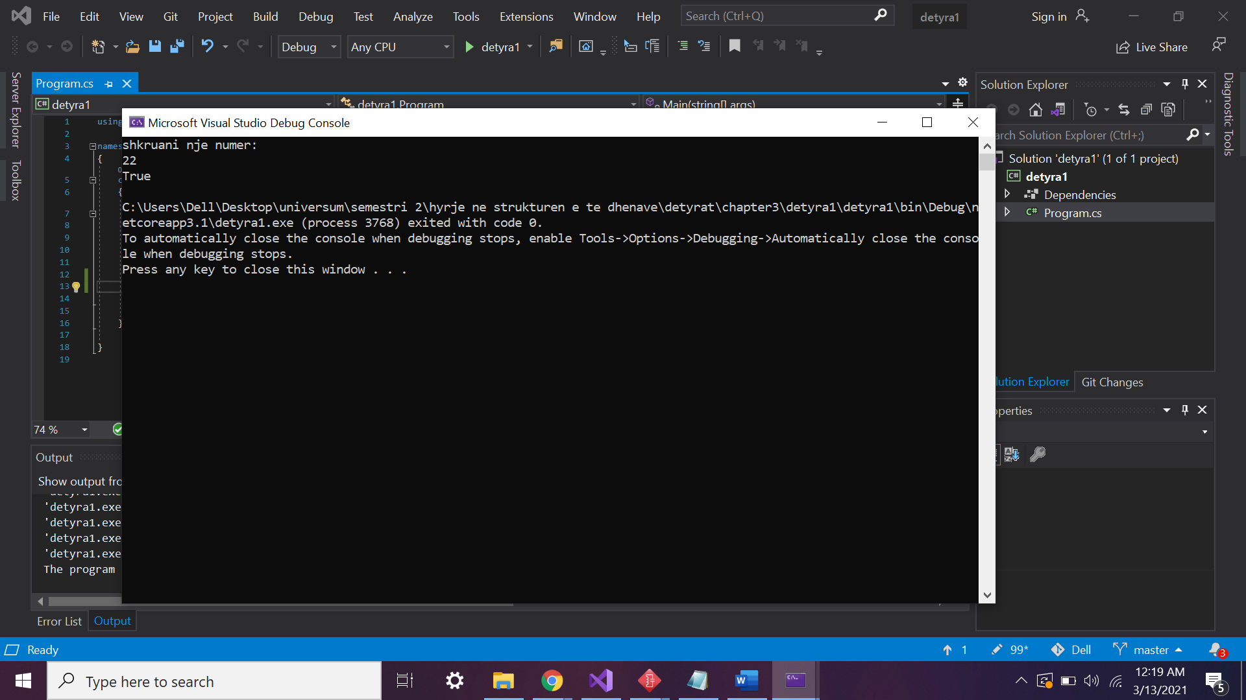

1. Write a Boolean expression that checks whether a given integer is **divisible by both 5 and 7**, without a remainder.

using System;

namespace detyra2

{

class Program

{

static void Main(string[] args)

{

int number = int.Parse(Console.ReadLine());

bool check = number % 5 == 0 && number % 7 == 0 ? true : false ;

if (check = true)

{

Console.WriteLine("the number {0} is divisible by 5 and 7", number);

}

else

{

Console.WriteLine("the number {0} is not divisible by 5 and 7", number);

}

}

}

}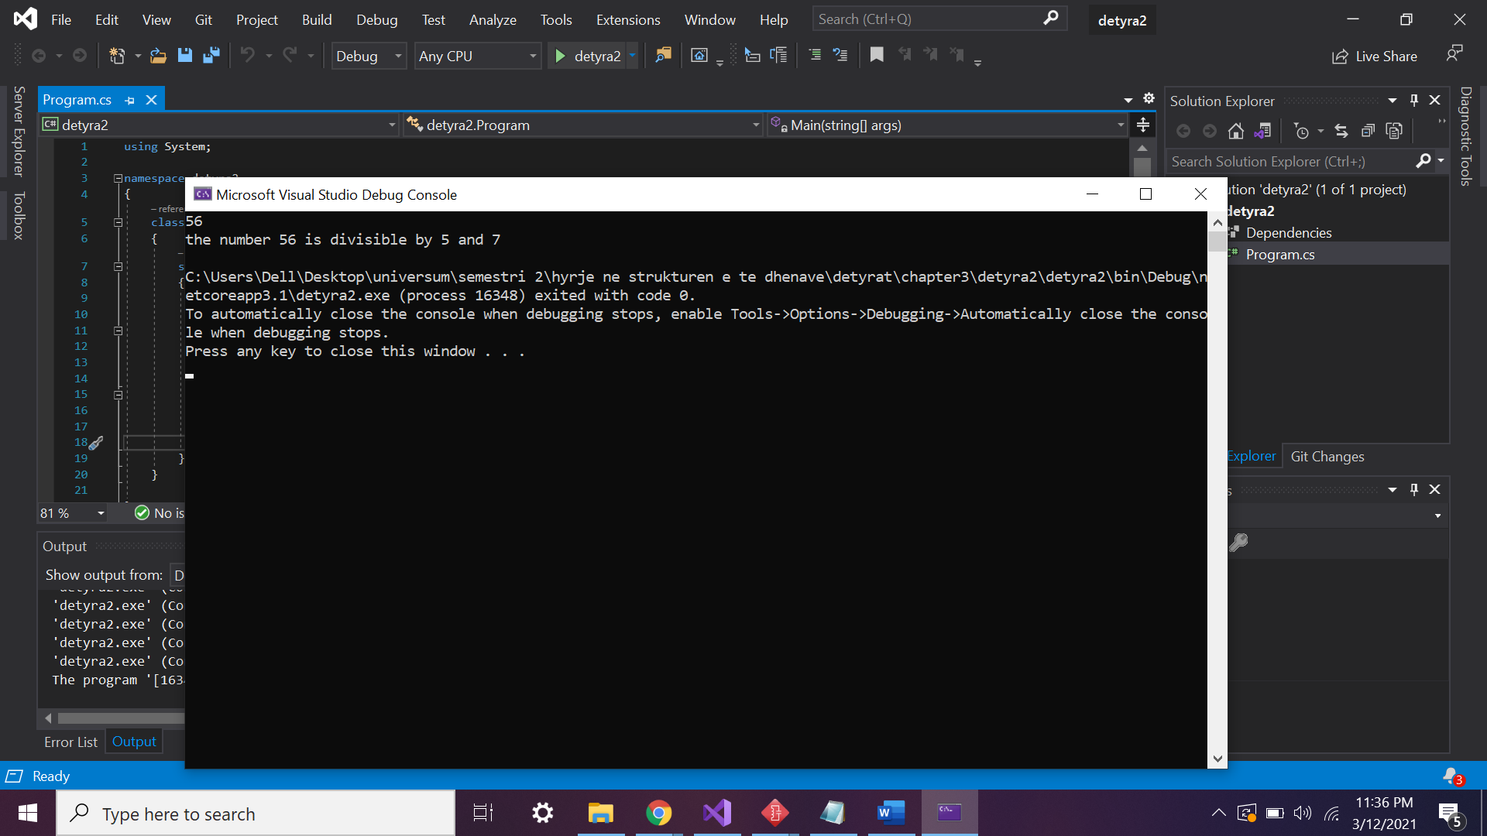

1. Write an expression that checks for a given integer if its **third digit** (right to left) is 7.

using System;

namespace detyra3

{

class Program

{

static void Main(string[] args)

{

Console.WriteLine("shkruani nje numer:");

int number = int.Parse(Console.ReadLine());

int thirdDigit = (number / 100) % 10 ;

if (thirdDigit == 7)

{

Console.WriteLine("numri i trete eshte shtate");

}

else

{

Console.WriteLine("numri i trete nuk eshte shtate");

}

Console.ReadKey();

}

}

}

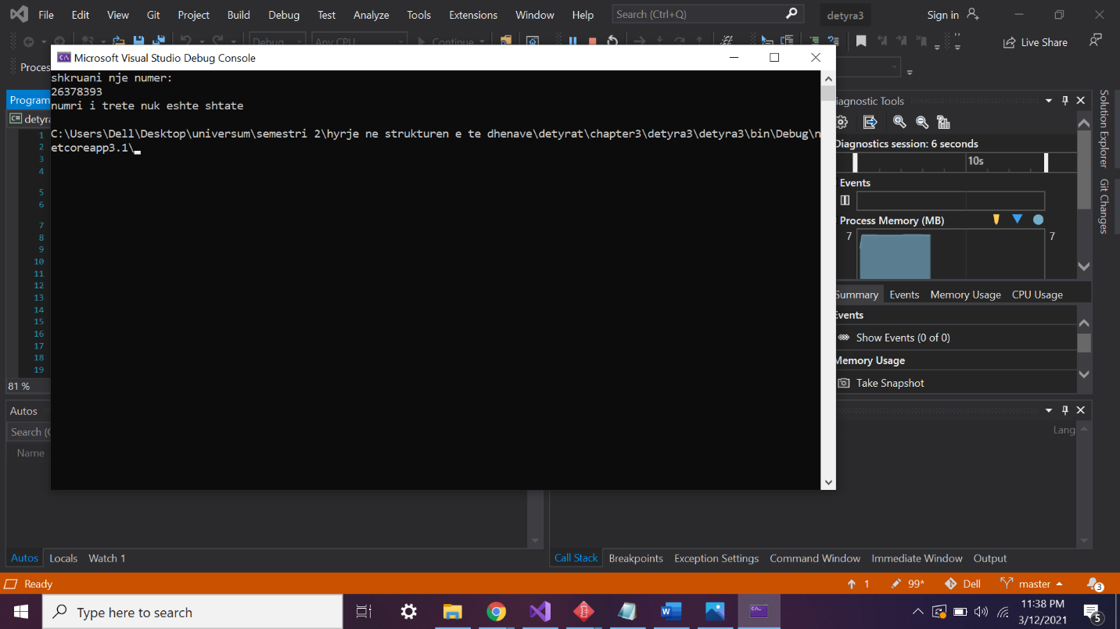

1. Write an expression that checks whether the **third bit** in a given integer is 1 or 0.

using System;

namespace detyra4

{

class Program

{

static void Main(string[] args)

{

int number = 452;

Console.WriteLine("The third bit of {0} is 1? {1}", number, ((number >> 3) & 1) == 1);

}

}

}

5.    Write an expression that calculates the **area of a trapezoid** by given sides **a**, **b** and height **h**.

using System;

namespace detyra5

{

class Program

{

static void Main(string[] args)

{

double a = double.Parse(Console.ReadLine());

double b = double.Parse(Console.ReadLine());

double h = double.Parse(Console.ReadLine());

Console.WriteLine("S ={0}", (a + b) / (2 * h));

}

}

}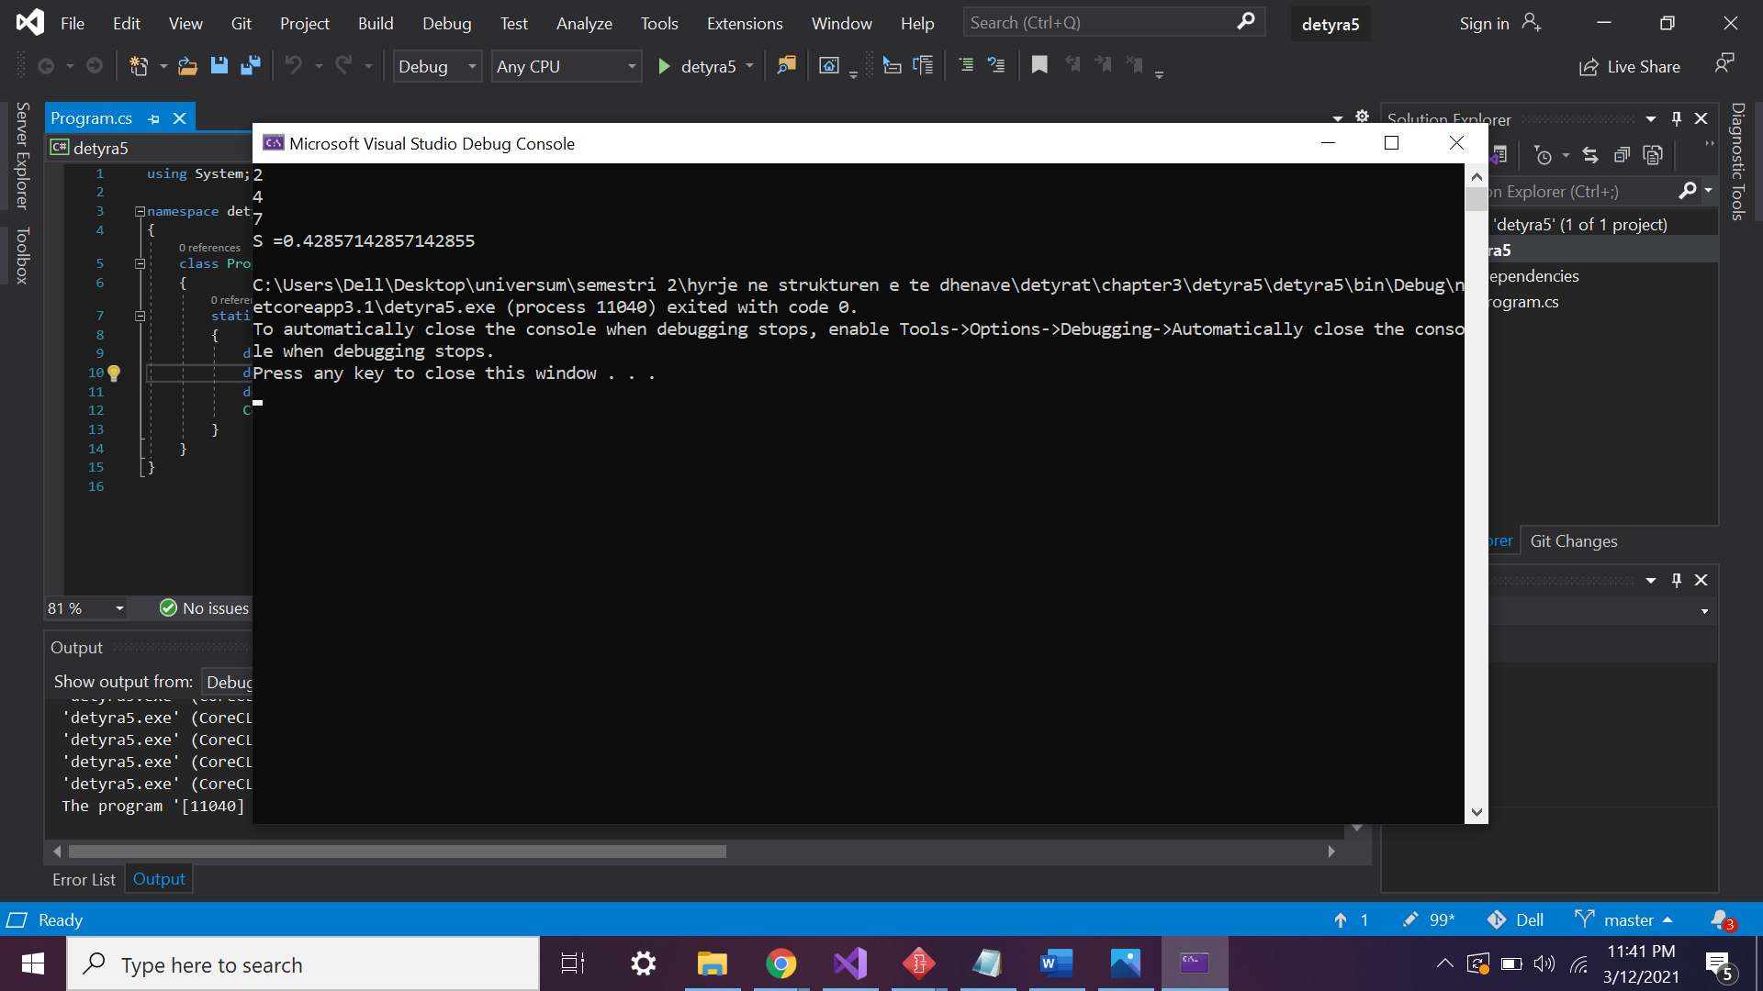

6.    Write a program that prints on the console the **perimeter and the area of a rectangle**by given side and height entered by the user.

using System;

namespace detyra6

{

class Program

{

static void Main(string[] args)

{

Console.Write("Enter a:");

double a = Convert.ToDouble(Console.ReadLine());

Console.Write("Enter h:");

double h = Convert.ToDouble(Console.ReadLine());

double perimeter = 2 * (a + h);

double area = a * h;

Console.WriteLine("perimetri{0} \nsiperfaqja{1}" , perimeter,area);

}

}

}

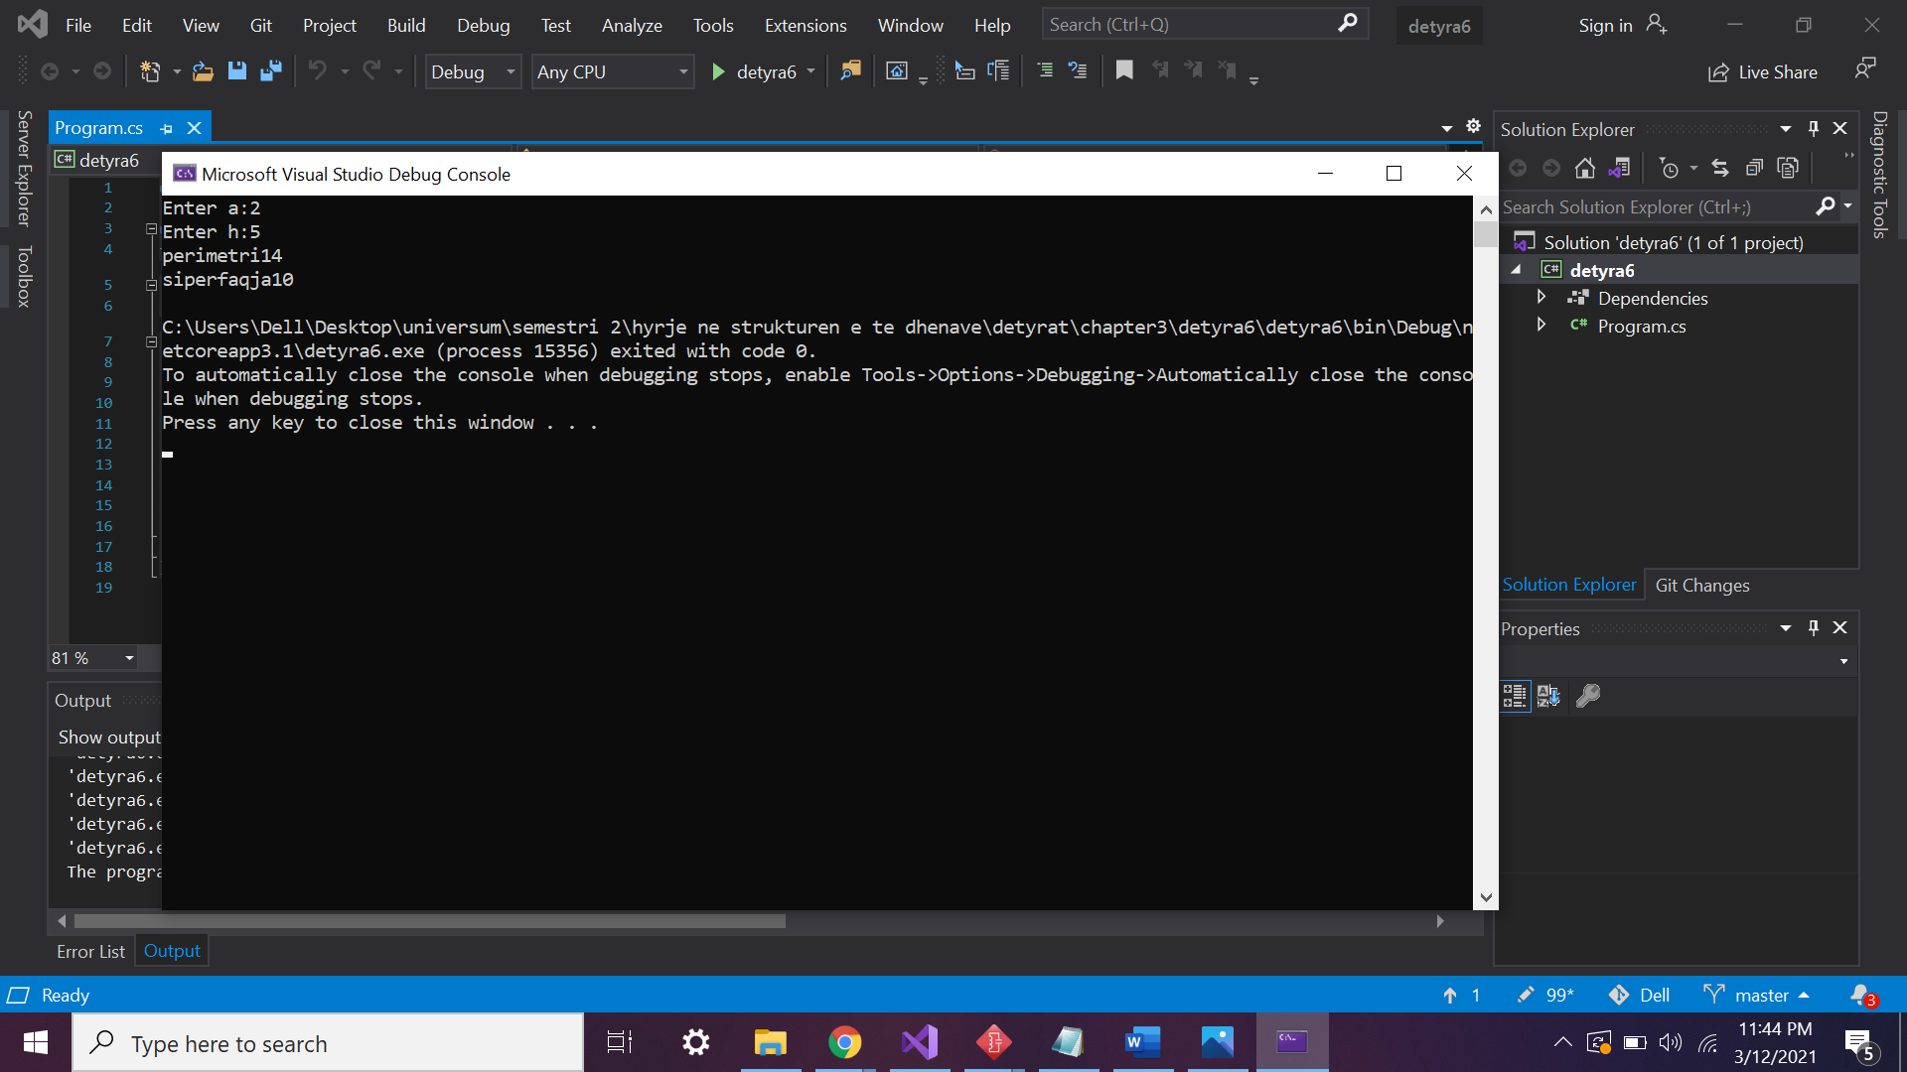

7.    The gravitational field of the Moon is approximately 17% of that on the Earth. Write a program that calculates the **weight of a man on the moon** by a given weight on the Earth.

using System;

namespace detyra7

{

class Program

{

static void Main(string[] args)

{

Console.WriteLine("Enter weight:");

int weight = Convert.ToInt32(Console.ReadLine());

Console.WriteLine("this person will weight {0}kg in the moon", weight * 0.17);

}

}

}

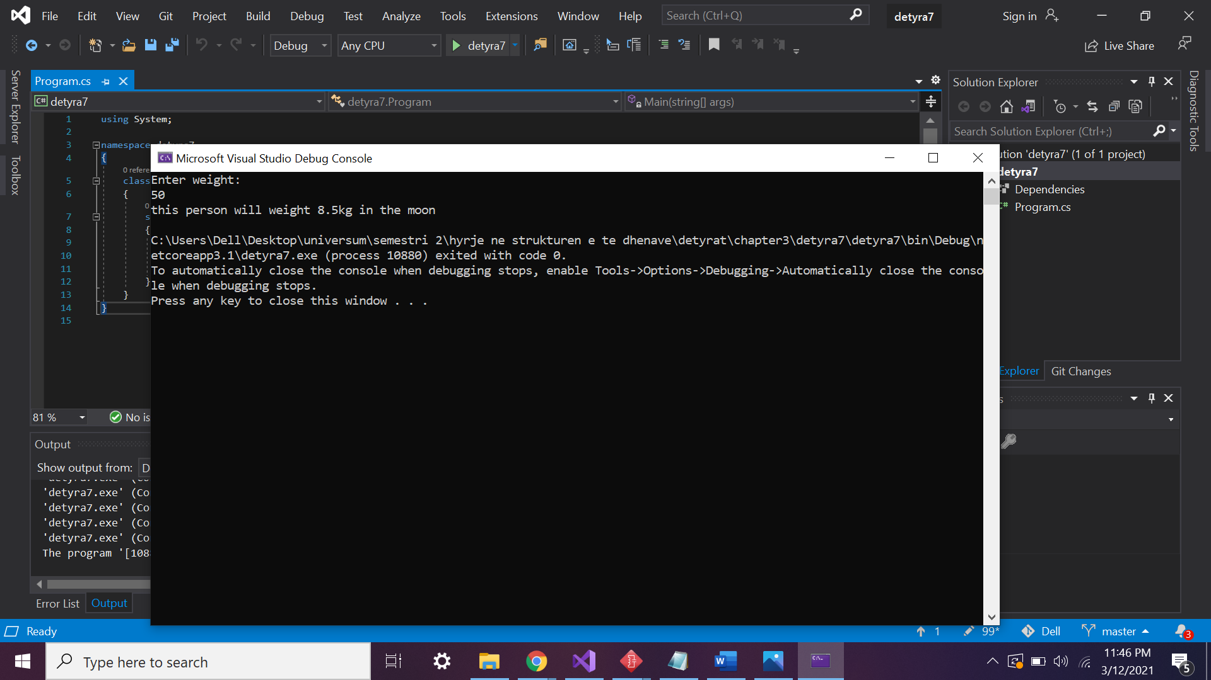

8.    Write an expression that checks for a given point {x, y} if it is **within the circle**K[{0, 0}, R=5]. Explanation: the point {0, 0} is the center of the circle and 5 is the radius.

using System;

namespace detyra8

{

class Program

{

static void Main(string[] args)

{

Console.Write("Enter x: ");

int x = Convert.ToInt32(Console.ReadLine());

Console.Write("Enter y: ");

int y = Convert.ToInt32(Console.ReadLine());

bool isInside = (x * * + y * y <= 5) ? true : false;

Console.WriteLine("The point O({0},{1}) is inside K((0,0),5)?: {2}", x, y, isInside);

}

}

}

9.    Write an expression that checks for given point {x, y} if it is **within the circle** K[{0, 0}, R=5] and **out of the rectangle** [{-1, 1}, {5, 5}]. Clarification: for the rectangle the lower left and the upper right corners are given.

using System;

namespace detyra9

{

class Program

{

static void Main(string[] args)

{

Console.Write("Enter x: ");

int x = Convert.ToInt32(Console.ReadKey());

Console.Write("Enter y: ");

int y = Convert.ToInt32(Console.ReadKey());

bool isInsideCircle = (x * x + y * y <= 5) ? true : false;

bool isOutsideRectangle = (x < -1 && x > 5 && y < 1 && y > 5) ? true : false;

Console.WriteLine("The point O({0},{1}) is inside K((0,0),5)?: {2}", x, y, isInsideCircle);

Console.WriteLine("The point O({0},{1}) is outside rectangle ((-1, 1), (5, 5)?: {2}", x, y, isOutsideRectangle);

}

}

}

10.   Write a program that takes as input a **four-digit number** in format **abcd** (e.g. 2011) and performs the following actions:

-     Calculates the sum of the digits (in our example 2+0+1+1 = 4).

-     Prints on the console the number in reversed order: **dcba** (in our example 1102).

-     Puts the last digit in the first position: **dabc** (in our example 1201).

-     Exchanges the second and the third digits: **acbd** (in our example 2101).

namespace detyra10

{

class Program

{

static void Main(string[] args)

{

Console.WriteLine("Enter a four digit number: ");

int number = Convert.ToInt32(Console.ReadLine());

int a = (number / 1000) % 10;

int b = (number / 100) % 10;

int c = (number / 10) % 10;

int d = number % 10;

Console.WriteLine("1.Sum of digits = {0}", a + b + c + d);

Console.WriteLine("2.Digits backwards {0}{1}{2}{3}", d, c, b, a);

Console.WriteLine("3.Last digit in first place {0}{1}{2}{3}", d, a,b,c);

Console.WriteLine("4.Exchanges the second and the third digits {0}{1}{2}{3}",a, c, b, d);

Console.ReadKey();

}

}

}

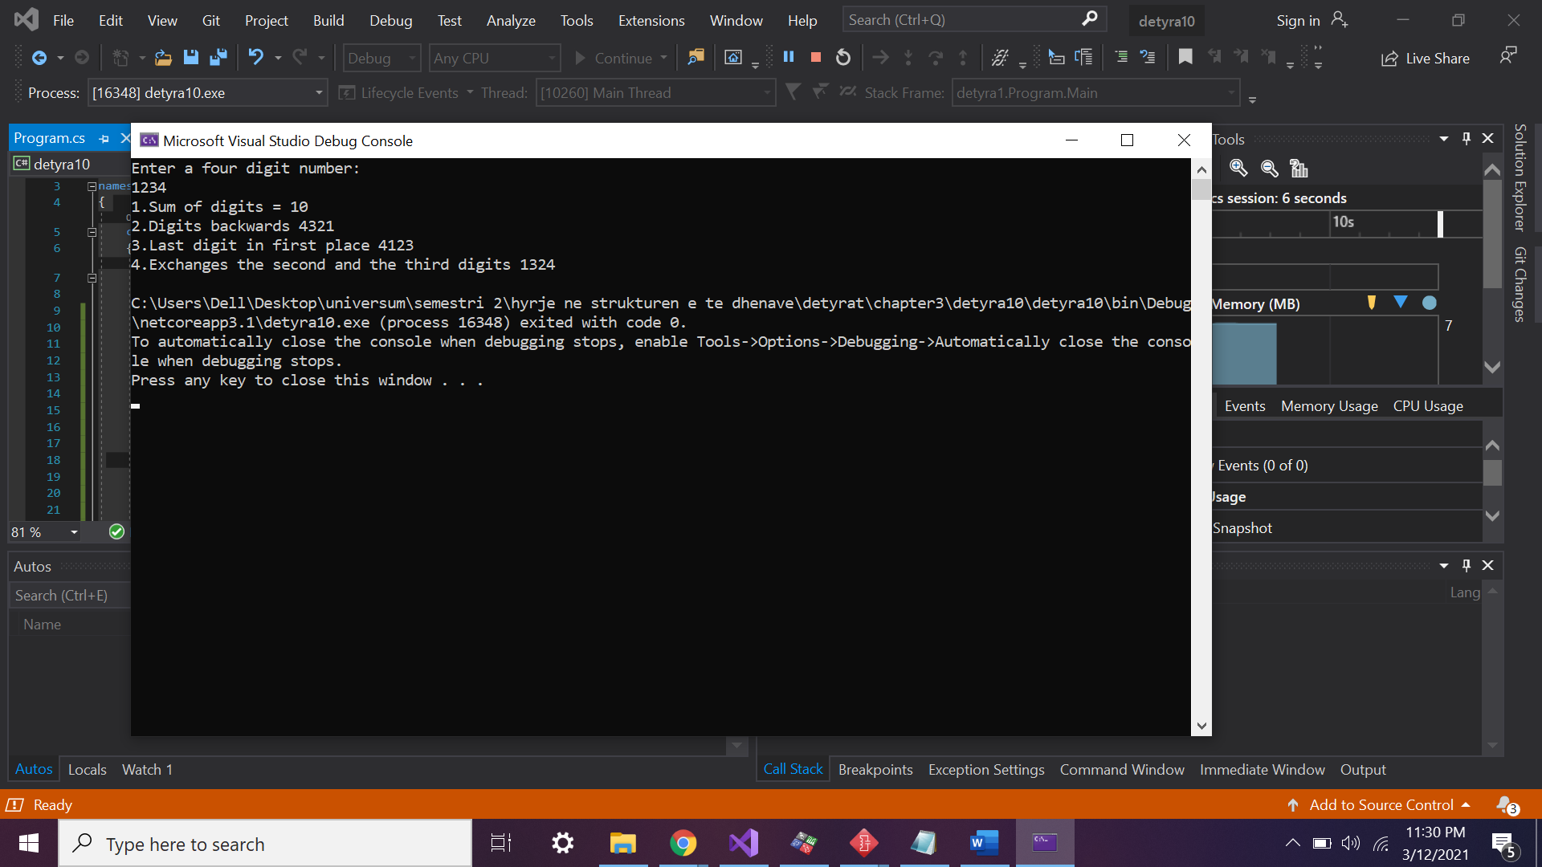

11.   We are given number **n** and position **p**. Write a sequence of operations that prints the value of **the bit on the position** **p** in the number (0 or 1). Example: **n**=35, **p**=5 -> 1. Another example: n=35, **p**=6 -> 0.

using System;

namespace detyra11

{

class Program

{

static void Main(string[] args)

{

int n = 35, p = 6, i = 1, mask = i << p;

Console.WriteLine((n & mask) != 0 ? "Third bit is 1" : "Third bit is 0");

}

}

}

12.   Write a Boolean expression that checks if the bit on position **p** in the integer **v** has the value 1. Example v=5, **p**=1 -> **false**.

using System;

namespace detyra12

{

class Program

{

static void Main(string[] args)

{

int v = 350;

int p = 350;

int mask = 1 << p;

bool isOne = (v & mask) != 0 ? true : false;

Console.WriteLine("The bit at position {0}of number {1} is 1? {2}", p, v, isOne);

}

}

}

13.   We are given the number **n**, the value **v** (**v** = 0 or 1) and the position **p**. write a sequence of operations that changes the value of **n**, so the bit on the position **p** has the value of **v**. Example: n=35, p=5, v=0 -> n=3. Another example: n=35, p=2, v=1 -> n=39.

using System;

namespace detyra13

{

class Program

{

static void Main(string[] args)

{

int n = 350;

int v = 0;

int p = 3;

n = (v == 0) ? n = n & (~(1 << p)) : n = n | (1 << p);

Console.WriteLine(n);

}

}

}

14.   Write a program that checks if a given number **n** (1 <**n** < 100) is a **prime number** (i.e. it is divisible without remainder only to itself and 1).

using System;

namespace detyra14

{

class Program

{

static void Main(string[] args)

{

int number = 72;

bool isPrime = true;

if (number > 2)

for (int i = 2; i <= Math.Ceiling(Math.Sqrt(number)); ++i)

{

if (number % i == 0) isPrime = false;

}

Console.WriteLine("{0} is prime?: {1}", number, isPrime);

}

}

}

15.   * Write a program that **exchanges the values of the bits** on positions 3, 4 and 5 with bits on positions 24, 25 and 26 of a given 32-bit unsigned integer.

using System;

namespace detyra15

{

class Program

{

static void Main(string[] args)

{

Console.Write("Enter number: ");

int v = Convert.ToInt32(Console.ReadLine());

int mask = 1 << 3;

int bitAt3 = (v & mask) != 0 ? 1 : 0;

mask = 1 << 4;

int bitAt4 = (v & mask) != 0 ? 1 : 0;

mask = 1 << 5;

int bitAt5 = (v & mask) != 0 ? 1 : 0;

mask = 1 << 24;

int bitAt24 = (v & mask) != 0 ? 1 : 0;

mask = 1 << 25;

int bitAt25 = (v & mask) != 0 ? 1 : 0;

mask = 1 << 26;

int bitAt26 = (v & mask) != 0 ? 1 : 0;

v = (bitAt3 == 0) ? v = v & (~(1 << 24)) : v = v | (1 << 24);

v = (bitAt4 == 0) ? v = v & (~(1 << 25)) : v = v | (1 << 25);

v = (bitAt5 == 0) ? v = v & (~(1 << 26)) : v = v | (1 << 26);

v = (bitAt24 == 0) ? v = v & (~(1 << 3)) : v = v | (1 << 3);

v = (bitAt25 == 0) ? v = v & (~(1 << 4)) : v = v | (1 << 4);

v = (bitAt26 == 0) ? v = v & (~(1 << 5)) : v = v | (1 << 5);

Console.WriteLine(v);

}

}

}

16.   * Write a program that **exchanges bits** {p, p+1, …, p+k-1} with bits {q, q+1, …, q+k-1} of a given 32-bit unsigned integer.

using System;

namespace detyra16

{

class Program

{

static void Main(string[] args)

{

Console.Write("Enter number: ");

uint number = uint.Parse(Console.ReadLine());

Console.Write("Enter p: ");

int p = int.Parse(Console.ReadLine());

Console.Write("Enter q: ");

int q = int.Parse(Console.ReadLine());

Console.Write("Enter k: ");

int k = int.Parse(Console.ReadLine());

if (p > q)

{

int oldValue = p;

p = q;

q = oldValue;

}

if (p + k >= q)

{

k += p - q - 1;

q += p + k + 1;

}

number = ModifyNumber(number, p, q, k);

Console.WriteLine(number);

}

}

}