**Exercises**

1.     Write a program that **reads** from the console **three numbers** of type **int** and prints their sum.

2.     Write a program that **reads** from the console the **radius** "**r**" of a circle and prints its **perimeter** **and area**.

using System;

namespace detyra2

{

class Program

{

static void Main(string[] args)

{

double r, per_cir;

double PI = 3.14;

Console.WriteLine("Radius:");

r = Convert.ToDouble(Console.ReadLine());

per_cir = 2 * PI * r;

Console.WriteLine("Perimeter of Circle: {0}", per_cir);

Console.Read();

}

}

}

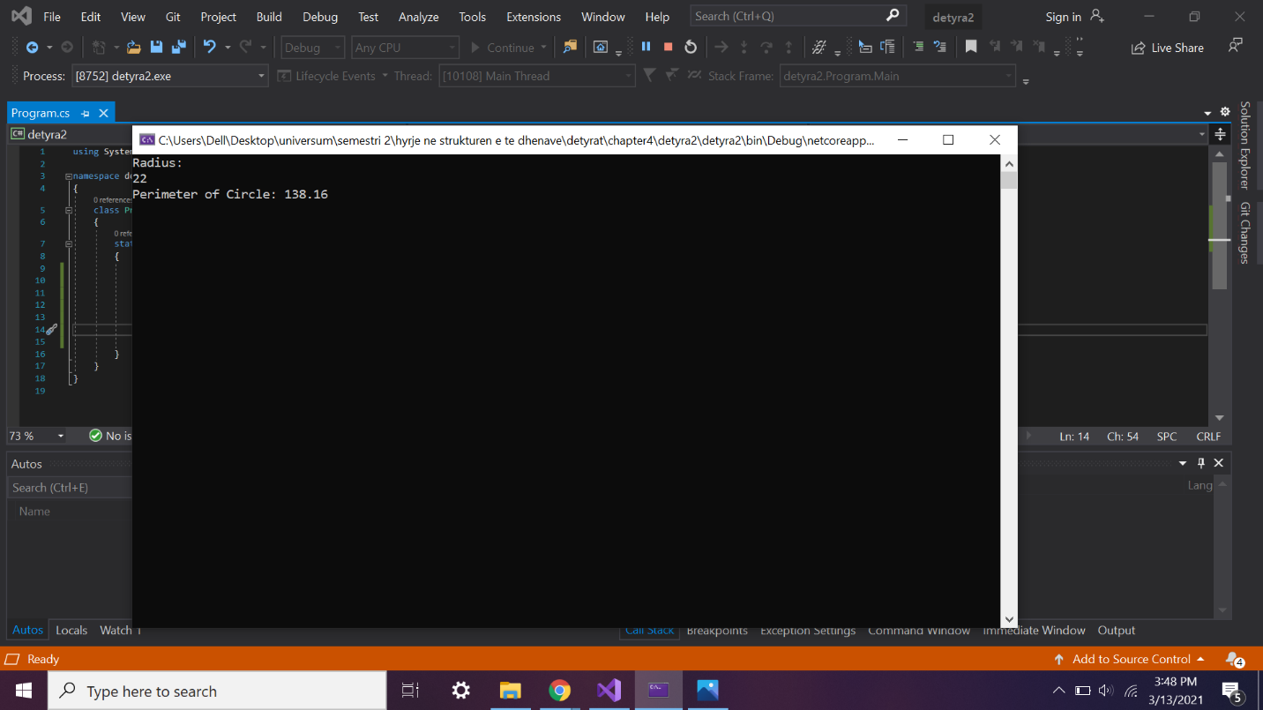

3.     A given company has name, address, phone number, fax number, web site and manager. The manager has name, surname and phone number. Write a program that **reads information about the company** and its manager and then **prints it** on the console.

using System;

namespace detyra3

{

class Program

{

static void Main(string[] args)

{

Console.Write("Enter company name: ");

string companyName = Console.ReadLine();

Console.Write("Enter company address: ");

string companyAddress = Console.ReadLine();

Console.Write("Enter company phone number: ");

string companyPhone = Console.ReadLine();

Console.Write("Enter company fax: ");

string companyFax = Console.ReadLine();

Console.Write("Enter company website: ");

string companySite = Console.ReadLine();

Console.Write("Enter company manager: ");

string companyManager = Console.ReadLine();

Console.Write("Enter manager first name: ");

string managerFirstName = Console.ReadLine();

Console.Write("Enter manager last name: ");

string managerLastName = Console.ReadLine();

Console.Write("Enter manager phone: ");

string managerPhone = Console.ReadLine();

Console.WriteLine("Firm: Name - {0}, Address - {1}, Number - {2}, Fax - {3}, Website - {4}, Manager - {5}", companyName, companyAddress, companyPhone, companyFax, companySite, companyManager);

Console.WriteLine("Manager: Name - {0} {1}, Phone - {2}", managerFirstName, managerLastName, managerPhone);

}

}

}

4.     Write a program that **prints three numbers in three virtual columns** on the console. Each column should have a width of 10 characters and the numbers should be **left aligned**. The first number should be an integer in **hexadecimal**; the second should be **fractional positive**; and the third – a **negative fraction**. The last two numbers have to be rounded to the second decimal place.

using System;

namespace detyra4

{

class Program

{

static void Main(string[] args)

{

int hexNumber = 2015;

Console.WriteLine("|0x{0,-8:X|", hexNumber);

double fractNumber = -1.856;

Console.WriteLine("|0,-10:f2}|", fractNumber);

}

}

}

5.     Write a program that reads from the console two integer numbers (**int**) and prints how many numbers between them exist, such that **the remainder of their division by 5 is 0**. Example: in the range (14, 25) there are 3 such numbers: 15, 20 and 25.

using System;

namespace detyra5

{

class Program

{

static void Main(string[] args)

{

int counter = 0;

Console.Write("Enter first number: ");

int a = Int32.Parse(Console.ReadLine());

Console.Write("Enter second number: ");

int b = Int32.Parse(Console.ReadLine());

for (int i = a; i <= b; i++)

{

if (i % 5 == 0) counter++;

}

Console.WriteLine("{0} numbers found.", counter);

}

}

}

6.     Write a program that reads two numbers from the console and **prints the greater of them**. Solve the problem without using conditional statements.

using System;

namespace detyra6

{

class Program

{

static void Main(string[] args)

{

Console.WriteLine("First number:");

double firstNumber = double.Parse(Console.ReadLine());

Console.WriteLine("Second number:");

double secondNumber = double.Parse(Console.ReadLine());

double compareNumbers = Math.Max(firstNumber, secondNumber);

Console.WriteLine("Number {0} is greater", compareNumbers);

}

}

}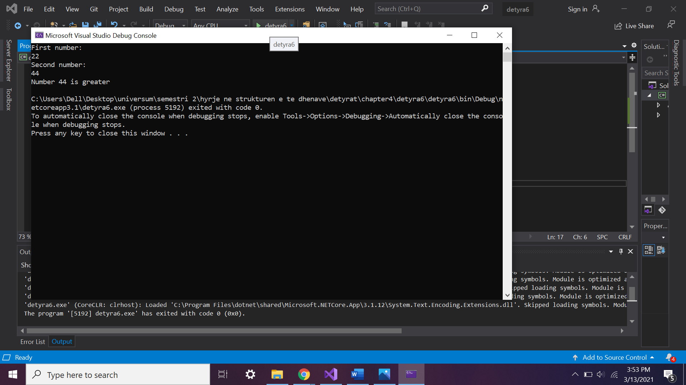

7.     Write a program that **reads five integer numbers and prints their sum**. If an invalid number is entered the program should prompt the user to enter another number.

using System;

namespace detyra7

{

class Program

{

static void Main(string[] args)

{

int a, b, c, d, e, sum;

bool validity = false;

do

{

Console.WriteLine("enter the first number");

validity = int.TryParse(Console.ReadLine(), out a);

} while (!validity);

do

{

Console.WriteLine("enter the second number");

validity = int.TryParse(Console.ReadLine(), out b);

} while (!validity);

do

{

Console.WriteLine("enter the third number");

validity = int.TryParse(Console.ReadLine(), out c);

} while (!validity);

do

{

Console.WriteLine("enter the fouth number");

validity = int.TryParse(Console.ReadLine(), out d);

} while (!validity);

do

{

Console.WriteLine("enter the fifth number");

validity = int.TryParse(Console.ReadLine(), out e);

} while (!validity);

sum = a + b + c + d + e;

Console.WriteLine($"The sum of all numbers is: {sum}");

}

}

}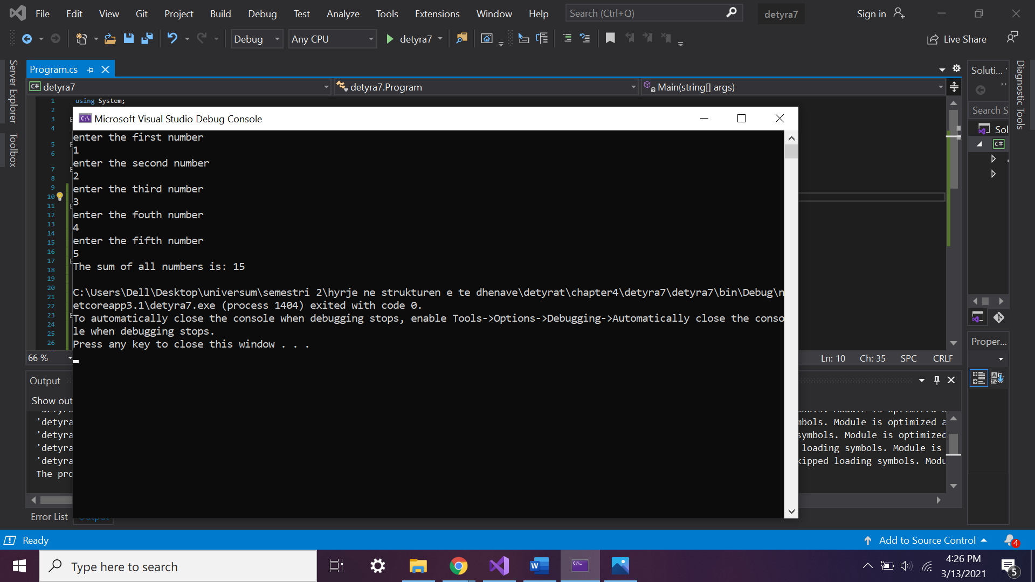

8.     Write a program that reads five numbers from the console and prints the **greatest** of them.

using System;

namespace detyra8

{

class Program

{

static void Main(string[] args)

{

Console.Write("Enter first number");

int a = Int32.Parse(Console.ReadLine());

Console.Write("Enter second number");

int b = Int32.Parse(Console.ReadLine());

Console.Write("Enter third number");

int c = Int32.Parse(Console.ReadLine());

Console.Write("Enter fourth number");

int d = Int32.Parse(Console.ReadLine());

Console.Write("Enter fifth number");

int e = Int32.Parse(Console.ReadLine());

if (a > b && a > c && a > d && a > e) Console.WriteLine("{0} eshte me i madhi", a);

else if (b > a && b > c && b > d && b > e) Console.WriteLine("{0} eshte me i madhi", b);

else if (c > a && c > b && c > d && c > e) Console.WriteLine("{0} eshte me i madhi", c);

else if (d > a && d > b && d > c && d > e) Console.WriteLine("{0} eshte me i madhi", d);

else if (e > a && e > b && e > c && e > d) Console.WriteLine("{0} eshte me i madhi", e);

else Console.WriteLine("ska numer me te madh.");

}

}

}

9.     Write a program that reads an integer number **n** from the console. After that reads **n** numbers from the console and prints their **sum**.

using System;

namespace detyra9

{

class Program

{

static void Main(string[] args)

{

double d, x1, x2;

Console.Write("Enter A (A != 0): ");

double a = Int32.Parse(Console.ReadLine());

Console.Write("Enter B: ");

double b = Int32.Parse(Console.ReadLine());

Console.Write("Enter C: ");

double c = Int32.Parse(Console.ReadLine());

d = b * b - 4 * a * c;

if (d < 0) Console.WriteLine("D={0}, There are no real roots.", d);

else if (d == 0)

{

x1 = (-b / (2 * a));

Console.WriteLine("X={0}", x1);

}

else

{

x1 = (-b + Math.Sqrt(d)) / (2 * a);

x2 = (-b - Math.Sqrt(d)) / (2 * a);

Console.WriteLine("X1={0}, X2={1}", x1, x2);

}

}

}

}

10.   Write a program that reads an integer number **n** from the console and **prints** **all numbers in the range** **[1…n]**, each on a separate line.

using System;

namespace detyra10

{

class Program

{

static void Main(string[] args)

{

int sum = 0;

Console.Write("Enter number: ");

int length = Int32.Parse(Console.ReadLine());

for (int i = 1; i <= length; i++)

{

Console.WriteLine(i);

}

}

}

}

11.   Write a program that prints on the console the first 100 numbers in the **Fibonacci sequence**: 0, 1, 1, 2, 3, 5, 8, 13, 21, 34, 55, 89, 144, 233, …

using System;

namespace detyra11

{

class Program

{

static void Main(string[] args)

{

int num1 = 0;

int num2 = 1;

int sum = 1;

int count = 0;

Console.WriteLine(num1);

while (count < 100)

{

sum = num1 + num2;

num1 = num2;

num2 = sum;

Console.WriteLine(num2);

count++;

}

}

}

}

12.   Write a program that calculates the **sum** (with **precision of 0.001**) of the following sequence: 1 + 1/2 - 1/3 + 1/4 - 1/5 + …

using System;

namespace detyra12

{

class Program

{

static void Main(string[] args)

{

Console.Write("Enter last number: ");

int length = Int32.Parse(Console.ReadLine());

double sum = 1.0;

for (int i = 2; i <= length; i++)

{

sum += (1.0 / i);

}

Console.WriteLine("{0:F3}", sum);

}

}

}