**Blue Team**

**Team Members**

Abraham Caban Rios - <https://github.com/AbeCaban/csd-310.git>

Isaac Frett - <https://github.com/isaacfrett/csd-310.git>

Oscar Acheampong - <https://github.com/dboat10/csd-310>

Bethany Mehring -<https://github.com/mehringb/csd-310.git>

Ryan Hoover- <https://github.com/RHoover13/csd-310>

**Reports and the Descriptions.**

Report 1: Allows us to see how many customers have purchased equipment.​

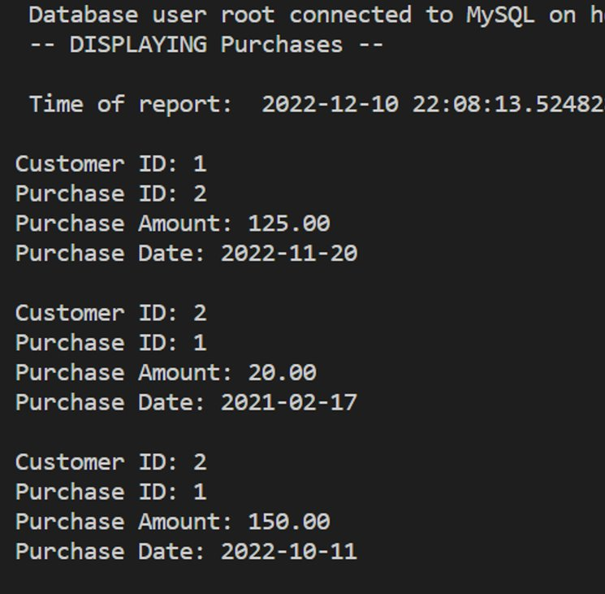 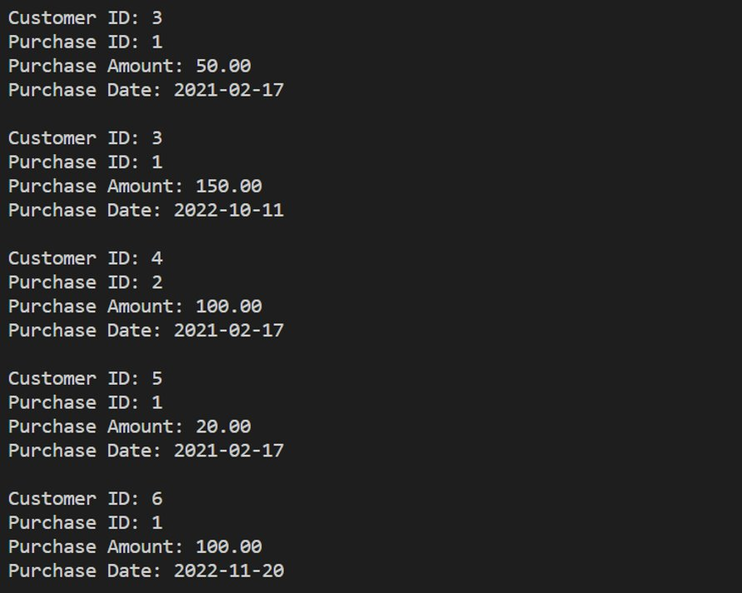

Report 2: Allows us to view how many trips have been booked to each continent within the last 90 days. 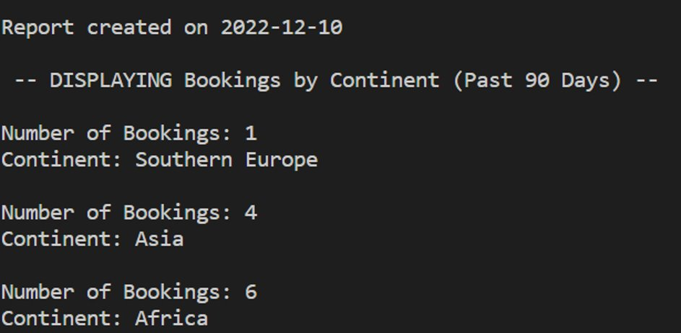

Report 3: Allow us to view the equipment with an acquisition date older than 5 years from today’s date.

