Job Autofiller: Intelligent Automated Job Application System

B. Tech. Computer Science & Engineering CSD334 MINI PROJECT

23CSA41 MDL23CS116 Mehrin Fathima Shamim 23CSA47 MDL23CS140 Noel Mathew Anil 23CSA19 MDL23CS063 Diya Jojo
23CSA50 MDL23CS146 Pranath Prasanth



Department of Computer Engineering Model Engineering College, Ernakulam Thrikkakara, Kochi 682021
March 2026

Model Engineering College, Ernakulam Dept. of Computer Engineering



C E R T I F I C A T E
This is to certify that, this report titled Job Autofiller: Intelligent Automated Job Application System is a bonafide record of the work done by
23CSA41 MDL23CS116 Mehrin Fathima Shamim 23CSA47 MDL23CS140 Noel Mathew Anil 23CSA19 MDL23CS063 Diya Jojo
23CSA50 MDL23CS146 Pranath Prasanth
Sixth Semester B.Tech Computer Science & Engineering students for the course work in CSD334 Mini Project, developed under our guidance and supervision in partial ful- fillment of the requirements for the award of the degree B.Tech Computer Science and Engineering of APJ Abdul Kalam Technological University.

Guide Coordinator

Head of Department

March 2026

Acknowledgement

We would like to express our sincere gratitude to the Principal of Model Engineering College and the Head of Department of Computer Engineering for providing us with the opportunity to undertake this mini project.
We extend our sincere thanks to our project guide and coordinator for their valuable suggestions, encouragement, and guidance throughout the development of this project.
We also thank all faculty members and friends who directly or indirectly helped us during the completion of this work.

Mehrin Fathima Shamim Noel Mathew Anil
Diya Jojo Pranath Prasanth

Abstract

Job applications today require candidates to repeatedly enter similar information across multiple job platforms, making the process time-consuming and inefficient. The Job Autofiller system is an AI-powered platform designed to automate the job application workflow by intelligently parsing resumes, matching candidates to job descriptions, and generating context-aware responses.
The system integrates Natural Language Processing techniques, transformer-based models such as BERT and SBERT for semantic job matching, and web automation technologies for automatic form filling. Resume data is extracted using Named Entity Recognition and structured parsing methods.
The platform follows a modular multi-agent architecture where specialized agents handle resume parsing, job scraping, semantic matching, form filling, response validation, and submission tracking. Selenium WebDriver enables browser automation for interacting with job portals.
This approach significantly reduces the time required for job applications from approx- imately 15-20 minutes to less than 2 minutes while improving accuracy and consistency in application submissions.

Contents

- Introduction 5
  - Proposed Project . . . . . . . . . . . . . . . . . . . . . . . . . . . . . . . 5
    - Problem Statement . . . . . . . . . . . . . . . . . . . . . . . . . . 5
    - Proposed Solution . . . . . . . . . . . . . . . . . . . . . . . . . . 5
- Report of Preparatory Work 6
  - System Study Report . . . . . . . . . . . . . . . . . . . . . . . . . . . . .
  - Literature Survey 6
- Software Requirements Specification Document 7
  - Introduction . . . . . . . . . . . . . . . . . . . . . . . . . . . . . . . . . . 7
  - Functional Requirements . . . . . . . . . . . . . . . . . . . . . . . . . . . 7
  - Non-Functional Requirements . . . . . . . . . . . . . . . . . . . . . . . . 7
  - Conclusion . . . . . . . . . . . . . . . . . . . . . . . . . . . . . . . . . . . 8
- Software Design Description 9
  - System Design . . . . . . . . . . . . . . . . . . . . . . . . . . . . . . . . . 9
    - Architecture Diagram . . . . . . . . . . . . . . . . . . . . . . . . . 9
    - Use Case Diagram . . . . . . . . . . . . . . . . . . . . . . . . . . 9
    - State Diagram . . . . . . . . . . . . . . . . . . . . . . . . . . . . . 9
    - Level 0 Data Flow Diagram . . . . . . . . . . . . . . . . . . . . . 9
    - Level 1 Data Flow Diagram . . . . . . . . . . . . . . . . . . . . . 9
    - Level 2 Data Flow Diagram . . . . . . . . . . . . . . . . . . . . . 9
    - Activity Diagram . . . . . . . . . . . . . . . . . . . . . . . . . . . 9
  - Module Description . . . . . . . . . . . . . . . . . . . . . . . . . . . . . . 9
  - Hardware Software Requirements . . . . . . . . . . . . . . . . . . . . . . 9
- Screenshots 16
- Future Scope
- Conclusion
- Reference 21

Chapter 1 Introduction
Applying for jobs online often requires candidates to repeatedly enter the same personal and professional information across multiple platforms. This process is tedious and prone to errors.

Proposed Project
The proposed project is an AI-powered automated job application system that simpli- fies the application process by intelligently parsing resumes, performing semantic job matching, and automatically filling application forms.

Problem Statement
Manual job applications are repetitive and time-consuming. Candidates typically spend 15-20 minutes completing each application, and repetitive data entry can lead to incon- sistencies and mistakes.

Proposed Solution
The Job Autofiller system automates this process using Artificial Intelligence techniques including:
      - Resume parsing using Natural Language Processing
      - Semantic job matching using transformer models
      - Intelligent automated form filling
      - Context-aware response generation
      - Human-in-the-loop validation

Chapter 2
Report of Preparatory Work

System Study Report

Technical Feasibility
The system can be implemented using modern AI frameworks such as spaCy, BERT, SBERT, Selenium automation, and web technologies like FastAPI and React.

Behavioral Feasibility
Job seekers frequently apply to many companies and benefit significantly from auto- mated assistance that reduces repetitive work.

Economic Feasibility
The system can be implemented using open-source technologies, minimizing develop- ment cost while maintaining scalability.

  - Literature Survey
2.2.1 AI-Driven Resume Parsing and Job Matching – A. Rahmah et al. [1]
This paper reviews techniques for resume parsing and job matching using NER, layout-aware parsing, and models like Random Forest (92.9%) and BERT (93%). Combining NER with structural analysis improves extraction accuracy.
Advantages: High accuracy and robust handling of diverse resume formats.
Drawbacks: Based on secondary studies and prone to algorithmic bias.

2.2.2 Multi-Agent Framework for Automated Job Applications – A. Bozkurt et al. [2]
This work proposes a multi-agent system using CrewAI and Selenium for end-to-end job application automation, achieving an F1-score of 0.92.
Advantages: Modular design, reduced manual effort, and parallel processing.
Drawbacks: Sensitive to website structure changes and high maintenance effort.

2.2.3 NLP and Large Language Models for Job Matching – H. Zhao et al. [3]
The study uses BERT and SBERT for semantic job matching, achieving up to 92% accuracy and outperforming TF-IDF methods.
Advantages: Strong semantic understanding and improved matching accuracy.
Drawbacks: High computational cost and lack of explainability.

2.2.4 Domain-Specific Matching with LoRA Fine-Tuning – M. F. Mridha et al. [4]
This approach fine-tunes BERT using LoRA for domain-specific matching, improving performance with reduced parameters.
Advantages: Efficient fine-tuning and improved domain-specific accuracy.
Drawbacks: Limited generalization and requires labeled domain data.

2.2.5 Context-Aware Form Filling via Bayesian Networks – M. Afsharizadeh et al. [5]
This system uses Bayesian Networks to model dependencies between form fields and improve prediction accuracy.
Advantages: Reduces user effort and supports flexible form filling.
Drawbacks: Cold-start problem and need for retraining with new forms.

2.2.6 Local Modeling for Categorical Field Prediction – D. Yan et al. [6]
This paper uses k-modes clustering with Bayesian Networks for localized predictions, achieving up to 90% accuracy.
Advantages: Improved prediction accuracy and better handling of local patterns.
Drawbacks: Requires large datasets and has computational overhead.

2.2.7 Machine Learning Framework for Job Application Systems – J. Smith et al. [7]
This framework integrates resume parsing, job scraping, and automation into a unified pipeline.
Advantages: End-to-end automation and modular architecture.
Drawbacks: Lacks detailed evaluation and vulnerable to scraping issues.

2.2.8 Cross-Application Form Filling via Pattern Mining – R. Gupta et al. [8]
This study uses pattern mining and TF-IDF to automate repeated form filling using user history.
Advantages: Reduces repetitive data entry and improves efficiency.
Drawbacks: Privacy concerns and limited semantic understanding.

Chapter 3
Software Requirements Specification Document

Introduction
This document defines the functional and non-functional requirements of the Job Aut- ofiller system.

Functional Requirements
    - Resume parsing using Named Entity Recognition.
    - Semantic job matching using BERT and SBERT embeddings.
    - Automated application form filling using Selenium.
    - Response generation using Large Language Models.
    - Application tracking through a dashboard interface.

Non-Functional Requirements

Usability
The system should provide an intuitive interface for resume upload and job manage- ment.

Performance
Resume parsing should complete within two seconds and form filling should complete within thirty seconds.

Security
User data must be securely stored and protected using secure authentication and encrypted storage.

Conclusion
The SRS defines the complete functional and non-functional requirements required for building the Job Autofiller system.

Chapter 4
Software Design Description

System Design

Architecture Diagram

Use Case Diagram

State Diagram

Level 0 Data Flow Diagram

Level 1 Data Flow Diagram

Level 2 Data Flow Diagram

Activity Diagram

Module Description
The system is composed of multiple modules including resume parsing, job matching, form filling, response generation, validation, and submission monitoring.

Hardware Software Requirements

Hardware

- 8GB RAM
- Dual Core Processor
- 10GB Storage

Software

- Python
- FastAPI
- spaCy
- BERT / SBERT
- Selenium
- React
- PostgreSQL

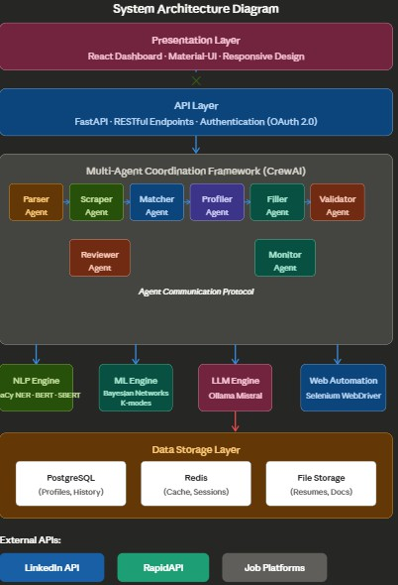
Figure 4.1: Architecture Diagram
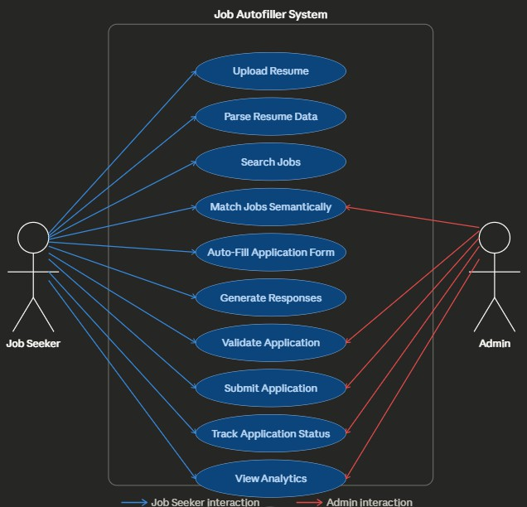
Figure 4.2: Use Case Diagram

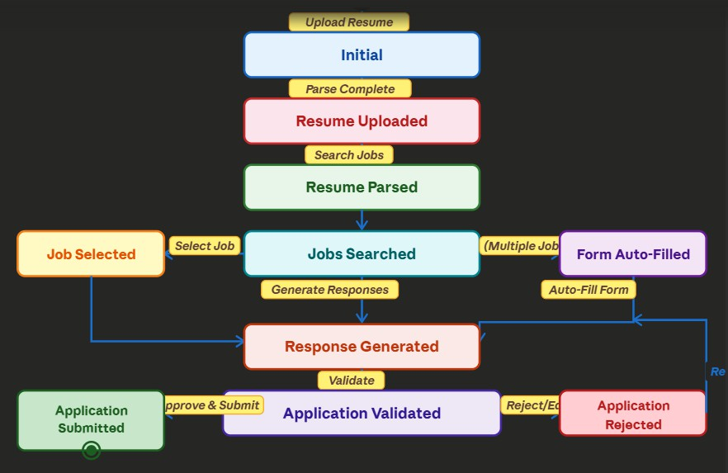

Figure 4.3: State Diagram

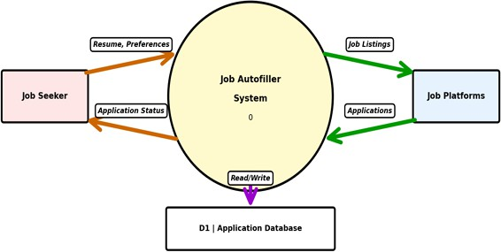

Figure 4.4: Level 0 Data Flow Diagram

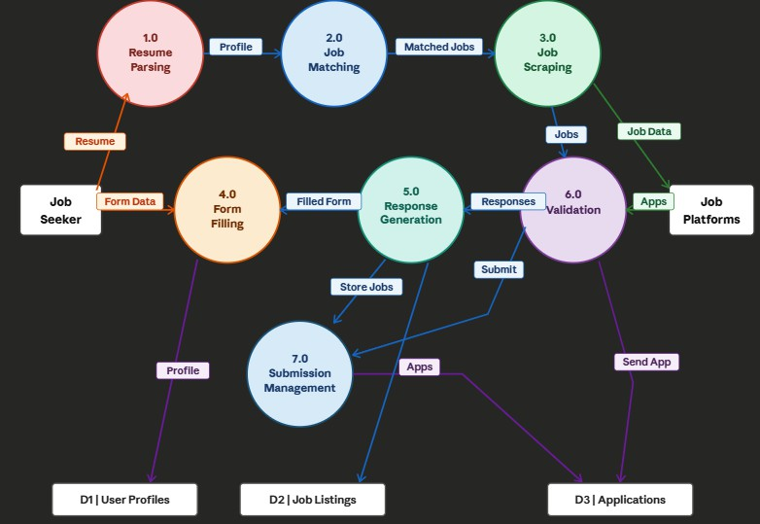
Figure 4.5: Level 1 Data Flow Diagram

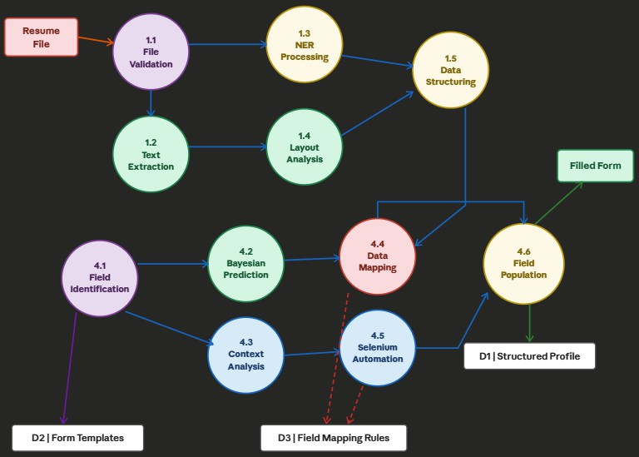
Figure 4.6: Level 2 Data Flow Diagram
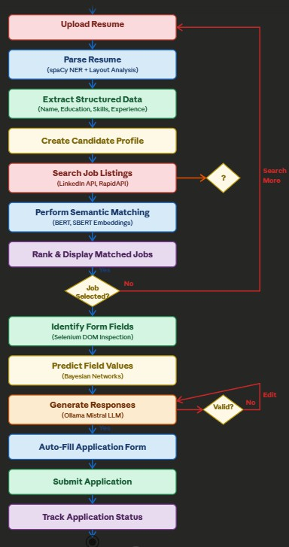
Figure 4.7: Activity Diagram

Chapter 5 Screenshots

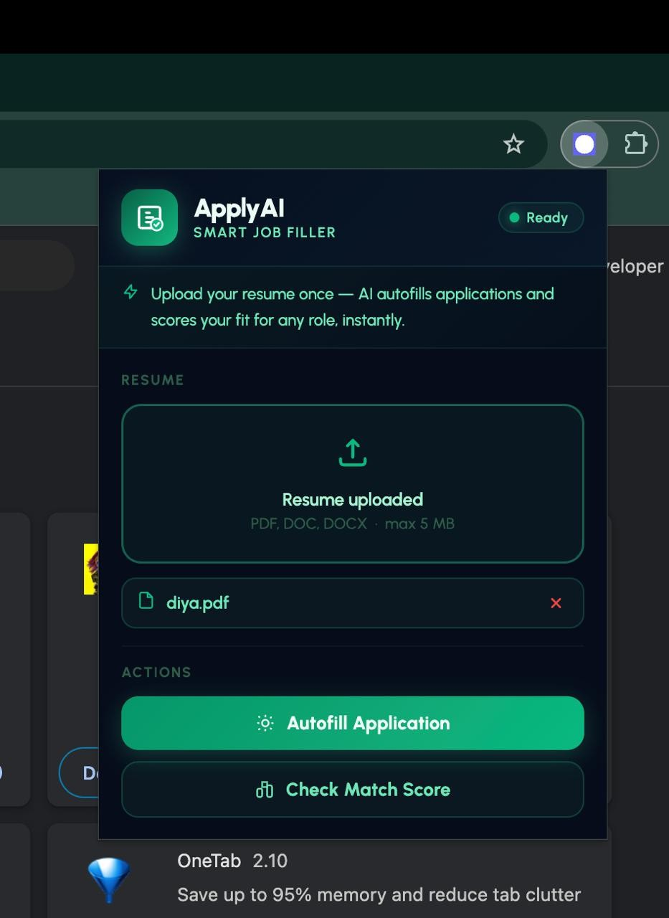
Figure 5.1: Job Autofiller Dashboard

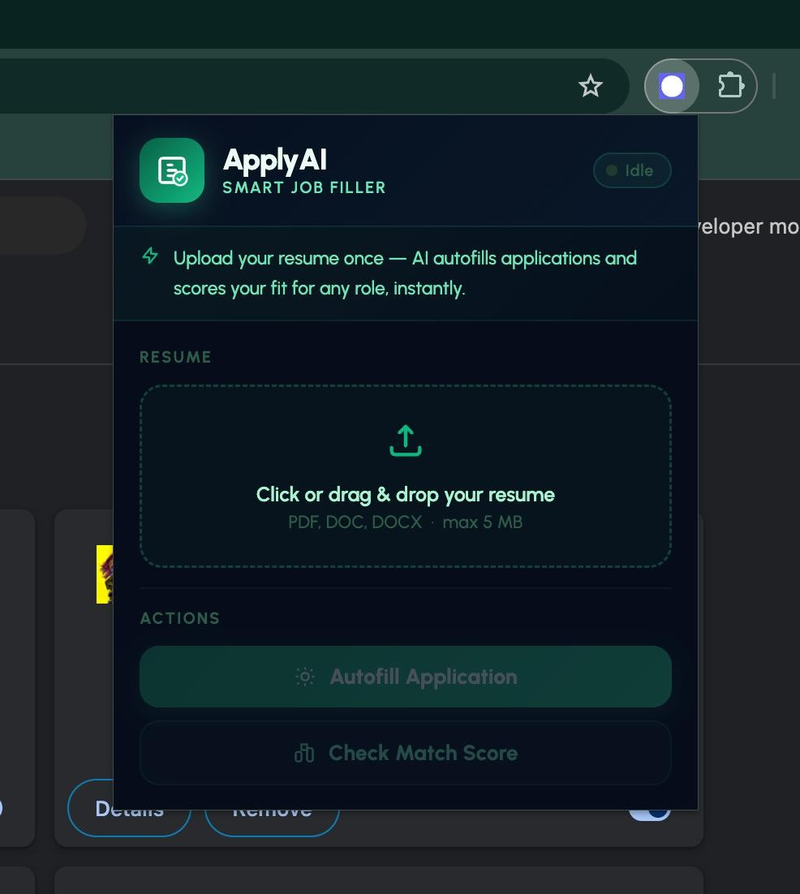
Figure 5.2: Automated Job Application Form Filling

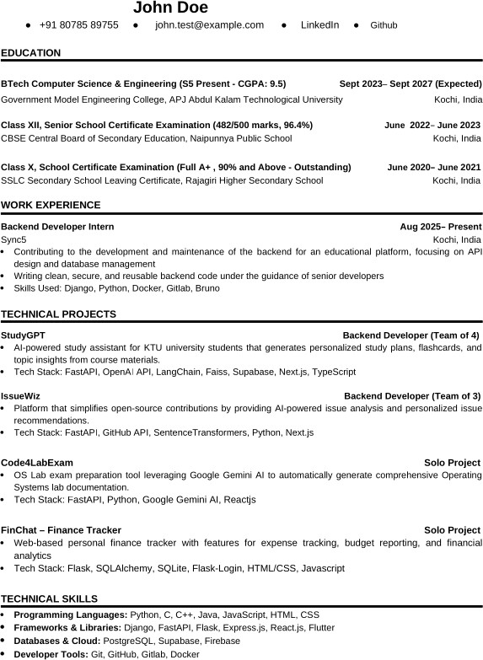

Figure 5.3: Sample Resume

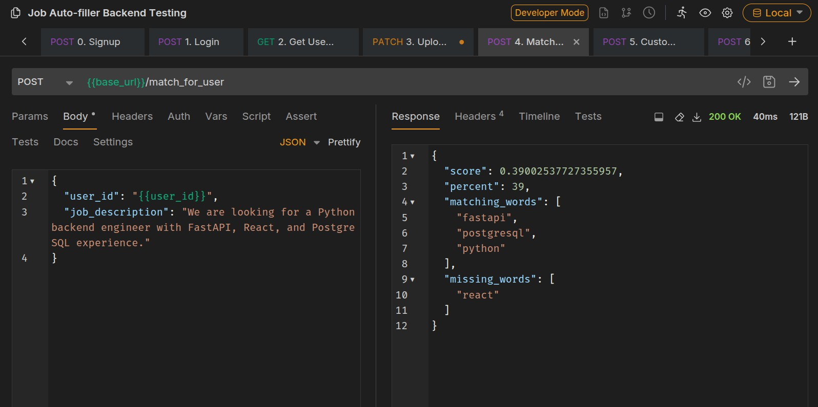

Figure 5.4: Job Matching API

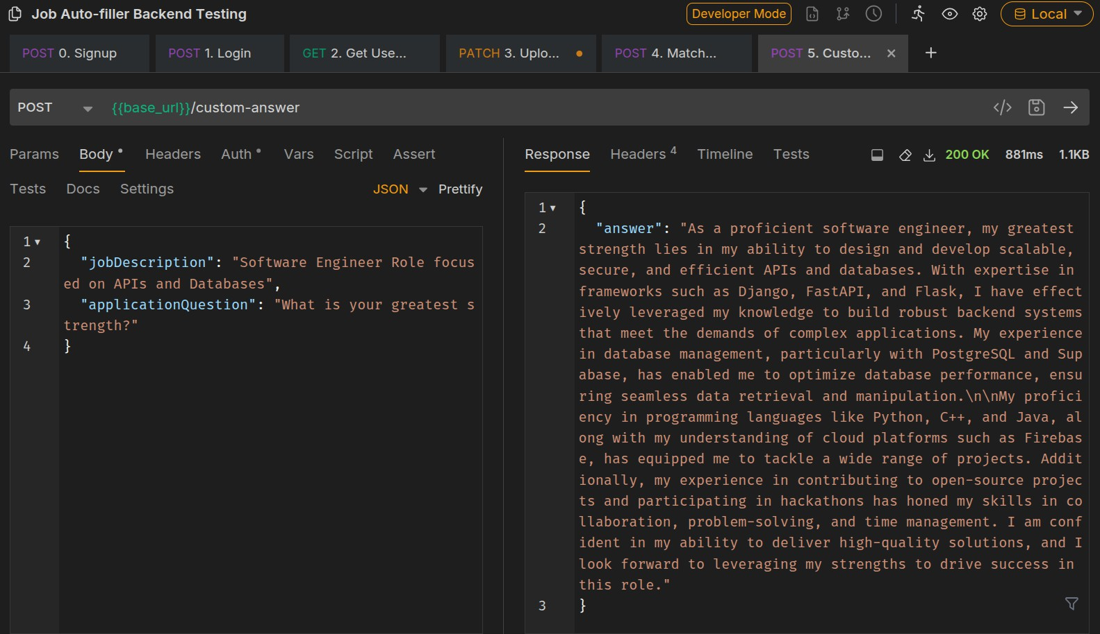
Figure 5.5: Job Application Auto-fill API

Chapter 6 Conclusion
The Job Autofiller system provides an intelligent automated solution for job applications by integrating NLP techniques, semantic job matching, probabilistic form prediction, and web automation. The system reduces repetitive manual effort and significantly improves the efficiency of applying for jobs.
Future improvements include multilingual job support, improved dynamic form de- tection, and enhanced fairness mechanisms in job matching algorithms.

Bibliography

- AI Driven Resume Parsing and Job Matching Systems, International Journal of Com- puter Science.
- Multi Agent Framework for Automated Job Applications, IEEE Access.
- NLP and Large Language Models for Job Matching Systems.

