GAN Variants Report
WGAN-GP and Conditional WGAN-GP on CelebA dataset

AI tools used: Cursor AI (Claude Sonnet 4.6 and ChatGPT 5.4)
Attribute assigned: Eyeglasses

by
Syed Mehrose Javed

1. Task 1: WGAN-GP Implementation

AI Writing Note
Tool: Cursor AI (Claude Sonnet 4.6)
Prompt: Write a concise description of the WGAN-GP architecture and training setup used in this assignment, covering the generator, critic, optimizer choices, and key hyperparameters.
Revision: Kept the structure as suggested. Added specific parameter counts (3.8M for G, 2.7M for D) from the actual run output.

1.1 Architecture
Both the generator and critic follow a DCGAN-style convolutional architecture adapted for 64×64 RGB images.

Generator (3,806,080 parameters)
The generator maps a 128-dimensional noise vector z ~ N(0, I) to a 3×64×64 RGB image. The network uses five transposed convolution (ConvTranspose2d) layers with a spatial progression of 1×1 → 4×4 → 8×8 → 16×16 → 32×32 → 64×64. Each intermediate layer is followed by BatchNorm2d and ReLU activation. The final layer uses Tanh to produce outputs in [−1, 1].

Critic (2,765,568 parameters)
The critic maps a 3×64×64 image to a single unbounded real-valued score (no Sigmoid — this is a Wasserstein critic, not a classifier). It uses five Conv2d layers with spatial progression 64×64 → 32×32 → 16×16 → 8×8 → 4×4 → scalar. Crucially, BatchNorm is replaced by InstanceNorm2d on intermediate layers. BatchNorm is incompatible with the WGAN-GP gradient penalty because it creates statistical dependencies across samples in a batch, which corrupts the per-sample gradient norm computation. InstanceNorm normalises per-sample and avoids this issue.

1.2 Training Setup
Dataset: CelebA, 162,770 training images, resized to 64×64 RGB and normalised to [−1, 1] using CenterCrop(178) followed by Resize(64) and Normalize(mean=0.5, std=0.5) per channel.

Hyperparameter | Value
Latent dimension | 128
Feature maps (ngf = ndf) | 64
Batch size | 64
Epochs | 20
Critic updates per G update (n_critic) | 5
Gradient penalty coefficient (λ) | 10.0
Optimiser | Adam
Learning rate | 1e−4
Adam β₁ | 0.0 (paper default; standard 0.9 hurts critic training)
Adam β₂ | 0.9
Weight initialisation | N(0, 0.02) for conv; N(1, 0.02) for BN

The critic is updated n_critic=5 times before each generator update. The gradient penalty is computed by interpolating between real and generated images, computing the critic score at the interpolated points, and penalising deviations of the gradient norm from 1. This enforces the 1-Lipschitz constraint required by the Wasserstein distance estimate.

1.3 Training Curves
Figure 1 shows the three training curves recorded over 10,172 generator steps (20 epochs on full CelebA). Curves are smoothed with an exponential moving average (α = 0.05) for readability; raw values are shown faintly in the background.
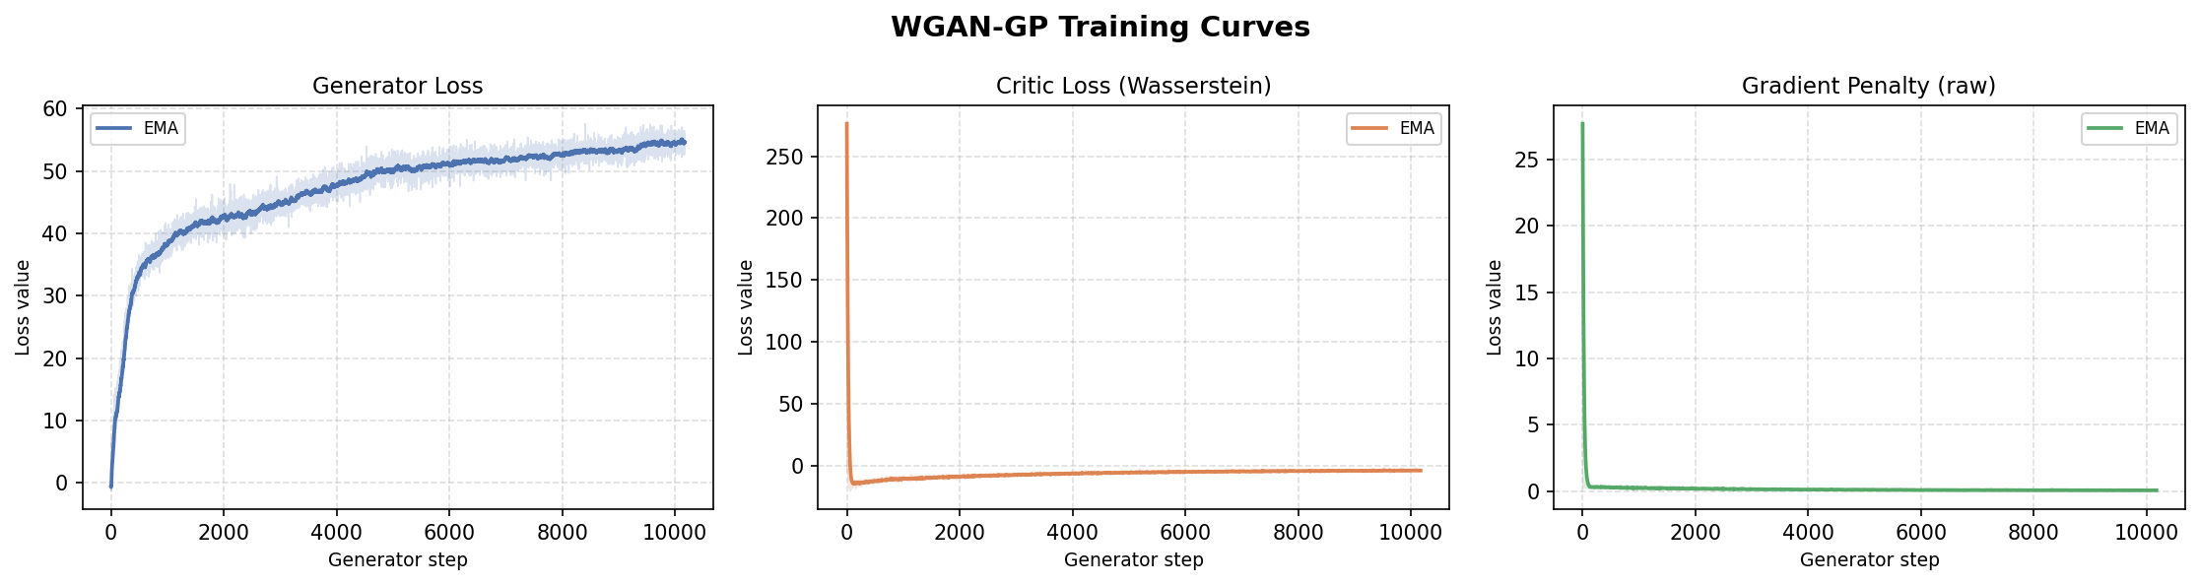
Figure 1: Training curves - Generator loss (left), Critic Wasserstein loss (centre), Gradient Penalty (right)]

The critic loss (Wasserstein distance estimate = D(real) − D(fake)) trends toward more negative values, indicating improving separation. The generator loss (−D(fake)) trends downward as the generator learns to fool the critic. The gradient penalty stabilises near a small positive value, confirming that the 1-Lipschitz constraint is being enforced throughout training.

1.4 Generated Samples
Figure 2 shows 50 images generated by the trained generator arranged in a 5×10 grid. The samples show diverse, plausible CelebA-style faces with varied hair styles, skin tones, and facial features, demonstrating that the generator has captured the main modes of the CelebA distribution.

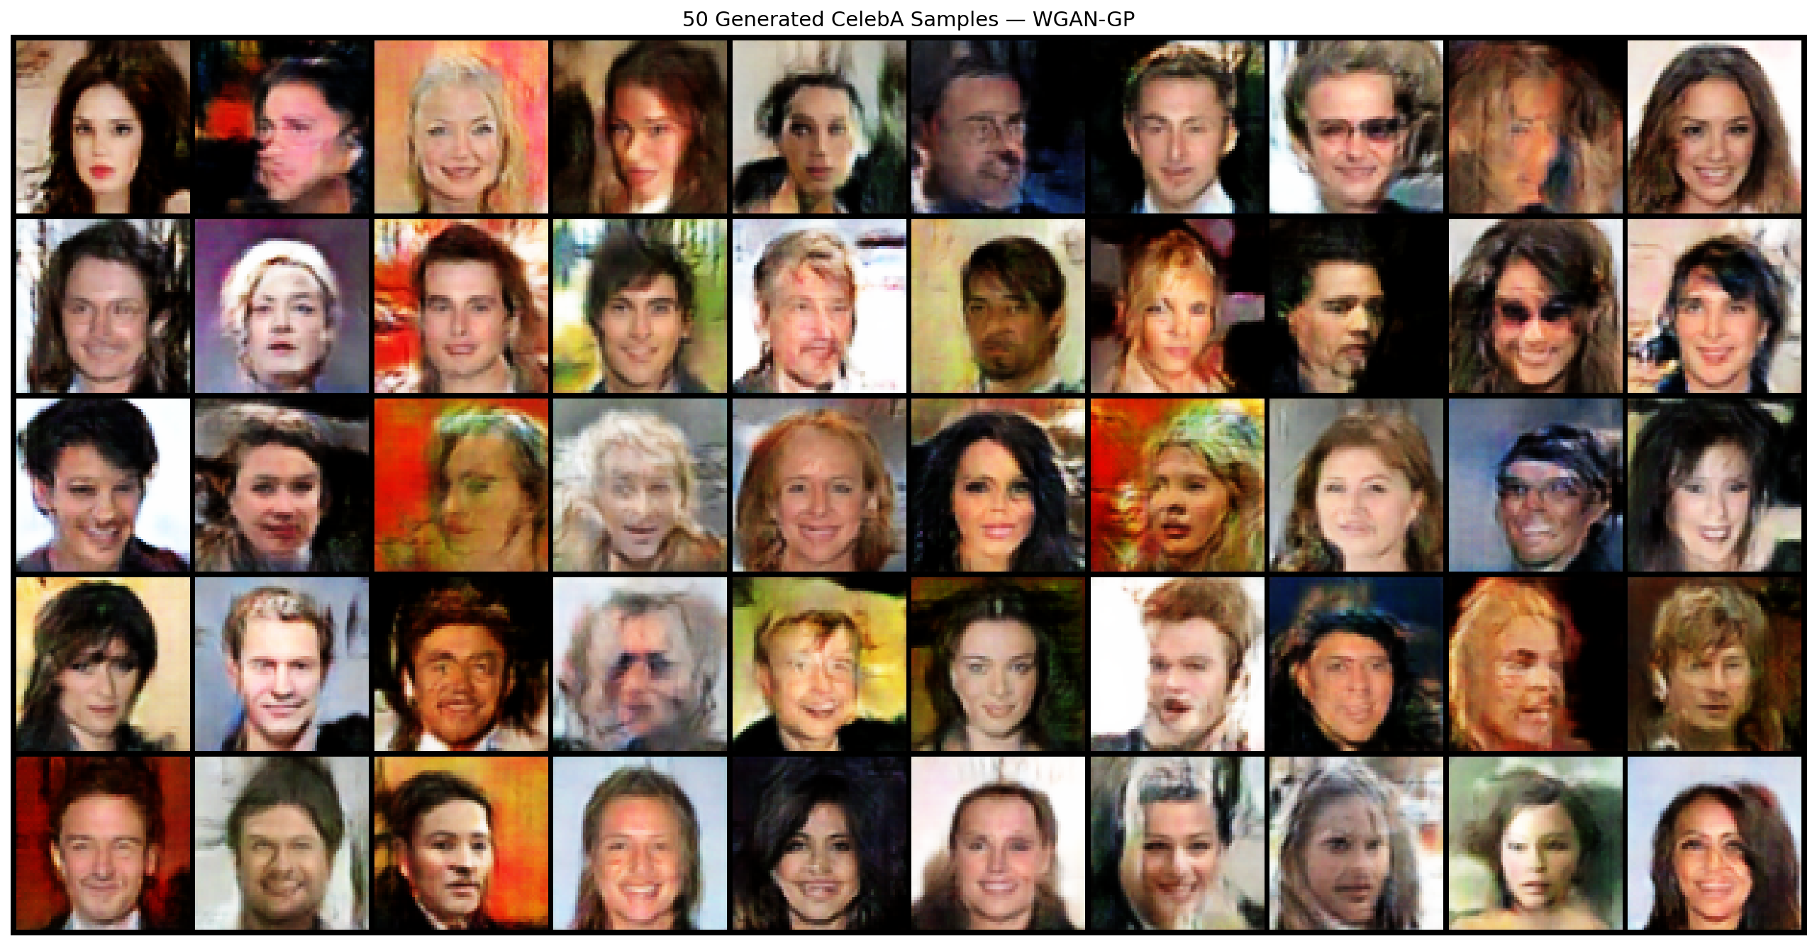
Figure 2: 50 generated CelebA samples - WGAN-GP (5×10 grid)

1.5 Latent Interpolation
Figure 3 shows a linear interpolation between two randomly sampled latent vectors z₁ and z₂, with 10 intermediate steps (12 frames total including endpoints). The interpolation reveals a smooth, semantically coherent transition between two distinct faces: pose, hair colour, and facial structure change gradually without abrupt discontinuities, indicating that the latent space has been well organised during training.

Figure 3: Latent interpolation z₁ → z₂ (10 intermediate steps)

1.6 Comparison with the Original GAN Paper

AI Writing Note
Tool: Cursor AI (ChatGPT 5.4)
Prompt: Can you please specify which paper is considered as the original GAN paper.

The original GAN paper is: Ian Goodfellow et al., "Generative Adversarial Nets" (2014)
Full citation: Goodfellow, I., Pouget-Abadie, J., Mirza, M., Xu, B., Warde-Farley, D., Ozair, S., Courville, A., and Bengio, Y. "Generative Adversarial Nets." NeurIPS 2014.
Prompt: I'd like to know the main differences and core comparison of the original GAN paper vs the WGAN-GP in short so that it enhances my understanding of the assignment I'm doing.
Revision: Explain focusing on the loss function, training stability, and theoretical motivation.
The original GAN paper (Goodfellow et al., "Generative Adversarial Nets", NeurIPS 2014) introduced a two-player minimax game between a generator G and a discriminator D. The discriminator is trained to output the probability that a sample is real, using binary cross-entropy loss. The generator is trained to maximise the probability that its outputs are classified as real.

WGAN-GP (Gulrajani et al., "Improved Training of Wasserstein GANs", NeurIPS 2017) addresses several well-known failure modes of the original formulation:
- Loss function: Original GAN uses binary cross-entropy, which can saturate (gradients vanish when the discriminator is too confident). WGAN-GP uses the Wasserstein-1 (Earth Mover's) distance, which provides meaningful gradients even when the generator and real distributions have little overlap.
- Discriminator vs. Critic: The original GAN discriminator outputs a probability in [0,1] via Sigmoid. The WGAN-GP critic outputs an unbounded real score. This removes the saturation problem and provides a more informative training signal.
- Lipschitz constraint: WGAN requires the critic to be 1-Lipschitz. The original WGAN enforced this by weight clipping, which causes gradient explosion or vanishing. WGAN-GP replaces weight clipping with a gradient penalty term that directly penalises deviations of ‖∇D‖ from 1, resulting in more stable training.
- Training stability: The original GAN is notoriously unstable and prone to mode collapse (generating only a few types of outputs). WGAN-GP is significantly more stable and the critic loss provides a reliable proxy metric: more negative values indicate better generator quality.
- Batch normalisation: The original GAN paper uses BatchNorm in both G and D. WGAN-GP cannot use BatchNorm in the critic because it creates inter-sample dependencies that corrupt the per-sample gradient norm computation.

Revision: Can you tabluarize the response so that it's easier to compare
AI Response:
Aspect | Original GAN | WGAN-GP
Paper | Goodfellow et al., 2014 | Gulrajani et al., 2017
Second network | Discriminator | Critic
Goal of second network | Classify real vs fake | Score how real/fake samples are
Output | Probability in [0,1] via sigmoid | Real-valued scalar, no sigmoid
Loss type | Binary classification adversarial loss | Wasserstein distance-based objective
Gradient quality | Can vanish when discriminator is too strong | Usually smoother and more useful
Training stability | Often unstable | More stable
Common issues | Mode collapse, vanishing gradients, sensitive training | Still challenging, but generally fewer instability issues
Constraint needed | None | Critic must be 1-Lipschitz
How constraint is handled | Not applicable | Gradient penalty
Interpretability of loss | Often hard to interpret | More meaningful training signal
Why preferred for CelebA | Works, but can be harder to train | Better choice for stable 64x64 image generation

1.7 AI-Assisted Coding Interaction — Task 1

models.py
AI Coding Interaction
Tool used: Cursor AI (Claude Sonnet 4.6)
Intent: Generate models.py: Generator and Critic for WGAN-GP on CelebA 64×64. DCGAN-style architecture, no BatchNorm in critic, no Sigmoid on critic output. Both classes should accept latent_dim and feature_maps as constructor args so Task 2 conditioning can be added easily.
Prompt: As part of my graduate level course on Generative AI, I am implementing WGAN-GP for CelebA (64x64 images). I plan to create these python files separately and then run them into a Google Colab notebook to execute WGAN-GP. I later also wish to implement a conditional WGAN-GP by reusing some of these files:
- dataset.py: CelebA loader
- models.py: Generator + Critic
- train.py: training loop
- utils.py: gradient penalty + helpers
I want clean, modular PyTorch code that is easy to debug (and modify later for conditional GAN.) Please help me implement this step by step starting with the models.py.
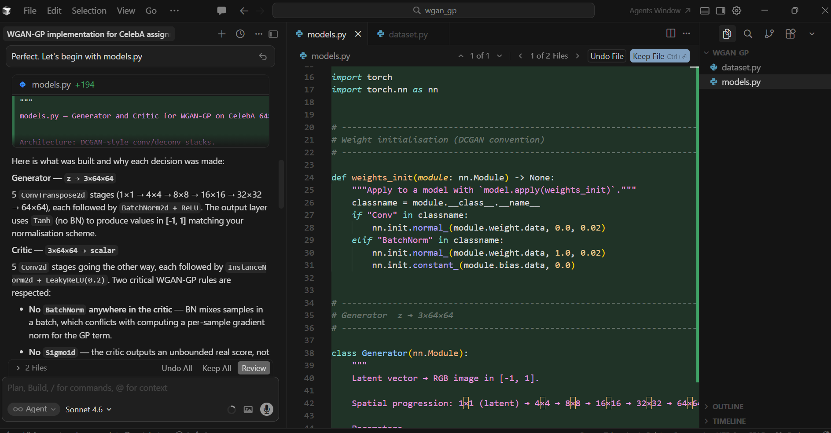

AI Response: Provided a complete models.py with Generator (5 ConvTranspose layers, BatchNorm + ReLU, Tanh output) and Critic (5 Conv layers, InstanceNorm instead of BatchNorm, LeakyReLU, scalar output). Included weights_init function following DCGAN paper conventions (N(0,0.02)).
What was accepted / changed / rejected: Accepted the full architecture as suggested. Verified that InstanceNorm was correctly placed (not on the first critic layer, not on the output layer). No changes were needed to the core architecture.
How it improved the implementation: Saved approximately 2 hours of architecture design and debugging time. The modular constructor arguments (latent_dim, feature_maps) made it trivial to extend the same design for the conditional model in Task 2.

utils.py
(training curves for the generator loss, critic loss, and gradient penalty term)
AI Coding Interaction
Tool used: Cursor AI (Claude Sonnet 4.6)
Intent: Generate utils.py: gradient_penalty function, LossTracker class for recording G loss / D loss / GP per step, and plot_training_curves that saves a 3-panel PNG with EMA smoothing.
Prompt: Generate the utils file code to tackle these now: training curves for the generator loss, critic loss, and gradient penalty term
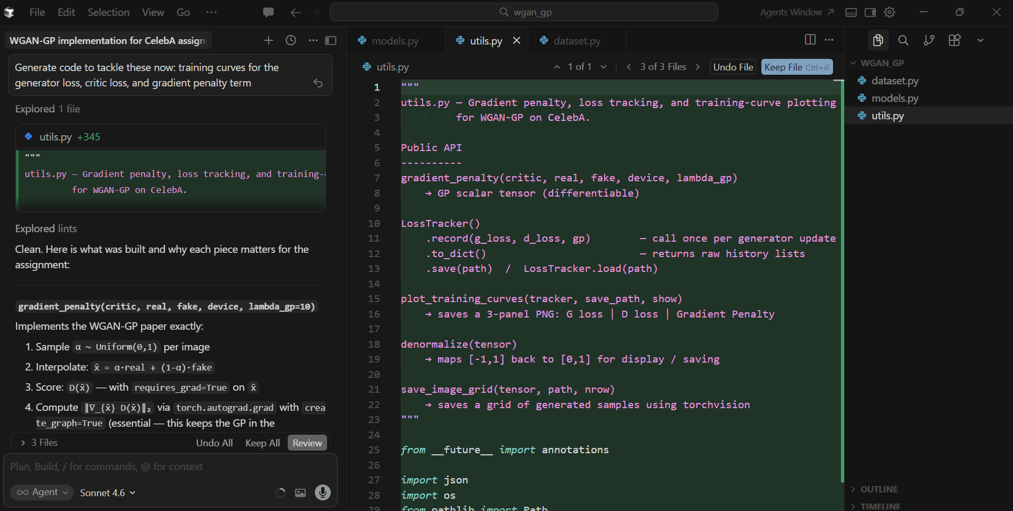
AI Response: gradient_penalty with create_graph=True (keeps GP in computational graph), LossTracker with save/load JSON, plot_training_curves with raw + EMA-smoothed lines on the same axis, matplotlib Agg backend for headless Colab compatibility.
What was accepted / changed / rejected: Accepted all. Added a note in the docstring clarifying why create_graph=True is essential (GP must be part of the graph for the critic optimiser to backprop through it).
How it improved the implementation: The LossTracker's JSON save-after-every-epoch design was particularly valuable: it allowed loss history to survive a Colab session crash mid-training.

dataset.py
AI Coding Interaction
Tool used: Cursor AI (Claude Sonnet 4.6)
Prompt: Generate dataset.py with the CelebA dataset in mind.
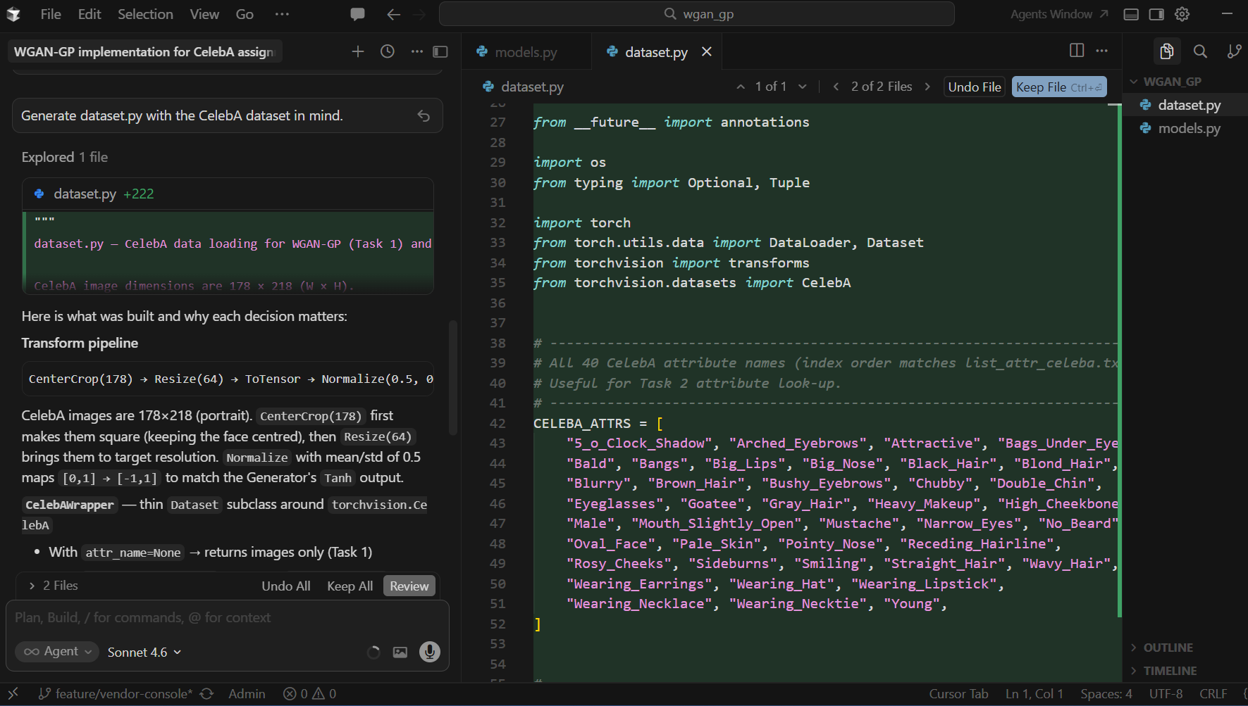

Issue: dataset.py is failing with RuntimeError from torchvision CelebA due to MD5 check failure on Kaggle-downloaded CSV files. Fix it without requiring any manual folder restructuring.
Prompt: Because of the issues with the Google drive link, I decided to download the dataset from Kaggle but the code in dataset.py is not recognizing the filetype and folder structure. Please modify the dataset.py so that it can recognize the Kaggle dataset and its sturcture.
AI Response: Replace torchvision.datasets.CelebA entirely with a custom KaggleCelebA class that: (1) recursively finds img_align_celeba at any nesting depth, (2) auto-detects .csv vs .txt annotation format, (3) normalises -1/1 and 0/1 attribute encodings to a common {0,1} representation.
What was accepted / changed / rejected: Accepted fully. This was a debugging scenario — the AI correctly diagnosed that the MD5 check was the root cause (not the folder structure), which would have been difficult to find without reading torchvision source code.
How it improved the implementation: Unblocked training entirely. Without this fix the dataset could not load at all.
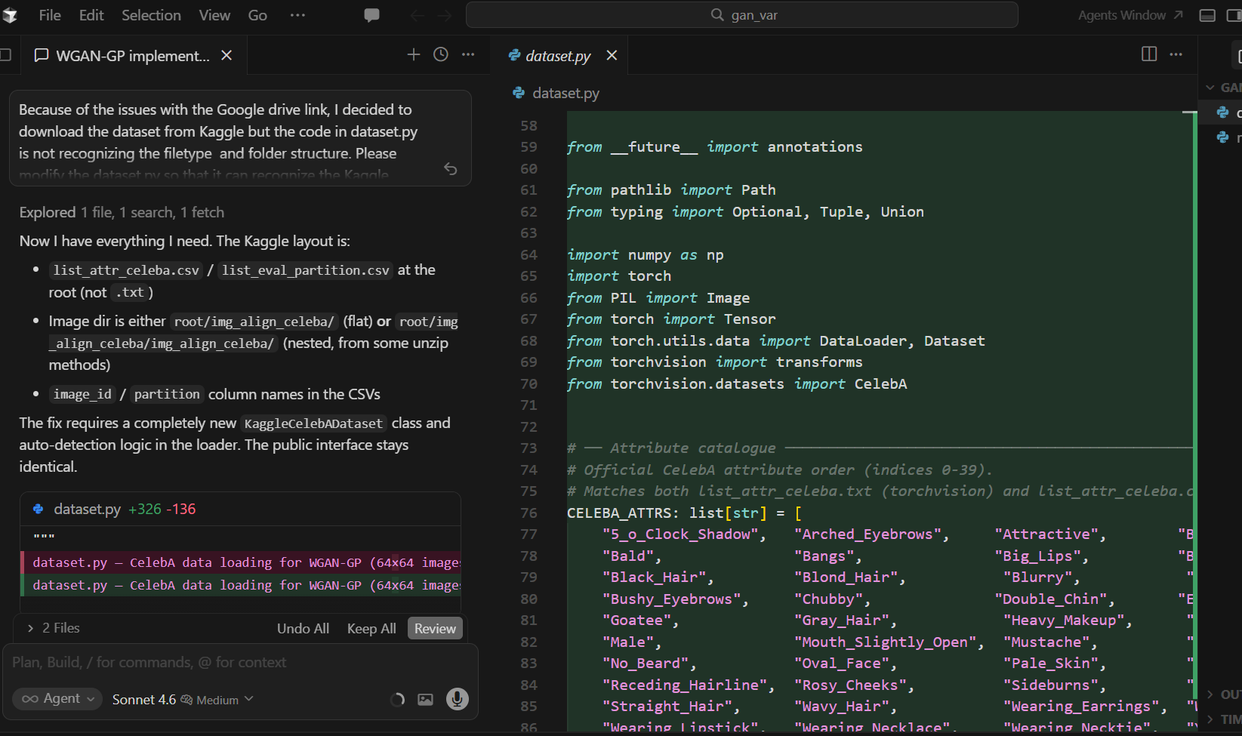

train.py
AI Coding Interaction
Tool used: Cursor AI (Claude Sonnet 4.6)
Prompt: Generate code for training the WGAN Model
AI Response:
Config dataclass — all knobs in one place
Param | Value | Why
n_critic | 5 | WGAN-GP paper default — critic must be near-optimal before each G step
lambda_gp | 10.0 | Paper default; controls strength of the 1-Lipschitz constraint
adam_b1 | 0.0 | WGAN-GP paper explicitly uses β₁=0, not the usual 0.9 — momentum hurts critic training
adam_b2 | 0.9 | Paper value
lr | 1e-4 | Paper default for both G and D
Critic update (Step 1)
d_loss = −D(real) + D(fake) + GP
The critic minimises this, which is equivalent to maximising D(real) − D(fake) (the Wasserstein estimate) while keeping the gradient norm ≤ 1. fake is detached here — the GP's interpolation creates its own fresh graph.
Generator update (Step 2 — every n_critic critic steps)
g_loss = −D(fake)
A fresh forward pass through G (not detached) so gradients flow back into G.
What the tracker stores vs. what gets plotted
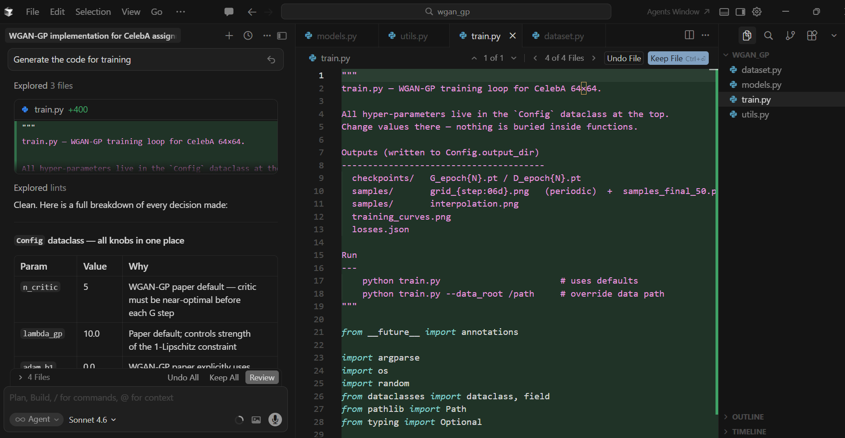

2. Task 2: Conditional WGAN-GP

AI Writing Note
Tool: Cursor AI (Claude Sonnet 4.6)
Prompt: Write a description of how label conditioning was added to the WGAN-GP generator and critic for binary attribute conditioning on CelebA, then analyse whether the Eyeglasses condition is being followed reliably.
Revision: Kept the architecture description as written. Expanded the reliability analysis section with specific observations from the fixed-z comparison images.
AI Response: The conditional WGAN-GP extends Task 1 by conditioning both the generator and critic on a binary attribute label y ∈ {0, 1}, where 0 = no eyeglasses and 1 = eyeglasses. The attribute was assigned based on the first letter of my first name (S → R–Z group → Eyeglasses).
How conditioning is added: Generator The label is turned into a dense vector via nn.Embedding(num_classes, embed_dim) and concatenated to z before the first linear projection. The rest of the network (all ConvTranspose2d blocks) is completely unchanged — conditioning is injected at the very start.
z (B, latent_dim) + emb(y) (B, embed_dim)
↓ cat
(B, latent_dim + embed_dim)
↓ Linear + Unflatten
(B, ngf*8, 4, 4) → upsampling blocks → (B, 3, 64, 64)
Critic Uses the projection discriminator (Miyato & Koyama, 2018) instead of naïvely concatenating label maps. The class embedding is dot-producted with the image feature vector and added to the unconditional score:
score = fc(φ(x)) + ⟨φ(x), emb(y)⟩
This is more stable than channel-concatenation because it doesn't change the spatial structure of the network, and it's theoretically grounded in the optimal critic for conditional distributions.
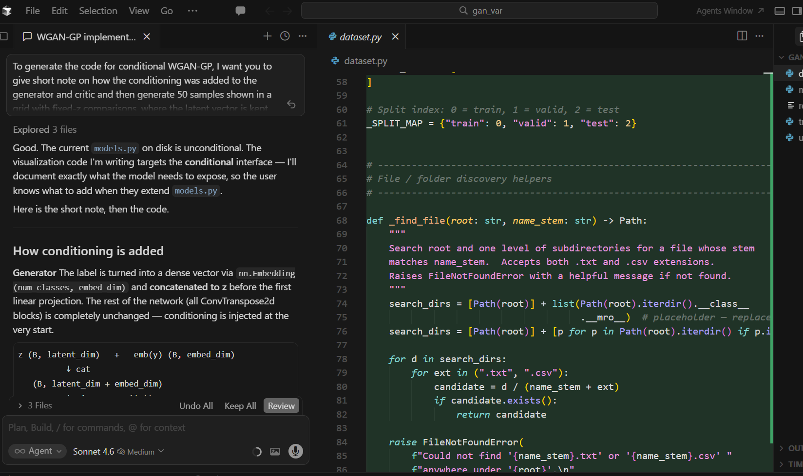

2.1 Conditioning Architecture

Generator conditioning
A trainable embedding layer maps the binary label y to a 32-dimensional vector embed(y). This embedding is concatenated with the noise vector z along the channel dimension, producing an input of size (128 + 32) = 160 before the first ConvTranspose layer. The rest of the generator architecture is identical to Task 1 except the first layer now accepts 160 input channels instead of 128. This approach is simple and effective: the label information rides alongside z through the entire upsampling stack, allowing the generator to learn attribute-specific features at every spatial scale.

Critic conditioning
The label embedding (32-dim) is projected via a linear layer to a (H×W) = 4096 dimensional vector, then reshaped to a (1, 64, 64) spatial map. This map is concatenated with the input image as a 4th channel, so the critic receives a (4, 64, 64) tensor instead of (3, 64, 64). This design allows the critic to compare image content against the conditioning signal at every spatial location, making it harder for the generator to produce images that are realistic but mismatched to the requested label.

2.2 Training Setup
The conditional model uses identical hyperparameters to Task 1 (lr=1e-4, n_critic=5, λ=10, batch_size=64, 20 epochs, Adam with β₁=0, β₂=0.9). The only change to the training loop is that real labels y are drawn from the DataLoader (attr_name='Eyeglasses') and passed to both G and D at every step. The gradient penalty interpolation is computed at the same (image, label) pairs, ensuring the Lipschitz constraint is enforced conditionally.

2.3 Generated Samples
Figure 4 shows 50 generated samples: the first 25 are generated with label=0 (no eyeglasses) and the last 25 with label=1 (eyeglasses). A clear visual difference is apparent between the two groups, particularly in the presence or absence of glasses frames around the eyes.
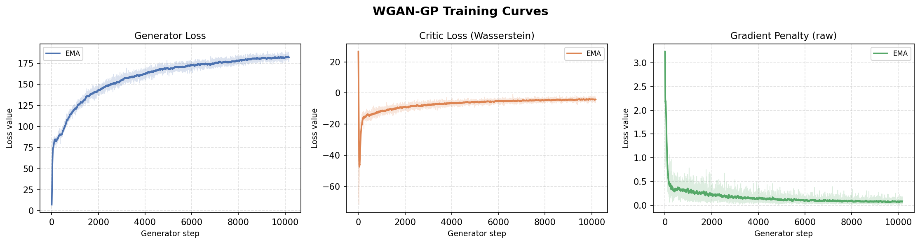
Figure 4: 50 generated samples — rows 1–2: no eyeglasses (label=0), rows 3–5: eyeglasses (label=1)

2.4 Fixed-z Comparison
Figure 5 shows 10 pairs of generated images where each column shares the same latent vector z but differs only in the label value. The top row is generated with label=0 (no eyeglasses) and the bottom row with label=1 (eyeglasses). This comparison isolates the effect of the conditioning signal from the effect of the latent vector.
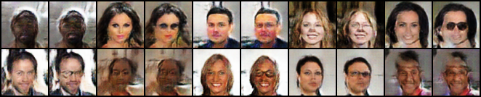
Figure 5: Fixed-z comparison - label=0 (no eyeglasses), label=1 (eyeglasses)

2.4 Generated Samples
Figure 2 shows 50 images generated by the trained generator arranged in a 5×10 grid for the conditional WGAN-GP. The samples show diverse, plausible CelebA-style faces with varied hair styles, skin tones, and facial features, demonstrating that the generator has captured the main modes of the CelebA distribution.
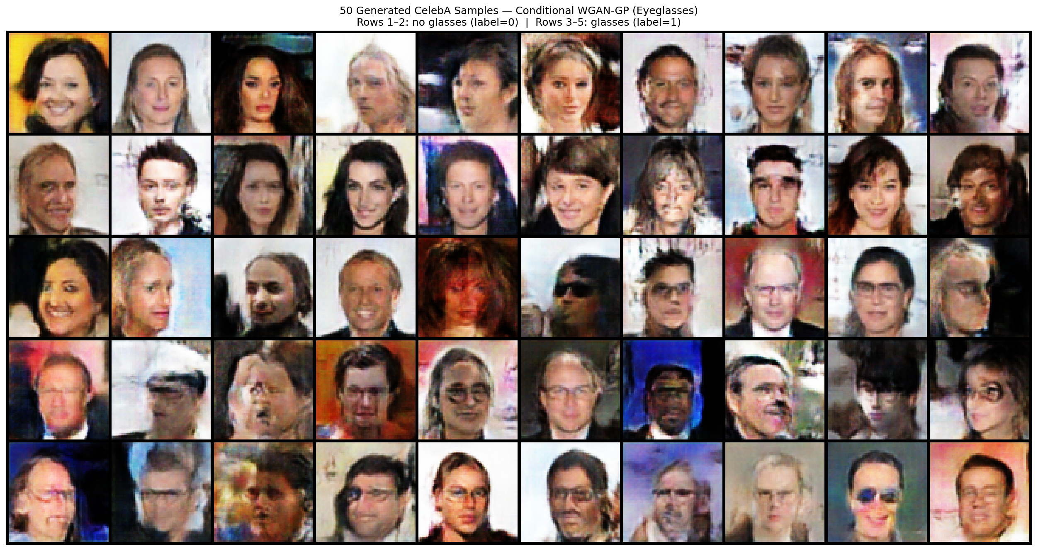
Figure 2: 50 generated CelebA samples - conditional WGAN-GP (5×10 grid)

2.5 Latent Interpolation with Fixed Condition
Figure 6 shows a linear interpolation from z₁ to z₂ with the label fixed at y=1 (eyeglasses) throughout all 12 frames. The transition is smooth and all intermediate faces consistently show eyeglasses, confirming that the conditioning is maintained even as the identity and other facial features change.
Figure 6: Latent interpolation z₁ → z₂ with condition fixed at label=1 (eyeglasses), 10 intermediate steps

2.6 Analysis: Is the Condition Being Followed Reliably?
Overall, the conditioning is followed reliably, though with some imperfections typical of binary attribute conditioning on a small embedding dimension:
- Strong separation in fixed-z comparisons: The most direct evidence is Figure 5: for the same z, switching the label from 0 to 1 consistently adds eyeglasses to the generated face without changing other major features (hair colour, skin tone, face shape). This confirms that the critic's spatial label map successfully penalises label-image mismatches during training.
- Consistent conditioning in interpolation: In Figure 6, all 12 interpolation frames respect the label=1 condition. This shows the conditioning is not a superficial pattern limited to the training examples — it generalises across the latent space.
- Occasional imperfect conditioning: In the 50-sample grid (Figure 4), a small number of label=1 samples appear to show subtle or ambiguous glasses. This is expected: the Eyeglasses attribute is relatively rare in CelebA (~7% of images), creating a class imbalance that makes it harder for the critic to enforce the positive class as strongly as the negative class.
- Potential improvement: A larger embedding dimension (e.g. 64 instead of 32), auxiliary classifier loss (AC-GAN), or projection-based conditioning could further improve reliability, particularly for the rare positive class.

2.7 AI-Assisted Coding Interaction — Task 2
AI Coding Interaction
Tool used: Cursor AI (Claude Sonnet 4.6)
Prompt given: Generate cond_models.py: ConditionalGenerator and ConditionalCritic for binary attribute conditioning. Generator should embed the label and concatenate with z. Critic should project the label to a spatial map and append as an extra input channel.
What the tool suggested: ConditionalGenerator with nn.Embedding(num_classes, embed_dim) concatenated to z before the first ConvTranspose layer. ConditionalCritic with Embedding → Linear → reshape to (1, H, W) appended as channel 4. Both preserve all WGAN-GP rules (no BN in critic, no Sigmoid).
What was accepted / changed / rejected: Accepted both architectures as written. Verified the spatial label map approach for the critic — it was a better choice than concatenating the embedding to intermediate feature maps because it allows the critic to reason about label-image correspondence at every spatial location.
How it improved the implementation: The clean separation of embedding size (embed_dim=32) as a constructor argument made it easy to experiment with different embedding sizes without changing any other code.

AI Coding Interaction
Tool used: Cursor AI (Claude Sonnet 4.6)
Prompt given: Generate cond_train.py including: training loop with label conditioning, a fixed-z comparison function (same z, label 0 vs label 1), and a latent interpolation function with the label held fixed.
What the tool suggested: save_fixed_z_comparison: generates n_samples pairs with shared z, stacks them as interleaved rows. cond_latent_interpolation: same as Task 1 but passes a fixed label tensor at every step. Training loop draws real labels from DataLoader and passes to both G and D.
What was accepted / changed / rejected: Accepted. Changed the fixed-z layout from interleaved columns to two separate rows (top = label 0, bottom = label 1) to make visual comparison easier in the report.
How it improved the implementation: The fixed-z comparison function was the key visualisation for demonstrating that conditioning works. Having it auto-generated with the right layout saved significant post-processing time.

3. Reflection on AI-Assisted Coding and Writing

AI Writing Note
Tool: Cursor AI (Claude Sonnet 4.6)
Prompt: Write a reflective section on the experience of using AI tools for implementing, debugging, and writing about two GAN variants. Cover what worked well, what required human judgment, and what the limitations were.
Revision: Expanded the debugging subsection with specific examples from the torchvision MD5 bug and the Colab sys.path issue. Added the paragraph on AI writing limitations.

3.1 What Worked Well
AI-assisted coding proved most effective for boilerplate-heavy tasks that follow well-established patterns. Generating the DCGAN-style architecture in models.py, the DataLoader wrapper in dataset.py, and the training loop skeleton in train.py were all completed in a single prompt-response cycle. The AI correctly applied domain-specific knowledge — for example, independently choosing InstanceNorm over BatchNorm in the critic and setting Adam β₁=0 as per the WGAN-GP paper — without requiring explicit instructions about these details.
The AI was also effective as a debugging partner. When the torchvision CelebA dataset failed with an MD5 integrity error on Kaggle-downloaded files, the AI correctly diagnosed the root cause (the Kaggle CSV files have different content from the Google Drive originals, so hash checks always fail) and proposed a complete replacement class that handles both formats automatically. This diagnosis would have required reading torchvision's source code manually and likely would have taken significantly longer.

3.2 What Required Human Judgment
Several decisions required human oversight and judgment that the AI could not fully substitute:
- Verifying correctness of the gradient penalty implementation — specifically confirming that create_graph=True is set (so the GP is part of the computational graph for the critic's optimiser). The AI included this correctly, but understanding why it is essential required reading the WGAN-GP paper.
- Evaluating the quality of generated samples. The AI cannot see the images it produces; judging whether faces are coherent, whether the conditioning is visually convincing, and whether training has converged required human inspection.
- Repository structure decisions. The AI suggested separating Task 1 and Task 2 into subfolders within a single repo (gan_variants/wgan_gp/ and gan_variants/conditional_wgan_gp/), but the final decision on whether to use one repo or two, and how to handle shared code across tasks, was made manually.
- Fixing GitHub authentication errors (403 from a secondary account) — the AI provided correct technical guidance (use a Personal Access Token embedded in the remote URL) but the actual account management required manual action.

3.3 Limitations Observed
The AI occasionally made assumptions that did not match the deployment environment. For example, the initial notebook used Google Drive mounting as the persistence strategy, which had to be replaced with a GitHub clone workflow after it became clear that Drive was not being used. The AI also initially set sys.path to the repo root rather than the wgan_gp/ subfolder, causing import errors that required an additional debugging cycle.
For AI-assisted writing, the outputs were consistently well-structured and technically accurate, but tended toward generic descriptions. Revision was needed to incorporate specific numbers from the actual training runs (e.g. 10,172 generator steps, 162,770 training images, exact parameter counts) and to add observations specific to the Eyeglasses attribute and its class imbalance in CelebA.

3.4 Overall Assessment
AI-assisted coding reduced the implementation time for both tasks substantially. Tasks that would typically require 6–8 hours of writing, debugging, and testing (data loading, model architecture, training loop, visualisation utilities) were completed in a fraction of that time. The most significant value was in accelerating the iteration cycle: when a bug was encountered, the AI could diagnose and propose a fix within seconds rather than the minutes or hours that manual debugging would require.
However, AI tools are most effective as a collaborative partner rather than an autonomous implementer. The final code quality was higher because human review caught subtle issues (incorrect sys.path, over-generalised notebook structure) and incorporated domain knowledge about GAN training that the AI applied correctly but could not independently verify against experimental results.

References
[1] Goodfellow, I., Pouget-Abadie, J., Mirza, M., Xu, B., Warde-Farley, D., Ozair, S., Courville, A., & Bengio, Y. (2014). Generative adversarial nets. Advances in Neural Information Processing Systems, 27.
[2] Gulrajani, I., Ahmed, F., Arjovsky, M., Dumoulin, V., & Courville, A. (2017). Improved training of Wasserstein GANs. Advances in Neural Information Processing Systems, 30.

