**Step by Step on r/place data analysis via Dataiku V1.**

**Team:**

Mehrpad Moattari (Narrator, please reach out to him for comments or concerns on this file).

Jacob Shoenburg

Olliver Sheehan

Parker Peterson

**Data Upload:**

CSV files were uploaded by 2 members of the team to their local operating systems and uploaded to Dataiku using the upload feature.

For more information on upload steps please visit the following link and choose the Core Designer course under Learning Paths.

<https://academy.dataiku.com/>

**Overview of the entire ‘flow’ on Dataiku and legend for the steps.**

**Step 5**

**Step 6.C**

**Step 6.B**

**Step 6.A**

**Step 6**

**Step 5.A**

**Step 4.D**

**Step 4.C**

**Step 4.B**

**Step 4.A**

**Step 4**

**Step 3**

**Step 2**

**Step 1**

Step1:

Select all the datasets and use the Stack action to stack all of the datasets into one large datasets.

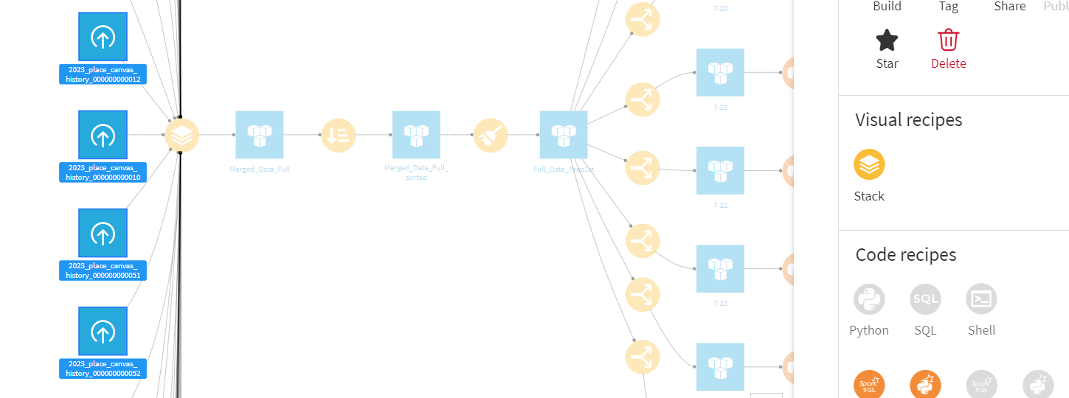

Step2:

Once all the datasets are merged, use the Sort action to sort the data from the smallest to the largest timestamp.

Step3:

After the Sort action, select the Prepare action shown below to turn the Timestamp into two new columns Date and Time.

Step4:

After the creation of the two new columns, use the Group action to group the data by the column ‘user’. As shown below:

Step4A:

Use the Prepare action to rename ‘count’ column to ‘quant’.

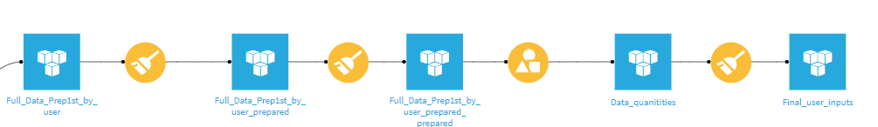

Step4b:

Use the Prepare action to create the ‘Quant Range’ column out of the ‘quant’ column.

Step4c:

Use the Group action to group the “Quant Range” based on the user counts.

Step4d:

Use the Prepare action to get a table that outputs the number of users per range pixels submission.

Step5:

Using the Prepare action to perform parsing as shown below for further analysis on the hourly inputs for users.

Step5A:

Use the Group by action to group the data by Day and Hour.

Step6:

Use the Split action to split the data into each separate day from 7-20 to 7-25.

Step6A:

Once the data is separated into each day, run the following Python Code using the Python action to indicate the existence of Bot for the entry.

The Python script:

# -*- coding: utf-8 -*-

import dataiku

import pandas as pd, numpy as np

from dataiku import pandasutils as pdu

input_dataset = dataiku.Dataset("7-20")

output_dataset = dataiku.Dataset("7-20_bots")

with output_dataset .get_writer() as writer:

for input_chunk_df in input_dataset.iter_dataframes(10000):

# input_chunk_df is a dataframe containing just a

# chunk of data from input_dataset, with at most 10000 records

df = input_chunk_df

# Process here the data ...

df['isBot'] = df.groupby(['user', 'coordinate', 'pixel_color'])['user'].transform('size').ge(2).astype(int)

df.loc[df['isBot'] == 1, 'isBot'] = 1

output_chunk_df = df

# Append the processed chunk to the output

writer.write_dataframe(output_chunk_df)

Step6B:

After the Python script is completed for each day, stack the data similar to Step1.

Step6C:

After the data is merged again, use the Sample/Filter Recipe to filter for bots.

Some of the outputs were exported as small Excel sheets and charts were made via Jypyter notebook, and some charts were made within Dataiku by using the Charts feature that’s available to each dataset in the Flow. Further analysis could be done by using the Statistics feature.

