MTNAI
Mountain Terrain Analysis — User Guide
Features, how to use them, every setting and how each tool thinks
Built on the teachings of GSP Mountain Warfare (low and high altitude operations)
How to read this guide. Each tool has four parts: what it does (in plain words), the doctrine behind it, a flowchart of how it works, and a table of every setting with its default. Screenshots use the demo terrain.
Contents. 1 What MtnAI is · 2 Quick start · 3 The screen · 4 Getting terrain · 5 Coordinates and grids · 6 Setting the scene · 7 Terrain tools · 8 Visibility tools · 9 Siting tools · 10 Movement tools · 11 Layers, tables and saving · 12 Settings · 13 Doctrine in MtnAI · 14 Shortcuts and limits

1. WHAT MTNAI IS
MtnAI is a map program for planning fights in the mountains. You give it a height map of the ground (a DEM). It then tells you, square by square:
- where troops and vehicles can go, go slowly, or cannot go;
- which heights matter and where the passes are;
- what can be seen from a point, and what the enemy can see;
- the best places for posts, OPs, weapons, minefields, picquets and helipads;
- the best route from A to B, how long it takes, and a route card.
It runs fully offline in a web browser. Nothing leaves the computer. The only optional internet use is the Download DEM tool.
It looks and works like ArcGIS Pro: a ribbon at the top, layers on the left, tools on the right, map in the middle.
Doctrine. The rules in GSP Mountain Warfare are built into the tools: march times, ridge routes, tiered defence, strong points, OPs at many heights, minefields in valleys, uphill / downhill fire, picquets and helipad slopes (Section 13 lists them all).
Important. MtnAI suggests; it does not decide. Always confirm on the ground, as the pamphlet directs.

2. QUICK START (FIVE MINUTES)
- Double-click MtnAI.html (or open index.html). Use Chrome, Edge or Firefox.
- Click Demo terrain to load the practice area, or Add Data to open your own DEM, or Download DEM to fetch one.
- On the Map tab, use Situation to place Own position, Enemy, Target, Start A and End B (the demo has them already).
- On the Analysis tab, click a tool (for example Posts / OPs). Its settings open on the right. Click Run.
- Look at the result on the map, in the Attributes pane and in the Attribute table. Save with Ctrl+S; print the report with Ctrl+P.
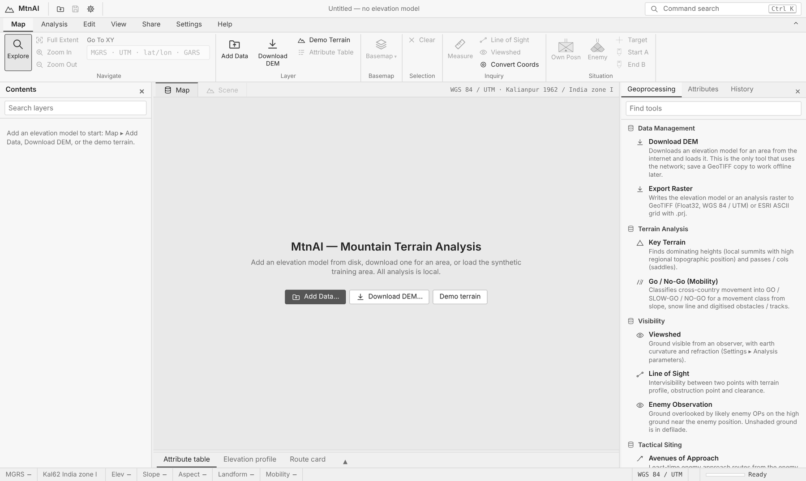
Figure 1. The start screen: Add Data, Download DEM or Demo terrain.
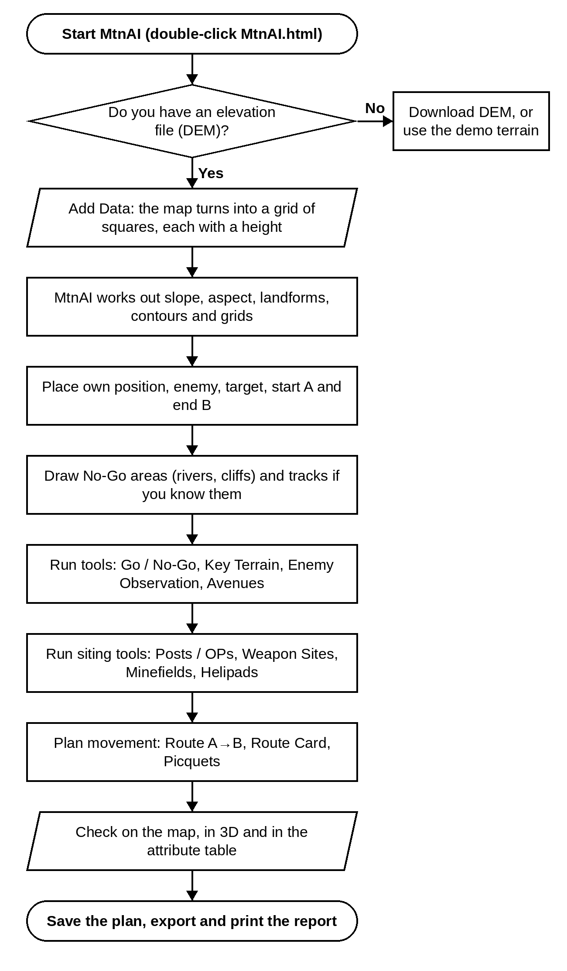
Figure 2. Flowchart — the whole planning job, start to finish.

3. THE SCREEN
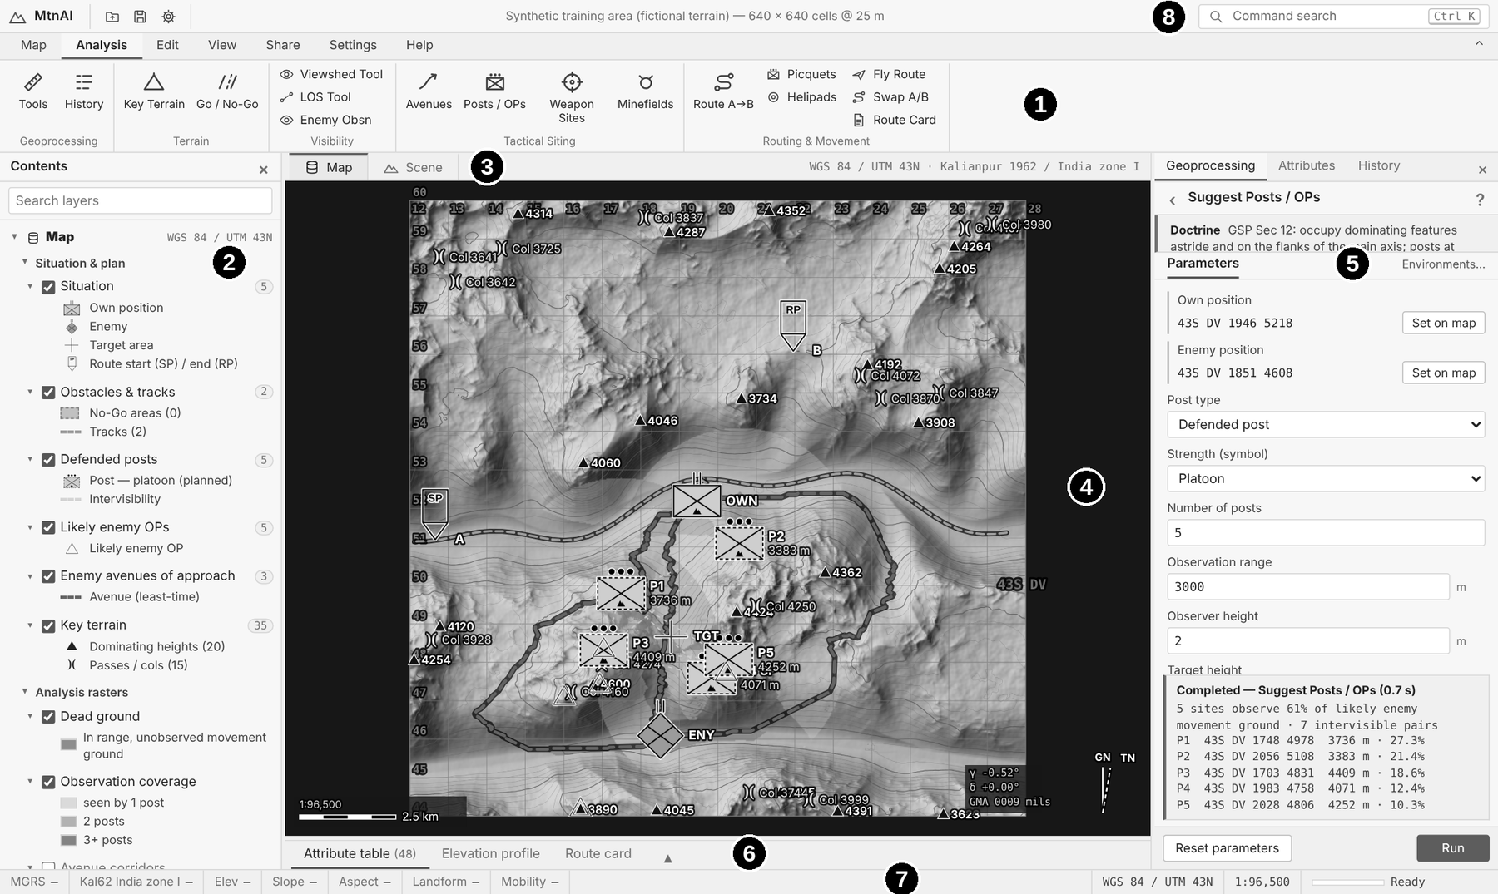
Figure 3. The MtnAI screen. The numbers match the table below.
No. | Part | What it is for
1 | Ribbon | Tabs of buttons: Map, Analysis, Edit, View, Share, Settings, Help. Double-click a tab to hide or show it.
2 | Contents pane | Every layer with a tick box (show / hide) and a key. Right-click a layer for Zoom To, Attribute Table, Transparency, Remove, Properties.
3 | View tabs | Map (flat, 2D) or Scene (3D). The text on the right shows the coordinate systems in use.
4 | Map | Drag to move, wheel to zoom, click a symbol to see its details.
5 | Side pane | Geoprocessing (tool settings and Run), Attributes (details of what you clicked), History (every tool run).
6 | Bottom dock | Attribute table, Elevation profile and Route card.
7 | Status bar | Grid reference, height, slope, aspect, landform and Go / No-Go under the mouse; scale; progress.
8 | Command search | Type what you want (Ctrl+K), for example "minefield".

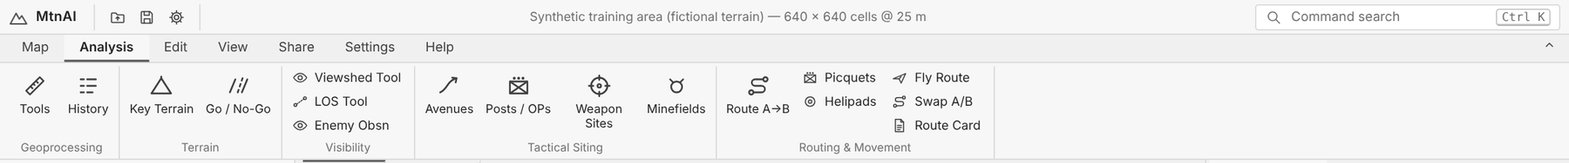
Figure 4. The Analysis tab of the ribbon: every planning tool is one click away.

Running any tool
- Click the tool on the ribbon (or search for it). Its form opens in the Geoprocessing pane.
- Read the Doctrine note at the top (click it to open it fully).
- Check the settings. Points can be picked on the map or typed as a grid reference. Click a grey section heading to open more settings.
- Click Run. A green note shows the result; red means it failed and says why.
- Reset parameters puts every setting back to its default. Your changes are remembered between sessions.

4. GETTING TERRAIN (THE DEM)
A DEM is a picture where each pixel is a height. MtnAI turns it into a grid of equal squares (cells) in metres (WGS 84 / UTM).

Add Data (offline)
- Files: SRTM .hgt, GeoTIFF (.tif), ESRI ASCII grid (.asc) or a .zip of these. Several tiles join together.
- Drag files onto the map, or Map ▸ Add Data (Ctrl+O).
- Crop to AOI (Edit tab) cuts out a smaller area at finer detail. Full DEM goes back.

Download DEM (needs internet)
Fetches heights for any area. Save the GeoTIFF copy it makes, then you can work offline later with Add Data.
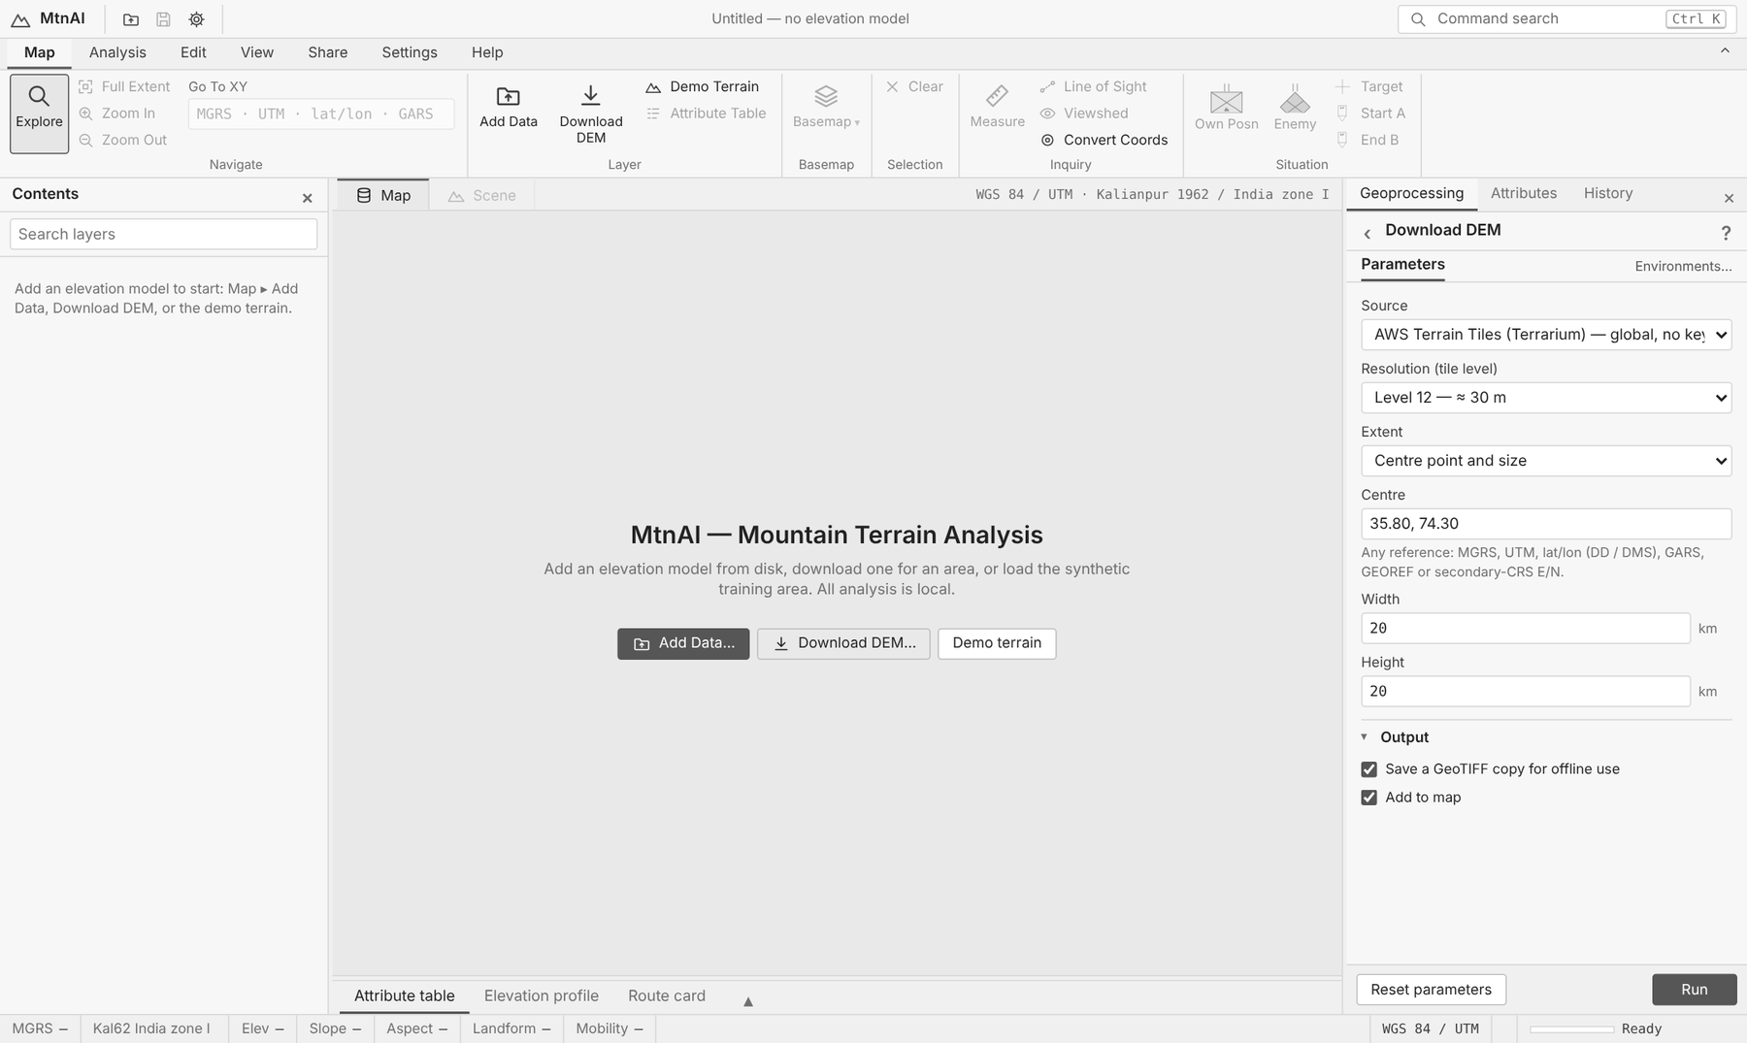
Figure 5. The Download DEM tool.
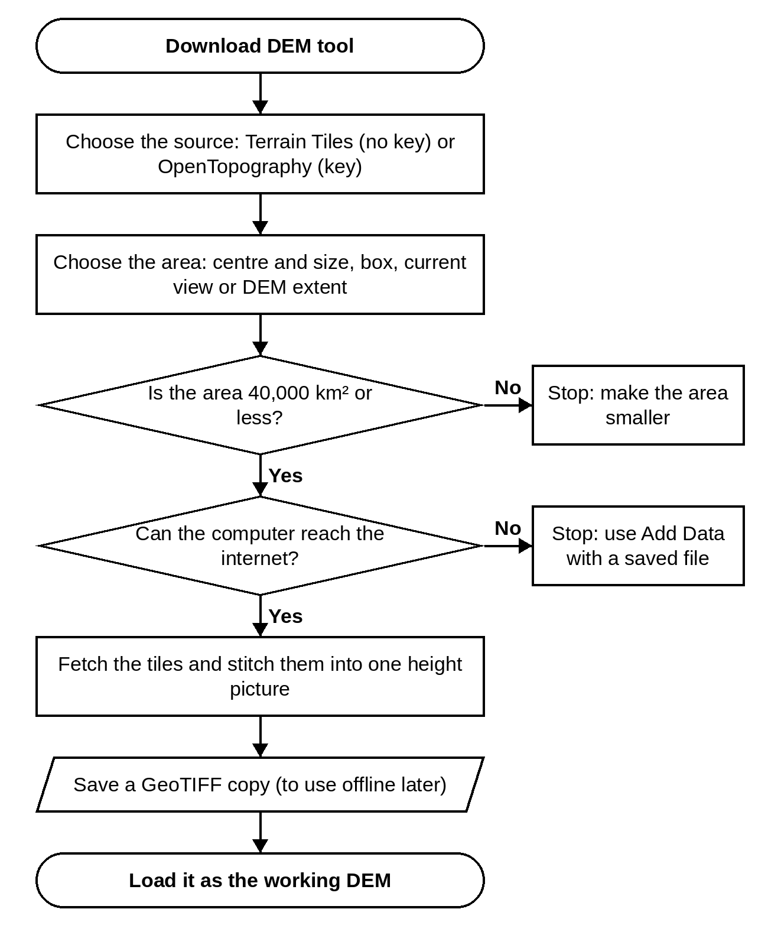
Figure 6. Flowchart — Download DEM.
Setting | Default | Notes
Source | AWS Terrain Tiles (Terrarium) — global, no key
Resolution (tile level) | Level 12 — ≈ 30 m | only shown for some choices
Dataset | Copernicus GLO-30 (30 m) | only shown for some choices
OpenTopography API key | — | Free from opentopography.org (MyOpenTopo ▸ Get an API key). only shown for some choices
Extent | Centre point and size
Centre | 35.80, 74.30 | Any reference: MGRS, UTM, lat/lon (DD / DMS), GARS, GEOREF or secondary-CRS E/N. only shown for some choices
Width | 20 km | only shown for some choices
Height | 20 km | only shown for some choices
West (lon °) | 74.2 | only shown for some choices
South (lat °) | 35.7 | only shown for some choices
East (lon °) | 74.45 | only shown for some choices
North (lat °) | 35.9 | only shown for some choices
Output
Save a GeoTIFF copy for offline use | Yes
Add to map | Yes

Export Raster
Writes the height map, slope, aspect, landforms, ruggedness or any analysis layer to a GeoTIFF or ASCII grid, for use in other GIS programs.
Setting | Default | Notes
Raster | Elevation
Format | GeoTIFF (.tif)

5. COORDINATES, GRIDS AND MEASURING
Open Settings ▸ Coordinate Systems (or click the coordinate text above the map).
- Analysis grid: WGS 84 / UTM, zone chosen automatically or forced.
- Second system: for example Kalianpur 1962 / India zone I or IIa, Kalianpur UTM, or your own.
- Grid references: MGRS (2 to 10 figures), UTM, latitude / longitude (DD, DM, DMS), GARS, GEOREF.
- North: grid, true or magnetic (enter declination). Angles in mils (6400 or 6000), degrees or gradians.
- Map grids: MGRS / UTM lines, a lat / long graticule and the second system's grid (View ▸ Grids & Labels).
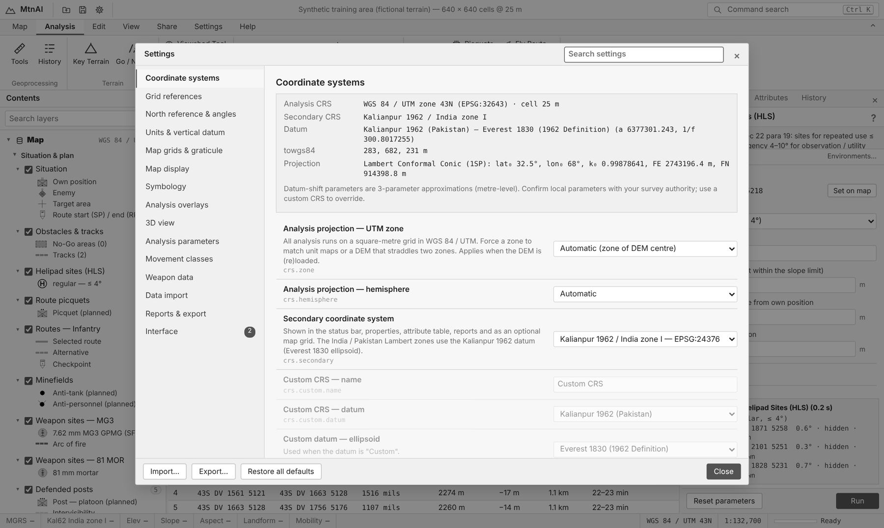
Figure 7. Settings ▸ Coordinate systems.

Go To XY and Convert Coordinates
Type any reference in Go To XY (Map tab) and press Enter to jump there. Convert Coords shows the same point in every format.

Measure
Map ▸ Measure (key M): click two points. You get distance, slope distance, grid / true / magnetic bearing, back bearing, height difference and the GSP march time by day and by night.
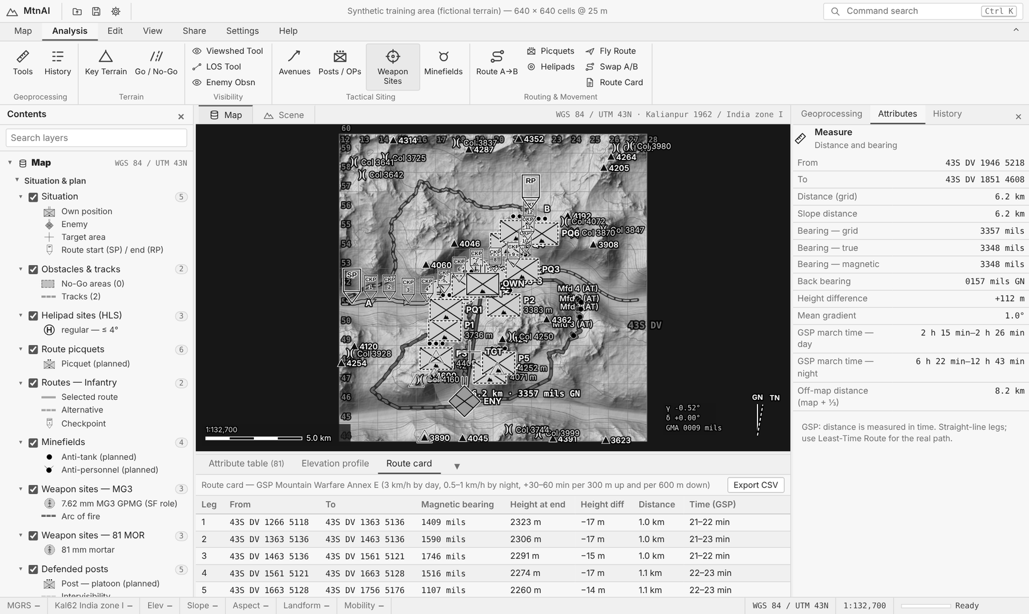
Figure 8. Measure result with the GSP march time.

6. SETTING THE SCENE

Place the units
Button | Meaning | Used by
Own Posn | Your defended area or HQ | Posts, weapons, minefields, avenues, helipads, access
Enemy | Where the enemy is | Enemy observation, avenues, posts, minefields, routes
Target | Area for mortars and guns to hit | Indirect-fire weapon sites
Start A / End B | Start and end of a move | Route A→B, route card, picquets

Click the button, then click the map. Edit ▸ Situation also sets your echelon and the enemy type (infantry, wheeled, armour, mule).

Draw what the DEM does not show
- No-Go Area: click corners of a river, glacier, cliff or minefield; double-click (or Enter) to finish. Backspace removes the last corner, Esc cancels.
- Track: click along a road or mule track; double-click to finish. Tracks are always GO and faster.
You see the shape while you draw it. Every tool respects these shapes.

7. TERRAIN TOOLS

7.1 Go / No-Go (Mobility)
Colours every square: GO (easy), SLOW-GO (hard), NO-GO (impossible) for the chosen movement class. It works from slope, snow line, your No-Go areas and tracks.
Doctrine. GSP Sec 4 para 8–13: mobility is the key-note; vehicles keep to valley roads, cross-compartment travel is often impossible. A loaded mule can climb any slope a man can negotiate without using his hands (Annex H).
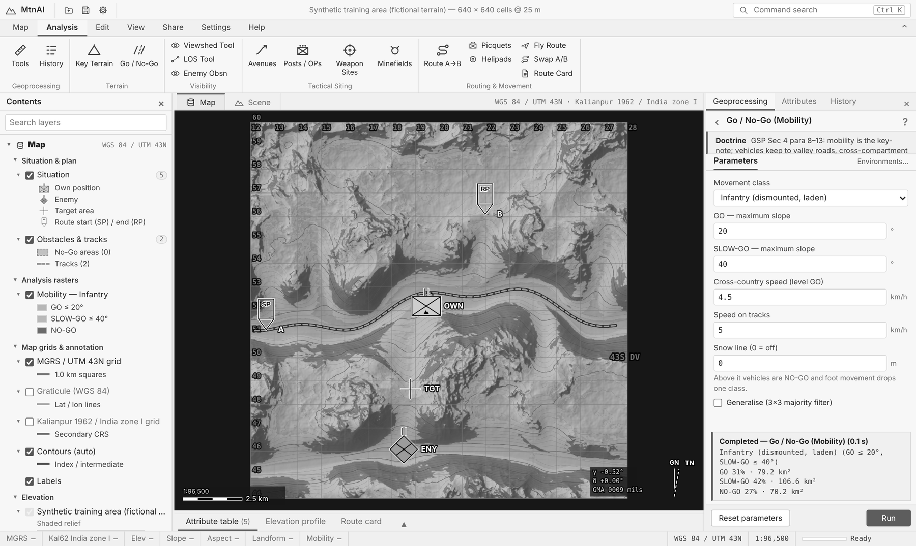
Figure 9. Go / No-Go for infantry. The key for the three classes is in the Contents pane.
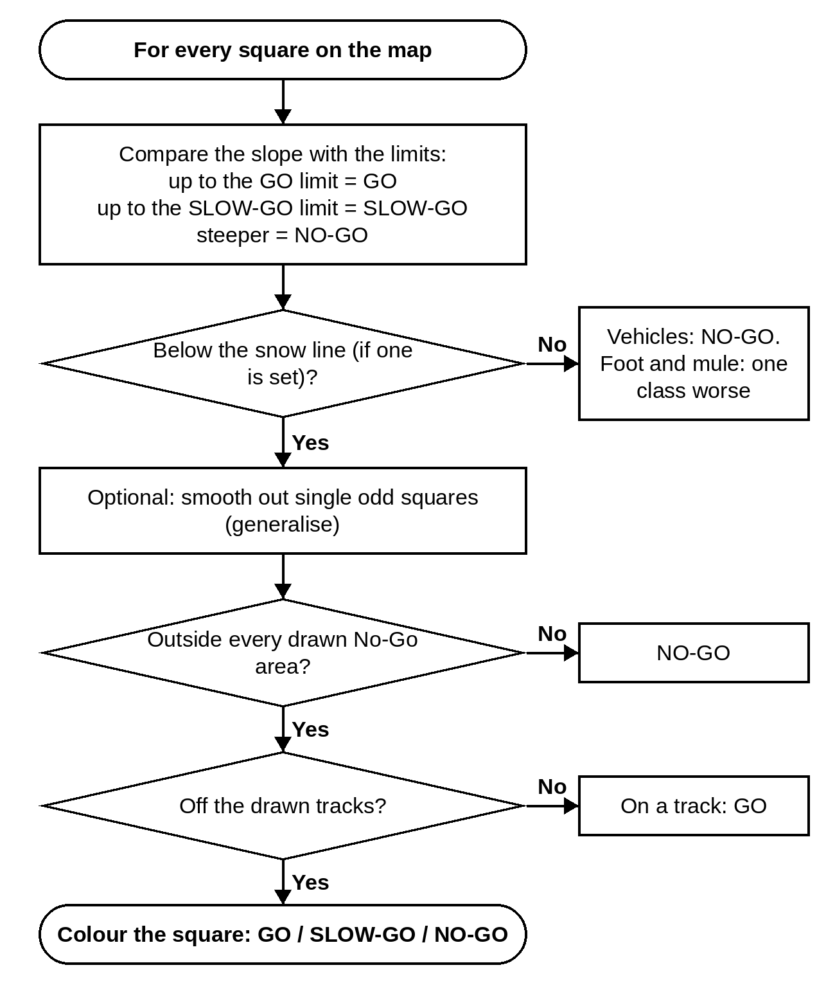
Figure 10. Flowchart — Go / No-Go.
Setting | Default | Notes
Movement class | Infantry (dismounted, laden)
GO — maximum slope | from movement class
SLOW-GO — maximum slope | from movement class
Cross-country speed (level GO) | from movement class
Speed on tracks | from movement class
Snow line (0 = off) | 0 m | Above it vehicles are NO-GO and foot movement drops one class.
Generalise (3×3 majority filter) | No

Movement class | GO up to | SLOW-GO up to | Speed (km/h) | On tracks (km/h)
Infantry (dismounted, laden) | 20° | 40° | 4.5 | 5
Mule / Animal Transport | 15° | 30° | 3.5 | 4.5
Light vehicle (jeep / 4x4) | 10° | 20° | 20 | 35
Truck / towed gun | 6° | 12° | 12 | 30
Tracked (tank / APC) | 15° | 30° | 18 | 30

7.2 Key Terrain
Finds dominating heights (summits that stand high above the area around them) and passes / cols (low points between two heights that lead from one valley to the next).
Doctrine. GSP Sec 4 para 6–7: routes are overlooked by dominating heights; at brigade level and below, objectives are the seizure or retention of specific dominating heights. Passes are held from the heights on both shoulders (Sec 12 para 14).
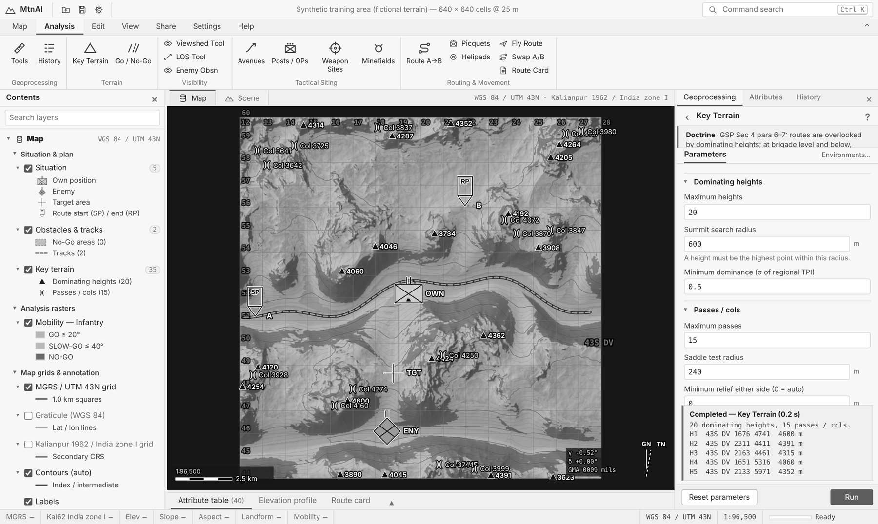
Figure 11. Key terrain: ▲ heights and )( passes.
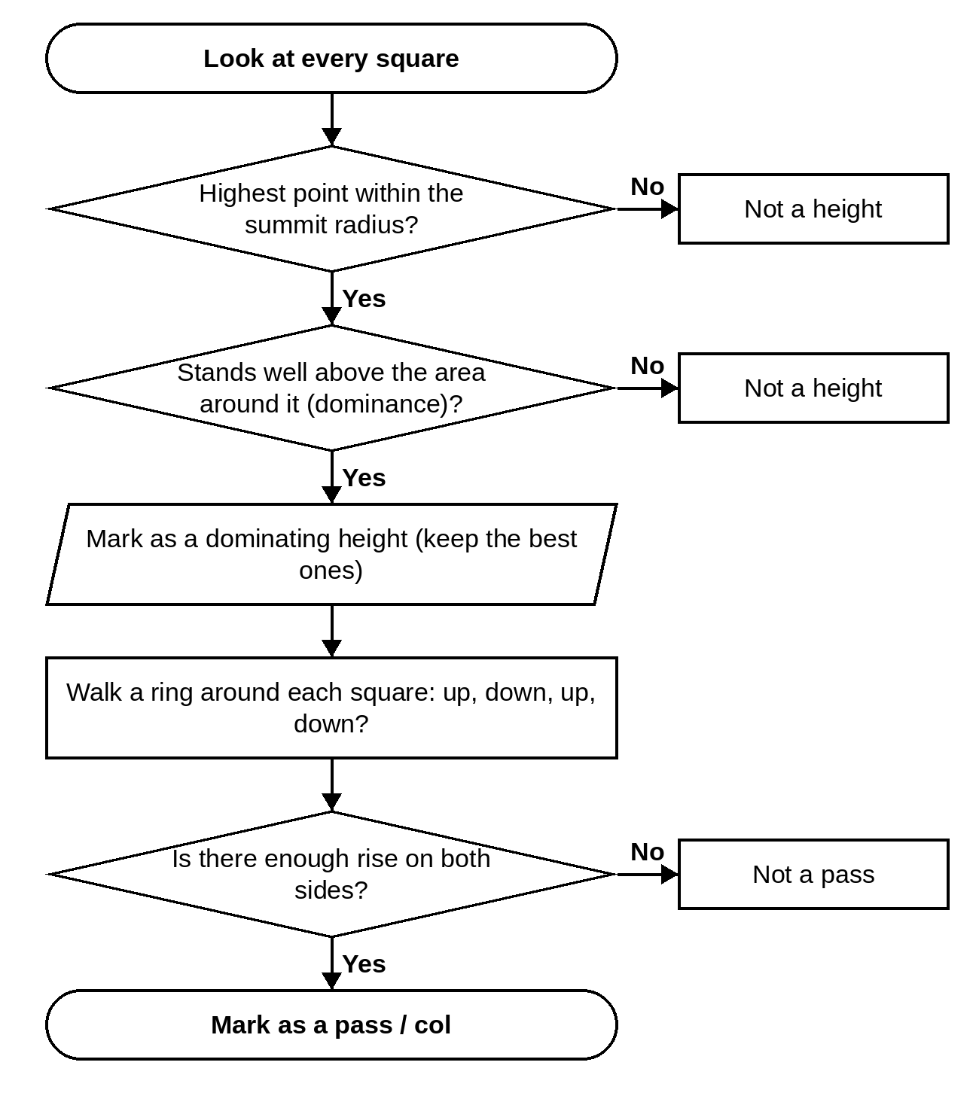
Figure 12. Flowchart — Key Terrain.
Setting | Default | Notes
Dominating heights
Maximum heights | 20
Summit search radius | 600 m | A height must be the highest point within this radius.
Minimum dominance (σ of regional TPI) | 0.5
Passes / cols
Maximum passes | 15
Saddle test radius | 240 m
Minimum relief either side (0 = auto) | 0 m

8. VISIBILITY TOOLS

8.1 Viewshed and Line of Sight
Viewshed: shades all ground an observer can see. Line of Sight: answers "can A see B?" and draws the ground profile. Both allow for the earth's curve and the bending of light in air.
Uphill / downhill fire (GSP Section 18). Shots fired steeply up or down strike high. Line of Sight gives the angle of sight and tells you to set the sight to slant range ÷ factor:
Angle up or down | 0° | 10° | 15° | 20° | 25° | 30° | 45° | 60°
Divide range by | 1.00 | 1.02 | 1.04 | 1.06 | 1.10 | 1.15 | 1.41 | 2.00

Doctrine. GSP Sec 4 para 15: heights give long-range observation but rugged ground leaves dead space at mid ranges. A voice in a valley can be heard on ridges 900 m above — cover valleys with listening posts.
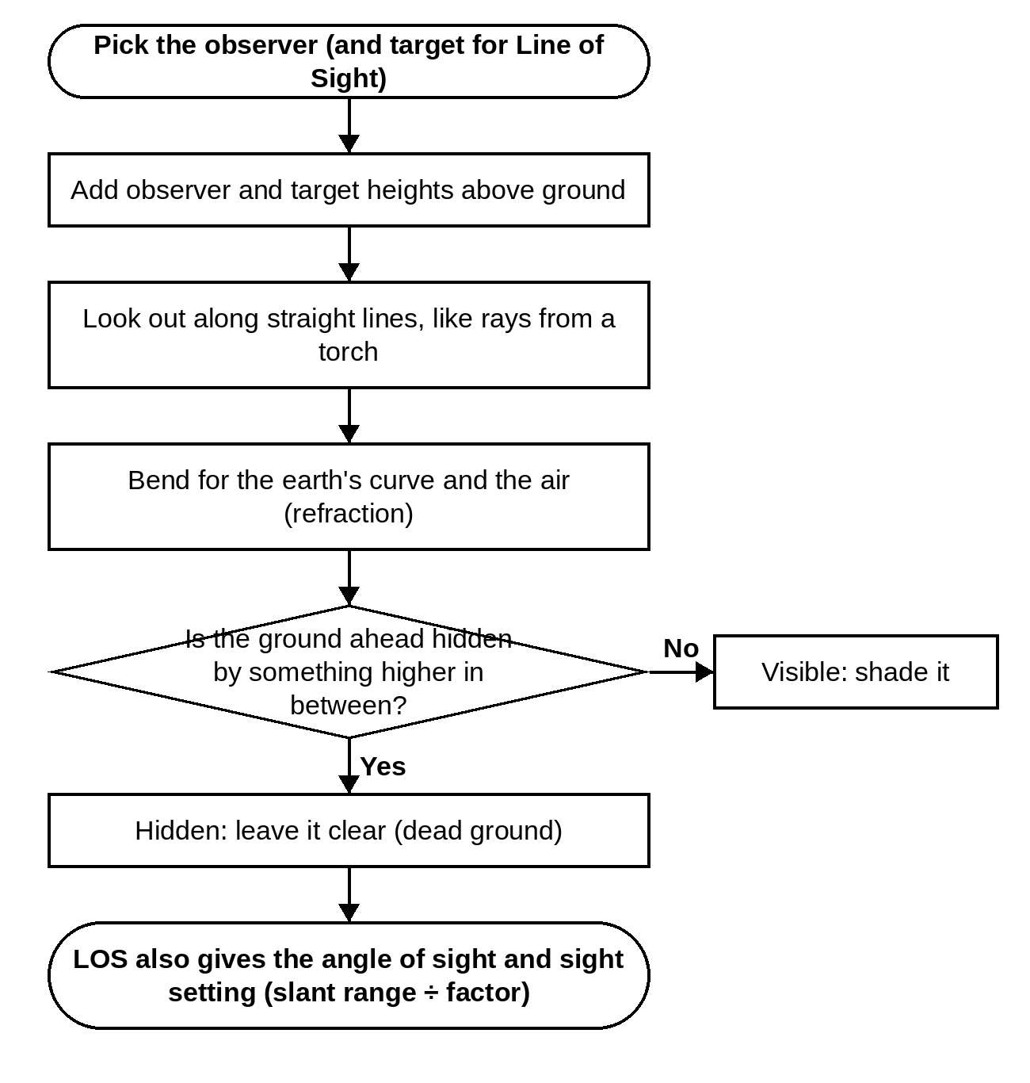
Figure 13. Flowchart — Viewshed and Line of Sight.
Setting | Default | Notes
Observer point | pick on the map
Observer height above ground | 2 m
Target height above ground | 1.5 m
Radius | 5000 m

Setting | Default | Notes
Observer point | pick on the map
Target point | pick on the map
Observer height | 2 m
Target height | 2 m

8.2 Enemy Observation
Guesses where the enemy would put his OPs (the high ground near him) and shades all ground they can see. Clear ground is hidden from the enemy (defilade) — good for mortars, guns, helipads and covered routes.
Doctrine. GSP Sec 12: heights are conspicuous — dig down and conceal; use reverse slopes when the forward slope is under enemy observation. Light guns and mortars deploy on reverse slopes and in valleys (Sec 22).
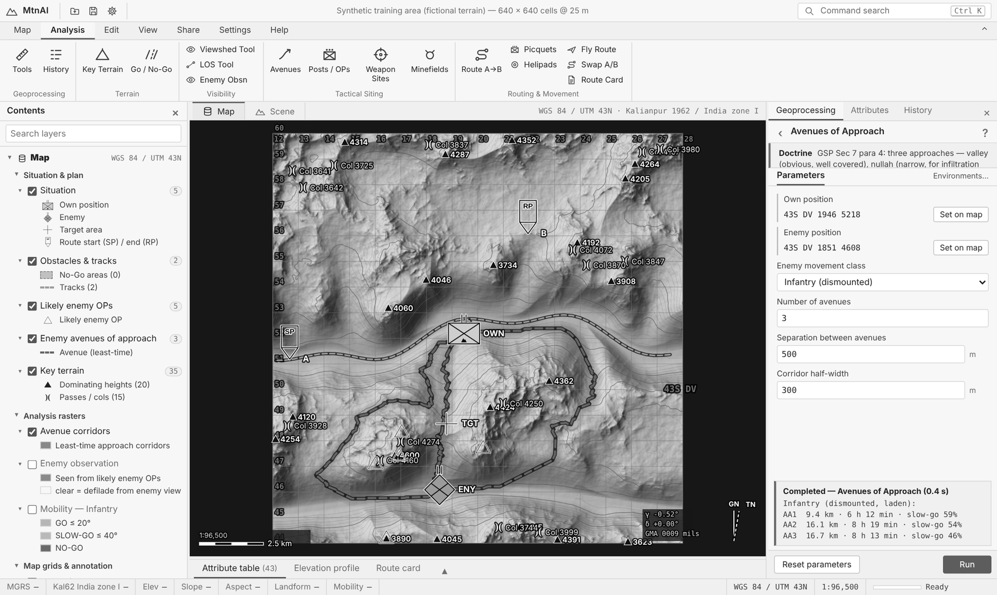
Figure 14. Enemy observation (shaded) and the enemy avenues of approach (dashed).
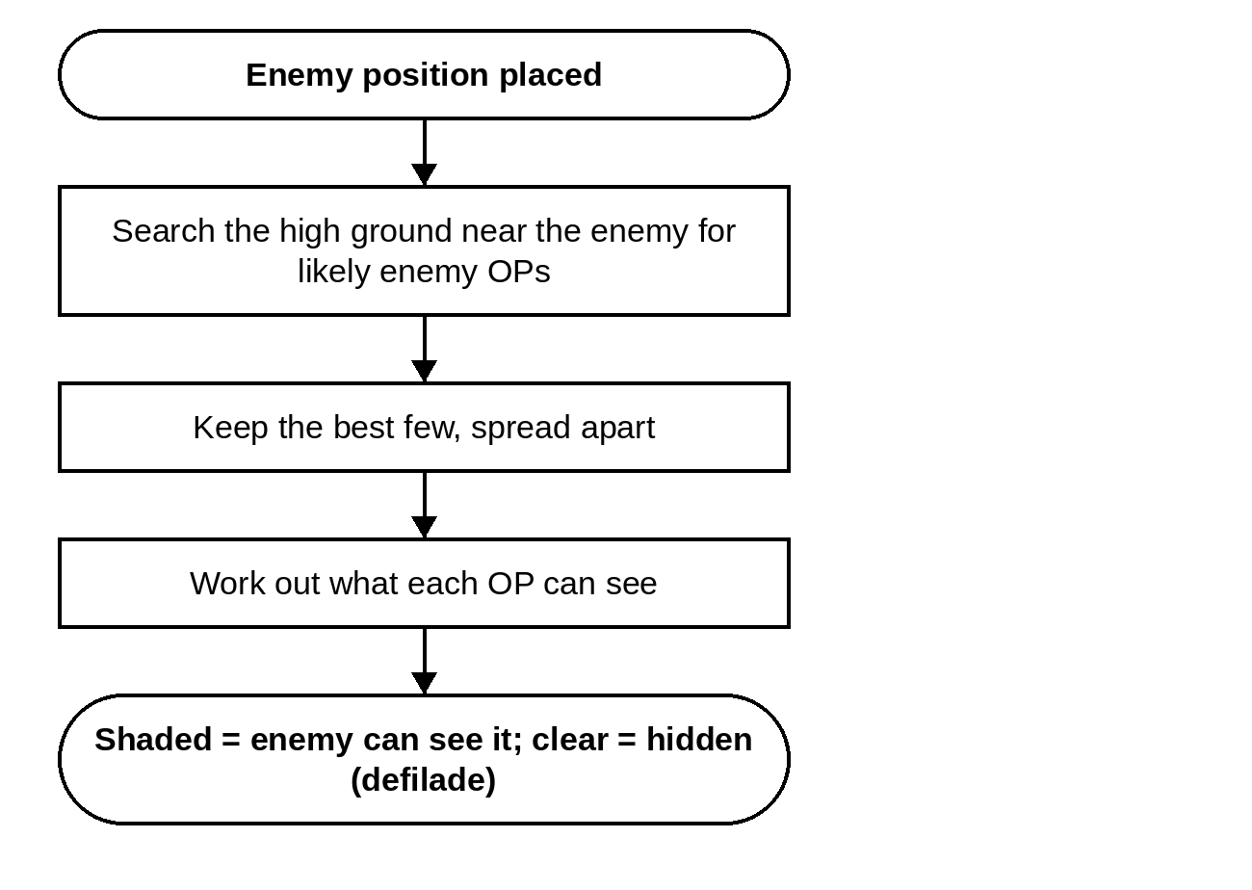
Figure 15. Flowchart — Enemy Observation.
Setting | Default | Notes
Enemy position | set on the map
Likely enemy OPs to model | 5
OP search radius around enemy | 3000 m
Minimum OP separation | 600 m
Observation range | 8000 m
Enemy observer height | 3 m
Target height (own troops) | 1.5 m
Include the enemy position itself | Yes

8.3 Avenues of Approach
Finds the quickest ways the enemy can reach your position, for his type of movement, and how long each takes.
Doctrine. GSP Sec 7 para 4: three approaches — valley (obvious, well covered), nullah (narrow, for infiltration and ambush) and ridge line (easy to fight on, hard to maintain). Every conceivable approach must be guarded (Sec 4 para 23).
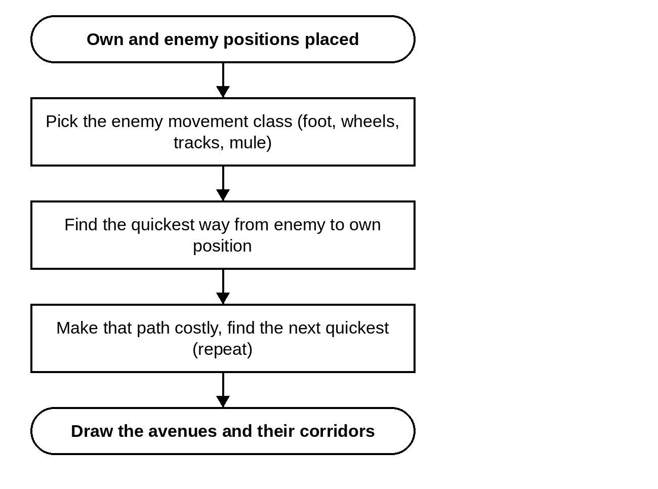
Figure 16. Flowchart — Avenues of Approach.
Setting | Default | Notes
Own position | set on the map
Enemy position | set on the map
Enemy movement class | Infantry (dismounted)
Number of avenues | 3
Separation between avenues | 500 m
Corridor half-width | 300 m

9. SITING TOOLS

9.1 Posts and OPs
Puts posts or OPs on the heights so that, together, they see as much of the enemy's likely ground as possible. It also shows dead ground (ground in range that no post sees), which posts can see each other, the defence tier of each post and the strong point.
Doctrine. GSP Sec 12: occupy dominating features astride and on the flanks of the main axis; posts at platoon level; tiered defence (valley / foothill, mid slope, ridge line); a strong point on the most dominating feature; OPs laterally, in depth and at varying heights.
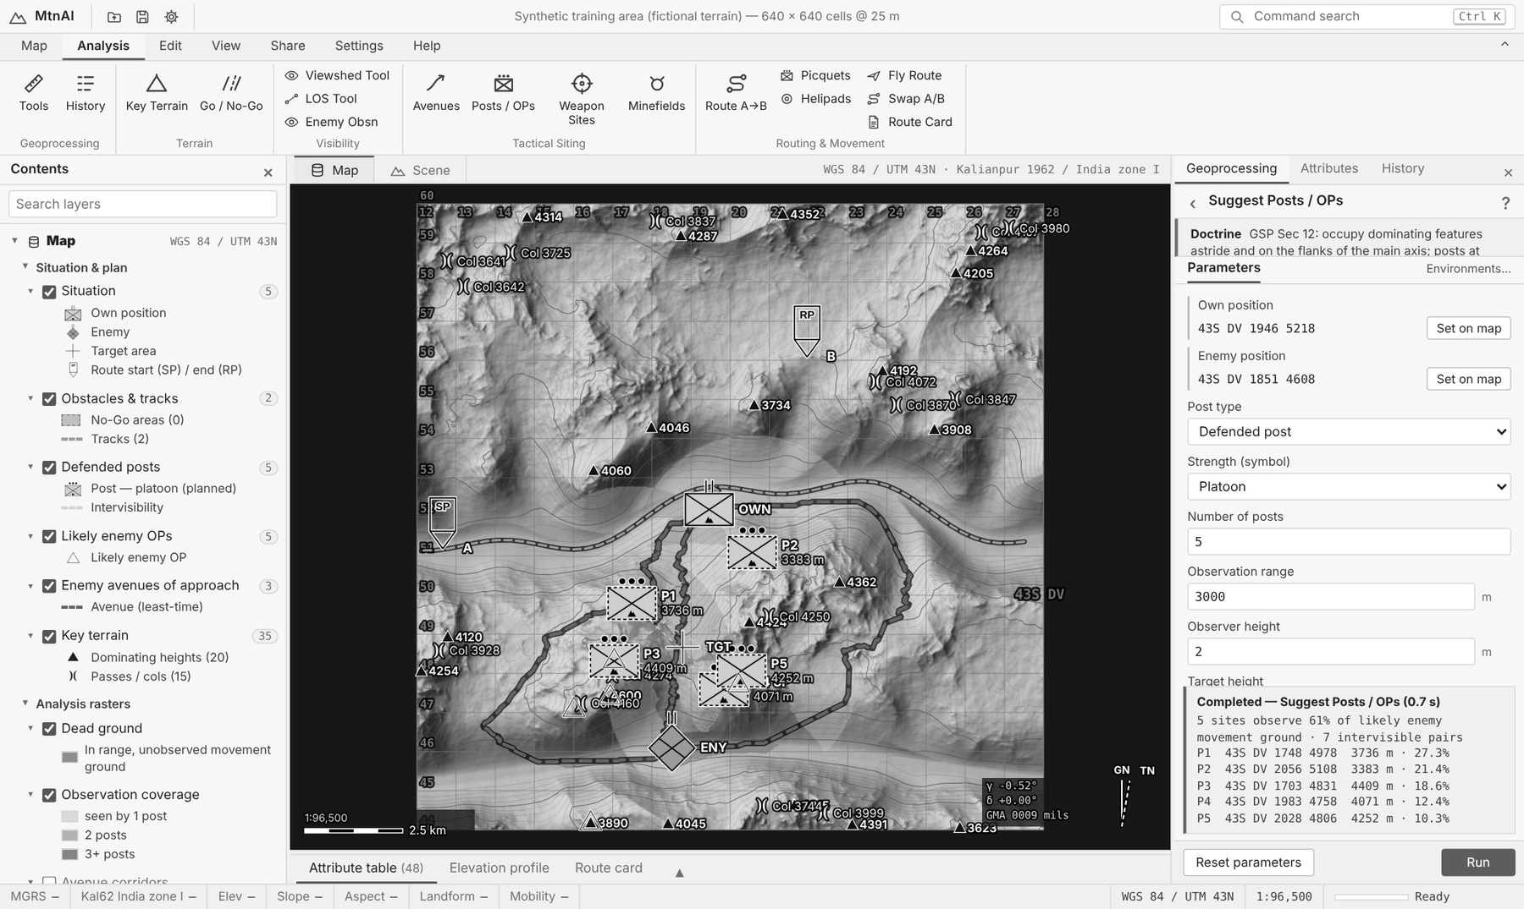
Figure 17. Five suggested posts, their coverage and the result message.
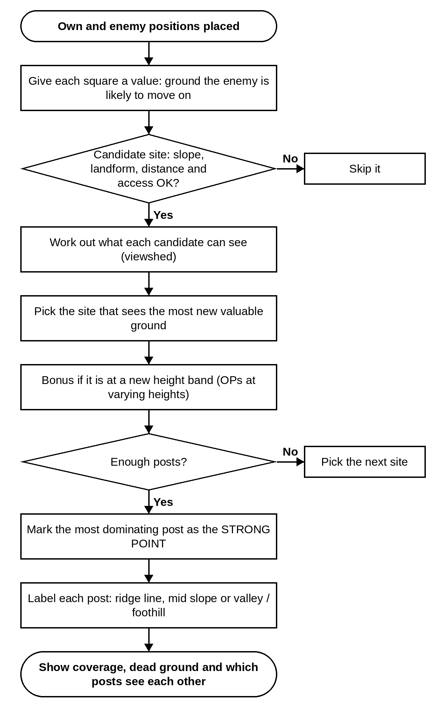
Figure 18. Flowchart — Posts and OPs.
Setting | Default | Notes
Own position | set on the map
Enemy position | set on the map
Post type | Defended post
Strength (symbol) | Platoon
Number of posts | 5
Observation range | 3000 m
Observer height | 2 m
Target height | 1.5 m
Minimum separation | 600 m
Site constraints
Maximum site slope | 35°
Allowed landforms | Mid slope, Upper slope, Ridge
Maximum distance from own position | 7000 m
Minimum distance from enemy | 500 m
Must be reachable from own position | Yes
Access movement class | Infantry (dismounted, laden) | only shown for some choices
Maximum access time (0 = any) | 0 h | only shown for some choices
Search & scoring
Candidate sites evaluated | 110 | More candidates = better coverage, longer run time.
Value of repeated coverage (0–1) | 0.25 | 0 = no credit for ground already observed; 1 = full credit (mutual support).
Range decay (0–1) | 0.5
Prescore — regional dominance | 0.6
Prescore — local prominence | 0.4
Prescore — absolute height | 0.4
Prescore — closeness to approach | 0.4
Dead-ground value threshold (0–1) | 0.25
Intervisibility check range (× obs range) | 2.5
Height band for OP tiers (0 = off) | 150 m | GSP: site OPs laterally, in depth and at varying altitudes so low cloud cannot blind them all.
Credit for a new height tier (0–1) | 0.15
Target value — enemy movement ground
Dismounted GO ground | 1
Dismounted SLOW-GO ground | 0.55
Dismounted NO-GO ground | 0.05
Vehicle GO ground | 1
Vehicle SLOW-GO ground | 0.35
Vehicle NO-GO ground | 0
Share for dismounted movement | 0.7
Share for vehicle movement | 0.5
Bonus on avenues of approach (×) | 2 | Extra value for ground within the enemy avenue corridors (0 = ignore avenues).
Concentrate on the enemy approach corridor | Yes
Corridor width (fraction of enemy distance) | 0.45
Minimum corridor width | 1500 m
Value of ground behind own position | 0.3

9.2 Weapon Sites
Picks positions for one weapon at a time. Run it again for each weapon; each gets its own layer.
- Direct fire (MG, HMG, RPG-7, 106 RCL, Baktar-Shikan, TOW): sees the target ground in its range band; prefers fire across the enemy's path (enfilade). Ground beyond the mount's up / down limits is dead to the weapon. Each site shows its arc of fire and sight setting.
- Indirect fire (60 / 81 / 120 mm mortars, 105 / 122 / 130 / 155 mm guns): behind own troops, in range of the target, able to clear the crests, ideally hidden from enemy OPs.
- Air defence (Anza, 35 mm): covers the low flying routes along valleys and defiles from dominating ground.
Doctrine. GSP Sec 18: fire up- or downhill strikes high — set the sight to slant range ÷ factor (10° 1.02, 20° 1.06, 25° 1.10, 60° 2.0). Plunging fire leaves dead ground; cover it with 60 / 81 mm mortars, riflemen and mines. Air defence covers defiles, gun areas and logistic sites from dominating features (Sec 22).
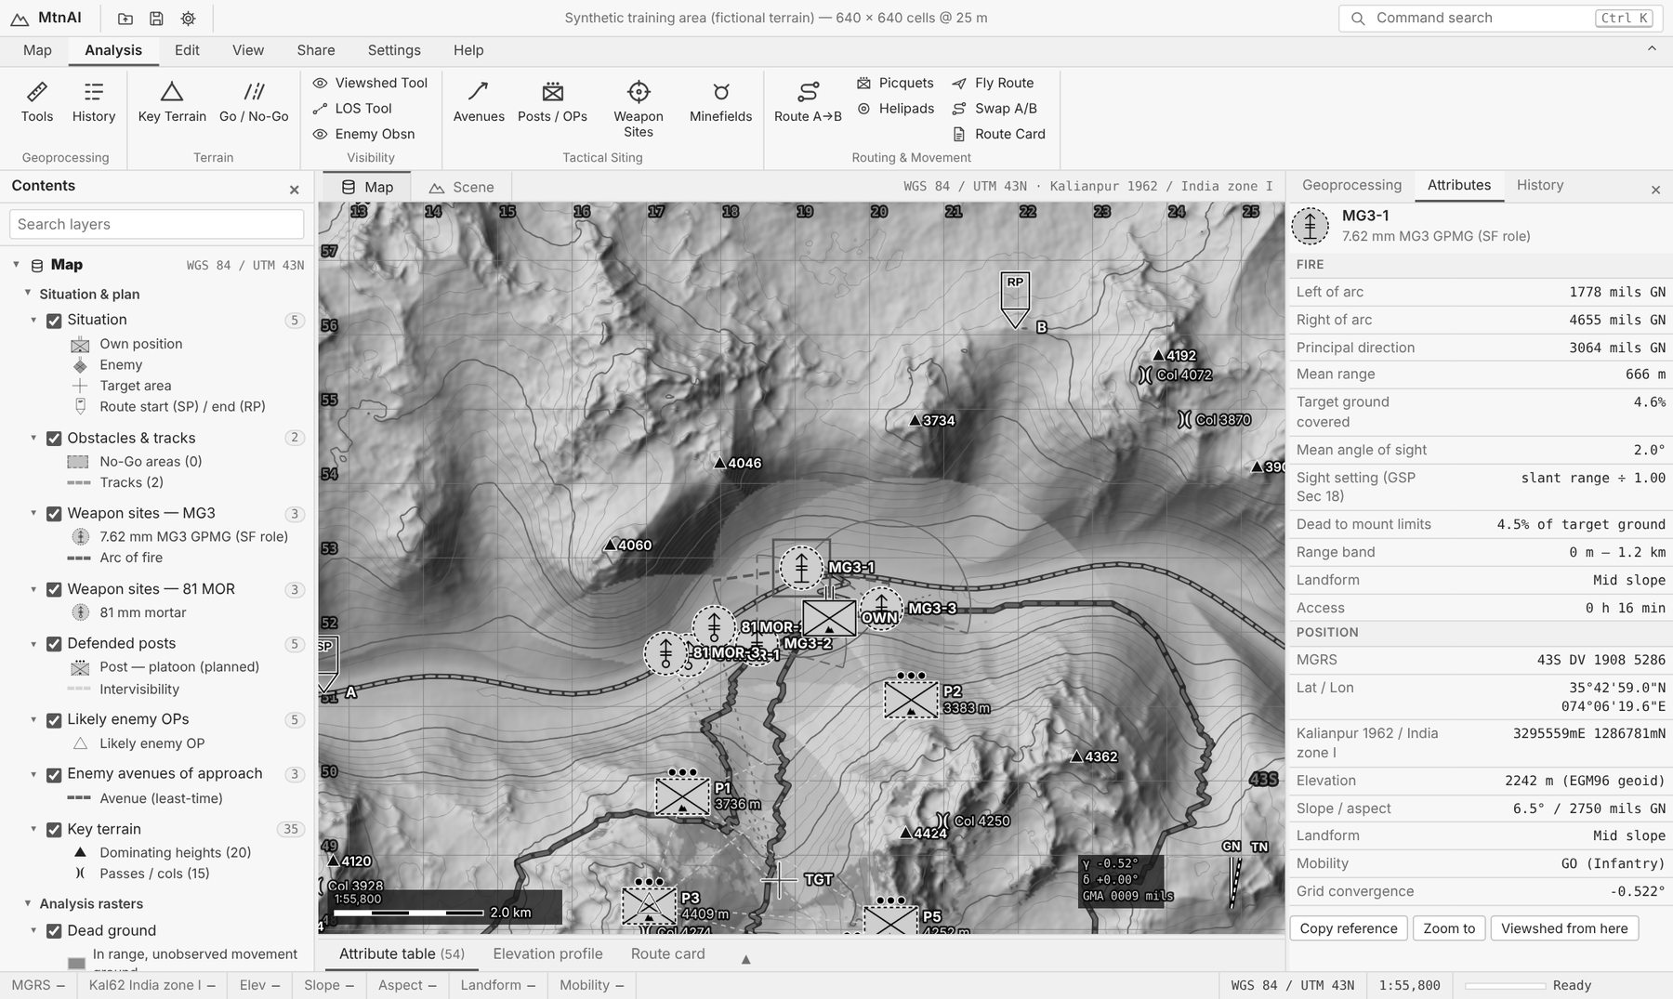
Figure 19. An MG3 site: arc of fire, mean angle of sight, sight setting and the share of ground dead to the mount limits.
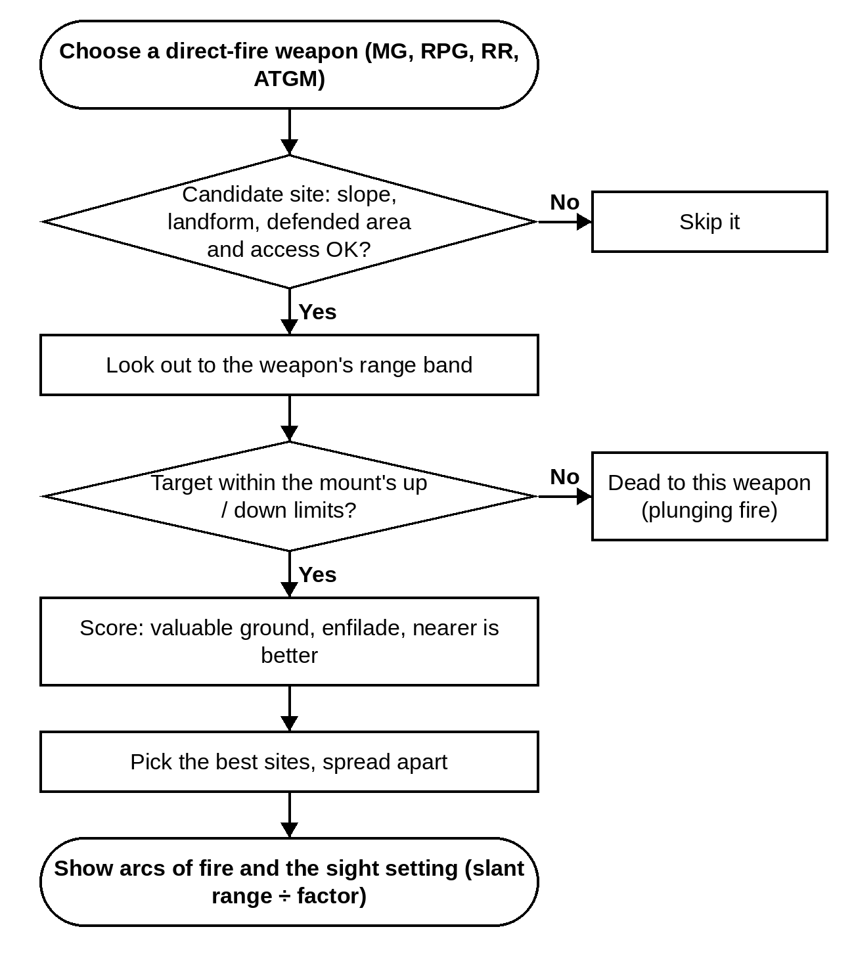
Figure 20. Flowchart — direct-fire weapon sites.
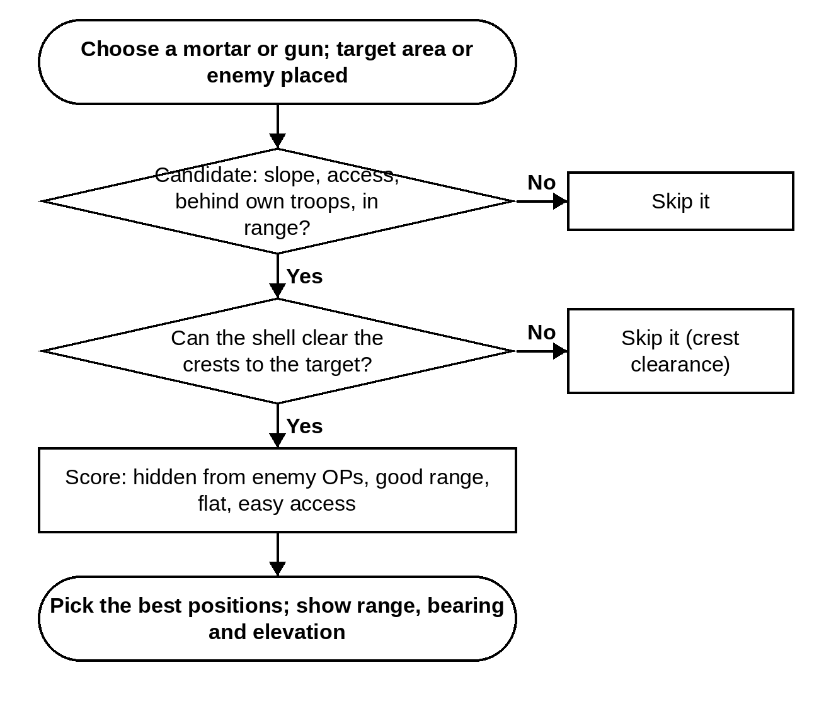
Figure 21. Flowchart — indirect-fire (mortar and gun) positions.
Setting | Default | Notes
Own position | set on the map
Enemy position | set on the map
Target area | set on the map
Weapon | 7.62 mm MG3 GPMG (SF role) — Direct fire — anti-personnel
Number of sites | 3
Weapon data (saved to Settings ▸ Weapon data)
Minimum range | from weapon data
Maximum / effective range | from weapon data
Maximum site slope | from weapon data
Sight height | from weapon data
Target height | from weapon data
Mount elevation limit (blank = none) | from weapon data | GSP Sec 18: MG on mount +6° / −8.5°; 75 mm RR +30° / −5°. Ground beyond the limits is dead to the weapon (plunging fire).
Mount depression limit (blank = none) | from weapon data
Access movement class | from weapon data
Site constraints
Defended-area radius around own position | 3000 m
Minimum separation | 300 m
Must be reachable from own position | Yes
Maximum access time (0 = any) | 0 h
Enfilade preference (0–1, blank = weapon default) | — | Credit for fire across the enemy approach rather than head-on.
Position must be hidden from enemy observation | No | indirect fire only
Maximum forward of own position (fraction) | 0.25 | indirect fire only
Minimum range to target (× max range) | 0.15 | indirect fire only
Maximum range to target (× max range) | 0.92 | indirect fire only
Preferred range to target (× max range) | 0.55 | indirect fire only
Target-area spread (crest clearance fan) | 400 m | indirect fire only
Crest clearance margin | 15 m | indirect fire only
Search & scoring
Candidate sites evaluated | 120
Value of overlapping arcs (0–1) | 0.5
Range decay (0–1) | 0.35
Landform preference | 0.25, 0.5, 0.6, 0.85, 1, 0.55
Landform preference (site) | 0.1, 0.3, 0.45, 0.7, 1, 1 | air defence only
Air corridor value by landform | 1, 0.8, 0.7, 0.25, 0.1, 0.05 | Where low-flying aircraft are expected (helicopters follow valleys). air defence only
Landform preference | 0.7, 0.9, 1, 0.6, 0.35, 0.15 | indirect fire only
Weight — crest clearance | 0.35 | indirect fire only
Weight — defilade from enemy view | 0.3 | indirect fire only
Weight — range suitability | 0.15 | indirect fire only
Weight — flat ground | 0.1 | indirect fire only
Weight — access time | 0.1 | indirect fire only
Target value — enemy movement ground
Dismounted GO ground | 1
Dismounted SLOW-GO ground | 0.55
Dismounted NO-GO ground | 0.05
Vehicle GO ground | 1
Vehicle SLOW-GO ground | 0.35
Vehicle NO-GO ground | 0
Bonus on avenues of approach (×) | 2 | Extra value for ground within the enemy avenue corridors (0 = ignore avenues).
Concentrate on the enemy approach corridor | Yes
Corridor width (fraction of enemy distance) | 0.45
Minimum corridor width | 1500 m
Value of ground behind own position | 0.3

Weapon | Group | Range (m) | Site slope | Mount limits
7.62 mm MG3 GPMG (SF role) | Direct fire — anti-personnel | 0–1200 | 30° | +6° / −8.5°
12.7 mm HMG (Type 54 / W-85) | Direct fire — anti-personnel | 0–1600 | 25° | —
RPG-7 (AT rocket launcher) | Direct fire — anti-armour | 30–300 | 35° | —
106 mm RCL (M40) | Direct fire — anti-armour | 50–1100 | 12° | +30° / −5°
Baktar-Shikan ATGM | Direct fire — anti-armour | 100–3000 | 20° | —
TOW-2A ATGM | Direct fire — anti-armour | 65–3750 | 15° | —
60 mm light mortar | Indirect fire — mortars | 100–2500 | 15° | —
81 mm mortar | Indirect fire — mortars | 100–5600 | 12° | —
120 mm mortar | Indirect fire — mortars | 450–7200 | 10° | —
105 mm M56 pack howitzer (mountain arty) | Indirect fire — artillery | 1000–10500 | 10° | —
122 mm Type 54-1 howitzer | Indirect fire — artillery | 2000–11800 | 8° | —
130 mm Type 59-1 field gun | Indirect fire — artillery | 3000–27000 | 6° | —
155 mm M198 howitzer | Indirect fire — artillery | 2500–22400 | 6° | —
Anza Mk-II MANPADS | Air defence | 500–5000 | 35° | —
Anza Mk-III MANPADS | Air defence | 500–6000 | 35° | —
35 mm Oerlikon GDF twin AD gun | Air defence | 0–4000 | 8° | —

All weapon figures are open-source planning values. Change them in Settings ▸ Weapon data or in the tool.

9.3 Minefields
Finds the narrowest gaps (defiles) on the enemy's avenues and draws an AT or AP minefield across each, tied into No-Go ground. It counts mines and says if each field is watched by your posts or weapons.
Doctrine. GSP Sec 12: gaps between posts are covered by mines, fire and obstacles; density thickest in valleys and foothills. Mines lose effect in heavy snow and rocky ground and wash away on slopes — use wire there.
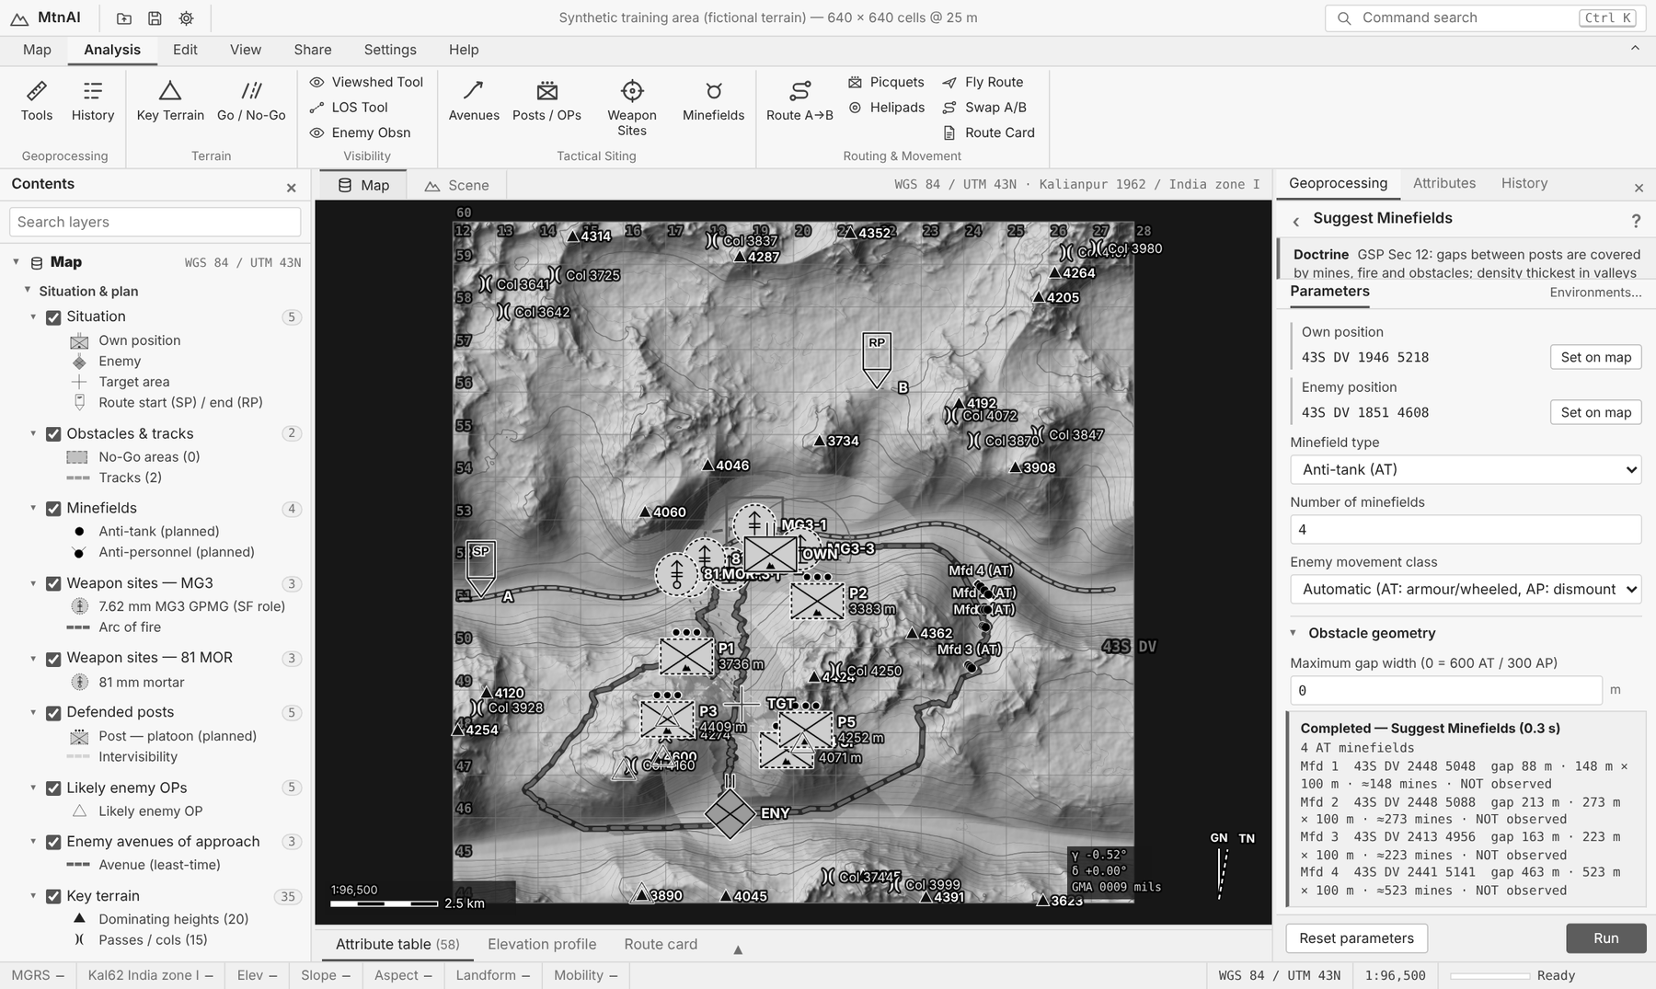
Figure 22. Suggested anti-tank minefields across the enemy avenues.
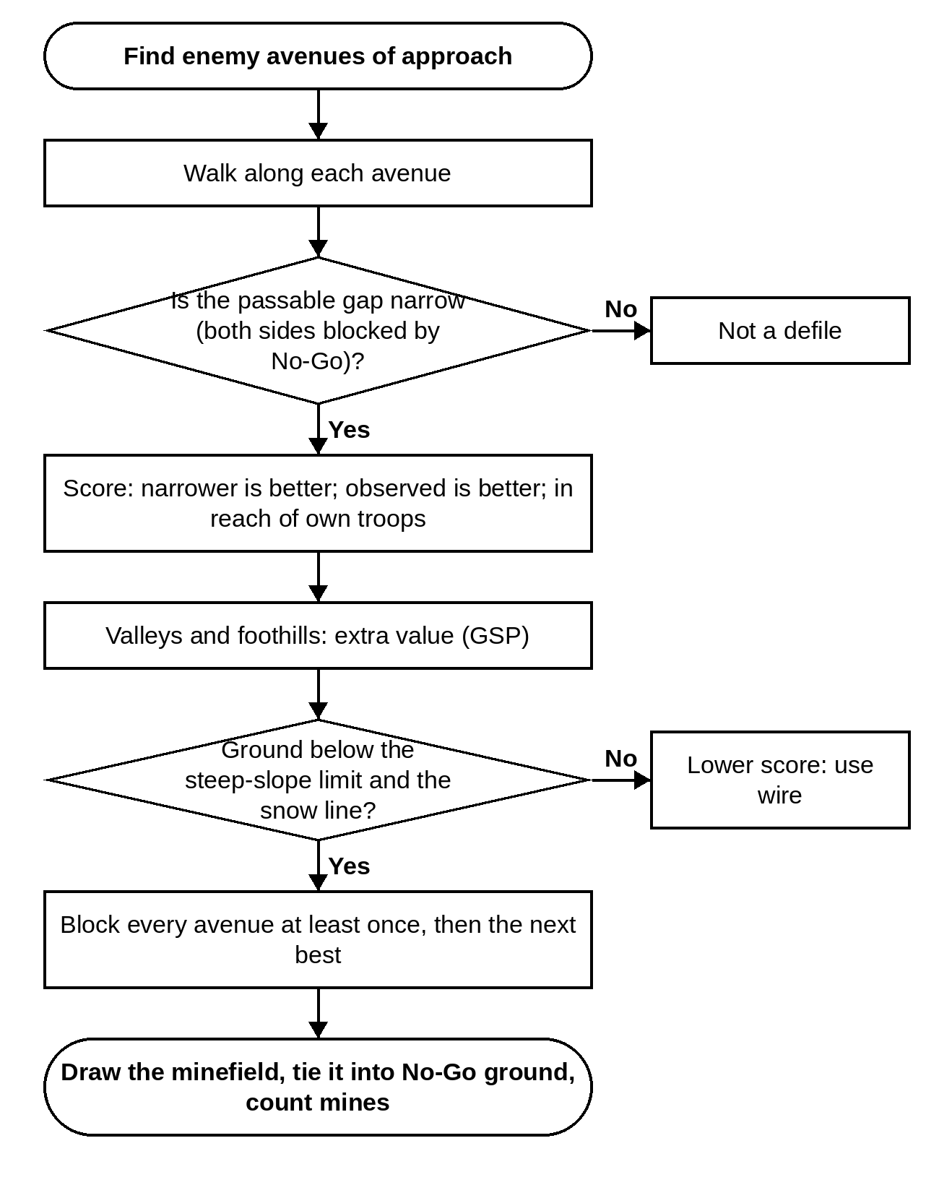
Figure 23. Flowchart — Minefields.
Setting | Default | Notes
Own position | set on the map
Enemy position | set on the map
Minefield type | Anti-tank (AT)
Number of minefields | 4
Enemy movement class | Automatic (AT: armour/wheeled, AP: dismounted)
Obstacle geometry
Maximum gap width (0 = 600 AT / 300 AP) | 0 m
Depth (0 = 100 AT / 40 AP) | 0 m
Density (0 = 1 AT / 3 AP) | 0 mines/m
Tie-in into NO-GO ground | 30 m
Siting constraints
Minimum distance from own position | 300 m
Maximum distance from own position | 3000 m
Minimum separation | 400 m
Avenues of approach considered | 3
Block every avenue at least once | Yes
Only sites under own observation / fire | No
Search & scoring
Orientations tested at each defile | 8
Weight of narrowness (0–1) | 0.7
Factor if not observed (0–1) | 0.45
Factor behind own position (0–1) | 0.2
Factor outside distance band (0–1) | 0.15
Ground (GSP Mountain Warfare)
Extra value in valleys / foothills | 0.25 | GSP: minefield density is thickest in the valleys and foothills.
Steep-slope limit | 30° | GSP: mines on slopes wash away in rain and slides; use wire on rocky / steep slopes.
Factor on steeper ground (0–1) | 0.35
Snow line (0 = off) | 0 m | GSP: heavy snow cover greatly reduces the effect of mines.
Factor above the snow line (0–1) | 0.4

9.4 Helipad Sites (HLS)
Finds flat, hidden places where a helicopter can land, near your position.
Doctrine. GSP Sec 22 para 19: sites for repeated use ≤ 4° slope; in emergency 4–10° for observation / utility and 4–20° for cargo helicopters. Shield the site and its approach from enemy observation; avoid dust (dry barren ground) — hard ground, rock or grass is best.
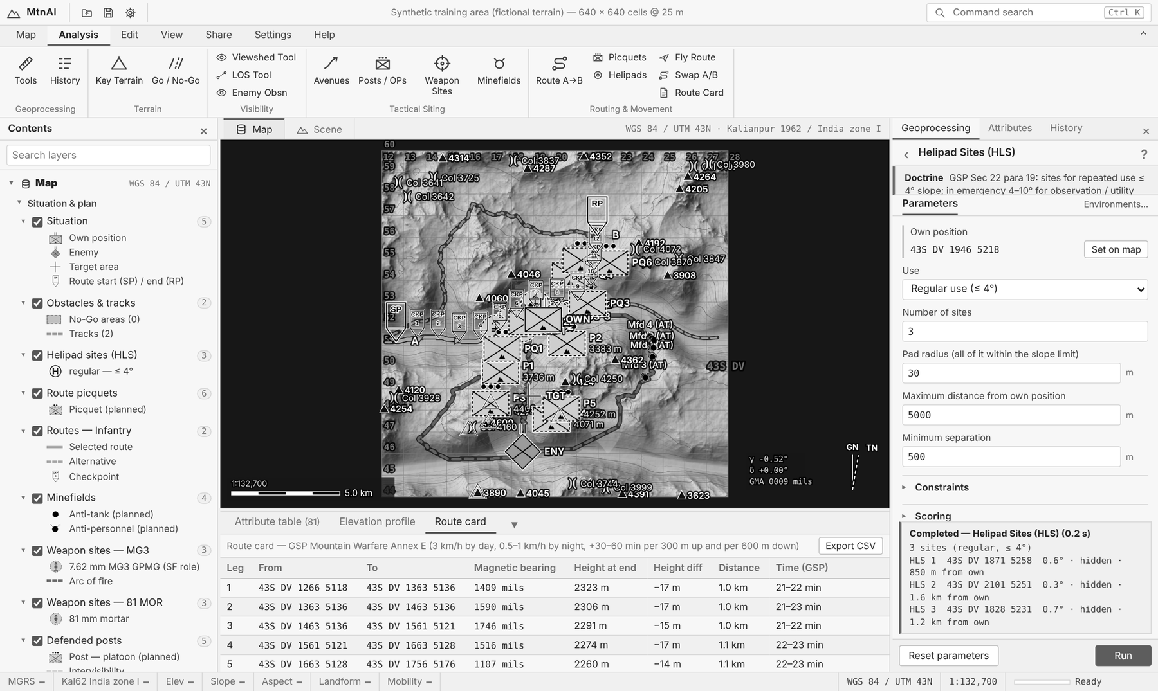
Figure 24. Helipad sites (H) and their details.
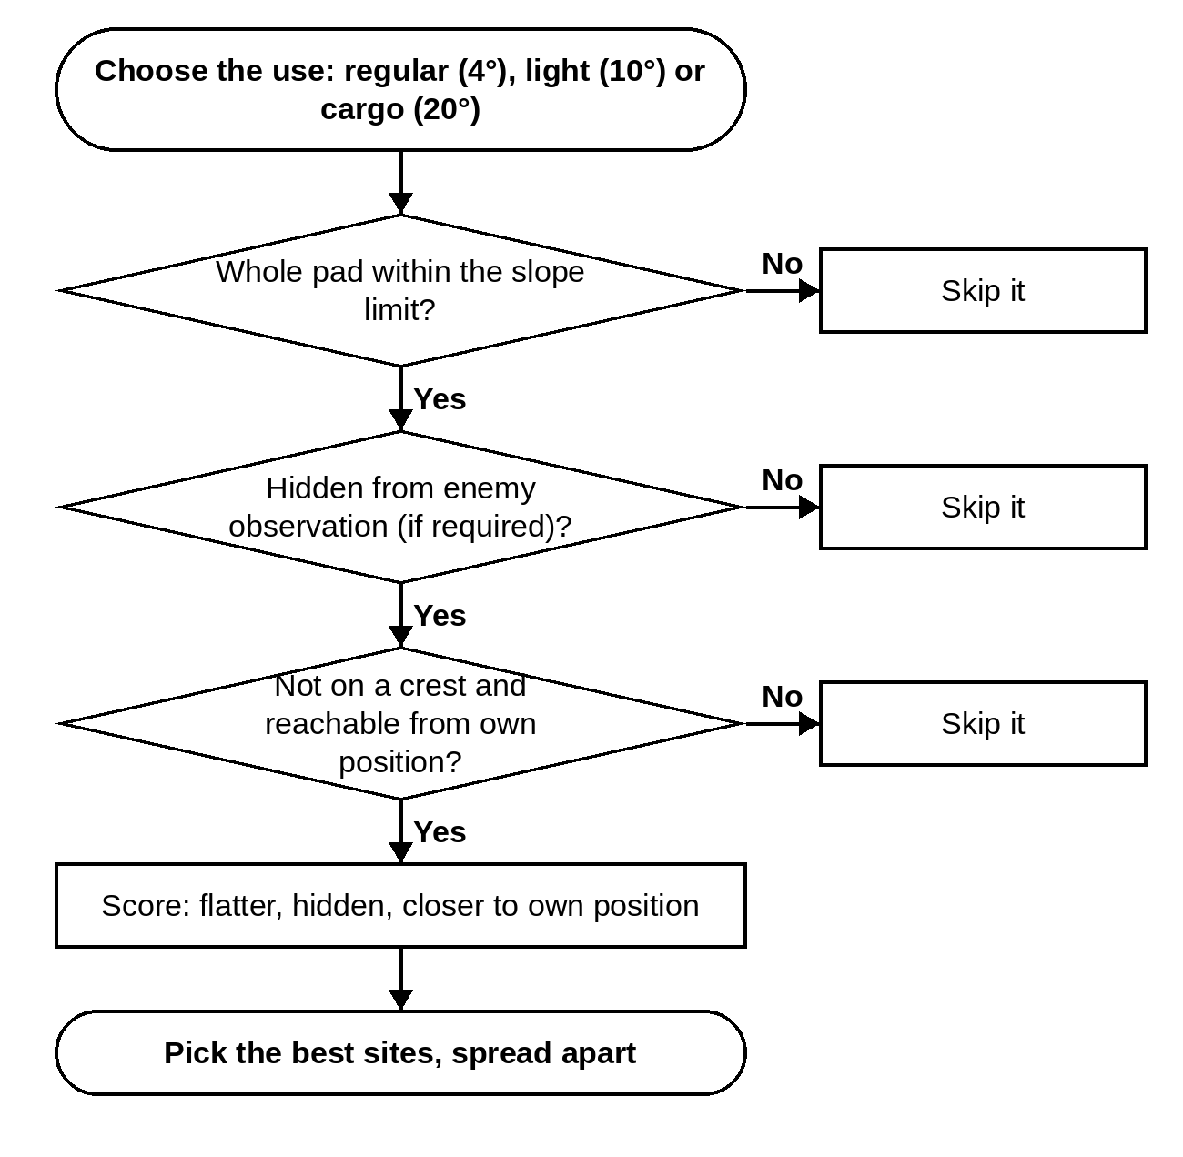
Figure 25. Flowchart — Helipad Sites.
Setting | Default | Notes
Own position | set on the map
Use | Regular use (≤ 4°)
Number of sites | 3
Pad radius (all of it within the slope limit) | 30 m
Maximum distance from own position | 5000 m
Minimum separation | 500 m
Constraints
Hidden from enemy observation | Yes
Not on crests (skyline, wind) | Yes
Reachable from own position | Yes
Access movement class | Infantry (dismounted, laden) | only shown for some choices
Maximum access time (0 = any) | 0 h | only shown for some choices
Scoring
Weight — flatness | 0.4
Weight — concealment | 0.35
Weight — closeness to own position | 0.25

10. MOVEMENT TOOLS

10.1 Least-Time Route (A to B) and the Route Card
Finds the quickest safe path between Start A and End B for the chosen movement class. It knows that walking uphill is slow, steep downhill is slow too, and NO-GO ground is impossible. It can also keep you out of enemy view, off skylines and out of nullah beds.
Each route shows: length, climb and descent, steepest part, share in SLOW-GO and in enemy view, the model time and the GSP time (day and night). The Route Card (bottom dock) lists every leg as in GSP Annex E: start and end reference, magnetic bearing, height at end, height difference, distance and time. Export it as CSV.
Doctrine. GSP Sec 4 / 7 / Annex E: measure distance in time — 3 km/h by day, 0.5–1 km/h by night, plus 30–60 min per 300 m of ascent and per 600 m of descent. Avoid losing height (a 3 km ridge detour beats a 600 m down-and-up). Follow ridges, not gullies. Prepare a route card.
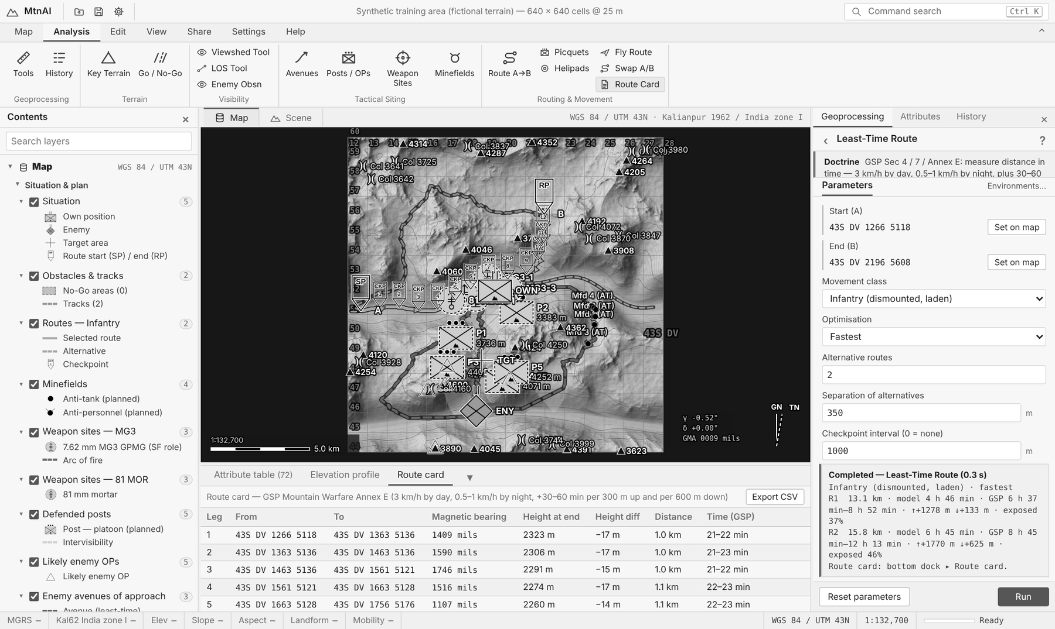
Figure 26. Route A→B with checkpoints and the GSP route card in the bottom dock.
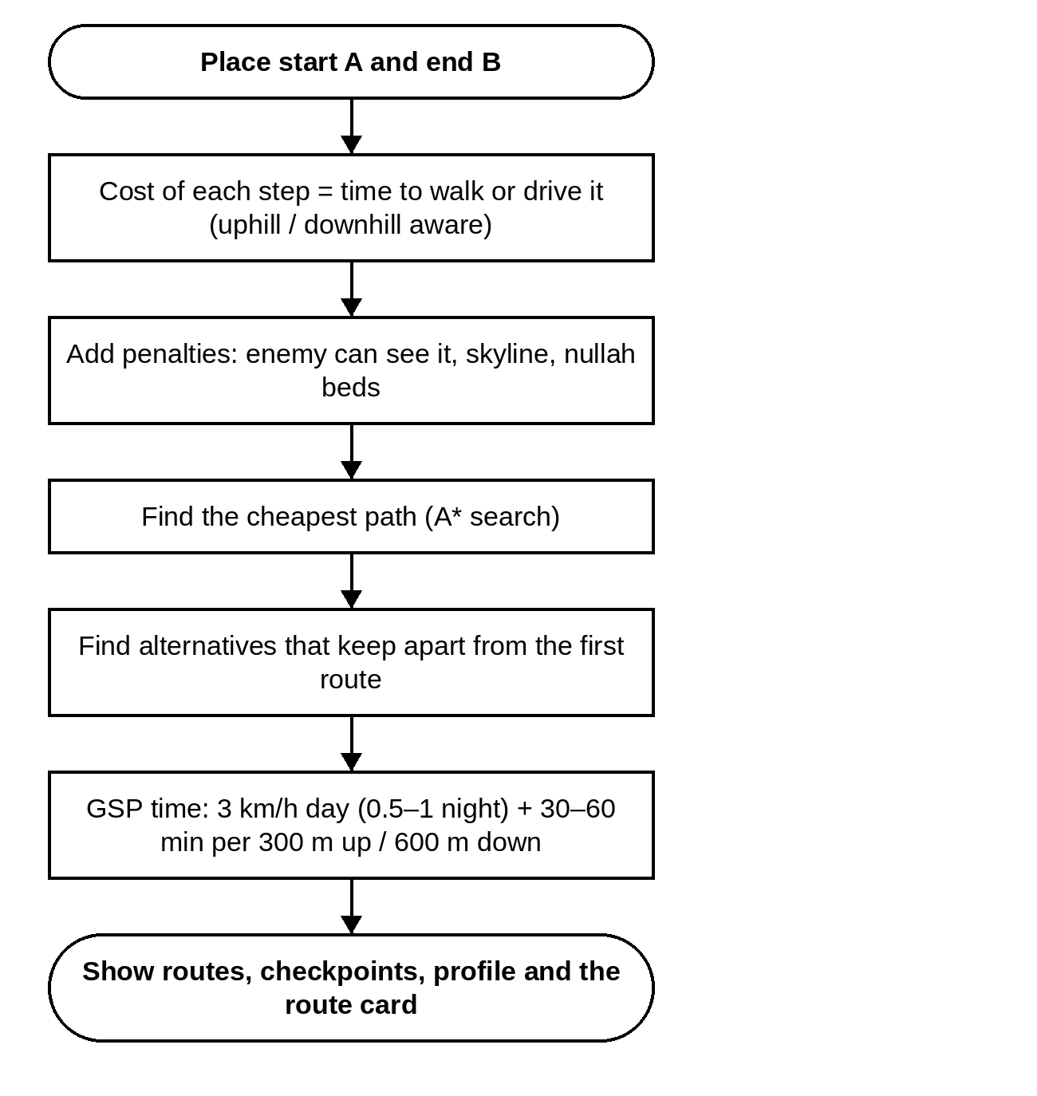
Figure 27. Flowchart — Least-Time Route.
Setting | Default | Notes
Start A | set on the map
End B | set on the map
Movement class | Infantry (dismounted, laden)
Optimisation | Fastest
Exposure penalty | 3 × | only shown for some choices
Skyline (crest) penalty | 0.8 × | only shown for some choices
Alternative routes | 2
Separation of alternatives | 350 m
Checkpoint interval (0 = none) | 1000 m
Keep out of nullah beds (penalty) | 0.5 × | GSP: routes follow ridge lines rather than gullies and stream beds (scree, vertical patches, ambush). Tracks are exempt.
Route card (GSP Annex E)
Leg length | 1000 m
Night move (0.5–1 km/h instead of 3 km/h) | No

10.2 Route Picquets
Puts picquets on the heights that overlook the chosen route, so the column below is safe ("crowning the heights").
Doctrine. GSP Sec 6: the axis passes through valleys and defiles dominated by flanking heights — secure (picquet) these heights for the main body and to protect the main supply route.
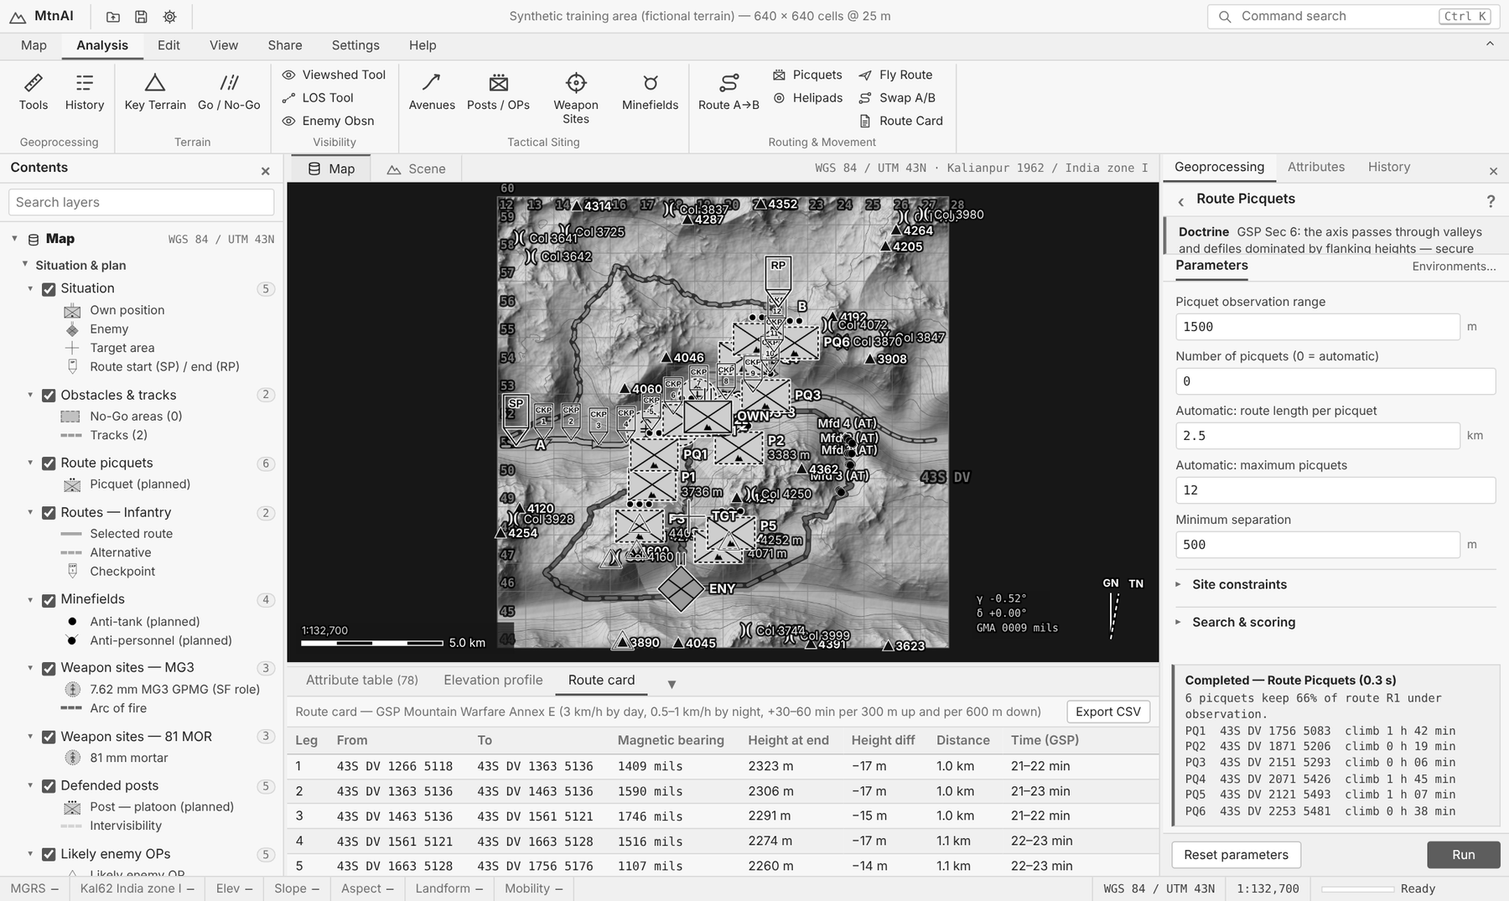
Figure 28. Route picquets on the heights above the route.
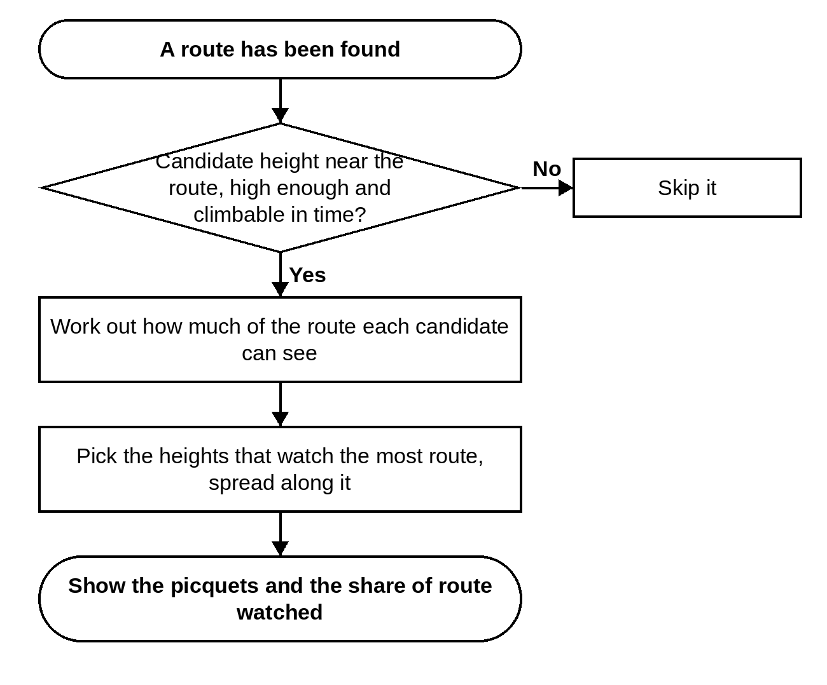
Figure 29. Flowchart — Route Picquets.
Setting | Default | Notes
Picquet observation range | 1500 m
Number of picquets (0 = automatic) | 0
Automatic: route length per picquet | 2.5 km | only shown for some choices
Automatic: maximum picquets | 12 | only shown for some choices
Minimum separation | 500 m
Site constraints
Maximum distance from route | 2000 m
Lowest landform allowed | Upper slope
Maximum site slope | 38°
Maximum climb time from route | 4 h
Search & scoring
Candidate sites evaluated | 120
Value of overlapping coverage (0–1) | 0.15
Observer height | 2 m
Target height | 1.5 m

10.3 Fly Route (3D)
Flies the camera along the route in the Scene view. Press Esc to stop.
Setting | Default | Notes
Speed | 260 m/s
Height above route | 140 m

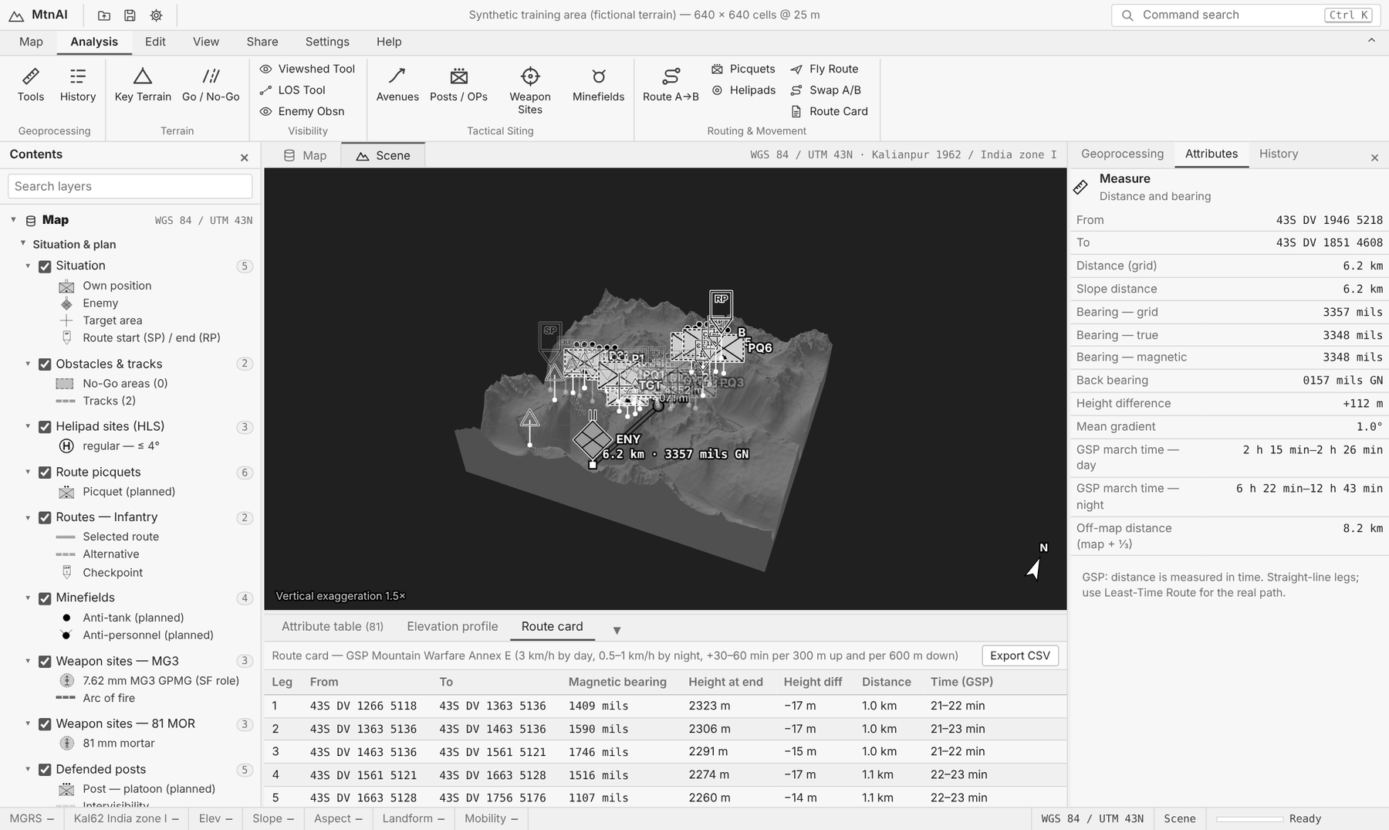
Figure 30. The Scene (3D) view.

11. LAYERS, TABLES AND SAVING

Contents pane
- Tick or untick a layer to show or hide it. Click ▸ to open its key.
- Right-click: Zoom To Layer, Attribute Table, Transparency, Remove, Symbology settings, Properties.
- Double-click the height layer to change the base map (shaded relief, height colours, slope, aspect, landforms, ruggedness) and see its statistics.
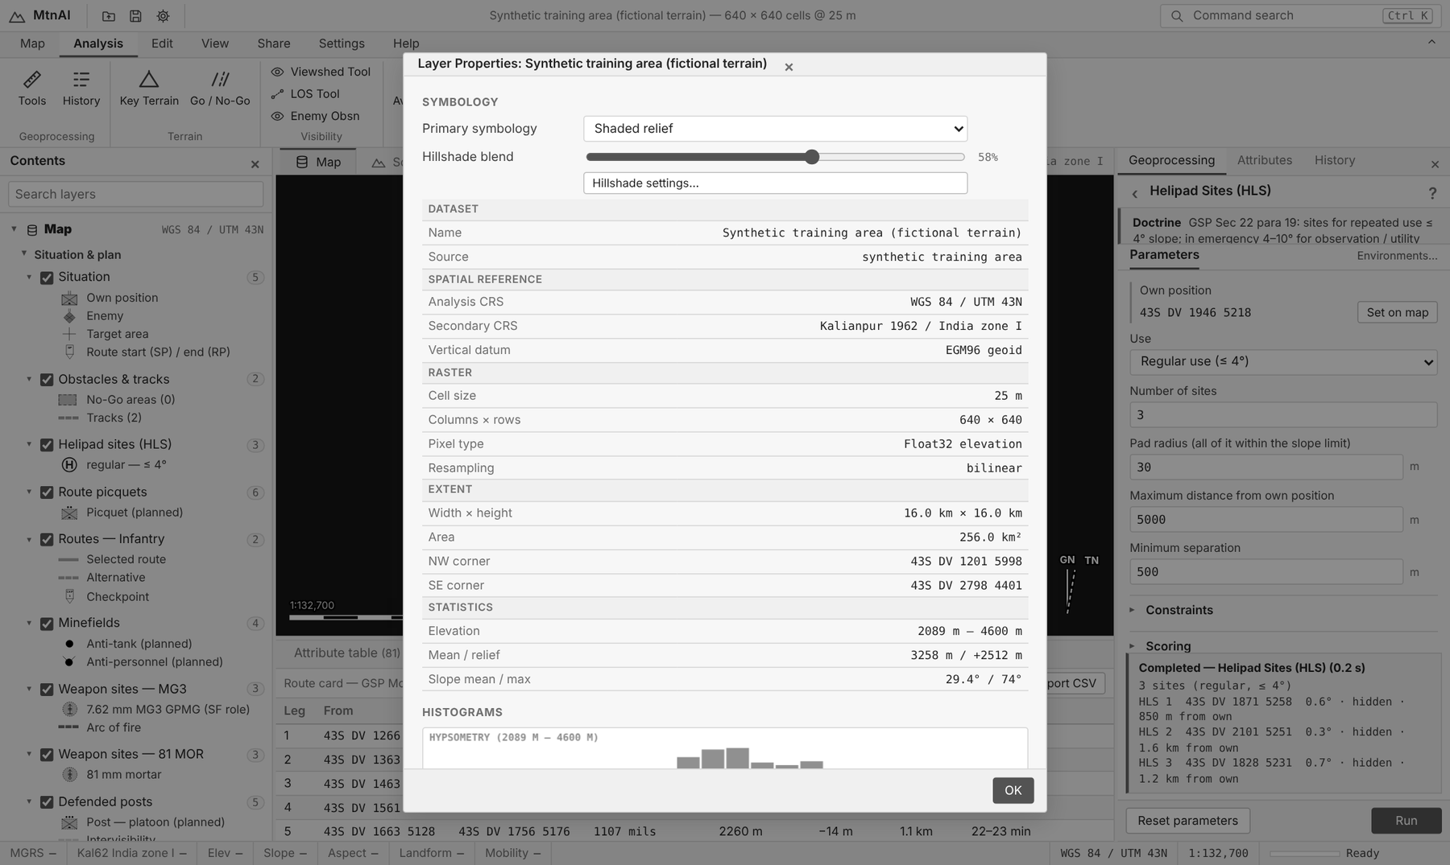
Figure 31. Layer Properties of the DEM: symbology, data source, coordinate system, extent and statistics.

Attribute table and Attributes pane
- Attribute table (Ctrl+T): every planned item, one row each. Choose a layer, filter, sort by clicking a column, click a row to zoom. Export CSV saves it.
- Attributes pane: everything about the item you clicked, with its position in every coordinate system. Buttons: Copy reference, Zoom to, Viewshed from here.

Saving and sharing (Share tab)
Button | Gives you
Save Plan / Open Plan | A small .json file with your markers, drawings and results. Open it again later on the same DEM.
GeoJSON | All features with NATO symbol codes (SIDC) for other GIS or C2 systems.
Table (CSV) | The attribute table for Excel.
Raster | Any layer as GeoTIFF or ASCII grid.
View (PNG) | A picture of the map or the 3D view.
Report | A printable terrain assessment with maps and every result (Ctrl+P).

12. SETTINGS
Settings (Ctrl+,) are grouped. Changed settings are marked; you can search, export, import and restore defaults.
Group | What you can change
Coordinate systems | Analysis UTM zone and hemisphere; second system (Kalianpur etc.) or a custom one.
Grid references | Main format, number of figures, spacing, lat / long decimals.
North reference | Grid, true or magnetic; declination and yearly change; mils, degrees or gradians.
Units | Distance, height, area and time units; vertical datum.
Map grids | Which grids, their spacing, labels and colours.
Map display | Base map, hillshade sun direction, contours.
Symbology | NATO symbol size, colours, labels.
Overlays | Colours and transparency of the analysis layers.
3D view | Height exaggeration, mesh detail, light, haze, fly speed.
Analysis | Earth curve and refraction, observer heights, landform scales, altitude slow-down, route options.
Movement classes | GO / SLOW-GO slopes and speeds for each class.
Weapon data | Range, site slope, heights, access and mount limits of each weapon.
Data, Report, Interface | Import options, report header, theme (dark, light, high contrast, night red), text size.

13. DOCTRINE IN MTNAI (GSP MOUNTAIN WARFARE)
These rules from the pamphlet are built into the tools. Help ▸ Doctrine shows the same table inside the app.
Subject | GSP teaching | Where in MtnAI
Planning (Sec 4) | Measure distance in time. Map distance + ⅓ ≈ ground distance. Avoid losing height (a 3 km ridge detour beats a 600 m down-and-up). Follow ridges, not gullies. Make a route card. | Route: GSP time, nullah penalty, route card. Measure: GSP time.
Rate of march (Sec 7, Annex E) | Day 3 km/h; night 0.5–1 km/h; add 30–60 min for every 300 m up and every 600 m down. | GSP time on every route and route-card leg.
Objectives (Sec 4, 7) | Seize or hold the dominating heights; objectives on the flanks and rear that dominate the enemy. | Key Terrain.
Approaches (Sec 7) | Valley (obvious, well covered), nullah (infiltration, ambush), ridge line (easy to fight on, hard to supply). Guard every approach. | Avenues of Approach.
Defence (Sec 12, 13) | Hold heights astride and beside the main axis; posts at platoon level; tiered defence (valley, mid slope, ridge); strong point on the most dominating feature; reverse slopes when the forward slope is under fire. | Posts: tier and strong point. Enemy Observation.
Observation (Sec 4, 22) | Dead space at mid ranges. OPs laterally, in depth and at varying heights so cloud cannot blind them all. Voices carry 900 m up: listening posts in valleys. | Posts: height tiers, dead ground. Viewshed.
Obstacles (Sec 12, 13) | Cover gaps with mines, fire and wire; mines thickest in valleys and foothills; mines wash away on slopes and fail in snow and rock: use wire there. | Minefields: valley bonus, steep and snow factors, notes.
Fire (Sec 18) | Up- or downhill fire strikes high: sight = slant range ÷ factor. Plunging fire leaves dead ground. MG mount +6° / −8.5°; 75 mm RR +30° / −5°. Mortars cover dead space. | Weapon sites: sight factor, mount limits. LOS: sight setting.
Artillery and AD (Sec 22) | High-angle weapons beat crests; light guns and mortars on reverse slopes and in valleys; harass passes and defiles. AD covers defiles, gun areas and logistic sites from heights. | Indirect fire: crest clearance, defilade. AD air corridors.
Advance (Sec 6) | The axis runs through valleys and defiles under flanking heights: picquet them for the main body and supply route. | Route Picquets.
Helicopters (Sec 22) | Landing sites ≤ 4° for regular use; emergency 4–10° light and 4–20° cargo. Hide site and approach. Hard ground, rock or grass. | Helipad Sites.
Animal transport (Annex H) | A loaded mule climbs any slope a man can without using his hands; about 16 miles a day, 8 under load; 65 kg in hills. | Mule class: SLOW-GO up to 30°.

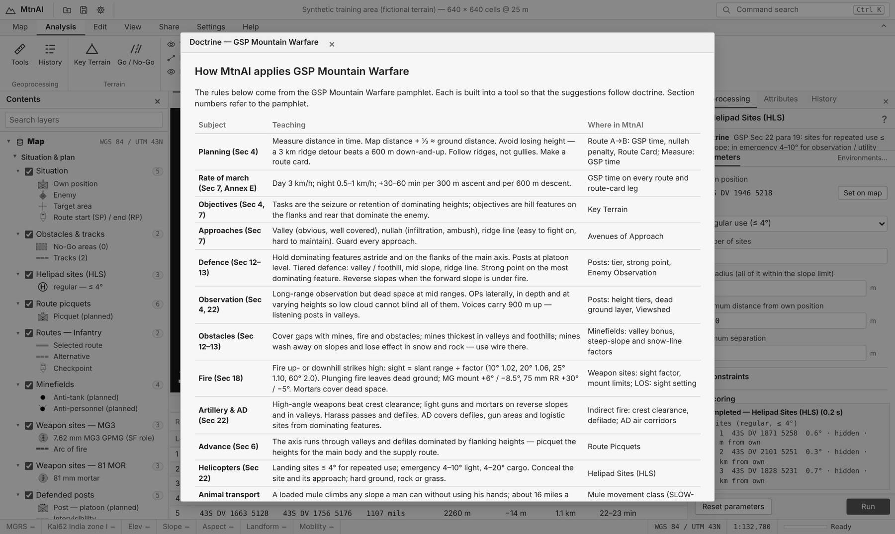
Figure 32. Help ▸ Doctrine inside the app.

14. SHORTCUTS AND LIMITS
Keys | Action
Ctrl+O | Add Data
Ctrl+S | Save plan
Ctrl+P | Report
Ctrl+, | Settings
Ctrl+K or / | Command search
Ctrl+G | Go To XY
Ctrl+B | Contents pane
Ctrl+T | Attribute table
Ctrl+J | Bottom dock
2 / 3 | Map / Scene view
F | Full extent
+ / − | Zoom
M / L / V | Measure / Line of Sight / Viewshed
Esc | Cancel a tool, drawing or fly-through
F1 | Help

Limits
- Results are only as good as the DEM. A 30 m DEM smooths cliffs, narrow nullahs and small features.
- Trees, snow depth, soil, rivers and buildings are not known unless you draw them.
- Weapon and movement figures are planning values. Use your unit's current data.
- Every suggestion is a starting point for reconnaissance, not a replacement for it.

