Customer and Market Segmentation.
Mehrthur Luís Lemos da Silva
Derly Vanessa Carrillo Hernandez
Laura Andrea Martinez Sarmiento
Erick Jossue Murrillo Herrera
The University of Niagara Falls Canada
Term 1
Teacher : Dr. Patty Zakaria
October 11, 2026

Introduction
The database Wholesale Customer portraits annual spending of 440 customers of a Wholesale distributor . The dataset has 8 Features which are fresh, milk, grocery, frozen, detergents_paper, delicatessen, channel, region. Each line represents one client. According to James et al. (2021), K-means clustering is an unsupervised learning method that partitions observations into a predefined number of distinct, non-overlapping clusters. The objective is to minimize within-cluster variation, ensuring that observations within the same cluster are as similar as possible. The main target in this field is to identify and wholesale customer segments based on their annual spendings patterns using K-means clustering in R. These findings will support marketing decisions and help develop marketing strategies for different customer groups.

Part 1 – Develop the Segmentation Questions
Understanding customer purchasing behaviour is essential for developing effective marketing strategies. In the wholesale industry, customers have different purchasing needs, spending levels, and product preferences. Therefore, applying the same marketing strategy to every customer may not be the most effective approach.
The main business question is how can a wholesale distributor increase customer spending and loyalty through personalized marketing strategies based on purchasing behaviour?
Supporting Business Questions
Business Question | Marketing Objective | Research Hypotheses
Q1. How can we encourage high-spending customers to purchase more products? | Identify opportunities for upselling, cross-selling, and volume-based discounts. | H1 – High-Spending Customers | High-spending customers have distinct purchasing patterns that may reveal opportunities for upselling, cross-selling, and volume-based discounts.
Q2. How can we identify customer purchasing profiles and determine which products to promote to each group? | Develop customer profiles and personalized product promotions based on purchasing patterns. | H2 – Personalized Product Recommendations | Different customer segments have different purchasing preferences, creating opportunities to develop targeted product promotions based on their spending patterns.
Q3. Which customer segments would be the best candidates for an annual loyalty programme, and what product-based benefits should it offer? | Identify potential loyalty programme participants and propose relevant product discounts and purchasing benefits. | H3 – Customer segments with higher annual spending and identifiable product preferences may be suitable candidates for an annual loyalty programme. This programme could encourage customers to voluntarily provide their email addresses or phone numbers to receive personalized promotions, exclusive discounts, and notifications about new products. Additionally, free home or business delivery could be offered for selected products or orders that meet a minimum purchase value. | Customer segments with higher annual spending and identifiable product preferences may be suitable candidates for an annual loyalty programme offering personalized discounts and purchasing benefits.

Note, let's imagine the distributor identifies clients whose spent a lot on a certain product, the distributor would offers:
Email or SMS: Personalized promotions based on customers' most frequently purchased product categories.
Loyalty Card: Special benefits and rewards for registered customers.
Free Delivery: Free delivery for orders that meet a minimum purchase value.
Exclusive Offers: Discounts on complementary products to encourage additional purchases.
The collection of email addresses or phone numbers must be voluntary, with explicit consent for promotional communications and the option to unsubscribe at any time.

Part 2 – Data Preparation
First of all, the data will present as it is, the data source is from wholesale_customers The dataset was examined for missing values, duplicate observations, variable types, potential outliers, and differences in measurement scales. Six numerical spending variables were selected for segmentation. Channel and Region were retained as categorical variables for subsequent customer profiling. Potential outliers were retained because unusually high purchasing expenditure may provide valuable information about customer behaviour. Logarithmic transformation and standardization were applied to prepare the spending variables for K-means clustering. The resulting dataset, spending_scaled, will be used in the clustering analysis.

Part 3 - Exploratory Analysis

Before conducting K-means clustering, the six spending variables were explored to understand their distributions and relationships. This analysis supports the business questions about high-spending customers (Q1), personalized product promotions (Q2), and potential candidates and benefits for an annual loyalty programme (Q3).

Descriptive statistics compare spending levels and variability across the six product categories, supporting Q1 and Q2.
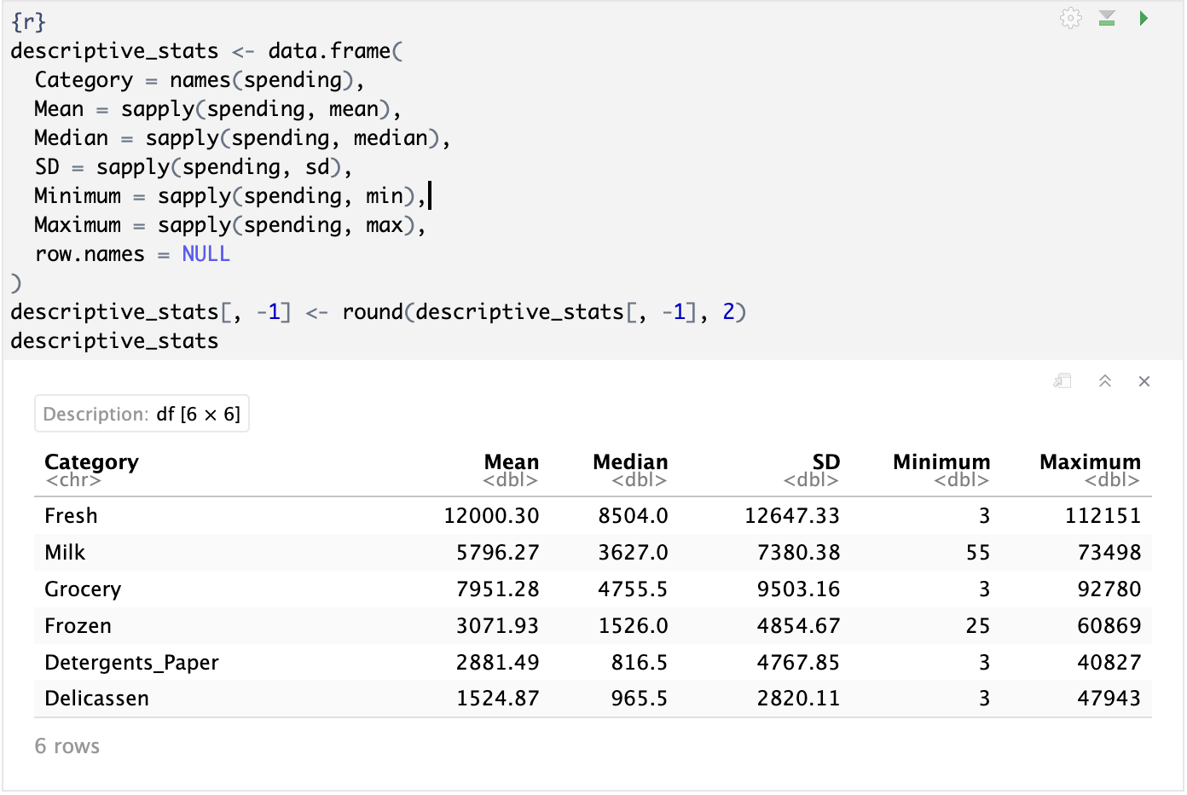

Histograms show the concentration and variation of spending. Comparing original and log-transformed spending helps assess skewness and the transformation applied in Part 2. These patterns support all three business questions.
The original spending distributions were strongly right-skewed across all six product categories, with most customers concentrated at lower spending levels and a small number reporting very high expenditure. After applying the log1p transformation, the distributions became less dominated by extreme values, making differences between customers easier to observe. Some asymmetry remained, particularly in Fresh and Grocery, while Detergents_Paper showed multiple apparent peaks. These findings support the use of log-transformed spending, followed by standardization, for K-means clustering. The transformation retains all observations and does not require the variables to follow a normal distribution.
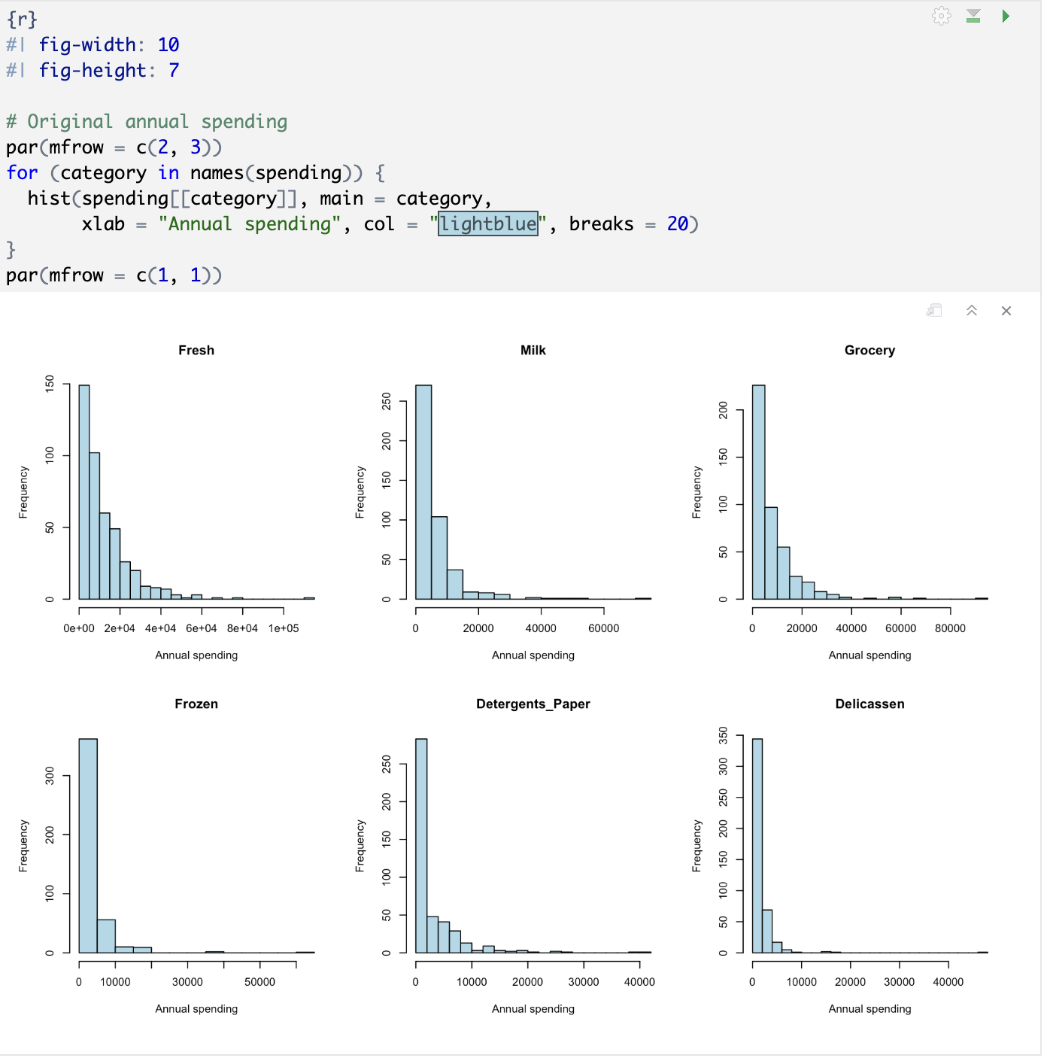
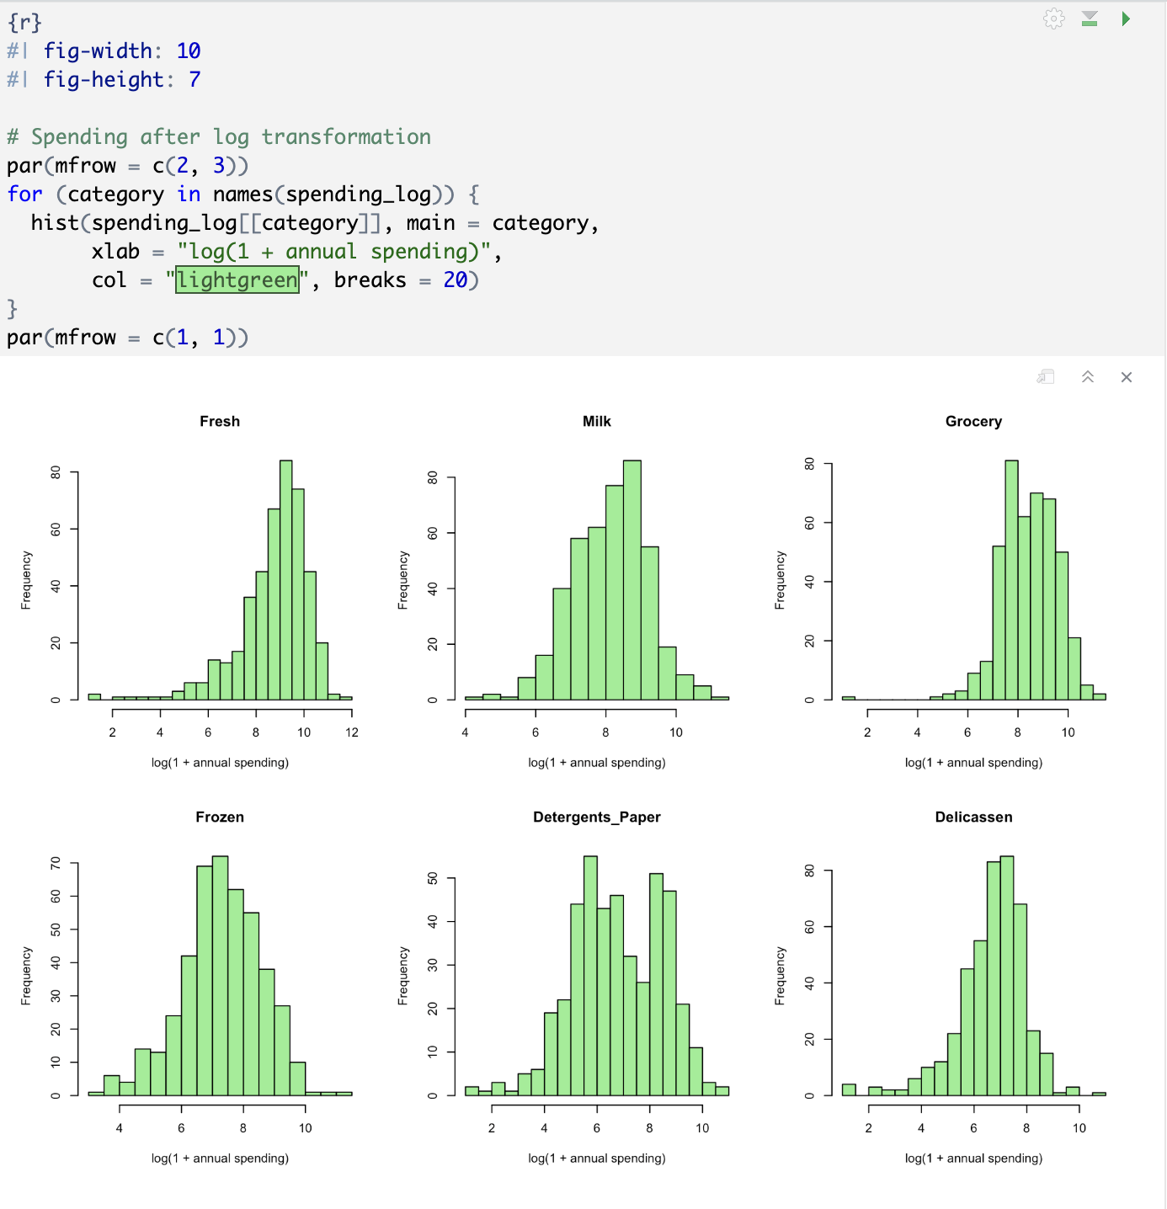

Pearson correlations were calculated using log-transformed spending. Positive correlations indicate categories in which spending tends to increase together across customers. These relationships may inform cross-selling opportunities (Q1), targeted promotions (Q2), and combinations of loyalty benefits (Q3). Correlations do not establish that a promotion will increase purchases.
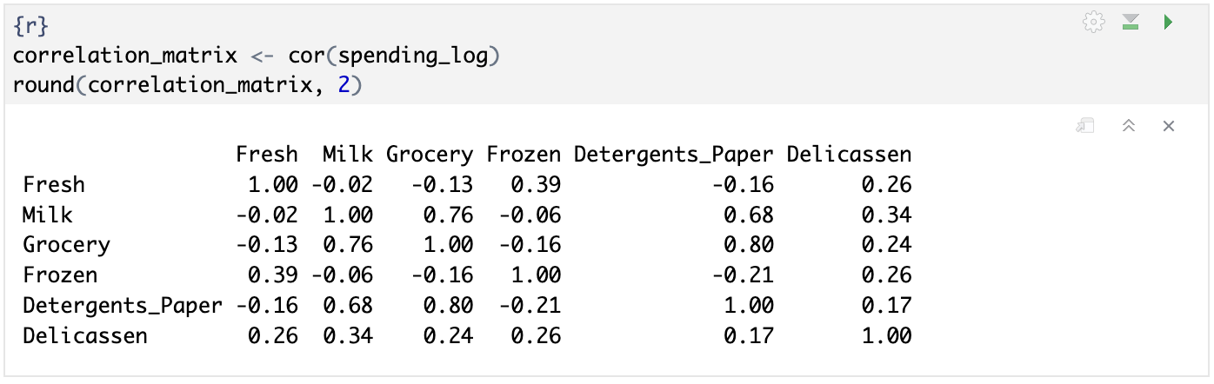
The strongest positive relationship was between Grocery and Detergents_Paper (r = 0.80), followed by Milk and Grocery (r = 0.76) and Milk and Detergents_Paper (r = 0.68). Customers with higher spending in these categories tended to spend more in the associated categories. Fresh and Frozen showed a moderate positive relationship (r = 0.39), while Fresh and Milk showed almost no linear relationship (r = −0.02).
These findings suggest potential opportunities for cross-selling (Q1), personalized product promotions (Q2), and combined loyalty programme benefits (Q3), particularly involving Grocery, Milk, and Detergents_Paper. However, these associations do not demonstrate that promotions will increase spending or loyalty. Final recommendations will also consider the customer profiles identified through clustering.

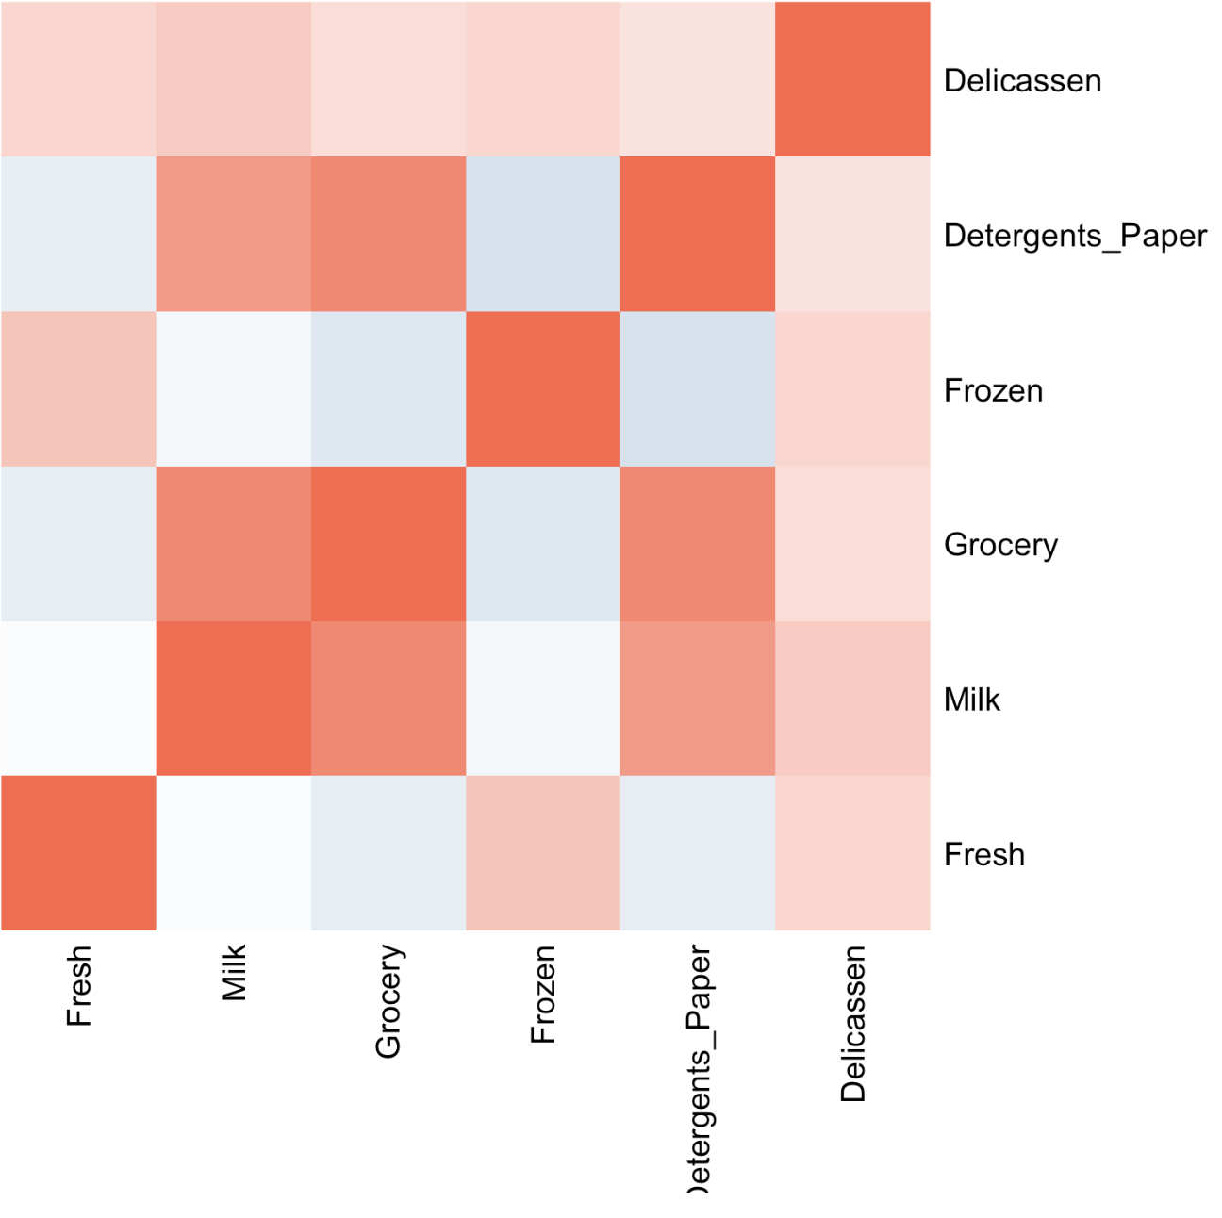
The heatmap uses a colour scale ranging from blue (−1) through white (0) to red (+1). Darker red indicates stronger positive correlations, meaning customers who spend more in one category tend to spend more in the other. Darker blue indicates stronger negative correlations, while white or pale colours indicate weak or near-zero correlations. The red diagonal represents each category’s correlation with itself (r = 1).
Total annual spending was calculated by summing the six categories. This supports Q1 and provides an initial exploration of potential loyalty programme candidates for Q3. Total spending is used only for exploration and is not added to the clustering variables.

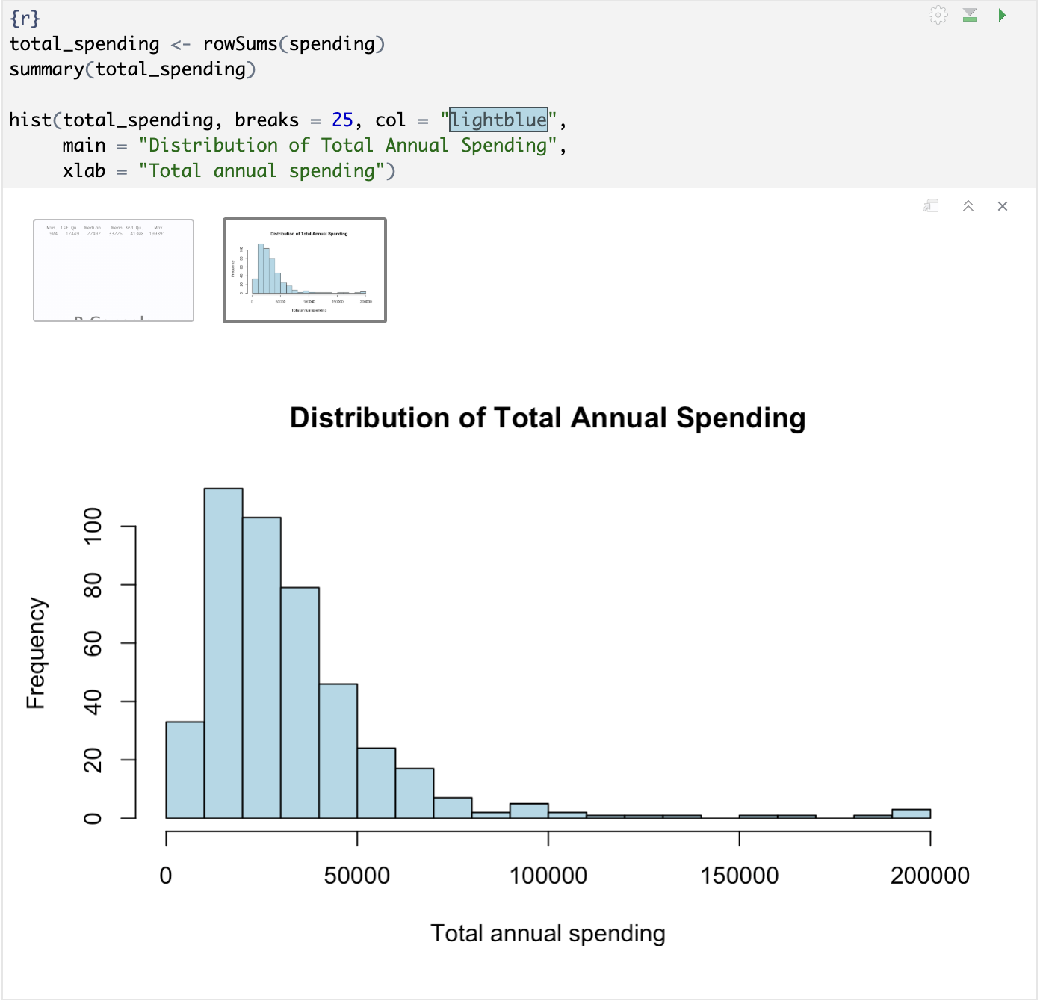
These findings support Q1 by highlighting higher-spending customers for further analysis and Q3 by suggesting potential candidates for an annual loyalty programme. Final recommendations will consider both spending levels and the purchasing profiles identified through clustering. Total spending was used for exploratory analysis only and was not included as an additional clustering variable.
Customers at or above the 75th percentile were examined as an exploratory group. This threshold is a descriptive reference, rather than a final eligibility rule. 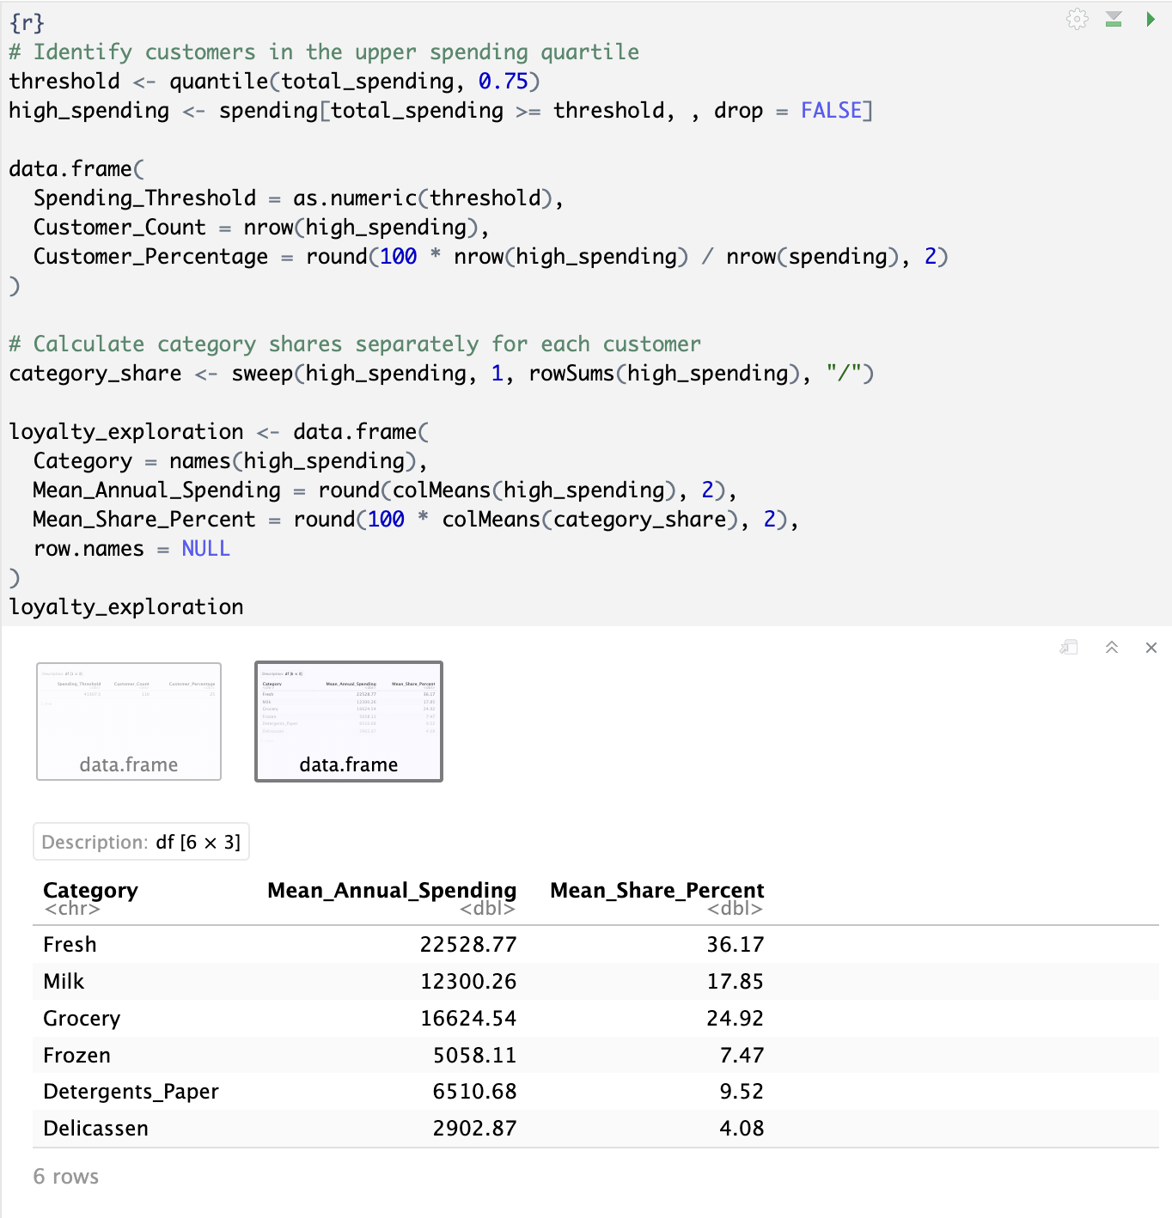

Average customer-level category shares help explore product benefits relevant to higher-spending customers. These measures describe expenditure patterns, rather than purchase frequency or measured interest in a loyalty programme. Cluster profiling will later inform the selection of candidate segments and suitable purchasing benefits.
Annual spending was right-skewed across all six categories, with many customers spending relatively little and a few spending very large amounts. The log transformation compressed extreme values, making spending patterns easier to observe. Grocery, Milk, and Detergents_Paper showed positive correlations ranging from 0.68 to 0.80 in the transformed data. The highest-spending 110 customers (25% of the sample) spent at least 41,307.50 annually. Within this group, Fresh (36.17%), Grocery (24.92%), and Milk (17.85%) accounted for the largest average customer-level shares of total spending.

. Animals are caught when they put their head (or a leg) into the snare and pull it tight as they keep moving (Noss, 1998). In some cases, wildlife is chased in the direction of snare lines by illegal hunters (sometimes using perimeter fencing around reserves to assist in funnelling wildlife. Because of the low value of snares, illegal hunters often check them infrequently, resulting in a high degree of wastage when animals are killed and rot without being retrieved (Noss, 1998). A study estimates that over 100,000 African elephants were killed by poachers across the continent between 2010 and 2012, largely driven by illegal hunting for ivory (Wittemyer et al., 2014).

Poisoning by cyanobacteria, hemorrhagic septicemia, and neurological problems and syndromes such as “floppy trunk” cause an avalanche of elephant deaths. In 2020, approximately 350 African elephants died after drinking water contaminated with toxic cyanobacteria, likely linked to environmental changes (Lomeo et al., 2024). Additionally, bacterial infections such as hemorrhagic septicemia have been identified as causes of elephant deaths in Zimbabwe (AP News, 2020). Conditions such as floppy trunk syndrome, which impairs feeding and leads to starvation, have also been documented among free-ranging elephants (Fowler, 2006). Unfortunately, governments and NGOs do not have programs or provide sufficient resources to protect elephants from these diseases, which results in the mass death of these animals, despite the existence of national wildlife parks.

Part 4 - Conduct Segmentation
In this section, we conducted the following analyses, keeping our three business questions as a reference:
- Compared solutions with 2 to 8 clusters using the elbow method and silhouette scores.
- Applied K-means clustering using the six log-transformed and standardized spending categories.
- Reported the number of customers in each cluster.
- Examined cluster centres, mean spending, and median spending.
- Created a cluster profile chart and summary tables to support Q1, Q2, and Q3.
K-means clustering was applied to identify customer groups with similar purchasing patterns. The analysis uses Fresh, Milk, Grocery, Frozen, Detergents_Paper, and Delicassen after log1p transformation and standardization. Channel, Region, and total spending are excluded from clustering; they are available for subsequent profiling. The original business questions guide the interpretation of high-spending customers (Q1), product promotions (Q2), and loyalty programme candidates and benefits (Q3).
Among the solutions evaluated, two clusters achieved the highest average silhouette score (0.290), followed by three clusters (0.259). Therefore, the two-cluster solution was selected according to this criterion. Within-cluster variation decreased as more clusters were added, as expected. However, the modest silhouette score suggests overlapping purchasing patterns, so segment profiles should be interpreted cautiously.
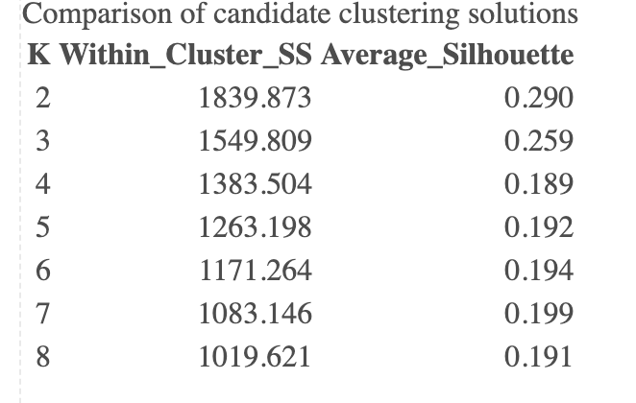
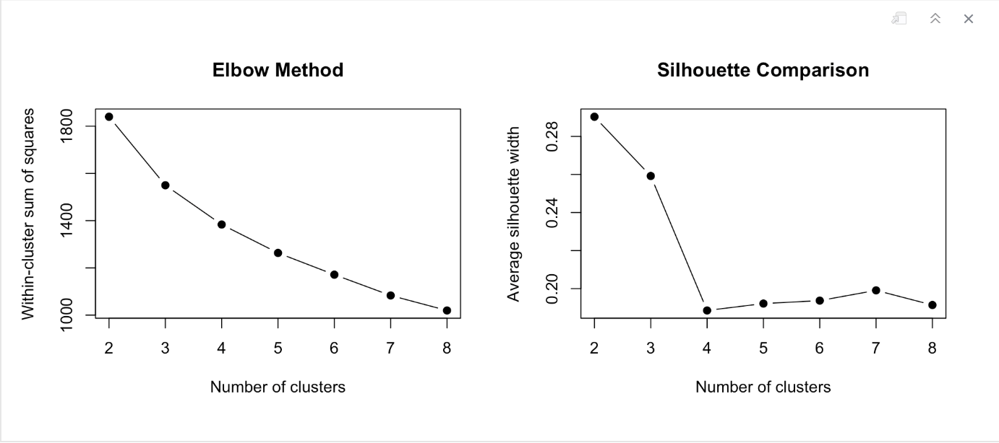
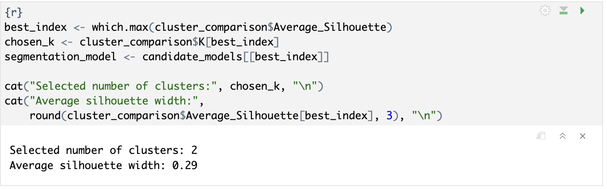
The silhouette score should also be considered in absolute terms: a modest score (0.29) indicates overlapping purchasing patterns, even when it is the best score among the candidate solutions. This comparison does not establish a universally optimal number of customer segments.
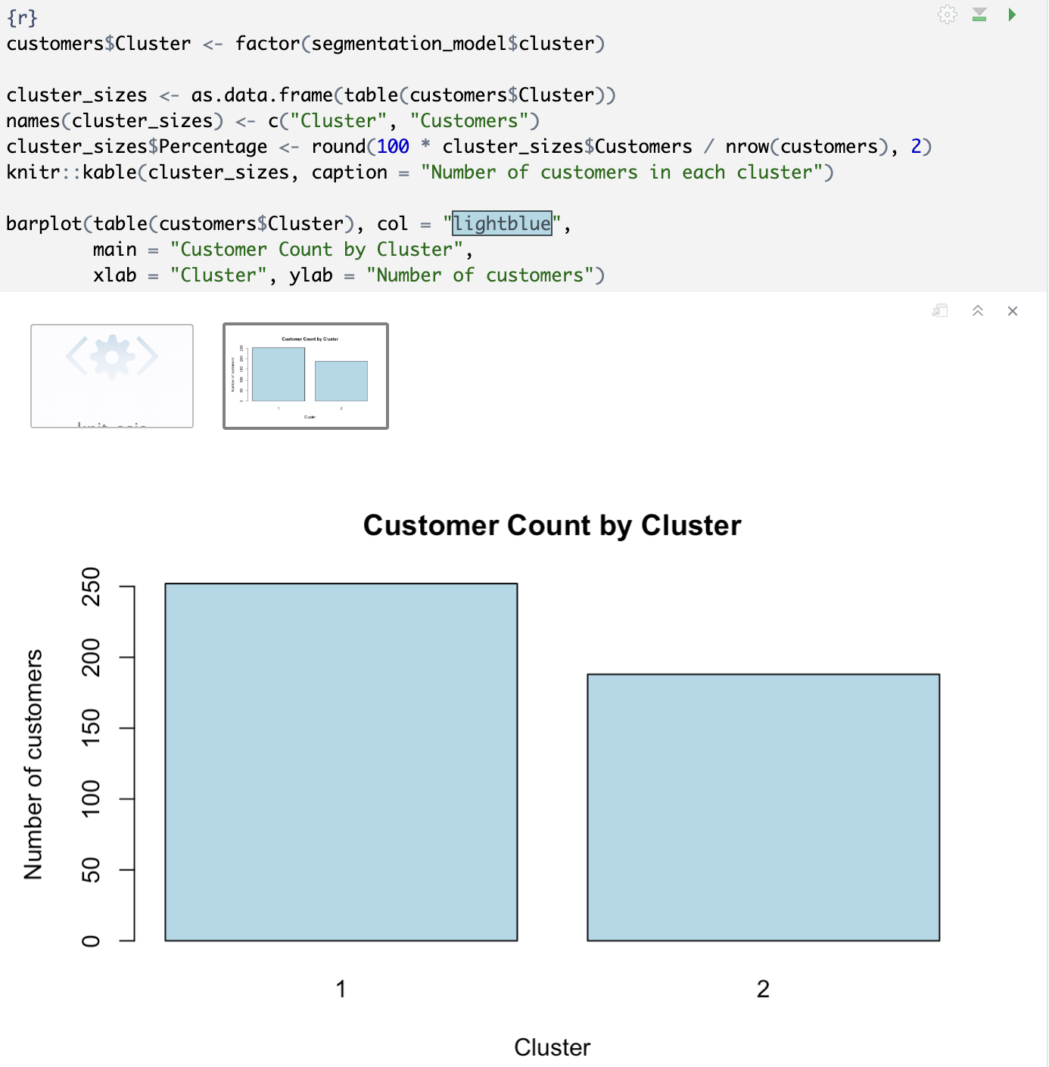
The 440 customers were assigned to two clusters. Cluster 1 contained 252 customers (57.27%), while Cluster 2 contained 188 customers (42.73%). These figures describe segment sizes; spending profiles are examined in the following analysis:
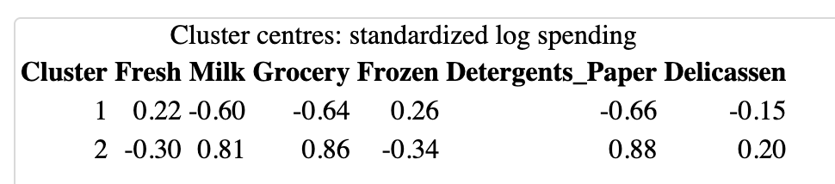
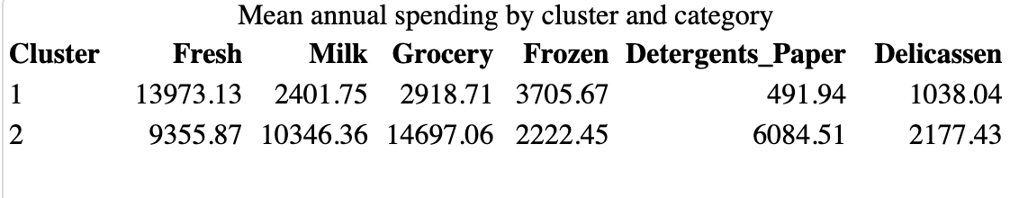
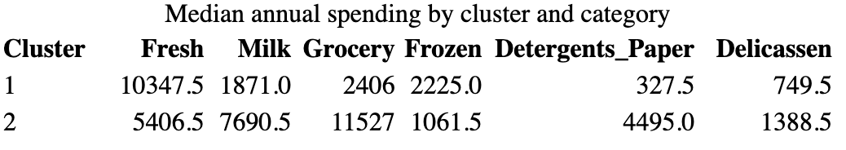
The K-means results identified two customer purchasing profiles:
Segment | Suggested Name | Purchasing Profile
Cluster 1 — 252 customers (57.27%) | Fresh and Frozen Focus | Higher spending on Fresh and Frozen, and lower spending on Milk, Grocery, and Detergents_Paper compared with Cluster 2.
Cluster 2 — 188 customers (42.73%) | Grocery, Milk and Detergents Focus | Higher spending on Grocery, Milk, Detergents_Paper, and Delicassen compared with Cluster 1.

The profile chart illustrates differences in standardized log spending between the two clusters. Cluster 1 shows above-average spending on Fresh and Frozen, while Cluster 2 shows above-average spending on Milk, Grocery, Detergents_Paper, and Delicassen. The largest differences occur in Milk, Grocery, and Detergents_Paper. These patterns support the proposed segment profiles and provide a basis for tailored product promotions and loyalty benefits.
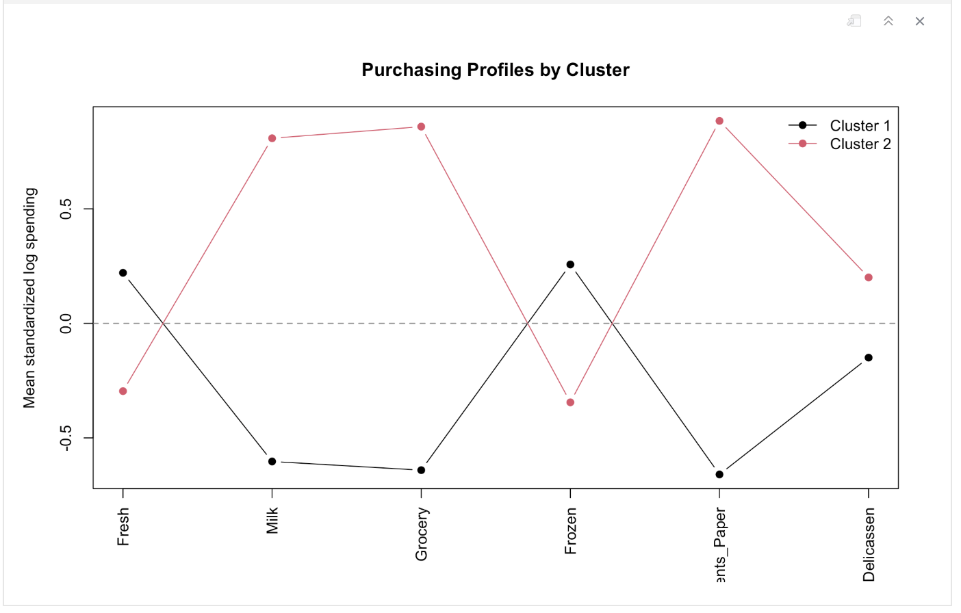

Cluster 2 had higher mean and median total annual spending (44,883.68 and 35,222.50) than Cluster 1 (24,529.24 and 19,745.00). It also contained 75 high-spending customers (39.89% of the cluster), compared with 35 (13.89%) in Cluster 1. Average customer-level spending shares further distinguished the profiles: Cluster 1 focused primarily on Fresh (50.78%), while Cluster 2 allocated larger shares to Grocery (34.06%), Milk (23.38%), and Detergents_Paper (13.81%). These findings support prioritizing Cluster 2 for high-spending customer initiatives while tailoring promotions and loyalty benefits to each segment’s purchasing profile:
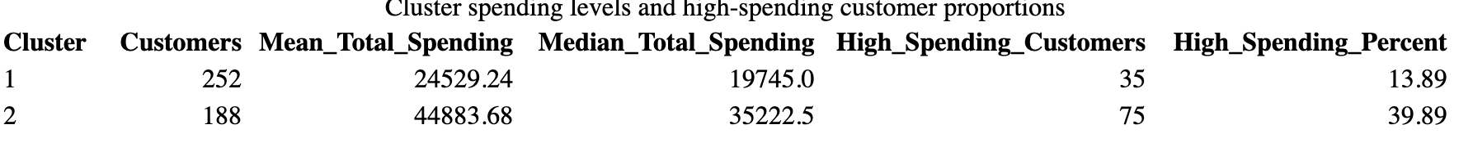
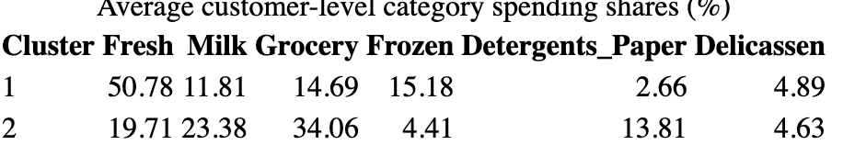
Cluster 2 had higher mean and median total annual spending (44,883.68 and 35,222.50) than Cluster 1 (24,529.24 and 19,745.00). It also contained 75 high-spending customers (39.89% of the cluster), compared with 35 (13.89%) in Cluster 1. Average customer-level spending shares further distinguished the profiles: Cluster 1 focused primarily on Fresh (50.78%), while Cluster 2 allocated larger shares to Grocery (34.06%), Milk (23.38%), and Detergents_Paper (13.81%). These findings support prioritizing Cluster 2 for high-spending customer initiatives while tailoring promotions and loyalty benefits to each segment’s purchasing profile.

The segmentation results provide a basis for addressing the three business questions:
- Q1: Cluster 2 has higher total spending and a greater proportion of high-spending customers, making it a priority for exploring upselling, cross-selling, and volume-based discounts. High-spending customers in Cluster 1 should also be considered.
- Q2: Promotions can reflect each segment’s purchasing profile: Fresh and Frozen for Cluster 1, and Grocery, Milk, and Detergents_Paper for Cluster 2.
- Q3: Cluster 2 is a potential priority for an annual loyalty programme, with benefits tailored to its main purchasing categories. High-spending customers in Cluster 1 could receive Fresh- and Frozen-related benefits. Programme interest and effects on spending and loyalty would need to be evaluated after implementation.

Part 5 - Profile Segmentation
Segment 1 — Fresh and Frozen Focus: This is the larger segment, with 252 customers (57.27%). Customers have higher mean and median spending on Fresh and Frozen than Segment 2. Fresh accounts for 50.78% of average customer-level spending, followed by Frozen at 15.18%. Mean total annual spending is 24,529.24. Its 35 high-spending customers may be considered for category-specific volume discounts and loyalty benefits.
Segment 2 — Grocery, Milk and Detergents Focus: This segment contains 188 customers (42.73%) and has higher mean and median spending on Grocery, Milk, Detergents_Paper, and Delicassen than Segment 1. Grocery, Milk, and Detergents_Paper account for average customer-level spending shares of 34.06%, 23.38%, and 13.81%, respectively. Mean total annual spending is 44,883.68. Its higher spending and 75 high-spending customers make it a priority for testing cross-selling offers and tailored loyalty benefits.
Segment | Key Characteristics | Distinguishing Features | Potential Marketing Importance
1 — Fresh and Frozen Focus | 252 customers (57.27%). Mean total annual spending: 24,529.24. | Higher Fresh and Frozen spending than Segment 2. Average spending shares: Fresh 50.78%, Frozen 15.18%. 35 high-spending customers (13.89%). | Fresh and Frozen promotions and volume discounts (Q1–Q2); tailored loyalty benefits for high-spending customers (Q3).
2 — Grocery, Milk and Detergents Focus | 188 customers (42.73%). Mean total annual spending: 44,883.68. | Higher Grocery, Milk, Detergents_Paper, and Delicassen spending than Segment 1. Average shares: Grocery 34.06%, Milk 23.38%, Detergents_Paper 13.81%. 75 high-spending customers (39.89%). | Priority for testing cross-selling and volume discounts (Q1), targeted category promotions (Q2), and personalized loyalty benefits (Q3).
High-spending customers were defined as those spending at least 41,307.50 annually. These profiles provide descriptive evidence relevant to H1 and H2 and identify potential candidates for the programme proposed in H3. The hypotheses were not formally tested. The silhouette score of 0.29 indicates some overlap between segments; effects on spending and loyalty and interest in programme participation remain to be evaluated.

Part 6 - Visualize the Segment
Two visualizations were used to communicate the segmentation results. The customer count chart compares segment sizes: Cluster 1 contains 252 customers (57.27%), while Cluster 2 contains 188 customers (42.73%). The purchasing profile chart compares standardized log spending across the six categories. Cluster 1 shows above-average spending on Fresh and Frozen, whereas Cluster 2 shows above-average spending on Milk, Grocery, Detergents_Paper, and Delicassen. Together, these charts illustrate the relative size and purchasing characteristics of each segment.

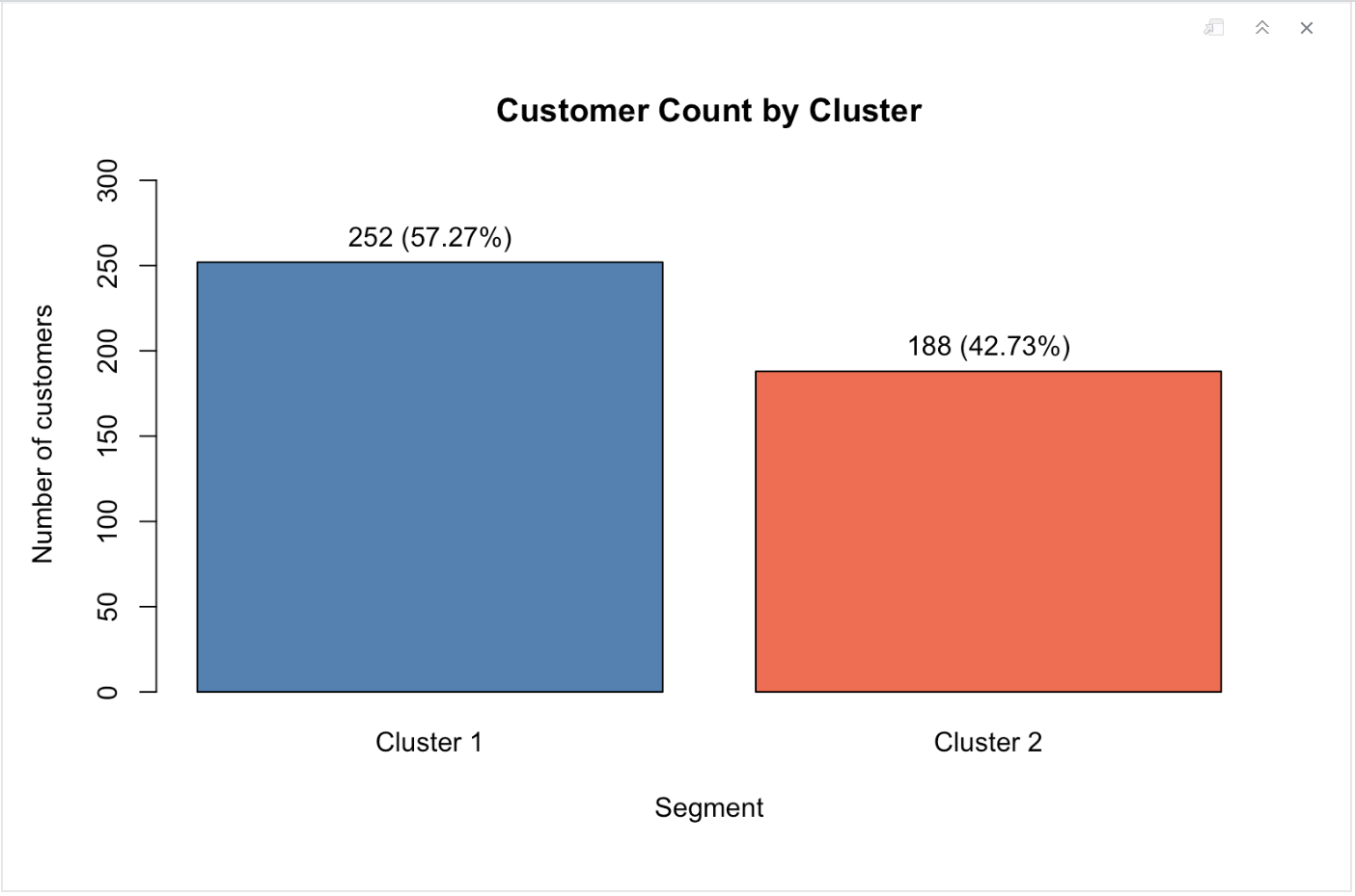
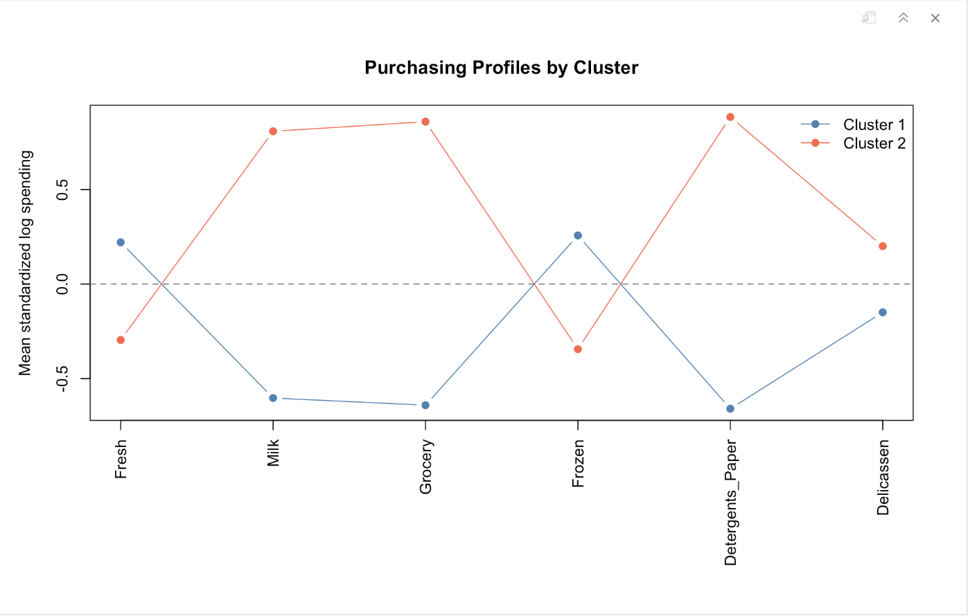

Part 7 - Marketing Interpretation and Recommendations
The following recommendations aim to increase customer spending and loyalty through strategies tailored to the two segments.
Recommendation | Segment Evidence | Proposed Action and Marketing Mix
1. Introduce a loyalty card | Cluster 2 includes 75 high-spending customers, while Cluster 1 includes 35. | Offer a loyalty card with rewards tailored to purchasing patterns: Fresh and Frozen benefits for Cluster 1, and Grocery, Milk, and Detergents_Paper benefits for Cluster 2. Reward thresholds could encourage additional purchases. Price and Promotion.
2. Send personalized email or SMS offers | Cluster 1 focuses on Fresh and Frozen; Cluster 2 focuses on Grocery, Milk, and Detergents_Paper. | With voluntary consent, send category-specific promotions and relevant complementary-product offers. These messages could increase revenue by encouraging additional purchases and making offers more relevant. Product and Promotion.
3. Test bundles and volume discounts | Cluster 2 has higher mean annual spending (44,883.68), and Grocery, Milk, and Detergents_Paper show positive spending associations in the full dataset. | Test combined offers involving these categories for Cluster 2 and Fresh and Frozen volume discounts for Cluster 1. Set discounts that protect margins. Product and Price.
4. Offer delivery benefits above a purchase threshold | Mean annual spending differs between Cluster 1 (24,529.24) and Cluster 2 (44,883.68). | Test free delivery for loyalty members whose orders exceed a minimum value. This could encourage larger orders, but thresholds should be based on order values, delivery costs, and margins, which are unavailable in this dataset. Place and Price.

Part 8 - Responsible Use and a Proposal Pilot
A supermarket pilot could test a loyalty programme and personalized messages using the supermarket's own customer data. A checkout system or shopping application could support voluntary email registration and, where there is a clear purpose, a customer-reported age range. Age should not be inferred from appearance. Promotional communications should require explicit consent and offer an unsubscribe option. Only necessary data should be collected, access should be restricted, and identifiable information should be retained only as long as needed for its stated purpose.
A partnership with a financial startup could explore a card usable at other retailers while offering special discounts at the supermarket. This proposal requires a separate assessment of feasibility, costs, and credit conditions. Spending clusters should not determine credit approval or credit limits. Any sharing of identifiable customer information with the partner should be transparent and subject to appropriate authorization.
Segments describe average tendencies, not identical individuals. Customers within the same segment may have different needs, budgets, and preferences, and these may change over time. Marketers should therefore allow individual choices, update profiles when appropriate, respect privacy, and avoid using segment labels to exclude or pressure customers. The pilot should compare outcomes with a control group and evaluate incremental revenue, profit, repeat purchases, and customer feedback before expansion.

Conclusion
The analysis identified two customer segments: one focused on Fresh and Frozen, and another on Grocery, Milk, and Detergents_Paper. These profiles informed recommendations for targeted promotions, volume discounts, and personalized loyalty benefits. The hypotheses helped guide the analysis and connect the findings to the business questions. However, they were explored rather than formally tested. Further testing is needed to determine whether the proposed strategies increase customer spending and loyalty.

References
K-Means Clustering
An introduction to statistical learning.
James, G., Witten, D., Hastie, T., & Tibshirani, R. (2021) : With applications in R(2nd ed.). Springer. https://doi.org/10.1007/978-1-0716-1418-1

Data Source Wholesale Customers
https://archive.ics.uci.edu/dataset/292/wholesale+customers .

