Customer Churn Prediction Using Supervised Machine Learning
Take Home Group Assignment 1
Group 4
Fabio Augusto De Oliveira Dutra
Gumashtha Devangiri Pandukabhaya Punchi Wedikkarage Don
Jose Vidal Asencio Santos
Mehrthur Luís Lemos da Silva
The University of Niagara Falls Canada
November 5, 2026

1 Problem Definition
We compare baseline and tuned versions of Logistic Regression and Decision Tree using 19 predictors without ZIP Code. Optimized LR uses a fixed 0.60 cutoff. The other configurations use their default 0.50 rule. Training CV churn F1 selects optimized LR at 0.6512. Its reused-test F1 is 0.6277 and accuracy is 77.86%. These revised development results require independent validation.
The business objective is to prioritize customers for retention contact. A false negative misses a churner; a false positive may waste an offer. Financial costs are unknown, so we use churn F1 to balance precision and recall. Historical labels make supervised learning appropriate. The source is the IBM Telco dataset listed on Kaggle [1].
Project element | Definition
Target | Churn Value: 1 = churn; 0 = no churn
Original data | 7,043 customers; 33 columns
Final predictors | 19 fields, 3 numerical and 16 categorical
Customer profile | Gender, Senior Citizen, Partner, Dependents
Account and geography | Tenure Months, Contract
Services | Phone Service, Multiple Lines, Internet Service, Online Security, Online Backup, Device Protection, Tech Support, Streaming TV, Streaming Movies
Billing | Paperless Billing, Payment Method, Monthly Charges, Total Charges
Evaluation | 5,634 training and 1,409 test customers; five-fold stratified training CV

The intended use would score active customers before a retention decision. This retrospective file does not establish a future prediction horizon or the availability time of every input. These assumptions must be verified before deployment. Predictive associations do not establish that an offer prevents churn.

2 Exploratory Data Analysis
Training contains 4,139 non-churners (73.46%) and 1,495 churners (26.54%). Always predicting no churn would yield 73.46% training accuracy but zero churn recall. The imbalance makes accuracy alone insufficient.
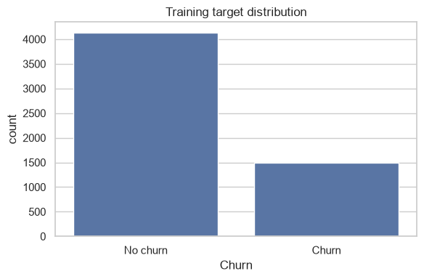
Figure 1 Training class distribution
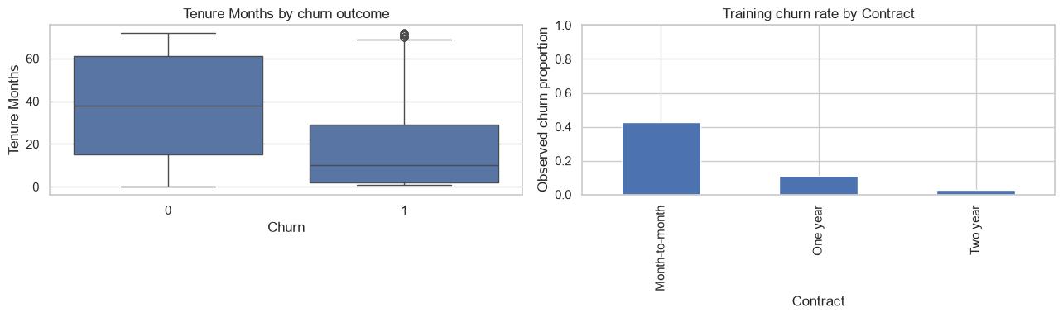
Figure 2 Tenure by churn and churn rate by contract
Churners have median tenure of 10 months, compared with 38 for non-churners. Month-to-month customers have 42.75% churn (3,102 observations), versus 11.08% for one-year contracts (1,173) and 2.87% for two-year contracts (1,359). These associations suggest tenure and contract may be useful predictors; they do not demonstrate causation.

3 Data Quality and Numerical Relationships
Training variable | Mean | Median | Range | Churn correlation
Tenure Months | 32.49 | 29.00 | 0–72 | −0.3456
Monthly Charges | 64.93 | 70.50 | 18.40–118.75 | 0.1980
Total Charges | 2,302.60 | 1,398.13 | 18.85–8,684.80 | −0.1948

Monthly charges are higher among churners: median 79.95 versus 64.40 for non-churners. Total charges are lower: 740.30 versus 1,691.90, consistent with shorter tenure. Correlations are modest and do not isolate causal effects.
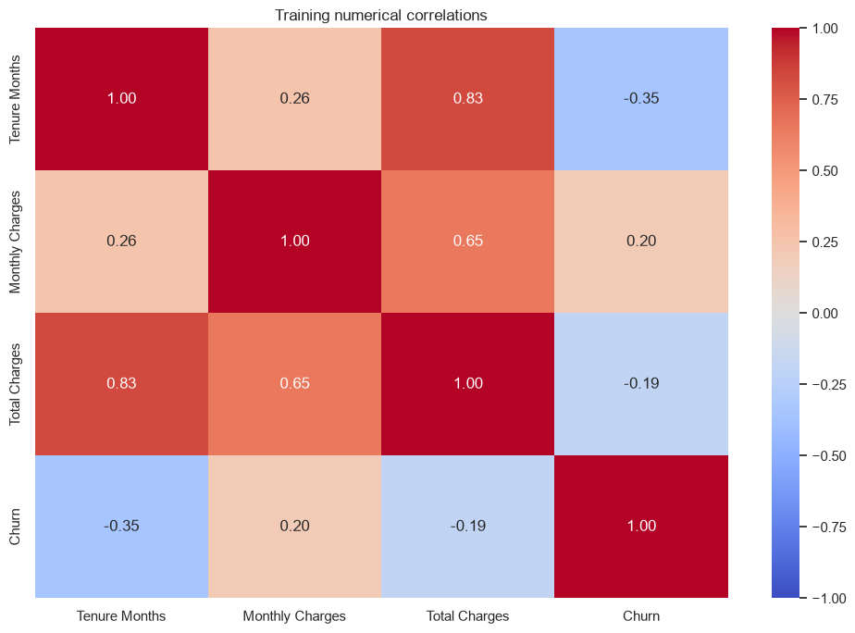
Figure 3 Numerical correlations using training data
Total Charges contains 11 blanks in the full file, including 8 in training. All 11 customers have zero tenure, suggesting charges may not yet have accumulated; the file does not confirm this explanation. No exact duplicates were found. No numerical training values fall outside their 1.5-IQR fences. High total charges are retained: skew alone does not make them errors.

4 Data Preprocessing
All models use the same stratified 80/20 split with random_state=42 and 19 raw inputs. Imputation, encoding and scaling are fitted inside each training fold using Pipeline and ColumnTransformer [2]. ZIP Code is excluded after near-zero importance in the earlier diagnostic. A controlled LR comparison in Appendix C tests that simplification at fixed hyperparameters.
Decision | Implementation and justification
Missing values | Training-fold median for numbers; most-frequent category for categories. Retains customers without learning statistics from test data.
ZIP Code | Exclude after low incremental diagnostic importance. Compare both feature sets at fixed LR settings in Appendix C.
Other categories | One-hot encoding, ignoring unseen categories at inference. Avoids imposing artificial order.
Numeric scaling | StandardScaler for tenure and charges. Supports Logistic Regression and keeps preprocessing common; the tree does not require scaling.
Constant fields | Remove Country, State and Count because they do not vary.
Repeated geography | Remove City, Lat Long, Latitude, Longitude and ZIP Code.
Identifier and outcomes | Exclude CustomerID, Churn Label, Churn Score and Churn Reason. Use Churn Value only as the target.
CLTV | Exclude because its calculation and availability before churn were not confirmed. This is precautionary, not proof of leakage.
Duplicates and imbalance | No duplicate rows found. No resampling; balanced class weights are tested for Logistic Regression.

ZIP Code removal reduces encoded dimensionality and dependence on location identifiers. The controlled comparison shows a small performance effect, so removal is justified primarily by simplification. It does not establish that geography is generally irrelevant. All four classifiers use the same 19 inputs.

5 Model Development and Optimization
Logistic Regression gives a regularized linear reference with inspectable coefficients [3]. Decision Tree learns nonlinear rules but can overfit when unrestricted [4]. Each baseline is compared with a tuned version of the same algorithm.
Model | Settings | CV F1 mean | CV F1 SD
LR baseline | C=1; no class weights | 0.6206 | 0.0291
Tree baseline | Default unrestricted tree | 0.5033 | 0.0324
LR optimized | C=0.01; balanced weights; cutoff 0.60 | 0.6512 | 0.0211
Tree optimized | entropy; depth=5; leaf minimum=15; split minimum=2 | 0.6128 | 0.0290

GridSearchCV compares configurations using five shuffled stratified training folds and churn F1. Optimized LR scoring applies the fixed 0.60 cutoff within each validation fold. Baselines and the optimized tree use their default 0.50 rule. ROC-AUC uses probabilities. The 0.60 cutoff was requested after earlier training diagnostics and was fixed before this rerun.
The Logistic Regression grid has 8 candidates: C in {0.01, 0.1, 1, 10} and class_weight in {None, balanced}. Smaller C means stronger regularization. Balanced weighting increases the minority class contribution [3].
The tree grid has 48 candidates: depth in {3, 5, 8, None}, leaf minimum in {1, 5, 15}, split minimum in {2, 10}, and Gini or entropy. Depth and leaf size control complexity; the criterion measures impurity when choosing splits [4].
Optimized Logistic Regression has the best mean CV F1, so it is selected before the revised test comparison. Fold SD describes variation, not a confidence interval. Best grid scores can be optimistic because they also select the settings; these results do not establish statistical significance.

6 Model Evaluation and Comparison
Model | Train acc | Test acc | Precision | Recall | F1
LR baseline | 0.8140 | 0.8020 | 0.6435 | 0.5695 | 0.6043
Tree baseline | 0.9980 | 0.7438 | 0.5159 | 0.5642 | 0.5390
LR optimized | 0.7985 | 0.7786 | 0.5668 | 0.7032 | 0.6277
Tree optimized | 0.8032 | 0.7913 | 0.6081 | 0.6016 | 0.6048

Precision, recall and F1 refer to churn (class 1). Accuracy includes both classes. LR means Logistic Regression. All models are evaluated on the same observations; Appendix B gives per-class reports and averages.
Model | ROC AUC | Accuracy gap | Main finding
LR baseline | 0.8487 | 1.20 points | Highest test accuracy and ROC AUC
Tree baseline | 0.6873 | 25.43 points | Largest accuracy gap
LR optimized | 0.8470 | 2.00 points | Highest training CV and test F1
Tree optimized | 0.8354 | 1.18 points | Smallest accuracy gap

LR test F1 changes from 0.6043 to 0.6277. Tree F1 changes from 0.5390 to 0.6048. Optimized LR has precision 56.68% and recall 70.32%. This revision changes both the input set and the LR decision policy, so Appendix C separates their effects with frozen LR settings.
The baseline tree has training accuracy 99.80% and test accuracy 74.38%. The large gap indicates overfitting. Optimized tree accuracy is 80.32% in training and 79.13% in testing. Optimized LR has the highest training CV F1 among the four defined configurations.

7 Confusion Matrices and Error Costs
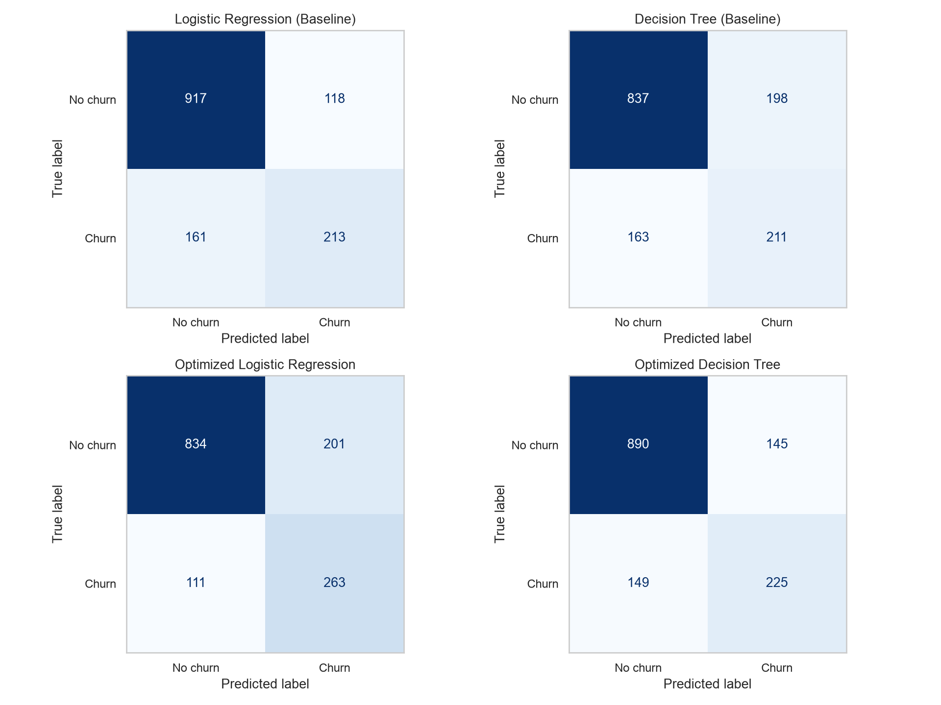
Figure 4 Confusion matrices on the common test set

Model | TP | FN | FP | TN
LR baseline | 213 | 161 | 118 | 917
Tree baseline | 211 | 163 | 198 | 837
LR optimized | 263 | 111 | 201 | 834
Tree optimized | 225 | 149 | 145 | 890

TP = detected churners; FN = missed churners; FP = incorrect churn alerts; TN = correct non-churners. The test set has 374 churners and 1,035 non-churners.
Optimized LR detects 263 churners, misses 111, and produces 201 false alerts. It detects 38 more churners than the optimized tree with 56 more false alerts. It flags 464 customers. The prior ZIP-based LR at cutoff 0.50 flagged 553, detected 286 and produced 267 false alerts.

8 ROC Curves and Model Interpretation
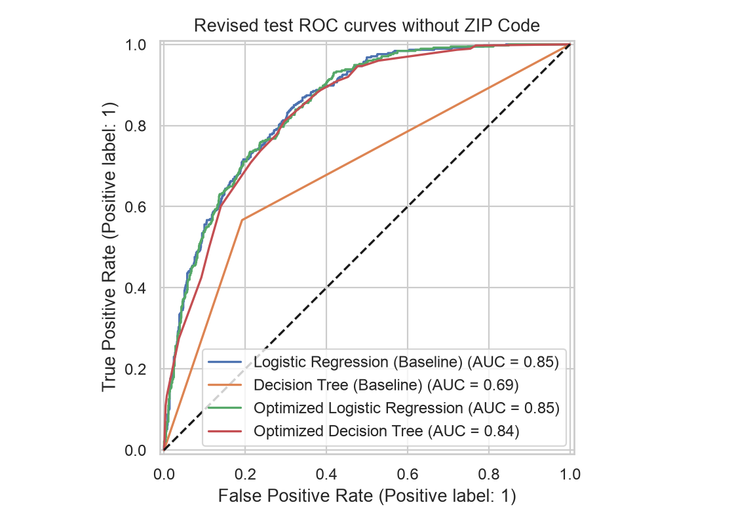
Figure 5 ROC curves on the revised test set

Baseline LR has ROC-AUC 0.8487, optimized LR 0.8470, and optimized tree 0.8354. ROC-AUC assesses probability ranking across cutoffs. The recommendation follows training CV F1 and the specified decision policies.
Model output | Value | Meaning in the fitted model
LR tenure coefficient | -0.6146 | Longer tenure lowers the churn score
LR month-to-month coefficient | 0.4957 | Month-to-month raises the churn score
Tree contract importance | 0.5014 | Largest impurity importance
Tree tenure importance | 0.1286 | Second-largest importance
Tree fiber-optic importance | 0.1155 | Third-largest importance

Numeric coefficients describe log-odds changes per training standard deviation, holding other inputs fixed. All one-hot levels are retained, so category comparisons use coefficient differences. The month-to-month versus two-year odds ratio is 2.3784. Coefficients and tree importance describe fitted associations. Appendix D adds permutation attribution.

9 Discussion and Conclusion
We recommend optimized LR without ZIP Code, with C=0.01, balanced class weights and cutoff 0.60, for independent validation. Its mean training CV F1 is 0.6512. Reused-test F1 is 0.6277, accuracy 77.86%, precision 56.68% and recall 70.32%. The previous ZIP-based model at cutoff 0.50 had F1 0.6170 and accuracy 74.80%.
The optimized tree has precision 60.81% and F1 0.6048. Optimized LR minus tree has a paired conditional 95% F1 interval of -0.0050 to 0.0512. It includes zero, so the observed advantage does not establish superiority. Cutoff changes trade missed churners against false alerts. Appendix C reports controlled comparisons and costs.
Limitations include class imbalance, California-only customers, unknown error costs and an unverified prediction horizon. All geographic fields, CLTV and outcome-related fields are excluded. The same test split was inspected in earlier development. ZIP removal and the cutoff follow earlier diagnostics, so the revised comparison remains exploratory and needs independent later customers.
Training out-of-fold mean predicted churn is 41.62% for weighted LR and 26.47% for the tree, against 26.54% observed. Appendix D reports calibration and threshold sensitivity. Scores need validation before interpretation as risks. Measure contact costs and intervention effectiveness before a retention pilot.
The notebook, report and API now use 19 inputs. The exported classifier embeds its selected cutoff so API predictions match the evaluation. Dependencies record the integrated environment. C=0.01 is selected by training CV in the final search, while the controlled comparison fixes C=0.1 to isolate the two requested changes. Reused-test scores do not determine either choice.

References
[1] Yeanzc. (n.d.). Telco customer churn: IBM dataset. Kaggle. https://www.kaggle.com/datasets/yeanzc/telco-customer-churn-ibm-dataset
[2] scikit-learn developers. (n.d.). Common pitfalls and recommended practices. https://scikit-learn.org/stable/common_pitfalls.html
[3] scikit-learn developers. (n.d.). LogisticRegression. https://scikit-learn.org/stable/modules/generated/sklearn.linear_model.LogisticRegression.html
[4] scikit-learn developers. (n.d.). DecisionTreeClassifier. https://scikit-learn.org/stable/modules/generated/sklearn.tree.DecisionTreeClassifier.html
[5] scikit-learn developers. (n.d.). GridSearchCV. https://scikit-learn.org/stable/modules/generated/sklearn.model_selection.GridSearchCV.html
References were accessed November 5, 2026. Report metrics and figures use the November 8 notebook execution with Python 3.14.8 and scikit-learn 1.9.1. Course Modules 2–5 supplied the teaching workflow.

Appendix A Optimized Decision Tree
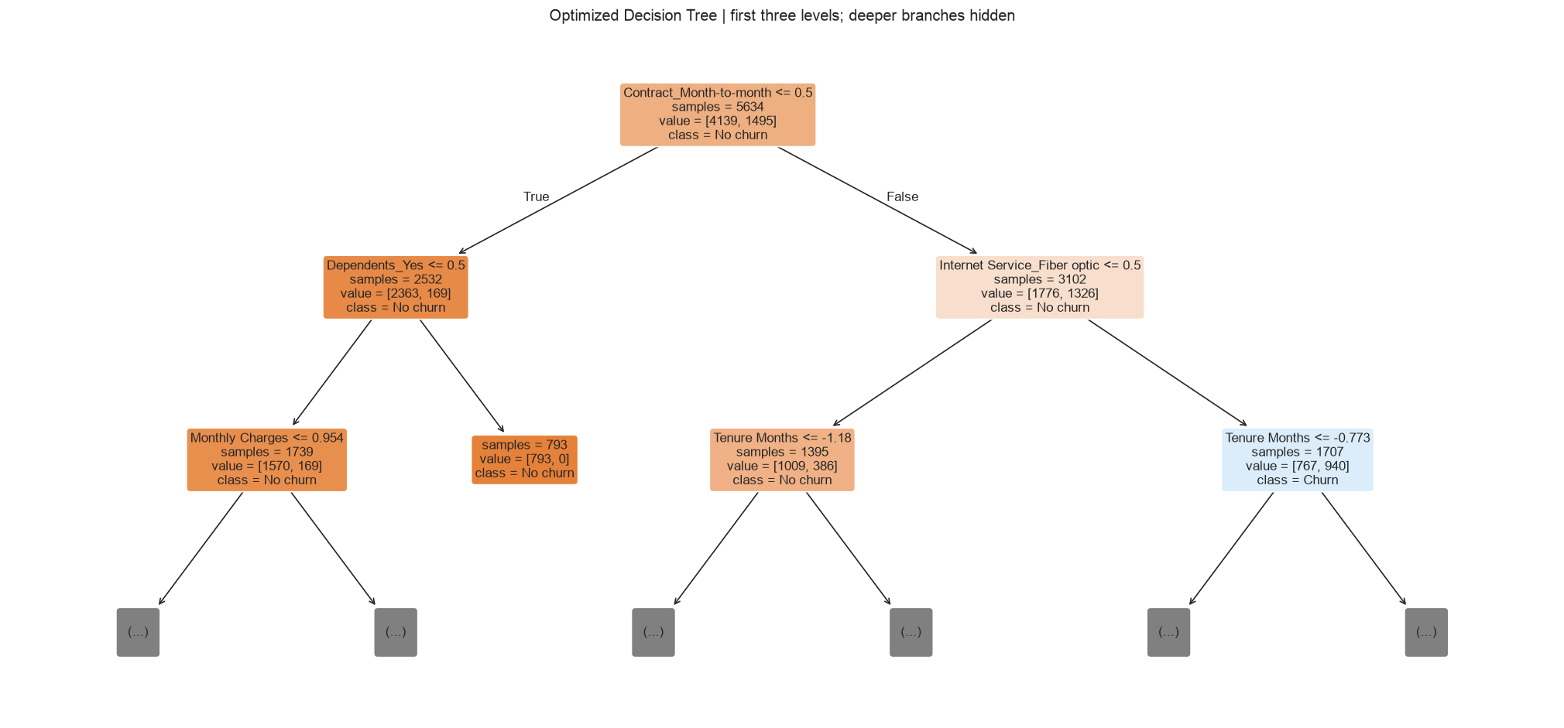
Figure 6 First three levels of the optimized Decision Tree
The first rule separates month-to-month contracts from other contracts. Later rules use dependents, internet service, tenure and charges. Orange means No churn and blue means Churn. Numerical thresholds use standardized units. The displayed three levels hide deeper branches of the depth-five tree.

Appendix B Classification Reports
Per-class metrics and macro and weighted averages use the same 1,409 test customers. Churn support is 374; No churn support is 1,035. Accuracy for each model is reported in Section 6.
Model | Class or average | Precision | Recall | F1 | Support
LR baseline | No churn | 0.8506 | 0.8860 | 0.8680 | 1035
LR baseline | Churn | 0.6435 | 0.5695 | 0.6043 | 374
LR baseline | macro avg | 0.7471 | 0.7278 | 0.7361 | 1409
LR baseline | weighted avg | 0.7957 | 0.8020 | 0.7980 | 1409
Tree baseline | No churn | 0.8370 | 0.8087 | 0.8226 | 1035
Tree baseline | Churn | 0.5159 | 0.5642 | 0.5390 | 374
Tree baseline | macro avg | 0.6764 | 0.6864 | 0.6808 | 1409
Tree baseline | weighted avg | 0.7518 | 0.7438 | 0.7473 | 1409
LR optimized | No churn | 0.8825 | 0.8058 | 0.8424 | 1035
LR optimized | Churn | 0.5668 | 0.7032 | 0.6277 | 374
LR optimized | macro avg | 0.7247 | 0.7545 | 0.7351 | 1409
LR optimized | weighted avg | 0.7987 | 0.7786 | 0.7854 | 1409
Tree optimized | No churn | 0.8566 | 0.8599 | 0.8582 | 1035
Tree optimized | Churn | 0.6081 | 0.6016 | 0.6048 | 374
Tree optimized | macro avg | 0.7324 | 0.7308 | 0.7315 | 1409
Tree optimized | weighted avg | 0.7906 | 0.7913 | 0.7910 | 1409

Macro averages give both classes equal weight. Weighted averages use the number of observations in each class, so the more common No churn class has more influence. Churn-specific F1 remains the predeclared model-selection metric.

Appendix C Controlled Changes and Uncertainty
This comparison holds LR at C=0.1 with balanced weights, identical customers and folds. It separates the cutoff from ZIP removal. The final search selects C=0.01 using training CV with the fixed 0.60 cutoff.
ZIP | Cutoff | Train OOF F1 | Test accuracy | Test F1
Yes | 0.50 | 0.6431 | 74.80% | 0.6170
Yes | 0.60 | 0.6489 | 78.00% | 0.6327
No | 0.50 | 0.6427 | 74.45% | 0.6162
No | 0.60 | 0.6510 | 77.93% | 0.6337
At fixed settings, raising the cutoff improves precision and reduces contact volume while lowering recall. Removing ZIP has a small effect. The combined fixed-settings test F1 is 0.6337. The final CV-selected model has F1 0.6277. The latter is retained because configuration selection uses training CV, rather than the larger reused-test score.
Paired class-stratified bootstrap uses 2,000 resamples of the same fixed predictions, retaining observed class counts. Intervals condition on these fitted models and exclude retraining and selection uncertainty.
Model | Test F1 | 95% lower | 95% upper
LR baseline | 0.6043 | 0.5619 | 0.6442
Tree baseline | 0.5390 | 0.5000 | 0.5769
LR optimized | 0.6277 | 0.5941 | 0.6604
Tree optimized | 0.6048 | 0.5645 | 0.6434
The LR-minus-tree interval includes zero. Test reuse remains a limitation. Simplified error costs below assign false alerts one unit and missed churners the ratio shown.
Missed churn / alert | LR base | Tree base | LR opt | Tree opt
1 | 279 | 361 | 312 | 294
2 | 440 | 524 | 423 | 443
5 | 923 | 1013 | 756 | 890
10 | 1728 | 1828 | 1311 | 1635
Cost equals FN times missed-churn cost plus FP times false-alert cost. It omits true-positive contact costs, intervention effectiveness, customer value and capacity. It is a sensitivity exercise.

Appendix D Probability and Interpretation Diagnostics
Out-of-fold probabilities fit each fold separately. Hyperparameters were selected using the same training set, so these diagnostics follow selection and require independent confirmation.
Model | Brier loss | Mean score | Observed churn
LR optimized | 0.1586 | 41.62% | 26.54%
Tree optimized | 0.1365 | 26.47% | 26.54%
The constant-prevalence Brier reference is 0.1949. Lower Brier loss means lower squared probability error. Balanced weighting changes the LR objective, so its scores need calibration assessment.
Model | Cutoff | Precision | Recall | F1 | Flagged
LR optimized | 0.30 | 0.4284 | 0.9298 | 0.5865 | 57.60%
LR optimized | 0.50 | 0.5330 | 0.7940 | 0.6378 | 39.53%
LR optimized | 0.60 | 0.5964 | 0.7177 | 0.6515 | 31.93%
Tree optimized | 0.30 | 0.5285 | 0.7940 | 0.6346 | 39.87%
Tree optimized | 0.50 | 0.6114 | 0.6167 | 0.6141 | 26.77%
Tree optimized | 0.60 | 0.7335 | 0.2742 | 0.3992 | 9.92%
The reported test and exported model use cutoff 0.60 for optimized LR and 0.50 for the other configurations. Threshold sensitivity describes training predictions and does not supply a new independent evaluation.
Diagnostic model | Input | Mean F1 decrease
LR optimized | Tenure Months | 0.0962
LR optimized | Contract | 0.0373
LR optimized | Dependents | 0.0356
Tree optimized | Contract | 0.1831
Tree optimized | Online Security | 0.1506
Tree optimized | Dependents | 0.0788
Permutation diagnostics refit on three quarters of training and shuffle raw fields on the other quarter, with eight repetitions. LR attribution uses F1 at 0.60, matching its policy. The full-training hyperparameter choice limits independence. Rankings depend on correlated inputs and fitting samples. They describe predictive reliance without establishing causes.

