Making a public repo
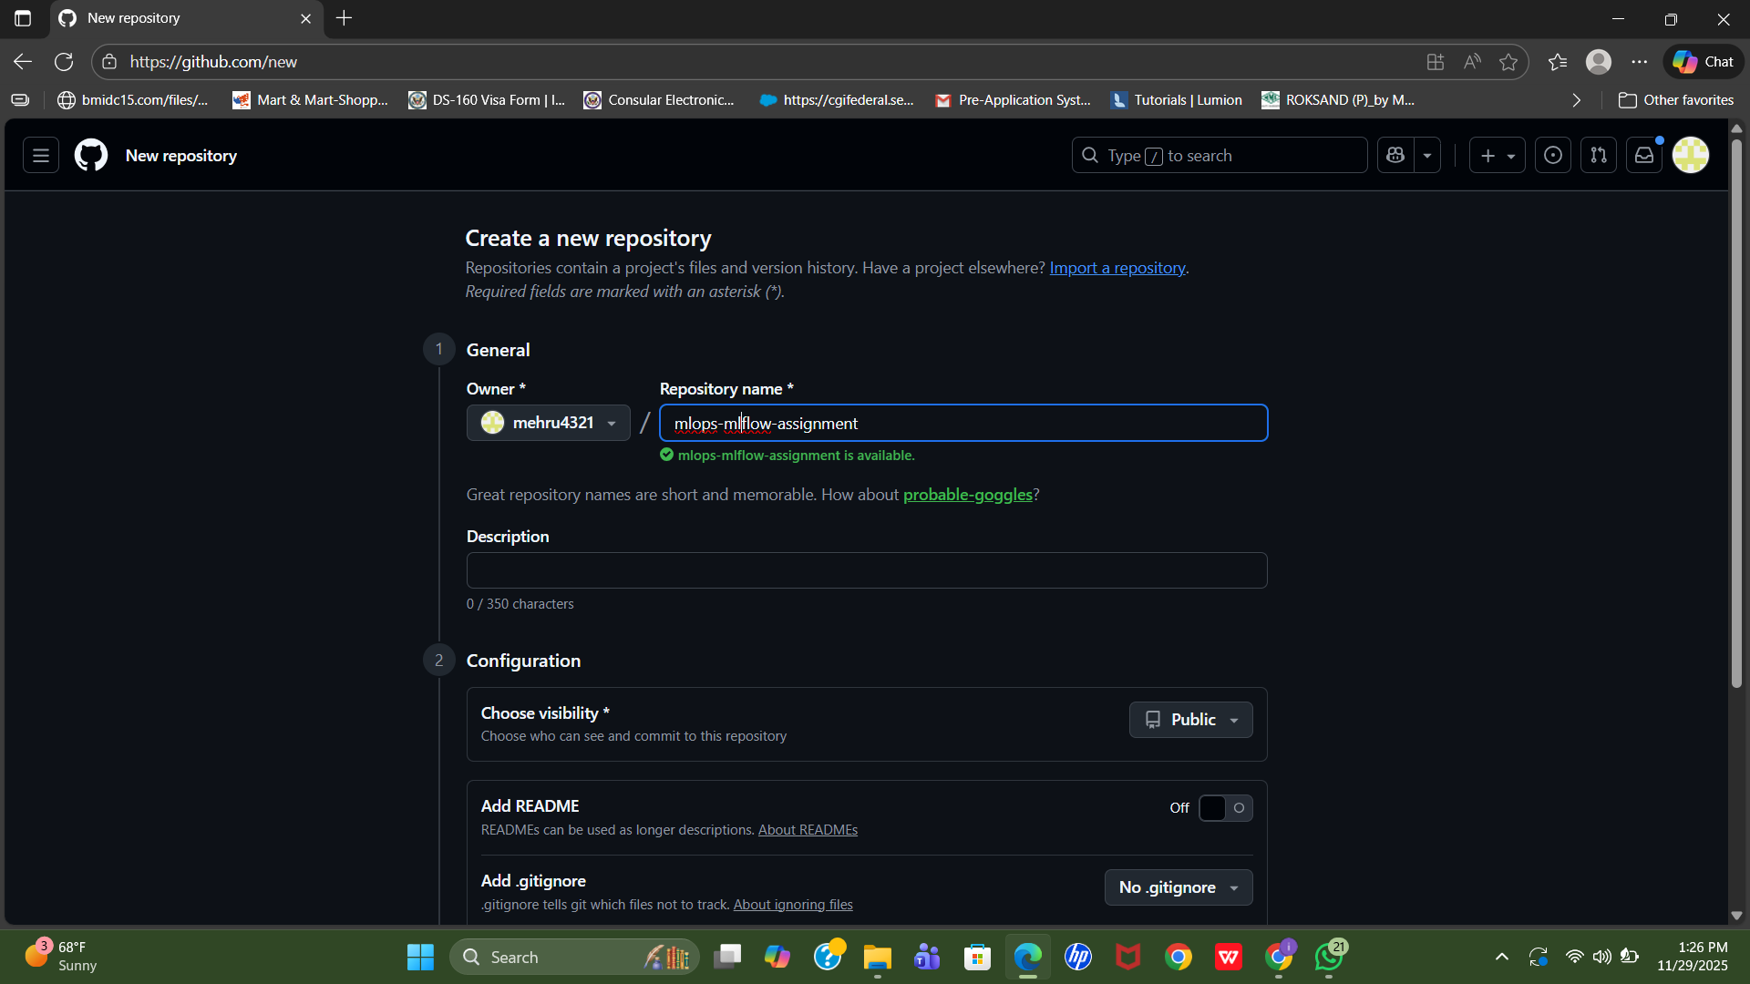

Contents of my requirement.txt and GitHub repository file structure showing all created files and folders.
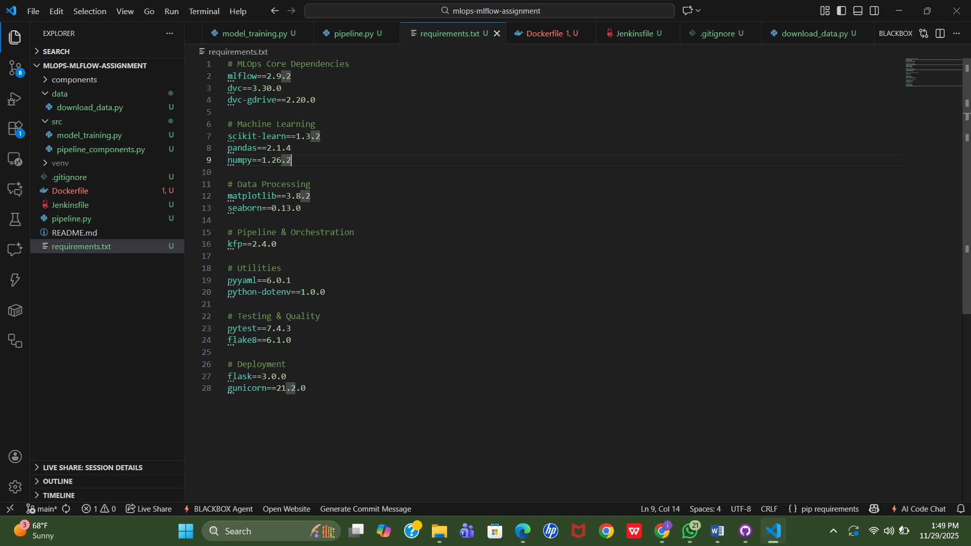

Download data as data/raw_data.csv
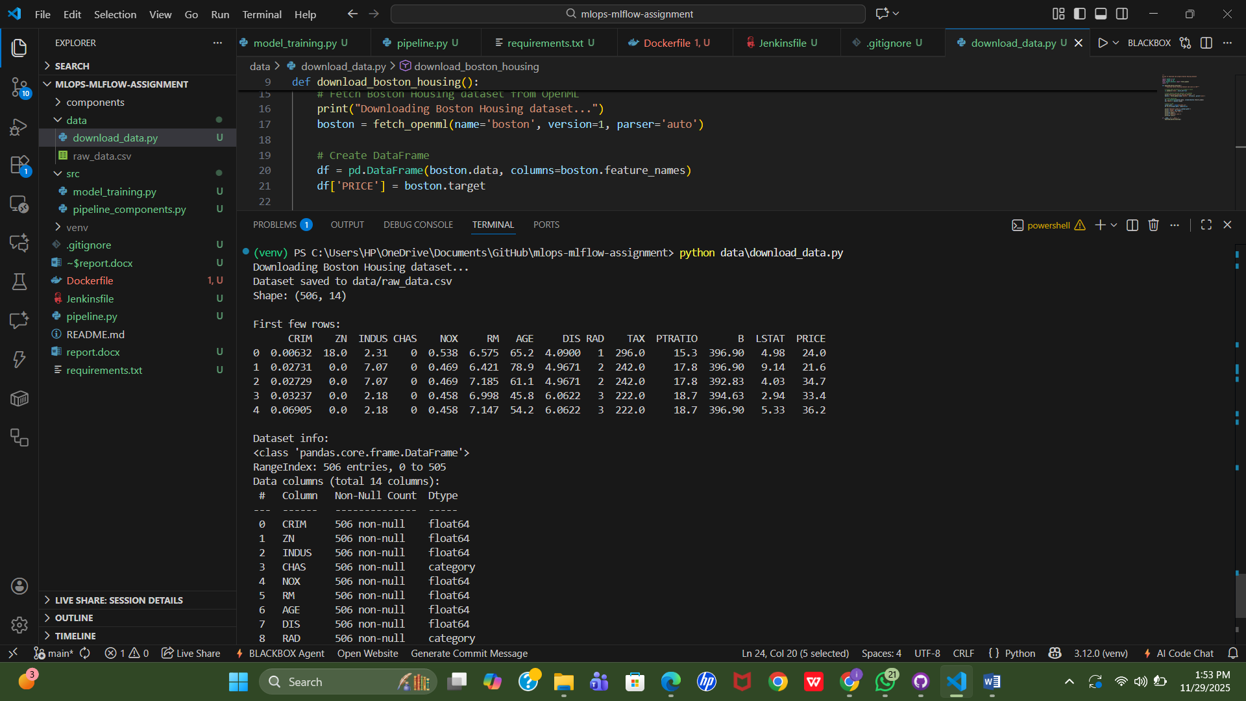

MLOps MLflow Assignment
This repository contains a complete Machine Learning Operations (MLOps) pipeline for housing price prediction.

Project Structure
mlops-mlflow-assignment/
├── data/
│ ├── raw/ # Raw data files (tracked by DVC)
│ └── processed/ # Processed data files
├── src/
│ ├── pipeline_components.py # MLflow component definitions
│ └── model_training.py # Standalone training script
├── components/ # Compiled MLflow components
├── models/ # Saved models
├── pipeline.py # Main MLflow pipeline definition
├── requirements.txt # Project dependencies
├── Dockerfile # Docker image definition
├── Jenkinsfile # Jenkins CI/CD pipeline
├── download_data.py # Script to download dataset
└── README.md # This file

Setup Instructions

1. Clone the Repository
git clone https://github.com/YOUR_USERNAME/mlops-mlflow-assignment.git
cd mlops-mlflow-assignment

2. Create Python Virtual Environment
python3 -m venv venv
source venv/bin/activate # On Windows: venv\Scripts\activate

3. Install Dependencies
pip install -r requirements.txt

4. Download Dataset
python download_data.py

5. Initialize DVC
# Initialize DVC
dvc init

# Create DVC remote storage directory
mkdir -p ../dvc-storage

# Add remote storage
dvc remote add -d local ../dvc-storage

# Commit DVC configuration
git add .dvc .dvcignore
git commit -m "Initialize DVC"

6. Track Data with DVC
# Add data to DVC tracking
dvc add data/raw/raw_data.csv

# Commit the DVC file
git add data/raw/raw_data.csv.dvc data/raw/.gitignore
git commit -m "Track dataset with DVC"

# Push data to DVC remote
dvc push

7. Verify DVC Setup
# Check DVC status
dvc status

# List DVC remotes
dvc remote list

Usage

Train Model (Standalone)
python src/model_training.py

Run MLflow Pipeline
python pipeline.py

Pull Data from DVC Remote
dvc pull

Build Docker Image
docker build -t mlops-housing-model:latest .

Run Docker Container
docker run mlops-housing-model:latest

Task 1 Deliverables

Deliverable 1: Repository Structure
- ✅ All required files and folders created
- ✅ Proper directory structure implemented

Deliverable 2: DVC Commands
- ✅ dvc status - Shows data tracking status
- ✅ dvc push - Pushes data to remote storage

Deliverable 3: Requirements File
- ✅ Contains all essential libraries:
  - kfp (Kubeflow Pipelines)
  - dvc (Data Version Control)
  - scikit-learn (Machine Learning)
  - pandas (Data Processing)
  - mlflow (Experiment Tracking)

Key Commands Reference
# DVC Commands
dvc status # Check data status
dvc push # Push data to remote
dvc pull # Pull data from remote
dvc add <file> # Track file with DVC
dvc remote list # List configured remotes

# Git Commands
git status # Check git status
git add . # Stage all changes
git commit -m "msg" # Commit changes
git push # Push to GitHub

# Python Commands
pip install -r requirements.txt # Install dependencies
python src/model_training.py # Train model
pytest tests/ # Run tests

Dataset Information
Dataset: California Housing Dataset (alternative to Boston Housing)
- Features: 8 numerical features including median income, house age, average rooms, etc.
- Target: Median house value
- Samples: 20,640 samples
- Source: sklearn.datasets

Technologies Used
- Python 3.9: Programming language
- DVC: Data version control
- MLflow: Experiment tracking and pipelines
- Kubeflow Pipelines (KFP): Pipeline orchestration
- Scikit-learn: Machine learning
- Docker: Containerization
- Jenkins: CI/CD automation
- Git/GitHub: Version control

Next Steps
- Complete Task 2: Pipeline orchestration with Kubeflow
- Complete Task 3: Model deployment with Kubernetes
- Complete Task 4: CI/CD with Jenkins/GitHub Actions
- Complete Task 5: Monitoring and logging

License
This project is created for educational purposes as part of an MLOps assignment.

