

**Tunnel Lighting Controller**

**System Requirements**

Document Number: 1975-TLC-SYS

Revision: 5.0

Date: January 15th 2015

Approved by:

__________ ________ __________

Jane Wilson Bill Cody Shawn Riley

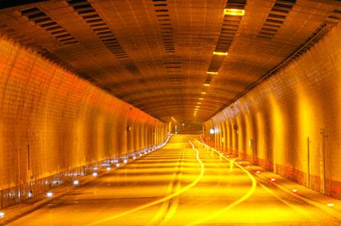

# Version History

|  |  |  |
| --- | --- | --- |
| **Version** | **Revised by** | **Description** |
| 1.0 | Jane Wilson | Original |
| 2.0 | Jane Wilson | Correction of typo errors |
| 3.0 | Jane Wilson | Addition of lamp siren & sign handling |
| 4.2 | Jane Wilson | Significant updates made for functional safety compliance |
| 5.0 | Jane Wilson | Changes made for updated requirement volume |

# Introduction

* 1. **Purpose**

The purpose of this document is to provide a complete description of system level requirements for a tunnel lighting system. As defined in BS5489-2:2003, the levels of the lighting inside a road tunnel needs to be varied depending on the brightness of the prevailing conditions on entry to and exit from that tunnel, to ensure that drives have good visibility into the tunnel as far as their safe stopping distance.

* 1. **Scope**

**The scope of this document is intended to be at the system level to describe the expected behaviour, physical components, constraints, and performance parameters of the Tunnel Lighting System and the aggregate of its components *(see figure 1 below).***

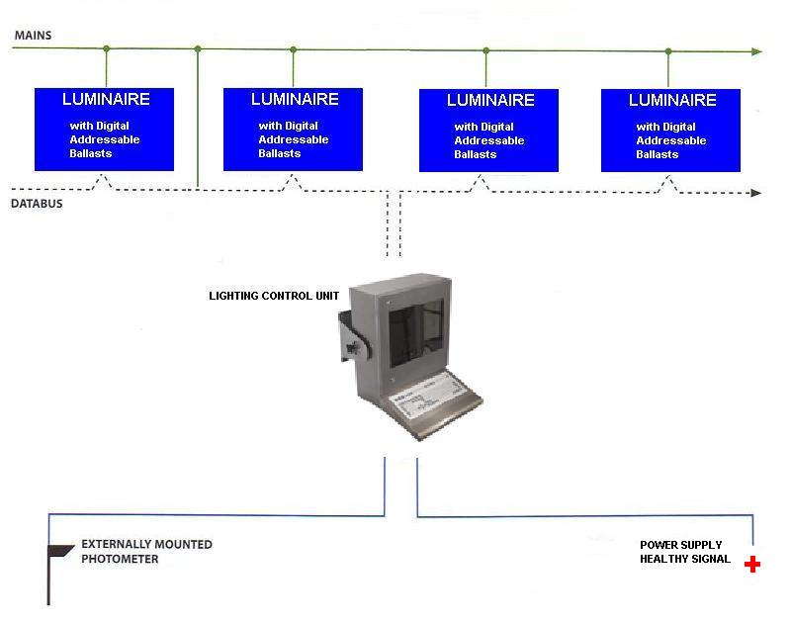

Figure 1

# Referenced Documents

1. IP66 specifications

# Requirements – Power Healthy

## Human Machine Interface and Configuration

SYS_0010: Display

The Tunnel Lighting system shall provide a human machine interface for emulation of input and examination of output data

SYS_0020: Initialisation and configuration

The Tunnel Lighting system shall be configurable via an external file and take into account tunnel dimensions, zones, spacing for signs, and efficiency factor

## Output Calculation

SYS_0030: Output Calculation

The Tunnel Lighting system shall manage output calculation in tiers so that lamps, cells, zones, and the tunnel can be controlled with the necessary granularity

## Photometer specification

SYS_0040: Photometer

The Tunnel lighting system shall include a single photometer placed at the entrance of the tunnel. The photometer will measure light intensity and provide this data to the lighting control unit. Typically, such a meter will employ a light receptor filtered to provide a spectral response close to that of the average human eye. Its reaction to changes in light levels is virtually instantaneous. The light receptor is used to measure average luminance (brightness) within an acceptance angle subtending 20º over a measurement range of 0-6500 cd/m2.

## Cleanliness factor reset

SYS_0050: Cleanliness factor

The Tunnel lighting system shall measure efficiency of lamps based on the number of days since cleaning the lamps

## Tunnel lighting system controller unit and inputs

SYS_0060: Lighting control unit

The Tunnel lighting system shall be controlled by a lighting control unit that will receive inputs from a power supply heath signal and an externally mounted photometer

## Luminary specifications

SYS_0070: Luminaries

Luminaires shall be industrial units sealed to comply with IP66 specifications. Version 3.0 of the system includes provision for siren & sign handling

SYS_0080: Sirens and Signs

The Tunnel lighting system shall include facilities for the handling of emergency exit signs and sirens. These should include provision to allow the basic configuration of the system itself, in particular:

1. the number of lamps which can be positioned in a particular ceiling section, and

2. the current drain placed on emergency battery provision by each model of lamp, and by the system as a whole

## Nominal and failure power conditions

SYS_0090: Failed Power Supply

Where there is a failure of the regular power supply to the lamps, a battery backup supply will be used. In order to conserve the batteries for as long as possible, the smallest lamp available in each luminaire will be utilised at the same low level

SYS_0100: Lighting Adjustment

Lighting shall be adjusted given photometer inputs and power failure conditions

## Lamp output

SYS_0110: Lamp output units

The output from each lamp shall specified via a Digital Addressable Ballast (DAB) unit

SYS_0120: Lamp sizes

A combination of different lamp sizes shall be utilised in each luminaire to allow efficiency to be optimized by the Lighting control unit

SYS_0130: Required luminance at ground level

The luminance provided at ground level shall be calculated based on the interior surface of the tunnel, the width of the tunnel, the efficiency of the luminaires, and the cleanliness of the lenses and the tunnel walls