**Project Title: ITSC Management**

**Group Name: SE Friends**

**Group Members:**

| Muhammad Jamshed | BSCS -2019-21 |
| --- | --- |
| Inayaitullah | BSCS -2019- |
| Bakhtullah | BSCS -2019- |
| Sania bibi | BSCS -2019-67 |
| Qais sikander | BSCS -2019- |

**Software Requirements Specification**

**Introduction:**

* **vision :**

Basically this document contains full details of ITSC. As we all know that the ITSC department plays a very important role in all universities as it manages and facilitates all the students as well as faculty members so it is very important. We are going to design a project in which we can facilitate the students according to their requirements. Here our main objective is to maintain the record of all the things which ITSC can provide.

* **Purpose/goals:**

The purpose of the software is the detailed description of the ITSC software. It will explain the purpose and features of the system, the interfaces of the system, what the system will do, the constraints under which it must operate and how the system will react to external stimuli. This document is intended for both the stakeholders and the developers of the system and will be proposed to the Namal University for its approval.

* **Scope:**

The main objective of our project is to facilitate the people of university so that they can use the standard technologies for their purpose easily. As ITSC stands for information technology steering committee so it is a group or a team who manage this whole system. As university students have different issues regarding software and other such as sometimes the LMS of the students is not working properly so in this situation the ITSC or a guiding team will help them. Hence all these things are under the control of ITSC. they will decide that decision should be made at the current situation. The ITSC shall meet on a monthly basis and the committee shall develop a scope of governance and clearly communicate it to the university community.The ITSC shall form subcommittees sufficient to thoughtfully and thoroughly review the work within the scope of governance.

**Executive summary:**

According to the requirements we have to design a user interface which contain different pages for users so that they can login to the website if they are already sign up and if they are new customer then they have to first sign up to the form in which we ask different detail of the user such as user name and user password will on login page and name password mail and contact number will be on sign up page. We have to design our form more properly so that it may look effective and understandable by users. So we are using HTML to design our pages .

Then we have to design the context diagram , container diagram and component diagram in which we have explain the big picture of the project like user accessing the ITSC product by using HTTP protocol and then the ITSC management send the email to the user using SMTP protocol and it has also contain the mainframe of the system software ITSC materials.

**Objective:**

The main objective of ITSC is to understand the Software Requirement Specification. With the help of ITSC software the ITSC members help the people with in particular the institute, they may be students, teachers and the principal of the institution. The problem may be in the LMS, Email and other accounts of the people in the institute.

**Theory:**

SRS document contains a software developer understanding a customer requirement of a software. This document ensures that the developer and the customer are in agreement with each other as a feature required in software being built. SRS is created after the entail requirements in which the developer interacts with the customer to understand the software need.

An SRS document should be written in very clear and simple language so that it can be reviewed or understood by the customer with minimal understanding and expertise. However it contains use case diagrams, entity relationship diagrams , data dictionaries etc. which can be used for detailed design and development. and it is the most important piece of software development which acts as the bridge between the customer and developer.

**Functional requirement specifications:**

This section outlines the use cases for each of the active readers separately. The reader, the author and the reviewer have only one use case apiece while the editor is the main actor in this system.

**Use cases.**

**Case1.**

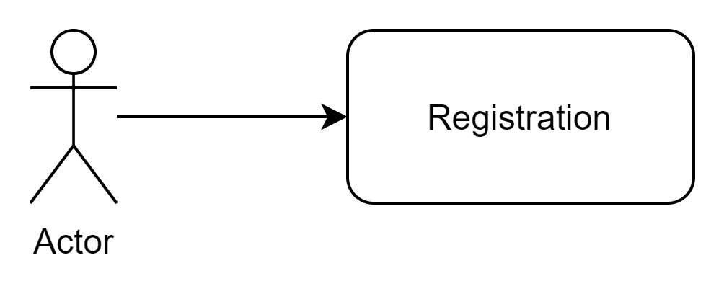

* **Brief Descriptions;**

Users can register here.

* **Initial step by step description;**

1. Users can visit the website.
2. Users can open it through the link.
3. Users can register him/her here.
4. After this registration completed

**Case2.**

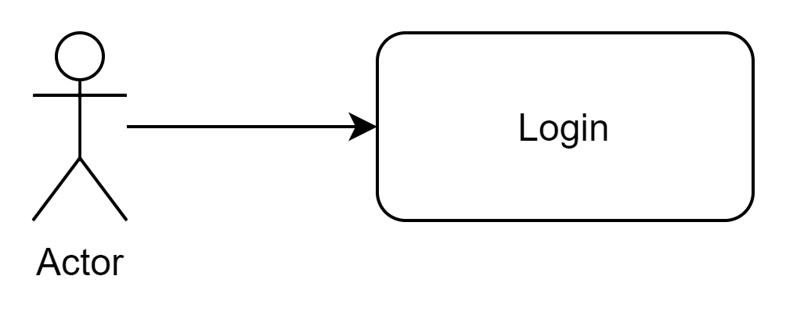

* **Brief description:**

Users can login here.

* **Initial step by step description:**

1. Users can login here with provided information like username and password.
2. If they forget their password they can change it.

**Case3.**

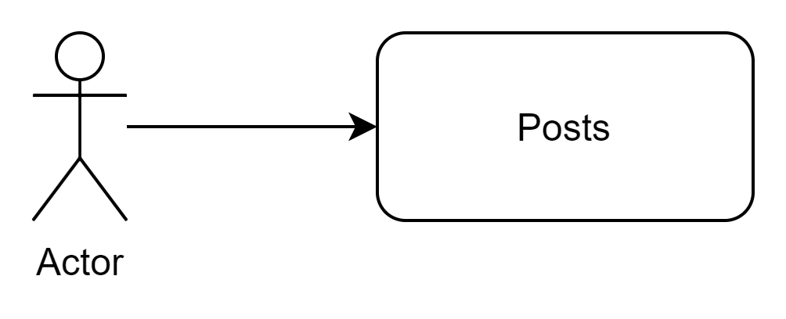

* **Brief description:**

Users can post here.

* **Initial step by step description:**

1. First users can register themselves.
2. They can login here.
3. They can post according to their issues provided in the categories.

**Description:**

First there will be a registration page for the users and also for the Login. After registration there will be the login page to proceed. After login there will be the option for the posts and

.

**Non-Functional Requirements**

The software developed here assumes the use of a tool for ITSC management such as connection between the students, faculty and staff to manage their issues and provide internet facility through their desires. Here the speed of software depends on the system hardware used. Also for the software efficiency we need flask version 0.11, python 3.9 , Mysql 5.7. This software will contain an access to the database where it will store the records of everything issued by itsc or having any complaint issues raised by the student or faculty.

**Constraints:**

The limitations and restrictions while composing the SRS document for this project are as follows. We are bound to design the login page in which we will have two buttons and two labels for signup,login and the username , password and then we redirect the login page to the signup in which we have first name, last name, email address and phone number. We also use the database at the backend for storing the user related information and also creating the post.These are the limitations and requirements for which we have to establish in our project by the sacrum master provided to us.

**Complaint system:**

There is a complaint system that will show the handler of the ITSC. This will help us to show all the complaints that are submitted in the ITSC.

**Administrator Login:**

There will be a login system for the Administrator that will show all the details and has authority to delete add data in the system.

**Context Diagram**

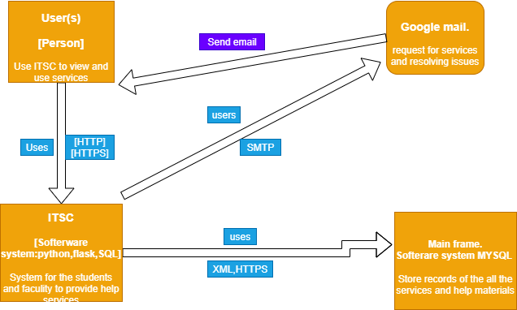

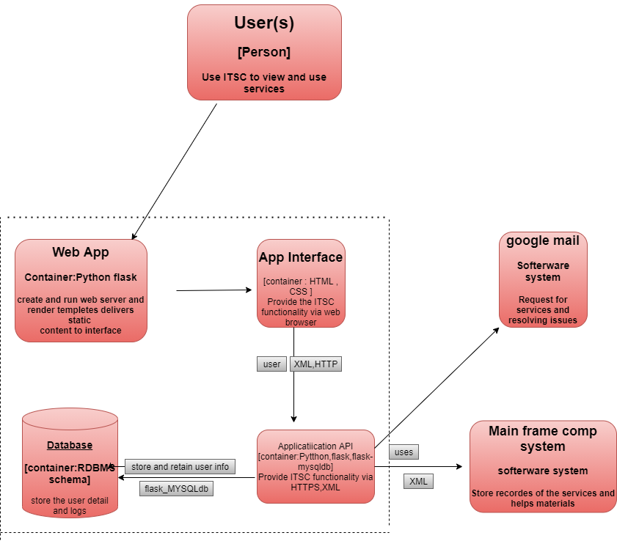

**Appendix-A: All Meeting Minutes**

**Sprint 1 – 12/11/2021 – 26/11/2021**

**Meeting-1**

| **Meeting Description** | |
| --- | --- |
| Meeting Title | Requirements for Sprint-1 |
| Date, Time, and Venue | Friday, 12/11/2021 – 11:45AM; LAWN |
| Facilitator, Scriber | jamshed,jamshed |
| Present | jamshed(Scrum Master), Customer Team(moazam, Ali,Hamza, safia,Asad) |
| Absent | NIL |

| **Agenda Items** | | | |
| --- | --- | --- | --- |
| **No.** | **Action Item** | **Owner** | **Due Date** |
| 1 | UI for Landing Page | Jamshed | 18/11/2021 |
| 2 | Database Connectivity | Qais and inayat | 19/11/2021 |
| 3 | Integrate Database with the App | Bakht and sania | 22/11/2021 |

| **Decisions** | | |
| --- | --- | --- |
| **No.** | **Action Item No.** | **Decision(s)** |
| 1 | 1 | 1. Background should be Namal’s Building  2. Login form at top  3. Registration form at below |
| 2 | 2 | 1. Use MySQL as Database  2. Create database with name “namal” |
| 3 | 3 | 1. Store registration form details in the users table  2. Retrieve and match username and passwords submitted by users to let them sign in. |

**Meeting-2**

| **Meeting Description** | |
| --- | --- |
| Meeting Title | Requirements for Sprint-1 |
| Date, Time, and Venue | Friday, 12/11/2021 – 11:45AM; |
| Facilitator, Scriber | Jamshed,jamshed |
| Present | Jamshed(Scrum Master), Customer Team(Hamza,Moazam,ALi,asad,safia) |
| Absent | All present. |

| **Agenda Items** | | | |
| --- | --- | --- | --- |
| **No.** | **Action Item** | **Owner** | **Due Date** |
| 1 | UI for Landing Page | jamshed | 18/11/2021 |
| 2 | Database Connectivity | Qais and inayat | 19/11/2021 |
| 3 | Integrate Database with the App | Bakht and sania | 22/11/2021 |

| **Decisions** | | |
| --- | --- | --- |
| **No.** | **Action Item No.** | **Decision(s)** |
| 1 | 1 | 4. Background should be Namal’s Building  5. Login form at top  6. Registration form at below |
| 2 | 2 | 3. Use MySQL as Database  4. Create database with name “namal” |
| 3 | 3 | 3. Store registration form details in the users table  4. Retrieve and match username and passwords submitted by users to let them sign in. |

**Sprint 2 – 26/11/2021 – 10/12/2021**

**Meeting-1**

| **Meeting Description** | |
| --- | --- |
| Meeting Title | Requirements for Sprint-1 |
| Date, Time, and Venue | Friday, 12/11/2021 – 11:45AM; |
| Facilitator, Scriber | Jamshed,jamshed |
| Present | jamshed(Scrum Master), Customer Team(moazam, Ali,Hamza, safia,Asad) |
| Absent | All present. |

| **Agenda Items** | | | |
| --- | --- | --- | --- |
| **No.** | **Action Item** | **Owner** | **Due Date** |
| 1 | UI for Landing Page | Jamshed | 18/12/2021 |
| 2 | Database Connectivity | Inayat and Qais | 19/12/2021 |
| 3 | Integrate Database with the App | Sania and Bakht | 22/11/2021 |

| **Decisions** | | |
| --- | --- | --- |
| **No.** | **Action Item No.** | **Decision(s)** |
| 1 | 1 | 7. Background should be Namal’s Building  8. Login form at top  9. Registration form at below |
| 2 | 2 | 5. Use MySQL as Database  6. Create database with name “project” |
| 3 | 3 | 5. Store registration form details in the users table  6. Retrieve and match username and passwords submitted by users to let them sign in. |

**Meeting-2**

| **Meeting Description** | |
| --- | --- |
| Meeting Title | Requirements for Sprint-1 |
| Date, Time, and Venue | Wednesday, 29/11/2021 – 10:15; |
| Facilitator, Scriber | Jamshed, Jamshed |
| Present | Jamshed(Scrum Master), Customer Team(moazam, Ali,Hamza, safia,Asad) |
| Absent | All present |

| **Agenda Items** | | | |
| --- | --- | --- | --- |
| **No.** | **Action Item** | **Owner** | **Due Date** |
| 1 | posts | Sania and bakht | 18/11/2021 |
| 2 | Complain system | Qais, Inayat | 19/11/2021 |
| 3 | Administration login | jamshed | 22/11/2021 |

| **Decisions** | | |
| --- | --- | --- |
| **No.** | **Action Item No.** | **Decision(s)** |
| 1 | 1 | 10. Background should be Namal’s Building  11. User have to post something  12. Show all the posts |
| 2 | 2 | 7. If any have issue with itsc services  8. just send email with complain |
| 3 | 3 | 7. Administrator will be one and he can control whole ITSC  8. He/she have the access to all |

| ID | Requirement Description | Verified by | Implemented | Test Status |
| --- | --- | --- | --- | --- |
| Req-1 | 1. Design the UI of Landing Page  2. Code Web App for Landing Page  3. Connect Database for Registration and Login | Jamshed-Scrum Master | Jamshed and hamza | 1. N/A  2. Pass  3. Pass |
| Req-2 | Python 3.9 , Mysql work bench ,Html 5 |  |  |  |

**Meeting-3**

| **Meeting description** | |
| --- | --- |
| **Meeting title** | **Requirements for sprint-2** |
| **Date, time and venue** | 6/12/2021 , 4:15 pm - 5:00 pm Aud-3 |
| **facilitator,scriber** | Bakht, Bakht |
| **present** | Bakht(scrum master) customer team( Ali mutaza, sardar moazam, hamza iqbal,asad ayyub,safia sultana |
| **absent** | All team member were present |

| **Agenda item** | | | |
| --- | --- | --- | --- |
| ***no*** | ***Action item*** | ***owner*** | ***Due-date*** |
| 1 | Create button in Dashboard for item creation | jamshed | 15/12/21 |
| 2 | Item creation to the portal | Qais sikander | 15/12/21 |