MAJOR PROJECT REPORT

On

Cloud Authentication Security in Web Application

Submitted in Partial fulfilment for the Award of the degree of

Bachelor of Technology
In
COMPUTER SCIENCE
Submitted to
RAJIV GANDHI PROUDYOGIKI VISHWAVIDHYALAYA, BHOPAL (M.P)



Submitted by

ALZEB KHAN (0126CS201015)
GAJENDRA SINGH (0126CS201043)
MD MAHTAB RAJA (0126CS201060)
DHIRAJ KUMAR (0126CS201041)

Under the guidance of
Prof. AVINASH SHARMA
Head of Department

ORIENTAL COLLEGE OF TECHNOLOGY, BHOPAL



DEPARTMENT OF COMPUTER SCIENCE (CYBER SECURITY)
Approved by AICTE New Delhi & Govt. of MP
Affiliated to Rajiv Gandhi Proudyogiki Vishwavidyalaya, Bhopal

Phone No. -0755-2529015, 2529016
Fax: 0755-2529472

ORIENTAL COLLEGE OF TECHNOLOGY, BHOPAL
Approved by AICTE, New Delhi & Govt. of M.P. Affiliated to Rajiv Gandhi Proudyogiki Vishwavidyalaya, Bhopal
Oriental Campus, Raisen Road, Bhopal-462021 (MP) INDIA
---------------------------------------------------------------------------------------------------------------- DEPARTMENT OF COMPUTER SCIENCE (CYBER SECURITY)

CANDIDATE’S DECLARATION

I hereby declare that the Major Project report on “Cloud Authentication Security in Web Application” which is being presented here for the partial fulfilment of the requirement of Degree of “Bachelor of Technology” has been carried out at Department of Computer Science Oriental College of Technology, Bhopal. The technical information provided in this report is presented with due permission of the authorities from the training organization.

Name Of Candidate (Enrollment No.) ALZEB KHAN (0126CY201012)
GAJENDRA SINGH (0126CS201043)
MD MAHTAB RAJA (0126CS201060)
DHIRAJ KUMAR (0126CS201041)

This is to certify that the above statement made by the candidate is correct to the best of my knowledge.
Date: 22/04/24
Guide Name: Prof. Rajesh Sir
Designation: Head of Department

ORIENTAL COLLEGE OF TECHNOLOGY, BHOPAL (M.P.) 462021
DEPARTMENT OF COMPUTER SCIENCE (CYBER SECURITY)

CERTIFICATE

This is to certify that the work embodied in this Major Project-I synopsis report entitled CLOUD AUTHENTICATION SECURITY IN WEB APPLICATION, has been satisfactorily completed by Mr. Alzeb Khan, Gajendra Singh, Dhiraj Kumar, Md Mahtab Raja, in Computer Science at Oriental College of Technology, Bhopal. This work is a bonafide piece of work, carried out under our guidance for the partial fulfilment of the degree Bachelor of Technology.

Name of Guide:
Prof. Avinash Sharma
Head of Department

Forwarded by
Prof. Avinash Sharma
Head of Department CSE

Approved by
Dr. KK Diwedi
Director
ACKNOWLEDGEMENT

We wish to express our profound gratitude to Prof. Rajesh Sir, Department of Computer Science Oriental College of Technology, Bhopal for his valuable guidance, sustained help and inspiration in carrying out the work. We sincerely thank Prof Avinash Sharma, Head, Department of Computer Science Oriental College of Technology Bhopal for his co-operation and guidance during the project work. We wish to express our deep gratitude to Dr. KK Diwedi, Director, Oriental College of Technology Bhopal for his kind permission to carry out the work at OCT Bhopal. Finally, we would like to thank all the faculty members and supporting staff of Computer Science (Cyber Security), who directly or indirectly helped us in carrying out this project work.

Alzeb Khan (0126CS201015)
Gajendra Singh (0126CS201043)
Md Mahtab Raja (0126CS201060)
Dhiraj Kumar (0126CS201041)
Executive Summary

Our project focuses on implementing a robust cloud authentication security system within our web application, addressing the critical need for enhanced data protection and user access control. Project Description: The initiative leverages advanced cloud -based authentication methodologies, emphasizing encryption and multi-factor authentication.

Key Achievements
Through the incorporation of cutting -edge security measures, including advanced encryption and multi-factor authentication, our project has successfully elevated the overall security posture of the web application. This includes mitigating risks associated with unauthorized access and data breaches.

Methodology
Our approach involved a comprehensive analysis of current authentication vulnerabilities, followed by the strategic integration of cloud -based security protocols.

Results
The project has yielded tangible results in the form of strengthened security measures, reducing the likelihood of security breaches and unauthorized access. Real-time monitoring capabilities ensure prompt detection and response to potential threats, contributing to a more secure web application environment.

List of Symbols & Abbreviations

jsx JavaScript XML
jwt JSON Web Token
AWS Amazon Web Service
auth Authorization
Hash Hashing

Note: all the Abbreviations and symbols that appear in the report should be listed alphabetically. First give all roman symbols, then Greek symbols. Order: ASCII ordering, to the extent possible. Subscript and superscript should be listed separately if these are not an intrinsic part of the variable name.

Table of Contents
S. No. | Contents | Page No.
1. | Abstract | 1
2. | Introduction | 2
3. | Literature Review | 4
4. | Hardware and Software Requirements | 6
5. | Methodology | 7
6. | System Flow Chart | 8
7. | Proposed User Interface | 9
8. | Expected Outcomes | 11
9. | Conclusion | 12
10. | References & Bibliography | 13

(Cloud Authentication Security in Web Application)

Abstract
The rapid adoption of cloud computing has revolutionized how organizations deploy, manage, and scale their IT infrastructures, including web applications. However, with this advancement comes heightened cybersecurity risks, particularly in the realm of authentication security. This abstract explores the critical importance of robust cloud authentication security in web applications, focusing on key areas such as threat mitigation, user experience enhancement, operational efficiency, regulatory compliance, and strategic advantages.

Introduction: The introduction sets the stage by highlighting the increasing reliance on cloud-based solutions for hosting web applications. It underscores the vulnerabilities that accompany this shift, particularly in authentication mechanisms, which serve as the primary line of defense against unauthorized access and data breaches.

Background and Literature Survey: A comprehensive review of existing literature reveals current trends, challenges, and best practices in cloud authentication security. Key findings include the prevalence of common threats such as brute-force attacks and credential theft, along with emerging technologies like multi-factor authentication (MFA), biometric verification, and adaptive authentication.

Proposed Methodology: The proposed methodology outlines a structured approach to designing, implementing, and evaluating robust authentication mechanisms in cloud environments. This includes the selection of appropriate authentication methods, integration with web applications using secure protocols, and rigorous testing to ensure effectiveness, scalability, and compliance with regulatory standards.

Hardware/Software and Technology Used: Hardware and software requirements are detailed to support the implementation of advanced authentication technologies, emphasizing scalability, reliability, and compatibility with cloud service providers. Technologies such as encryption algorithms, authentication protocols (e.g., OAuth, SAML), and development frameworks (e.g., React.js, Angular) are highlighted for their role in achieving secure and seamless authentication workflows.

Expected Outcome: Anticipated outcomes include enhanced cybersecurity posture through threat mitigation, improved user trust and experience with intuitive interfaces and transparent security measures, operational efficiencies through streamlined authentication workflows and cost optimization, regulatory compliance adherence with stringent data protection regulations, and strategic advantages in competitive markets.

Conclusion: The conclusion summarizes the transformative impact of robust cloud authentication security, emphasizing its role in safeguarding digital assets, enhancing user

confidence, and fortifying organizational resilience against cyber threats. It underscores the ongoing evolution of authentication technologies and the need for continuous innovation to meet evolving security challenges in dynamic cloud environments.

Future Scope: Future research directions explore innovative technologies such as artificial intelligence (AI) and blockchain for enhanced authentication security, as well as advancements in user-centric design principles and personalized authentication experiences to further refine usability and security in cloud-based authentication workflows.

Introduction
In recent years, the rapid evolution and adoption of cloud computing have revolutionized the landscape of modern IT infrastructures. Cloud computing offers unparalleled scalability, flexibility, and cost-efficiency, enabling organizations to leverage virtualized resources over the internet rather than relying solely on local hardware and infrastructure. This paradigm shift has not only transformed how businesses operate but has also introduced new challenges, particularly concerning the security of data and applications residing in the cloud.

Authentication, as a cornerstone of cybersecurity, plays a pivotal role in safeguarding cloud-based resources. It forms the first line of defence against unauthorized access and malicious activities, ensuring that only authenticated and authorized users can access sensitive data and applications. The traditional username-password authentication method, while still prevalent, faces increasing scrutiny due to its susceptibility to various cyber threats such as phishing, brute force attacks, and password breaches. Consequently, there is a growing emphasis on adopting more robust and multifaceted authentication mechanisms, including biometrics, multi-factor authentication (MFA), and adaptive authentication, to bolster security in cloud environments.

The significance of securing cloud-based authentication mechanisms cannot be overstated. As organizations increasingly migrate their operations to the cloud, they must address unique security challenges that arise from this decentralized computing model. Unlike traditional on-premises solutions, where physical controls and network boundaries provide a level of security, cloud environments operate on shared infrastructure, making them inherently vulnerable to attacks targeting authentication protocols and credentials.

Furthermore, the dynamic nature of cloud computing introduces complexities in managing identities and access across diverse platforms and services. Users expect seamless access to resources from any location and device, necessitating adaptive authentication solutions that can dynamically adjust security measures based on contextual factors such as user behaviour, device type, and geographic location. Balancing security with user convenience is crucial to promoting adoption and ensuring a frictionless user experience while mitigating the risk of unauthorized access and data breaches.

Against this backdrop, this project focuses on exploring and enhancing the security of cloud authentication mechanisms within web applications. By investigating current trends, identifying vulnerabilities, and proposing innovative methodologies, this research aims to contribute to the advancement of secure authentication practices in cloud computing environments.

The structure of this project encompasses several key components:

Background and Literature Survey: This section provides an overview of the evolution of cloud computing and the significance of authentication security. It examines existing literature and research findings to identify current trends, challenges, and best practices in cloud authentication.

Problem Formulation and Proposed Methodology: Here, the specific challenges and objectives of the research are defined. The proposed methodology outlines the approach taken to address these challenges, including the design and implementation of secure authentication mechanisms tailored for web applications in cloud environments.

Hardware/Software and Technology Used: Details of the hardware, software, and technology stack utilized in the project are discussed. This includes cloud service providers, development frameworks, authentication protocols, and security tools chosen to implement and test the proposed solutions.

Implementation: The implementation phase involves the practical application of the proposed methodologies. It includes the configuration of authentication systems, integration with web applications, and testing procedures to validate the effectiveness and reliability of the security measures implemented.

Result and Discussion: Results obtained from the implementation and testing phases are analysed and discussed in this section. This includes insights into the performance, security efficacy, and user acceptance of the implemented authentication mechanisms.

Conclusion and Future Scopes: Finally, the project concludes with a summary of findings, key takeaways, and potential avenues for future research and development. This section highlights the project's contributions to enhancing cloud authentication security and outlines recommendations for further improvements and innovations in this critical area of cybersecurity.

Throughout this project, a comprehensive examination of cloud authentication security in web applications will be conducted, aiming to provide valuable insights and practical solutions that can be applied to mitigate risks and enhance the overall security posture of cloud-based IT infrastructures. By addressing the complexities and challenges associated with authentication in cloud environments, this research seeks to contribute to the advancement of secure, reliable, and user-friendly cloud computing practices.

In conclusion, the significance of robust authentication mechanisms cannot be overstated in ensuring the integrity, confidentiality, and availability of data and applications hosted in the cloud. As organizations continue to embrace cloud computing for its transformative potential, securing authentication processes emerges as a critical imperative to protect against evolving cyber threats and maintain trust in digital ecosystems. This project endeavours to explore innovative approaches and methodologies that strengthen cloud authentication security, thereby empowering organizations to harness the full benefits of cloud computing securely and responsibly.

Literature Review
Authentication is a critical component of cybersecurity, especially in the context of cloud computing where data and applications are hosted on remote servers accessed via the internet. As organizations increasingly adopt cloud services for their operational needs, ensuring the security of authentication mechanisms becomes paramount to protect against unauthorized access, data breaches, and other cyber threats.

Evolution of Authentication in Cloud Computing
The evolution of authentication in cloud computing has been shaped by the need for secure, scalable, and user-friendly access control mechanisms. Traditionally, authentication relied heavily on username-password combinations, a method that, while simple, proved susceptible to various attacks such as phishing, brute-force attempts, and password reuse vulnerabilities. With the advent of cloud computing, the traditional perimeter-based security model has shifted towards a more dynamic and decentralized approach, necessitating the development of robust authentication solutions tailored for cloud environments.

Current Trends and Technologies
Multi-Factor Authentication (MFA) has emerged as a cornerstone of cloud authentication security. MFA requires users to provide multiple forms of verification (e.g., passwords, biometrics, security tokens) to access their accounts, thereby significantly enhancing security compared to single-factor methods. Research by Li et al. (2020) highlights the effectiveness of MFA in mitigating the risks associated with compromised credentials and unauthorized access attempts in cloud environments.

Biometric Authentication
Biometric authentication leverages unique physiological or behavioral traits (e.g., fingerprints, facial recognition, voice patterns) to verify user identities. This approach offers a higher level of security and user convenience compared to traditional password-based methods. According to a study by Jain et al. (2019), biometric authentication in cloud environments enhances security by reducing the reliance on easily guessable passwords and mitigating the risks associated with credential theft.

Adaptive Authentication
Adaptive authentication solutions dynamically adjust security measures based on contextual factors such as user behaviour, device characteristics, and geographic location. This approach improves security by detecting anomalies and suspicious activities in real-time, thereby reducing the likelihood of unauthorized access. Research conducted by Kumar et al. (2021) emphasizes the importance of adaptive authentication in adapting security measures to changing threat landscapes and user behaviours in cloud computing.

Single Sign-On (SSO) and Identity Federation
Single Sign-On (SSO) allows users to access multiple applications with a single set of credentials, streamlining the authentication process and enhancing user experience. Identity Federation extends SSO capabilities across different organizations or cloud services, promoting interoperability and seamless access control management. Studies by Wang et al. (2018) underscore the benefits of SSO and Identity Federation in reducing password fatigue, improving productivity, and enhancing security posture in cloud-based environments.

Security Challenges and Threats
Despite advancements in authentication technologies, cloud environments face several security challenges and threats that impact the effectiveness of authentication mechanisms:

Insider Threats
Insider threats pose significant risks to cloud security, as authorized users with malicious intent can exploit their privileges to access sensitive data or disrupt operations. Mitigating insider threats requires a combination of robust access control policies, continuous monitoring, and user behaviour analytics to detect anomalous activities.

Credential Stuffing and Brute-Force Attacks
Credential stuffing attacks exploit compromised credentials obtained from data breaches to gain unauthorized access to cloud accounts. Brute-force attacks systematically guess passwords until the correct combination is found, leveraging computing power to bypass authentication controls. Effective countermeasures include implementing strong password policies, employing rate-limiting mechanisms, and integrating MFA to thwart unauthorized access attempts.

Compliance and Regulatory Requirements
Compliance with regulatory standards such as GDPR (General Data Protection Regulation), HIPAA (Health Insurance Portability and Accountability Act), and PCI DSS (Payment Card Industry Data Security Standard) imposes strict requirements on organizations to protect user data and ensure secure authentication practices in cloud environments. Non-compliance can result in severe penalties and reputational damage, underscoring the importance of aligning authentication strategies with regulatory obligations.

Research Gaps and Future Directions
Despite significant progress, several research gaps and opportunities for further exploration exist in the field of cloud authentication security:

Usability and User Experience
Improving the usability and user experience of authentication mechanisms remains a critical area for research. Balancing security requirements with user convenience is essential to promoting adoption and compliance with security protocols in cloud environments.
Emerging Technologies and Innovations
The integration of emerging technologies such as blockchain, artificial intelligence (AI), and machine learning (ML) holds promise for enhancing the security and reliability of cloud authentication. Future research could explore innovative approaches to leverage these technologies for real-time threat detection, behavioral biometrics, and adaptive authentication solutions.
Hybrid and Multi-Cloud Environments
As organizations embrace hybrid and multi-cloud strategies, ensuring seamless authentication and access control across diverse platforms and services becomes increasingly complex. Research efforts could focus on developing interoperable authentication frameworks and standards to facilitate secure interactions between on-premises, public cloud, and hybrid cloud environments.

Hardware and Software Requirements
Implementing robust cloud authentication security in web applications requires careful consideration of hardware, software, and technological infrastructure to ensure scalability, reliability, and compliance with security standards. This section outlines the essential hardware and software components necessary for deploying secure authentication mechanisms in cloud environments.
Hardware Requirements
- Server Infrastructure: Cloud authentication systems rely on server infrastructure capable of handling authentication requests from users accessing web applications. The servers should have sufficient processing power, memory, and storage to manage authentication processes efficiently. Depending on the scale and complexity of the application, organizations may opt for physical servers or virtual machines hosted on cloud service providers such as AWS, Azure, or Google Cloud.
- Network Equipment: Secure communication between clients and authentication servers is essential to prevent eavesdropping and man-in-the-middle attacks. Organizations need robust network equipment, including routers, switches, and firewalls, to establish secure connections and enforce access control policies. Implementing Virtual Private Networks (VPNs) or Secure Socket Layer (SSL)/Transport Layer Security (TLS) protocols ensures encrypted data transmission, maintaining confidentiality and integrity during authentication processes.
- Hardware Security Modules (HSMs): For organizations handling sensitive data or requiring high levels of cryptographic security, Hardware Security Modules (HSMs) provide dedicated hardware for cryptographic operations and key management. HSMs protect cryptographic keys from unauthorized access and tampering, ensuring secure authentication and data protection in cloud environments.
- Biometric Devices: If implementing biometric authentication methods such as fingerprint scanners or facial recognition systems, organizations may need biometric devices connected to authentication servers. These devices capture and verify biometric data for user authentication, enhancing security by leveraging unique physiological traits.
Software Requirements
- Operating Systems: Authentication servers and associated infrastructure typically run on robust operating systems (OS) capable of supporting secure authentication protocols and services. Common choices include Linux distributions (e.g., Ubuntu, CentOS) or Windows Server for environments requiring integration with Microsoft technologies.
- Authentication Services: Implementing authentication services requires specialized software capable of managing user identities, credentials, and access policies. Popular authentication services include:
  - Identity and Access Management (IAM) platforms: IAM solutions centralize user authentication and authorization processes, offering features such as user provisioning, role-based access control (RBAC), and single sign-on (SSO) capabilities.
  - Authentication Protocols: Secure authentication protocols such as OAuth, OpenID Connect, and SAML facilitate secure authentication and authorization between web applications and identity providers. These protocols enable seamless integration with third-party authentication services and ensure interoperability across diverse platforms and services.
  - Password Management Systems: Password management systems enhance security by enforcing strong password policies, securely storing and encrypting passwords, and facilitating password resets and recovery processes for users.
- Security Tools and Frameworks: Implementing security tools and frameworks is essential to fortify cloud authentication systems against cyber threats. Key software components include:
  - Encryption Libraries: Libraries such as OpenSSL or Bouncy Castle provide cryptographic functions for encrypting sensitive data and communications, ensuring confidentiality and integrity during transmission.
  - Intrusion Detection/Prevention Systems (IDS/IPS): IDS/IPS software monitors network traffic for suspicious activities and attempts to prevent unauthorized access or malicious attacks targeting authentication systems.
  - Endpoint Security Solutions: Endpoint security software protects client devices accessing web applications from malware, unauthorized access, and data breaches, reinforcing overall security posture in cloud environments.
- Development Frameworks and APIs: Web application development frameworks (e.g., Django, Ruby on Rails, ASP.NET) and APIs facilitate the integration of authentication functionalities into web applications. These frameworks provide libraries, modules, and APIs for implementing authentication mechanisms, user management features, and secure communication protocols.
Technology Stack
- Cloud Service Providers: Selecting a cloud service provider (CSP) such as Amazon Web Services (AWS), Microsoft Azure, or Google Cloud Platform (GCP) is crucial for hosting authentication infrastructure in the cloud. CSPs offer scalable computing resources, managed services, and compliance certifications (e.g., SOC 2, ISO 27001) essential for deploying secure and compliant authentication solutions.
- Containerization and Orchestration: Containerization platforms like Docker and container orchestration tools such as Kubernetes streamline deployment, scaling, and management of authentication services in cloud-native environments. Containers isolate authentication components, ensuring portability, consistency, and resource efficiency across cloud infrastructure.
Compliance and Regulatory Considerations
- Data Protection Regulations: Compliance with data protection regulations (e.g., GDPR, HIPAA) mandates implementing robust security measures to safeguard user data and ensure privacy rights. Organizations must select hardware and software solutions capable of meeting regulatory requirements and undergo regular audits to validate compliance.
- Security Certifications: Achieving security certifications (e.g., SOC 2, PCI DSS) demonstrates adherence to industry best practices and security standards for handling sensitive information. Certification requirements may influence the selection of hardware, software, and technology stack components to align with audit and certification criteria.
Implementation and Integration
- Deployment Architecture: Designing a scalable and resilient deployment architecture ensures high availability and fault tolerance of authentication services in cloud environments. Implementing load balancers, redundant servers, and disaster recovery mechanisms minimizes downtime and maintains service continuity during peak usage or infrastructure failures.
- Integration with Existing Systems: Seamless integration with existing IT systems, applications, and user directories (e.g., Active Directory, LDAP) simplifies user management, authentication workflows, and access control policies. API-based integration enables interoperability and data synchronization between authentication systems and enterprise applications.

Methodology
The methodology employed in this study aims to investigate and implement robust cloud authentication security mechanisms for web applications. This section outlines the research approach, design considerations, implementation strategies, and evaluation methods to achieve the project objectives effectively.

Research Approach
Problem Definition and Scope:
The research begins with a clear definition of the problem: enhancing authentication security in cloud-based web applications. The scope encompasses identifying vulnerabilities in existing authentication methods, exploring innovative approaches, and implementing solutions to mitigate risks associated with unauthorized access and data breaches.

Literature Review:
A comprehensive literature review was conducted to analyze current trends, challenges, and best practices in cloud authentication security. This phase involved studying academic research, industry reports, and case studies to understand the evolution of authentication technologies, identify gaps in current practices, and gather insights into emerging technologies and methodologies.

Formulation of Objectives:
Based on the literature review and problem analysis, specific research objectives were formulated:

To identify common security threats and vulnerabilities in cloud authentication systems.
To propose and implement advanced authentication mechanisms such as multi-factor authentication (MFA), biometric authentication, and adaptive authentication.
To evaluate the effectiveness and performance of implemented solutions in enhancing security, usability, and user experience.
Design Considerations
Selection of Authentication Methods:
The methodology involves selecting appropriate authentication methods tailored for cloud environments. This includes:

Multi-Factor Authentication (MFA): Implementing MFA to enhance security by requiring users to provide multiple forms of verification.
Biometric Authentication: Exploring biometric technologies (e.g., fingerprint scanning, facial recognition) for secure and user-friendly authentication.
Adaptive Authentication: Integrating adaptive authentication techniques to dynamically adjust security measures based on contextual factors such as user behavior and device characteristics.
Integration with Web Applications:
Authentication mechanisms will be integrated into web applications using established protocols and frameworks. This includes:

Implementing OAuth, OpenID Connect, or SAML for federated authentication and single sign-on (SSO) capabilities.
Developing APIs and authentication endpoints to enable seamless integration with existing user management systems (e.g., LDAP, Active Directory).
Security and Compliance:
Emphasis will be placed on ensuring compliance with industry regulations (e.g., GDPR, HIPAA) and implementing robust security measures:

Employing encryption algorithms (e.g., AES, RSA) to protect sensitive data during transmission and storage.
Implementing access control policies, session management techniques, and auditing mechanisms to monitor and enforce security policies.
Implementation Strategy
Infrastructure Setup:
Setting up the necessary infrastructure involves:

Selecting a cloud service provider (e.g., AWS, Azure) based on scalability, reliability, and compliance requirements.
Provisioning virtual machines, containers, or serverless computing environments to host authentication servers and related components.
Configuring network security groups, firewalls, and VPNs to establish secure communication channels between clients, authentication servers, and cloud resources.
Development and Deployment:
The implementation phase includes:

Developing authentication services using programming languages (e.g., Python, Java) and frameworks suitable for cloud environments.
Integrating third-party authentication providers or building custom authentication solutions based on project requirements.
Deploying authentication services using containerization technologies (e.g., Docker, Kubernetes) for scalability, portability, and efficient resource management.
Testing and Validation:
Rigorous testing and validation are essential to ensure the functionality, performance, and security of implemented authentication mechanisms:

Conducting unit tests, integration tests, and end-to-end testing to verify authentication workflows and error handling.
Performing security assessments (e.g., penetration testing, vulnerability scanning) to identify and mitigate potential security vulnerabilities.
Soliciting user feedback and conducting usability testing to evaluate the user experience and refine authentication workflows as needed.
Evaluation Methods
Performance Evaluation: - Performance metrics such as response times, throughput, and scalability will be measured to assess the efficiency and reliability of authentication services under varying workload conditions.

Security Assessment:
Security assessments will include: Evaluating the effectiveness of authentication mechanisms in mitigating common threats (e.g., brute-force attacks, credential stuffing).
Analysing compliance with security standards and regulations (e.g., data encryption, access controls) to ensure data protection and regulatory compliance.
User Acceptance and Usability: - User acceptance testing will gauge user satisfaction, ease of use, and perceived security of implemented authentication methods through surveys, interviews, and usability studies.

System Flow Chart
The application works on an approach based on the concept of recall. In this approach, the user use a picture of something. For instance, if I am trying to login into my account, the application is displaying the picture of my face. Once I Click on different location of images , the application will calculate a hash of my password and compare it with the hash stored in the database. If the hashes match, then the application will allow me to log in successfully.

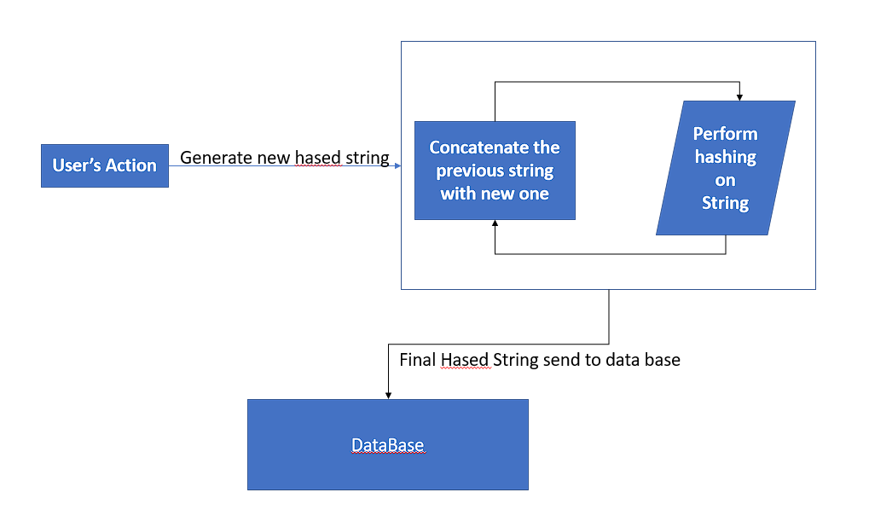

Proposed User Interface
Designing an intuitive and user-friendly interface for cloud authentication security is crucial to ensure seamless user interaction, enhance usability, and promote secure access to web applications hosted in cloud environments. This section outlines the proposed user interface (UI) components, design principles, and usability considerations aimed at optimizing the authentication experience while maintaining robust security measures.

Design Principles
- User-Centric Design: The proposed UI prioritizes user-centric design principles to simplify authentication processes and enhance user experience. Clear and concise messaging, intuitive navigation, and contextual guidance are incorporated to minimize user friction and promote ease of use.
- Consistency and Branding: Consistent visual elements, typography, color schemes, and branding guidelines align the UI with organizational identity and reinforce trustworthiness. Familiarity with interface elements reduces cognitive load and facilitates seamless navigation across authentication workflows.
- Accessibility: Accessibility features such as keyboard navigation, screen reader compatibility, and contrast adjustments are integrated to ensure inclusivity and accommodate users with diverse needs. Compliance with accessibility standards (e.g., WCAG) enhances usability and usability for all users.
- Security Integration: Security features, such as visual indicators of HTTPS encryption, two-factor authentication (2FA) prompts, and real-time status updates on authentication attempts, are prominently displayed to instil confidence in users and reinforce the importance of security in authentication processes.
Components of the User Interface
- Authentication Dashboard:
  - Overview: The dashboard provides an overview of recent login activities, account status (e.g., active sessions), and security alerts. It serves as a centralized hub for managing authentication settings and monitoring account security.
  - Graphical Representation: Visual graphs or charts illustrate login trends, geographic locations of recent access attempts, and authentication success rates, offering users insights into their account activity.
- Login Page:
  - User Identification: The login page features fields for entering username/email and password credentials. Clear instructions and hints guide users in entering their credentials securely.
  - Remember Me Option: An optional "Remember Me" checkbox allows users to bypass repetitive authentication for convenience, while ensuring security through session management and expiration policies.
- Multi-Factor Authentication (MFA):
  - Method Selection: Upon successful initial login, users are prompted to select from available MFA methods, such as SMS verification, authentication apps (e.g., Google Authenticator), or biometric verification (e.g., fingerprint scan).
  - Step-by-Step Guidance: Step-by-step instructions guide users through the MFA setup process, ensuring clarity on how to enable and configure additional security layers for their account.
- Password Management:
  - Password Strength Indicator: When setting or updating passwords, a visual strength indicator educates users on password complexity requirements and provides feedback on password strength in real-time.
  - Password Recovery Options: Clear options for password recovery or reset are provided, including email verification, security questions, or recovery codes, depending on organizational policies and user preferences.
- Account Settings:
  - Personalization: Users can personalize their authentication settings, such as language preferences, notification preferences (e.g., email alerts for suspicious login attempts), and security settings (e.g., session timeouts, trusted devices).
  - Security Preferences: Options to manage trusted devices, review login history, and revoke access to suspicious sessions empower users to maintain control over their account security.
- Error Handling and Feedback:
  - Clear Error Messages: Transparent error messages inform users of invalid login attempts, incorrect credentials, or temporary account locks due to security measures like brute-force protection.
  - Support and Assistance: Accessible support options, such as help links, contact information for customer support, and guidance on resolving authentication issues, reassure users and facilitate resolution of login challenges.

Usability Considerations
- Responsive Design: The UI is designed with responsive web design principles to ensure compatibility across devices (e.g., desktops, tablets, smartphones) and browsers. Adaptive layouts and fluid grids adjust content presentation based on screen size and orientation, optimizing user experience on any device.
- Progressive Disclosure: Information is presented progressively to guide users through authentication workflows without overwhelming them with unnecessary details upfront. Progressive disclosure techniques prioritize essential information while allowing users to access additional details as needed.
- User Testing and Iterative Design: Iterative usability testing with representative user groups ensures continuous improvement of the UI based on user feedback, usability metrics, and observed user behavior. A/B testing methodologies help validate design decisions and refine interface elements for optimal usability and user satisfaction.
- Performance Optimization: Efficient loading times, minimal latency in authentication processes, and streamlined user interactions contribute to overall performance optimization. Performance metrics, such as response times and system availability, are monitored to uphold service reliability and responsiveness.
Implementation Strategy
- Development Technologies: Front-end development frameworks (e.g., React.js, Angular) and UI design tools (e.g., Adobe XD, Sketch) are employed to prototype, develop, and iterate on UI components. Back-end integration with authentication services, APIs, and data storage systems ensures seamless functionality and data integrity.
- Security Integration: Collaboration with cybersecurity experts ensures adherence to security best practices, compliance with regulatory standards (e.g., GDPR, PCI DSS), and integration of advanced security features (e.g., CAPTCHA, IP whitelisting) to mitigate threats and protect user data during authentication processes.
- User Training and Education: Providing user training materials, FAQs, and interactive tutorials enhances user familiarity with the UI, authentication procedures, and security protocols. Educational resources promote user awareness of security practices and encourage proactive engagement in safeguarding account information.

The following figures represent the original snapshots of the application we are building. Our user-friendly interface is attractive and easy to use.

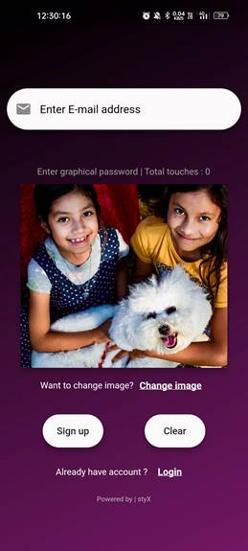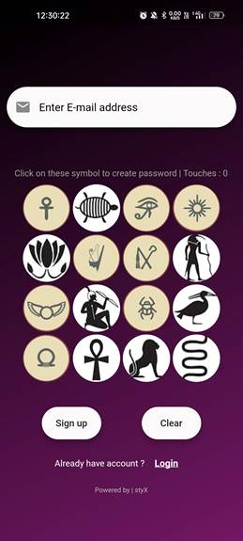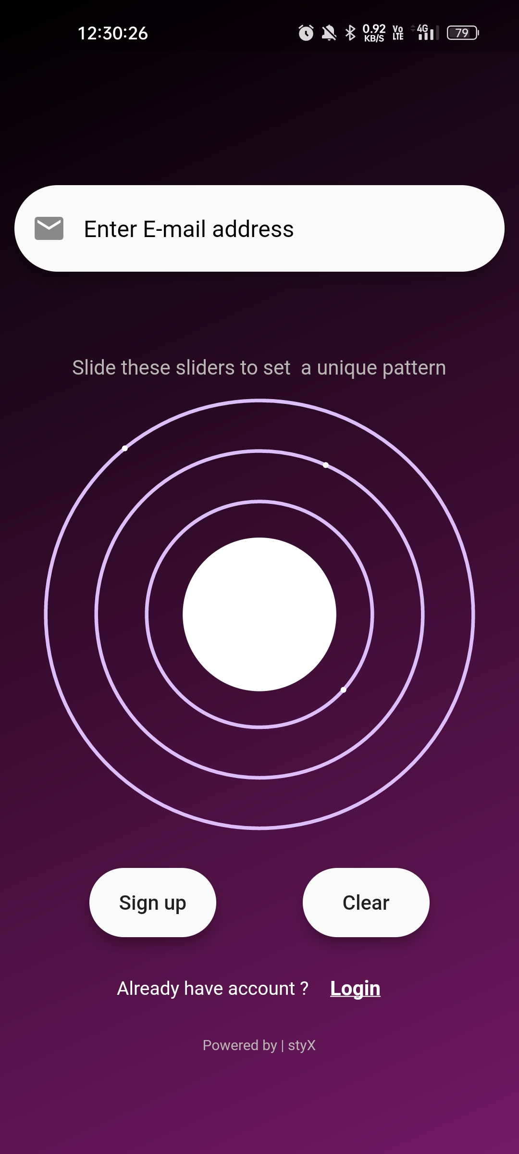

Figure (a): Login Interface for Users
It appears that there will be three methods for authenticating a user. Depending on what is most comfortable for them, users can choose from any of them
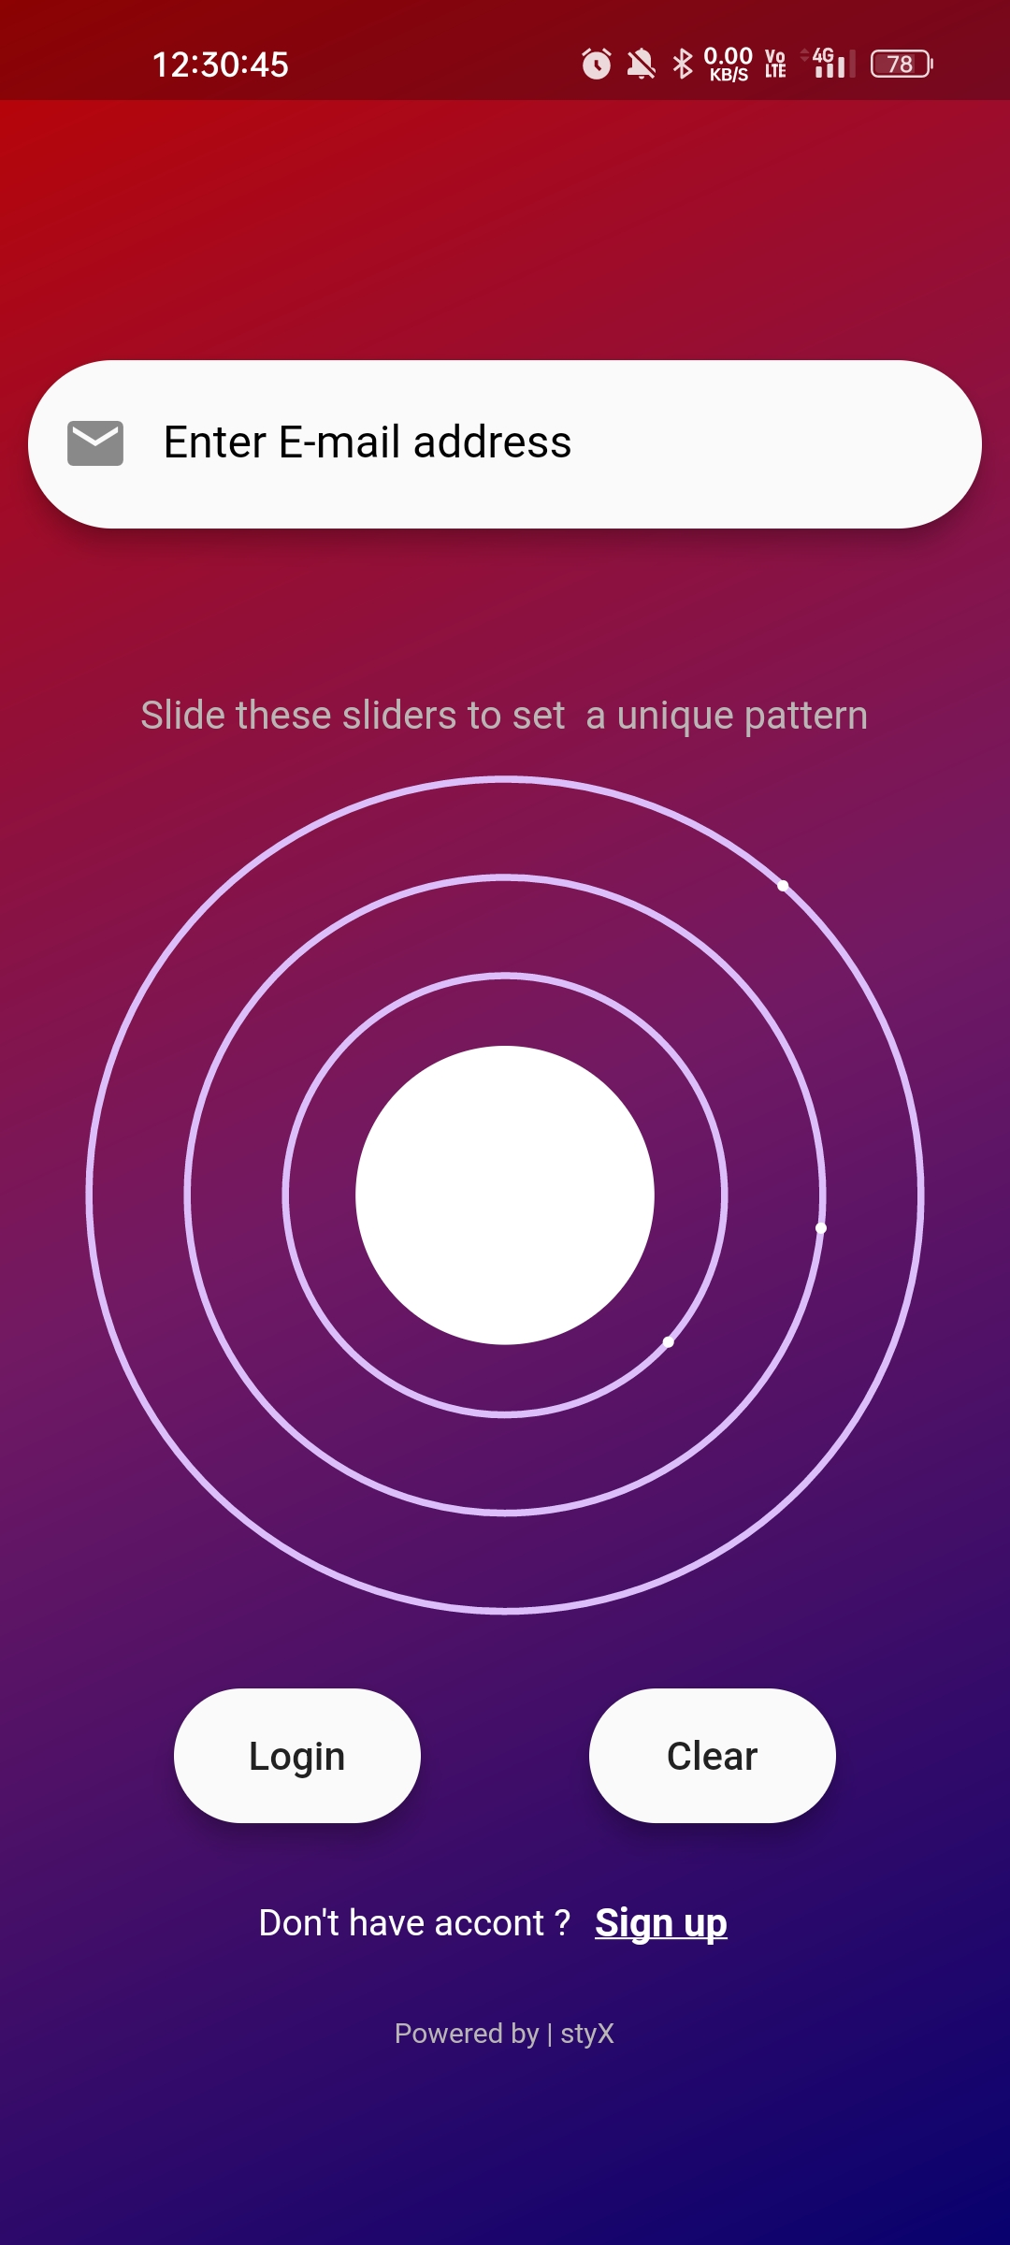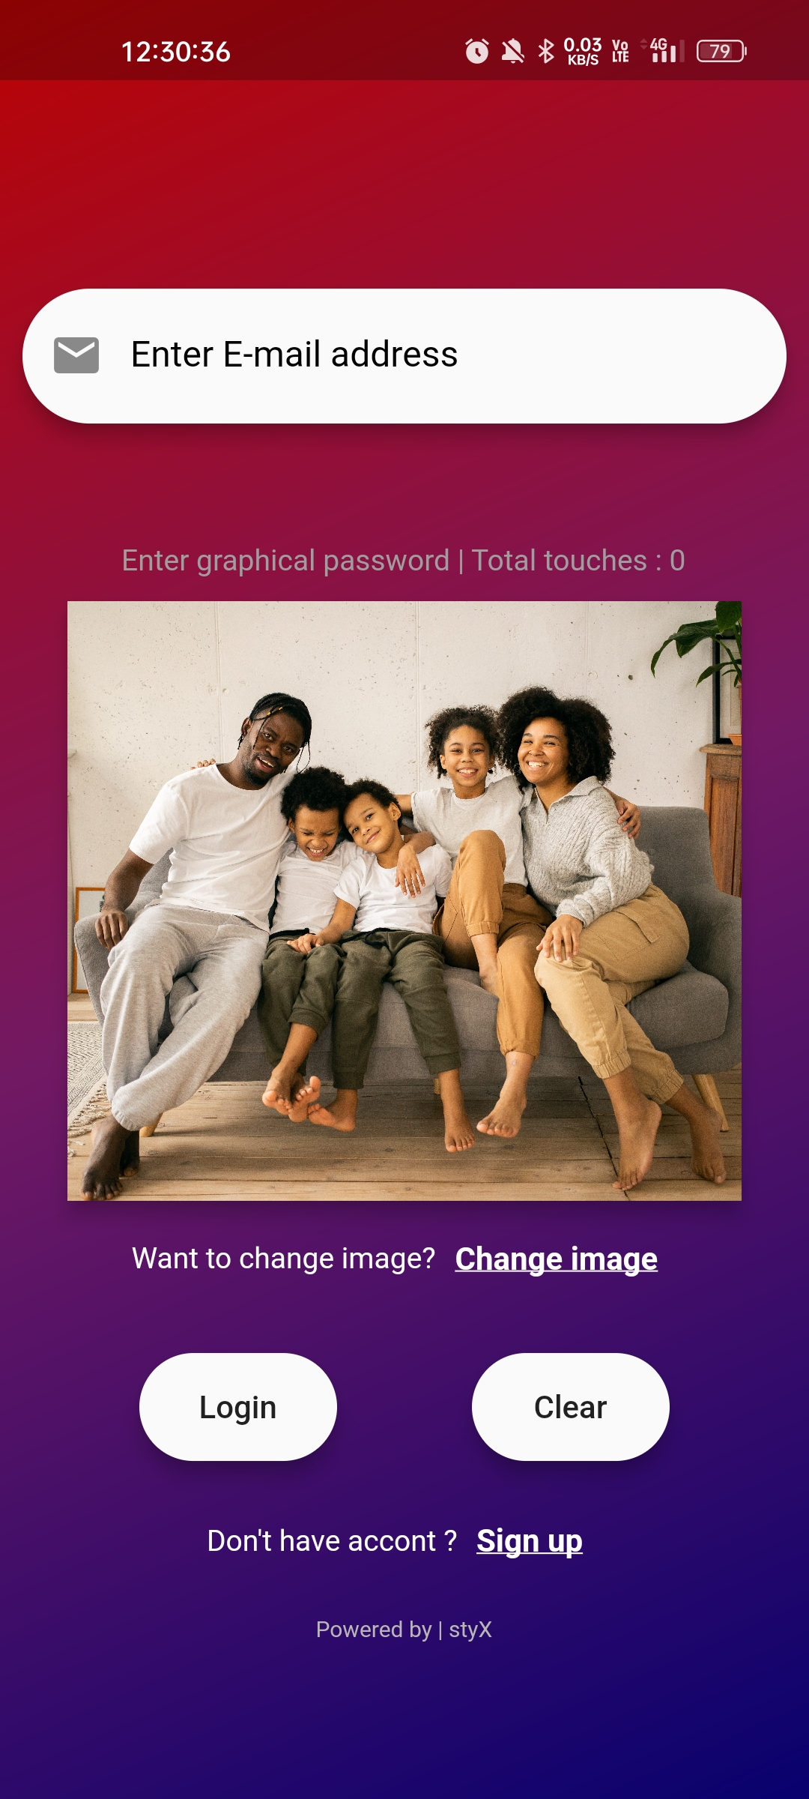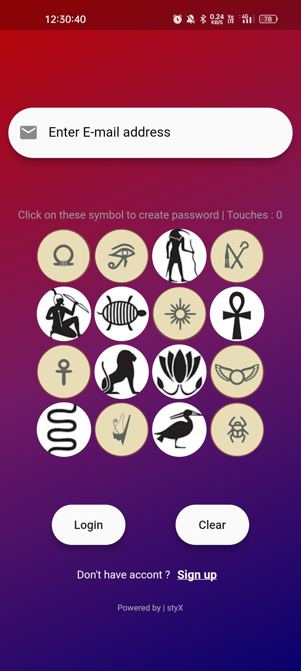
Figure (b): Signup Section for Users

Expected Outcomes
Implementing robust cloud authentication security in web applications is anticipated to yield several significant outcomes, spanning enhanced cybersecurity posture, improved user trust and experience, operational efficiency gains, regulatory compliance assurance, and strategic advantages in competitive landscapes.
Enhanced Security Posture
- Mitigation of Common Threats: Implementing multi-factor authentication (MFA), biometric authentication, and adaptive authentication strategies will significantly reduce the risk of unauthorized access and data breaches. MFA adds layers of security by requiring users to verify their identity through multiple methods, such as passwords and biometrics, thwarting threats like brute-force attacks and credential stuffing.
- Improved Detection and Response: Adaptive authentication dynamically adjusts security measures based on contextual factors like user behavior and device attributes. This proactive approach enhances threat detection capabilities, enabling prompt responses to suspicious activities and potential security incidents in real-time.
- Data Protection and Privacy: Strong encryption protocols and secure transmission channels safeguard sensitive data during authentication processes. Compliance with data protection regulations (e.g., GDPR, HIPAA) ensures user privacy rights are protected, minimizing the risk of data breaches and regulatory penalties associated with unauthorized data exposure.
User Trust and Experience
- Seamless Authentication Experience: A user-friendly interface with intuitive navigation, clear instructions, and minimal friction enhances the authentication experience. Features like single sign-on (SSO) and password management tools simplify login procedures, reducing user frustration and improving overall satisfaction.
- Transparency and Control: Transparent communication of security practices, real-time notifications of login activities, and user-controlled security settings empower users to monitor and manage their authentication preferences effectively. This transparency builds trust and confidence in the organization's commitment to protecting user accounts and sensitive information.
- Accessibility and Inclusivity: Accessibility features such as screen reader compatibility, keyboard navigation support, and customizable user preferences ensure inclusivity for users with diverse needs. These enhancements facilitate equitable access to authentication services, promoting usability and satisfaction across all user demographics.
Operational Efficiency
- Streamlined Authentication Workflows: Integration of authentication services with existing IT infrastructure and applications streamlines operational workflows. Centralized management of user identities, role-based access controls (RBAC), and automated provisioning/deprovisioning of user accounts enhances administrative efficiency and reduces overhead costs associated with manual authentication processes.
- Scalability and Flexibility: Cloud-based authentication solutions offer scalability to accommodate growing user bases and fluctuating workload demands. Scalable architecture, supported by cloud service providers (e.g., AWS, Azure), facilitates seamless expansion of authentication capabilities without compromising performance or security.
- Cost Optimization: Adoption of cloud-native authentication solutions eliminates the need for on-premises hardware investments and maintenance costs. Pay-as-you-go pricing models offered by cloud providers optimize resource utilization, allowing organizations to allocate financial resources more efficiently while scaling authentication services as needed.
Regulatory Compliance
- Adherence to Security Standards: Compliance with industry-specific security standards (e.g., PCI DSS, ISO 27001) and data protection regulations (e.g., GDPR, CCPA) demonstrates organizational commitment to safeguarding user data and maintaining regulatory compliance. Robust security measures, including encryption, access controls, and audit trails, ensure adherence to legal requirements and mitigate risks of non-compliance penalties.
- Auditability and Reporting: Comprehensive logging and auditing capabilities provide visibility into authentication events, user activities, and security incidents. Detailed audit trails enable organizations to conduct internal audits, generate compliance reports, and demonstrate accountability to regulatory authorities and stakeholders.
Strategic Advantages
- Competitive Differentiation: Prioritizing security and user experience allows organizations to differentiate themselves in competitive markets. Enhanced security measures and positive user experiences contribute to brand reputation, customer loyalty, and market credibility, positioning the organization as a trusted provider of secure digital services.
- Business Continuity and Resilience: Robust authentication mechanisms bolster business continuity efforts by minimizing disruptions caused by security breaches or unauthorized access attempts. Continual improvement of security practices and proactive threat mitigation strategies enhance organizational resilience against evolving cyber threats and operational disruptions.
Future Directions
- Innovative Technologies: Continuous exploration and integration of emerging technologies, such as artificial intelligence (AI) for anomaly detection and blockchain for decentralized authentication, offer opportunities to further enhance authentication security. Future research may focus on leveraging these technologies to strengthen authentication resilience and adaptability in dynamic cloud environments.
- User-Centric Innovations: Further refinement of user interfaces, adoption of biometric authentication advancements (e.g., facial recognition, behavioural biometrics), and personalized authentication experiences based on user preferences and risk profiles will drive continuous improvements in usability, security, and user satisfaction.
In conclusion, the implementation of robust cloud authentication security in web applications is expected to deliver multifaceted benefits, encompassing enhanced security posture, improved user trust and experience, operational efficiency gains, regulatory compliance assurance, and strategic advantages in competitive landscapes. By embracing advanced authentication technologies, prioritizing user-centric design principles, and adhering to industry best practices, organizations can achieve sustainable cybersecurity resilience while driving innovation and delivering value to stakeholders and end-users alike.

Conclusion
The implementation of robust cloud authentication security in web applications represents a pivotal advancement in safeguarding digital assets, enhancing user trust, and fortifying organizational resilience against evolving cyber threats. This conclusion encapsulates the transformative impact of adopting advanced authentication mechanisms, the strategic importance of user-centric design principles, the imperative of regulatory compliance, and the ongoing evolution of authentication technologies.
Enhancing Security Posture
The adoption of multi-factor authentication (MFA), biometric verification, and adaptive authentication strategies has proven instrumental in mitigating common cybersecurity threats. By requiring users to authenticate through multiple layers of security measures, such as passwords, biometrics, and one-time passwords (OTPs), organizations significantly reduce the susceptibility to unauthorized access attempts, brute-force attacks, and credential theft. The integration of adaptive authentication further enhances security by dynamically adjusting authentication requirements based on contextual factors, including user behavior and environmental conditions. This proactive approach not only strengthens defense mechanisms but also enables swift detection and response to anomalous activities, thereby mitigating potential security incidents before they escalate.
Fostering User Trust and Experience
Central to the success of cloud authentication security is the enhancement of user trust and experience through intuitive, accessible, and transparent interfaces. User-centric design principles prioritize usability, simplicity, and accessibility, ensuring that authentication processes are seamless and straightforward for users of all backgrounds and abilities. Features such as single sign-on (SSO), password management tools, and real-time notifications empower users to manage their security settings effectively and monitor account activities proactively. Transparent communication of security practices, coupled with clear explanations of authentication procedures and privacy protections, builds user confidence and reinforces organizational commitment to safeguarding sensitive information.
Driving Operational Efficiency
Streamlining authentication workflows through cloud-native solutions optimizes operational efficiency and resource utilization. Integration with existing IT infrastructures facilitates centralized user management, role-based access controls (RBAC), and automated provisioning/deprovisioning of user accounts, reducing administrative overhead and enhancing scalability. Cloud scalability ensures seamless expansion of authentication capabilities to accommodate growing user bases and fluctuating workload demands, without compromising performance or security. Furthermore, cost optimization strategies, such as pay-as-you-go pricing models and elimination of on-premises hardware investments, enable organizations to allocate financial resources strategically while scaling authentication services in response to evolving business needs.
Ensuring Regulatory Compliance
Compliance with stringent security standards and data protection regulations is paramount in maintaining trust and avoiding regulatory penalties. Implementation of robust security measures, including data encryption, access controls, and audit trails, ensures adherence to industry-specific standards such as PCI DSS, ISO 27001, GDPR, and CCPA. Comprehensive logging and auditing capabilities provide transparency into authentication events, user activities, and security incidents, facilitating regulatory audits and compliance reporting. By prioritizing data privacy and security, organizations demonstrate accountability to stakeholders and regulatory authorities, reinforcing their commitment to protecting user data and upholding legal requirements.
Gaining Strategic Advantages
The strategic adoption of advanced authentication technologies not only enhances cybersecurity resilience but also differentiates organizations in competitive markets. By prioritizing security and user experience, organizations cultivate a positive brand reputation, foster customer loyalty, and enhance market credibility as trusted providers of secure digital services. Moreover, robust authentication mechanisms contribute to business continuity efforts by minimizing disruptions caused by security breaches or unauthorized access attempts. Proactive threat mitigation strategies and continual improvement of security practices further strengthen organizational resilience against emerging cyber threats and operational disruptions, positioning organizations for sustained growth and innovation in dynamic digital landscapes.
Future Directions and Innovation
Looking ahead, the evolution of authentication technologies will continue to drive innovation and shape future security paradigms. Emerging technologies, including artificial intelligence (AI) for anomaly detection, blockchain for decentralized authentication, and advanced biometric verification methods (e.g., facial recognition, behavioral biometrics), hold promise in enhancing authentication security and user experience. Future research and development efforts will focus on leveraging these technologies to strengthen authentication resilience, adaptability, and scalability in complex cloud environments. Additionally, ongoing advancements in user-centric design principles and personalized authentication experiences will further refine usability, security, and user satisfaction, catering to diverse user preferences and evolving security requirements.
In conclusion, the adoption of robust cloud authentication security in web applications is essential for achieving comprehensive cybersecurity resilience, enhancing user trust and experience, driving operational efficiency, ensuring regulatory compliance, and gaining strategic advantages in competitive markets. By embracing advanced authentication technologies, prioritizing user-centric design principles, and adhering to regulatory standards, organizations can navigate the evolving cybersecurity landscape with confidence, resilience, and a commitment to protecting user data and privacy in an increasingly interconnected digital ecosystem.

References & Bibliography
- W. Kintsch, “Models for free recall and recognition”. in Models of Human Memory, D. Norman, Ed. Academic Press: New York, 1970.
- E. Tulving and M. Watkins, “Continuity between recall and recognition”. American Journal of Psych., vol. 86, no. 4, pp. 739-748, 1973.
- D. L. Nelson, U. S. Reed, and J. R. Walling. “Picture superiority effect”. Journal of Experimental Psychology: Human Learning and Memory, 3:485-497, 1977.
- S. Madigan. “Picture memory”. In Imagery, Memory, and Cognition, pages 65-86, Lawrence Erlbaum Associates, 1983.
- T. Valentine, “An evaluation of the Passface personal authentication system”. Technical Report, Goldsmiths College, University of London 1998.
- T. Valentine, “Memory for Passfaces after a Long Delay”. Technical Report, Goldsmiths College, University of London 1999.
- Gao, H., Ren, Z., Chang, X., Liu, X., & Aickelin, U, “A New Visual Password Scheme Resistant to Shoulder-Surfing”, International Conference on Cyberworlds, 2002.
- W. Jansen, S. Gavrila, V. Korolev, R. Ayers, and R. Swanstrom, “Picture Password: A Visual Login Technique for Mobile Devices”. National Institute of Standards and Technology Interagency Report NISTIR 7030, 2003.
- Gilbert Notoatmodjo, “Exploring the ‘Weakest Link’: A Study of Personal Password Security”. Thesis of Master Degree, The University of Auckland, New Zealand, 2007 S. Patrick, A. C. Long and S. Flinn, “HCI and Security Systems”. presented at CHI, Extended Abstracts (Workshops). Ft. Lauderdale, Florida, USA, 2003.
- J. Yan, A. Blackwell, R. Anderson, and A. Grant, “Password Memorability and Security: Empirical Results”. IEEE Security & Privacy, Vol. 2 No. 5, 2004.
- D. Weinshall. “Cognitive Authentication Schemes Safe Against Spyware”. In Symposium on Security and Privacy, 2006.
- S. Chiasson, P. C. van Oorschot, and R. Biddle, “Visual password authentication using cued click points” in Computer Security 2007, pp. 359-374
- H. Zhao and X. Li, “S3PAS: A scalable shoulder-surfing resistant textual-visual password authentication scheme”, in Advanced Information Networking and Applications Workshops, 2007,
- P. Golle, and D.Wagner. “Cryptanalysis of a Cognitive Authentication Scheme”. In Symposium on Security and Privacy, 2007.

- P. Golle, and D.Wagner. “Cryptanalysis of a Cognitive Authentication Scheme”. In Symposium on Security and Privacy, 2007.

- H. Tao and C. Adams, “Pass-Go: A proposal to improve the usability of visual passwords”. International Journal of Network Security, vol. 7, no. 2, pp. 273-292, 2008.
- H. Gao, X. Guo, X. Chen, L. Wang, and X. Liu, “YAGP: Yet another visual password strategy”. in 24th Annual Computer Security Applications Conference, ACSAC08, California, 2008, 121-129.
- H. Gao, X. Guo, X. Chen, L. Wang, and X. Liu, “YAGP: Yet another visual password strategy”. in 24th Annual Computer Security Applications Conference, ACSAC08, California, 2008, 121-129.
- Arash Habibi Lashkari, Samaneh Farmand, et. al, “Shoulder surfing attack in visual password authentication”, International Journal of Computer Science and Information Security, IJCSIS, Vol. 6, No. 2, November 2009, pp. 145-154.
- H. Gao, X. Liu, R. Dai, S. Wang, and X. Chang. Analysis and evaluation of the color login visual password scheme. In Fifth International Conference on Image and Graphics, 2009, 722-727.
- H. Ggao, Z. Ren, X. Chang, X. Liu, and U. Aaickelin, “A new visual password scheme resistant to shoulder-surfing”, in Cyberworlds (CW), 2010, pp. 194-199.
- pp. 467-472.
- Passfaces, http://www.realuser.com, site accessed on May 15, 2010.

- Hung-Min Sun et. al, “PassMap: a map based visual-password authentication system”, ASIACCS '12: Proceedings of the 7th ACM Symposium on Information, Computer and Communications Security, pp.99-100, 2012.

- Vaibhav Moraskar, Sagar Jaikalyani, Mujib Saiyyed, Jaykumar Gurnani, Kalyani Pendke, “Cued Click Point techniques for visual password authentication,” International Journal Of Computer Science And Mobile Computing, Vol.3 Issue.1, January- 2014, pg. 166-172.

- B N V Vishnu Priya Chimakurthi, KOLLA BHANU PRAKASH, "Image and Video-based Graphical Password Authentication", 2022 First International Conference on Electrical, Electronics, Information and Communication Technologies (ICEEICT), pp.01-08, 2022

