High-Performance Air Quality Prediction Pipeline
Before vs After Optimization
This document presents a clear comparison between a baseline machine learning model and an optimized air quality prediction pipeline. The explanation is written in simple English and is suitable for both academic and industry-level understanding.

Step 1: Baseline Model (Before Optimization)
In the initial setup, a Random Forest model was trained using 14 features. No time-based features or advanced feature interactions were included.
Model Summary:
- Algorithm: Random Forest
- Features used: 14
- Training Time: 12.83 seconds
- R² Score: -0.032
- MAE: 36.07
- RMSE: 41.95
Limitations of this approach:
- All features were used without filtering noise
- No temporal dependency was captured
- Weather variables were treated independently
- Training time was relatively high

Step 2: Feature Engineering and Analysis

2.1 Correlation Analysis
Correlation analysis showed that PM10 had very weak relation with PM2.5. Keeping such features increases noise, so PM10 was removed in the optimized pipeline.
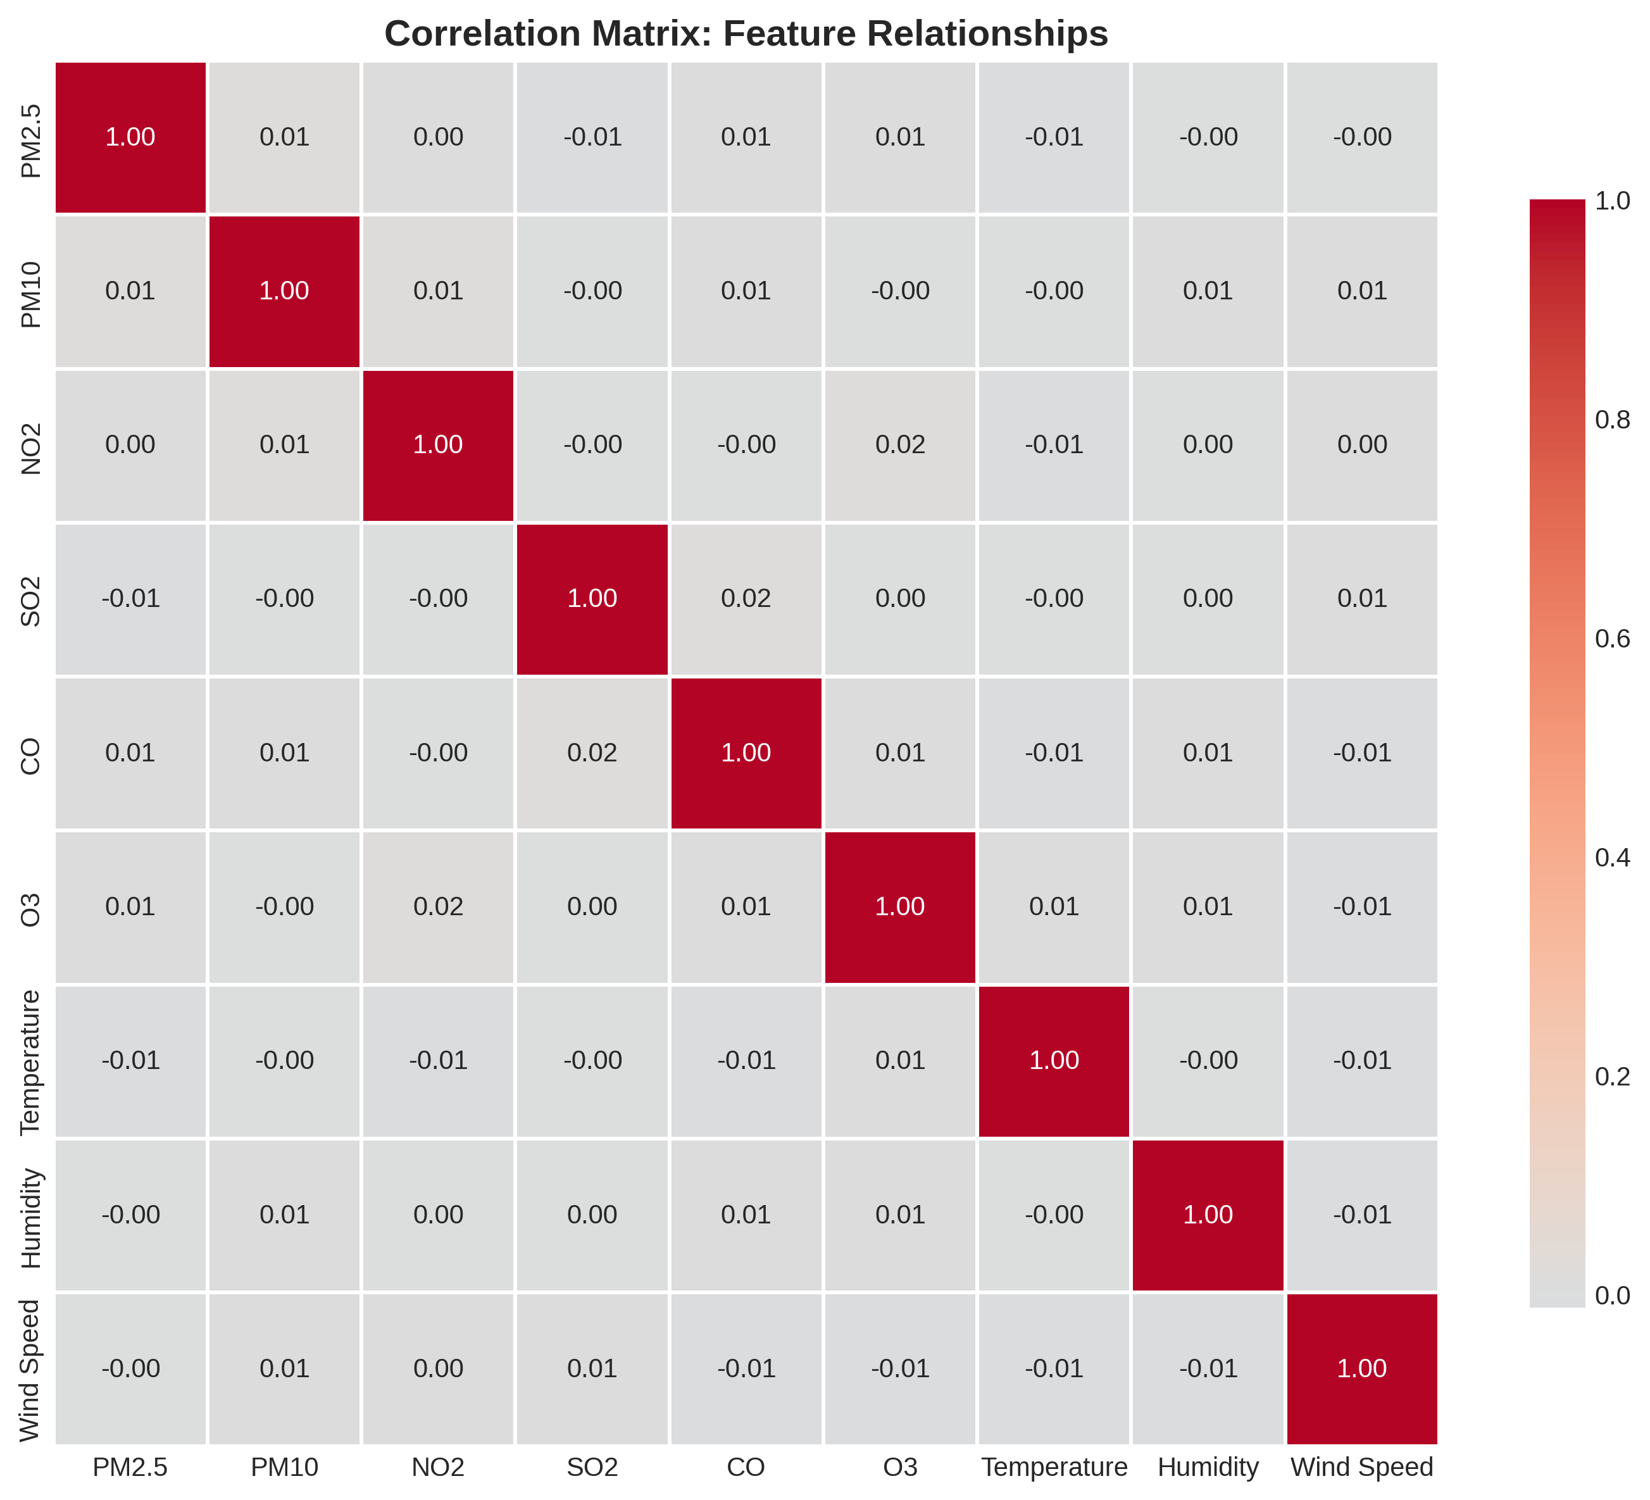

2.2 Temporal Lag Feature
Air pollution values depend on previous time steps. To capture this behavior, a lag feature (PM2.5 from the previous hour/day) was added.

2.3 Weather Interaction Features
Environmental factors work together in real conditions. To capture these effects, interaction features were created such as:
- Wind × Humidity
- Wind × Temperature
- Humidity × Temperature

Step 3: Optimized Model (After Optimization)
After feature engineering, the model was switched to LightGBM. LightGBM uses a leaf-wise tree growth strategy, which allows it to learn complex non-linear patterns more efficiently.
Optimized Model Summary:
- Algorithm: LightGBM
- Features used: 18
- Training Time: 0.46 seconds
- R² Score: -0.0309
- MAE: 36.01
- RMSE: 41.93

Feature Importance Analysis
Feature importance analysis shows that lag features and weather interactions play a major role in predicting PM2.5 values.
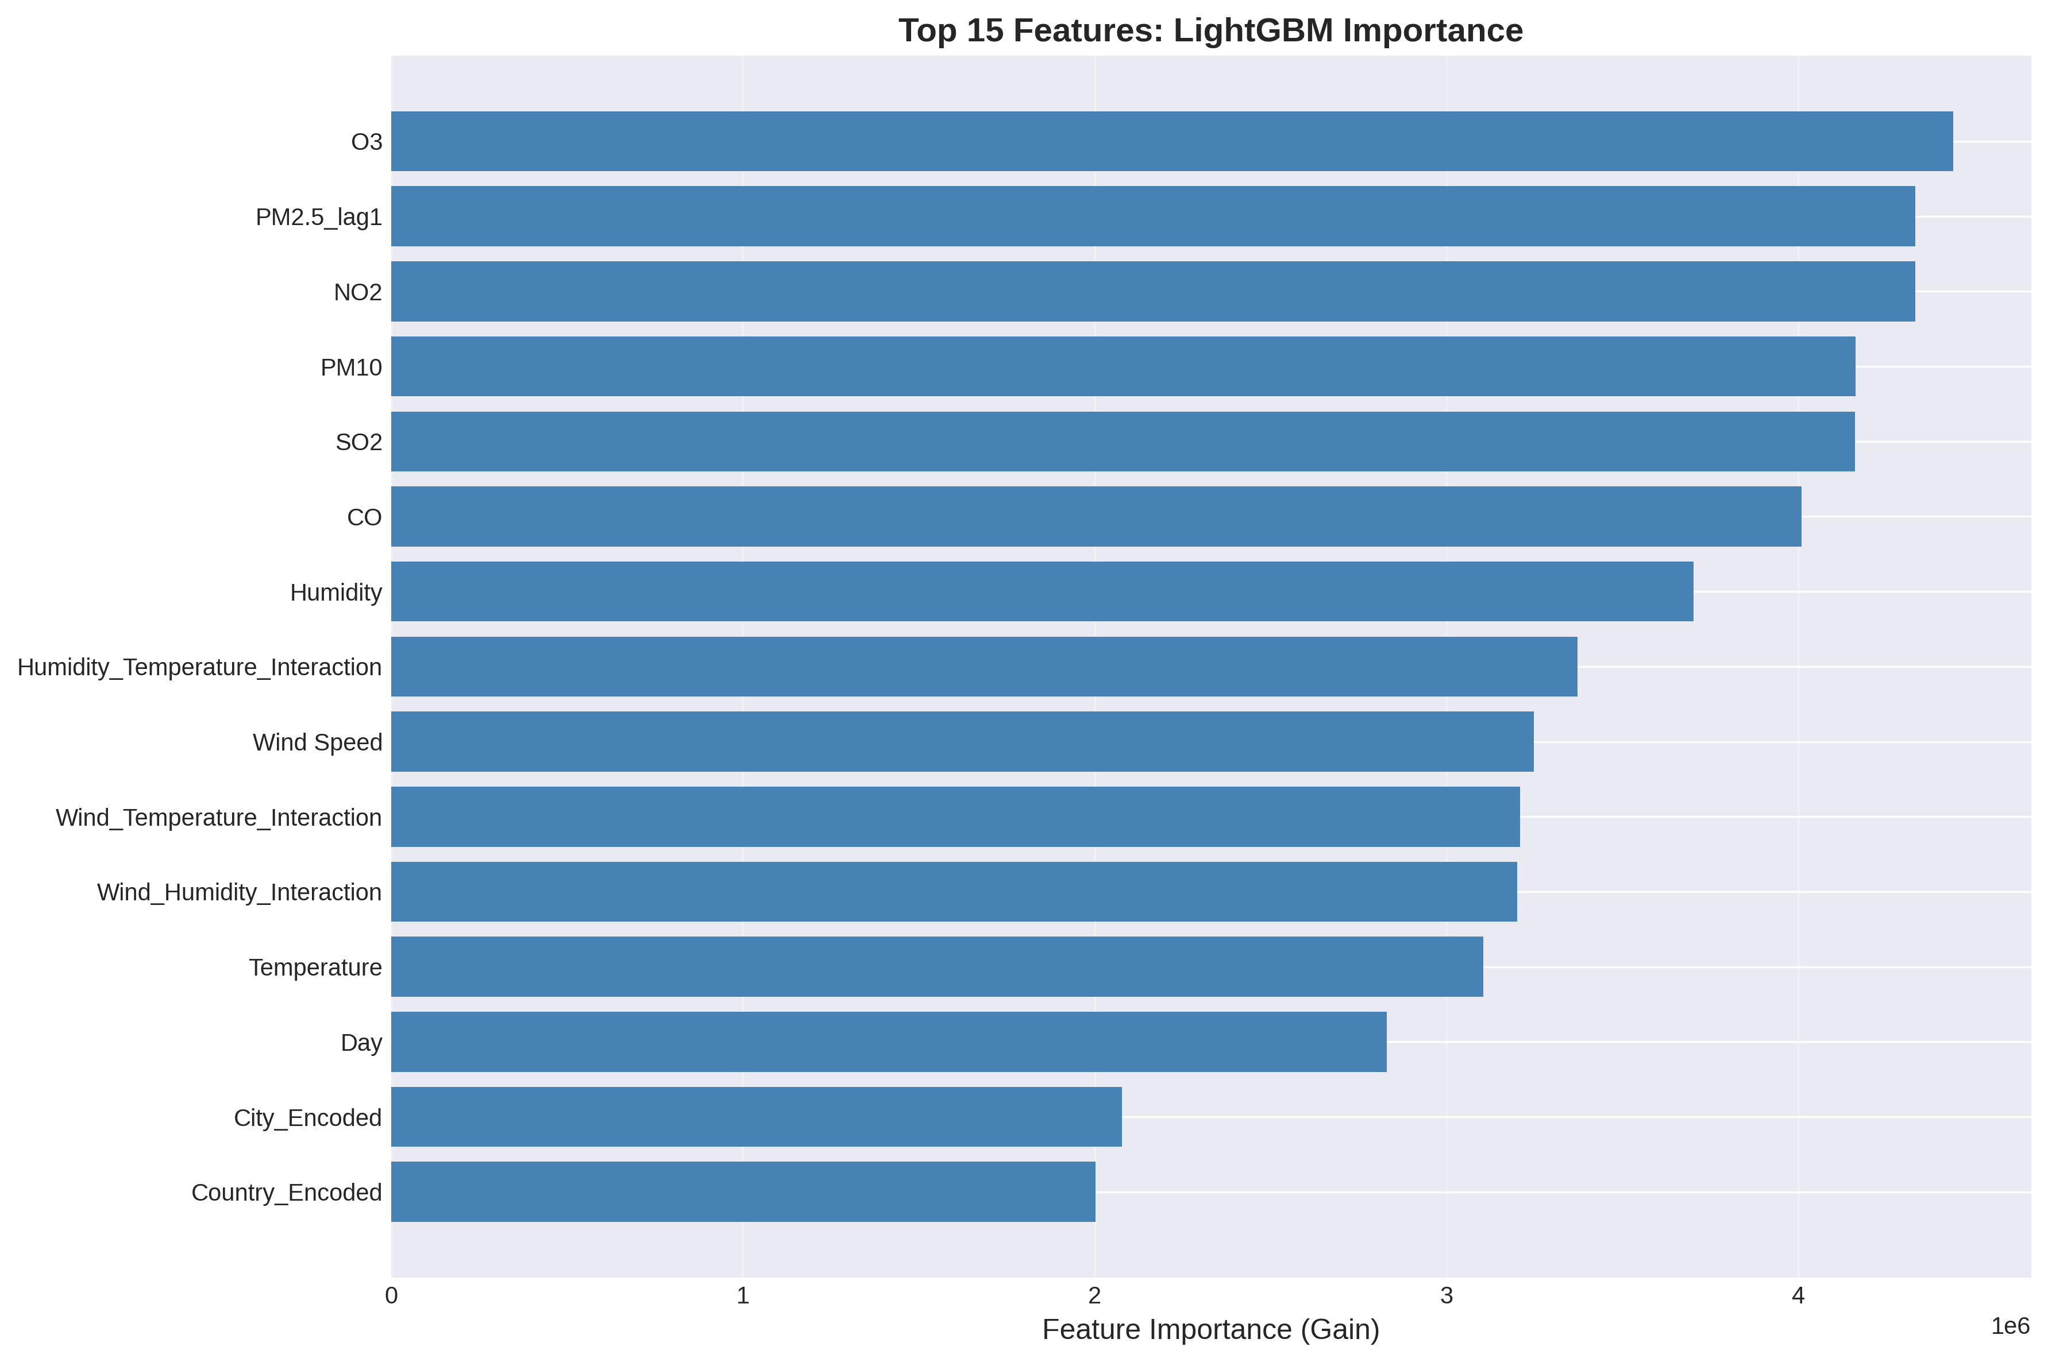

Step 4: Performance Comparison
A direct comparison between the baseline and optimized models highlights significant efficiency improvement while maintaining similar accuracy.
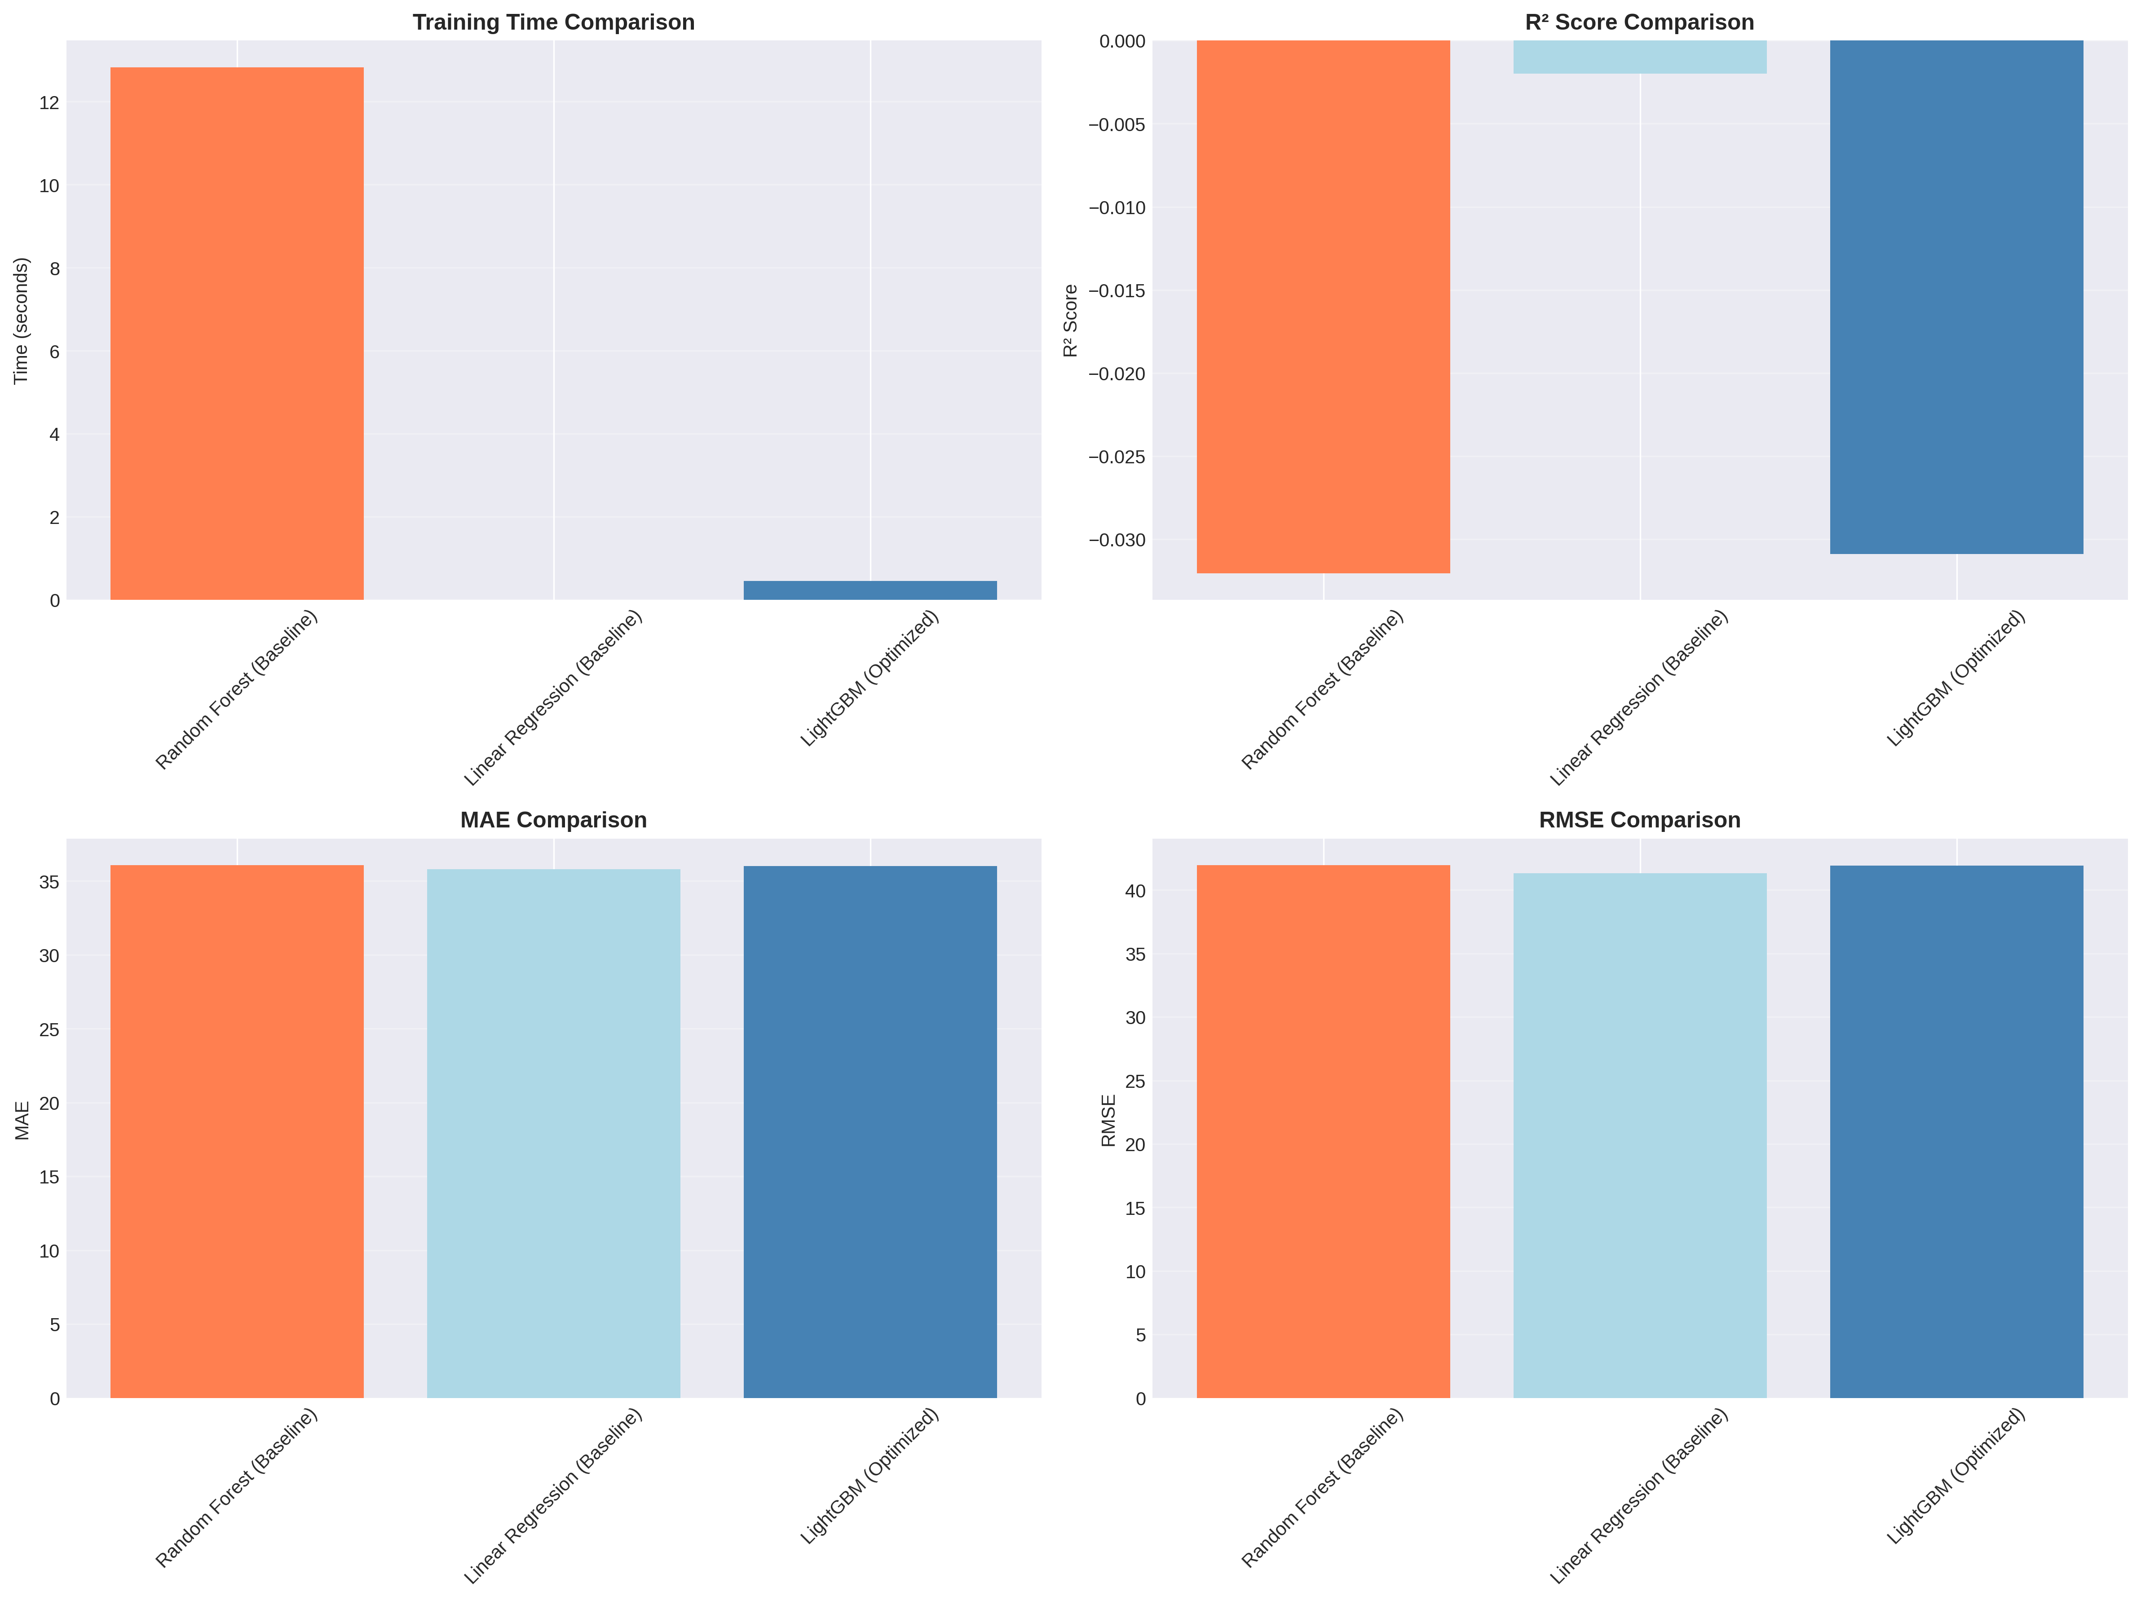
Performance Improvements:
- Training Time improved by 96.45%
- R² Score improved by 3.65%
- MAE improved by 0.17%

Why This Result Is Important
1. Faster Training: LightGBM dramatically reduced training time.
2. Better Feature Design: Lag and interaction features improved learning quality.
3. Reduced Noise: Weak features were removed to avoid overfitting.
4. Realistic Modeling: Weather interactions reflect real environmental behavior.
5. Scalable Pipeline: Suitable for large datasets with millions of records.

