Concrete Crack Segmentation and Severity Estimation
Using U-Net: A Comparison of Random and Pretrained Encoder Initialization
Deep Learning Course Project
Mehtab Ahmed (PGD/DSAI/DEC-25/309192)

Introduction

Context
Concrete crack inspection in the built environment is still largely performed by a trained inspector visually examining a surface and recording a subjective judgement of severity. This approach is reliable at small scale but does not scale efficiently across large property portfolios, and it produces judgements that are difficult to compare consistently across inspectors, time, or sites. Computer vision offers a way to convert a visual inspection into a repeatable, quantitative measurement rather than a one-off subjective call.

Research Gap
Most publicly available crack-detection work addresses one of two narrower problems: binary classification (crack present or not) or bounding-box object detection. Neither output directly supports a severity judgement, since neither measures the geometry of the crack itself. Pixel-level segmentation, combined with a geometric post-processing step that converts the mask into a width and coverage measurement, is comparatively less common in openly available course-level implementations, despite being the more natural fit: cracks are irregular, connected regions rather than discrete, separately countable objects, which segmentation represents more faithfully than detection does.

Aim of the Study
This project has three aims: (1) build and train two U-Net segmentation models that are identical except for encoder initialization, one with randomly initialized weights and one with an ImageNet-pretrained MobileNetV2 encoder, in order to isolate and measure the effect of transfer learning on this task; (2) design a post-processing pipeline that converts a predicted crack mask into a quantitative severity tier using skeletonization and distance-transform-based width measurement; and (3) evaluate the resulting pipeline both on held-out data from the training distribution and on an independently captured photograph, to test how well the system generalizes beyond the dataset it was trained on.

Materials and Methods

Study Objects and Materials
The Crack Segmentation Dataset, distributed via Roboflow and accessed through Ultralytics' built-in dataset configuration, was used for all training and evaluation. The dataset consists of close-up photographs of cracked concrete and pavement surfaces, with a single annotated class (crack), originally labelled as polygon outlines. The working split used in this project consisted of 3,717 training images and 200 validation images.

Data Preparation
Polygon annotations were rasterized into single-channel binary masks (255 = crack, 0 = background) using OpenCV, since the segmentation architecture used requires pixel masks rather than polygon coordinates. Images were resized to 224×224 pixels using bilinear interpolation; masks were resized using nearest-neighbour interpolation to avoid introducing fractional, non-binary values at mask edges. All pixel values were normalized to the [0, 1] range before being passed to the model.

Study Design
A two-arm comparative design was used. Both arms share an identical U-Net decoder and an identical encoder depth and skip-connection structure (five resolution stages: 224, 112, 56, 28, 14, and a 7×7 bottleneck). The only difference between arms is the encoder's starting weights:
- Model A (From Scratch): a plain convolutional encoder with randomly initialized (Glorot) weights.
- Model B (Transfer Learning): a MobileNetV2 encoder pretrained on ImageNet (14,482,497 total parameters; 14,445,761 trainable), with all layers left trainable and fine-tuned jointly with the decoder from the first epoch.
Both models were trained on the same data, with the same augmentation, loss function, optimizer, and epoch budget, so that any difference in outcome is attributable to the encoder initialization rather than a confound elsewhere in the pipeline.

Interventions
Both models were trained using the Adam optimizer (learning rate 1×10⁻⁴), a batch size of 16, for up to 20 epochs. The 20-epoch cap was set to fit the computing time available on Google Colab rather than being triggered by the early-stopping callback (patience of 8 epochs on validation IoU) configured for the run; this distinction is addressed further in the Limitations section. A learning-rate reduction callback (factor 0.5, patience 4 epochs on validation IoU) was also used. To reduce overfitting on a moderately sized dataset, training images (but not validation images) were augmented with random horizontal and vertical flips, random 90-degree rotations, and random brightness/contrast jitter, with identical geometric transforms applied to each image and its corresponding mask to keep labels aligned.

Methods of Measurement and Calculation
Segmentation quality was measured using a combined Binary Cross-Entropy and Dice loss, chosen because crack pixels form a small minority of each image and a plain cross-entropy loss is prone to being dominated by the background class. Model performance was reported using the Dice coefficient, Intersection over Union (IoU), and binary pixel accuracy on the held-out validation set.
Severity was estimated from each predicted mask in two steps. First, the mask was reduced to a one-pixel-wide skeleton (its morphological centreline), and a Euclidean distance transform was used to measure the local width of the crack at each point along that skeleton, giving a maximum crack width and mean crack width in pixels, alongside the percentage of the image occupied by crack pixels. Second, these per-image measurements were converted into a three-tier severity label (Minor, Moderate, Severe) using cutoffs set at the 33rd and 66th percentiles of the maximum-width distribution observed across the validation set. These cutoffs are therefore relative to this dataset and camera setup, not calibrated to a physical millimetre standard, since no camera calibration data (fixed distance or reference object of known size) was available for this dataset.

Statistical Analysis
Final validation metrics for both models were compared descriptively on the same held-out set. Descriptive statistics (mean, standard deviation, and quartiles) were computed for the crack-width and area-coverage distributions used to derive the severity cutoffs. No formal significance testing was performed, as each model configuration was trained once rather than across multiple random seeds; this is acknowledged explicitly as a limitation in Section 4.4.

Results

Segmentation Performance Comparison
Table 1 reports final validation metrics for both models after 20 epochs of training. Contrary to expectation, the from-scratch model matched or marginally exceeded the pretrained model on every metric measured.
Metric | From Scratch | Pretrained (MobileNetV2)
Loss (BCE + Dice) | 0.278 | 0.296
Dice Coefficient | 0.759 | 0.742
IoU | 0.637 | 0.632
Binary Accuracy | 0.9909 | 0.9904
Table 1. Final validation metrics for both models after 20 training epochs.
Figure 1 shows validation loss and validation IoU across training. The pretrained model began training with a substantially higher IoU (approximately 0.48 at epoch 0) than the from-scratch model (approximately 0.07), consistent with the expectation that pretrained features provide a useful head start. However, the from-scratch model's IoU rose sharply within the first two epochs and overtook the pretrained model shortly afterward; from that point on, the two curves track closely, with the from-scratch model holding a small, consistent lead through to epoch 20. The loss curves show a similar pattern in reverse.
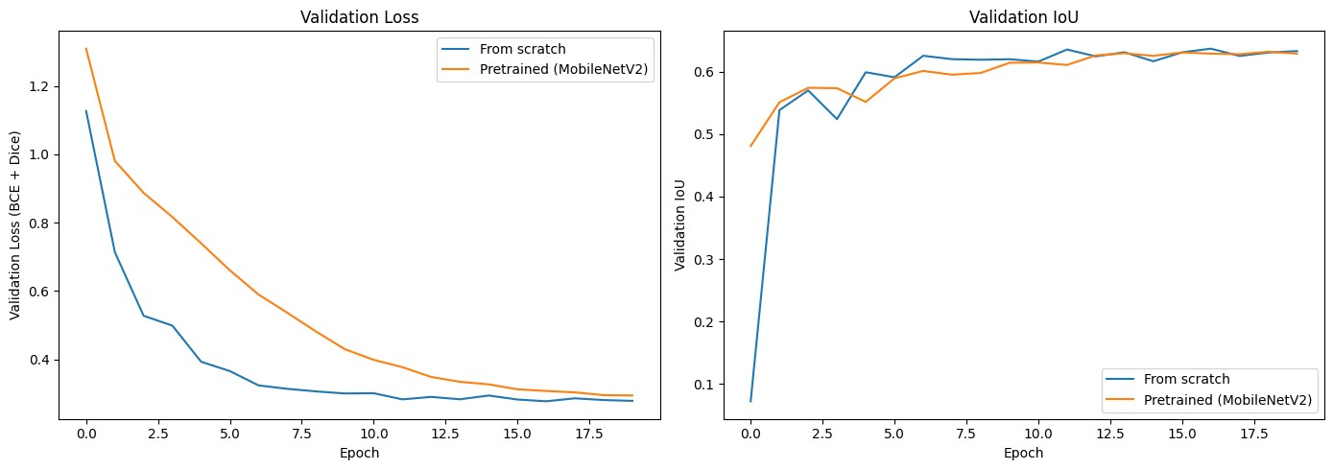
Figure 1. Validation loss (left) and validation IoU (right) across 20 training epochs, from-scratch model vs. pretrained (MobileNetV2) model.

Severity Quantification
Running the pretrained model over all 200 validation images produced a detectable crack mask in every image (200 of 200), consistent with the dataset containing only crack-positive images. From the resulting maximum-width distribution, severity cutoffs were set at 5.66 px (Minor/Moderate boundary) and 7.21 px (Moderate/Severe boundary). Table 2 summarizes the underlying distribution.
Statistic | Max Width (px) | Area Coverage (%)
Mean | 6.98 | 2.23
Std. Dev. | 2.74 | 1.01
Minimum | 4.00 | 0.70
25th percentile | 4.47 | 1.62
Median | 6.00 | 1.93
75th percentile | 8.25 | 2.51
Maximum | 20.88 | 8.23
Table 2. Descriptive statistics of maximum crack width and area coverage across 200 validation images (n = 200, all with a detected crack).
Applying these cutoffs to the same 200 images produced a severity distribution of 78 Severe, 70 Moderate, and 52 Minor cases, summing to the full validation set. Because every validation image contained a labelled crack, this evaluation does not include any true-negative (crack-free) surface, a point returned to in Section
4.4.

Qualitative Segmentation and Severity Output
Figure 2 shows the end-to-end pipeline output (predicted mask overlay, maximum width, area coverage, and severity label) on four validation images spanning different surface colours and textures. The predicted mask visibly follows the crack's irregular path in each case, and the resulting severity labels are consistent with the width cutoffs established in Section 3.2 (all four widths fall close to the 5.66 px and 7.21 px boundaries, explaining the mix of Minor, Moderate, and Severe labels shown).
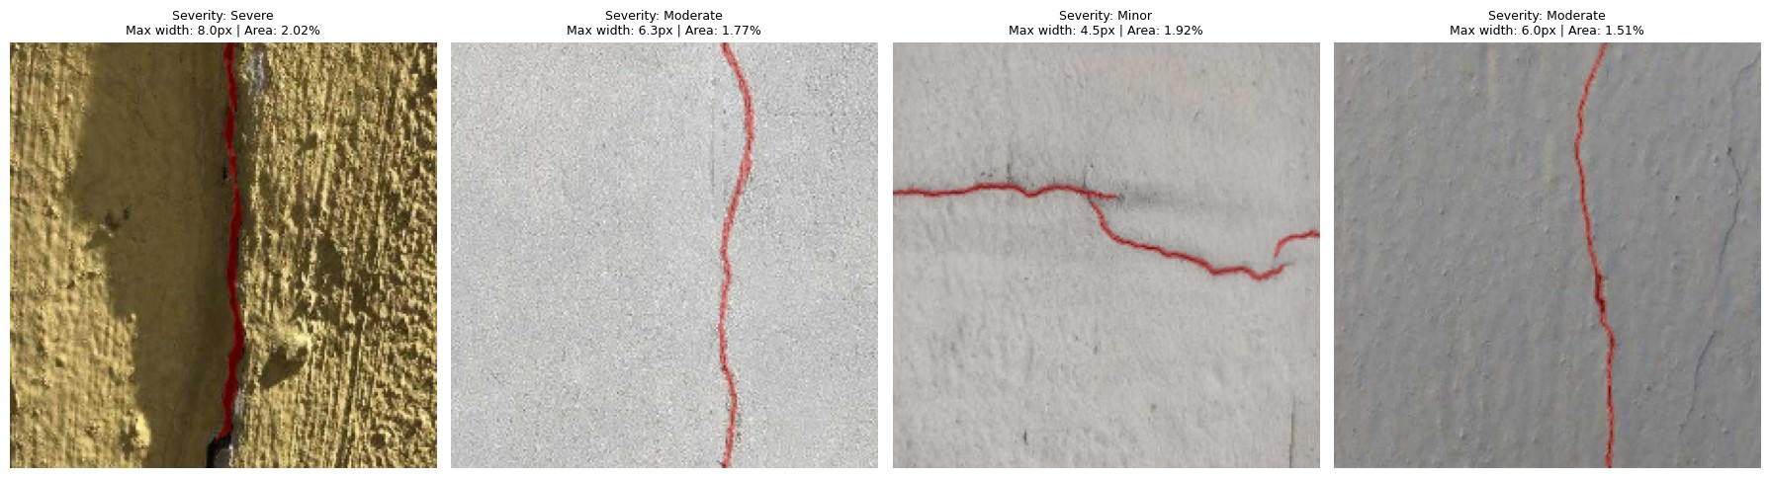
Figure 2. Pipeline output on four validation images of varying surface texture and colour, showing the predicted crack mask (red overlay) and resulting severity classification.

Generalization to an Independently Captured Photograph
As an exploratory test of generalization beyond the training distribution, a photograph of an actual wall crack, captured independently of the dataset, was submitted to the trained pipeline. In its original wide, full-room framing, the model reported no crack detected (0.0 px maximum width, 0.00% area coverage), despite a crack being clearly visible to a human viewer. The same crack, photographed with a tighter crop so that it occupied a larger proportion of the frame, was correctly detected and classified as Minor severity. Figure 3 shows the cropped photograph used in the successful detection.
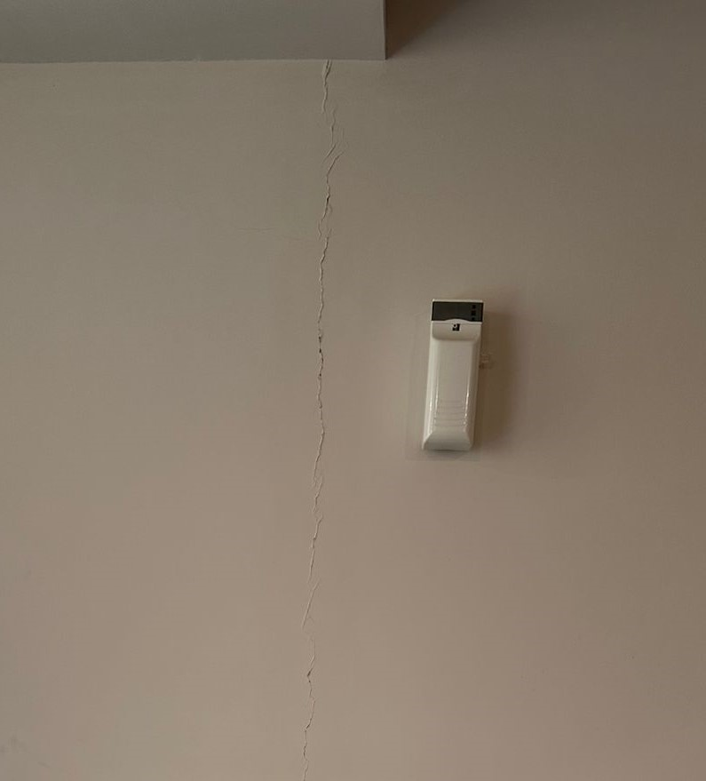
Figure 3. Independently captured photograph of a hairline wall crack, cropped tightly; correctly detected and classified as Minor severity by the trained pipeline. The same crack, in its original wide framing, was not detected (see Section 4.3 for discussion).

Discussion

Statement of Main Result
The main result of this project is that, within the tested 20-epoch budget, the from-scratch U-Net matched or marginally outperformed the ImageNet-pretrained MobileNetV2 U-Net on every validation metric (Dice, IoU, loss, and accuracy). This runs counter to the hypothesis motivating the study design, namely that a pretrained encoder would provide a measurable advantage over random initialization.

Expected vs. Observed Results
The training curves in Figure 1 show that the pretrained model's early advantage was real: at epoch 0, before any task-specific training had occurred, it already achieved a validation IoU roughly seven times higher than the from-scratch model, confirming that the pretrained features were indeed informative from the start. What was not expected was that this advantage narrowed and reversed within the first few epochs of training, rather than persisting or widening as training continued. This makes the result more specific and more interesting than a simple "transfer learning did not help" conclusion: transfer learning provided a clear initial benefit that was subsequently lost during training.

Comparison with Existing Literature and Explanation
The broader transfer-learning literature generally reports that pretrained encoders outperform randomly initialized ones, particularly on datasets of this size (a few thousand images). The result observed here is therefore more consistent with a specific, identifiable methodological cause than with a genuine limitation of transfer learning for this task. The most likely explanation is the fine-tuning schedule used: the pretrained encoder was left fully trainable and fine-tuned jointly with a randomly initialized decoder from the very first training step. Early in training, a randomly initialized decoder produces large, noisy gradients as it has not yet learned anything useful; because these gradients propagate back through the entire network, they can disturb or partially overwrite the pretrained encoder's features before the decoder has stabilized enough to make good use of them. This phenomenon is documented in the transfer-learning literature and is the reason a staged fine-tuning schedule, freezing the encoder while the decoder trains for several initial epochs, then unfreezing the encoder at a reduced learning rate, is commonly recommended rather than fine-tuning the full network from epoch one. That staged schedule was not implemented in this project, and its absence is the most plausible explanation for the observed result. Separately, the compressed 20-epoch training budget (Section 2.4) may not have given the pretrained model sufficient time to recover from this early disruption, even with the learning-rate reduction callback in place.
The wider use of segmentation-based, rather than purely detection-based, approaches to convert visual crack data into a severity judgement is consistent with concurrent work applying deep learning to multi-level crack severity classification in civil engineering inspection contexts, supporting the general framing adopted in this project even though the specific transfer-learning result obtained here diverges from what that broader literature would predict.

Limitations
- Training budget: both models were capped at 20 epochs due to available compute time on Google Colab, rather than being trained to convergence via the early-stopping callback. The validation curves appear to be flattening by the final epochs, but early stopping was not formally triggered, so full convergence cannot be confirmed.
- Single training run per configuration: each model configuration was trained once. No repeated runs across different random seeds were performed, so the observed from-scratch advantage cannot be statistically distinguished from run-to-run variance with the data currently available.
- No true-negative evaluation: all 200 validation images contained a labelled crack, so the model's false-positive rate on genuinely crack-free surfaces was not measured in this evaluation.
- Uncalibrated severity units: severity cutoffs are defined relative to the pixel-width distribution of this validation set, not calibrated to a physical millimetre standard, since no camera-distance or reference-object calibration data was available.
- Scale-dependent detection failure: the independent photograph test in Section 3.4 shows that a real crack, clearly visible to a human observer, was missed when captured in a wide, full-room frame, most likely because resizing the full image down to the model's 224×224 input resolution reduced the crack to a sub-pixel width before the model ever processed it. The same crack was correctly detected once cropped tightly. This indicates a resolution and capture-distance limitation rather than a failure to recognize crack morphology in general.
- Single combined mask per image: the U-Net architecture used produces one mask per image rather than separating individual, distinct cracks the way an instance-segmentation approach would; two nearby but separate cracks would currently be reported as a single connected region.

Generalizability
The qualitative results in Section 3.3 suggest the model generalizes reasonably well within the domain it was trained on, close-up photographs of concrete or pavement surfaces, across a range of surface colours and textures. Generalization outside that domain is currently weaker, as demonstrated directly in Section 3.4: a photograph of an interior painted wall, captured from typical room-scale distance rather than as a close-up, was missed entirely, while the same crack captured at a closer distance was correctly identified. In practical terms, this suggests the current model is best suited to photographs deliberately captured close to the surface of interest, and that generalizing to arbitrary, unconstrained photographs would likely require either additional training data representative of those conditions, or a pre-processing step (such as tiling a wide photograph into closer-range sections before inference) to keep cracks at a resolvable scale.

Conclusions
This project produced a complete, working pipeline that takes a raw photograph, segments any visible crack at the pixel level, measures its geometry, and assigns an interpretable severity label, built and trained within a constrained compute and time budget. The specific benefit expected from transfer learning was not observed in this run; the from-scratch model performed marginally better on every quantitative metric. The evidence gathered (in particular the pretrained model's strong initial IoU followed by a reversal early in training) points to the joint, unstaged fine-tuning schedule as the most likely cause, a fixable methodological choice rather than evidence that pretrained features are unhelpful for this task. The severity-quantification layer adds genuine interpretability beyond a plain detection output, converting a mask into a number that can be tracked, compared, and audited over time, though its current scope is explicitly relative rather than calibrated to physical units, and its reliability depends on the photograph being captured at a scale similar to the training data. Addressing the domain-shift and calibration limitations identified here would be the logical next step before this pipeline could be considered for any real inspection use.

