**Defining Tomcat SSL in both DM/DE**

1: Log into bdmssup6 server.

2: Navigate to the DM/DE server in which we need to define SSL(Instance should not be running):

i- Go to $JAVA_HOME and do “cd bin” (For eg “/home/bdadmin/dec_home_DE_Vivek/jdk/bin”)

ii- Run below command to generate Keytool and keytool password.

keytool -genkey -alias tomcat -keyalg RSA -keystore /home/bdadmin/dec_home_Vivek_6.11.0.6/app/decision

- Replace the yellow highlighted path with your respective file location (Here “decision” is the keytool file)

when you run above command it will ask to create the keystore password followed by some security questions as shown in the screen shot below:

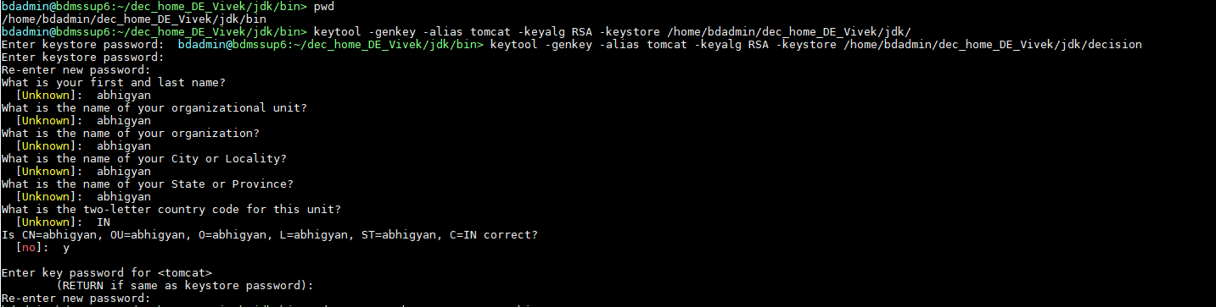

iii - Run below command to validate the keystore generated:

Run the command being in the same directory where you have created the keystore file.

“keytool -list -keystore decision”

System will ask for password provided while creating the keystore file and once entered the correct password the below result should appear on the screen.

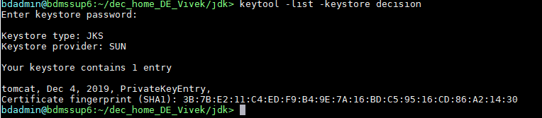

3. Now navigate to “conf” folder of tomcat:

Eg: /home/bdadmin/dec_home_DE_Vivek/apache-tomcat-8.5.47/conf

4: Update the server.xml file using vi editor to add the below block:



Lines need modification:

i) Connector port={Add a unique port number}

ii) keystoreFile={Add path of the keystore file}

ii) keystorePass={Add Password given at time of creating keystore file}

5: Now start the DE tomcat using ./startBdes.sh

6: Test the DE url using https:

