Introduction :

It is a website developed for an institute named SIES GST termed as SIES GST Portal. It was developed in order to make various task easy and to increase the efficiency of a staff at institute.

Various features :

1. Attendance Management System.
2. Online Application for railway concession.
3. All the university and college updates given at a distinct page. All sorted in a presize manner.

This project is now at alpha version. Technology used for UI here is materialize css. It is group project and will be completed in a coming month.

Design and Implementation :

When you go on to this website you need to login using your google account. This google account is created by the college authorities hence those email id are only allowed to login. After you finish login you will landed on the home page that will consist of latest updates by college. Using navigation bar you can bar you can navigate to different web where you can see your attendance, your profile and other recent updates.

Difficulties faced :

There was a lot of discussion on which ui framework to be used. After considering some aspects we decided to use materialize css for front end. Another big challenge was weather to use nodejs or php for server side. We all decided to go for nodejs.

Modules and libraries used :

Materialize css as a front end tool. Nodejs as back end tool. Packages used like passportjs, mongoose. Backend framework used is expressjs. Database used is mongodb. For live reloading we used nodemon. We are also using embedded javascript to make our work more easier.

Here are some Screenshots :

|

|

|

\/

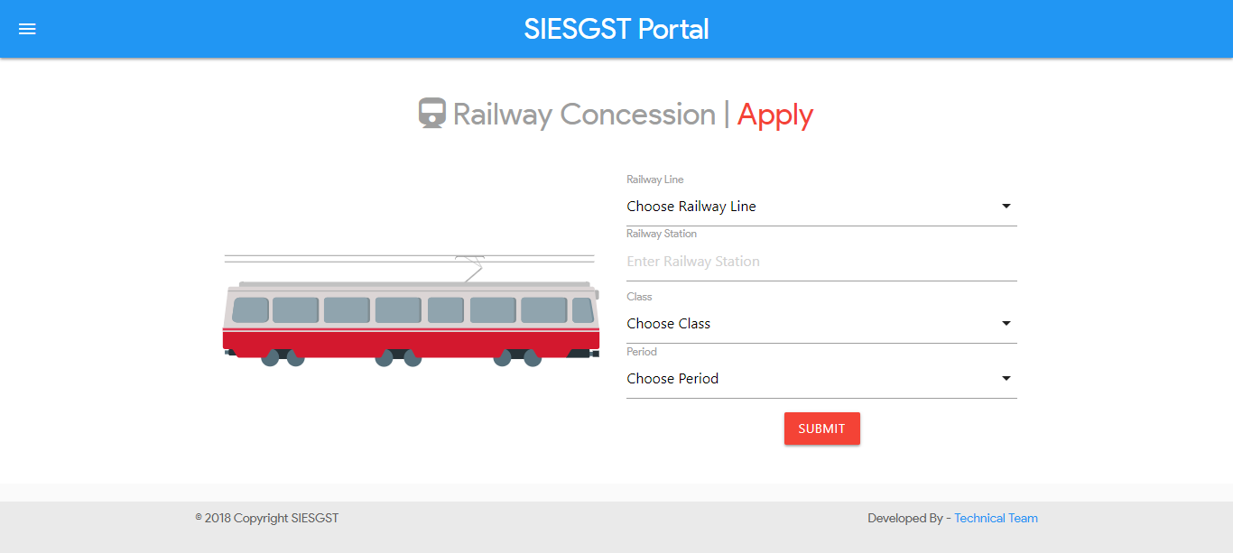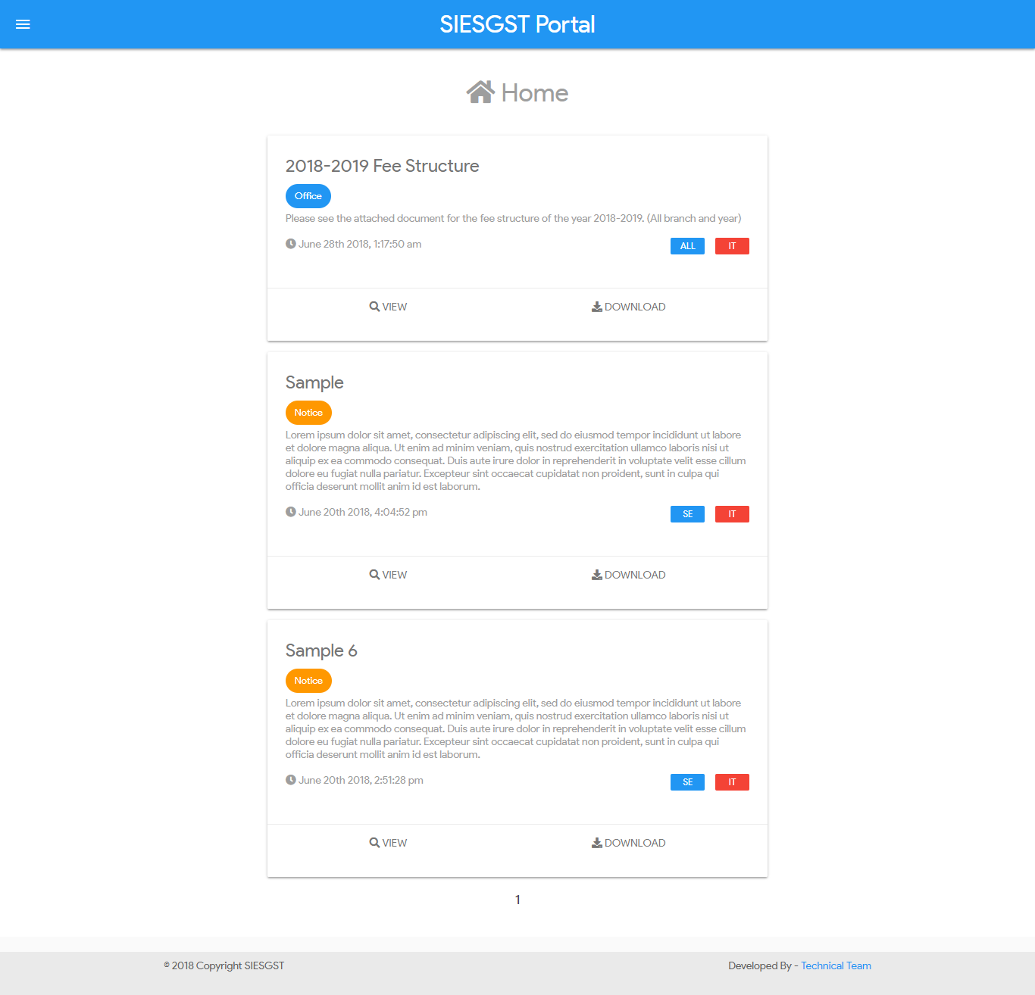

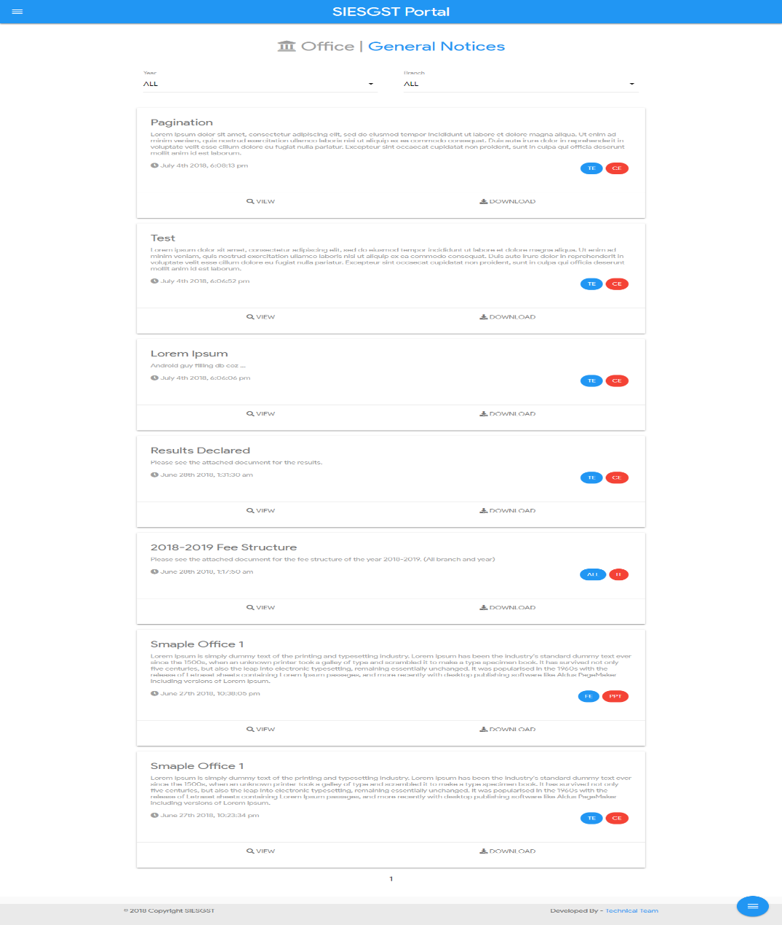

Conclusion :

This project helped me learn following things :

I learnt a new front end framework that is materialize css.

I learnt to work with a team and taking dicissions as per the team.

Learning any new technology as fast as possible.

Implementing and testing a website.

New attendance management feature coming soon.

References :

Materilaize css documentation.

Nodejs and mongodb documentation.

Stackoverflow.

Coursera courses.