Terrorism Data Analysis
Submitted in partial fulfillment of the requirements
of the degree of

Bachelor of Engineering
in
Information Technology
by
Vivek Iyer 116A3020
Dhiraj Mehta 116A3031
Karthik Mudaliar 116A3034

Under the Guidance of:
Ms. Seema Redekar



Department of Information Technology
SIES graduate School of Technology
2019-2020
CERTIFICATE

This is to certify that the R Mini project entitled “Terrorism Data Analysis” is a bonafide work of the following students, submitted to the University of Mumbai in partial fulfillment of the requirement for the award of the degree of Bachelor of Engineering in Information Technology.

Vivek Iyer 116A3020
Dhiraj Mehta 116A3031
Karthik Mudaliar 116A3034

Ms. Seema Redekar Ms. Lakshmi Sudha Dr. Atul Kemkar
Internal Guide Head of Department Principal
PROJECT REPORT APPROVAL

This R Mini project report entitled Terrorism Data Analysis by following students is approved for the degree of Bachelor of Engineering in Information Technology.
Vivek Iyer 116A3020
Dhiraj Mehta 116A3031
Karthik Mudaliar 116A3034

Name of External Examiner: --------------------------------
Signature:--------------------------------
Name of Internal Examiner: --------------------------------
Signature:--------------------------------
Date:
Place:
DECLARATION
I declare that this written submission represents my ideas in my own words and where others’ ideas or words have been included, I have adequately cited and referenced the original sources. I also declare that I have adhered to all principles of academic honesty and integrity and have not misrepresented or fabricated or falsified any idea/data/fact/source in my submission. I understand that any violation of the above will be cause for disciplinary action by the Institute and can also evoke penal action from the sources which have thus not been properly cited or from whom proper permission has not been taken when needed.

Vivek Iyer 116A3020 _____________

Dhiraj Mehta 116A3031 _____________

Karthik Mudaliar 116A3034 _____________

Signature

Date:
ACKNOWLEDGEMENT

It gives us immense pleasure to thank Dr. Atul Kemkar, our Principal for extending his support to carry out this project. We also thank to our Head of Department Ms. Lakshmi Sudha for her support in completing the project. We wish to express our deep sense of gratitude and thank to our Internal Guide, Ms Seema Redekar for her guidance, help and useful suggestions, which helped in completing our project work in time.
Also we would like to thank the entire faculty of Information Technology Department for their valuable ideas and timely assistance in this project, last but not the least, we would like to thank our non-teaching staff members of our college for their support, in facilitating timely completion of this project.

Project Team
Vivek Iyer
Dhiraj Mehta
Karthik Mudaliar
ABSTRACT
Terrorism has been rising from the last few decades. Rise in terrorism may lead to the disturbance in international peace and may lead to a heavy loss of economy and life of a nation. Hence it is important to understand the pattern followed by the terrorist to attack different countries.
In this project we collect a terrorism data from Global Terrorism Database. Based on the queries that can help us to find the active terror group and most affected nations, we had plan to visualize the data in the graphical format. This technique will help us to understand about different terror organization and their targeted countries. We also plan to study about the number of attacks done by each terror organization on the country. This may help to find the targeted countries of the given terror organization and will also help countries to be aware of such terror groups.

Contents
 |  | Page No.
Chapter 1 | Introduction | 5
 | Terrorism Data Analysis Concept | 5
Chapter 2 | Review of Literature | 6
Chapter 3 | Report on Present Investigation | 7
Chapter 4 | Study of various target boards and Sensors | 8
 | R Programming Language | 8
 | RStudio | 9
 | Global Terrorism Database | 9
Chapter 5 | Report on Proposed system and its implementation | 10
Chapter 6 | Code | 11
Chapter 7 | R Setup | 13
Chapter 8 | Output and Discussion | 14
Chapter 9 | Conclusion | 18
References |  | 19

List of Figures
Figure  No. | Figure Caption | Page  No.
4.1 | R Logo | 8
4.2 | RStudio Logo | 9
7.1 | R Environment Setup | 13
8.1 | CSV Data | 14
8.2 | Maximum Attack | 14
8.3 | Pie Chart | 15
8.4 | Number of Attacks by Terror Groups | 15
8.5 | Terror groups in Pakistan | 16
8.6 | Number of Attacks done on the different countries | 16
8.7 | Number of terror attacks done by different terror groups on different countries | 17

List of Abbreviations

GNU | GNU’s Not UNIX
GTD | Global Terrorism Database

Chapter 1
Introduction
Terrorism has been rising from the last few decades. Rise in terrorism may lead to the disturbance in international peace and may lead to a heavy loss of economy and life of a nation. Hence it is important to understand the pattern followed by the terrorist to attack different countries.
We accomplish our goal by doing data analysis using R programming language. R is a programming language and free software environment for statistical computing and graphics supported by the R Foundation for Statistical Computing. The R language is widely used among statisticians and data miners for developing statistical software and data analysis. As R is readily available with inbuilt functions to generate graph, it helps us to focus more on analysis without worrying much about visualization.
The collected dataset have the three columns, The definition for each column is as given below.
- Column 1: It consist of name of terrorist organizations.
- Column 2: It consist of countries on which corresponding terror groups have attacked.
- Column 3: Number of attacks done by the terror organization on the corresponding country.
The collected data is visualized based on different queries using pie chart, bar plot and more.

Chapter 2
Review of Literature
These papers will review the literature related to this area of study. This provides background to the research, thus providing the necessary backbone.
Lavanya Venkatagiri Hegde [1] Terrorist attacks are on the rise in the last few decades. As we look for alternative methods to address this problem, Social Network Analysis (SNA) offers promising techniques among which visual analytics combines the best of statistical analysis with human n ability to visually recognize hidden patterns and trends in terrorist events and networks. In this paper, we present our work on visual analytics of terrorism in India. Since structured data is not readily available for such analysis, we show how data extracted from online news articles and tweets can be integrated with the Global Terrorism Database (GTD) to produce promising results.
Anthony Scime [2] This research demonstrates the application of multiple data mining techniques to test theories of the macro-level causes of terrorism. The unique dataset is comprised of terrorist events and measures of social, political and economic contexts in 185 countries worldwide between the years 1970 and 2004. The theories are assessed using the iterative expert data mining (IEDM) methodology with classification mining and then association mining. The resulting 100 rules suggest that the level of democracy in a country is an integral part of the explanation for terrorism. This research shows that a multi-method data mining approach can be used to test competing theories in a discipline by analysing large, comprehensive datasets that capture multiple theories and include large numbers of records.
M Nasir [3] The phenomenon of terrorism has riveted world's unwavering attention since 9/11. The underlying study investigates the determinants of terrorism in the South Asian region. Applying negative binomial regression, the study finds that both political structure and economic conditions are responsible for terrorism. On the economic front, relative deprivation represented by income disparity is the major cause of terrorism. On the other hand, deprivation of the people of their political rights and civil liberties, exhibited by political repression, compels them to be involved in terrorist activities. Our findings illustrates that high literacy rate is one of the foremost reason for terrorism in the region.
Chapter 3
Report on present investigation
Due to increase in terrorism in a last few decade, it is important to understand and analyse the pattern of the different terror organizations. In order to do this, we visualize data from the dataset collected.
In the study we studied about different terror groups. It helped us to understand the most targeted countries. Visualizing was done with different methods such as boxplot, piechart, geometric plot and more.
- It helped us to understand about active terror groups
- We can get the most targeted nation.
- We can understand about the maximum number of attacks done by the given terror groups.
- It gives the visualization of how many attacks are done by the given terror groups on which country.

Chapter 4
Programming Language Used
- R language: [4] R is a language and environment for statistical computing and graphics. It is a GNU project which is similar to the S language and environment which was developed at Bell Laboratories (formerly AT&T, now Lucent Technologies) by John Chambers and colleagues. R can be considered as a different implementation of S. There are some important differences, but much code written for S runs unaltered under R.
R provides a wide variety of statistical (linear and nonlinear modelling, classical statistical tests, time-series analysis, classification, clustering, …) and graphical techniques, and is highly extensible. The S language is often the vehicle of choice for research in statistical methodology, and R provides an Open Source route to participation in that activity.
One of R’s strengths is the ease with which well-designed publication-quality plots can be produced, including mathematical symbols and formulae where needed. Great care has been taken over the defaults for the minor design choices in graphics, but the user retains full control.



Fig. no. 4.1 R Logo

Tools Used

- [5] RStudio : It is an integrated development environment (IDE) for R, a programming language for statistical computing and graphics. It is available in two formats: RStudio Desktop is a regular desktop application while RStudio Server runs on a remote server and allows accessing RStudio using a web browser. The RStudio IDE is developed by RStudio, Inc., a commercial enterprise founded by JJ Allaire,^{[17]} creator of the programming language ColdFusion. RStudio, Inc. has no formal connection to the R Foundation, a not for profit organization located in Vienna, Austria,^{[18]} which is responsible for overseeing development of the R environment for statistical computing.


Fig. no. 4.2 RStudio Logo

Dataset used
- [6] Global Terrorism Database: The Global Terrorism Database (GTD) is an open-source database including information on terrorist events around the world from 1970 through 2017 (with annual updates planned for the future). Unlike many other event databases, the GTD includes systematic data on domestic as well as international terrorist incidents that have occurred during this time period and now includes more than 180,000 cases.

Chapter 5
Proposed System
Terrorism has been rising from the last few decades. Rise in terrorism may lead to the disturbance in international peace and may lead to a heavy loss of economy and life of a nation. Hence it is important to understand the pattern followed by the terrorist to attack different countries.
We propose a solution from which we can identify the terrorist pattern and can understand about the most targeted countries. This will help the countries to be aware of the given set of terrorist groups. Our system also helps use visualize data based on the dataset collected.
Our system visualize data in different format such as pie chart, bar graph, boxplot, and more. It helps use find minimum and maximum attacking terror group, we can also identify how the number of attacks are related to countries where attack have taken place. Hence, we can visualize and understand the basic terror pattern from our system.

Chapter 6
Code
[7]
#"
# Analysis on terrorist dataset. Dataset inlcudes three colunms.
# --> 1st Colunmn = Terrorist Organization
# --> 2nd Colunmn = Country name (it is the name of the country in which the corresponding org. attacked)
# --> 3rd columnn = Number of atrakcs done by the terror org
#"

library(plotrix)

# Read csv data
csvData = read.csv('terrorist_data.csv', sep = ',')
print(csvData)

# get the details of the country which has maximum number of attacaks
maxAttack = subset(csvData, Number.of.Attacks == max(as.numeric(as.character(Number.of.Attacks))))
print(maxAttack)

# pie chart for number of attacks done by the given terror organization
pieData = subset(csvData, Number.of.Attacks > 10)
# print(pieData)
terOrg = pieData$Terrorist.Organization
# print(terOrg)
noOfAttacks = pieData$Number.of.Attacks
# print(noOfAttacks)
pie(noOfAttacks, labels = terOrg, main = "Pie chart of attacks done by the various terrorist organization.")

# Bar plot for which organiztion had done how many numbers of attack
par(mar=c(13, 6, 6, 6)) # Change the margin of bar to display it completely
barplot(noOfAttacks, names.arg = terOrg, main = "Bar plot for which organiztion had done how many numbers of attacks", ylim = c(0, 100), xlab = "Terrorist Organization", ylab = "Number of Attacks", las = 2)
country = pieData$Country
barplot(c(terOrg), name.arg = country, main = "Number of Terrorist Organization attacked the given Countries", las = 2, xlab = "Country", ylab = "Terrorist Organization")

# analysis for terror groups in pakistan and number of attacks done by each terror group
par(mar=c(13, 6, 6, 6))
pakData = subset(csvData, Country == "Pakistan")
barplot(pakData$Number.of.Attacks, names.arg = pakData$Terrorist.Organization, ylim = c(0, 20), main = "Bar for plot for terror groups in Pakistan", xlab = "Terror Groups in Pakistan", ylab = "No. of Attacks.", las = 2)

# analysis on which country have how many number of terror attacks.
par(mar=c(7, 3, 3, 3))
tableData = table(csvData$Country)
barplot(tableData, las = 2, ylim = c(0, 40))

# Visualization for number of attacks done by which country and which terror organization
ggplot(data = pieData, mapping = aes(x = Country, y = Number.of.Attacks)) +
geom_point(aes(color = Terrorist.Organization)) +
geom_jitter(alpha = 0.3, color = "tomato") +
theme(axis.text.x = element_text(angle=270)) +
labs(title = "Attacks made by given Terrorist Organization on given Countries",
x = "Country",
y = "Number of Attacks")
Chapter 7
R setup

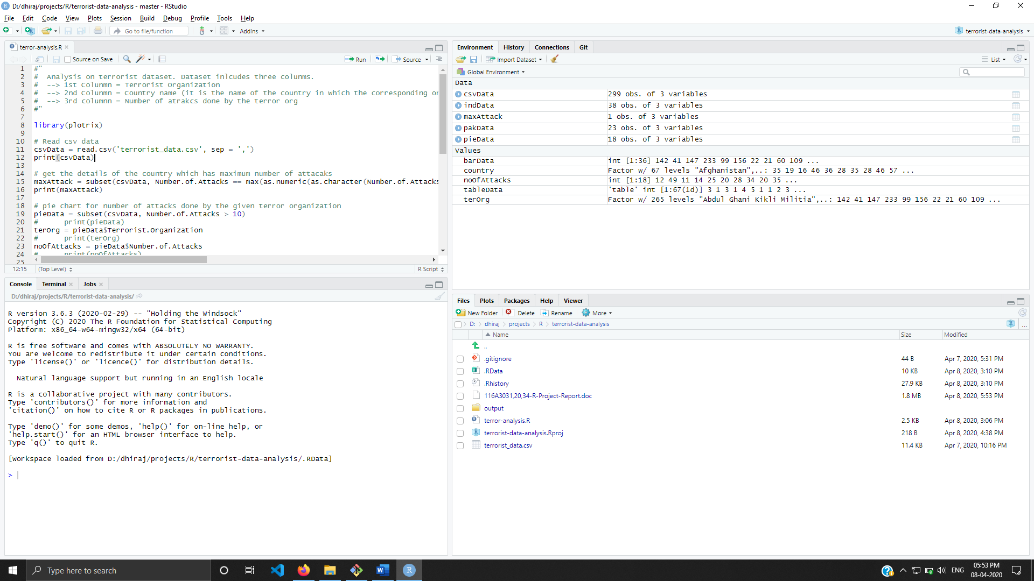

Fig 7.1 R Environment Setup

Chapter 8
Output
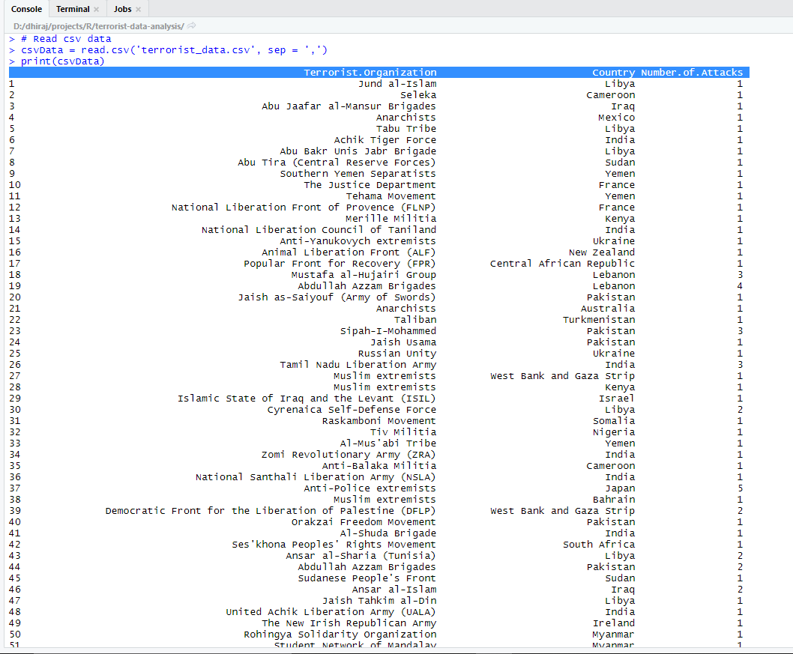
Fig 8.1 CSV Data

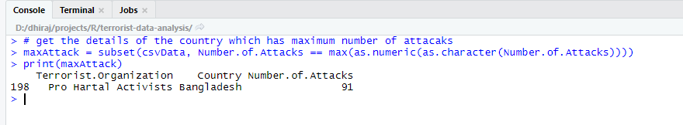
Fig 8.2 Maximum attack

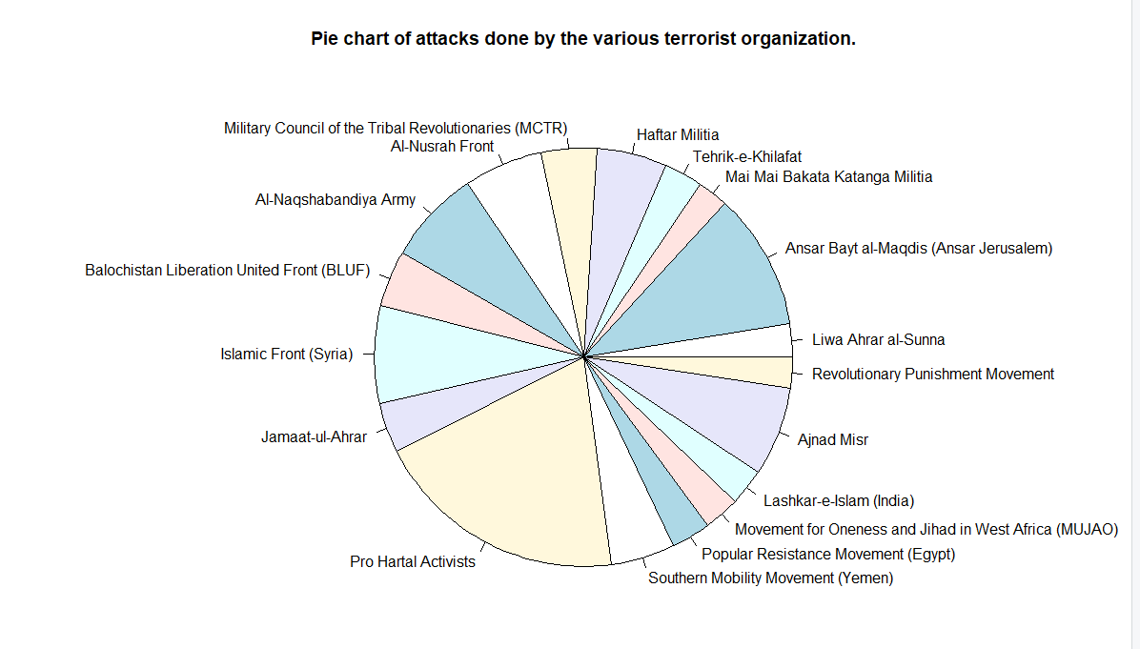
Fig 8.3 Pie Chart
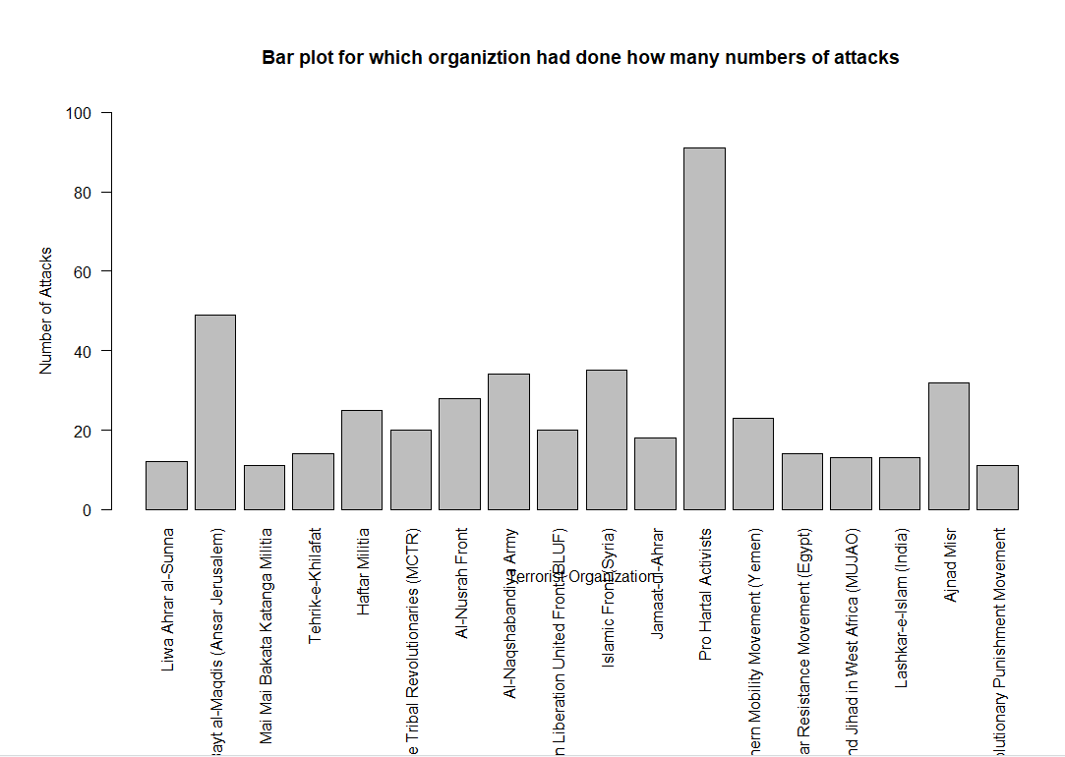
Fig 8.4 Number of attacks by terror groups.

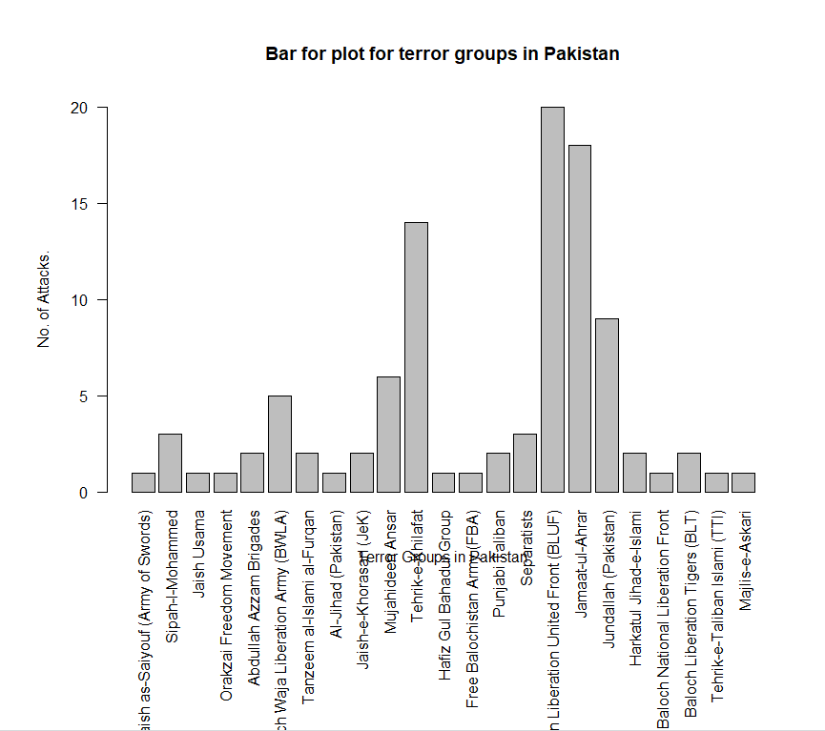
Fig 8.5 Terror Groups in Pakistan
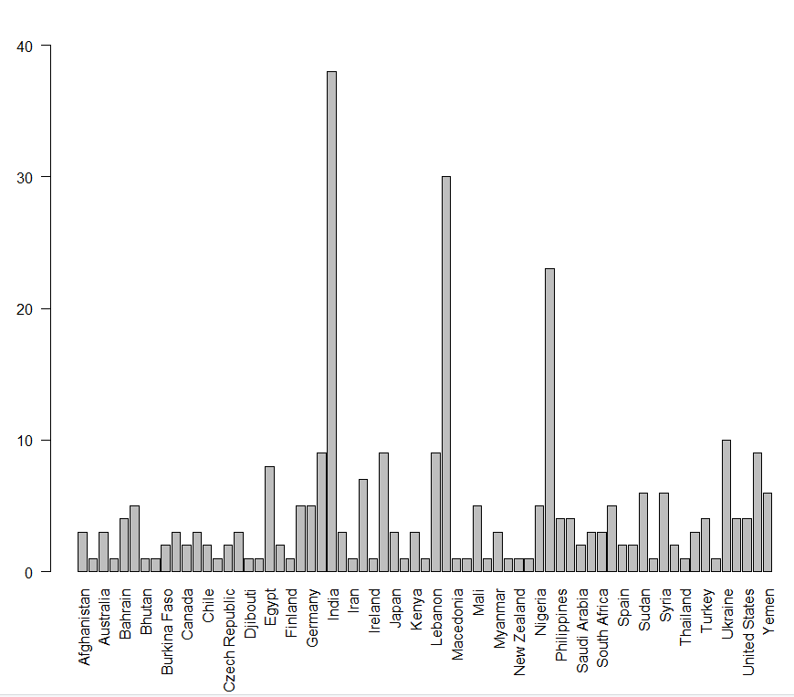
Fig 8.6 Number of Attacks done on the different countries
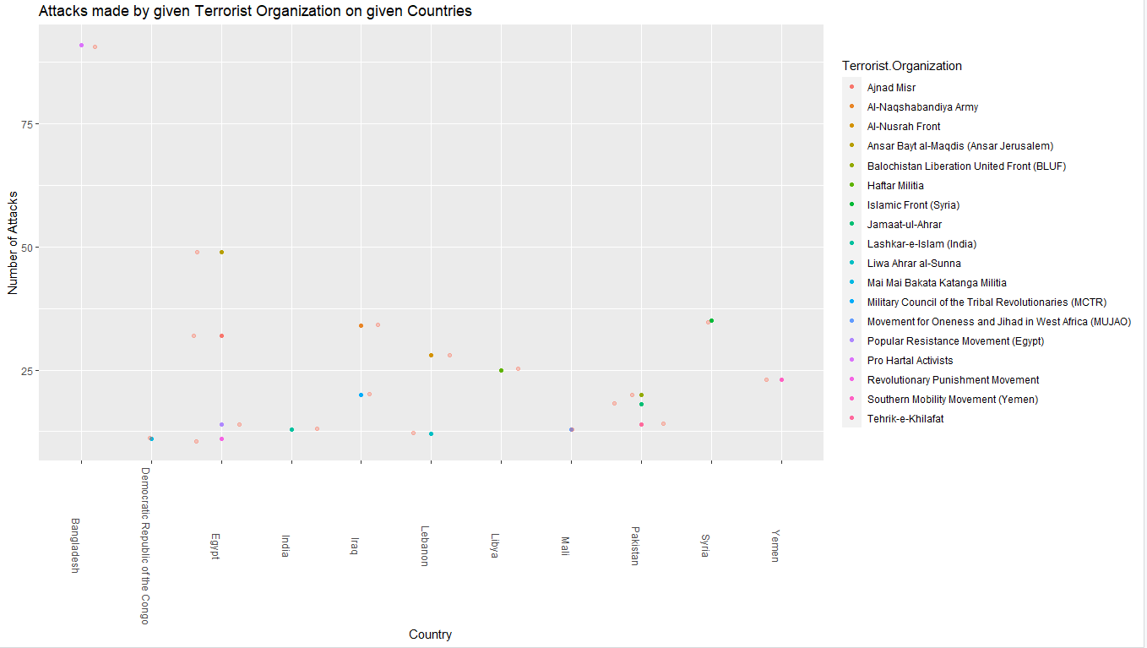
Fig 8.7 Number of terror attacks done by different terror groups on different countries

Chapter 9
Conclusion
Hence, we used different techniques to study the given dataset. We also visualized data in the graphical format that help us understand different terror patterns. We used different graphs format such as pie chart, boxplot, geometric format.
Our study gives the following results:
- The data visualized gives us the study that Bangladesh is the most affected countries with 91 attacks.
- India is the country with the greatest number of terror groups committing attacks.
- Pro Hartal Activist is the most active terror group.

References
[1] L. V. Hegde, N. Sreelakshmi and K. Mahesh, "Visual Analytics of Terrorism Data," 2016 IEEE International Conference on Cloud Computing in Emerging Markets (CCEM), Bangalore, 2016, pp. 90-94.
Available Online: https://ieeexplore.ieee.org/abstract/document/7819677/definitions

[2] D. Vimal Kumar, A. Tamilarasi. (2013) An effective approach to mine relational patterns and its extensive analysis on multi-relational databases. International Journal of Data Mining, Modelling and Management 5:3, 277-297.
Available Online:https://www.inderscienceonline.com/doi/abs/10.1504/IJDATS.2010.032453

[3] Nasir, Muhammad, Amanat Ali, and Faiz Ur Rehman. "Determinants of terrorism: a panel data analysis of selected South Asian countries." The Singapore Economic Review 56, no. 02 (2011): 175-187.
Available Online: https://www.worldscientific.com/doi/abs/10.1142/S0217590811004225

[4] https://www.r-project.org/about.html

[5] https://en.wikipedia.org/wiki/RStudio

[6] https://datacatalog.worldbank.org/dataset/world-external-geospatial-platforms-conflict/resource/bd582592-97c1-4667-b47c-5ac57f2c4cad

[7] Project Link : https://github.com/mehtadhiraj/R-project-terrorism-data-analysis

