**Arduino**

**Introduction :**

Arduino is an open-source electronics platform based on hardware and software. Arduino are used to read the input in the form of lights, from computer, from finger touch and give the output according to the program written in the IDE. A job can br assigned to your board by a set of instructions. To do so you use the [Arduino programming language](https://www.arduino.cc/en/Reference/HomePage) (based on [Wiring](http://wiring.org.co/)), and [the Arduino Software (IDE)](https://www.arduino.cc/en/Main/Software), based on [Processing](https://processing.org/).

Arduino was designed with the aim for the student who do not have any electronics background. As it’s usage started increasing day by day applications of Arduino also started increasing exponentially. It have the applications in various field such as 3D printing, IoT, Wearable and many more.

**Features of Arduino :** It’s very user friendly and easy to use. It is cost effective and it is easily understandable by the beginners and it’s a boon for advance users. It can be operated on any platform like Mac, Linux, Windows.

Parallax Basic Stamp, Netmedia's BX-24, Phidgets, MIT's Handyboard, are some of the other microcontroller used as substitute for Arduino. Some advantages offered by the Arduino to the students and teachers over these boards are listed below:

* Inexpensive – Arduino is very cost effective. It is very cheap when assembled and if pre-assembled is taken it is not more than $50.
* Cross-platform – It runs on all the platform such as Windows, Mac, Linux
* Easy programming environment -It is easy to use for beginners and a boon for advance developers. It is often recommended by teachers.
* It is open source – It is open source and programmer can inject it’s own code and can assemble it as per his or her requirement.

**Interfacing of sensors with Arduino board :**

**Interfacing of LCD :**

* This article is about interfacing an Arduino to 16×2 LCD. JHD162A is the LCD module used here. JHD162A is a 16×2 LCD module based on the **HD44780 driver from Hitachi**. The JHD162A has 16 pins and can be operated in 4-bit mode or 8-bit mode.

#### 16×2 LCD Module Pin Out Diagram

* The JHD162A lcd module has 16 pins and can be operated in 4-bit mode or 8-bit mode. Here we are using the LCD module in 4-bit mode.
* [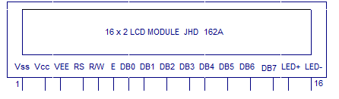](http://www.circuitstoday.com/wp-content/uploads/2014/06/JHD162A-LCD-module.png)
* **Pin1(Vss)**:Ground pin of the LCD module.
* **Pin2(Vcc)**: Power to LCD module (+5V supply is given to this pin)
* **Pin3(VEE)**:Contrast adjustment pin. This is done by connecting the ends of a 10K potentimeter to +5V and ground and then connecting the slider pin to the VEE pin.
* **Pin4(RS)**:Register select pin.The JHD162A has two registers namely **command register**and **data register**. Logic HIGH at RS pin selects data register and logic LOW at RS pin selects command register. If we make the RS pin HIGH and feed an input to the data lines (DB0 to DB7), this input will be treated as data to display on LCD screen.
* **Pin5(R/W)**: Read/Write modes. This pin is used for selecting between read and write modes. Logic HIGH at this pin activates read mode and logic LOW at this pin activates write mode.
* **Pin6(E)**: This pin is meant for enabling the LCD module. A HIGH to LOW signal at this pin will enable the module.
* **Pin7(DB0) to Pin14(DB7)**:  These are data pins. The commands and data are fed to the LCD module though these pins.
* **Pin15(LED+)**: Anode of the back light LED. When operated on 5V, a 560 ohm resistor should be connected in series to this pin. In arduino based projects the back light LED can be powered from the 3.3V source on the arduino board.
* **Pin16(LED-)**: Cathode of the back light LED.
* For knowing more about LCD module JHD162A and its pin functions, read this article: [**Interfacing 16×2 LCD and 8051 microcontroller**](http://www.circuitstoday.com/interfacing-16x2-lcd-with-8051). The circuit diagram of interfacing LCD to arduino for displaying a text message is shown below.
* Circuit diagram – Arduino to 16×2 LCD Module
* [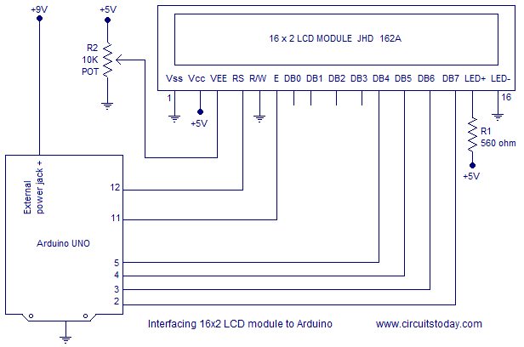](http://www.circuitstoday.com/wp-content/uploads/2014/06/interfacing-LCD-to-arduino.png)
* RS pin of the LCD module is connected to digital pin 12 of the arduino. R/W pin of the LCD is grounded. Enable pin of the LCD module is connected to digital pin 11 of the arduino. In this project, the **LCD module and arduino are interfaced in the 4-bit mode**. This means only four of the digital input lines( DB4 to DB7)  of the LCD are used. Digital lines DB4, DB5, DB6 and DB7 are interfaced to digital pins 5, 4, 3 and 2 of the Arduino. The 10K potentiometer is used for adjusting the contrast of the display. 560 ohm resistor R1 limits the current through the back light LED. +5V required in some other parts of the circuit can be tapped from the 5V source on the arduino board.
* Program – Arduino to LCD
* #include<LiquidCrystal.h>

##### LiquidCrystal lcd(12, 11, 5, 4, 3, 2); // sets the interfacing pins

##### void setup(){

##### lcd.begin(16, 2); // initializes the 16x2 LCD

##### }

##### void loop(){

##### lcd.setCursor(0,0); //sets the cursor at row 0 column 0

##### lcd.print("16x2 LCD MODULE"); // prints 16x2 LCD MODULE

##### lcd.setCursor(2,1); //sets the cursor at row 1 column 2

##### lcd.print("HELLO WORLD"); // prints HELLO WORLD

##### }

* **Some Other sensors for Arduino are as follows :**
* 1.Temperaature humidity sensors
* 2.Infrared emission sensors
* 3.Photoresister
* 4.Ultrasonic Distance sensor
* 5.Knock Sensor
* 6.Sound Sensor etc.

**How do I use Arduino :**

The Arduino Software (IDE) allows you to write programs and upload them to your board. In the [Arduino Software page](https://www.arduino.cc/en/Main/Software) you will find two options:  
  
1. If you have a reliable Internet connection, you should use the [online IDE](https://create.arduino.cc/editor) (Arduino Web Editor). It will allow you to save your sketches in the cloud, having them available from any device and backed up. You will always have the most up-to-date version of the IDE without the need to install updates or community generated libraries.  
  
2. If you would rather work offline, you should use the latest version of the [desktop IDE](https://www.arduino.cc/en/Main/Software#download).

**Installation of Arduino IDE :**

Get the latest version from the Arduino website listed in the references. When the download is completed process.

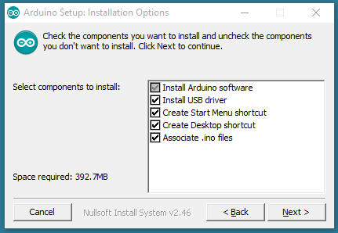

Choose the components to install

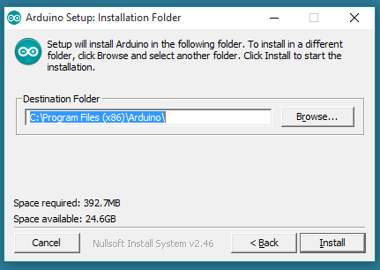

Choose the installation directory

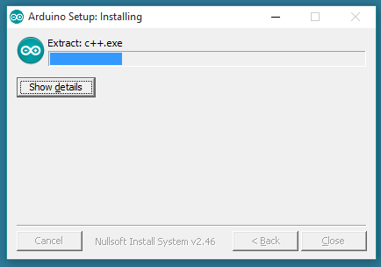

The process will extract and install the file.

**Refrences :**

<https://www.arduino.cc/en/Guide/HomePage>

<http://tutorial45.com/top-used-sensors-for-arduino/>

<http://www.circuitstoday.com/interfacing-lcd-to-arduino>