QuickStart guide: Android Studio Application Setup

Step 1. Open Android Studio

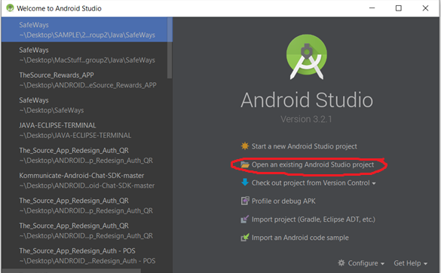

Step 2: *“Open an existing Android Studio Project”*

*Navigate to the directory where you cloned the repo. Open the directory to ‘Android’ 🡪 ‘SafeWays’, then press OK*

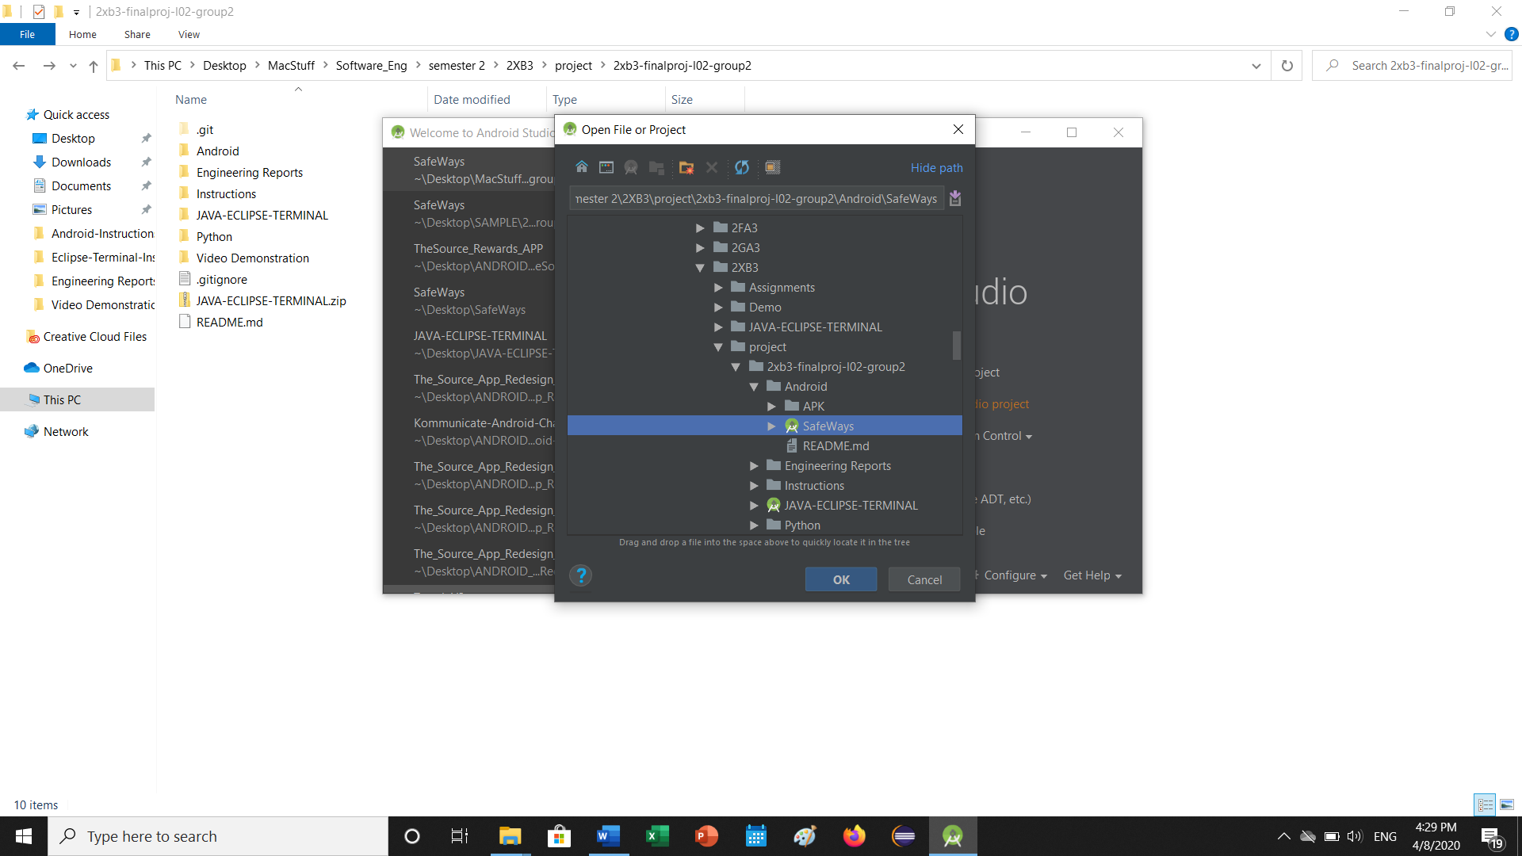

Step 3: Wait for the project to be setup in Android Studio.

Once complete, click the green ‘play’ button at the top.

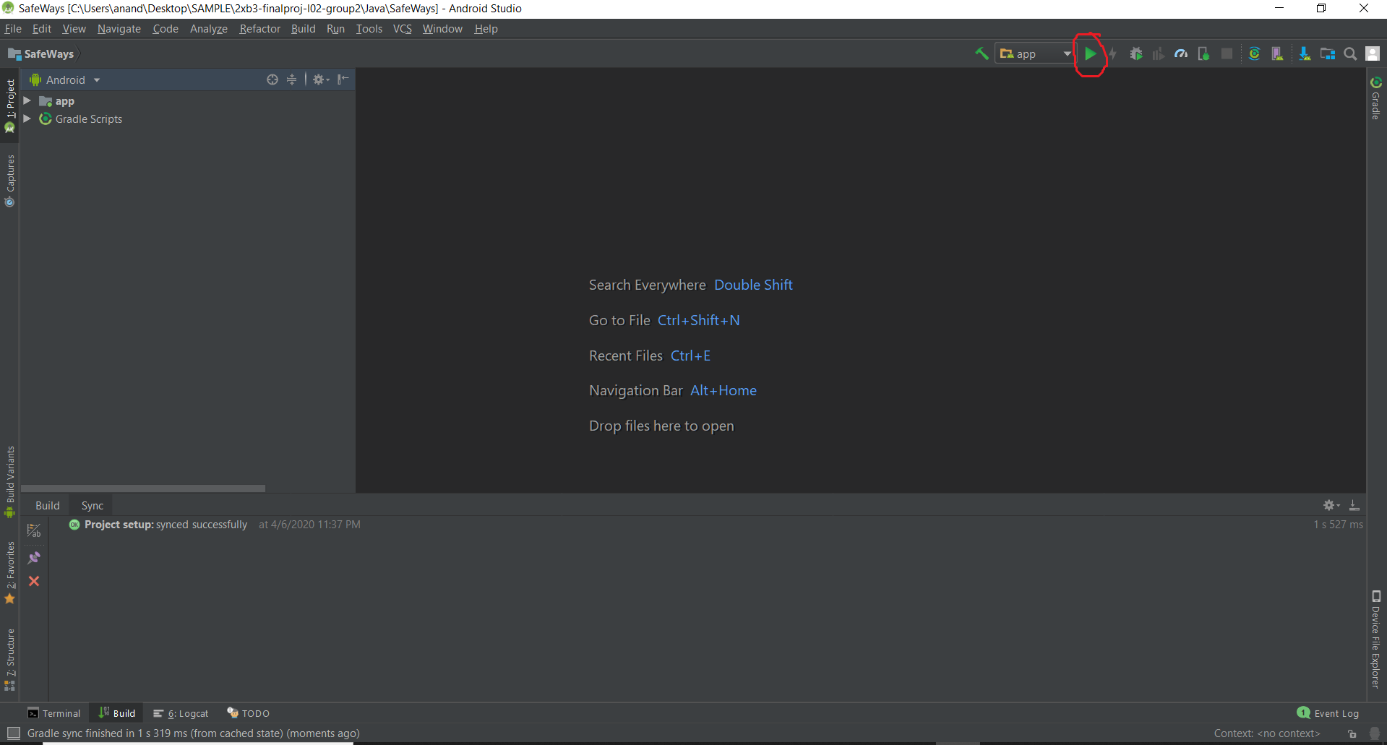

Step 4: Connect your Android Device to your Laptop/PC

Select your device from the available devices, or select the emulator. Press ‘OK’ and wait for it to install!

