QuickStart Guide: Java Eclipse Terminal Setup

This is a quickstart guide on how to get started on setting up and using the program. If you already imported the program into eclipse or IntelliJ, then skip to Step 4 to setup the external JAR libraries.

Step 1: Clone the repo

Step 2: Open up eclipse and then go to File -> “Open projects from File system…” -> 2XB3_GR02_FinalProject folder of the directory you cloned.

Alternatively, you can unzip the 2XB3_GR02_FinalProject.zip and then use “Import projects from file system” in which you select the *2XB3_GR02_FinalProject* folder that was unzipped.

Step 3: Setup the JSON Jackson API Jars to process JSON files. This is shown on page 4

***Step 2 – More Detail on Importing the Project***

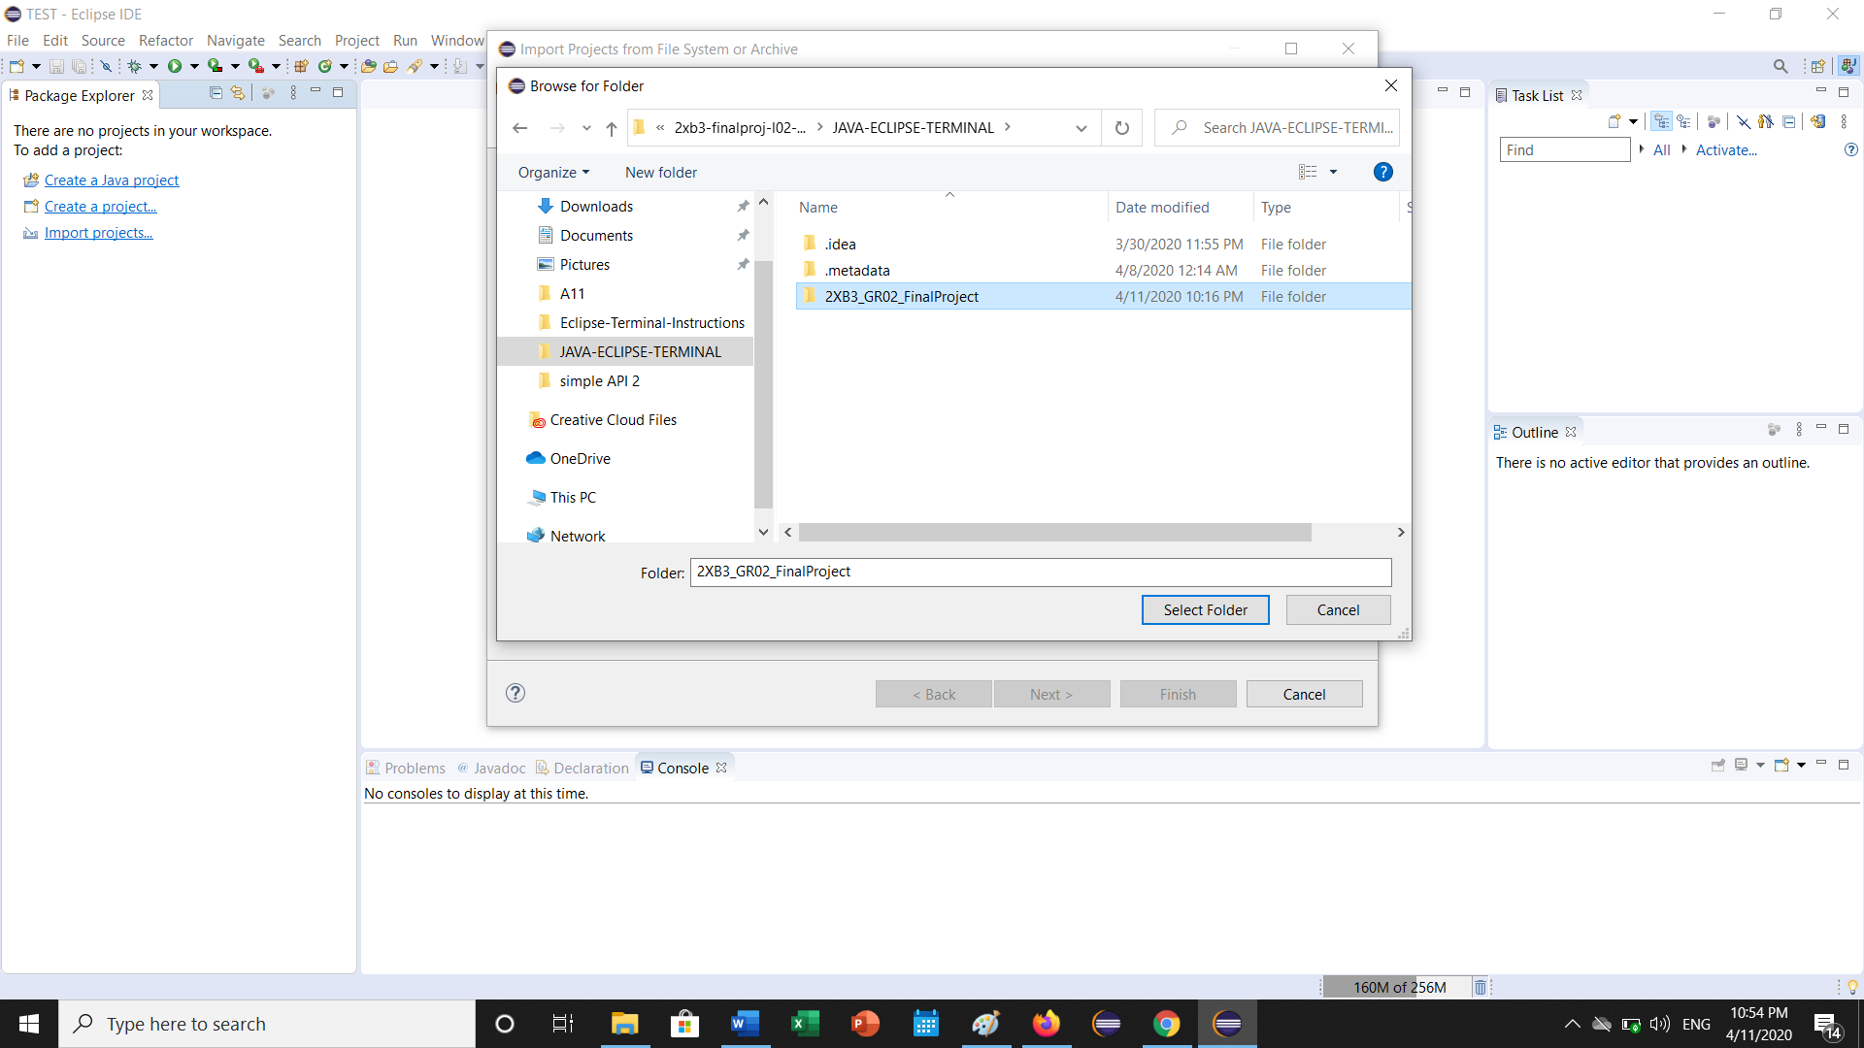

Select all the options available, then click Finish

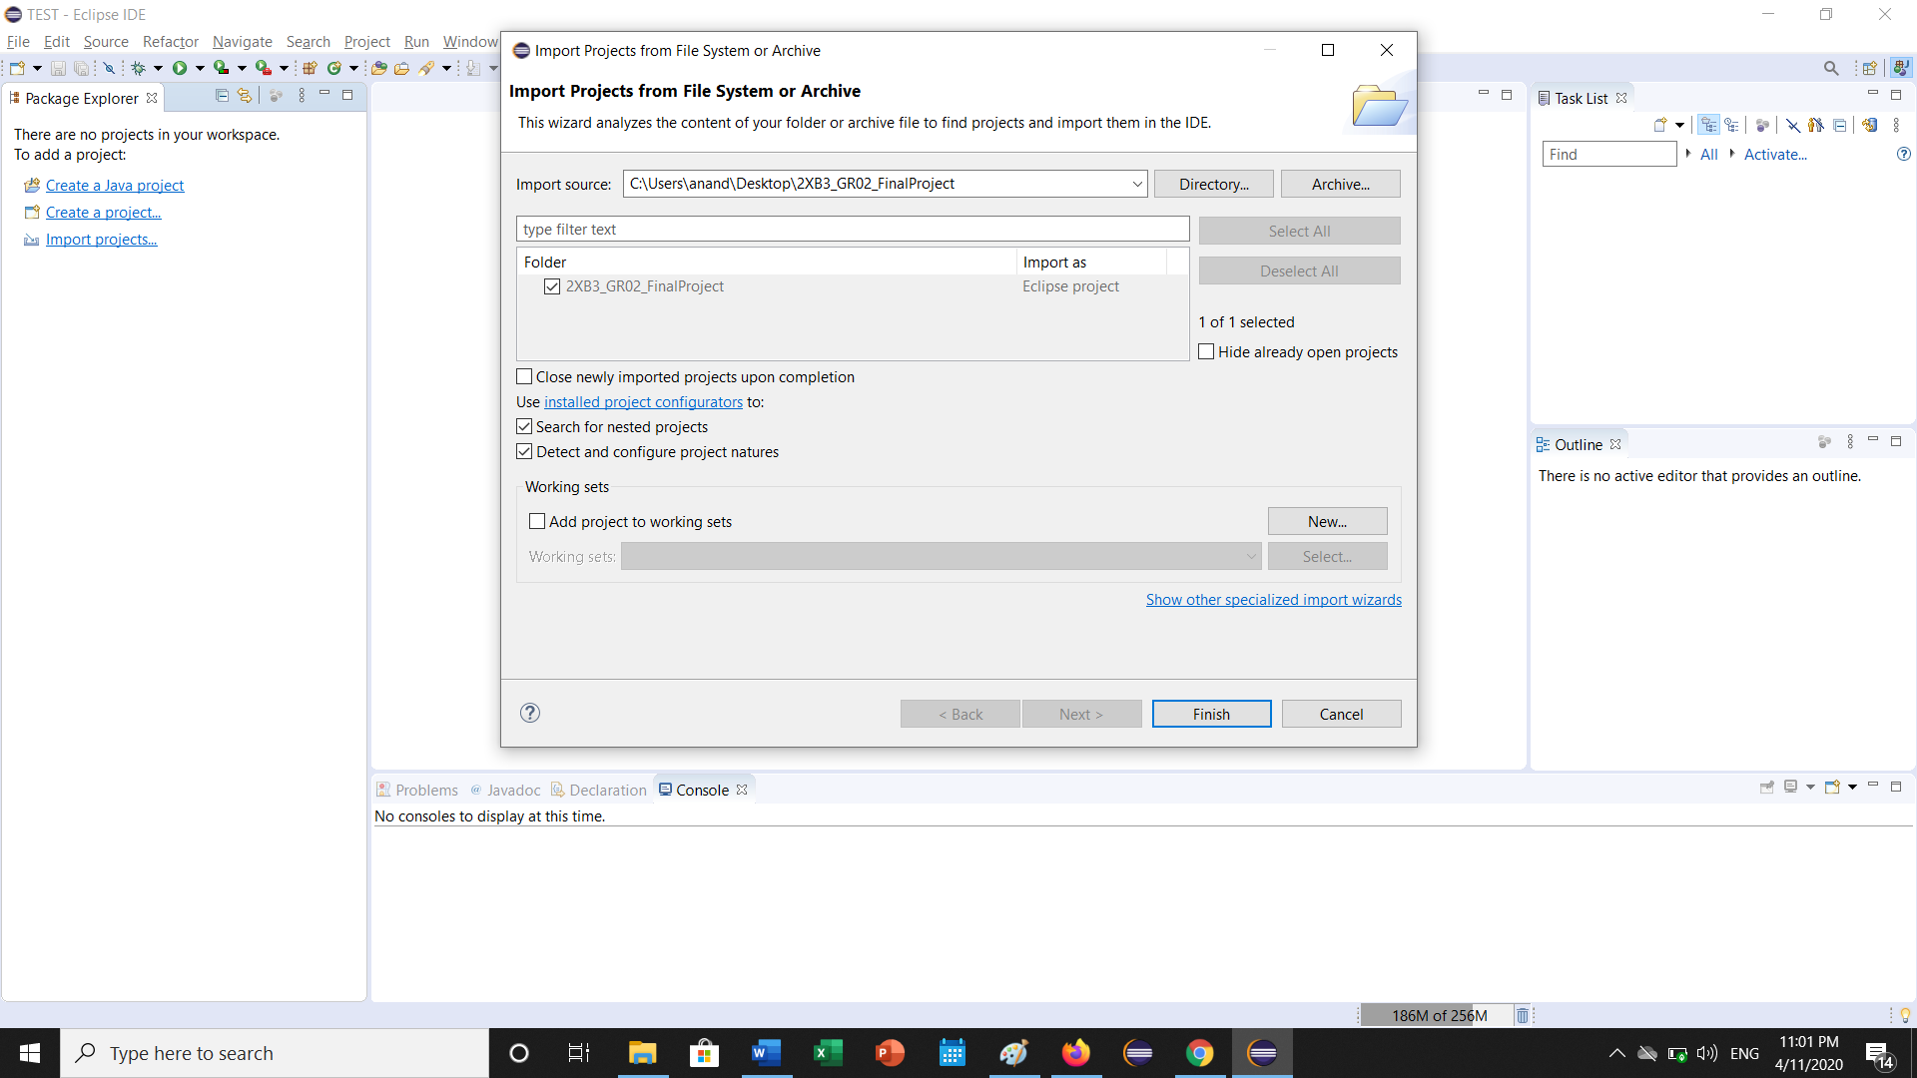

Once complete, the following Eclipse project format should appear as shown below.

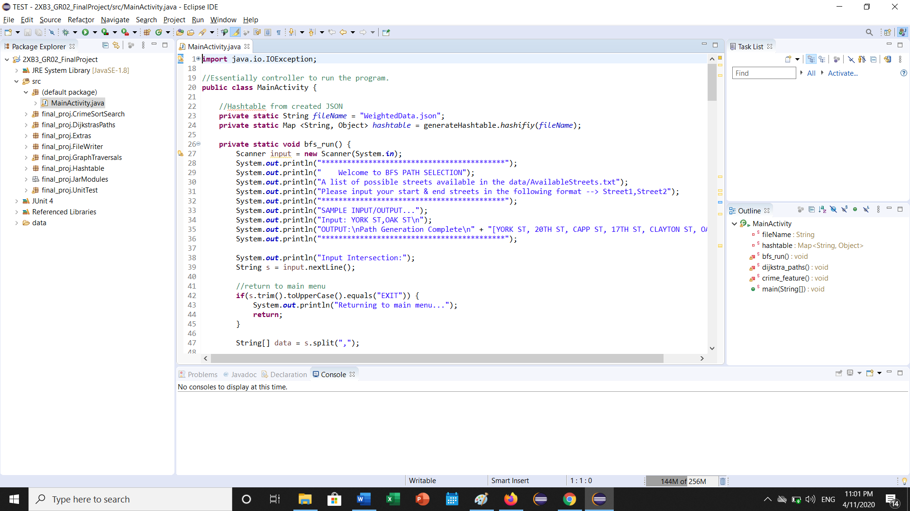

Step 4: **SETTING UP THE JAR LIBRARIES FOR JSON READ PARSING**

Click Project -> Properties

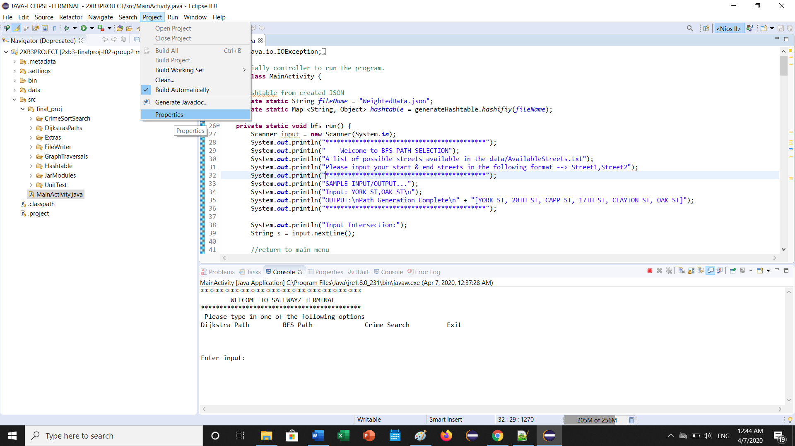

Step 5: Then click *“Java Build Path”,* and remove the highlighted libraries. This is because these libraries are pointing to a directory that is not on your computer, so must remove and re-add them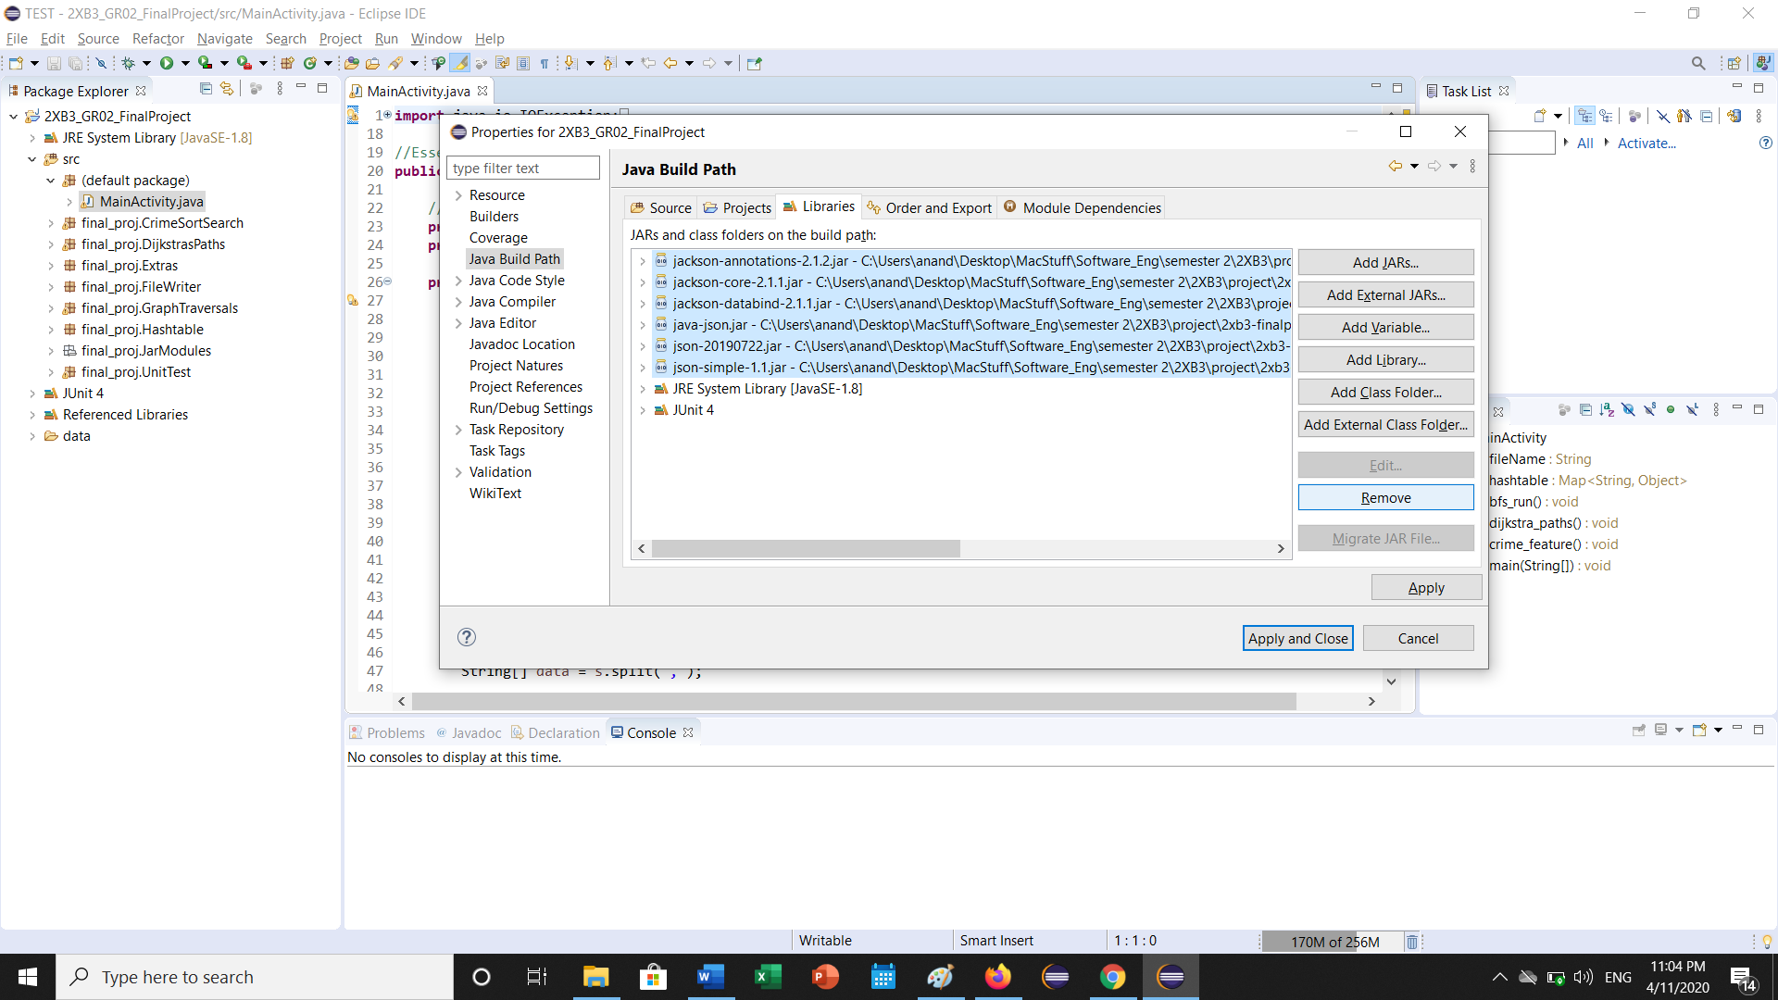

Step 6: Click “Add External JARs… button on the right-hand panel.

Navigate to the *src -> final_proj -> JarModules* folder

Highlight all the available modules and click “open”. Click Apply and close, and you should be good to go!

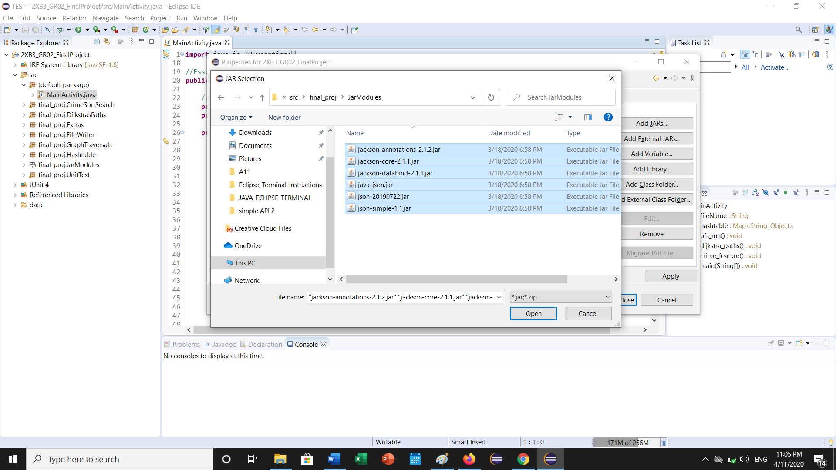

Step 7: Run MainActivity.java to execute the program in the console!

