QuickStart guide: Android Studio Application Setup
Step 1. Open Android Studio
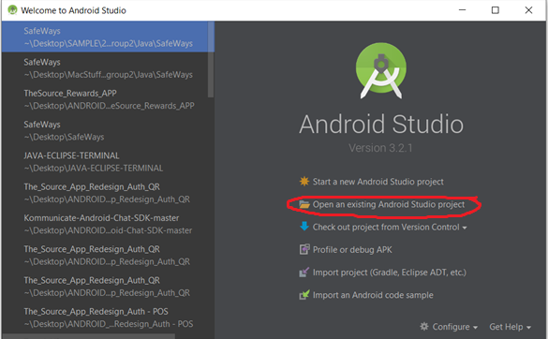

Step 2: “Open an existing Android Studio Project”
Navigate to the directory where you cloned the repo. Open the directory to ‘Java’ ‘SafeWays’, then press OK

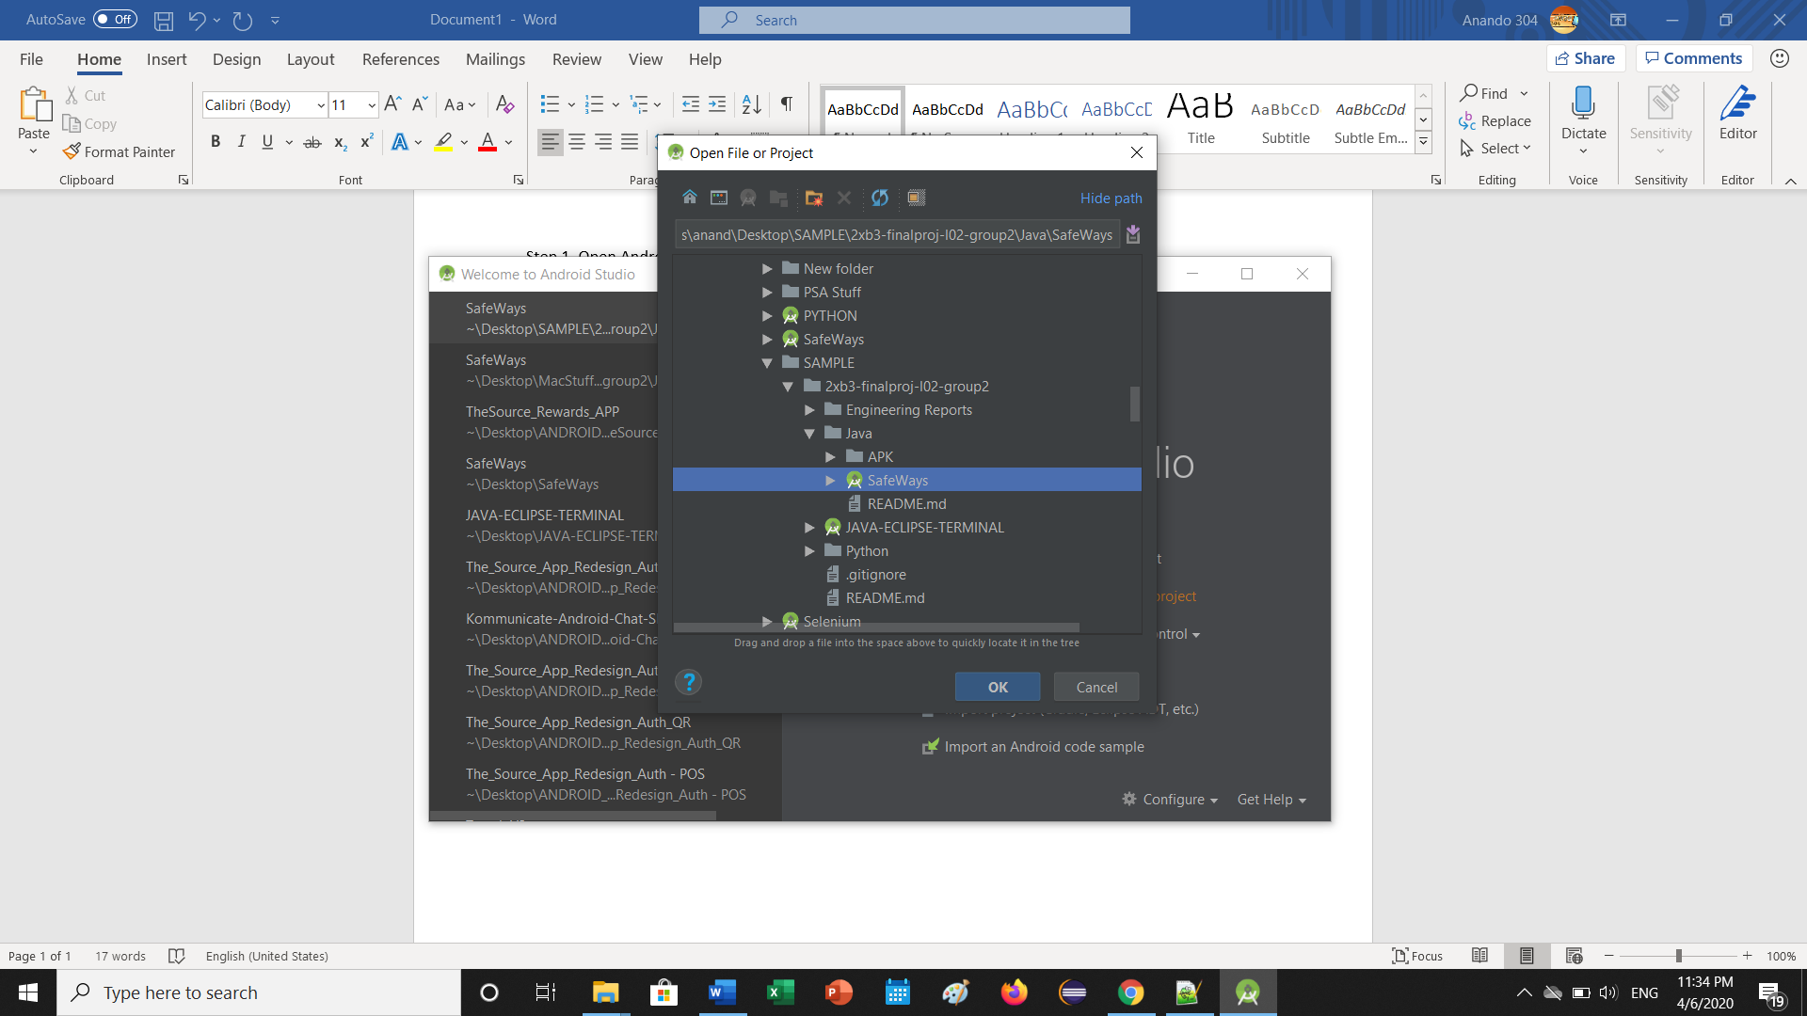
Step 3: Wait for the project to be setup in Android Studio.
Once complete, click the green ‘play’ button at the top.
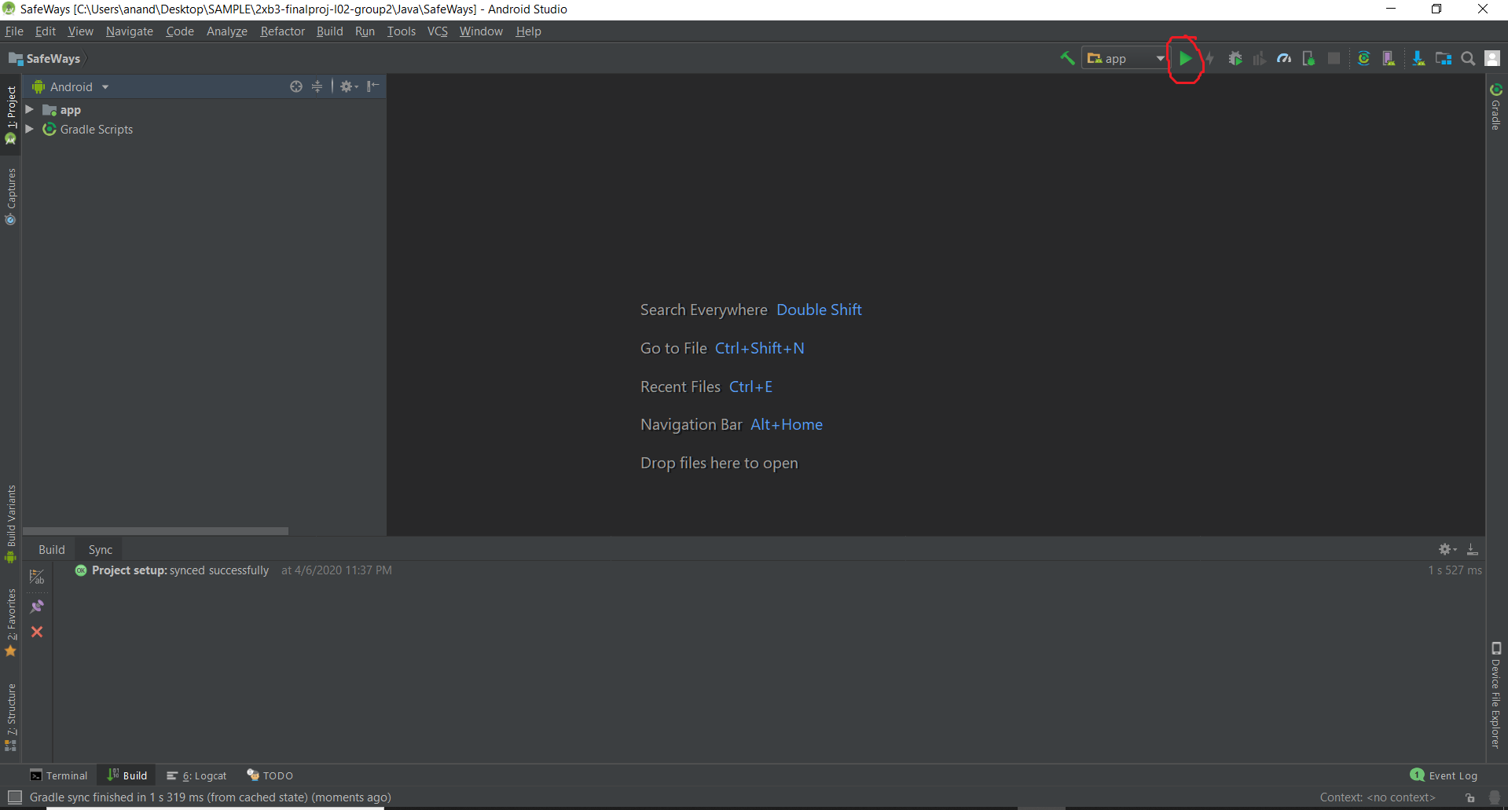

Step 4: Connect your Android Device to your Laptop/PC
Select your device from the available devices, or select the emulator. Press ‘OK’ and wait for it to install!
