QuickStart Guide: Java Eclipse Terminal Setup
This is a quickstart guide on how to get started on setting up and using the program. If you already imported the program into eclipse or IntelliJ, then skip to Step 4 to setup the external JAR libraries.
Step 1: Clone the repo
Step 2: Open the project to the following directory/workspace inside the repo using Eclipse, or IntelliJ or the IDE of your choice: ‘JAVA-ECLIPSE-TERMINAL’. Alternatively, you can also import the project using JAVA-ECLIPSE-TERMINAL.zip file
Step 3: Setup the JSON Jackson API Jars to process JSON files. This is shown on page 4
If you need more detail on changing workspaces, below shows how to change the workspace to the directory given above in Eclipse.
Step A: Navigate to the ‘JAVA-ECLIPSE-TERMINAL’ folder inside the directory of the repo.
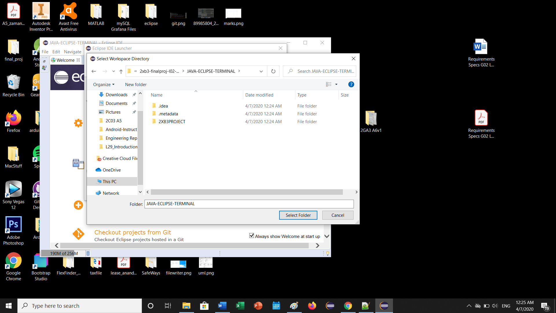

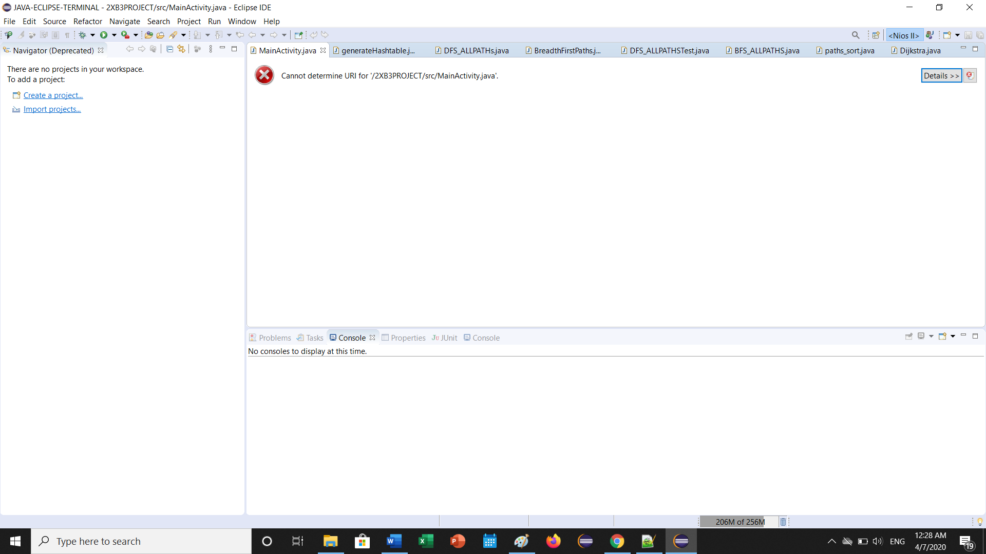

Step B: If you get the following error above follow the next few steps. Otherwise, skip to step D.
To fix this error, navigate to File ->Open Projects from File System. Then click ‘Directory’. The window below should appear. Click ‘Select Folder’.
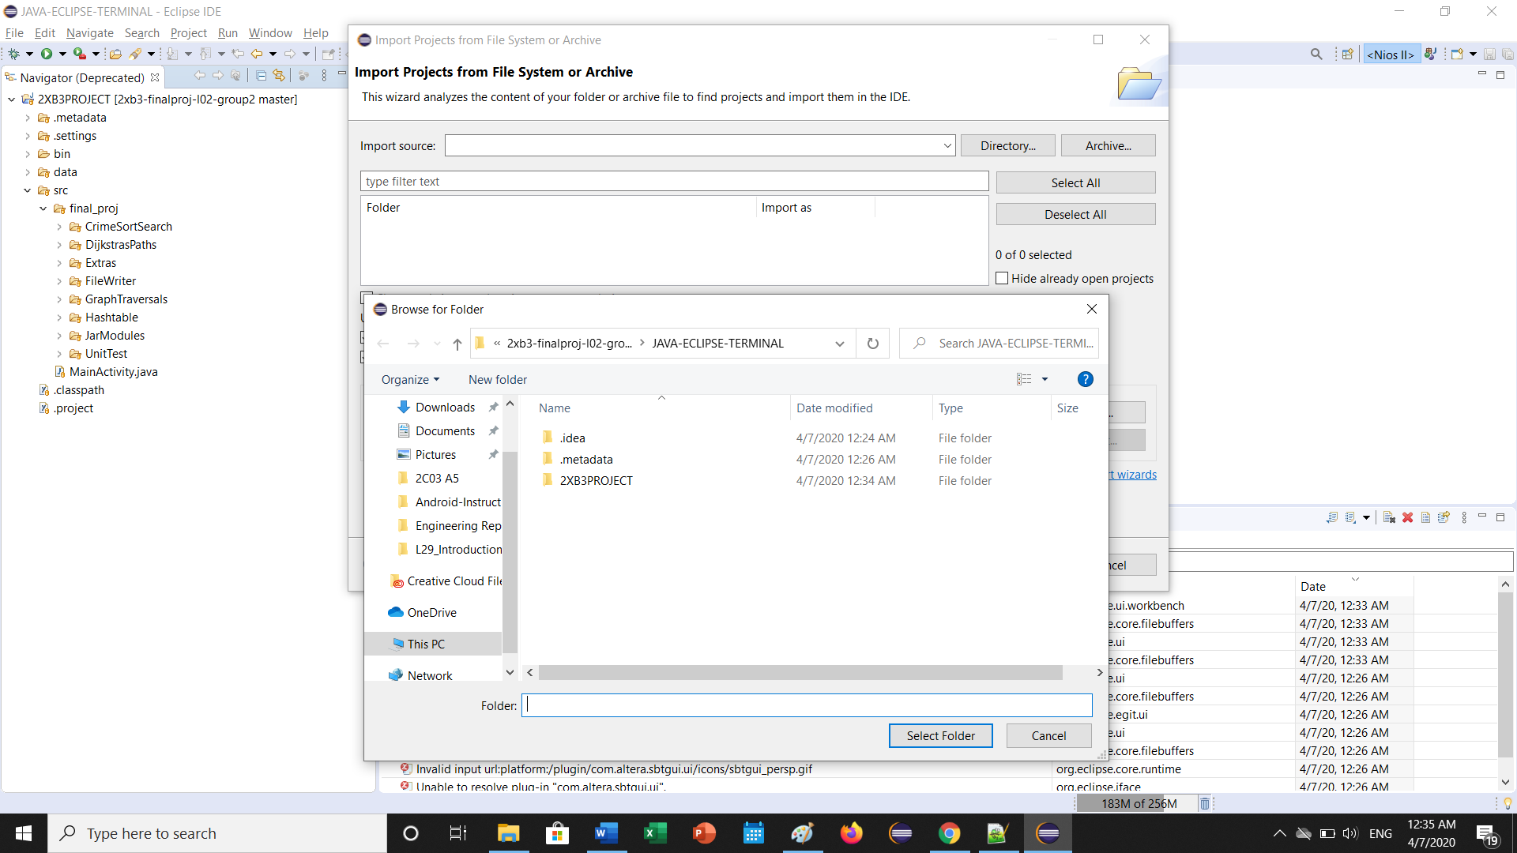

Step C: Select all the options available, then click Finish
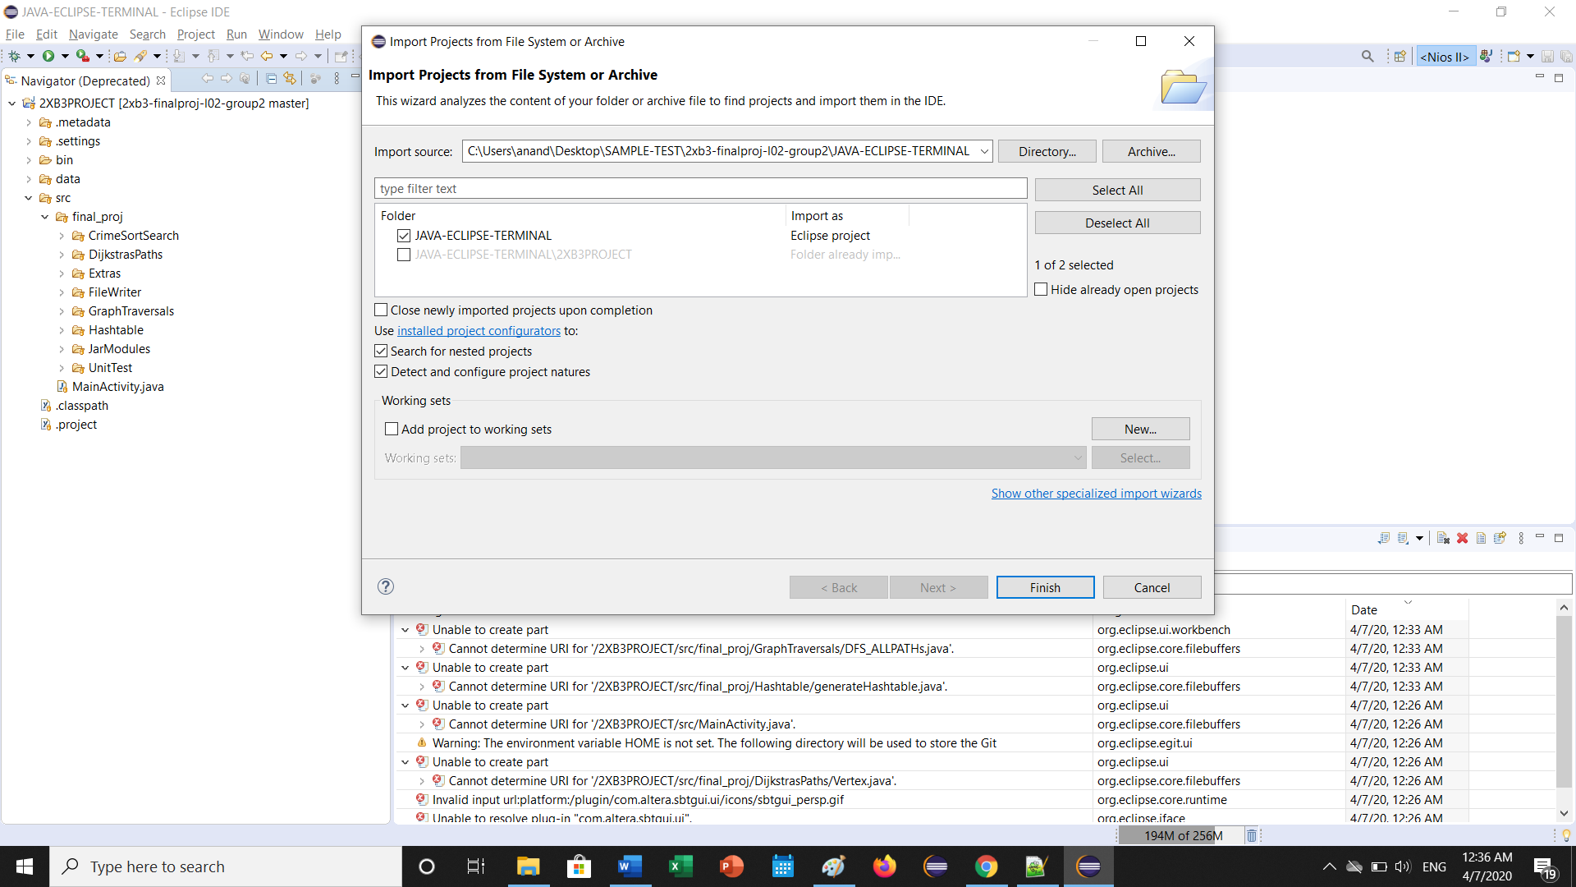

Step D below: Once complete, the code should appear.
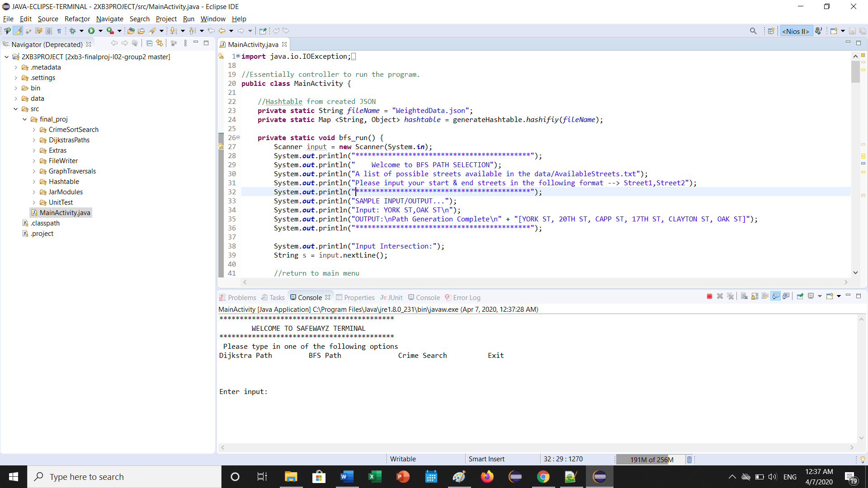

Step 4: SETTING UP THE JAR LIBRARIES FOR JSON READ PARSING
Click Project -> Properties
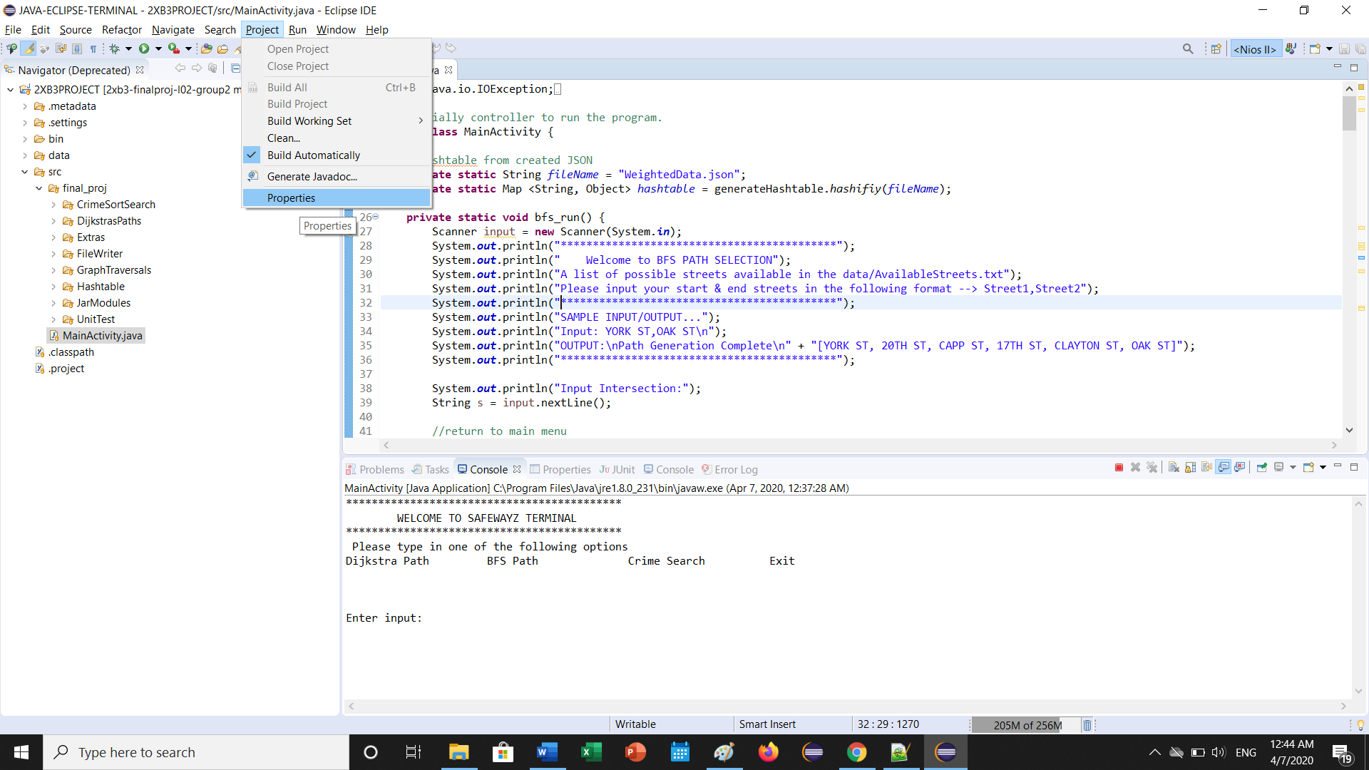

Step 5: Then click “Java Build Path”, and remove the highlighted libraries. This is because these libraries are pointing to a directory that is not on your computer, so must remove and re-add them
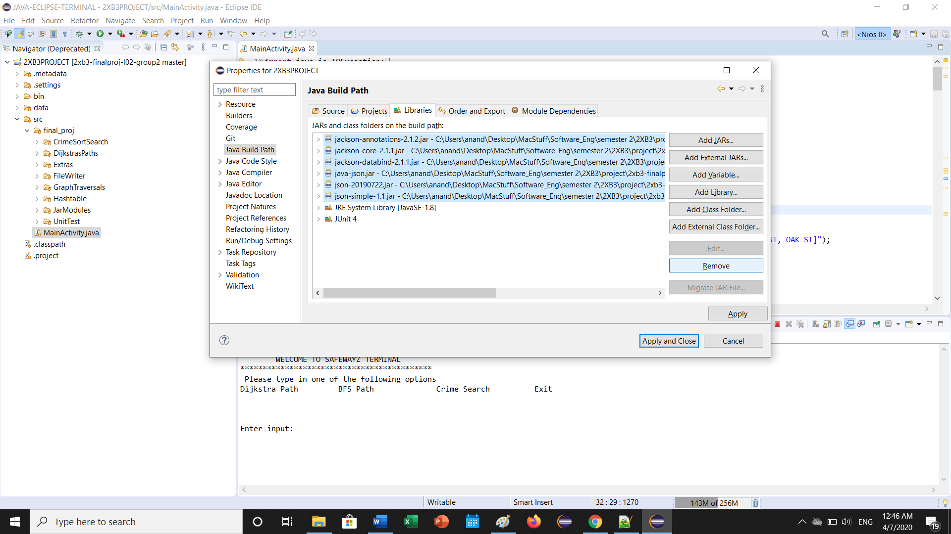
Step 6: Click “Add External JARs… button on the right-hand panel.
Navigate to the JAVA-ECLIPSE-TERMINAL -> 2XB3PROJECT -> src -> final_proj -> JarModules folder
Highlight all the available modules and click “open”. Click Apply and close, and you should be good to go!
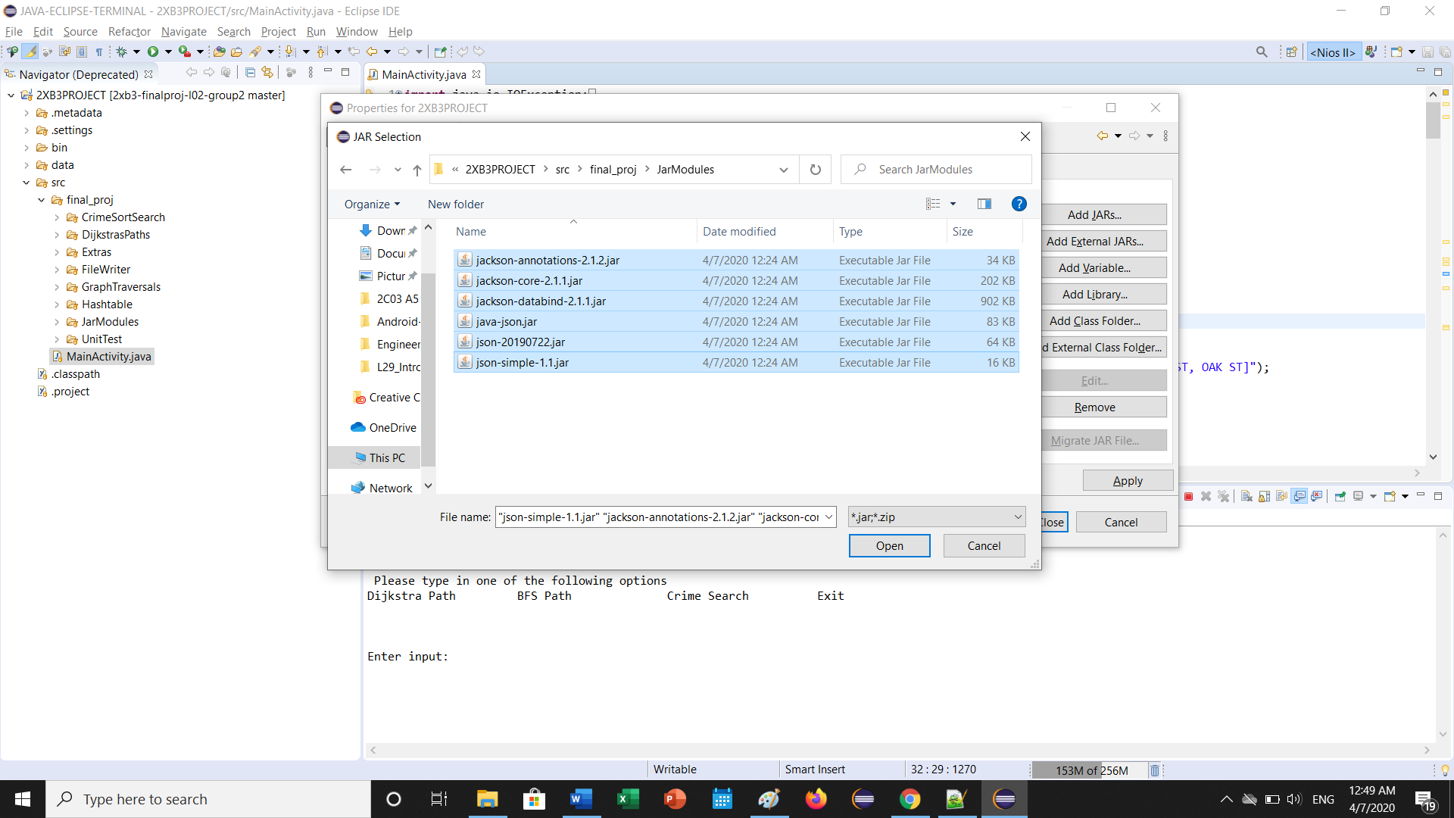

Step 7: Run MainActivity.java to execute the program in the console!

