Data Structures
Array
Linked List
Stack
Queue
Binary Tree
Binary Search Tree
Heap
Hashing
Graph

Linked List | Set 1 (Introduction)

Like arrays, Linked List is a linear data structure. Unlike arrays, linked list elements are not stored at contiguous location; the elements are linked using pointers.

Why Linked List?

The size of the arrays is fixed:

Inserting a new element in an array of elements is expensive, because room has to be created for the new elements and to create room existing elements have to shifted.

Drawbacks:
1) Random access is not allowed.
2) Extra memory space for a pointer is required with each element of the list.

Stack and Queue

Binary Tree | Set 1 (Introduction)
Trees: Unlike Arrays, Linked Lists, Stack and queues, which are linear data structures, trees are hierarchical data structures.

- one reason to use trees might be because you want to store information that naturally forms a hierarchy.

2. Trees (with some ordering e.g., BST) provide moderate access/search (quicker than Linked List and slower than arrays).

3. Trees provide moderate insertion/deletion (quicker than Arrays and slower than Unordered Linked Lists).

4. Like Linked Lists and unlike Arrays, Trees don’t have an upper limit on number of nodes as nodes are linked using pointers.

- The maximum number of nodes at level ‘l’ of a binary tree is 2(l-1).

- Maximum number of nodes in a binary tree of height ‘h’ is 2h – 1.

Binary Tree: A tree whose elements have at most 2 children is called a binary tree

Full Binary Tree A Binary Tree is full if every node has 0 or 2 children. Following are examples of full binary tree. We can also say a full binary tree is a binary tree in which all nodes except leaves have two children.

Complete Binary Tree: A Binary Tree is complete Binary Tree if all levels are completely filled except possibly the last level and the last level has all keys as left as possible

Perfect Binary Tree A Binary tree is Perfect Binary Tree in which all internal nodes have two children and all leaves are at same level.

BalancedBinaryTree
A binary tree is balanced if height of the tree is O(Log n) where n is number of nodes. For Example, AVL tree maintain O(Log n) height by making sure that the difference between heights of left and right subtrees is 1.

BFS vs DFS for Binary Tree

A Tree is typically traversed in two ways:

Breadth First Traversal (Or Level Order Traversal) : [ queue ,adjacent nodes are aded while removing from queue]

Depth First Traversals [Stack]
  - Inorder Traversal (Left-Root-Right)
  - Preorder Traversal (Root-Left-Right)
  - Postorder Traversal (Left-Right-Root)

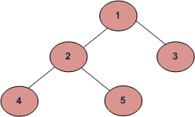
BFS and DFSs of above Tree
Breadth First Traversal : 1 2 3 4 5
Depth First Traversals:
Preorder Traversal : 1 2 4 5 3
Inorder Traversal : 4 2 5 1 3
Postorder Traversal : 4 5 2 3 1
All four traversals require O(n) time as they visit every node exactly once.

Binary Search Tree | Set 1

Binary Search Tree, is a node-based binary tree data structure which has the following properties:

The left subtree of a node contains only nodes with keys lesser than the node’s key.

The right subtree of a node contains only nodes with keys greater than the node’s key.
The left and right subtree each must also be a binary search tree.There must be no duplicate nodes.

100 100
/ \ Insert 40 / \
20 500 ---------> 20 500
/ \ / \
10 30 10 30
\
40

1) Node to be deleted is leaf: Simply remove from the tree.
50 50
/ \ delete(20) / \
30 70 ---------> 30 70
/ \ / \ \ / \
20 40 60 80 40 60 80

2)Node to be deleted has only one child: Copy the child to the node and delete the child
50 50
/ \ delete(30) / \
30 70 ---------> 40 70
\ / \ / \
40 60 80 60 80
3) Node to be deleted has two children: Find inorder successor of the node. Copy contents of the inorder successor to the node and delete the inorder successor. Note that inorder predecessor can also be used.
50 60
/ \ delete(50) / \
40 70 ---------> 40 70
/ \ \
60 80 80

Advantages of BST over Hash Table
Hash Table supports following operations in Θ(1) time.
1) Search
2) Insert
3) Delete
Hash Table seems to beating BST in all common operations. When should we prefer BST over Hash Tables, what are advantages. Following are some important points in favor of BSTs.

We can get all keys in sorted order by just doing Inorder Traversal of BST. This is not a natural operation in Hash Tables and requires extra efforts.
- Doing order statistics, finding closest lower and greater elements, doing range queries are easy to do with BSTs. Like sorting, these operations are not a natural operation with Hash Tables.
- BSTs are easy to implement compared to hashing, we can easily implement our own customized BST. To implement Hashing, we generally rely on libraries provided by programming languages.
- With Self-Balancing BSTs, all operations are guaranteed to work in O(Logn) time. But with Hashing, Θ(1) is average time and some particular operations may be costly, especially when table resizing happens.

Self balancing tree
AVL tree is a self-balancing Binary Search Tree (BST) where the difference between heights of left and right subtrees cannot be more than one for all nodes.

Binary Heap

A Binary Heap is a Binary Tree with following properties.
1) It’s a complete tree (All levels are completely filled except possibly the last level and the last level has all keys as left as possible). This property of Binary Heap makes them suitable to be stored in an array.
- A Binary Heap is either Min Heap or Max Heap. In a Min Binary Heap, the key at root must be minimum among all keys present in Binary Heap. The same property must be recursively true for all nodes in Binary Tree. Max Binary Heap is similar to Min Heap.

How is Binary Heap represented?
A Binary Heap is a Complete Binary Tree. A binary heap is typically represented as array.
- The root element will be at Arr[0].
- Below table shows indexes of other nodes for the ith node, i.e., Arr[i]:
Arr[i/2] | Returns the parent node
Arr[(2*i)+1] | Returns the left child node
Arr[(2*i)+2] | Returns the right child node

Applications of Heaps:
1) Heap Sort: Heap Sort uses Binary Heap to sort an array in O(nLogn) time.

2) Priority Queue:

3) Graph Algorithms: The priority queues are especially used in Graph Algorithms like Dijkstra’s Shortest Path and Prim’s Minimum Spanning Tree.

Hash Algorithm

Suppose we want to design a system for storing employee records keyed using phone numbers. And we want following queries to be performed efficiently:
- Insert a phone number and corresponding information.
- Search a phone number and fetch the information.
- Delete a phone number and related information.
We can think of using the following data structures to maintain information about different phone numbers.
- Array of phone numbers and records.
- Linked List of phone numbers and records.
- Balanced binary search tree with phone numbers as keys.
For arrays and linked lists, we need to search in a linear fashion, which can be costly in practice
With balanced binary search tree, we get moderate search, insert and delete times. All of these operations can be guaranteed to be in O(Logn) time

Hashing is the solution that can be used in almost all such situations and performs extremely well compared to above data structures like Array, Linked List, Balanced BST in practice. With hashing we get O(1) search time on average (under reasonable assumptions) and O(n) in worst case.

Hash Function: A function that converts a given big phone number to a small practical integer value. The mapped integer value is used as an index in hash table. In simple terms, a hash function maps a big number or string to a small integer that can be used as index in hash table.
A good hash function should have following properties
1) Efficiently computable.
2) Should uniformly distribute the keys (Each table position equally likely for each key)

Hash Table: An array that stores pointers to records corresponding to a given phone number. An entry in hash table is NIL if no existing phone number has hash function value equal to the index for the entry.

Collision Handling: Since a hash function gets us a small number for a big key, there is possibility that two keys result in same value.
Following are the ways to handle collisions:
Chaining and Open Addressing:

Chaining :

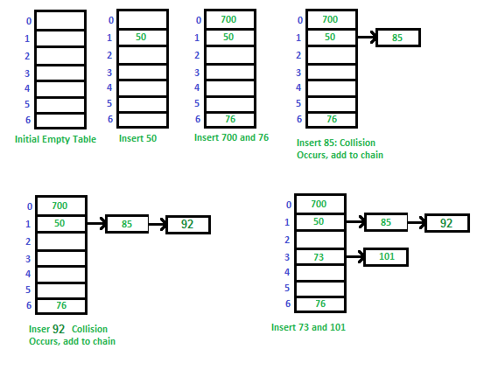

Open Addressing

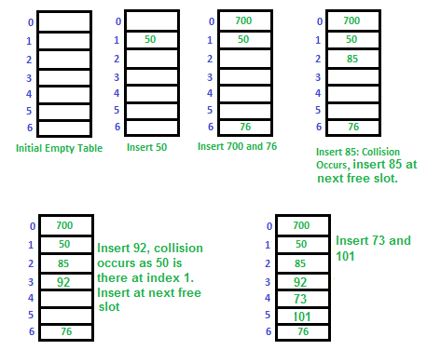

Graph and its representations
Graph is a data structure that consists of following two components:
1. A finite set of vertices also called as nodes.
2. A finite set of ordered pair of the form (u, v) called as edge. The pair is ordered because (u, v) is not same as (v, u) in case of directed graph(di-graph). The pair of form (u, v) indicates that there is an edge from vertex u to vertex v. The edges may contain weight/value/cost.
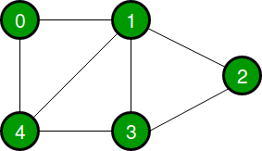
Following two are the most commonly used representations of graph.
1. Adjacency Matrix
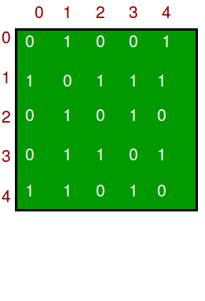
2. Adjacency List
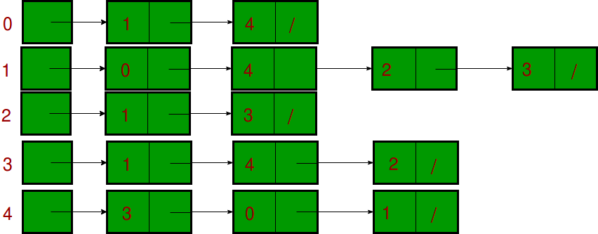

Traversing in graps

BFS : queue Time Complexity: O(V+E) where V is number of vertices in the graph and E is number of edges in the graph. [BFS like tree]

DFS like stack and do backtrack

Applications of Depth First Search
Detecting cycle in a graph
Path Finding

Applications of Breadth First Traversal
Shortest Path and Minimum Spanning Tree for unweighted graph
Peer to Peer Networks
Crawlers in Search Engines:

GRAPh Algorithom
Kruskal algorithms

Prim’s Minimum Spanning Tree (MST))
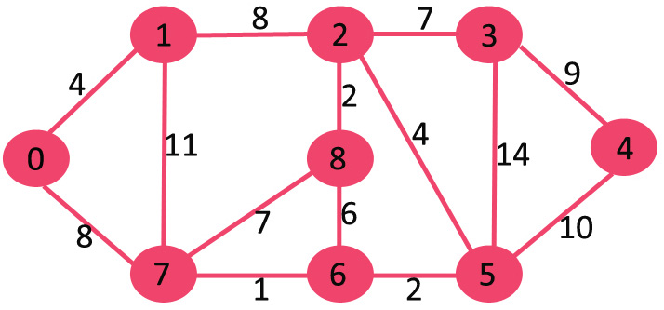
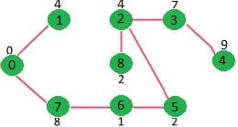

Dijkstra’s shortest path algorithm)
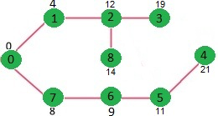

Backtracking
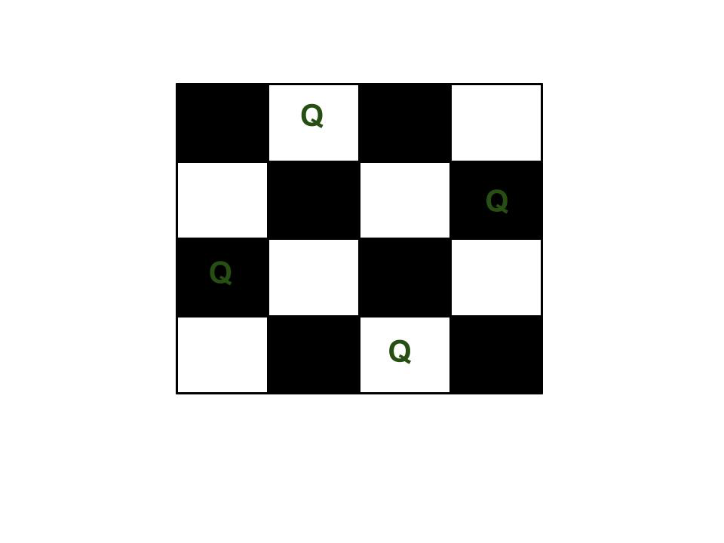

Algorithom :

Searching and Sorting:

Linear Search,Binary Search [Must be sorted and divide and conquer]

Selection Sort : First Find minimum move upward
Bubble Sort : Swap with next one if it is big value so bigger values sorted first
Insertion Sort : Insert element
Merge Sort,: Devide and conquer
Radix Sort, : Find number of digit it contains in side didit after that compare
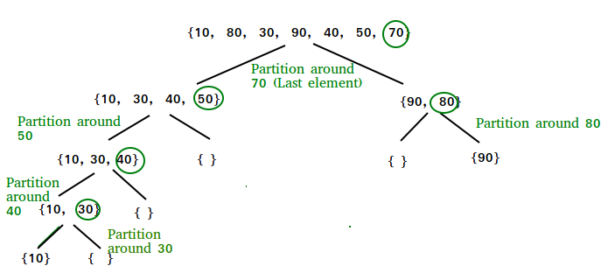
QuickSort, :From Pivotal it will divide and conquer

Greedy Algorithms:
Prim’s Minimum Spanning Tree Algorithm
Dijkstra’s Shortest Path Algorithm
Dynamic Programming:(Egg Dropping Puzzle)
- The egg breaks (2) The egg doesn’t break.
- eggDrop(n, k) ==> Minimum number of trials needed to find the critical
floor in worst case.
eggDrop(n, k) = 1 + min{max(eggDrop(n - 1, x - 1), eggDrop(n, k - x)):
x in {1, 2, ..., k}}

