In appdelegate :

1.didFinishLaunchingWithOptions :

registerForPushNotifications(application: application)
ApplicationDidTimoutNotification
DoTheSwizzling
setAppLanguageForFirstTime

Push Notification
https://www.appcoda.com/push-notification-ios/

if #available(iOS 10.0, *){
UNUserNotificationCenter.current().delegate = self
UNUserNotificationCenter.current().requestAuthorization(options: [.init(rawValue: 0)],
UIApplication.shared.registerForRemoteNotifications()
}else{ // If user is not on iOS 10 use the old methods we've been using

let notificationSettings = UIUserNotificationSettings(types: [.init(rawValue: 0)], categories: nil)
application.registerUserNotificationSettings(notificationSettings)
}

Now First You have to generate SSL certificate by enabling push notification for you app ID.
That SSL certificate after downloading you need to export and need to upload iand then create provisoning profile which need to n in Amazon Pinpoint

Language Swapping

Bundle.localizedString , UIApplication.userInterfaceLayoutDirection
Bundle.main.path

UIRefreshControl for Pull to refresh

Oauth 2.0
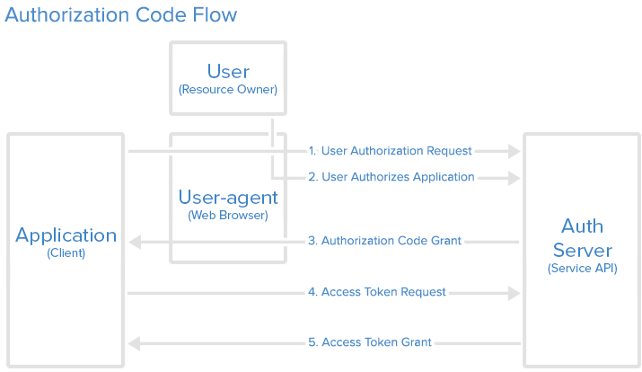

Authorization Grant
Authorization Code: used with server-side Applications
- Implicit: used with Mobile Apps or Web Applications (applications that run on the user's device)
- Resource Owner Password Credentials: used with trusted Applications, such as those owned by the service itself
- Client Credentials: used with Applications API access

Java Script Bridge

An iOS bridge for sending messages between Objective C and Javascript via a UIWebview
The idea is to allow some workflow and model code to be shared across web app, android and ios

A package consists of Swift source files and a manifest file.

open sourced switf-corelibs-foundation package by Apple,

Library is a packaged collection of object files that program can link against.

So a library is a bunch of compiled code. You can create two kinds of libraries:
- static
- dynamic
Linking refers to the creation of a single executable file from multiple object files.

A framework is a hierarchical directory that encapsulates shared resources, such as a dynamic shared library, nib files, image files, localized strings, header files, and reference documentation in a single package.

Swift organizes code into modules. Each module specifies a namespace and enforces access controls on which parts of that code can be used outside of the module.
clang
the Clang C, C++, and Objective-C compiler
Clang is a compiler frontend for C languages (C, C++, Objective-C). If you have ever tried to compiled C code with gcc during your university years, you can imagine that clang is more or less the same as gcc, but nowadays it can do even more.

LLVM: compiler backend system, which can compile and optimize the intermediate representation (IR) code generated by clang or the Swift compiler for example. It's language independent, and it can do so many things that could fit into a book, but for now let's say that LLVM is making the final machine code for your executabl
swiftc:As you can see this tool is what actually can compile the Swift source files into Mach-O's or final executables. There is a short example in the attached repository, you should check on that if you'd like to learn more about the Swift compiler.

An open class is accessible and subclassable outside of the defining module. An open class member is accessible and overridable outside of the defining module.
- A public class is accessible but not subclassable outside of the defining module. A publicclass member is accessible but not overridable outside of the defining module.

How to create framework
http://iosbrain.com/blog/2018/01/13/building-swift-4-frameworks-and-including-them-in-your-apps-xcode-9/

Protocol Oriented programming
- Implicit sharing(Solution value type)
    - Overriding complexity in Subclass, which class need to be override?(Using Protocol delegate)
    - type compatibility , we need to do forcefully casting(We can use self)
Example of drawable,render.Circle,rectangle,diagram
-Testability of protocol for different environment
Circle with in Circle
-Extension of protocol
-Extension with constraint
Now we need to use self for forcefully casting but it makes homogenous instead heterogeneous.
If we need to make heterogeneous with equatable self the use
extension drawable where self:equatable{
isEqualTo(other:Drawable)->Bool{
if let o = other as? Self {return o == self}
}
}

Protocol and Value Oriented Programming in UIKit Apps

Local Reasoning

How function is going to work by seeing function.
View as Model
Ex. LayoutView used in UIView,TableViewcell or Sknode

struct Decorate{
var content:Layout
var decoration:Layout
mutating func(){
content.frame = ..
decoration.frame = ..
}
}
protocol Layout{
var frame:CGRect{get set}
}
extension UIVIew:Layout{}
extension SKNode:Layout{}

For Sharing code for UI we don't use Inhertiance Instead we will use Composition (share code with out reducing local reasoning)

Composite of Views
class instance are expensive so we use composition of Values

Use Model as seprate filepath
Use UI Bool property as enum

