CS 663: Digital Image Processing Project

Number plate Recognition

Name: MEHTA NIHAR NIKHIL

Roll: 13D100011

# INTRODUCTION

The number plate recognition is a standard problem in image processing. It involves multiple concepts of image processing like filtering, transformations, segmentation and recognition.

The problem consisted of three parts:  
1. Number plate region extraction

2. Segmentation of the number plate into different characters

3. Recognition of the characters

The first two parts are complete but the third part can recognize the numbers only. A neural network is used in the third part for character recognition. There are alternatives like tesseract that can accomplish the character recognition very well. However, we decided to try neural networks as our own algorithm for recognizing characters. The current neural network is trained only on numbers. This shall be extended on letters too in the future work.

## PART 1: NUMBER PLATE REGION EXTRACTION

Original image:

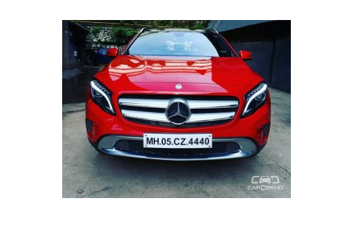

First we convert this image to grayscale

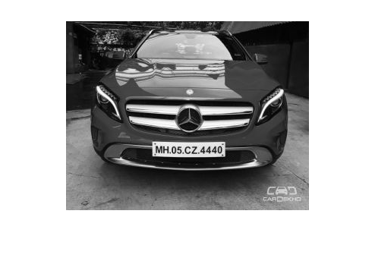

Next, we contrast stretch the image:

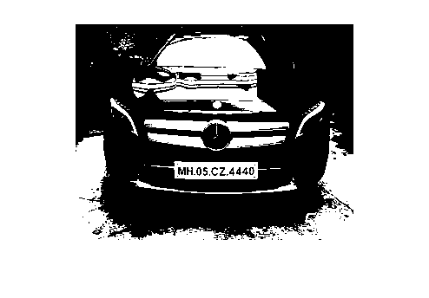

Next, we apply a 3x3 median filter on the image:

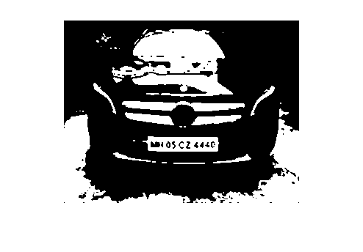

Next, we apply a high pass filter on the image

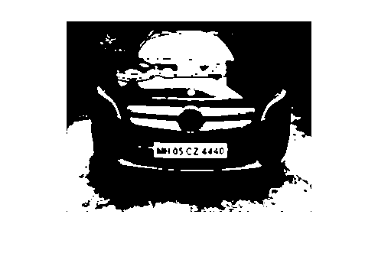

Now, we perform morphological opening of the image:

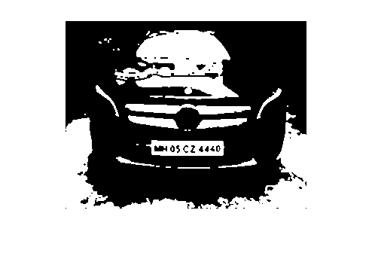

Next, we detect the edges of this image using Canny edge detector:

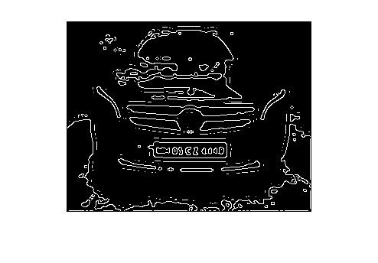

Now we need to find the connected components in the image. This can be done by using the MATLAB function regionprops. We get a lot of connected regions from regionprops as follows:

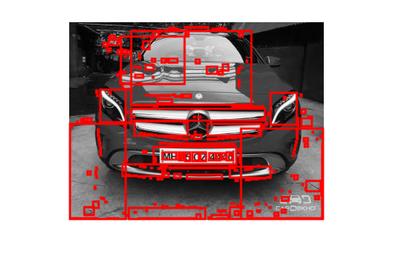

But, we know that the number plate is of a specific size and hence we an rule out the obvious irrelevant boxes. This is done by using the following conditions:

1. Length of box / Breadth of box must be greater than 1.5 and less than 10. These are quite loose restrictions so that we do not rule out the relevant box.
2. The length of the box must be in the range 0.1*rowsize to 0.7*rowsize

Thus now, few possibilities remain:

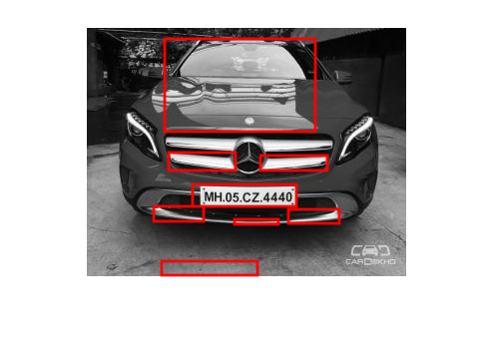

As we can see , the relevant box is still present. This is because the rules are applicable to it.

Next, we perform OCR on the boxes and try to check if there is any letter in the box. If yes, then we can separately consider it for segmentation.

So, we consider each box and run OCR function on it. If atleast 5 characters can be detected, the box must be considered. Hence, after applying this, we get

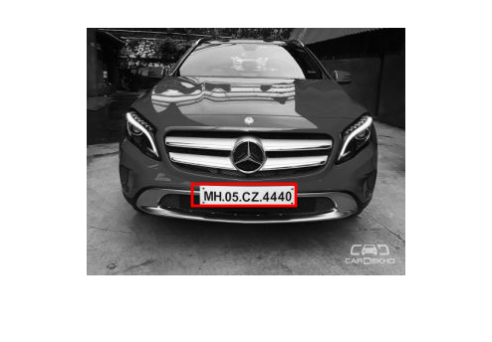

Luckily, only the relevant bounding box remains. This is because no other bounding box had any optical text inside it.

Now we move to PART 2

## PART 2: Segmentation of the extracted number plate

The cropped plate is as follows:

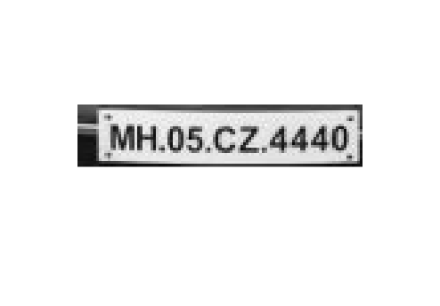

First resize the plate and threshold it

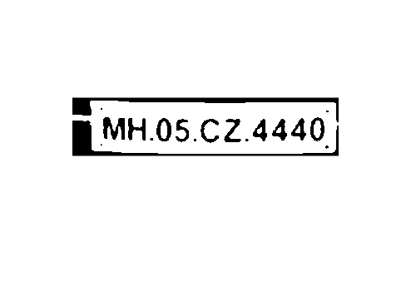

Now, erode the image so that any connected letters are separated

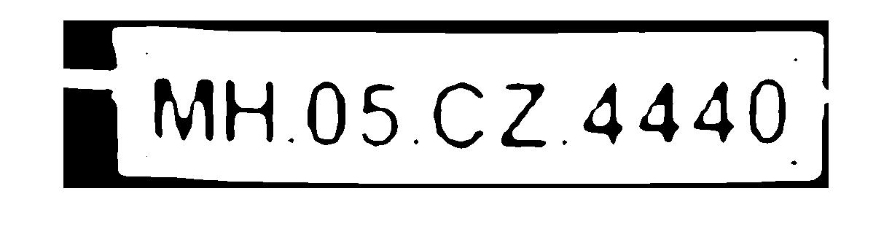

This looks quite promising. Now, we can move further and try to crop the image from top and bottom

Compute the row histogram:

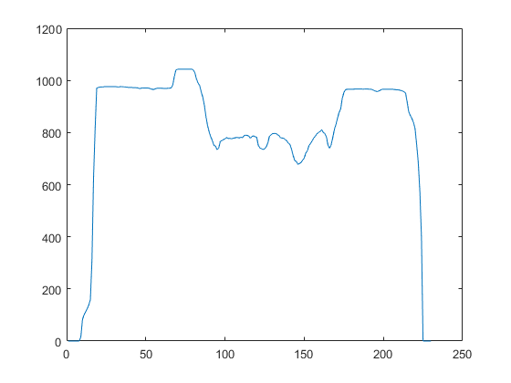

Remove the top black part and the bottom black part and thereshold the image with respect to the median of the peaks obtained from the histogram.

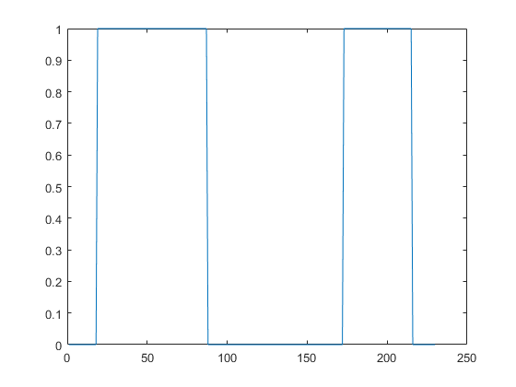

The above thresholded image signifies three important regions

Rows 20-50 have whitespace, rows 100-170 have characters and rows 170-220 have whitespace

Cropping the image from 20-220, we get

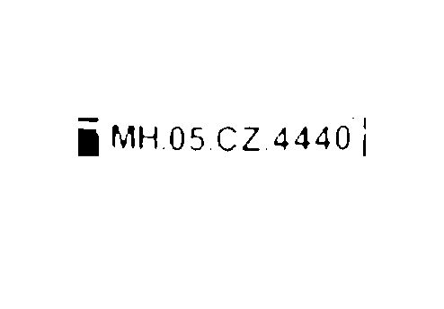

Next, we move on to horizontal scanning of the image:

Column histogram:

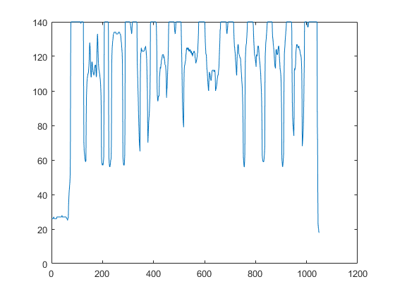

First find the left and the right points for iteration. They will be when whitespace starts.

The segments are formed as follows:

First threshold the histogram so that all values with maximum – 6 pixels go to 1 and rest to 0.

This gives:

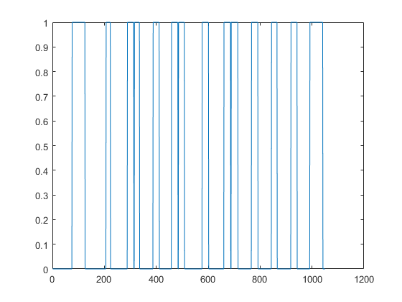

Now, we shall segment every whitespace containing more than 2 pixels.

This gives:



Now, we can move on to part C:

## PART C: Recognition of letters

This can be done using any standard OCR packages like Tesseract. We just need to crop the location of the letter from the original image and pass it to the package.

However, in order to try something new, we train a neural network on handwritten characters. For now, the neural network has been trained only on numbers and not alphabets. But once that is done, the network can predict letters too along with numbers.

So, the current network only predicts numbers

Lets take the 5 in the image.

We crop it and subtract the image from 1 to get the letter in white and background in black on which neural network was trained.

Next, we resize the image to 20 x 20, the size on which the neural network was trained.

This gives:

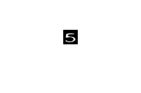

Next, we flatten the image to get a 1 x 400 feature vector and pass it to the neural network.

Final output from neural network: 5

Hence, we have successfully completed all parts of the problem.

## Future work and Challenges:

1. Pose variation will be a very big challenge for this method. One solution will be to use the Radon transform for correcting for pose variation and obtaining an appropriate image pose for this method.
2. The method shall be extended to recognize letters too. This is straightforward and will be accomplished soon.
3. Many alterations can be done in this method. For example, instead of using OCR to detect the presence of letters, one can use the segmenting technique used for segmentation of the plates and decide whether the box is a potential candidate for a number plate depending on the segments obtained. The segments must be greater than 5 and less than 20.
4. Other modification can be to use SWT (Stroke Width Transform) for letter detection.
5. We can also use the Connected components method to check how many connected components are present within a box and check whether they resemble the characters depending on their aspect ratio.

# References:

1. LICENSE PLATE EXTRACTION METHOD FOR IDENTIFICATION OF VEHICLE VIOLATIONS AT A RAILWAY LEVEL CROSSING by B. K. CHO, S. H. RYU, D. R. SHIN and J. I. JUNG
2. License Plate Recognition for High Security Registration Plates: A Review by Siddhartha Choubey, Anshuman Rai
3. Text Locating from Natural Scene Images Using Image Intensities by JiSoo Kim, SangCheol Park, and SooHyung Kim
4. Number Plate Recognition Using an Improved Segmentation by Mr. G. T. Sutar ,Prof. Mr. A.V. Shah