CS 736 Assignment 1 Report – Shape Analysis

Q1.

a) Input Pointset

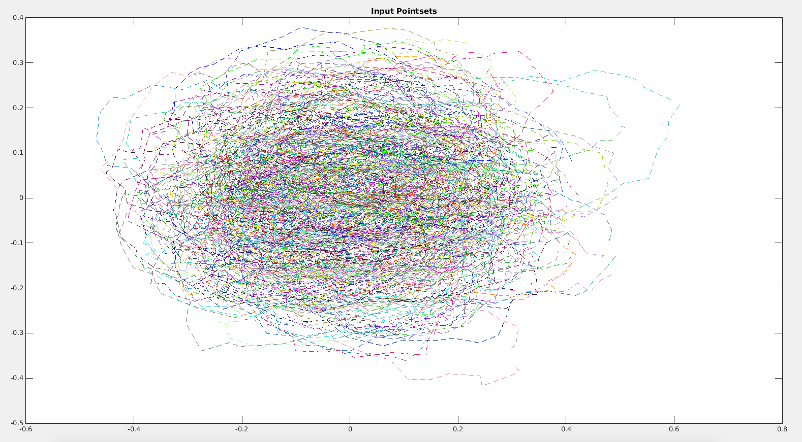

b) Shape Mean with aligned pointset

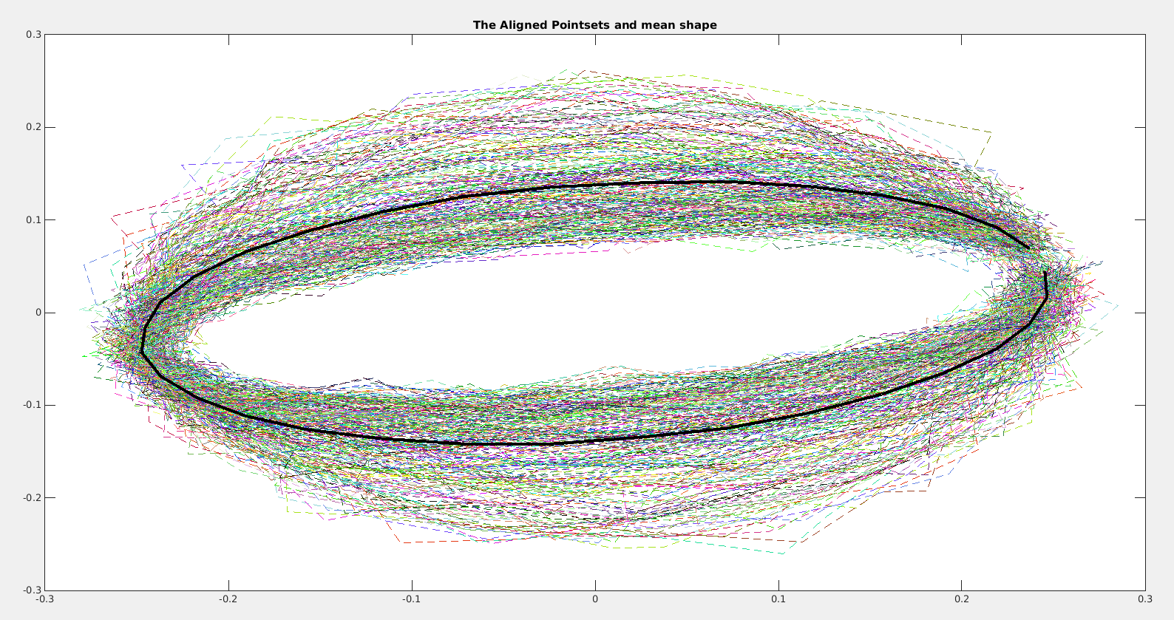

c) Plot of Eigenvalues,

x­axis indicate principal mode of, y­axis denote eigenvalue for corresponding mode.

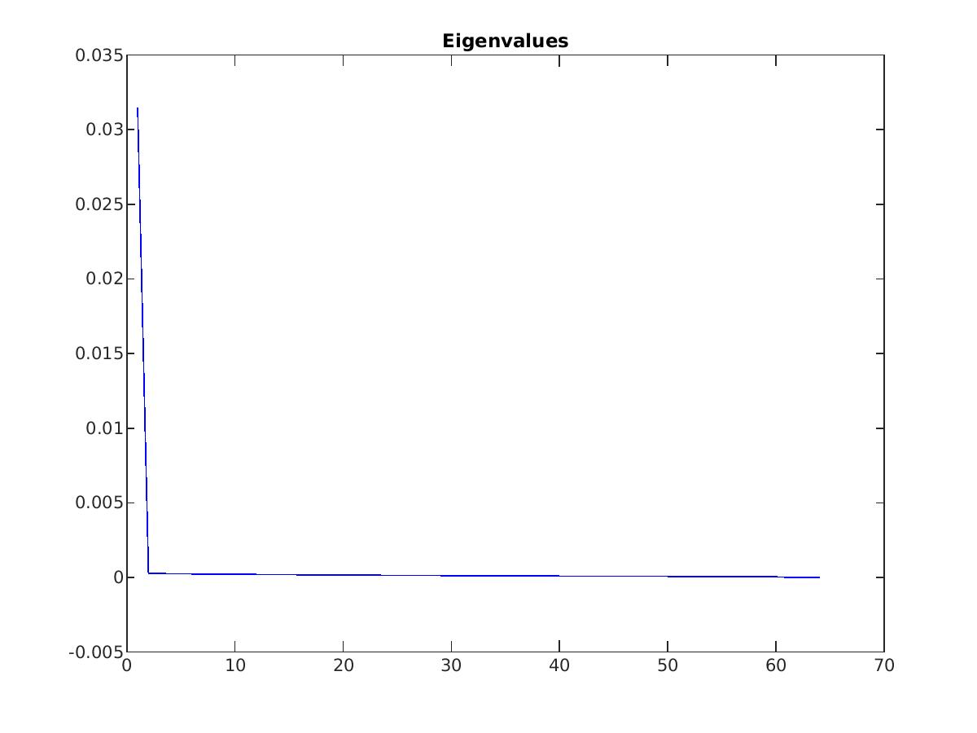

d) Principal mode of shape variation, middle one (Red) is mean  
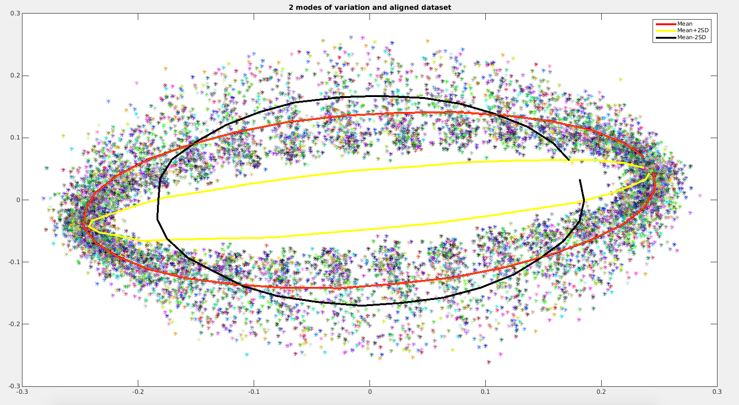

Q2.

a) Input Pointset

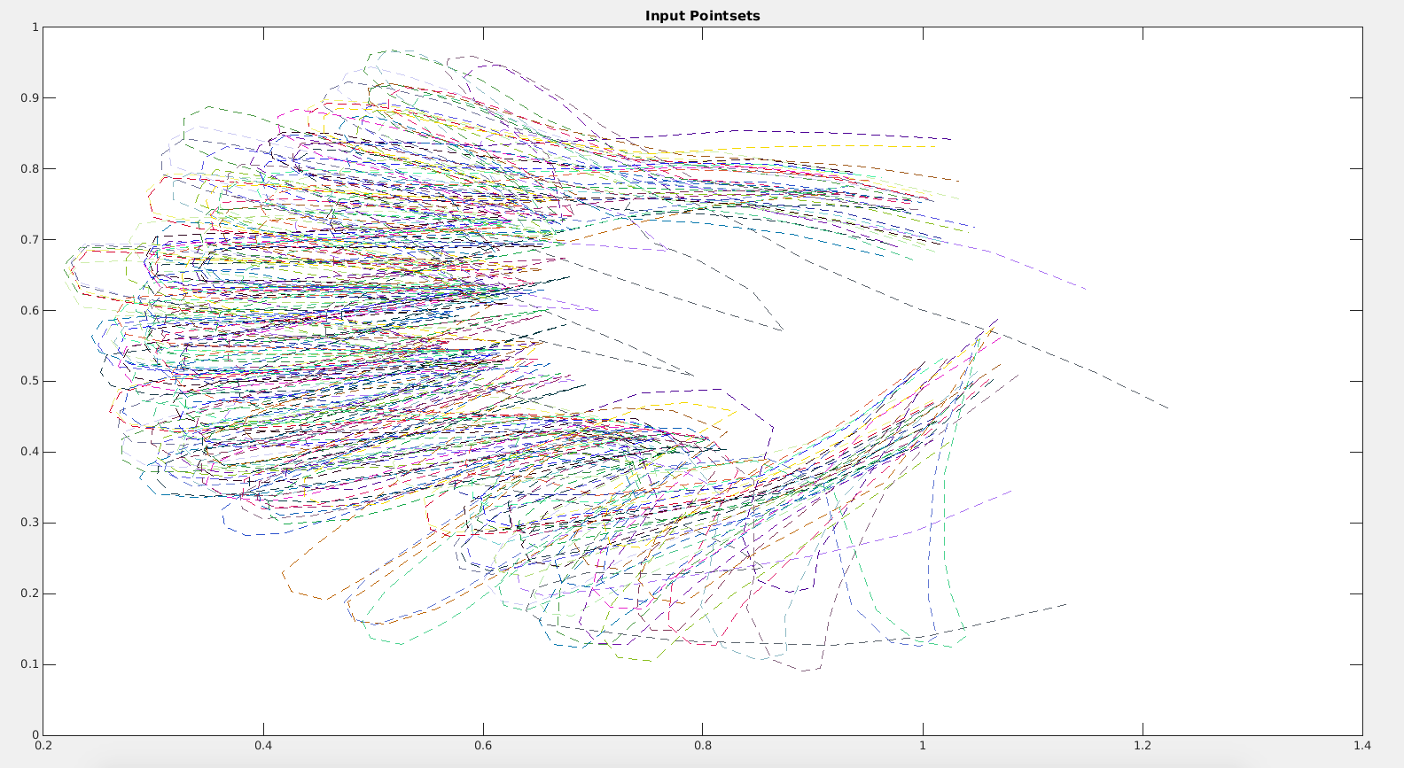

b) Shape Mean with aligned pointset

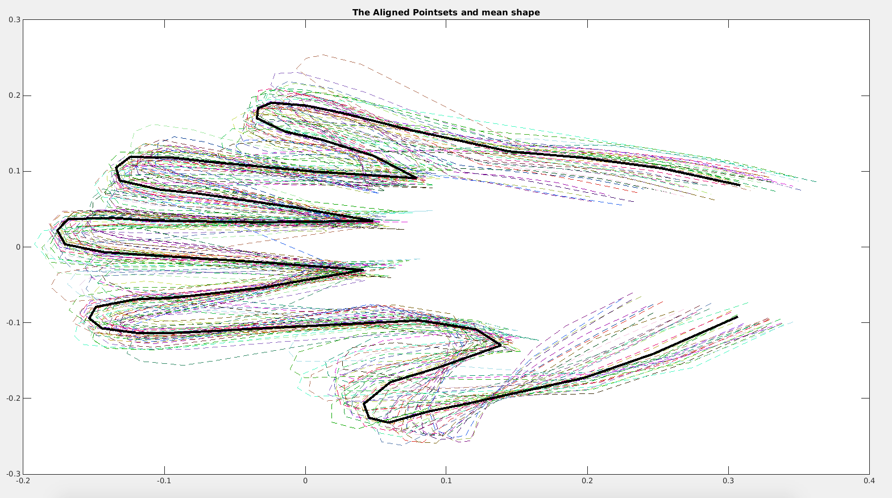

c) Plot of Eigenvalues,

x­axis indicate principal mode of, y­axis denote eigenvalue for corresponding mode.

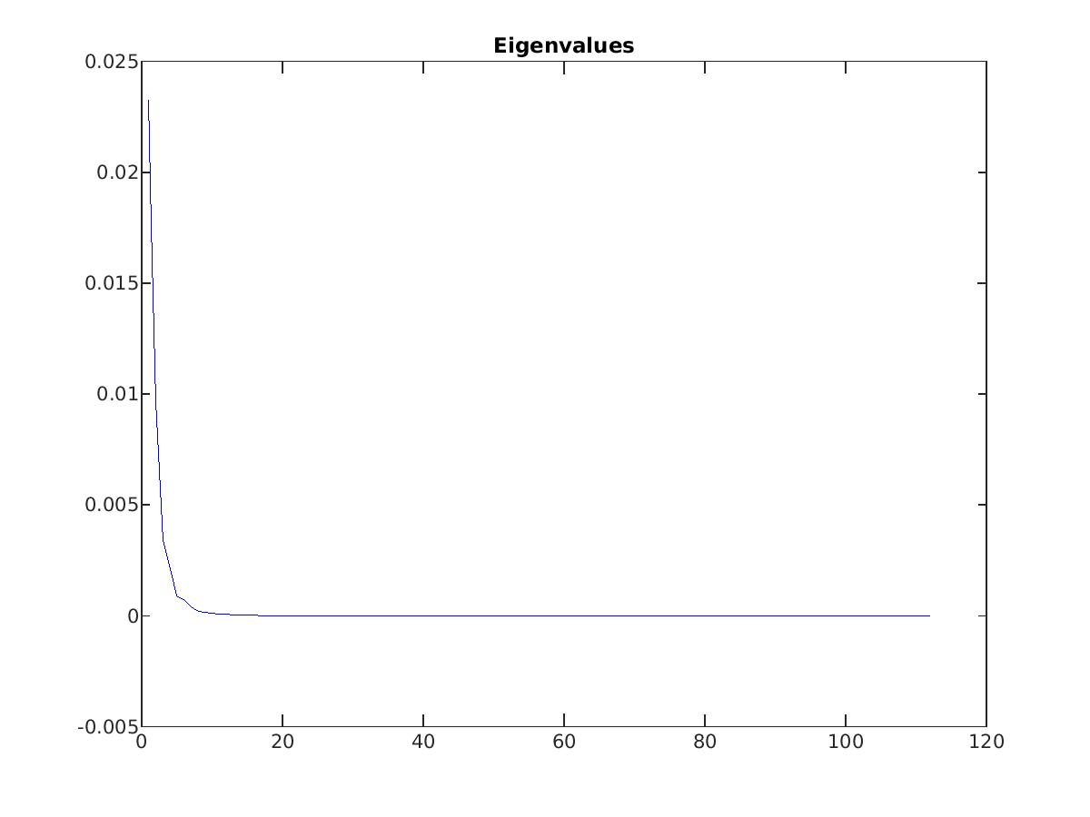

d) Principal mode of shape variation, middle one (Red) is mean.

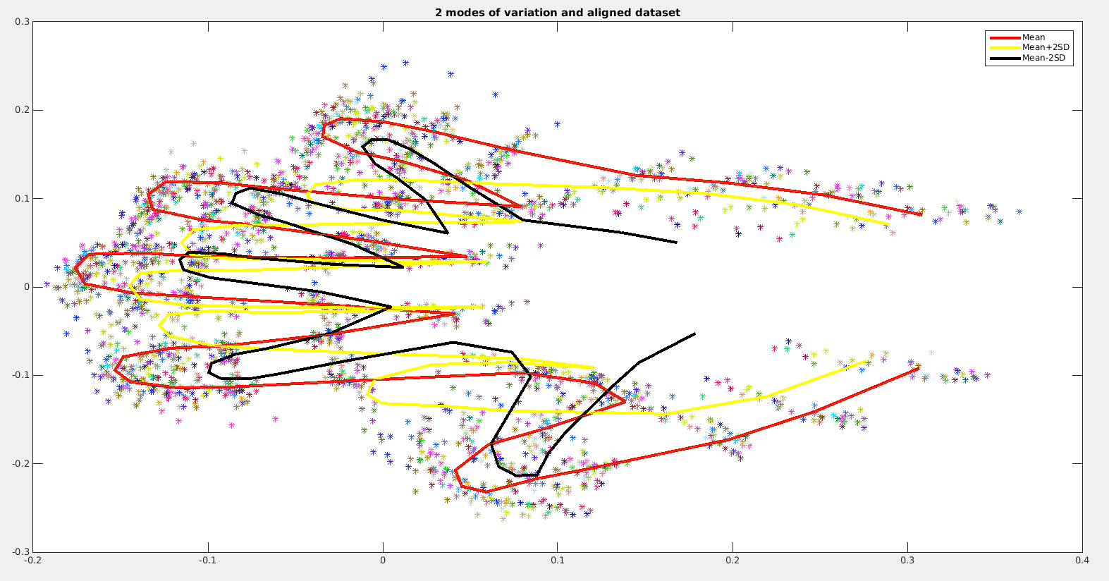

Q3.

Input Pointset

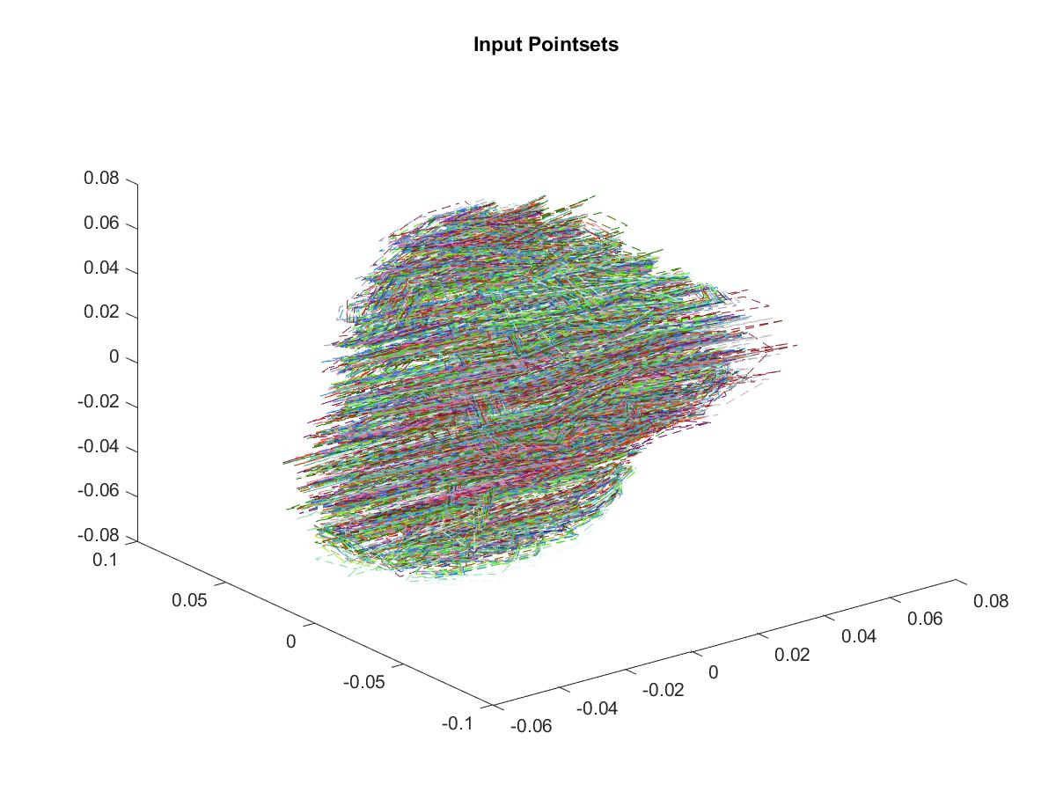

Shape Mean with aligned pointset

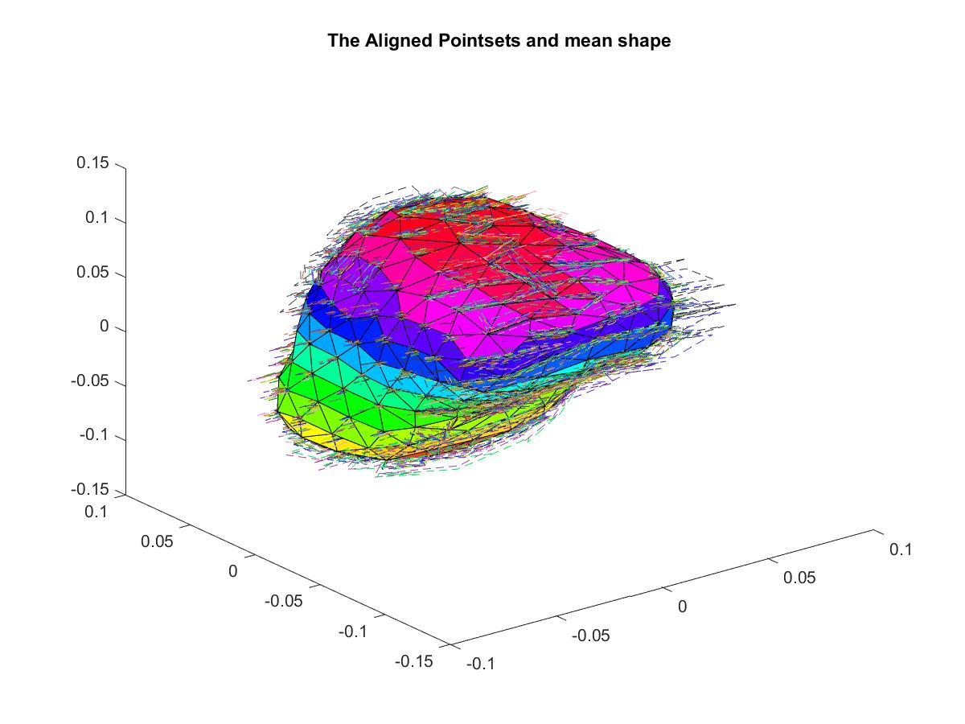

Plot of Eigenvalues,

x­axis indicate principal mode of, y­axis denote eigenvalue for corresponding mode.

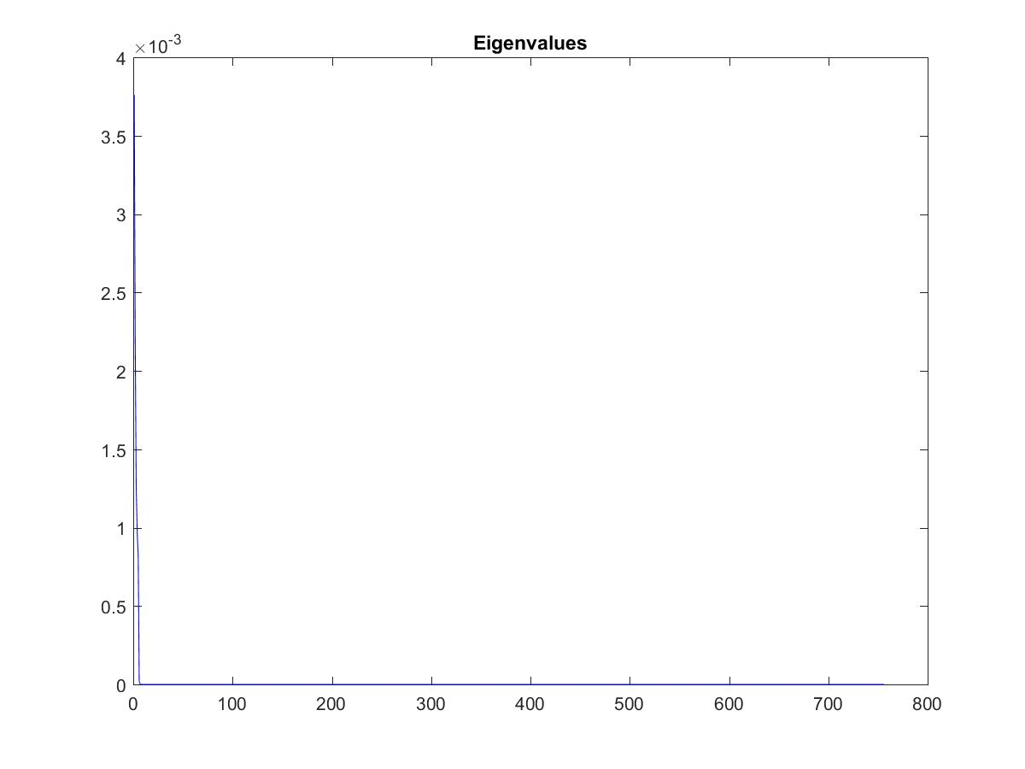

Principal mode of shape variation, middle one (Red) is mean.

All the required codes are available in the code folder with the individual functions.

The high resolution images for the required plots are stored in the results folder.