**README:**

This README file contains server design, instructions on how to compile and run the code and few output snapshots for reference.

Client(s) will send request with specific command to the server.

1. **Server Design:**

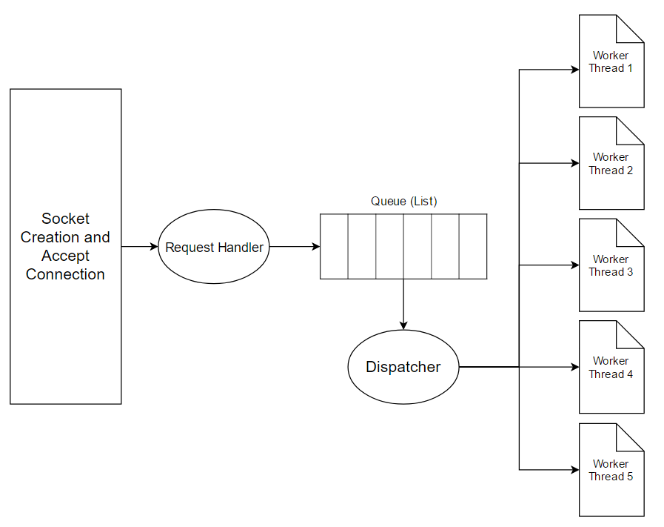

* Server initially create socket and keeps accepting connections from the clients.
* Once, request is received from some client(s), request handler calls corresponding sub routine for the command.
* For ping site command, queue (Linked List) is created with each website.
* In parallel, worker threads are in wait state.
* Dispatcher continuously monitors for new request in queue and dispatch job to worker threads.
* Once, there is any new website request in the queue, dispatcher signals thread to start serving that request.
* The process keeps continuing till server closes its socket.

1. **Instructions on how to compile and run the code:**

There are 2 source code files (server.c and client.c). To compile and run both files, command is:

For Server:

* Compile: gcc server.c -o server -lpthread -w
* Run: ./server Port
  + E.g. ./server 9999

For Client:

* Compile: gcc client.c -o client
* Run: ./client IP_Adress Port
  + E.g. ./client 127.0.0.1 9999

1. **Snapshots:**

Below are few output snapshots for reference:

* Usage:

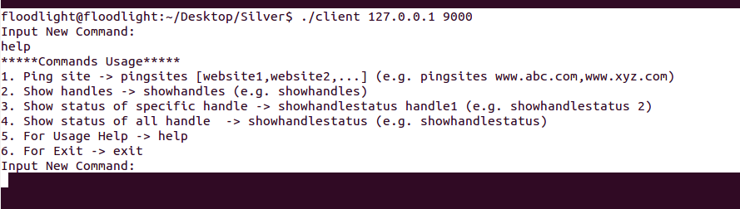

* Ping 7 Sites:



* Status on another client before and after job completion:

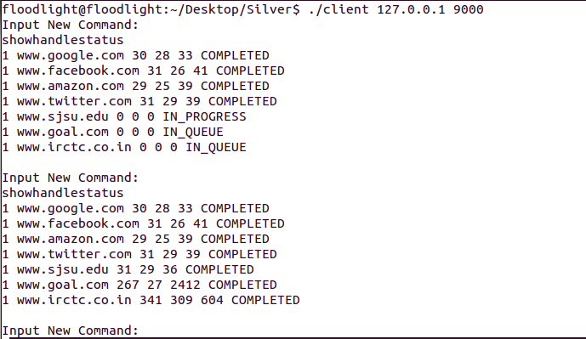

* Status after adding requesting ping for new sites from another client:

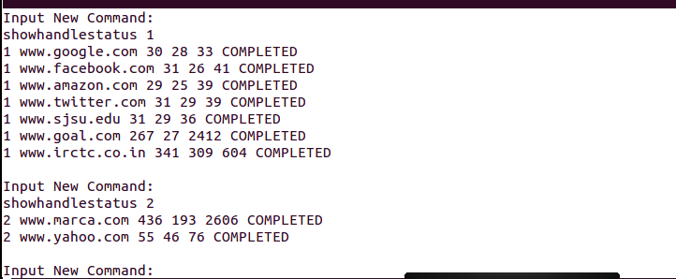

* Show all handle Ids

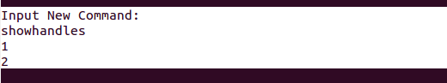

* Show handle status of both handle id:

